Text consolidated by Valsts valodas centrs (State Language Centre) with amending regulations of:
10 June 2008 [shall come into force on 14 June 2008];
29 September 2009 [shall come into force on 3 October 2009];
14 September 2010 [shall come into force on 18 September 2010];
13 August 2013 [shall come into force on 16 August 2013];
2 February 2016 [shall come into force on 12 February 2016];
25 September 2018 [shall come into force on 28 September 2018];
15 January 2019 [shall come into force on 18 January 2019];
14 July 2022 [shall come into force on 19 July 2022].
If a whole or part of a paragraph has been amended, the date of the amending regulation appears in square brackets at the end of the paragraph. If a whole paragraph or sub-paragraph has been deleted, the date of the deletion appears in square brackets beside the deleted paragraph or sub-paragraph.

Republic of Latvia

Cabinet
Regulation No. 436
Adopted 26 June 2007

Procedures for the Importation and Exportation of Medicinal Products

Issued pursuant to
Section 5, Clause 3 of the Pharmaceutical Law and Section 28 of the Law on the Legal Trade of Narcotic and Psychotropic Substances and Medicinal Products, and also Precursors
[14 July 2022]

I. General Provisions

1. The Regulation prescribes:
1.1. the procedures for the importation and exportation of medicinal products;
1.2. the customs control points (hereinafter – the border crossing points through which the import and export of the substances and medicinal products included in Schedules II and III of Narcotic Substances, Psychotropic Substances and Precursors to be Controlled in Latvia;
1.3. the supervision of the importation and exportation of medicinal products.
[14 July 2022]

2. The Regulation applies to the importation into the customs territory of the European Union of these medicinal products and auxiliary medicinal products (hereinafter – the medicinal products) (imports of medicinal products) and their exportation from the customs territory of the European Union (exports of medicinal products):
2.1. the import of such medicinal products which have been registered in the Register of Medicinal Products of the Republic of Latvia or under the centralised authorisation procedure in accordance with Regulation (EC) No 726/2004 of the European Parliament and of the Council of 31 March 2004 laying down Community procedures for the authorisation and supervision of medicinal products for human use and establishing a European Medicines Agency (hereinafter – Regulation No 726/2004 of the European Parliament and of the Council);
2.2. the import of such medicinal products that have not been registered in the Register of Medicinal Products of the Republic of Latvia or under the centralised authorisation procedure in accordance with Regulation (EC) No 726/2004 of the European Parliament and of the Council, but have been registered in third countries (hereinafter – the unregistered medicinal products from third countries);
2.3. the import of medicinal products by budget institutions or public benefit organisations in accordance with Council Regulation (EC) No 1186/2009 of 16 November 2009 setting up a Community system of reliefs from customs duty (does not apply to auxiliary medicinal products);
2.4. the import of the samples of medicinal products, including substances used as reference substances for the testing of medicinal products (hereinafter – the samples of reference standards);
2.5. the export of medicinal products and sample medicinal products, including samples of reference standards;
2.6. the import and export of investigational medicinal products.
[14 July 2022]

2.¹ In free ports, special economic zones and customs warehouses, and also in other storage places for medicinal products referred to in Paragraph 2 of the Regulation, the entry (import) and exit (export) of medicinal products shall be subject to supervision in accordance with the Regulation.
[14 July 2022]

2.² The importation of investigational medicinal products (hereinafter – the investigational medicinal products) specified in Article 2(2)(5) of Regulation (EC) No 536/2014 of the European Parliament and of the Council of 16 April 2014 on clinical trials on medicinal products for human use and repealing Directive 2001/20/EC (hereinafter – Regulation No 536/2014 of the European Parliament and of the Council), and the import of auxiliary medicinal products specified in Article 2(2)(8) of Regulation No 536/2014 of the European Parliament and of the Council shall be carried out in accordance with Chapter IX of Regulation No 536/2014 of the European Parliament and of the Council and this Regulation.
[14 July 2022]

3. This Regulation shall not apply to:
3.1. the importation of medicinal products from countries of the European Economic Area or the exportation of medicinal products to countries of the European Economic Area;
3.2. the importation and exportation of medicinal products for personal use by a natural person, for example, to medicinal products in the luggage of a traveller;
3.3. medicinal products which a natural person receives or sends as postal items;
3.4. veterinary medicinal products.
[14 September 2010; 14 July 2022]

4. The import and export of the medicinal products referred to in Paragraph 2 of this Regulation (including medicinal products containing the substances (narcotic medicinal products) included in Schedule II of Narcotic Substances, Psychotropic Substances and Precursors to be Controlled in Latvia and the substances (psychotropic medicinal products) included in Schedule III of Narcotic Substances, Psychotropic Substances and Precursors to be Controlled in Latvia) are permitted through border crossing points in which the Food and Veterinary Service performs food safety and non-food product safety, quality and classification checks in relation to compliance with the temperature regime which are specified in the laws and regulations regarding border crossing points and the inspections to be carried out therein.
[14 July 2022]

5. The importation and exportation of medicinal products shall be controlled by the customs authorities in accordance with the Customs Law and the relevant laws and regulations that govern the procedures for customs clearance and customs control.

5.¹ The Health Inspectorate shall carry out market surveillance as regards the medicinal products for human use in accordance with the Pharmaceutical Law, the laws and regulations regarding the distribution and quality control of medicinal products and this Regulation.
[14 July 2022]

6. The Food and Veterinary Service shall carry out documentary checks and also, on the basis of risk analysis, identity and physical checks in accordance with:
6.1. this Regulation;
6.2. Regulation No 2016/793 of the European Parliament and of the Council of 11 May 2016 to avoid trade diversion into the European Union of certain key medicines (codification) (hereinafter – Regulation No 2016/793 of the European Parliament and of the Council);
6.3. Article 14 of Regulation (EC) No 816/2006 of the European Parliament and of the Council of 17 May 2006 on compulsory licensing of patents relating to the manufacture of pharmaceutical products for export to countries with public health problems (hereinafter – Regulation No 816/2006 of the European Parliament and of the Council).
[14 July 2022]

7. [1 January 2023 / See Paragraph 56.³]

7.¹ The Health Inspectorate shall, prior to the issuing or re-registration of a special authorisation (licence), inspect the conformity of such customs warehouses where medicinal products are intended to be stored for more than 72 hours, premises, equipment, facilities and personnel with the requirements specified in the laws and regulations regarding the distribution of medicinal products. After inspection, the Health Inspectorate shall prepare and issue an inspection deed to the holder of the customs warehouse permit, and also submit it to the State Agency of Medicines.
[14 July 2022]

7.² If the medicinal products are stored in a customs warehouse for up to 72 hours or at a place of temporary storage, the holder of the authorisation for the relevant customs warehouse and the holder of the authorisation for the temporary storage facility has the obligation to notify the Health Inspectorate thereof prior to the commencement of such service. The abovementioned notice shall not apply to the customs warehouses to which the Health Inspectorate has issued an opinion on the conformity of the warehouse with the requirements for the storage of medicinal products and to the customs warehouses specified in the special authorisation (licence) of the medicinal product wholesaler.
[14 July 2022 / Paragraph shall come into force on 1 January 2023. See Paragraph 56.⁴]

8. The owner or the possessor (hereinafter – the possessor of medicinal products) of a freight of medicinal products shall:
8.1. submit an instruction to the holder of the authorisation for a customs warehouse and the holder of the authorisation for a temporary storage facility, specifying the requirements for the storage of medicinal products in accordance with the storage conditions specified by the medicinal product manufacturer (instructions for use of medicinal products, descriptions of medicinal products). The holder of the authorisation for a customs warehouse and holder of the authorisation for a temporary storage facility shall ensure conditions for the storage of medicinal products in the customs warehouse and temporary storage facility accordingly in compliance with the instructions of the possessor of medicinal products and requirements for the storage of medicinal products in accordance with the guidelines for good distribution practice of medicinal products published by the European Commission (available in the official language on the website of the State Agency of Medicines);
8.2. cover the expenditures that are related to the ensuring of the conditions for the storage of medicinal products in the customs warehouse;
8.3. when importing medicinal products, present them at the places for checks referred to in Paragraph 4 of this Regulation for the check of the Food and Veterinary Service and ensure free access for the officials of the Health Inspectorate to the place where medicinal products are stored in customs warehouses and temporary storage facilities.
[10 June 2008; 29 September 2009; 14 September 2010; 2 February 2016; 14 July 2022]

9. An accompanying document issued by the relevant foreign country shall be attached by the possessor of medicinal products to the freight of medicinal products that is imported, and the following information shall be indicated therein:
9.1. the date of the delivery of medicinal products, name of the medicinal products, pharmaceutical form, strength or concentration of the medicinal products and the manufacturing batch number and amount of each medicinal product supplied, the firm name and address of the supplier of the medicinal products (consignor), the firm name of the medicinal product manufacturer, the name of the country of manufacture of the medicinal products and the firm name and address of the consignee of the medicinal products;
9.2. the price for which the medicinal products have been sold to the consignee of the medicinal products.
[13 August 2013]

10. If the possessor of medicinal products uses, on the basis of a contract, transport services provided by another person (hereinafter – the commercial carrier) for the import of freight, then the commercial carrier shall, in addition to the requirements laid down in Paragraph 9 of this Regulation, present to the customs authority the contract concluded between the possessor of medicinal products and the commercial carrier for the provision of transport services or the authorisation of the possessor of medicinal products for the performance of the relevant activity.

II. Import of Medicinal Products

11. Medicinal products may be imported by a person who, according to the laws and regulations regarding the procedures for the licensing of pharmaceutical activity, has a special authorisation (licence) issued by the State Agency of Medicines for the manufacture or importation of medicinal products with the authorised activity – import of medicinal products (this shall not apply to unregistered medicinal products, samples of medicinal product, and transit of medicinal products – freight of medicinal products that enters from third countries into the places referred to in Paragraph 2.¹ of this Regulation and is exported to third countries). Investigational medicinal products may be imported by a person in the special authorisation (licence) for the manufacture/importation of medicinal products of whom it is indicated that the import of investigational medicinal products is permitted.
[14 July 2022]

11.¹ The special authorisation (licence) for the manufacture and importation of medicinal products issued by the State Agency of Medicines shall not be necessary for a freight of medicinal products that is imported from third countries on the basis of a licence for the manufacture and importation of medicinal products issued by the competent authority of another European Union Member State and that is transported in transit (including placed in a customs warehouse) through the territory of Latvia.
[14 July 2022]

12. A person who is involved in the activities for the performance of which the special authorisation (licence) for the manufacture/importing of medicinal products (hereinafter – the importer of medicinal products) is necessary shall ensure the fulfilment of the following requirements:
12.1. the imported medicinal products, including the investigational medicinal products, have been manufactured in compliance with the requirements that are equivalent to or higher than the principles of and guidelines for good manufacturing practice specified in the Pharmaceutical Law and laws and regulations regarding the procedures for the manufacture and control of medicinal products. Investigational medicinal products are subject to the principles of and guidelines for good manufacturing practice referred to in Article 63 of Regulation No 536/2014 of the European Parliament and of the Council under Chapter II of Commission Delegated Regulation (EU) 2017/1569 of 23 May 2017 supplementing Regulation (EU) No 536/2014 of the European Parliament and of the Council by specifying principles of and guidelines for good manufacturing practice for investigational medicinal products for human use and arrangements for inspections (hereinafter – Commission Delegated Regulation No 2017/1569);
12.2. the medicinal product manufacturer has a relevant authorisation for the manufacture of medicinal products in the relevant country;
12.3. at least one responsible official with corresponding education and professional experience (hereinafter – the qualified person) is permanently and continuously at the disposal thereof. The State Agency of Medicines shall be immediately, but not later than within five days, must be notified in writing of the change of the qualified person;
12.4. a personnel it at the disposal thereof which meets the requirements laid down in the laws and regulations regarding the manufacture and control of medicinal products;
12.5. a possibility to visit the premises of the importer of medicinal products at any time is ensured to officials of the State Agency of Medicines and the Health Inspectorate;
12.6. the qualified person is provided with the possibility to fulfil the requirements referred to in Paragraphs 14, 15 and 16 of this Regulation (in relation to investigational medicinal products – the requirements referred to in Paragraphs 21 and 22 of this Regulation), for example, by placing at the disposal thereof the necessary facilities;
12.7. the principles of and guidelines for good manufacturing practice that have been specified in the laws and regulations regarding the manufacture and control of medicinal products is complied with in the quality control and batch release of the imported medicinal products;
12.8. in the distribution of medicinal products, principles of good distribution practice of medicinal products laid down in the guidelines for good distribution practice of medicinal products published by the European Commission (available in the official language on the website of the State Agency of Medicines) are followed. The requirements laid down in the laws and regulations for the conducting the clinical trials of medicinal products must be complied with in relation to investigational medicinal products.
[2 February 2016; 25 September 2018; 14 July 2022]

13. The education and professional experience of the qualified person shall conform to the qualification and professional experience criteria that have been determined in the laws and regulations regarding the manufacture and control of medicinal products.

14. The qualified person shall, without prejudice to his or her relationship with the importer of medicinal products, be responsible for ensuring that a full qualitative analysis and quantitative analysis of all active substances is carried out for each batch of imported medicinal products (also if the medicinal products have been manufactured within the European Community (Member States of the European Union and countries of the European Economic Area), exported to third countries and re-imported) and shall also carry out all the other tests and checks that are necessary to ensure the quality of the medicinal products in accordance with the requirements of the medicinal product registration documentation. The quality control of medicinal products shall not be carried out for the batches of imported medicinal products that have undergone such controls in another Member State of the European Community, and the medicinal products have been supplied from another Member State together with a control report signed by the qualified person.

15. The quality control of the medicinal products referred to in Paragraph 14 of this Regulation need not be carried out if the medicinal products are imported from the countries that have entered into a mutual recognition agreement with the European Community on the conformity assessment of good manufacturing practice of medicinal products, and this agreement provides that the testing of each batch of medicinal products (the qualitative and quantitative analysis) is carried out in the exporting country. In such case, the certificate of the batch of medicinal products referred to in Paragraph 34 of this Regulation shall accompany each batch of imported medicinal products.
[2 February 2016]

15.¹ The exception referred to in Paragraph 15 of this Regulation shall apply only to the manufacturing activities or pharmaceutical forms that are indicated in the agreement between the European Union and the respective country.
[2 February 2016]

16. The qualified person shall certify the batches of medicinal products in all cases by making precise entries in a registration logbook or in an equivalent document provided for that purpose and by certifying with a signature that each batch of the medicinal products has been manufactured and controlled in conformity with the requirements referred to in Paragraphs 14 and 15 of this Regulation. The registration logbook or the equivalent document shall be kept up to date as certain activities are carried out and shall be kept at the undertaking at least for five years after the making of the last entry, ensuring access to such logbook or document to the officials of the State Agency of Medicines and the Health Inspectorate.
[2 February 2016]

16.¹ If the medicinal products are to be placed on the market of the European Union, the qualified person shall ensure that the packaging of the relevant medicinal products has safety features referred to in Article 3(2)(a) and (b) of Commission Delegated Regulation (EU) 2016/161 of 2 October 2015 supplementing Directive 2001/83/EC of the European Parliament and of the Council by laying down detailed rules for the safety features appearing on the packaging of medicinal products for human use (hereinafter – Delegated Regulation No 2016/161).
[15 January 2019 / Paragraph shall be applied from 9 February 2019 in compliance with the transitional measures specified in Articles 48 and 50 of Delegated Regulation No 2016/161. See Paragraph 56.²]

17. In order to carry out the quality control of the medicinal products referred to in Paragraph 14 of this Regulation, a quality control laboratory of another person may be used (hereinafter – the contract acceptor), if the importer of medicinal products and the contract acceptor enter into a written contract in compliance with the requirements of Paragraphs 18, 19 and 20 of this Regulation.

18. The contract shall clearly define the obligations of the parties, in particular, the obligation of the contract acceptor to comply with the principles of and guidelines for good manufacturing practice, and also the manner in which the qualified person who is responsible for the certification of each batch shall fulfil his or her obligations.

19. The contract acceptor shall ensure the fulfilment of the following requirements:
19.1. if a written authorisation has not been received from the importer of medicinal products, the contract acceptor shall not enter into subcontract with a third person for the work which has been entrusted to the contract acceptor in conformity with the contract referred to in Paragraph 17 of this Regulation;
19.2. shall comply with the principles of and guidelines for good manufacturing practice that have been specified in the laws and regulations regarding the manufacture and control of medicinal products and shall also subject oneself to the control of the State Agency of Medicines.

20. Prior to entering into a contract for the performance of the quality control of medicinal products, the importer of medicinal products shall ensure that a statement is provided by the State Agency of Medicines on the conformity of the laboratory to the requirements for good manufacturing practice that have been laid down in the guidelines of the European Commission for good manufacturing practice for medicinal products and investigational medicinal products. If the laboratory is located in another country, the State Agency of Medicines shall establish that the relevant laboratory has a valid certificate of good manufacturing practice in the European Union database on manufacturing and import licences and good manufacturing practice certificates (EudraGMDP database) which includes quality control of the relevant type of testing for which a contract is intended to be entered into.
[14 July 2022]

21. In relation to the investigational medicinal products which have been manufactured in third countries, the qualified person shall be responsible for ensuring that each batch of the medicinal products has been manufactured and checked in conformity with the principles of and guidelines for good manufacturing practice that are at specified in Chapter II of the Commission Delegated Regulation No 2017/1569 and also in conformity with the product specification and information indicated by the sponsor in the submission to the State Agency of Medicines for the receipt of the authorisation for the clinical trial of medicinal products. For investigational medicinal products from a third country used for comparison in a clinical trial and registered in third countries but for which a documentary evidence cannot be obtained that each series has been produced under conditions that are at least equivalent to the principles of good manufacturing practice laid down in Chapter II of Commission Delegated Regulation No 2017/1569 and the guidelines, the qualified person shall be responsible for the analysis, testing and inspection of each batch of the preparation in order to certify that the quality thereof conforms to the information provided by the sponsor to the State Agency of Medicines for the receipt of the authorisation for clinical trials or an authorisation with a condition referred to in the laws and regulations regarding clinical trials.
[14 July 2022]

22. In all cases, the qualified person shall make accurate entries in the registration logbook or other equivalent document intended for this purpose as regards the investigational medicinal products and shall certify with a signature that each batch of medicinal products conforms to the requirements referred to in Paragraph 21 of this Regulation. After specified activities, the registration logbook or the relevant document shall be supplemented and stored in the undertaking for at least five years from the completion or official termination of the last study in which the specific batch of investigational medicinal products was used and shall ensure access to the aforementioned journal or document to officials of the State Agency of Medicines.
[14 July 2022]

23. [14 July 2022]

24. The special authorisation (licence) for the manufacture/importation of medicinal products referred to in Paragraph 11 of this Regulation shall apply only to the medicinal products (in relation to investigational medicinal products – to the types of medicinal products and pharmaceutical forms) that have been indicated by the importer of medicinal products in the submission for the receipt of the special authorisation (licence) for the manufacture/importation of medicinal products and that, when issuing the aforementioned special authorisation (licence), have been included by the State Agency of Medicines in the data base in accordance with the laws and regulations regarding the procedures for licensing the pharmaceutical activity.
[2 February 2016]

25. The importer of medicinal products may import narcotic and psychotropic medicinal products that have been indicated in the submission for the receipt of the special authorisation (licence) for the manufacture or importation of medicinal products and that, when issuing the aforementioned special authorisation (licence), have been included by the State Agency of Medicines in the database in accordance with the laws and regulations regarding the procedures for licensing the pharmaceutical activity if a single-use authorisation issued by the State Agency of Medicines which corresponds to the requirements of the Commission on Narcotic Drugs of the United Nations Organisation (hereinafter – the UN) Economic and Social Council is issued for the importation of the respective medicinal products in accordance with the Law on the Legal Trade of Narcotic and Psychotropic Substances and Medicinal Products, and also Precursors. In addition to the requirements laid down in this Regulation, the requirements specified in the Law on the Legal Trade of Narcotic and Psychotropic Substances and Medicinal Products, and also Precursors shall be complied with.
[14 July 2022]

26. The importer of medicinal products may import non-prescription medicinal products that have been included in the Register of Medicinal Products of the Republic of Latvia or that have been centrally registered in accordance with Regulation No 726/2004 of the European Parliament and of the Council on behalf of budget institutions or public benefit organisations.
[14 July 2022]

III. Importation of the Samples of Medicinal Products and Unregistered Medicinal Products from Third Countries

27. Unregistered medicinal products may be imported from third countries by a person who, in accordance with the laws and regulations regarding the licensing of pharmaceutical activity, has received the special authorisation (licence) issued by the State Agency of Medicines for the wholesale distribution of medicinal products for human use and who has the authorisation for the distribution of unregistered medicinal products issued by the State Agency of Medicines in accordance with the procedures specified in the laws and regulations regarding the distribution and quality control of medicinal products for the individually assigned medicinal products.
[14 July 2022]

27.¹ Unregistered narcotic and psychotropic medicinal products may be imported from third countries by a person, if, in addition to the requirements referred to in Paragraph 27 of this Regulation, a single-use authorisation issued by the State Agency of Medicines which corresponds to the requirements of the Commission on Narcotic Drugs of the UN Economic and Social Council is issued for the import of the specific medicinal products in accordance with the Law on the Legal Trade of Narcotic and Psychotropic Substances and Medicinal Products, and also Precursors.
[14 July 2022]

27.² The requirements specified in Paragraph 27 of this Regulation shall also apply to unregistered non-prescription medicinal products referred to in Paragraph 26 of this Regulation.
[14 July 2022]

28. Samples of medicinal products may be imported on the basis of the authorisation referred to in Paragraph 28.¹ of this Regulation, if they are intended:
28.1. for the registration of medicinal products by submitting them to the State Agency of Medicines;
28.2. for use in research or development testing in Latvia or other countries (not applicable to investigational medicinal products, including medicinal products used for comparison, including placebo);
28.3. to be used for educational purposes;
28.4. to be used as samples of reference standards in testing.
[14 July 2022]

28.¹ Samples of medicinal products (except for the samples of narcotic and psychotropic medicinal products) may be imported from third countries by a person who has the authorisation for the importation of the samples of medicinal products into the Republic of Latvia issued by the State Agency of Medicines (Annex 1). After the importation of the number of packaging units of medicinal products indicated in the authorisation, a new authorisation shall be needed for a recurrent importation of medicinal products.
[2 February 2016]

28.² Samples of narcotic drugs and psychotropic medicinal products may be imported by a person who, in accordance with the Law on the Legal Trade of Narcotic and Psychotropic Substances and Medicinal Products, and also Precursors, has a single-use authorisation issued by the State Agency of Medicines which corresponds to the requirements of the Commission on Narcotic Drugs of the UN Economic and Social Council. In this case, the authorisation issued by the State Agency of Medicines referred to in Paragraph 28.¹ of this Regulation for the importation of samples of medicinal products into the Republic of Latvia shall not be necessary.
[14 July 2022]

29. In order to receive the authorisation for the importation of the samples of medicinal products, the applicant for the authorisation shall submit a submission to the State Agency of Medicines in conformity with the requirements specified in Annex 2 to this Regulation. The submission shall include a certification in which the need for importing samples of medicinal products for the specific purpose specified in the submission is justified.
[14 July 2022]

29.¹ In order to receive the authorisation for the importation of the samples of medicinal products, the following persons shall be entitled to submit the submission:
29.¹ 1. a person who, in accordance with the laws and regulations regarding the procedures for licensing pharmaceutical activity, has received the special authorisation (licence) issued by the State Agency of Medicines for the manufacture or importation of medicinal products or the special authorisation (licence) for the wholesale distribution of medicinal products for human use;
29.¹ 2. the person referred to in Section 25.¹ of the Pharmaceutical Law to whom the special authorisation (licence) which gives the right to the wholesale or manufacture of medicinal products has been issued in a Member State of the European Union or a country of the European Economic Area.
[14 July 2022]

29.² The authorisation for the importation of the samples of medicinal products shall indicate accordingly to whom the holder of the authorisation is entitled to distribute the samples of medicinal products:
29.² 1. samples for the registration of medicinal products – to the person who submits medicinal products for registration to the State Agency of Medicines;
29.² 2. samples for research or development testing – to the person engaged in research or development testing in Latvia or other countries;
29.² 3. samples for educational purposes – to an educational institution;
29.²4. for testing – a test laboratory in Latvia or other countries.
[14 July 2022]

30. The State Agency of Medicines shall, within five working days after receipt of the submission referred to in Paragraph 29 of this Regulation, verify whether the provided information meets the requirements laid down in this Regulation. If the provided information is incomplete or incorrect, the State Agency of Medicines shall request in writing additional information.

31. The State Agency of Medicines shall take the decision to refuse to issue the authorisation for the importation of the samples of medicinal products, if the information requested (justification) has not been received from the submitter of the submission within one month after requesting the additional information referred to in Paragraph 29 of this Regulation.

32. [14 July 2022]

32.¹ The expenditures which are related to the issue of the authorisation for the importation of the samples of medicinal products shall be covered by the submitter of the submission according to the price list of the paid services provided by the State Agency of Medicines. The State Agency of Medicines shall issue the authorisation for the importation of the samples of medicinal products to the applicant for the authorisation in the form of an electronic document within three working days after taking the decision by sending it to the electronic mail address indicated in the submission. The authorisation in the form of a printed document shall be issued upon a request within three working days for an additional fee according to the price list of the paid services provided by the State Agency of Medicines.
[14 July 2022]

IV. Exportation of Medicinal Products

33. Medicinal products, including investigational medicinal products and samples of medicinal products, may be exported by a person who, in accordance with the laws and regulations regarding the procedures for licensing pharmaceutical activity, has received the special authorisation (licence) issued by the State Agency of Medicines for the manufacture or importation of medicinal products or the special authorisation (licence) for the wholesale distribution of medicinal products for human use in which a condition – the exportation of medicinal products – has been specified (special authorisation (licence) for the opening (operation) of a medicinal product wholesaler). The special authorisation (licence) for the manufacture/importation of medicinal products issued by the State Agency of Medicines shall not be necessary for the freight of medicinal products that is exported to third countries on the basis of the authorisation for the manufacture/importation of medicinal products issued by a competent authority of another European Union Member State, and that is transported in transit through the territory of Latvia (including placed in the customs warehouse).
[14 July 2022]

33.¹ Narcotic and psychotropic medicinal products and samples of medicinal products may be exported by a person who, in addition to the special authorisations (licences) referred to in Paragraph 33 of the Regulation, has a single-use authorisation issued by the State Agency of Medicines that corresponds to the requirements of the Commission on Narcotic Drugs of the UN Economic and Social Council for the exportation of the specific medicinal products in accordance with the procedures specified by the Law on the Legal Trade of Narcotic and Psychotropic Substances and Medicinal Products, and also Precursors.
[14 July 2022]

33.² The person who exports medicinal products shall ensure the following:
33.² 1. the requirements specified in the guidelines for good distribution practice of medicinal products which are published by the European Commission (available in the official language on the website of the State Agency of Medicines) are complied with;
33.² 2. the medicinal products are supplied to such persons in the third countries who are entitled to receive them for the wholesale distribution or delivery thereof to population in the third countries. For all supplies of medicinal products, a document shall be enclosed where the following is indicated:
33.² 2.1. the date of supply;
33.² 2.2. the name of the medicinal product, the form and strength or concentration of the medicinal product;
33.² 2.3. the supplied quantity (for each medicinal product);
33.² 2.4. the name and address of the consignee and supplier;
33.² 2.5. the manufacturing serial number of each supplied batch of medicinal products.
[2 February 2016]

33.³ A person who has received the samples of medicinal products referred to in Paragraph 28 of the Regulation to be used for research or development testing, or as samples of reference standards in testing, but the use of these samples for research or development testing, or in testing is intended in a third country may export such samples to the relevant country for distribution to the recipient of the samples of medicinal products in the third country indicated in the authorisation.
[14 July 2022]

34. If a manufacturer registered in Latvia exports medicinal products to a country which has entered into a mutual recognition agreement for the conformity assessment of medicinal product good manufacturing practice with the European Community, a certificate of the batch of medicinal products signed by the qualified person in which information has been indicated in accordance with Annex 3 to this Regulation shall be attached to each batch of the medicinal products to be exported.

35. The State Agency of Medicines shall, on the basis of a submission of the medicinal product manufacturer, exporting country, importing country or the competent authority of the importing country shall issue the following:
35.1. a product certificate (Annex 4). A product, within the meaning of this Paragraph, shall be such medicinal products in the final pharmaceutical form thereof intended for humans and the active substances for the use in such pharmaceutical forms, which, in accordance with the procedures laid down in the laws and regulations governing pharmaceutical activities, have been subject to control in the exporting country and in the importing country. The product certificate shall conform to the form recommended by the World Health Organisation (WHO) and shall determine the status of the product, as well as the status of the certificate requester in the exporting country. The certificate shall be intended only for a product of one type;
35.2. a statement on the licensing status of the pharmaceutical product (Annex 5). This statement shall be intended for a representative of the importer of medicinal products who participates in international offers (tenders) in accordance with the requirements of the invitation. This statement shall denote that the specific medicinal products have been registered in the Republic of Latvia (exporting country) and they are permitted to be distributed. Upon request of the applicant and the medicinal product registration owner, if they are different persons, the State Agency of Medicines shall issue the product certificate referred to in Sub-paragraph 35.1 of this Regulation for each product referred to in the statement.
[13 August 2013]

35.¹ The State Agency of Medicines shall, on the basis of a submission by the manufacturer of medicinal products or active substance (product) registered in Latvia or a request of the competent authority of the third country, issue a product certificate in an abridged format – a pharmaceutical product certificate or free trade certificate (hereinafter – the abridged certificate). The abridged certificate shall be issued per one product type (in Latvian and English). If one medicinal product has different strengths, they shall be considered as one type product. If one medicinal product has different pharmaceutical forms (for example, pellets, solution), a separate submission shall be submitted and the abridged certificate shall be issued for each pharmaceutical form.
[29 September 2009]

35.² The abridged certificate shall be drawn up, taking into account the requirements of the third country specified in the submission insofar as they are not in contradiction with the guidelines of the World Health Organisation (WHO) for the certification scheme on the quality of pharmaceutical products moving in international commerce. The abridged certificate shall provide at least the following information:
35.² 1. the certificate name: “Pharmaceutical Product Certificate” or “Free Trade Certificate” in conformity with the requirements of the third country;
35.² 2. the product name. Strength (quantity of active substance(-s)
per strength, volume and mass unit) and pharmaceutical form shall be specified for medicinal products. The international non-proprietary name (INN) shall be specified for the active substance, or, if there is not any, the chemical name. The registration number, registration date and term of validity, if any has been determined, shall be determined for the medicinal products registered in Latvia;
35.² 3. the composition of the product. Strength per one strength unit (packaging unit) shall be specified for the active substance;
35.² 4. the name of the manufacturer (the firm name of the merchant), unified registration number in the Commercial Register, legal address, name, number, issuer, date of issue, term of validity of the special authorisation (licence) (if any) and address of the production unit;
35.² 5. the given name, surname or firm name and legal address of the person responsible for placing on the market of the medicinal product (applies to the medicinal products registered in Latvia);
35.² 6. the given name, surname or firm name and legal address of the person in whose name it is intended to register medicinal products (applies to the medicinal products submitted for registration in Latvia or in another country);
35.² 7. if medicinal products are under registration procedure, it shall be specified. If the registration of medicinal products is not intended, “not intended to be registered for placing on the market in Latvia” or “intended only for exportation” shall be indicated. If the medicinal products or active substance may not be distributed in Latvia, the relevant reason shall be specified, for example, “registration suspended”, “registration annulled” or “registration refused”. “Not to be registered” or “intended only for exportation” shall be indicated for the active substance;
35.² 8. a certification that the relevant product may be freely sold on the market of the particular third country in accordance with the requirements laid down in the laws and regulations of the relevant country and on the basis of quality specifications of the particular manufacturer (specify the name) and that the particular manufacturer subject to regular inspection and certification procedure of good manufacturing practice (specify the frequency of the carrying out of inspections in accordance with the procedures laid down in the laws and regulations regarding manufacture and control of medicinal products) is responsible for the quality of the aforementioned product.
[29 September 2009]

35.³ It shall be determined in the abridged certificate that the quality specification of the compliant product has been drawn up on the basis of the quality indicators of the European Pharmacopoeia and the quality specification of the manufacturer of the active substance, if the requester of the abridged certificate has stipulated the necessity of such information in a submission justifying it with the requirements of the third country. This information need not be indicated if the active substance has a certificate of conformity issued by the European Directorate for the Quality of Medicines.
[14 July 2022]

35.⁴ A copy of the description of the medicinal product, instructions for use and labelling shall be appended to the abridged certificate. The abovementioned requirement shall not apply to the abridged certificate form which is issued for an active substance.
[29 September 2009]

36. In order to receive the product certificate referred to in Sub-paragraph 35.1 of this Regulation, the medicinal product manufacturer shall submit a submission to the State Agency of Medicines in which the following shall be indicated:
36.1. the given name, surname or firm name and address, as well as contact information (telephone, fax and electronic mail address) of the applicant for the certificate;
36.2. the status of the applicant for the certificate:
36.2.1. manufactures the dosage form;
36.2.2. packages and labels the dosage form which is manufactured by another independent manufacturer;
36.2.3. is not involved in the activities referred to in Sub-paragraphs 36.2.1 and 36.2.2 of this Regulation;
36.3. if the applicant for a certificate is not the manufacturer of the dosage form, the firm name and address of the manufacturer of the dosage form shall be indicated;
36.4. the name, strength and dosage form of the product:
36.4.1. in Latvia;
36.4.2. in other countries;
36.5. the name of the active substances (by using the international non-proprietary name (INNs) or national non-proprietary name) and the amount thereof in one strength;
36.6. a full composition, including excipients (the quantitative composition shall also be indicated if a consent with the product registration certificate owner has been attached);
36.7. whether the product has been registered in Latvia;
36.8. whether the product is distributed in Latvia;
36.9. the number of the product registration certificate and date of issue (if necessary, whether the registration certificate is provisional, or the product has not yet been approved shall be indicated);
36.10. the given name and address of the medicinal product registration owner;
36.11. the status of the medicinal product registration owner in accordance with Sub-paragraphs 36.2.1, 36.2.2 and 36.2.3 of this Regulation;
36.12. if the medicinal product registration owner is not the manufacturer of the pharmaceutical form, the firm name and address of the manufacturer of the pharmaceutical form shall be indicated and a document certifying that the medicinal product registration owner agrees to make such information available to the public shall be attached;
36.13. if the registration certificate is not requested for the product, one of the following reasons why it is not necessary shall be indicated:
36.13.1. the product has been created only for special medical treatment, mostly for the treatment of tropical diseases which are not endemic in Latvia;
36.13.2. the product has been reformulated to improve its stability under tropical conditions;
36.13.3. the product has been reformulated to exclude excipients in the composition thereof not approved for use in the importing country;
36.13.4. the product has been reformulated in order to create another maximum possible strength limit for an active substance;
36.13.5. other reasons (specify which);
36.14. if the status of the medicinal product registration owner or the applicant for the certificate corresponds to the status referred to in Sub-paragraph 36.2.2 or 36.2.3 of this Regulation (especially if a foreign manufacturer is involved in the manufacture of the product), the applicant for the certificate shall submit information to the State Agency of Medicines in which the conformity of each party involved in the manufacture in relation to each stage of the manufacturing process and the final product are determined, as well as the type and amount of the control carried out by each party.
[13 August 2013]

37. In order to receive the statement on the licensing status of pharmaceutical product referred to in Sub-paragraph 35.2 of this Regulation, a person shall submit a submission to the State Agency of Medicines in which the following is indicated:
37.1. the given name, surname or firm and address, as well as contact information (telephone, fax and electronic mail address) of the applicant for the certificate;
37.2. the importing country;
37.3. the name of the product, strength and pharmaceutical form, the name of the active substances (by using the international non-proprietary names (INNs) or national non-proprietary names) and the amount thereof in one strength, the number of the registration certificate and date of issue. If the product has not been registered, “not required” or “not requested”, or “under consideration”, or “refused” shall be indicated as appropriate.
[13 August 2013]

37.¹ In order to receive the abridged certificate referred to in Paragraph 35.¹ of this Regulation, a medicinal product manufacturer registered in Latvia shall submit a submission to the State Agency of Medicines. The submission shall indicate:
37.¹ 1. the given name, surname or firm name and address, as well as contact information (telephone, fax and electronic mail address) of the applicant for the certificate;
37.¹ 2. the third country, the competent institution and the requirements to be specified in the abridged certificate, as well as the requirements of the third country for the validity of the certificate of good manufacturing practice, if any have been determined;
37.¹ 3. the information referred to in Sub-paragraphs 35.² 1, 35.² 2, 35.² 3, 35.² 4, 35.² 5, 35.² 6 and 35.¹ 7 of this Regulation. If medicinal products have been submitted for registration, the country (countries) where the submission for registration has been submitted shall be specified. If the product has not been registered in Latvia, the country (countries)
in which the product has been registered shall be specified;
37.¹ 4. if the information referred to in Paragraph 35.³ of this Regulation is to be included in the abridged certificate, the quality specification of the product shall be appended to the submission. The quality specification (specifications) of the manufacturer of active substance (substances) shall also be submitted for the medicinal products.
[29 September 2009; 13 August 2013]

38. The State Agency of Medicines shall issue the product certificate and the statement on the licensing status of the pharmaceutical product referred to in Paragraph 35 of this Regulation within 30 days after receipt of the submission. The expenditures associated with the issue of the product certificate shall be covered by the submitter of the submission in accordance with the price list of the paid services provided by the State Agency of Medicines. The State Agency of Medicines shall issue the certificate and the statement on the licensing status of the pharmaceutical product in the form of an electronic document, sending it to the electronic mail address indicated in the submission. The certificate and statement or its duplicate shall, upon request, be issued in the form of a printed document within three working days for an additional fee in accordance with the price list of the paid services provided by the State Agency of Medicines.
[13 August 2013; 2 February 2016]

38.¹ The State Agency of Medicines shall issue the abridged certificate referred to in Paragraph 35.¹ of this Regulation within 30 days after receipt of a submission. If the product certificate referred to in Sub-paragraph 35.1 of this Regulation has been issued for the product and repeat assessment of good manufacturing practice or assessment of the data referred to in Paragraph 35.³ of this Regulation is not necessary, the State Agency of Medicines shall issue the abridged certificate referred to in Paragraph 35.¹ of this Regulation within 10 days after receipt of the submission. The expenditures associated with the issue of the abridged certificate shall be covered by the submitter of the submission in accordance with the price list of the paid services of the State Agency of Medicines.
[29 September 2009; 2 February 2016]

38.² The State Agency of Medicines shall issue the abridged certificate in the form of an electronic document, sending it to the electronic mail address indicated in the submission. The certificate and statement or its duplicate shall, upon request, be issued in the form of a printed document within three working days for an additional fee in accordance with the price list of the paid services provided by the State Agency of Medicines.
[13 August 2013; 2 February 2016]

38.³ The submission for the issue of the product certificate referred to in Sub-paragraph 35.1 of this Regulation, the statement on the product licensing status referred to in Sub-paragraph 35.2 of this Regulation and the abridged certificate referred to in Paragraph 35.¹ of this Regulation may be submitted in the form of an electronic document, preparing it in accordance with the laws and regulations regarding drawing up of electronic documents.
[13 August 2013]

39. If an inspection of the manufacturing site of the active substance and conformity assessment of good manufacturing practice of the active substance is necessary for the issue of the certificate referred to in Sub-paragraph 35.1 of this Regulation for a product that is an active substance to be used in pharmaceutical form, the applicant for the certificate shall request the State Agency of Medicines to carry out the conformity assessment of the manufacturing of the active substances. The abovementioned inspection shall be carried out and the certificate of good manufacturing practice shall be issued by the State Agency of Medicines in accordance with the procedures laid down in the laws and regulations regarding the manufacture and control of medicinal products.
[10 June 2008]

39.¹ Should an inspection of the manufacturing site of the product and conformity assessment of good manufacturing practice need to be made for issuing the abridged certificate referred to in Paragraph 35.¹ of this Regulation, the applicant for the certificate shall request the State Agency of Medicines to carry out the conformity assessment of good manufacturing practice and to issue the certificate of good manufacturing practice. Such inspection shall be carried out and the certificate of good manufacturing practice shall be issued by the State Agency of Medicines in accordance with the procedures laid down in the laws and regulations regarding the manufacture and control of medicinal products.
[29 September 2009]

V. Supervision and Sanctions

40. The Food and Veterinary Service shall:
40.1. control the conformity of the importation of medicinal products with the requirements specified in Sub-paragraphs 8.3 and 9.1 of this Regulation and in Paragraphs 6, 11, 25, 27, 27.¹, 27.², 28, 28.¹, 28.², 43 and 43.¹ of this Regulation;
40.2. control the importation of medicinal products and also the conformity of transport and storage conditions (including temperature regime) with the instructions of the medicinal product manufacturer;
40.3. provide information to the Health Inspectorate on the violations of the requirements laid down in this Regulation.
[10 June 2008; 29 September 2009; 14 September 2010; 2 February 2016; 14 July 2022]

41. The Food and Veterinary Service is entitled to prohibit the importation of medicinal products:
41.1. in the following cases:
41.1.1. the accompanying freight documents do not conform to the requirements laid down in Sub-paragraph 9.1 of the Regulation or the medicinal products cannot be identified (there is no labelling);
41.1.2. the imported medicinal products are not indicated in the database of the State Agency of Medicines in accordance with the laws and regulations regarding the procedures for licensing pharmaceutical activity;
41.1.3. the medicinal products do not have the relevant licences or authorisations referred to in Paragraphs 11, 25, 27, 27.¹, 27.², 28, 28.¹, and 28.² of the Regulation or they are not valid;
41.1.4. the requirements for the transportation of medicinal products (including the storage temperature regime) have been violated;
41.1.5. the medicinal products have expired;
41.1.6. the consignor and the consignee of the freight of the medicinal products cannot be identified;
41.2. in accordance with Article 9 of the Council Regulation No 2016/793, if it has been determined that the imported medicinal products are the tiered-priced products that have been included in Annex 1 to the Council Regulation No 2016/793;
41.3. in accordance with Article 14 of the Council Regulation No 816/2006, if there are grounds for suspecting that the importation prohibition in relation to the medicinal products that have been manufactured in accordance with a compulsory licence laid down in Article 13(1) of the Council Regulation No 816/2006 has been breached;
41.4. if the special authorisation (licence) for pharmaceutical activity issued to a merchant who imports the medicinal products referred to in Sub-paragraph 41.1.2 of this Regulation is not in effect;
41.5. if the rapid alert statement of the Health Inspectorate on a suspected quality defect and withdrawal of medicinal products from the market applies to the imported medicinal products in accordance with the laws and regulations regarding the procedures for the distribution and quality control of medicinal products;
41.6. if there are suspicions of possibly falsified medicinal products.
[14 July 2022]

42. The Food and Veterinary Service shall notify the Health Inspectorate of the decision on the day when it is taken.
[14 July 2022]

43. [1 January 2023 / See Paragraph 56.⁵]
43.¹ Medicinal products the importation of which is prohibited in accordance with Paragraph 41 of this Regulation shall be diverted to the customs warehouse which has received the special authorisation (licence) referred to in Paragraph 7.¹ of this Regulation.
[14 July 2022 / Paragraph shall come into force on 1 January 2023. See Paragraph 56.⁶]

44. If the Food and Veterinary Service has prohibited the importation of medicinal products in accordance with Paragraph 41 of the Regulation, the Health Inspectorate shall, after final clarification of the circumstances, take the decision to revoke the suspension of the importation of medicinal products or on the further movement of the medicinal product and shall notify the customs authority of the decision taken.
[14 July 2022]

45. [2 February 2016]

46. The expenditures associated with the disposal or re-exportation of the specific freight of medicinal products shall be covered by the person to whom the prohibition of placing medicinal products on the market (the possessor of the medicinal products) provided for in Regulation No 765/2008 of the European Parliament and of the Council refers.
[2 February 2016]

47. The State Agency of Medicines shall control the conformity of the importer of medicinal products with the requirements laid down in Paragraphs 12, 14, 15, 16, 17, 18, 19, 20, 21, 22 and 23 of this Regulation in accordance with the procedures laid down in laws and regulations regarding the manufacture and control of medicinal products.

48. The importer of medicinal products shall provide the following data to the officials of the State Agency of Medicines during the check:
48.1. data on the quality control of each batch of the medicinal products (that has been carried out in a country of the European Economic Area) in accordance with the medicinal product registration documentation;
48.2. all copies of the control reports approved by a qualified person on immunological preparations and medicinal products derived from human blood or plasma.

49. The Health Inspectorate shall, based on a report of the State Agency of Medicines, be entitled to suspend the importation of the medicinal products referred to in a file of the special authorisation (licence) of the importer for specific or all medicinal products or, by evaluating each case separately in cooperation with the State Agency of Medicines, to decide on suspension of the importation of medicinal products if:
49.1. the quality control of the medicinal products and the batch release do not conform to the requirements laid down in Paragraphs 14, 15 and 16 of this Regulation;
49.2. the qualified person does not fulfil the obligations laid down in Paragraphs 14, 15 and 16 of this Regulation (in relation to the investigational medicinal products – Paragraphs 21 and 22 of this Regulation);
49.3. the importer of medicinal products does not provide the data and information laid down in Paragraph 48 of this Regulation during the check;
49.4. the importer of medicinal products performs its pharmaceutical activities in the area (address) and premises that are not indicated in the respective special authorisation (licence) and submission for the receipt thereof, as well as in the file of the licence;
49.5. the importer of medicinal products imports the medicinal products that are not indicated in the respective submission for the receipt of the special authorisation (licence) and file of the licence (this shall not refer to samples of medicinal products and unregistered medicinal products);
49.6. the importer of medicinal products has no qualified personnel whose qualification and professional experience correspond to the requirements laid down in the laws and regulations regarding the procedures for the manufacture and control of medicinal products;
49.7. manufacture of the imported medicinal products or active substances of medicinal products does not comply with the requirements for good manufacturing practice of medicinal products or active substances;
49.8. medicinal products or active substances of medicinal products are falsified.
[10 June 2008; 2 February 2016]

50. The State Agency of Medicines shall fulfil the obligations of the competent supervisory authority referred to in Article 19 of Regulation No 726/2004 of the European Parliament and of the Council in relation to medicinal products that in accordance with the aforementioned Regulation have been registered under the centralised licensing procedure and have been imported from third countries.

51. The Health Inspectorate shall:
51.1. monitor whether the distribution and transportation of medicinal products in the areas referred to in Paragraph 2.¹ of this Regulation complies with the requirements laid down in this Regulation, laws and regulations regarding the distribution of medicinal products, and the guidelines for good distribution practice of medicinal products published by the European Commission (available in the official language on the website of the State Agency of Medicines);
51.2. [1 January 2023 / See Paragraph 56.⁷];
51.3. is entitled to request and receive information which is related to the fulfilment of this Regulation from the State Agency of Medicines, the Food and Veterinary Service and other competent State institutions;
51.4. provide the necessary information to the State Agency of Medicines, the Food and Veterinary Service and other competent State institutions;
51.5. inform the European Commission of all decisions that have been taken in accordance with the fulfilment of the requirements of Council Regulation No 2016/793 of the European Parliament and of the Council;
51.6. inform the European Commission of any decisions in relation to the confiscation or disposal of products that have been taken in accordance with Regulation No 816/2006 of the European Parliament and of the Council.
[10 June 2008; 29 September 2009; 14 September 2010; 2 February 2016; 14 July 2022 / See Paragraph 56.⁷]

52. The officials of the relevant institutions shall not disclose trade secrets of the controlled person which have become known to them during the performance of their official duties in accordance with this Regulation.

53. The Health Inspectorate, the State Agency of Medicines, the Food and Veterinary Service and the customs authorities shall, within the scope of their competence, ensure prompt mutual exchange of information, as well as, in order to prevent the diversion of medicinal products to illegal circulation, provide information to the law enforcement institutions and the Ministry of Health on the facts of which they have become aware.
[10 June 2008; 29 September 2009]

53.¹ The Health Inspectorate, the State Agency of Medicines and the Food and Veterinary Service shall co-operate within the scope of their competence to ensure that the medicinal products which are imported and which are not intended to be placed on the market of the European Union do not enter circulation, if there are justified suspicions that they are falsified.
[13 August 2013]

53.² The customs authorities shall notify the Health Inspectorate and the State Agency of Medicines without delay, if there are suspicions of possibly falsified medicinal products.
[13 August 2013]

VI. Closing Provisions

54. Cabinet Regulation No. 88 of 27 February 2001, Regulations regarding the Import, Export and Distribution of Medicinal Products and Requirements for the Opening and Operation of Medicinal Product Wholesalers (Latvijas Vēstnesis, 2001, No. 35, 52; 2003, No. 114; 2004, No. 69), is repealed.

55. The medicinal product wholesalers to which, on the day of coming into force of this Regulation, the special authorisation (licence) for the opening (operation) of a medicinal product wholesaler with a condition of special activity – the importation of medicinal products into Latvia from a country which is not located in the European Economic Area, and the authorisation issued by the State Agency of Medicines for the importation of the respective medicinal products into the Republic of Latvia from third countries has been issued are entitled to import medicinal products until the receipt of the special authorisation (licence) for the manufacture/importation of medicinal products referred to in the laws and regulations laying down the procedures for the issuing, suspension, re-registration, and revocation of the special authorisation (licence) for pharmaceutical activity, but not longer than until 1 January 2008.

56. The sponsor to which, on the day of coming into force of this Regulation, the authorisation for the import of medicinal products for human use intended for clinical trials into the Republic of Latvia has been issued by the State Agency of Medicines is entitled to import the investigational medicinal products until the receipt of the special authorisation (licence) for the manufacture/importation of the medicinal products referred to in the laws and regulations laying down the procedures for the issuing, suspension, re-registration, and revocation of the special authorisation (licence) for pharmaceutical activity, but not longer than until 1 January 2008.

56.¹ The requirement which applies to the issuing of the documents referred to in Paragraphs 32.¹, 38, 38.² and 38.³ of this Regulation in the form of a printed document for an additional fee shall be applicable from 1 July 2014.
[13 August 2013]

56.² Paragraph 16.¹ of this Regulation shall be applied from 9 February 2019 in compliance with the transitional measures specified in Articles 48 and 50 of Delegated Regulation No 2016/161.
[15 January 2019]

56.³ Paragraph 7 of this Regulation shall be in force until 31 December 2022.
[14 July 2022]

56.⁴ Paragraph 7.² of this Regulation shall come into force on 1 January 2023.
[14 July 2022]

56.⁵ Paragraph 43 of this Regulation shall be in force until 31 December 2022.
[14 July 2022]

56.⁶ Paragraph 43.¹ of this Regulation shall come into force on 1 January 2023.
[14 July 2022]

56.⁷ Sub-paragraph 51.2 of this Regulation shall be in force until 31 December 2022.
[14 July 2022]

57. This Regulation shall come into force on 1 August 2007.

Informative Reference to the European Union Directives
[29 September 2009; 13 August 2013; 25 September 2018; 14 July 2022]

This Regulation contains legal norms arising from:
1) [25 September 2018 / See Paragraph 2 of Amendments];
2) Directive 2001/83/EC of the European Parliament and of the Council of 6 November 2001 on the Community code relating to medicinal products for human use;
3) [25 September 2018 / See Paragraph 2 of Amendments];
4) Directive 2004/27/EC of the European Parliament and of the Council of 31 March 2004 amending Directive 2001/83/EC on the Community code relating to medicinal products for human use;
5) [14 July 2022];
6) [25 September 2018 / See Paragraph 2 of Amendments];
7) Commission Directive (EU) 2017/1572 of 15 September 2017 supplementing Directive 2001/83/EC of the European Parliament and of the Council as regards the principles and guidelines of good manufacturing practice for medicinal products for human use;
8) Directive 2011/62/EU of the European Union and of the Council of 8 June 2011 amending Directive 2001/83/EC on the Community code relating to medicinal products for human use, as regards the prevention of the entry into the legal supply chain of falsified medicinal products.

Prime Minister A. Kalvītis

Acting for the Minister for Health, Minister for Welfare D. Staķe

Annex 1
Cabinet Regulation No. 436
26 June 2007
[14 July 2022]

Authorisation for the Importation of the Samples of Medicinal Products into the Republic of Latvia

STATE AGENCY OF MEDICINES

(legal address, telephone number, fax number, electronic mail address)

Rīga

 |  |  |  | No.
(date)
On the basis of decision No. |  |  | of the State Agency of Medicines
 |  | (date)
on the issuing of the authorisation for the importation of the samples of medicinal products from third countries

(name, type, registration number of the legal person)

(submission for the receipt of authorisation No. |  | ),
 | (registration number with the State Agency of Medicines, date of submission and registration)

is allowed to import the following samples of medicinal products in the Republic of Latvia from third countries:

Name of the sample of medicinal products, dosage form, strength, size of packaging | Number of the samples of medicinal products | Purpose of use of the samples of medicinal products | It is allowed to receive the samples of medicinal products | Medicinal product manufacturer, country
1 | 2 | 3 | 4 | 5

Director of the State Agency of Medicines
(given name, surname, signature)

Place for a seal

Date

Notes.
1. In a Table’s column or row, which is not completed, draw a dash.
2. In column 3 of the Table, the purpose of the use of the samples of medicinal products – “Submission to the State Agency of Medicines in relation to the registration of medicinal products”, “Use for scientific purposes”, “Use for educational purposes”, or “Use in the testing of medicinal products as the sample of reference standards” shall be indicated.
3. In column 4 of the Table, the person to whom the authorisation owner is entitled to distribute the samples of medicinal products referred to in the authorisation shall be indicated by including an indication:
3.1. “To the applicant for the receipt of the medicinal product registration certificate” and its name and country;
3.2. “To the medicinal products registration owner” and its name and country;
3.3. “To the scientific research institution” and its name, number of the taxpayer certificate of the State Revenue Service in the State Revenue Service Value Added Tax Taxable Persons Register;
3.4. “To the educational institution” and its name, number of the taxpayer certificate of the State Revenue Service in the State Revenue Service Value Added Tax Taxable Persons Register;
3.5. “To the test laboratory” and its name, number of the taxpayer certificate of the State Revenue Service in the State Revenue Service Value Added Tax Taxable Persons Register.
4. The details of the document “signature” and “place for a seal” shall not be completed if the electronic document has been prepared in accordance with the laws and regulations regarding drawing up of electronic documents.

Annex 2
Cabinet Regulation No. 436
26 June 2007
[14 July 2022]

Submission for the Receipt of the Authorisation for the Importation of the Samples of Medicinal Products into the Republic of Latvia

Hereby we ask the State Agency of Medicines to issue the authorisation for the importation of the samples of medicinal products into the Republic of Latvia from third countries with the aim (mark as appropriate with an X):

to submit them to the State Agency of Medicines in relation to the registration of medicinal products
to use them for research or development testing
to export to another country
to use for educational purposes
to use them in the testing of medicinal products as the sample of reference standards
to export to another country

We want to receive the authorisation in a printed form (mark as appropriate with an X):

yes
no

Part I
Information on the applicant and medicinal product

 | 1. Applicant:
 | 1.1. name
 |  | number of the taxable person for value added tax in the State Revenue Service Value Added Tax Taxable Persons Register
 | 1.2. legal address
 | 1.3. address of the place of operation
 |  | 1.4. telephone number |  |  |  |  |  |  |  |  |  |  |  | fax number
 | 1.5. official electronic address (if the submitter of the submission does not use the official electronic address – electronic mail address)
 | 2. Samples of medicinal products:
 | 2.1. name
 |  | 2.2. form of the medicinal product
 | 2.3. active ingredient and strength or concentration
 | 2.4. package size
 | 2.5. registration number in the Medicinal Product Register of Latvia (for registered medicinal products)
 | 2.6. amount of packages (number)
 | 3. Consignor of the samples of medicinal products, its address, telephone number, fax number, electronic mail address
 | 4. Medicinal product manufacturer:
 | 4.1. name
 | 4.2. legal address and address of the workplace of the undertaking
 |  | 4.3. telephone number |  |  |  |  |  |  |  |  |  |  |  | fax number
 |  | Person to contact in connection with the submission (given name, surname, telephone number, fax number, official electronic address (if the submitter of the submission does not use the official electronic address – electronic mail address))

Part II
Appended Documents

 | Appended Documents |  | Mark as appropriate with X, No. of pages
 | 1. A certification that the samples of medicinal products have been received from the medicinal product manufacturer (if the samples are imported for the registration of medicinal products) or from a person who has the right to distribute medicinal products in the exporting country
 | 2. A certification that the samples of medicinal products are intended for submission to the State Agency of Medicines in relation to the registration of medicinal products
3. A certification that the samples of medicinal products are intended to be used for research or development testing
__________________________________________________________________
__________________________________________________________________
(name of the study and address of the study/development test location)

4. A certification that the samples of medicinal products are intended to be used for educational purposes
__________________________________________________________________
__________________________________________________________________
(name, location of the educational institution, speciality (study programme))

5. A certification that the samples of medicinal products are intended to be used as the samples of reference standards in the testing of medicinal products
____________________________________________________________
____________________________________________________________
(name and address of the test laboratory)

6. If the study or development testing of the samples of medicinal products or the testing of the samples of reference standards is intended in another country:
6.1. an authorisation or a certification issued by the competent authority of the relevant country or the public information of the competent authority (for example, whether the merchant has a valid special authorisation (licence) which allows to purchase the specific medicinal products) that the recipient of the samples of medicinal products indicated by the submitter is entitled to receive the samples of medicinal products
_______________________________________________________________________________________________________
_______________________________________________________________________________________________________
6.2. the name of the recipient
__________________________________________________________________
__________________________________________________________________
(identification number in the enterprise register or taxpayer register of the relevant country)

6.3. address, number of the special authorisation (licence) (if any), identifier of the study (if any)
_____________________________________________
I,
 |  | (given name, surname, position of the responsible official (an authorised representative of the applicant))

certify that the information provided by me is true.

Responsible official
(authorised representative of the applicant)
(position, given name, surname, signature)
Date
(date of receipt of the submission in the State Agency of Medicines)

Notes.
1. In a column or row, which is not completed, draw a dash.
2. If the form is sent without using electronic data media, the applicant shall sign each page appended to the form.
3. If the submission is drawn up on several pages, the responsible official shall sign each page.
4. The detail of the document “signature” shall not be completed if the electronic document has been prepared in accordance with the laws and regulations regarding drawing up of electronic documents.

Annex 3
Cabinet Regulation No. 436
26 June 2007

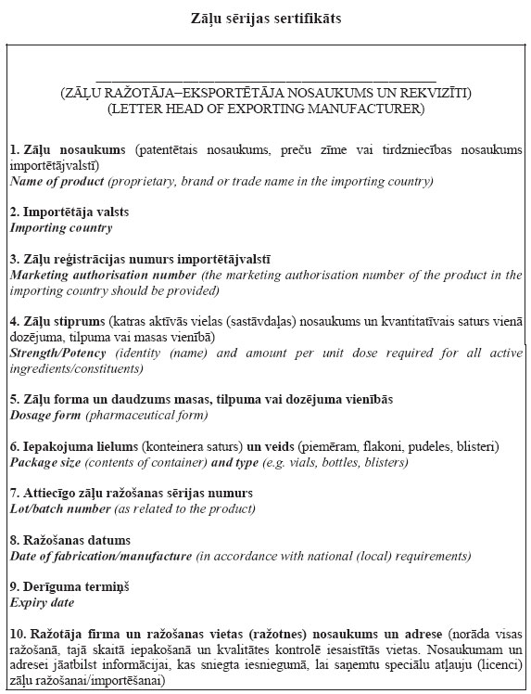
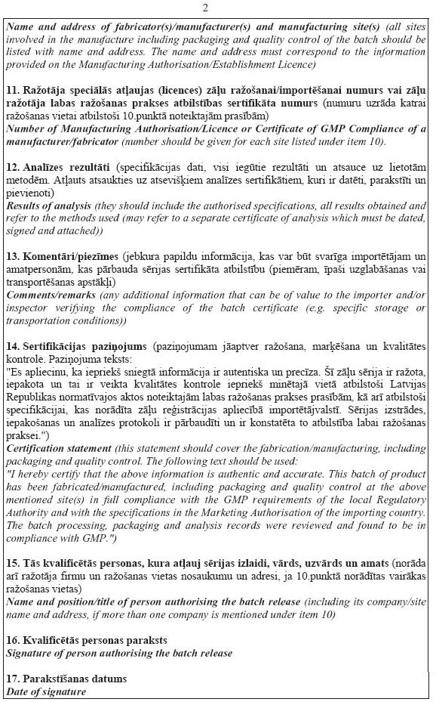

Acting for the Minister for Health, Minister for Welfare D. Staķe
Annex 4
Cabinet Regulation No. 436
26 June 2007
[13 August 2013]

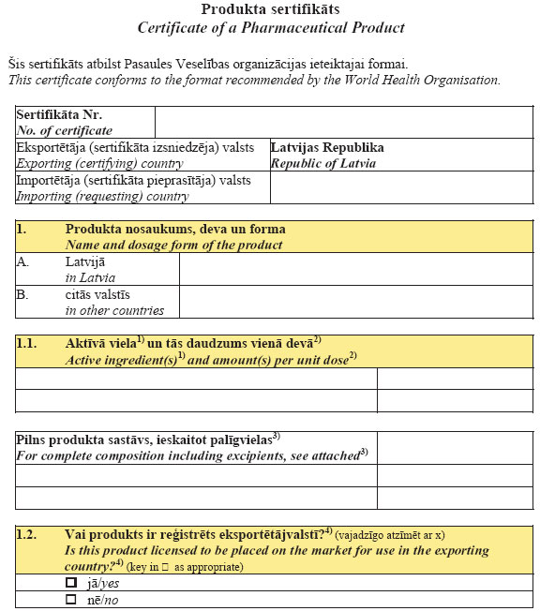
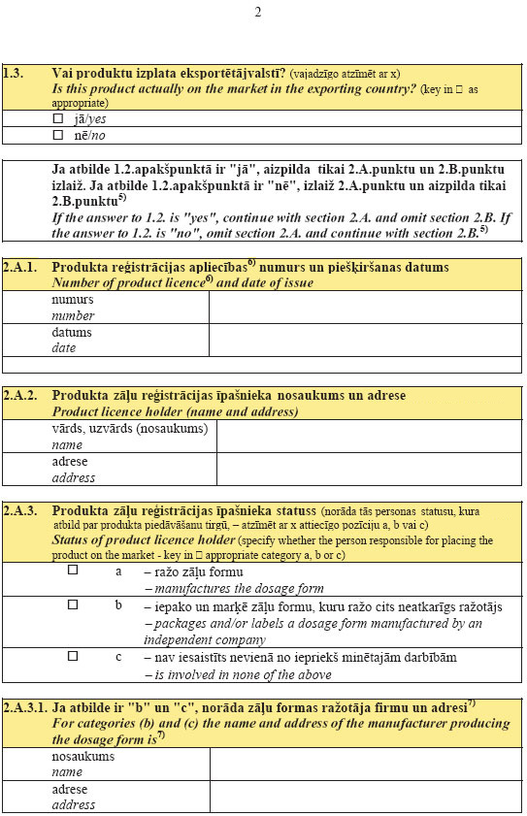
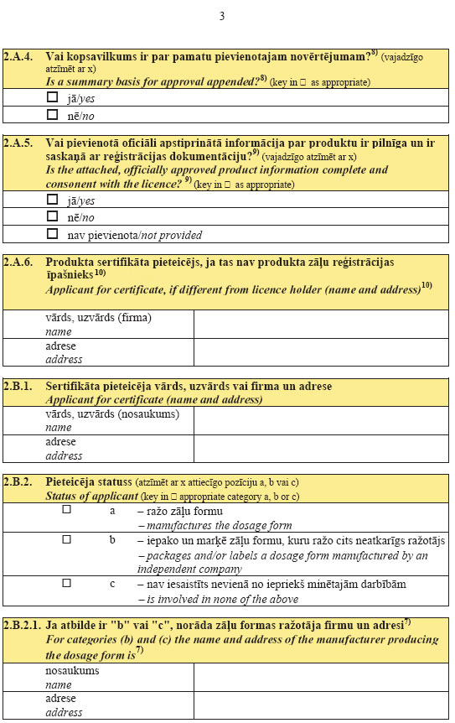
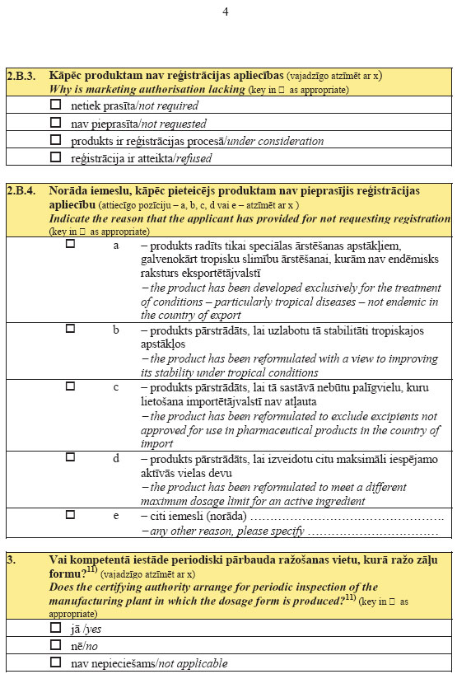
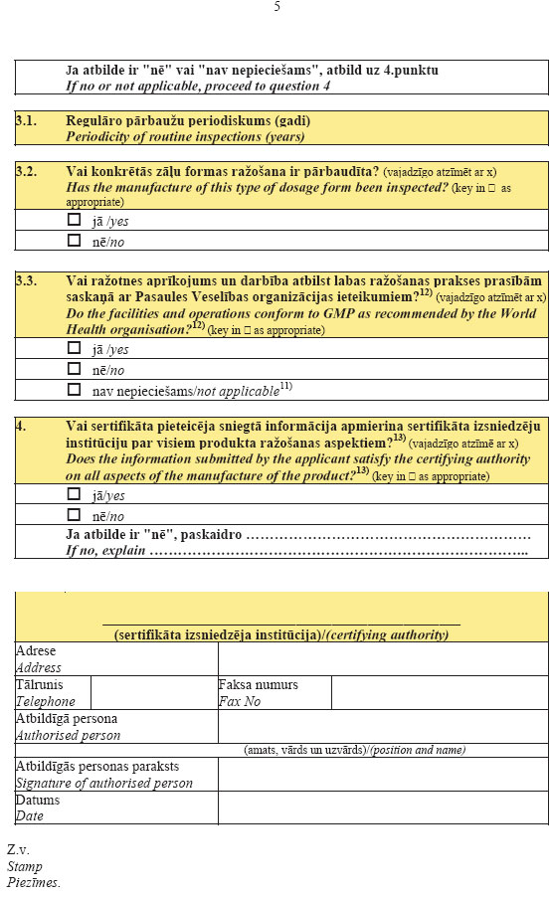
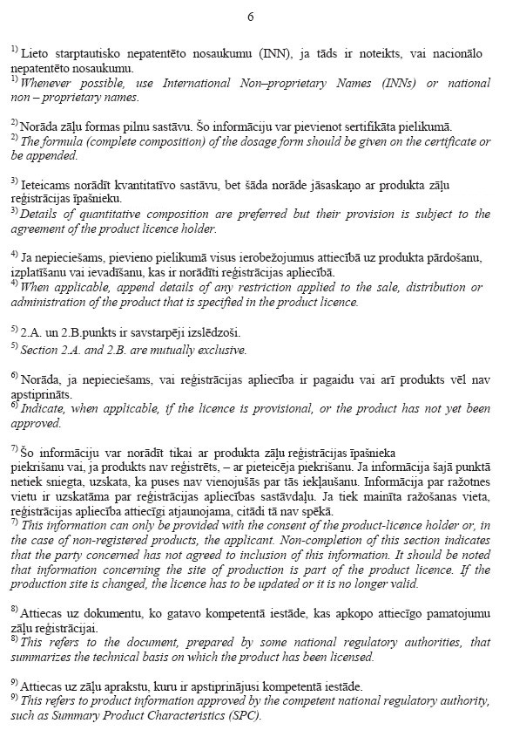
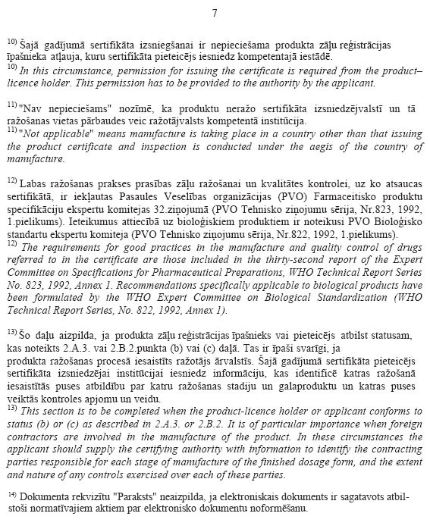

Acting for the Minister for Health, Minister for Welfare D. Staķe

Annex 5
Cabinet Regulation No. 436
26 June 2007
[13 August 2013]

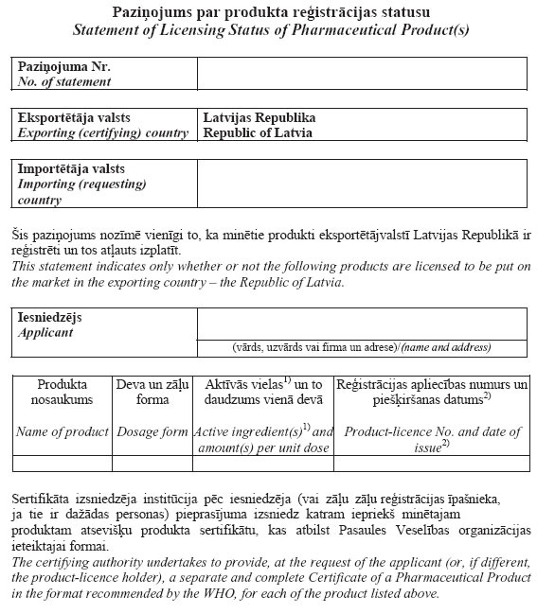
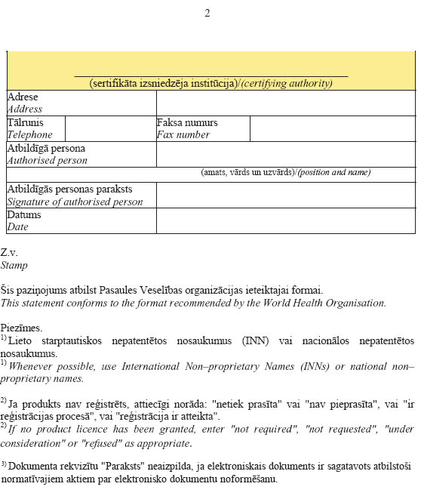

Acting for the Minister for Health, Minister for Welfare D. Staķe

