Text consolidated by Valsts valodas centrs (State Language Centre) with amending regulations of:
29 January 2013 [shall come into force on 1 April 2013];
27 January 2015 [shall come into force on 29 January 2015];
12 May 2015 [shall come into force on 15 May 2015];
29 August 2017 [shall come into force on 1 September 2017];
27 August 2019 [shall come into force on 2 September 2019];
7 January 2021 [shall come into force on 13 January 2021];
12 October 2021 [shall come into force on 16 October 2021];
25 October 2022 [shall come into force on 28 October 2022].
If a whole or part of a paragraph has been amended, the date of the amending regulation appears in square brackets at the end of the paragraph. If a whole paragraph or sub-paragraph has been deleted, the date of the deletion appears in square brackets beside the deleted paragraph or sub-paragraph.

Republic of Latvia

Cabinet
Regulation No. 134
Adopted 21 February 2012

Regulations Regarding Personal Identification Documents

Issued pursuant to
Section 4, Paragraph four, Section 5, Paragraphs four and eight, and Section 6, Paragraph seven of the Personal Identification Documents Law

I. General Provision

1. The Regulation prescribes:
1.1. the specimens of passports of citizens and non-citizens of Latvia, as well as of travel documents of stateless persons, refugees, and persons to whom alternative status has been granted, their content, the procedures and conditions for issue, as well as the term of validity;
1.2. the specimens of identity cards (except identity cards of accredited persons), their content, the procedures and conditions for issue, as well as the term of validity;
1.3. the amount and content of the information to be included in the electronic form of the identity card, the procedures for creating, activating, deactivating and updating it, as well as the restrictions for use;
1.4. additional information to be included in the personal identity document.

II. Content of a Personal Identification Document

2. The following information shall be included in a personal identification document:
2.1. information on the person according to the data of the Register of Natural Persons:
2.1.1. surname – full surname of the person shall be indicated sequentially, ensuring that the entry does not exceed 32 characters with spaces;
2.1.2. given name (names) – full given names of the person shall be indicated sequentially, ensuring that the entry does not exceed 36 characters with spaces;
2.1.3. personal identity number;
2.1.4. nationality or legal status in the Republic of Latvia;
2.1.5. sex;
2.1.6. date of birth;
2.1.7. place of birth (in passport and residence permit);
2.2. picture of the face of the person;
2.3. image of the signature of the person;
2.4. height of the person in centimetres (excluding residence permit);
2.5. regarding the personal identification document:
2.5.1. type of the document;
2.5.2. three-letter code of the issuing country (hereinafter – the ICAO code) established in the Document 9303 “Machine Readable Travel Documents” of the International Civil Aviation Organisation (ICAO);
2.5.3. document number;
2.5.4. date of issue – the date on which information regarding the person and the document is entered in the preform of the personal identification document;
2.5.5. term of validity;
2.5.6. issuing authority or place of issue;
2.6. card access number (in identity card).
[27 August 2019]

3. In an identity card or residence permit of a citizen of another European Union Member State, Member State of the European Economic Area or the Swiss Confederation (hereinafter – citizen of the Union), information regarding the residence status in the Republic of Latvia and the right to employment of a citizen of the Union or a third country citizen shall be included in addition to the information referred to in Paragraph 2 of this Regulation. The note “Asylum seeker” and information on the right to employment shall be included in an identity card of a foreigner which has been issued to an asylum seeker. The note “Šis dokuments nav uzturēšanās atļauja/This document is not a residence permit” shall be included in an identity card of a foreigner (except for an identity card of a foreigner which has been issued to an asylum seeker).
[25 October 2022]

4. The citizenship or the legal status of a person in the Republic of Latvia shall be indicated in a personal identification document as follows:
4.1. in a passport and identity card of a citizen of Latvia, in a travel document of a refugee or a person to whom alternative status has been granted – citizenship;
4.2. in an identity card and residence permit of a citizen of the Union and in an identity card of a foreigner – ICAO code of the country of citizenship;
4.3. in an identity card of a non-citizen of Latvia – legal status of the person in the Republic of Latvia;
4.4. in a passport of a non-citizen of Latvia and in a travel document of a stateless person – ICAO code of the legal status of the person.
[12 October 2021]

5. The place of birth of a person shall be indicated in a personal identification document as follows:
5.1. in a passport:
5.1.1. name of the State city, municipality (if the municipality is not territorially divided), municipality town or rural territory of municipality if the person was born in Latvia;
5.1.2. name and ICAO code of the country of birth if the person was born in a foreign country;
5.1.3. note “LATVIJA” if the place of birth was in the administrative territory of Latvia at the time of birth of the person, but outside the administrative territory of Latvia at the time of issue of the passport and if the person wishes so;
5.2. in a residence permit – ICAO code of the country of birth.
[12 October 2021]

6. The issuing authority or the place of issue shall be indicated in a personal identification document as follows:
6.1. short form of the name of the territorial division of the Office of Citizenship and Migration Affairs (hereinafter – the Office) in which the person receives the personal identification document;
6.2. “PMLP Rīgas 9. nodaļa” if the person receives the personal identification document at the diplomatic or consular mission of the Republic of Latvia in a foreign country (hereinafter – the mission of Latvia).

7. The machine readable zone of a personal identification document shall be made according to the provisions of the Document 9303 “Machine Readable Travel Documents” of the International Civil Aviation Organisation (ICAO). The personal name shall be indicated in the machine readable zone, without diacritical marks.

7.¹ If the Minister for the Interior has taken a decision on prohibition for a citizen, non-citizen of Latvia, a person to whom the status of a stateless person or an alternative status is granted in the Republic of Latvia, or a refugee to exit from the Republic of Latvia, the following text shall be indicated in the machine readable zone of an identity card or a residence permit issued after taking of the decision: "Šis dokuments nav derīgs ceļošanai/This document is not valid for travel".
[29 August 2017]

7.² The following text shall be indicated in the machine readable zone of an identity card of a foreigner: "Šis dokuments nav derīgs ceļošanai/This document is not valid for travel".
[25 October 2022]

8. If a citizen of Latvia or a non-citizen of Latvia wishes, a personal identification document shall include the original form of the personal name in another language as transliterated into the Latin alphabet or the historical form of the surname of the family, or the historical form of the personal name or the surname of the family in another language as transliterated into the Latin alphabet. The entry of the original form of the personal name in another language as transliterated into the Latin alphabet as well as the historical form of the surname of the family or the historical form of the personal name or the surname of the family in another language as transliterated into the Latin alphabet shall be formed, indicating full parts of the personal name or the surname of the family sequentially and ensuring that the entry in the identity card does not exceed 75 characters with spaces. Transliteration of the personal name or the surname of the family into the Latin alphabet shall be carried out in accordance with the transliteration table (Annex 1) of the International Civil Aviation Organisation (ICAO).
[12 October 2021]

9. If a person wishes, the passport shall include the following information from the Register of Natural Persons:
9.1. regarding the nationality if the person is a citizen or non-citizen;
9.2. regarding the person's child that is under the age of 18:
9.2.1. personal name;
9.2.2. date of birth;
9.2.3. sex;
9.2.4. personal identity number if the child is registered in the Register of Natural Persons.
[29 January 2013; 12 October 2021]

10. A personal identification document shall contain a data-carrying medium – a microchip with the following information:
10.1. information regarding the person from the machine readable zone:
10.1.1. personal name without diacritical marks;
10.1.2. ICAO code of the country of citizenship or of the legal status;
10.1.3. date of birth;
10.1.4. personal identity number;
10.1.5. sex;
10.2. information regarding the personal identification document from the machine readable zone:
10.2.1. type;
10.2.2. ICAO code of the country of issue;
10.2.3. number;
10.2.4. period of validity;
10.3. digital image of the face of a person;
10.4. digital image of the fingerprints of a person:
10.4.1. in a passport and identity card (except residence permit) of a person from 12 years of age;
10.4.2. in a residence permit of a person from 6 years of age;
10.5. data for the protection and automated processing of the included information (metadata).
[27 August 2019]

11. An identity card shall contain a data-carrying medium – a microchip which conforms to the requirements laid down in the legal acts for safe instruments for the creation of electronic signature and which contains the following information regarding a person from 14 years of age:
11.1. data for the creation and verification of an electronic signature;
11.2. qualified electronic signature certificate;
11.3. data for the electronic certification and verification of identity which is necessary to ensure qualified increased security electronic identification of the holder of the identity card (hereinafter – the electronic authentication);
11.4. electronic identification certificate;
11.5. data for the protection and automated processing of the included information (metadata).
[12 May 2015; 27 August 2019]

12. If a person wishes, during the period of validity of the identity card the information included in the microchip of an identity card may be renewed, updated, or supplemented with an additional information specified by the Office which does not contradict the requirements of the legal acts regarding safe instruments for the creation of electronic signature and personal data protection, using an electronic service provided by the Office. The electronic service shall be available by confirming identity with a valid and activated electronic identification certificate which is included in the microchip of the identity card.
[12 May 2015; 27 August 2019]

13. The name, number, and date of the issue of such document shall be indicated in the refugee travel document or in the travel document of such person, to whom alternative status has been granted, on the basis of which the relevant travel document has been issued.

14. The name and ICAO code of the country, in which the document is not valid, shall be indicated in the refugee travel document.

15. The specimens of personal identification documents have been determined in the Annexes to this Regulation:
15.1. passport of a citizen of Latvia (Annex 2);
15.2. passport of a non-citizen of Latvia (Annex 3);
15.3. travel document of a stateless person (Annex 4);
15.4. travel document of a refugee (Annex 5);
15.5. travel document of a person to whom alternative status has been granted (Annex 6);
15.6. identity card of a citizen of Latvia (Annex 7);
15.7. identity card of a non-citizen of Latvia (Annex 8);
15.8. identity card of a citizen of the Union (Annex 9);
15.9. residence permit (Annex 10);
15.10. an identity card of a foreigner (Annex 13).
[12 October 2021]

15.¹ A uniform format of the residence permit referred to in Sub-paragraph 15.9 of this Regulation shall be determined by Annex to Council Regulation (EC) No 1030/2002 of 13 June 2002 laying down a uniform format for residence permits for third-country nationals.
[7 January 2021]

III. Procedures and Conditions for the Issue of a Personal Identification Document

16. Reasons for the issue of a personal identification document:
16.1. initial issue of a personal identification document;
16.2. the previous personal identification document has been lost;
16.3. the previous personal identification document has become invalid for use because:
16.3.1. the given name or surname (given name and surname) of the person has changed;
16.3.2. the legal status of the person has changed;
16.3.3. there are damages to the personal identification document, due to which it is not possible to visually identify the holder of the personal identification document or to read the information indicated therein, or the personal identification document does not conform to the specimen specified;
16.3.4. notes that are not provided for in laws and regulations or changes in the initial content have been made in the personal identification document;
16.3.5. information indicated in the personal identification document regarding the holder thereof has changed or inaccuracies in records thereof have been established;
16.3.6. the holder of the personal identification document had notified in writing the loss of the respective document in accordance with the procedures laid down in the Personal Identification Documents Law, but the document has been found;
16.3.7. the term of validity of the personal identification document has expired;
16.3.8. the holder of the personal identification document is prohibited from exiting the Republic of Latvia;
16.4. the person wishes to receive a new personal identification document because the look of the person has changed;
16.5. the previous personal identification document is not valid for travelling;
16.6. the person wishes to receive a new personal identification document (except for a residence permit) in the place of a valid former specimen of a personal identification document;
16.7. the person wishes to receive another personal identification document of another type;
16.8. registration of a residence permit;
16.9. reissuing of a residence permit;
16.10. reissuing of an identity card of a citizen of the Union;
16.11. reissuing of an identity card of a foreigner.
[29 August 2017; 27 August 2019; 12 October 2021]

17. A person shall submit or present the documents necessary for the issue of a personal identification document and shall receive the personal identification document at a territorial division of the Office.

18. A person who is residing in a foreign country shall submit or present the documents necessary for the issue of a personal identification document (except an identity card or a residence permit of a citizen of the Union, or an identity card issued due to the reason referred to in Sub-paragraph 16.3.8 of this Regulation) at a mission of Latvia and shall receive the personal identification document at the mission where the documents were submitted or presented. A mission of Latvia may send the passport or identity card to a person who is residing in a foreign country and has informed the mission that he or she cannot arrive at the mission due to objective reasons (for example, due to his or her health condition or distance of the place of residence) by a registered mail or courier service (hereinafter – the consignment). If the microchip of the identity card includes the information referred to in Paragraph 11 of this Regulation, PIN1, PIN2, and PUK codes and the identity card shall be sent in separate consignments. The costs of delivery shall be covered by the relevant person.
[27 August 2019]

18.¹ A person who is residing in a foreign country shall submit or present the documents necessary for issuing an identity card of a foreigner to the mission of Latvia specified by the Ministry of Foreign Affairs.
[25 October 2022]

19. A refugee and a person, to whom alternative status has been granted, shall submit or present the documents necessary for the issue of a personal identification document and shall receive the personal identification document at a territorial division indicated by the Office.

20. A person, who cannot arrive at the institution referred to in Paragraph 17 or 19 of this Regulation due to objective reasons (for example, due to his or her health condition or if he or she is located in a deprivation of liberty institution) and informs the Office thereof, shall submit or present the documents necessary for the issue of a personal identification document (passport, or identity card of a citizen or non-citizen of Latvia) and shall receive the personal identification document at the location of the person.

21. When a person submits or presents documents, an official shall prepare an electronic application according to a standard form approved by the Office for the issue of a personal identification document (hereinafter – application). When preparing an application, the official shall identify the person and verify the authenticity of the submitted or presented documents by using the documents submitted or presented by the person, as well as the information in State information systems and at the disposal of the Office.

22. In order to prepare an application, the person shall submit the following:
22.1. the previous personal identification document, if such has been issued to the person and has become invalid for use;
22.2. notification according to a standard form approved by the Office regarding the loss of a personal identification document, with an explanation of the conditions of stealing, loss or destruction of the personal identification document, if the abovementioned document is lost;
22.3. a photograph, which is made in accordance with the requirements referred to in Annex 11 to this Regulation, in the following cases:
22.3.1. if the person submits or presents documents in accordance with the procedures referred to in Paragraph 20 of this Regulation and an employee of the Office cannot take a photograph of the person at the place of his or her location due to technical reasons;
22.3.2. if the person or lawful representative of a child up to 15 years of age wishes to submit a photograph;
22.3.3. if it is not possible to obtain a quality digital image when taking a photograph of a child up to five years of age;
22.3.4. if a possibility has not been provided to take a photograph of a person at a mission of Latvia;
22.4. the documents specified in the legal acts governing the entry and residence of foreigners for the requesting an identity card or a residence permit of a citizen of the Union, if the person requests an identity card or a residence permit of a citizen of the Union.
[27 January 2015]

23. In order to prepare an application, a person shall present the following documents:
23.1. a birth certificate or a document certifying birth, if the person is a citizen of Latvia, a non-citizen of Latvia, or a stateless person and no personal identification document has been issued to the person, and also if information regarding the birth certificate or document certifying birth has not been included in the Register of Natural Persons;
23.2. a personal identification document, if a personal identification document has been issued to the person and it is valid for use;
23.3. a document that certifies the changes in the entries of a previously issued personal identification document, if the information regarding the changes is not included in the Register of Natural Persons (for example, marriage certificate, a document that certifies the change of a given name or surname, a court ruling);
23.4. a personal document of an asylum seeker, if the person is a refugee or if alternative status has been granted to him or her, and if no personal identification document has been issued to the person;
23.5. a personal identification or travel document issued by another country, if any or if the person wishes to receive an identity card of a foreigner;
23.6. if a person wishes that the original form of the personal name in another language as transliterated into the Latin alphabet is included in a passport or identity card and if the respective distinctness has not been indicated in the Register of Natural Persons or in the previous personal identification document, the document that is issued in another language and certifies the differences in the spelling of the personal name – a birth certificate, a marriage certificate, a document certifying divorce, or a document certifying the change of a personal name;
23.7. if a person wishes that the historical form of the personal name or the surname of the family or the historical form of the personal name or the surname of the family in another language as transliterated into the Latin alphabet is included in a passport or identity card and if the abovementioned form has not been indicated in the Register of Natural Persons or in the previous personal identification document – a document certifying the historical form of spelling of the personal name or of the surname of the family or the historical form of the personal name or the surname of the family in another language as transliterated into the Latin alphabet;
23.8. a personal document of an asylum seeker, if an asylum seeker wishes to receive an identity card of a foreigner.
[27 January 2015; 27 August 2019; 12 October 2021]

24. When submitting or presenting the documents necessary for the issue of a personal identification document, a person shall inform an official whether he or she wishes:
24.1. that the information referred to in Paragraph 8 or 9 of this Regulation is indicated in the personal identification document;
24.2. that he or she is informed regarding the approaching expiry of the term of validity of the personal identification document, and shall indicate his or her contact details (electronic mail address or mobile telephone number) in order to receive a notification from the Office.
[12 May 2015]

25. In order to obtain a digital image of the face of a person to be included in a personal identification document:
25.1. the person shall be photographed at the institution referred to in Paragraph 17, 18, or 19 of this Regulation:
25.1.1. if the person does not submit a photograph in accordance with the procedures laid down in Sub-paragraph 22.3 of this Regulation;
25.1.2. if the photograph submitted by the person does not conform to the requirements referred to in Annex 11 to this Regulation;
25.1.3. if it is not possible to obtain a quality digital image from the submitted photograph;
25.1.4. if it is not possible to identify the person by using the submitted photograph;
25.2. the person shall be photographed at his or her location, if it is technically possible for the employees of the Office to do it;
25.3. a photograph, which has been submitted by the person in accordance with Sub-paragraph 22.3 of this Regulation, shall be scanned. The photograph submitted by the person shall be returned to the person after being scanned.

26. The obtained digital image of the face of a person shall conform to the requirements referred to in Annex 11 of this Regulation.

27. The digital image of a person’s fingerprints to be included in the microchip of a personal identification document shall be obtained from the index fingers of the hands. If the person does not have an index finger or it has been damaged so that it is not possible to obtain a digital image of the fingerprint, the middle finger, the ring finger, or the thumb of the respective hand shall be used to obtain the digital image of the fingerprint, or, if it is not possible to obtain a digital image of the fingerprints from the respective hand, the fingers of the other hand shall be used in the same order. If the person does not have any fingers or they have been damaged so that it is not possible to obtain digital image of the fingerprints, the digital image of the fingerprints of the person shall not be included in the microchip of the personal identification document. Digital images of a person's fingerprints to be included in the microchip of a personal identification document shall be obtained at the institution referred to in Paragraph 17, 18, or 19 of this Regulation or at the location of the person, if the person submits or presents documents in accordance with the procedures laid down in Paragraph 20 of this Regulation and it is technically impossible to obtain image of the fingerprints at the location of the person.
[27 August 2019]

28. The image of a person's signature to be included in a personal identification document shall be obtained by the person signing a printed-out application or by the person signing on the sensor of the hardware for obtaining the signature image. The signature in a personal identification document shall be the personal name written with one's own hand of the person in the full or short version. The signature in a personal identification document may be legible or illegible.
[27 January 2015]

29. A person up to 10 years of age or a person, who is not able to sign due to physical deficiencies, health condition or inability to write, shall sign neither the application, nor the sensor of the hardware for obtaining the image of the signature, and the person's signature shall not be included or a note regarding the absence of a signature shall be included in a personal identification document.
[27 January 2015]

30. A person, when signing an application, shall agree to the information included therein and shall certify the accuracy of the information indicated in the application. If a person is not able to sign due to physical deficiencies, health condition or inability to write, the person shall certify orally that he or she agrees with the information indicated into the application and shall certify the accuracy of the information indicated in the application.
[27 January 2015]

31. If a person concurrently submits or presents documents for receiving both a passport and an identity card, one application shall be prepared, and the person shall sign it.

32. If the information referred to in Sub-paragraphs 11.2 and 11.4 of this Regulation is to be included in the microchip of an identity card (hereinafter – the certificates), the person, when signing an application, shall:
32.1. apply for the certification services (hereinafter – certification services) provided by a reliable provider of certification services – State stock company VAS “Latvijas Valsts radio un televīzijas centrs” (Latvian Radio and Television Centre) (hereinafter – the Centre);
32.2. certify that he or she is informed regarding the duties and responsibility of the holder of certificates (subject), as prescribed in the legal acts regarding personal identification documents and electronic identification of natural persons, and reliability services;
32.3. provide contact details (electronic mail address or mobile telephone number) in order to receive notifications from the Office and the Centre or shall indicate the respective information when receiving an identity card;
32.4. indicate a security question and provide an answer to the security question, which can only be used for verification of the identity of a person, if the person wishes to suspend the operation of certificates by calling the help desk of the Centre, or shall indicate the respective information when receiving an identity card;
32.5. agree that the information referred to in Sub-paragraphs 2.1.1, 2.1.2, 2.1.3, 2.5.3, 32.3, and 32.4 of this Regulation is handed over to the Centre for the provision of certification services laid down in legal acts, as well as shall allow inclusion of the information referred to in Sub-paragraphs 2.1.1, 2.1.2, and 2.1.3 of this Regulation into certificates, in the case of use of which this information shall become available to third persons.
[12 May 2015; 27 August 2019]

33. A citizen of Latvia or a non-citizen of Latvia, who has attained 15 years of age and who does not have a valid personal identification document, shall submit or present the documents referred to in Paragraphs 22 and 23 of this Regulation within 30 days:
33.1. after attaining 15 years of age;
33.2. after coming into force or determination of the condition referred to in Sub-paragraphs 16.2 and 16.3 of this Regulation.

34. A stateless person, a refugee, a person to whom alternative status has been granted, a citizen of the Union, or a third country citizen shall submit or present the documents referred to in Paragraphs 22 and 23 of this Regulation within 30 days after coming into force or determination of the condition referred to in Sub-paragraph 16.2 or 16.3 of this Regulation.

35. If an identity card with the certificates included in the microchip is lost or there is a reason to believe that the information included in the microchip of an identity card has been used without the consent of the person, the person has an obligation to request immediately to suspend the operation of the certificates by calling the help desk of the Centre or by visiting the institution referred to in Paragraph 17 or 18 of this Regulation.
[12 May 2015; 27 August 2019]

36. A person shall submit the passport to the institution referred to in Paragraph 17, 18, or 19 of this Regulation, if the person wishes to supplement it with the information referred to in Paragraph 9 of this Regulation.

37. A person shall submit the passport, which has been issued after 20 November 2007, to the institution referred to in Paragraph 17, 18, or 19 of this Regulation, if the person wishes to supplement it with the information referred to in Paragraph 8 of this Regulation.

38. After signing an application, a personal identification document shall be prepared for the issue within the following time periods according to the wish expressed by the person:
38.1. within 10 working days;
38.2. within two working days.

39. An identity card or a residence permit of a citizen of the Union shall be prepared for the issue within the time period referred to in Paragraph 38 of this Regulation, counting from the day when a decision to grant an identity card or a residence permit of a citizen of the Union was taken.

40. If a person submits or presents the documents necessary for the issue of a personal identification document (except an identity card or a residence permit of a citizen of the Union) at a mission of Latvia and if his or her previous personal identification document is lost, the personal identification document shall be prepared for the issue within the time period referred to in Paragraph 38 of this Regulation after the necessary documents are received by the Office.
[27 January 2015]

41. When issuing a personal identification document, an official shall identify the person and verify the authenticity of the submitted or presented documents by using the documents submitted or presented by the person, as well as the information in State information systems and at the disposal of the Office.

42. The following information which conforms to the information included in an identity card and referred to in Sub-paragraph 11.5 of this Regulation shall be issued or delivered secretly to a person who receives an identity card with certificates included in a microchip:
42.1. personal identification number of the electronic identification (hereinafter – PIN1);
42.1. personal identification number of electronic signing (hereinafter – PIN2);
42.3. PIN1 and PIN2 unlock code (hereinafter – PUK).
[12 May 2015; 27 August 2019]

42.¹ The Centre shall ensure online time stamping of electronic documents and verification of electronic identity free of charge to a person who receives an identity card with certificates included in a microchip.
[27 August 2019]

43. If a person wishes to receive a new PIN1, PIN2, and PUK, he or she shall submit an identity card with certificates included in a microchip to the institution referred to in Paragraph 17, 18, or 19 of this Regulation. During the period of preparing the new PIN1, PIN2, and PUK, the Office shall suspend the operation of certificates and shall renew (activate) it by issuing an identity card and new PIN1, PIN2, and PUK to the person in the manner referred to in Paragraph 42 of this Regulation.
[12 May 2015; 27 August 2019]

44. A person shall sign for the receipt of a personal identification document in an application, except for the case if a passport or an identity card has been sent to the person and shall submit:
44.1. a personal identification document, which is invalid for use, at the disposal of a person, if any;
44.2. a personal document of an asylum seeker, if the person receives a travel document of a refugee or a travel document of a person to whom alternative status has been granted, for the first time.
[27 January 2015; 27 August 2019]

45. If certificates have been included in the microchip of an identity card, a person shall request the activation of the certificates by a separate signature in the application and shall confirm that he or she has become acquainted with the information system for the provision of certification services, the description of safety measures of facilities and procedures, the provisions for providing certification services included in the register of reliable providers of certification services and other security measures performed by a reliable provider of certification services in order to prevent illegal use of the qualified certificate, and also with the provisions and restrictions included in the qualified certificate (hereinafter – the provisions for certification services). If the Centre makes any changes in the provisions of certification services, they shall enter into effect not earlier than seven days after placing the respective notification on the portal www.eparaksts.lv.
[12 May 2015; 27 August 2019]

46. A person has the right to opt out of certificate activation by not fulfilling the requirements referred to in Paragraph 45 of this Regulation, as well as to request cancellation of certificates, suspension of operation, initial activation, or renewal of operation throughout the whole term of validity of an identity card. Suspension of certificate operation may be requested by calling the help desk of the Centre or by visiting the territorial division of the Office or a mission of Latvia. The initial activation and renewal of operation of certificates may only be requested by visiting the territorial division of the Office, the mission of Latvia, the Centre or the service provider, with whom the Office and the Centre have concluded a trilateral agreement regarding provision of services for the initial activation and renewal of operation of certificates. In the case of initial activation of certificates, the person shall fulfil those requirements referred to in Paragraphs 32 and 45 of this Regulation, which had not been fulfilled when the identity card was issued. Prior to initial activation, cancellation, suspension and renewal of operation of a certificate, the identity of the person shall be verified.
[12 May 2015]

47. Certificates included in the microchip of an identity card shall be cancelled if the identity card becomes invalid for use prior to the end of the term of validity of certificates and also in other cases laid down in other legal acts regarding electronic identification and reliability services.
[12 May 2015; 27 August 2019]

48. When receiving a personal identification document, a person has the right to become acquainted with the information regarding the person and the document which is included in the microchip of the personal identification document.
[27 August 2019]

49. After receipt of a personal identification document, the invalid passport of the person, if the person has such, shall be pierced through and left at the disposal of the person if there is a valid visa or a residence permit in the passport or if the passport is necessary for the receipt of a visa or for travel to foreign countries.
[27 August 2019]

50. The Office shall keep an undelivered personal identification document and the information related thereto referred to in Paragraph 42 of this Regulation for two years and shall destroy it after that. A mission of Latvia shall keep an undelivered personal identification document at its disposal and the information related thereto referred to in Paragraph 42 of this Regulation for two years and shall send it to the Office after that.
[27 January 2015; 12 May 2015]

51. The Office shall keep an invalid personal identification document at its disposal for six months and shall destroy it after that. A mission of Latvia shall send an invalid personal identification document at its disposal to the Office.
[12 May 2015]

51.¹ The personal identification document of a citizen, non-citizen of Latvia, a person to whom the status of a stateless person or an alternative status is granted in the Republic of Latvia, or a refugee at the disposal of the Office that has been handed over for storage to the Office due to the adoption of a decision on prohibition for a person to exit the Republic of Latvia shall be stored for the time period indicated in the decision of the Minister for the Interior. After the expiry of the storage time period the Office shall return to the person the personal identification document thereof if it has not become invalid for use.
[29 August 2017]

52. The Office and a mission of Latvia shall send a personal identification document with indications of falsification at the disposal thereof, as well as information regarding such personal identification document to the State Police.

IV. Term of Validity of Personal Identification Documents

53. A personal identification document of a citizen of Latvia or of a non-citizen of Latvia shall be issued with the following term of validity:
53.1. to a person under five years of age – for two years or for the period of travel if it is longer than two years, but not longer than for five years;
53.2. to a person from five years of age until 20 years of age – for five years;
53.3. to persons from 20 years of age – for ten years.
[27 August 2019]

54. An identity card of a citizen of Latvia or a non-citizen of Latvia shall be issued to a person in respect of whom the Minister for the Interior has taken the decision on prohibition to exit the Republic of Latvia for the time period indicated in the decision.
[27 August 2019]

55. A travel document of a stateless person shall be issued for two years.

56. A travel document of a refugee or a travel document of such person, to whom alternative status has been granted, shall be issued with the following term of validity:
56.1. to a person under the age of five – for two years or for the period of travel if it is longer than two years, but not longer than for five years;
56.2. to a person from five years of age – for five years.

57. An identity card of a citizen of the Union or a residence permit to his or her family member, who is not a citizen of the Union, shall be issued with a term of validity of five years, unless another term has been indicated in the decision to issue an identification document of a citizen of the Union or a residence permit of his or her family member.

58. A residence permit shall be issued for the time period indicated in the decision to issue the residence permit, but not longer than for five years. For a person in respect of whom the Minister for the Interior has taken a decision on prohibition to exit the Republic of Latvia the residence permit shall be issued for the time period indicated in the decision.
[29 August 2017]

58.¹ An identity card of a foreigner shall be issued for a period of five years. An identity card of a foreign shall be issued to an asylum seeker for a period of one year.
[12 October 2021]

V. Closing Provisions

59. A passport that has been issued within time period from 1 July 1992 until 27 January 2015 shall be valid until expiry of the term of validity indicated therein, if it has not become invalid for use due to other reason.
[27 January 2015]

60. A passport of a Latvian citizen, which has been issued within a time period from 1 July 1992 until 30 June 2002, shall not be valid for travel.

61. A passport of a Latvian citizen, which has been issued within a time period from 1 July 2002 until 19 November 2007 and the period of validity of which is 50 years, and a passport of a Latvian non-citizen, which has been issued within a time period from 10 April 1997 until 19 November 2007 and the period of validity of which is 50 years, shall not be valid for travel, except travels until 19 November 2017 to countries that apply the provisions of Schengen aquis regarding abolition of border controls at internal borders.

62. A permanent residence certificate and a residence permit of a citizen of the Union, which has been issued until 31 March 2012, shall be valid until expiry of the term of validity indicated therein, if it has not become invalid for use due to other reason.

63. [29 August 2017]

64. Paragraph 12 of this Regulation shall come into force on 1 January 2013.

64.¹ An identity card that has been issued within the time period from 1 April 2012 to 1 September 2019 shall be valid until expiry of the term of validity indicated therein if it has not become invalid for use due to other reason.
[27 August 2019]

65. This Regulation shall come into force on 1 April 2012.

Prime Minister V. Dombrovskis

Minister for the Interior R. Kozlovskis

Annex 1
Cabinet Regulation No. 134
21 February 2012
[25 October 2022]

Table of Transliteration

United Latin Alphabetic Transliteration of the Letters of Other Languages

No. | Letter of another language | Transliterated letter
A. Transliteration of Specific Letters in the Latin Alphabet
1. | Á | A
2. | À | A
3. | Â | A
4. | Ä | AE or A
5. | Ã | A
6. | Ă | A
7. | Å | AA or A
8. | Ā | A
9. | Ą | A
10. | Ć | C
11. | Ĉ | C
12. | Č | C
13. | Ċ | C
14. | Ç | C
15. | Đ | D
16. | Ď | D
17. | É | E
18. | È | E
19. | Ê | E
20. | Ë | E
21. | Ě | E
22. | Ė | E
23. | Ē | E
24. | Ę | E
25. | Ĕ | E
26. | Ĝ | G
27. | Ğ | G
28. | Ġ | G
29. | Ģ | G
30. | Ħ | H
31. | Ĥ | H
32. | I | I
33. | Í | I
34. | Ì | I
35. | Î | I
36. | Ï | I
37. | Ĩ | I
38. | İ | I
39. | Ī | I
40. | Į | I
41. | Ĭ | I
42. | Ĵ | J
43. | Ķ | K
44. | Ĺ | L
45. | Ļ | L
46. | Ļ | L
47. | Ŀ | L
48. | Ł | L
49. | Ń | N
50. | Ñ | N or NXX
51. | Ň | N
52. | Ņ | N
53. | Ŋ | N
54. | Ø | OE
55. | Ó | O
56. | Ò | O
57. | Ô | O
58. | Ö | OE or O
59. | Õ | O
60. | Ő | O
61. | Ō | O
62. | Ŏ | O
63. | Ŕ | R
64. | Ř | R
65. | Ŗ | R
66. | Ś | S
67. | Ŝ | S
68. | Š | S
69. | Ş | S
70. | Ŧ | T
71. | Ť | T
72. | Ţ | T
73. | Ú | U
74. | Ù | U
75. | Û | U
76. | Ü | UE or UXX or U
77. | Ũ | U
78. | Ŭ | U
79. | Ű | U
80. | Ů | U
81. | Ū | U
82. | Ų | U
83. | Ŵ | W
84. | Ý | Y
85. | Ŷ | Y
86. | Ÿ | Y
87. | Ź | Z
88. | Ž | Z
89. | Ż | Z
90. | Þ | TH
91. | Æ | AE
92. | Ĳ | IJ
93. | Œ | OE
94. | β | SS
B. Transliteration of Cyrillic Letters
1. | A | A
2. | Б | B
3. | В | V
4. | Г | G  H (if the document has been issued in Belarus, Serbia, or Ukraine)
5. | Д | D
6. | Е | E
7. | Ë | E  IO (if the document has been issued in Belarus)
8. | Ж | ZH  Z (if the document has been issued in Serbia)
9. | З | Z
10. | И | I  Y (if the document has been issued in Ukraine)
11. | I | I
12. | Й | I  Y (if the first letter in a document issued in Ukraine)
13. | К | K
14. | Л | L
15. | М | M
16. | Н | N
17. | О | O
18. | П | P
19. | Р | R
20. | С | S
21. | Т | T
22. | У | U
23. | Ф | F
24. | Х | KH  H (if the document has been issued in Serbia or Macedonia)
25. | Ц | TS  C (if the document has been issued in Serbia or Macedonia)
26. | Ч | CH  C (if the document has been issued in Serbia)
27. | Ш | SH  S (if the document has been issued in Serbia)
28. | Щ | SHCH  SHT (if the document has been issued in Bulgaria)
29. | Ы | Y
30. | Ъ | IE
31. | Э | E
32. | Ю | IU  YU (if the first letter in a document issued in Ukraine)
33. | Я | IA  YA (if the first letter in a document issued in Ukraine)
34. | Ѫ | U
35. | V | Y
36. | Ў | U
37. | Ґ | G
38. | Ғ | G  GJ (if the document has been issued in Macedonia)
39. | Ђ | D
40. | S | DZ
41. | J | J
42. | Ќ | K  KJ (if the document has been issued in Macedonia)
43. | Љ | LJ
44. | Њ | NJ
45. | h | C
46. | Џ | DZ  DJ (if the document has been issued in Macedonia)
47. | Є | IE  YE (if the first letter in a document issued in Ukraine)
48. | Ї | I  YI (if the first letter in a document issued in Ukraine)

Annex 2
Cabinet Regulation No. 134
21 February 2012

Specimen of a Passport of a Citizen of Latvia
[27 January 2015]

I. Cover of the passport (cover 1) (Picture 1)

Colour: maroon – violet

EIROPAS SAVIENĪBA

REPUBLIC OF LATVIA

Symbols of the State: the great coat of arms in golden colour

PASE

Symbol of microchip (in accordance with the ICAO)

II. First inside page of the cover of passport (Cover 2) (Picture 2a)

III. Page 1 (other side of data page) (Picture 2b)

European Union
Европейски Съюз
Unión Europea
Evropská unie
Europæiske Union
Europäische Union
Euroopa Liit
Еυρωπαϊκή 'Ενωση
European Union
Union Européenne
An tAontas Eorpach
Unione Europea
Europos Sąjunga
Európai Unió
Unjoni Ewropea
Europese Unie
Unia Europejska
União Europeia
Uniunea Europeană
Európska únia
Evropska unija
Euroopan unioni
Europeiska Unionen
Europska Unija
The Republic of Latvia
Република Латвия
República de Letonia
Lotyšská republika
Republikken Letland
die Republik Lettland
Läti Vabariik
Δημοκρατία της Λετονίας
Republic of Latvia
la République de Lettonie
Poblacht na Laitvia
Repubblica di Lettonia
Latvijos Respublika
Lett Köztársaság
Repubblika tal-Latvja
de Republiek Letland
Republika Łotewska
República da Letónia
Republica Letonă
Lotyšská republika
Republika Latvija
Latvian tasavalta
Republiken Lettland
Republika Latvija

Pase
Паспорт
Pasaporte
Cestovní pas
Pas
Reisepass
Pass
Διαβατήριο
Passport
Passeport
Pas
Passaporto
Pasas
Útlevél
Passaport
Paspoort
Paszport
Passaporte
Paşaport
Cestovný pas
Potni list
Passi
Pass
Putovnica

IV. Page 2 (data page) (Picture 3a)

Data page – names of information areas in Latvian, English, French, index by the information areas – for information purposes and for detection of a conforming translation

Pase/Passport/Passeport

Latvija/Latvia/Lettonie

Tips/Type/Type

P

Valsts kods/Code of Issuing State/Code du pays

LVA

Pases Nr./Passport No./No de passeport

1. Uzvārds/Surname/Nom

2. Vārds(-i)/Given name(-s)/Prénom(-s)

3. Pilsonība/Nationality/Nationalité

4. Augums/Height/Taille

5. Dzimums/Sex/Sexe

6. Dzimšanas datums/Date of birth/Date de naissance

7. Personas kods/Personal No./Code d'identité

8. Izdevējiestāde/Authority/Autorité

9. Dzimšanas vieta/Place of birth/Lieu de naissance

10. Izdošanas datums/Date of issue/Date de délivrance

11. Paraksts/Holder's signature/Signature du titulaire

12. Derīga līdz/Date of expiry/Date d'expiration

V. Page 3 (Picture 3b)

Tautība XXXXXXX

Pases turētāja personvārda oriģinālforma latīņalfabētiskajā transliterācijā ir/

The original form of the name of the holder of this passport transliterated in Latin alphabet is/

La forme originale du nom du titulaire de ce passeport en translittération à l'alphabet latin est

PERSONAL NAME

Pases turētāja personvārda vai dzimtas uzvārda vēsturiskā forma ir/

The historical form of the given name or the family name of the holder of this passport is/

La forme historique du prénom ou du nom de famille du titulaire de ce passeport est

PERSONAL NAME

(Entries shall be made in the process of personalisation)

VI. Pages 4 and 5 (Pictures 4a and 4b)

Translation of the names of information areas of data page in the languages of the European Union states

BG

1. Фамилия 2. Имена 3. Гражданство 4. Ръст 5. Пол 6. Дата на раждане 7. Единен граждански номер 8. Издаден от 9. Място на раждане 10. Дата на издаване 11. Подпис на притежателя 12. Дата на валидност

ES

1. Apellido 2. Nombre (s) 3. Nacionalidad 4. Talla 5. Sexo 6. Fecha de nacimiento 7. Número de identidad 8. Autoridad 9. Lugar de nacimiento 10. Fecha de expedición 11. Firma del titular 12. Fecha de caducidad

CS

1. Přijmení 2. Jméno 3. Státní občanství 4. Výška 5. Pohlaví 6. Datum narození 7. Rodné číslo 8. Pas vydal 9. Místo narození 10. Datum vydání 11. Podpis držitele 12. Platnost do

DA

1. Efternavn 2. Fornavne 3. Nationalitet 4. Højde 5. Køn 6. Fødselsdato 7. Personnummer 8. Myndighed 9. Fødested 10. Udstedelsesdato 11. Indehaverens underskrift 12. Gyldigt indtil

DE

1. Name 2. Vornamen 3. Staatsangehörigkeit 4. Größe 5. Geschlecht 6. Geburtstag 7. Persoenliche Identifizierungsnummer 8. Ausstellende Behörde 9. Geburtsort 10. Ausstellungsdatum 11. Unterschrift der Inhaberin 12. Gültig bis

ET

1. Perekonnanimi 2. Eesnimed 3. Kodakondsus 4. Pikkus 5. Sugu 6. Sünniaeg 7. Isikukood 8. Väljaandja 9. Sünnikoht 10. Välja antud 11. Kasutaja allkiri 12. Kehtiv kuni

EL

1. Επώνυμο 2.'Ονομα 3. Ιϑαγένεια 4. Υψος 5. Φύλο 6. Ημερομηνία γέννησης 7. Προσωπική ταυτοποίηση 8. Εκδούσα Αρχή 9. Τόπος γεννήσεως 10. Ημερομηνία έκδοσης 11. Υπογραφή κατόχου 12. Ημερομηνία λήξης

GA

1. Sloinne 2. Réamhainm (neacha) 3. Náisiúntacht 4. Airde 5. Gnéas 6. Dáta breithe 7. Uimhir aitheantais phearsanta 8. Údarás eisiúna 9. Áit bhreithe 10. Dáta eisiúna 11. Síniú an tsealbhóra 12. As feidhm

IT

1. Cognome 2. Nome 3. Cittadinanza 4. Statura 5. Sesso 6. Data di nascita 7. Codice fiscale 8. Autorità di rilascio 9. Luogo di nascita 10. Data di rilascio 11. Firma del titolare 12. Data di scadenza

LT

1. Pavardé 2. Vardas(-ai) 3. Pilietybé 4. Ūgis 5. Lytis 6. Gimimo data 7. Asmens kodas 8. Išdavusi institucija 9. Gimimo vieta 10. Išdavimo data 11. Asmens parašas 12. Galioja iki

HU

1. Családi név 2. Utónév(-ek) 3. Állampolgárság 4. Magasság 5. Nem 6. Születési idö 7. Személyi szám 8. Kiállitó hatóság 9. Születési hely 10. Kiállítási dátum 11. Aláírás 12. Érvényességi idő

MT

1. Kunjom 2. Ismijiet 3. Ċittadinanza 4. Tul 5. Sess 6. Data tat-twelid 7. Numru ta ' identifikazzjoni personali 8. Uffiċċju min fejn inħareġ 9. Post tat-twelid 10. Data tal-ħruġ 11. Firma tad-detentur 12. Data meta jiskadi

NL

1. Naam 2. Voornamen 3. Nationaliteit 4. Lengte 5. Geslacht 6. Geboortedatum 7. Persoonsnummer 8. Instantie 9. Geboorteplaats 10. Datum van afgifte 11. Handtekening van de houder 12. De geldigheidsduur van dit paspoort eindigt op

PL

1. Nazwisko 2. Imię 3. Obywatelstwo 4. Wzrost 5. Płeč 6. Data urodzenia 7. Numer identyfikacyjny 8. Organ wydający 9. Miejsce urodzenia 10. Data wydania 11. Podpis posiadacza 12. Data upływu waźnośçi

PT

1. Apelido 2. Nome(-s) próprio(-s) 3. Nacionalidade 4. Altura 5. Sexo 6. Data de nascimento 7. Número de identificação pessoal 8. Autoridade 9. Local de nascimento 10. Data da emissão 11. Assinatura do titular 12. Válido até

RO

1. Numele 2. Prenumele 3. Naţionalitatea 4. Înălţimea 5.Înălţimea 6. Data naşterii 7. Cod numeric personal 8. Organul emitent 9. Locul naşterii 10. Data eliberării 11. Semnătura titularului 12. Data expirării

SK

1. Priezvisko 2. Meno 3. Štátna príslušnost 4. Výška 5. Pohlavie 6. Dátum narodenia 7. Rodné čislo 8. Pas vydal 9. Miesto narodenia 10. Dátum vydania 11. Podpis držitel'a 12. Dátum platnosti

SL

1. Priimek 2. Ime 3. Državljanstvo 4. Višina 5. Spol 6. Rojstni datum 7. EMŠO 8. Pristojni organ 9. Rojstni kraj 10. Datum izdaje 11. Lastnoročni podpis 12. Velja do

FI

1. Sukunimi 2. Etunimet 3. Kansalaisuus 4. Pituus 5. Sukupuoli 6. Syntymäaika 7. Henkilötunnus 8. Myöntävä viranomainen 9. Syntymäkotikunta 10. Myönnetty 11. Haltijan nimikirjoitus 12. Viimeinen voimassaolopäivä

SV

1. Efternamn 2. Förnamn 3. Nationalitet 4. Längd 5. Kön 6. Födelsedatum 7. Personnummer 8. Utfärdande myndighet 9. Födelseort 10. Utfärdat 11. Innehavarens namnteckning 12. Sista giltighetsdag

HR

1. Prezime 2. Ime(-na) 3. Nacionalnost 4. Visina 5. Spol 6. Datum rođenja 7. OIB 8. Izdana od 9. Mjesto rođenja 10. Datum izdavanja 11. Potpis vlasnika 12. Datum isteka valjanosti

VII. Pages 6, 7, and 8 (for entries regarding the children of a person)

(Pictures 5a, 5b, and 6a)

Bērni/Children/Enfants

1. Uzvārds/Surname/Nom

2. Vārds(-i)/Given name(-s)/Prénom(-s)

5. Dzimums/Sex/Sexe

6. Dzimšanas datums/Date of birth/Date de naissance

7. Personas kods/Personal No./Code d'identité

VIII. Page 9 (blank, without any entries) (Picture 6b)

IX. Page 10 and the following pages (Pictures 7a and 7b)

Vīzas/Visas/Visas

X. Page 34 (Picture 8a)

Šī pase ir Latvijas Republikas īpašums. Šīs pases turētājs ir Latvijas Republikas aizsardzībā. Latvijas Republikas valdība lūdz visus, no kuriem tas atkarīgs, ļaut šīs pases turētājam brīvi pārvietoties, kā arī sniegt viņam tādu palīdzību un aizsardzību, kāda varētu būt nepieciešama. Šī pase ir derīga ceļošanai uz visām valstīm. Šīs pases turētājam ir tiesības izbraukt no Latvijas Republikas un atgriezties Latvijas Republikā.

This passport is the property of the Republic of Latvia. The holder of this passport is under the protection of the Republic of Latvia. The Government of the Republic of Latvia requests all those whom it may concern to allow the holder to pass freely without let or hindrance and to afford such assistance and protection as may be necessary. This passport is valid to travel to all countries. The holder of this passport is entitled to depart and enter the Republic of Latvia.

Ce passeport est la propriéte de la Republique de Lettonie. Le titulaire de ce passeport est sous la protection de la République de Lettonie. Le gouvernement de la République de Lettonie prie tous, de qui cela dépend, à permettre au titulaire de ce passeport se déplacer librement, ainsi que prêter à lui l’assistance et la protection nécessaire. Ce passeport est valable pour voyager dans tous les pays. Le titulaire de ce passeport a le droit à la sortie et l’entrée en République de Lettonie.

XI. Inside page of the cover 2 (cover 3) (Picture 8b)

Šajā pasē ir 34 lappuses
Този паспорт съдържа 34 страници
Este pasaporte contiene 34 páginas
Tento pas obsahuje 34 stran.
Dette pas består af 34 sider
Dieser Pass enthält 34 Seiten
Passis on 34 lehekülge
Αυτό το διαβατήριο περιέχει 34 σελίδες
This passport contains 34 pages
Ce passeport contient 34 pages
Tá 34 leathanach sa phas seo.
Questo passaporto contiene 34 pagine
Šiame pase 34 numeruoti puslapiai
Az útlevél 34 oldalt tartalmaz
Dan il-passaport fih 34 paġna
Dit paspoort bevat 34 bladzijden
Ten paszport zawiera 34 stron
Este passaporte contém 34 páginas
Acest paşaport conţine 34 de pagini
Tento pas obsahuje 34 strán
Ta potni list vsebuje 34 strani
Tämä passi sisältää 34 sivua
Detta pass innehåller 34 sidor
Ova putovnica sadrži 34 stranice

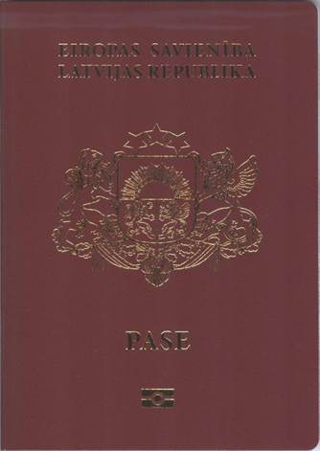

Picture 1

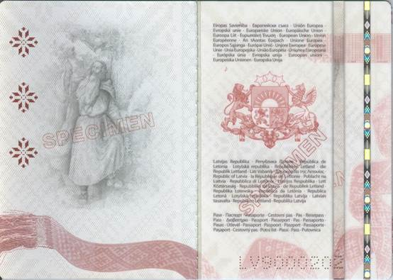

Pictures 2a and 2b

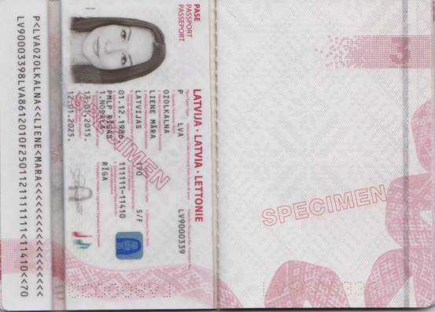

Pictures 3a and 3b

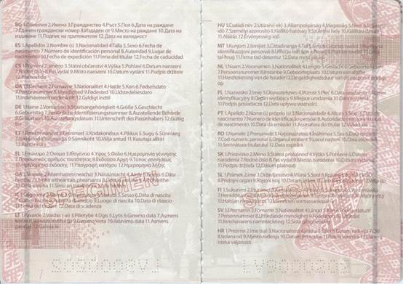

Pictures 4a and 4b

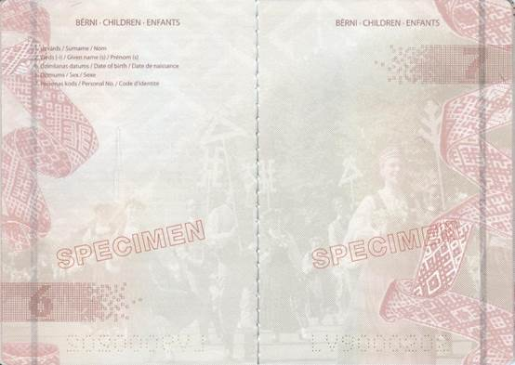

Pictures 5a and 5b

Pictures 6a and 6b

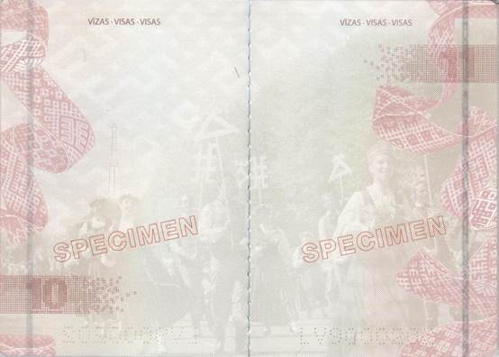

Pictures 7a and 7b

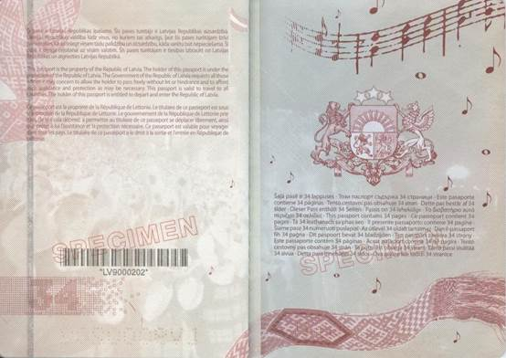

Pictures 8a and 8b

Annex 3
Cabinet Regulation No. 134
21 February 2012

Specimen of a Passport of a Non-citizen of Latvia
[12 May 2015]

I. Cover of the passport (cover 1) (Picture 1)

Colour: violet

REPUBLIC OF LATVIA

Symbols of the State: the great coat of arms in golden colour

NEPILSOŅA PASE

Symbol of microchip (in accordance with the ICAO)

II. First inside page of the cover of the passport (cover 2) (Picture 2a)

III. Page 1 (other side of data page) (Picture 2. b)

Latvijas Republika
Република Латвия
República de Letonia
Lotyšská republika
Republikken Letland
Die Republik Lettland
Läti Vabariik
Δημοκρατία της Λετονίας
Republic of Latvia
La République de Lettonie
Poblacht na Laitvia
Repubblica di Lettonia
Latvijos Respublika
Lett Köztársaság
Repubblika tal-Latvja
De Republiek Letland
Republika Łotewska
República da Letónia
Republica Letonă
Lotyšská republika
Republika Latvija
Latvian tasavalta
Republiken Lettland
Republika Latvija

Nepilsoņa pase
Паспорт на чужденец
Pasaporte para extranjeros
Cizinecký pas
Fremmedpas
Fremdenpass
Välismaalase pass
Διαβατήριο αλλοδαπών
Aliens Passport
Passeport pour étrangers
Pas d'Eachtrannaigh
Passaporto per stranieri
Užsieniečio pasas
Útlevél külföldi részére
Passaport għall-barranin
Vreemdelingenpaspoort
Dokument Cudzoziemca
Passaporte para Estrangeiros
Paşaport pentru străini
Cudzinecký pas
Potni list za tujca
Muukalaispassi
Främlingspass
Putovnica državljanina treće zemlje

IV. Page 2 (data page) (Picture 3. a)

Data page – names of information areas in Latvian, English, French, index by the information areas – for information purposes and for detection of a conforming translation

NEPILSOŅA PASE/ALIENS PASSPORT/PASSEPORT POUR ETRANGERS

LATVIJA/LATVIA/LETTONIE

Tips/Type/Type

PN

Valsts kods/Code of Issuing State/Code du pays

LVA

Pases Nr./Passport No./Passeport No

(two letters and seven digits)

1. Uzvārds/Surname/Nom

2. Vārds(-i)/Given name(s)/Prénom(s)

3. Pilsonība/Nationality/Nationalité

4. Augums/Height/Taille

5. Dzimums/Sex/Sexe

6. Dzimšanas datums/Date of birth/Date de naissance

7. Personas kods/Personal No./Code d'identité

8. Izdevējiestāde/Authority/Autorité

9. Dzimšanas vieta/Place of birth/Lieu de naissance

10. Izdošanas datums/Date of issue/Date de délivrance

11. Paraksts/Holder's signature/Signature du titulaire

12. Derīga līdz/Date of expiry/Date d'expiration

V. Page 3 (Picture 3b)

Tautība XXXXXXX

Pases turētāja personvārda oriģinālforma latīņalfabētiskajā transliterācijā ir/

The original form of the name of the holder of this passport transliterated in Latin alphabet is/

La forme originale du nom du titulaire de ce passeport en translittération à l'alphabet latin est

PERSONAL NAME

Pases turētāja personvārda vai dzimtas uzvārda vēsturiskā forma ir/

The historical form of the given name or the family name of the holder of this passport is/

La forme historique du prénom ou du nom de famille du titulaire de ce passeport est

PERSONAL NAME

(Entries shall be made in the process of personalisation)

VI. Pages 4 and 5 (Pictures 4. a and 4. b)

Translation of the names of information areas of data page in the languages of the European Union states

BG

1. Фамилия 2. Имена 3. Гражданство 4. Ръст 5. Пол 6. Дата на раждане 7. Единен граждански номер 8. Издаден от 9. Място на раждане 10. Дата на издаване 11. Подпис на притежателя 12. Дата на валидност

ES

1. Apellido 2. Nombre (s) 3. Nacionalidad 4. Talla 5. Sexo 6. Fecha de nacimiento 7. Número de identidad 8. Autoridad 9. Lugar de nacimiento 10. Fecha de expedición 11. Firma del titular 12. Fecha de caducidad

CS

1. Přijmení 2. Jméno 3. Státní občanství 4. Výška 5. Pohlaví 6. Datum narození 7. Rodné číslo 8. Pas vydal 9. Místo narození 10. Datum vydání 11. Podpis držitele 12. Platnost do

DA

1. Efternavn 2. Fornavne 3. Nationalitet 4. Højde 5. Køn 6. Fødselsdato 7. Personnummer 8. Myndighed 9. Fødested 10. Udstedelsesdato 11. Indehaverens underskrift 12. Gyldigt indtil

DE

1. Name 2. Vornamen 3. Staatsangehörigkeit 4. Ggröße 5. Geschlecht 6. Geburtstag 7. Persönliche Identifizierungsnummer 8. Ausstellende Behörde 9. Geburtsort 10. Ausstellungsdatum 11. Unterschrift der Inhaberin 12. Gültig bis

ET

1. Perekonnanimi 2. Eesnimed 3. Kodakondsus 4. Pikkus 5. Sugu 6. Sünniaeg 7. Isikukood 8. Väljaandja 9. Sünnikoht 10. Välja antud 11. Kasutaja allkiri 12. Kehtiv kuni

EL

1. Επώνυμο 2. ‘Ονομα 3. Ιϑαγένεια 4. Υψος 5. Φύλο 6. Ημερομηνία γέννησης 7. Προσωπική ταυτοποίηση 8. Εκδούσα Αρχή 9. Τόπος γεννήσεως 10. Ημερομηνία έκδοσης 11. Υπογραφή κατόχου 12. Ημερομηνία λήξης

GA

1. Sloinne 2. Réamhainm (neacha) 3. Náisiúntacht 4. Airde 5. Gnéas 6. Dáta breithe 7. Uimhir aitheantais phearsanta 8. Údarás eisiúna 9. Áit bhreithe 10. Dáta eisiúna 11. Síniú an tsealbhóra 12. As feidhm

IT

1. Cognome 2. Nome 3. Cittadinanza 4. Statura 5. Sesso 6. Data di nascita 7. Codice fiscale 8. Autorità di rilascio 9. Luogo di nascita 10. Data di rilascio 11. Firma del titolare 12. Data di scadenza

LT

1. Pavardé 2. Vardas(-ai) 3. Pilietybé 4. Ūgis 5. Lytis 6. Gimimo data 7. Asmens kodas 8. Išdavusi institucija 9. Gimimo vieta 10. Išdavimo data 11. Asmens parašas 12. Galioja iki

HU

1. Családi név 2. Utónév(-ek) 3. Állampolgárság 4. Magasság 5. Nem 6. Születési idö 7. Személyi szám 8. Kiállitó hatóság 9. Születési hely 10. Kiállítási dátum 11. Aláírás 12. Érvényességi idő

MT

1. Kunjom 2. Ismijiet 3. Ċittadinanza 4. Tul 5. Sess 6. Data tat-twelid 7. Numru ta' identifikazzjoni personali 8. Uffiċċju min fejn inħareġ 9. Post tat-twelid 10. Data tal-ħruġ 11. Firma tad-detentur 12. Data meta jiskadi

NL

1. Naam 2. Voornamen 3. Nationaliteit 4. Lengte 5. Geslacht 6. Geboortedatum 7. Persoonsnummer 8. Instantie 9. Geboorteplaats 10. Datum van afgifte 11. Handtekening van de houder 12. De geldigheidsduur van dit paspoort eindigt op

PL

1. Nazwisko 2. Imię 3. Obywatelstwo 4. Wzrost 5. Płeč 6. Data urodzenia 7. Numer identyfikacyjny 8. Organ wydający 9. Miejsce urodzenia 10. Data wydania 11. Podpis posiadacza 12. Data upływu waźnośçi

PT

1. Apelido 2. Nome(s) próprio(s) 3. Nacionalidade 4. Altura 5. Sexo 6. Data de nascimento 7. Número de identificação pessoal 8. Autoridade 9. Local de nascimento 10. Data da emissão 11. Assinatura do titular 12. Válido até

RO

1. Numele 2. Prenumele 3. Naţionalitatea 4. Înălţimea 5. Sex 6. Data naşterii 7. Cod numeric personal 8. Organul emitent 9. Locul naşterii 10. Data eliberării 11. Semnătura titularului 12. Data expirării

SK

1. Priezvisko 2. Meno 3. Štátna príslušnost 4. Výška 5. Pohlavie 6. Dátum narodenia 7. Rodné čislo 8. Pas vydal 9. Miesto narodenia 10. Dátum vydania 11. Podpis držitel'a 12. Dátum platnosti

SL

1. Priimek 2. Ime 3. Državljanstvo 4. Višina 5. Spol 6. Rojstni datum 7. EMŠO 8. Pristojni organ 9. Rojstni kraj 10. Datum izdaje 11. Lastnoročni podpis 12. Velja do

FI

1. Sukunimi 2. Etunimet 3. Kansalaisuus 4. Pituus 5. Sukupuoli 6. Syntymäaika 7. Henkilötunnus 8. Myöntävä viranomainen 9. Syntymäkotikunta 10. Myönnetty 11. Haltijan nimikirjoitus 12. Viimeinen voimassaolopäivä

SV

1. Efternamn 2. Förnamn 3. Nationalitet 4. Längd 5. Kön 6. Födelsedatum 7. Personnummer 8. Utfärdande myndighet 9. Födelseort 10. Utfärdat 11. Innehavarens namnteckning 12. Sista giltighetsdag

HR

1. Prezime 2. Ime(na) 3. Nacionalnost 4. Visina 5. Spol 6. Datum rođenja 7. OIB 8. Izdana od 9. Mjesto rođenja 10. Datum izdavanja 11. Potpis vlasnika 12. Datumj isteka valjanosti

VII. Pages 6, 7, and 8 (entries regarding the children of a person) (Pictures 5. a, 5. b, and 6. a)

Bērni/Children/Enfants

1. Uzvārds/Surname/Nom

2. Vārds(-i)/Given name(s)/Prénom(s)

6. Dzimšanas datums/Date of birth/Date de naissance

5. Dzimums/Sex/Sexe

7. Personas kods/Personal No./Code d'identité

VIII. Page 9 (Picture 6b)

Blank, without any entries

IX. Page 10 and the following pages until the page 33 (Pictures 7a and 7b)

For visas

VĪZAS/VISAS/VISAS

X. Page 34 (Picture 8a)

Šī pase ir Latvijas Republikas īpašums. Šīs pases turētājs ir Latvijas Republikas aizsardzībā. Latvijas Republikas valdība lūdz visus, no kuriem tas atkarīgs, ļaut šīs pases turētājam brīvi pārvietoties, kā arī sniegt viņam tādu palīdzību un aizsardzību, kāda varētu būt nepieciešama. Šī pase ir derīga ceļošanai uz visām valstīm. Šīs pases turētājam ir tiesības izbraukt no Latvijas Republikas un atgriezties Latvijas Republikā.

This passport is the property of the Republic of Latvia. The holder of this passport is under the protection of the Republic of Latvia. The Government of the Republic of Latvia requests all those whom it may concern to allow the holder to pass freely without let or hindrance and to afford such assistance and protection as may be necessary. This passport is valid to travel to all countries. The holder of this passport is entitled to depart and enter the Republic of Latvia.

Ce passeport est la propriéte de la République de Lettonie. Le titulaire de ce passeport est sous la protection de la République de Lettonie. Le gouvernement de la République de Lettonie prie tous, de qui cela dépend, à permettre au titulaire de ce passeport se déplacer librement, ainsi que prêter à lui l’assistance et la protection nécessaire. Ce passeport est valable pour voyager dans tous les pays. Le titulaire de ce passeport a le droit à la sortie et l’entrée en République de Lettonie.

XI. Inside page of the cover 2 (cover 3) (Picture 8b)

Šajā pasē ir 34 lappuses
Този паспорт съдържа 34 страници
Este pasaporte contiene 34 páginas
Tento cestovni pas obsahuje 34 stran
Dette pas består af 34 sider
Dieser Pass enthält 34 Seiten
Passis on 34 lehekülge
Το διαβατήριο αυτό περιέχει 32 σελίδες
This passport contains 34 pages
Ce passeport contient 34 pages
Tá 34 leathanach sa phas seo
Il presente passaporto contiene 34 pagine
Šiame pase 34 numeruoti puslapiai
Az útlevél 34 oldalt tartalmaz
Dan il-passaport fih 34 paġna
Dit paspoort bevat 34 bladzijden
Ten paszport zawiera 34 strony
Este passaporte contém 34 páginas
Acest paşaport conţine 34 de pagini
Tento cestovný pas obsahuje 32 strán
Ta potni list obsega 34 strani
Tämä passi sisältää 34 sivua
Detta pass innehåller 34 sidor
Ova putovnica sadrži 34 stranice

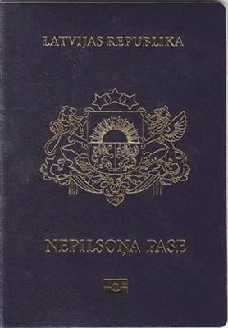

Picture 1

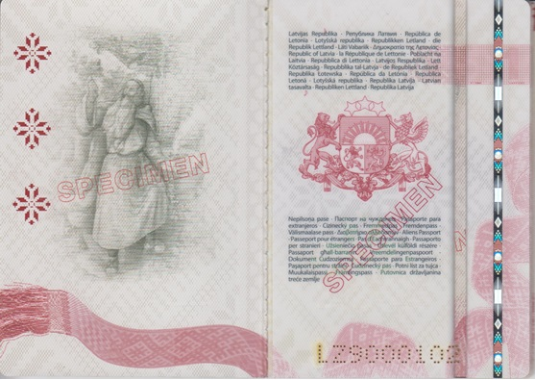

Pictures 2a and 2b

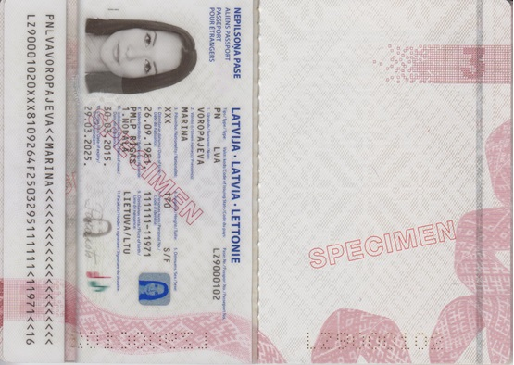

Pictures 3a and 3b

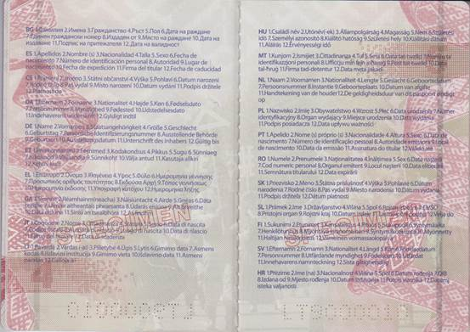

Pictures 4a and 4b

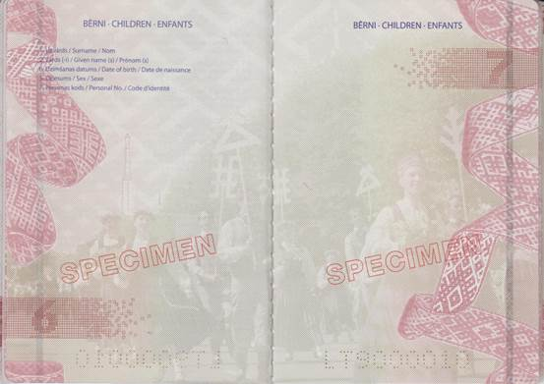

Pictures 5a and 5b

Pictures 6a and 6b

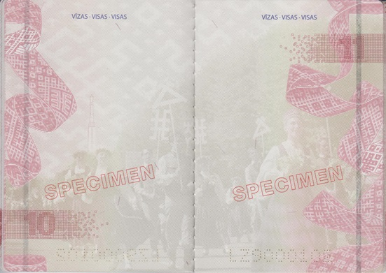

Pictures 7a and 7b

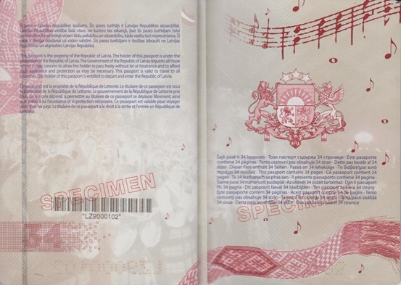

Pictures 8a and 8b

Annex 4
Cabinet Regulation No. 134
21 February 2012

Specimen of a Travel Document of a Stateless Person
[12 May 2015]

I. Cover of the passport (cover 1) (Picture 1)

Colour: brown

LATVIJAS REPUBLIKA

REPUBLIC OF LATVIA

Symbols of the State: the great coat of arms in golden colour

CEĻOŠANAS DOKUMENTS

TRAVEL DOCUMENT

(CONVENTION OF 28 SEPTEMBER 1954)

Symbol of microchip (in accordance with the ICAO)

II. First inside page of the cover of the passport (cover 2) (Picture 2a)

III. Page 1 (Picture 2b)

Latvijas Republika
Република Латвия
República de Letonia
Lotyšská republika
Republikken Letland
die Republik Lettland
Läti Vabariik
Δημοκρατία της Λετονίας
Republic of Latvia
la République de Lettonie
Poblacht na Laitvia
Repubblica di Lettonia
Latvijos Respublika
Lett Köztársaság
Repubblika tal-Latvja
de Republiek Letland
Republika Łotewska
República da Letónia
Republica Letonă
Lotyšská republika
Republika Latvija
Latvian tasavalta
Republiken Lettland
Republika Latvija

Bezvalstnieka ceļošanas dokuments
Документ за пътуване на лице без гражданство
Documento de viaje para apátridas
Cestovní doklad osoby bez státní příslušnosti
Rejsedokument til statsløs person
Reiseausweis für Staatenlose
Kodakondsuseta isiku reisidokument
Ταξιδιωτικό έγγραφο για απάτριδες
Stateless Person Travel Document
Titre de voyage pour apatride
Cáipéis Taistil Duine gan Stát
Documento di viaggio per apolidi
Asmens be pilietybės kelionės dokumentas
Utazási igazolvány hontalan személy részére
Dokument ta' l-ivvjaġġar għal-persuna mingħajr ċittadinanza
Reisdocument voor staatlozen
Dokument Podróży osoby bez obywatelstwa
Título de viagem para Apátridas
Paşaport pentru persoană fără cetăţenie
Cestovný doklad osoby bez štátnej príslušnosti
Potna listina za apatrida
Valtiottoman henkilön matkustusasiakirja
Resedokument för statslös person
Putna isprava osobe bez državljanstva

IV. Page 2 (Picture 3a)

Data page – names of information areas in Latvian, English, French, index by the information areas – for information purposes and for detection of a conforming translation

BEZVALSTNIEKA CEĻOŠANAS DOKUMENTS

STATELESS PERSON TRAVEL DOCUMENT

TITRE DE VOYAGE POUR APATRIDE

LATVIJA/LATVIA/LETTONIE

Tips/Type/Type

PB

Valsts kods/Code of Issuing State/Code du pays

LVA

Dokumenta Nr./Document No./Nº du Titre

(two letters and seven digits)

1. Uzvārds/Surname/Nom

2. Vārds(-i)/Given name(s)/Prénom(s)

3. Augums/Height/Taille

4. Dzimums/Sex/Sexe

5. Dzimšanas datums/Date of birth/Date de naissance

6. Personas kods/Personal No./Code d'identité

7. Izdevējiestāde/Authority/Autorité

8. Dzimšanas vieta/Place of birth/Lieu de naissance

9. Izdošanas datums/Date of issue/Date de délivrance

10. Paraksts/Holder's signature/Signature du titulaire

11. Derīga līdz/Date of expiry/Date d'expiration

V. Page 3 (Picture 3b)

Pases turētāja personvārda oriģinālforma latīņalfabētiskajā transliterācijā ir/

The original form of the name of the holder of this passport transliterated in Latin alphabet is/

La forme originale du nom du titulaire de ce passeport en translittération à l'alphabet latin est

PERSONAL NAME

Pases turētāja personvārda vai dzimtas uzvārda vēsturiskā forma ir/

The historical form of the given name or the family name of the holder of this passport is/

La forme historique du prénom ou du nom de famille du titulaire de ce passeport est

PERSONAL NAME

Entries shall be made according to the person's wish during the personalisation process

VI. Pages 4 and 5 (Pictures 4a and 4b)

Translation of the names of information fields of data page in the languages of the European Union states

BG

1. Фамилия 2. Имена 3. Ръст 4. Пол 5. Дата на раждане 6. Единен граждански номер 7. Издаден от 8. Място на раждане 9. Дата на издаване 10. Подпис на притежателя 11. Дата на валидност

ES

1. Apellidos 2. Nombre(s) 3. Talla 4. Sexo 5. Fecha de nacimiento 6. Número de identificación personal 7. Autoridad 8. Lugar de nacimiento 9. Fecha de expedición 10. Firma del titular 11. Fecha de caducidad

CS

1. Přijmení 2. Jméno 3. Výška 4. Pohlaví 5. Datum narození 6. Rodné číslo 7. Pas vydal 8. Místo narození 9. Datum vydání 10. Podpis držitele 11. Platnost do

DA

1. Efternavn 2. Fornavne 3. Højde 4. Køn 5. Fødselsdato 6. Personnummer 7. Myndighed 8. Fødested 9. Udstedelsesdato 10. Indehaverens underskrift 11. Gyldigt indtil

DE

1. Name 2. Vornamen 3. Größe 4. Geschlecht 5. Geburtstag 6. Persönliche Identifizierungsnummer 7. Ausstellende Behörde 8. Geburtsort 9. Ausstellungsdatum 10. Unterschrift der Inhaberin 11. Gültig bis

ET

1. Perekonnanimi 2. Eesnimed 3. Pikkus 4. Sugu 5. Sünniaeg 6. Isikukood 7. Väljaandja 8. Sünnikoht 9. Välja antud 10. Kasutaja allkiri 11. Kehtiv kuni

EL

1. Επώνυμο 2. ‘Ονομα 3. Υψος 4. Φύλο 5. Ημερομηνία γέννησης 6. Προσωπικός αριθμός ταυτότητας 7. Εκδούσα Αρχή 8. Τόπος γεννήσεως 9. Ημερομηνία έκδοσης 10. Υπογραφή κατόχου 11. Ημερομηνία λήξης

GA

1. Sloinne 2. Réamhainm (neacha) 3. Airde 4. Gnéas 5. Dáta breithe 6. Uimhir aitheantais phearsanta 7. Údarás eisiúna 8. Áit bhreithe 9. Dáta eisiúna 10. Síniú an tsealbhóra 11. Ss feidhm

IT

1. Cognome 2. Nome 3. Statura 4. Sesso 5. Data di nascita 6. Codice fiscale 7. Autorità di rilascio 8. Luogo di nascita 9. Data di rilascio 10. Firma del titolare 11. Data di scadenza

LT

1. Pavardé 2. Vardas(-ai) 3. Ūgis 4. Lytis 5. Gimimo data 6. Asmens kodas 7. Išdavusi institucija 8. Gimimo vieta 9. Išdavimo data 10. Asmens parašas 11. Galioja iki

HU

1. Családi név 2. Utónév(-ek) 3. Magasság 4. Nem 5. Születési idö 6. Személyi azonosító 7. Kiállító hatóság 8. Születési hely 9. Kiállítási dátum 10. Aláírás 11. Érvényességi idő

MT

1. Kunjom 2. Ismijiet 3. Tul 4. Sess 5. Data tat-twelid 6. Numru ta' identifikazzjoni personali 7. Uffiċċju min fejn inħareġ 8. Post tat-twelid 9. Data tal-ħruġ 10. Firma tad-detentur 11. Data meta jiskadi

NL

1. Naam 2. Voornamen 3. Lengte 4. Geslacht 5. Geboortedatum 6. Persoonsnummer 7. Instantie 8. Geboorteplaats 9. Datum van afgifte 10. Handtekening van de houder 11. De geldigheidsduur van dit paspoort eindigt op

PL

1. Nazwisko 2. Imię 3. Wzrost 4. Płeč 5. Data urodzenia 6. Numer identyfikacyjny 7. Organ wydający 8. Miejsce urodzenia 9. Data wydania 10. Podpis posiadacza 11. Data upływu waźnośçi

PT

1. Apelido 2. Nome(s) próprio(s) 3. Altura 4. Sexo 5. Data de nascimento 6. Número de identificação pessoal 7. Autoridade emissora 8. Local de nascimento 9. Data da emissão 10. Assinatura do titular 11. Válido até

RO

1. Numele 2. Prenumele 3. Înălţimea 4. Sex 5. Data naşterii 6. Cod numeric personal 7. Organul emitent 8. Locul naşterii 9. Data eliberării 10. Semnătura titularului 11. Data expirării

SK

1. Priezvisko 2. Meno 3. Výška 4. Pohlavie 5. Dátum narodenia 6. Rodné čislo 7. Pas vydal 8. Miesto narodenia 9. Dátum vydania 10. Podpis držitel'a 11. Dátum platnosti

SL

1. Priimek 2. Ime 3. Višina 4. Spol 5. Rojstni datum 6. EMŠO 7. Pristojni organ 8. Rojstni kraj 9. Datum izdaje 10. Lastnoročni podpis 11. Velja do

FI

1. Sukunimi 2. Etunimet 3. Pituus 4. Sukupuoli 5. Syntymäaika 6. Henkilötunnus 7. Myöntävä viranomainen 8. Syntymäkotikunta 9. Myönnetty 10. Haltijan nimikirjoitus 11. Viimeinen voimassaolopäivä

SV

1. Efternamn 2. Förnamn 3. Längd 4. Kön 5. Födelsedatum 6. Personnummer 7. Utfärdande myndighet 8. Födelseort 9. Utfärdat 10. Innehavarens namnteckning 11. Sista giltighetsdag

HR

1. Prezime 2. Ime(na) 3. Visina 4. Spol 5. Datum rođenja 6. OIB 7. Izdana od 8. Mjesto rođenja 9. Datum izdavanja 10. Potpis vlasnika 11. Datumj isteka valjanosti

VII. Pages 6, 7, and 8 (Pictures 5a, 5b, and 6a)

Pages are provided for the entries regarding the children of the person

BĒRNI/CHILDREN/ENFANTS

1. Uzvārds/Surname/Nom

2. Vārds(-i)/Given name(s)/Prénom(s)

5. Dzimšanas datums/Date of birth/Date de naissance

4. Dzimums/Sex/Sexe

6. Personas kods/Personal No./Code d'identité

At the bottom of the page

1954. GADA 28. SEPTEMBRA KONVENCIJA

CONVENTION OF 28 SEPTEMBER 1954

VIII. Page 9 (Picture 6b)

At the bottom of the page

1954. GADA 28. SEPTEMBRA KONVENCIJA

CONVENTION OF 28 SEPTEMBER 1954

IX. Page 10 and the following pages until the page 33 (Pictures 7a and 7b)

For visas

VĪZAS/VISAS/VISAS

At the bottom of the page

1954. GADA 28. SEPTEMBRA KONVENCIJA

CONVENTION OF 28 SEPTEMBER 1954

X. Page 34 (Picture 8a)

Šis ceļošanas dokuments ir Latvijas Republikas īpašums.
Šis dokuments ir izdots, lai tā turētāju nodrošinātu ar ceļošanas dokumentu, kuru varētu lietot nacionālās pases vietā. Dokumenta izdošana nekādā veidā neiespaido un neietekmē tā turētāja statusu, it īpaši attiecībā uz pilsonību.
Ja šī dokumenta turētājs ir apmeties uz pastāvīgu dzīvi valstī, kas nav šī dokumenta izdevējvalsts, un vēlas ceļot, viņam jāgriežas pie mītnes zemes kompetentām iestādēm, lai saņemtu jaunu dokumentu. Iestāde, kas izsniedz jaunu dokumentu, iepriekšējo ceļošanas dokumentu izņem un nogādā izdevējvalstij.
Dokumenta turētājam atļauts atgriezties Latvijas Republikā dokumenta derīguma termiņa laikā.

This Travel Document is the property of the Republic of Latvia.
This document is issued in order to provide the holder with a travel document, which could serve instead of a national passport. The issue of document in no way affects the holder’s status, particularly as regards nationality.
In case when the holder has taken up residence in a country other than which issued the present document, he must, if he wishes to travel again, apply to the competent authorities of the country of residence for a new document. The authority issuing a new document shall withdraw the old document and shall return it to the country of issue.
The holder is authorized to return to the Republic of Latvia within the period of validity of the document.

Ce Titre de voyage est la propriéte de la République de Lettonie.
Ce document est délivré afin que de fournir au titulaire le document de voyage lequel pourrait servir au lieu d’un passeport national. La délivrance du document n’affecte d’aucune façon le statut du titulaire, particulièrement en ce qui concerne la nationalité.
En cas le titulaire de présent document a élu domicile dans un pays autre lequel a délivré le présent document, il, s’il veux voyager de nouveau, doit s'appliquer aux autorités compétentes du pays de résidence pour un nouveau document. L’autorité délivrant un nouveau document est obligé de reprendre le document ancien et le rendre au pays de la délivrance.
Le titulaire du document est autorisé de revenir à la République de la Lettonie en cours de validité du document.

XI. Inside page of the cover 2 (cover 3) (Picture 8b)

Šajā ceļošanas dokumentā ir 34 lappuses
Този документ за пътуване съдържа 34 страници
Documento de viaje contiene 34 páginas
Cestovní doklad obsahuje 34 stran
Rejsedokument består af 34 sider
Reiseausweis enthält 34 Seiten
Reisidokument on 34 lehekülge
Ταξιδιωτικό έγγραφο για περιέχει 34 σελίδες
This Travel Document contains 34 pages
Titre de voyage contient 34 pages
Tá 34 leathanach sa Cáipéis Taistil
Il presente documento di viaggio contiene 34 pagine
Kelionės dokumentas 34 numeruoti puslapiai
Az úti okmánya 34 oldalt tartalmaz
Dan Dokument ta' l-ivvjaġġar fih 34 paġna
Dit Reisdocument bevat 34 bladzijden
Ten Dokument zawiera 34 strony
Este Título de viagem contém 34 páginas
Acest Document de călătorie conţine 34 de pagini
Tento cestovný doklad obsahuje 34 strán
Ta potna listina obsega 34 strani
Tämä matkustusasiakirja sisältää 34 sivua
Detta resedokument innehåller 34 sidor
Putna isprava sadrži 34 stranice

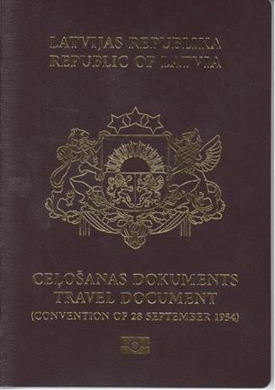

Picture 1

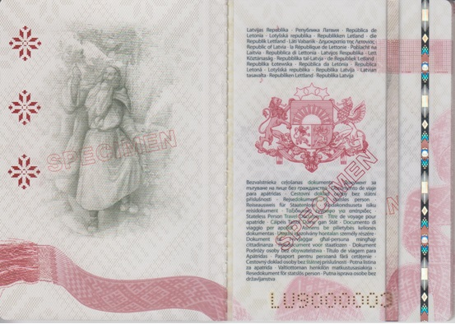

Pictures 2a and 2b

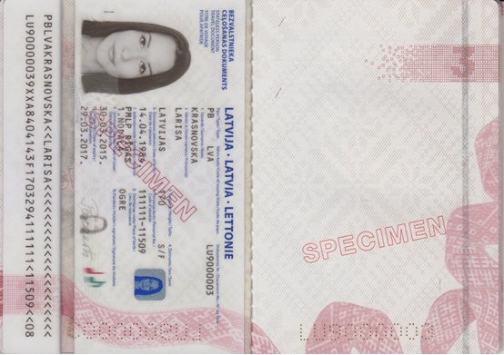

Pictures 3a and 3b

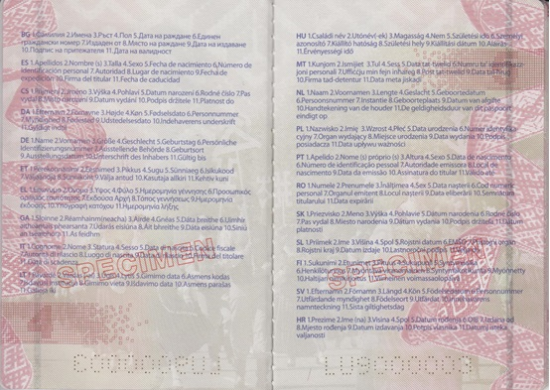

Pictures 4a and 4b

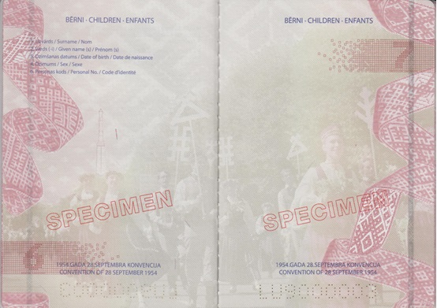

Pictures 5a and 5b

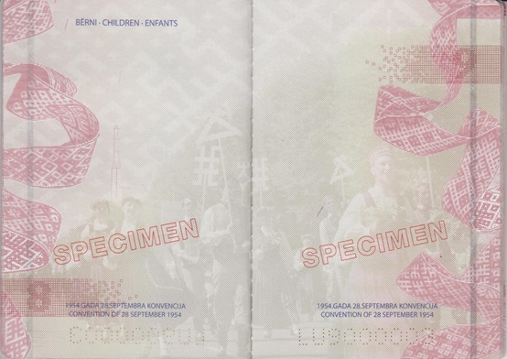

Pictures 6a and 6b

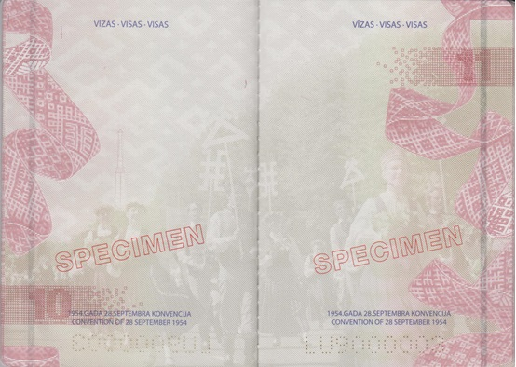

Pictures 7a and 7b

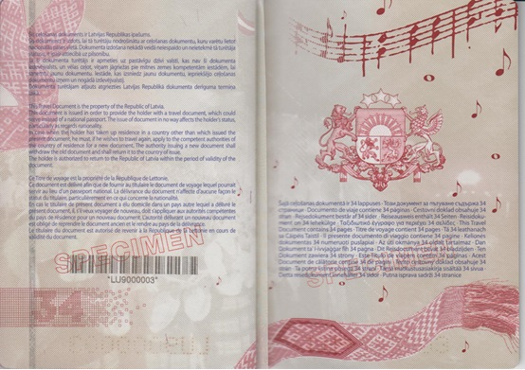

Pictures 8a and 8b

Annex 5
Cabinet Regulation No. 134
21 February 2012

Specimen of a Travel Document of a Refugee
[12 May 2015]

I. Cover of the passport (cover 1) (Picture 1)

Colour: blue

LATVIJAS REPUBLIKA

REPUBLIC OF LATVIA

Symbols of the State: the great coat of arms in golden colour

CEĻOŠANAS DOKUMENTS

TRAVEL DOCUMENT

(Convention of 28 July 1951)

Symbol of microchip (in accordance with the ICAO)

II. First inside page of the cover of the passport (cover 2) (Picture 2a)

III. Page 1 (Picture 2b)

Latvijas Republika
Република Латвия
República de Letonia
Lotyšská republika
Republikken Letland
die Republik Lettland
Läti Vabariik
Δημοκρατία της Λετονίας
Republic of Latvia
la République de Lettonie
Poblacht na Laitvia
Repubblica di Lettonia
Latvijos Respublika
Lett Köztársaság
Repubblika tal-Latvja
de Republiek Letland
Republika Łotewska
República da Letónia
Republica Letonă
Lotyšská republika
Republika Latvija
Latvian tasavalta
Republiken Lettland
Republika Latvija

Bēgļa ceļošanas dokuments
Документ за пътуване на бежанец
Documento de viaje para refugiados
Cestovní doklad pro uprchíka
Rejsedokument for flygtning
Reiseausweis für Flüchtlinge
Pagulase reisidokument
Ταξιδιωτικό έγγραφο για πρόσφυγες
Refugee Travel Document
Titre de voyage pour réfugié
Cáipéis Taistil Dídeanaí
Documento di viaggio per rifugiati
Pabėgėlio kelionės dokumentas
Menekültek úti okmánya
Dokument ta' l-ivvjaġġar għal-refuġjat
Reisdocument voor vluchtelingen
Dokument uchodźcy
Título de viagem para Refugiados
Document de călătorie pentru refugiaţi
Cestovný doklad utecenca
Potna listina za begunca
Pakolaisen matkustusasiakirja
Resedokument för flykting
Izbjeglička putna isprava

IV. Page 2 (Picture 3a)

Data page – names of information areas in Latvian, English, French, index by the information areas – for information purposes and for detection of a conforming translation

BĒGĻA CEĻOŠANAS DOKUMENTS/REFUGEE TRAVEL DOCUMENT/TITRE DE VOYAGE POUR REFUGIE

LATVIJA/LATVIA/LETTONIE

Tips/Type/Type

PP

Valsts kods/Code of Issuing State/Code du pays

LVA

Dokumenta Nr./Document No./Nº du Titre

Two letters and seven digits

1. Uzvārds/Surname/Nom

2. Vārds(-i)/Given name(s)/Prénom(s)

3. Pilsonība/Nationality/Nationalité

4. Augums/Height/Taille

5. Dzimums/Sex/Sexe

6. Dzimšanas datums/Date of birth/Date de naissance

7. Personas kods/Personal No./Code d'identité

8. Izdevējiestāde/Authority/Autorité

9. Dzimšanas vieta/Place of birth/Lieu de naissance

10. Izdošanas datums/Date of issue/Date de délivrance

11. Paraksts/Holder's signature/Signature du titulaire

12. Derīga līdz/Date of expiry/Date d'expiration

V. Page 3 (Picture 3b)

Dokumenta turētāja personvārda oriģinālforma latīņalfabētiskajā transliterācijā ir/

The original form of the name of the holder of this document transliterated in Latin alphabet is/

La forme originale du nom du titulaire de ce titre en translittération à l’alphabet latin est/

PERSONAL NAME

Dokumenta turētāja personvārda vai dzimtas uzvārda vēsturiskā forma ir/

The historical form of the given name or the family name of the holder of this document is/

La forme historique du prénom ou du nom de famille du titulaire de ce titre est/

PERSONAL NAME

Information regarding the personal name shall be made according to the person's wish during the personalisation process

Šis ceļošanas dokuments ir derīgs visās valstīs, izņemot/This Travel Document is valid for all countries except/Ce titre de voyage est valable pour tous pays excepté:

NAME OF THE STATE

Dokuments, uz kura pamata izdots šis dokuments/Document on the basis of which the present document is issued/Document sur la base duquel ou desquels le présent titre est délivré:

NAME, NUMBER, AND DATE OF THE DOCUMENT

VI. Pages 4 and 5 (Pictures 4a and 4b)

Names of information fields of data page in the languages of the European Union states

BG

1. Фамилия 2. Имена 3. Гражданство 4. Ръст 5. Пол 6. Дата на раждане 7. Единен граждански номер 8. Издаден от 9. Място на раждане 10. Дата на издаване 11. Подпис на притежателя 12. Дата на валидност

ES

1. Apellidos 2. Nombre(s) 3. Nacionalidad 4. Talla 5. Sexo 6. Fecha de nacimiento 7. Número de identificación personal 8. Autoridad 9. Lugar de nacimiento 10. Fecha de expedición 11. Firma del titular 12. Fecha de caducidad

CS

1. Přijmení 2. Jméno 3. Státní občanství 4. Výška 5. Pohlaví 6. Datum narození 7. Rodné číslo 8. Pas vydal 9. Místo narození 10. Datum vydání 11. Podpis držitele 12. Platnost do

DA

1. Efternavn 2. Fornavne 3. Nationalitet 4. Højde 5. Køn 6. Fødselsdato 7. Personnummer 8. Myndighed 9. Fødested 10. Udstedelsesdato 11. Indehaverens underskrift 12. Gyldigt indtil

DE

1. Name 2. Vornamen 3. Staatsangehörigkeit 4. Größe 5. Geschlecht 6. Geburtstag 7. Persönliche Identifizierungsnummer 8. Ausstellende Behörde 9. Geburtsort 10. Ausstellungsdatum 11. Unterschrift der Inhaberin 12. Gültig bis

ET

1. Perekonnanimi 2. Eesnimed 3. Kodakondsus 4. Pikkus 5. Sugu 6. Sünniaeg 7. Isikukood 8. Väljaandja 9. Sünnikoht 10. Välja antud 11. Kasutaja allkiri 12. Kehtiv kuni

EL

1. Επώνυμο 2. ‘Ονομα 3. Ιϑαγένεια 4. Υψος 5. Φύλο 6. Ημερομηνία γέννησης 7. Προσωπικός αριθμός ταυτότητας 8. Εκδούσα Αρχή 9. Τόπος γεννήσεως 10. Ημερομηνία έκδοσης 11. Υπογραφή κατόχου 12. Ημερομηνία λήξης

GA

1. Sloinne 2. Réamhainm (neacha) 3. Náisiúntacht 4. Airde 5. Gnéas 6. Dáta breithe 7. Uimhir aitheantais phearsanta 8. Údarás eisiúna 9. Áit bhreithe 10. Dáta eisiúna 11. Síniú an tsealbhóra 12. As feidhm

IT

1. Cognome 2. Nome 3. Cittadinanza 4. Statura 5. Sesso 6. Data di nascita 7. Codice fiscale 8. Autorità di rilascio 9. Luogo di nascita 10. Data di rilascio 11. Firma del titolare 12. Data di scadenza

LT

1. Pavardé 2. Vardas(-ai) 3. Pilietybé 4. Ūgis 5. Lytis 6. Gimimo data 7. Asmens kodas 8. Išdavusi institucija 9. Gimimo vieta 10. Išdavimo data 11. Asmens parašas 12. Galioja iki

HU

1. Családi név 2. Utónév(-ek) 3. Állampolgárság 4. Magasság 5. Nem 6. Születési idö 7. Személyi azonositó 8. Kiállító hatóság 9. Születési hely 10. Kiállítási dátum 11. Aláírás 12. Érvényességi idő

MT

1. Kunjom 2. Ismijiet 3. Ċittadinanza 4. Tul 5. Sess 6. Data tat-twelid 7. Numru ta' identifikazzjoni personali 8. Uffiċċju min fejn inħareġ 9. Post tat-twelid 10. Data tal-ħruġ 11. Firma tad-detentur 12. Data meta jiskadi

NL

1. Naam 2. Voornamen 3. Nationaliteit 4. Lengte 5. Geslacht 6. Geboortedatum 7. Persoonsnummer 8. Instantie 9. Geboorteplaats 10. Datum van afgifte 11. Handtekening van de houder 12. De geldigheidsduur van dit paspoort eindigt op

PL

1. Nazwisko 2. Imię 3. Obywatelstwo 4. Wzrost 5. Płeč 6. Data urodzenia 7. Numer identyfikacyjny 8. Organ wydający 9. Miejsce urodzenia 10. Data wydania 11. Podpis posiadacza 12. Data upływu waźnośçi

PT

1. Apelido 2. Nome(s) próprio(s) 3. Nacionalidade 4. Altura 5. Sexo 6. Data de nascimento 7. Número de identificação pessoal 8. Autoridade emissora 9. Local de nascimento 10. Data da emissão 11. Assinatura do titular 12. Válido até

RO

1. Numele 2. Prenumele 3. Naţionalitatea 4. Înălţimea 5. Sex 6. Data naşterii 7. Cod numeric personal 8. Organul emitent 9. Locul naşterii 10. Data eliberării 11. Semnătura titularului 12. Data expirării

SK

1. Priezvisko 2. Meno 3. Štátna príslušnosť 4. Výška 5. Pohlavie 6. Dátum narodenia 7. Rodné čislo 8. Pas vydal 9. Miesto narodenia 10. Dátum vydania 11. Podpis držitel'a 12. Dátum platnosti

SL

1. Priimek 2. Ime 3. Državljanstvo 4. Višina 5. Spol 6. Rojstni datum 7. EMŠO 8. Pristojni organ 9. Rojstni kraj 10. Datum izdaje 11. Lastnoročni podpis 12. Velja do

FI

1. Sukunimi 2. Etunimet 3. Kansalaisuus 4. Pituus 5. Sukupuoli 6. Syntymäaika 7. Henkilötunnus 8. Myöntävä viranomainen 9. Syntymäkotikunta 10. Myönnetty 11. Haltijan nimikirjoitus 12. Viimeinen voimassaolopäivä

SV

1. Efternamn 2. Förnamn 3. Nationalitet 4. Längd 5. Kön 6. Födelsedatum 7. Personnummer 8. Utfärdande myndighet 9. Födelseort 10. Utfärdat 11. Innehavarens namnteckning 12. Sista giltighetsdag

HR

1. Prezime 2. Ime(na) 3. Nacionalnost 4. Visina 5. Spol 6. Datum rođenja 7. OIB 8. Izdana od 9. Mjesto rođenja 10. Datum izdavanja 11. Potpis vlasnika 12. Datumj isteka valjanosti

VII. Pages 6, 7, and 8 (Pictures 5a, 5b, and 6a)

Pages are provided for the entries regarding the children of the person

BĒRNI/CHILDREN/ENFANTS

1. Uzvārds/Surname/Nom

2. Vārds(-i)/Given name(s)/Prénom(s)

6. Dzimšanas datums/Date of birth/Date de naissance

5. Dzimums/Sex/Sexe

7. Personas kods/Personal No./Code d'identité

At the lower side of the page

1951. GADA 28. JŪLIJA KONVENCIJA

CONVENTION OF 28 JULY 1951

VIII. Page 9 (Picture 6b)

At the lower side of the page

1951. GADA 28. JŪLIJA KONVENCIJA

CONVENTION OF 28 JULY 1951

IX. Page 10 and the Following Pages until the Page 33 (Pictures 7a and 7b)

Pages are provided for visas

VĪZAS/VISAS/VISAS

At the lower side of the page

1951. GADA 28. JŪLIJA KONVENCIJA

CONVENTION OF 28 JULY 1951

X. Page 34 (Picture 8a)

Šis ceļošanas dokuments ir Latvijas Republikas īpašums.
Dokuments tā turētājam izdots vienīgi ceļošanai; dokuments var aizstāt arī pilsonības valsts pasi, bet tas nekādā veidā neietekmē dokumenta turētāja pilsonību.
Ja dokumenta turētājs apmetas uz dzīvi valstī, kas nav izdevusi šo dokumentu, un vēlas ceļot atkārtoti, viņam šīs valsts attiecīgajās iestādēs jāsaņem jauns ceļošanas dokuments. (Jaunā dokumenta izdevējiestāde iepriekšējo ceļošanas dokumentu nodod atpakaļ izdevējiestādei iepriekšējā valstī – dzīvesvietā.)
Dokumenta turētājam atļauts atgriezties Latvijas Republikā dokumenta derīguma termiņa laikā.

This Travel Document is the property of the Republic of Latvia.
This document is issued solely with a view to providing the holder with a travel document which can serve in lieu of a national passport. It is without prejudice to and in no way affects the holder’s nationality.
Should the holder take up residence in a country other than that which issued the present document, he must, if he wishes to travel again, apply to the competent authorities of his country of residence for a new document. (The old travel document shall be withdrawn by the authority issuing the new document and returned to the authority which issued it.)
The holder is authorized to return to the Republic of Latvia within the period of validity of the document.

Ce Titre de voyage est la propriéte de la République de Lettonie.
Ce titre est délivre uniquement en vue de fournir au titulaire un document de voyage pouvant tenir lieu de passeport national. Il ne préjuge pas de la nationalité du titulaire et est sans effet sur celle-ci.
En cas d’établissement dans un autre pays que celui ou le présent titre a été délivré, le titulaire doit, s’il veut se déplacer à nouveau, faire la demande d’un nouveau titre aux autorités compétentes du pays de sa résidence. (Lancien titre de voyage sera remis à l’autorité qui délivre le nouveau titre pour être renvoyé à l’autorité qui l’a délivré.)
Le titulaire du document est autorisé de revenir à la République de la Lettonie en cours de validité du document.
Le titulaire du document est autorisé de revenir à la République de la Lettonie en cours de validité du document.

XI. Inside page of the cover 2 (cover 3) (Picture 8b)

Šajā ceļošanas dokumentā ir 34 lappuses
Този документ за пътуване съдържа 34 страници
Documento de viaje contiene 34 páginas
Cestovní doklad obsahuje 34 stran
Rejsedokument består af 34 sider
Reiseausweis enthält 34 Seiten
Reisidokument on 34 lehekülge
Ταξιδιωτικό έγγραφο για περιέχει 34 σελίδες
This Travel Document contains 34 pages
Titre de voyage contient 34 pages
Tá 34 leathanach sa Cáipéis Taistil
Il presente documento di viaggio contiene 34 pagine
Kelionės dokumentas 34 numeruoti puslapiai
Az úti okmánya 34 oldalt tartalmaz
Dan Dokument ta' l-ivvjaġġar fih 34 paġna
Dit Reisdocument bevat 34 bladzijden
Ten Dokument zawiera 34 strony
Este Título de viagem contém 34 páginas
Acest Document de călătorie conţine 34 de pagini
Tento cestovný doklad obsahuje 34 strán
Ta potna listina obsega 34 strani
Tämä matkustusasiakirja sisältää 34 sivua
Detta resedokument innehåller 34 sidor
Putna isprava sadrži 34 stranice

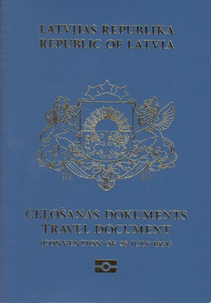

Picture 1

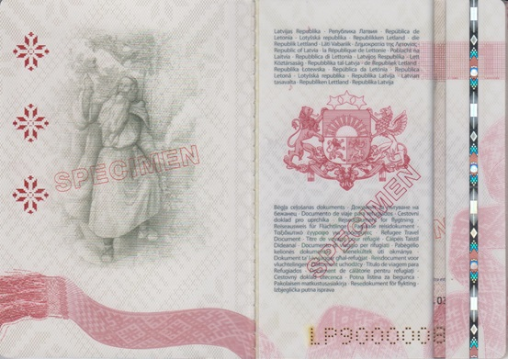

Pictures 2a and 2b

e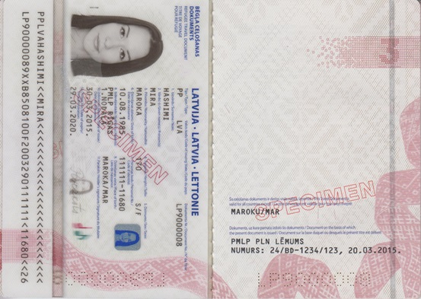

Pictures 3a and 3b

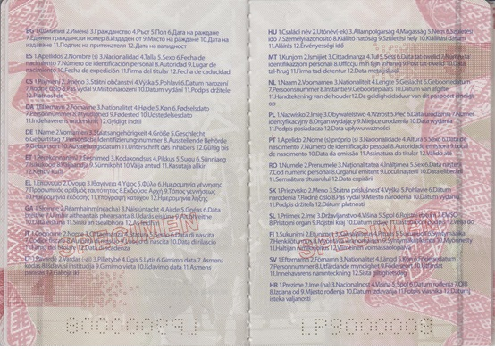

Pictures 4a and 4b

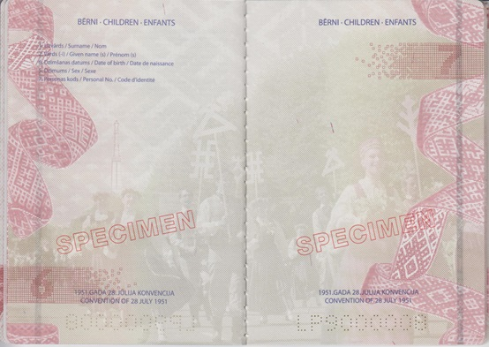

Pictures 5a and 5b

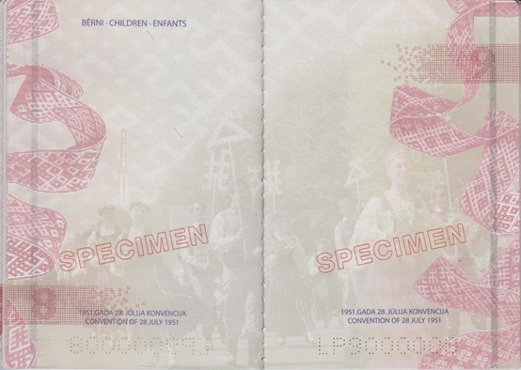

Pictures 6a and 6b

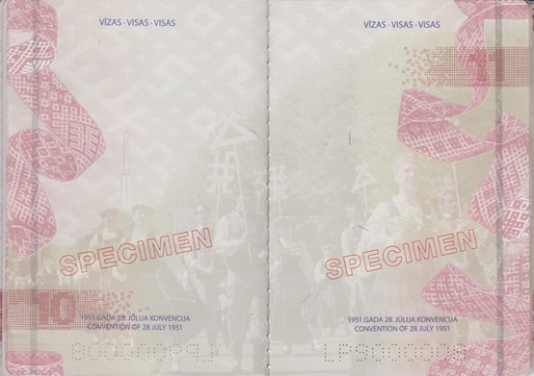

Pictures 7a and 7b

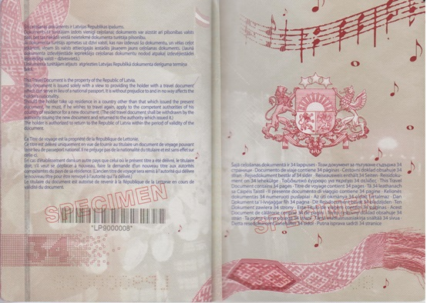

Pictures 8a and 8b

Annex 6
Cabinet Regulation No. 134
21 February 2012

Specimen of a Travel Document of a Person to whom Alternative Status has been Granted
[12 May 2015]

I. Cover of the passport (cover 1) (Picture 1)

Colour: blue

LATVIJAS REPUBLIKA

REPUBLIC OF LATVIA

Symbols of the State: the great coat of arms in golden colour

CEĻOŠANAS DOKUMENTS

TRAVEL DOCUMENT

Symbol of microchip (in accordance with the ICAO)

II. First inside page of the cover of the passport (cover 2) (Picture 2a)

III. Page 1 (Picture 2b)

Latvijas Republika
Република Латвия
República de Letonia
Lotyšská republika
Republikken Letland
die Republik Lettland
Läti Vabariik
Δημοκρατία της Λετονίας
Republic of Latvia
la République de Lettonie
Poblacht na Laitvia
Repubblica di Lettonia
Latvijos Respublika
Lett Köztársaság
Repubblika tal-Latvja
de Republiek Letland
Republika Łotewska
República da Letónia
Republica Letonă
Lotyšská republika
Republika Latvija
Latvian tasavalta
Republiken Lettland
Republika Latvija

Ceļošanas dokuments
Документ за пътуване
Documento de viaje
Cestovní doklad
Rejsedokument
Reiseausweis
Reisidokument
Ταξιδιωτικό έγγραφο
Travel Document
Titre de voyage
Cáipéis Taistil
Documento di viaggio
Kelionės dokumentas
Utazási igazolvány hontalan személy részére
Dokument ta' l-ivvjaġġar
Reisdocument
Dokument Podróży
Título de viagem
Document de călătorie
Cestovný doklad
Potna listina
Matkustusasiakirja
Resedokument
Putna isprava

IV. Page 2 (Picture 3a)

Data page – names of information areas in Latvian, English, French, index by the information areas – for information purposes and for detection of a conforming translation

CEĻOŠANAS DOKUMENTS (ALTERNATĪVAIS STATUSS)/TRAVEL DOCUMENT (SUBSIDIARY PROTECTION STATUS)/TITRE DE VOYAGE (LE STATUT DE PROTECTION SUBSIDIAIRE)

LATVIJA/LATVIA/LETTONIE

Tips/Type/Type

PA

Valsts kods/Code of Issuing State/Code du pays

LVA

Dokumenta Nr./Document No./Nº du Titre

Two letters and seven digits

1. Uzvārds/Surname/Nom

2. Vārds(-i)/Given name(s)/Prénom(s)

3. Pilsonība/Nationality/Nationalité

4. Augums/Height/Taille

5. Dzimums/Sex/Sexe

6. Dzimšanas datums/Date of birth/Date de naissance

7. Personas kods/Personal No./Code d'identité

8. Izdevējiestāde/Authority/Autorité

9. Dzimšanas vieta/Place of birth/Lieu de naissance

10. Izdošanas datums/Date of issue/Date de délivrance

11. Paraksts/Holder's signature/Signature du titulaire

12. Derīga līdz/Date of expiry/Date d'expiration

V. Page 3 (Picture 3b)

Dokumenta turētāja personvārda oriģinālforma latīņalfabētiskajā transliterācijā ir/

The original form of the name of the holder of this document transliterated in Latin alphabet is/

La forme originale du nom du titulaire de ce titre en translittération à l’alphabet latin est/

PERSONAL NAME

Dokumenta turētāja personvārda vai dzimtas uzvārda vēsturiskā forma ir/

The historical form of the given name or the family name of the holder of this document is/

La forme historique du prénom ou du nom de famille du titulaire de ce titre est/

PERSONAL NAME

Entries regarding the personal name shall be made according to the person's wish during the personalisation process

Dokuments, uz kura pamata izdots šis dokuments/Document on the basis of which the present document is issued/Document sur la base duquel ou desquels le présent titre est délivré:

NAME, NUMBER, AND DATE OF THE DOCUMENT

VI. Pages 4 and 5 (Pictures 4a and 4b)

Indices and translation of the names of information fields of data page in all the languages of the European Union states

BG

1. Фамилия 2. Имена 3. Гражданство 4. Ръст 5. Пол 6. Дата на раждане 7. Единен граждански номер 8. Издаден от 9. Място на раждане 10. Дата на издаване 11. Подпис на притежателя 12. Дата на валидност

ES

1. Apellidos 2. Nombre(s) 3. Nacionalidad 4. Talla 5. Sexo 6. Fecha de nacimiento 7. Número de identificación personal 8. Autoridad 9. Lugar de nacimiento 10. Fecha de expedición 11. Firma del titular 12. Fecha de caducidad

CS

1. Přijmení 2. Jméno 3. Státní občanství 4. Výška 5. Pohlaví 6. Datum narození 7. Rodné číslo 8. Pas vydal 9. Místo narození 10. Datum vydání 11. Podpis držitele 12. Platnost do

DA

1. Efternavn 2. Fornavne 3. Nationalitet 4. Højde 5. Køn 6. Fødselsdato 7. Personnummer 8. Myndighed 9. Fødested 10. Udstedelsesdato 11. Indehaverens underskrift 12. Gyldigt indtil

DE

1. Name 2. Vornamen 3. Staatsangehörigkeit 4. Größe 5. Geschlecht 6. Geburtstag 7. Persönliche Identifizierungsnummer 8. Ausstellende Behörde 9. Geburtsort 10. Ausstellungsdatum 11. Unterschrift der Inhaberin 12. Gültig bis

ET

1. Perekonnanimi 2. Eesnimed 3. Kodakondsus 4. Pikkus 5. Sugu 6. Sünniaeg 7. Isikukood 8. Väljaandja 9. Sünnikoht 10. Välja antud 11. Kasutaja allkiri 12. Kehtiv kuni

EL

1. Επώνυμο 2. ‘Ονομα 3. Ιϑαγένεια 4. Υψος 5. Φύλο 6. Ημερομηνία γέννησης 7. Προσωπικός αριθμός ταυτότητας 8. Εκδούσα Αρχή 9. Τόπος γεννήσεως 10. Ημερομηνία έκδοσης 11. Υπογραφή κατόχου 12. Ημερομηνία λήξης

GA

1. Sloinne 2. Réamhainm (neacha) 3. Náisiúntacht 4. Airde 5. Gnéas 6. Dáta breithe 7. Uimhir aitheantais phearsanta 8. Údarás eisiúna 9. Áit bhreithe 10. Dáta eisiúna 11. Síniú an tsealbhóra 12. As feidhm

IT

1. Cognome 2. Nome 3. Cittadinanza 4. Statura 5. Sesso 6. Data di nascita 7. Codice fiscale 8. Autorità di rilascio 9. Luogo di nascita 10. Data di rilascio 11. Firma del titolare 12. Data di scadenza

LT

1. Pavardé 2. Vardas(-ai) 3. Pilietybé 4. Ūgis 5. Lytis 6. Gimimo data 7. Asmens kodas 8. Išdavusi institucija 9. Gimimo vieta 10. Išdavimo data 11. Asmens parašas 12. Galioja iki

HU

1. Családi név 2. Utónév(-ek) 3. Állampolgárság 4. Magasság 5. Nem 6. Születési idö 7. Személyi azonosító 8. Kiállító hatóság 9. Születési hely 10. Kiállítási dátum 11. Aláírás 12. Érvényességi idő

MT

1. Kunjom 2. Ismijiet 3. Ċittadinanza 4. Tul 5. Sess 6. Data tat-twelid 7. Numru ta' identifikazzjoni personali 8. Uffiċċju min fejn inħareġ 9. Post tat-twelid 10. Data tal-ħruġ 11. Firma tad-detentur 12. Data meta jiskadi

NL

1. Naam 2. Voornamen 3. Nationaliteit 4. Lengte 5. Geslacht 6. Geboortedatum 7. Persoonsnummer 8. Instantie 9. Geboorteplaats 10. Datum van afgifte 11. Handtekening van de houder 12. De geldigheidsduur van dit paspoort eindigt op

PL

1. Nazwisko 2. Imię 3. Obywatelstwo 4. Wzrost 5. Płeč 6. Data urodzenia 7. Numer identyfikacyjny 8. Organ wydający 9. Miejsce urodzenia 10. Data wydania 11. Podpis posiadacza 12. Data upływu waźnośçi

PT

1. Apelido 2. Nome(s) próprio(s) 3. Nacionalidade 4. Altura 5. Sexo 6. Data de nascimento 7. Número de identificação pessoal 8. Autoridade emissora 9. Local de nascimento 10. Data da emissão 11. Assinatura do titular 12. Válido até

RO

1. Numele 2. Prenumele 3. Naţionalitatea 4. Înălţimea 5. Sex 6. Data naşterii 7. Cod numeric personal 8. Organul emitent 9. Locul naşterii 10. Data eliberării 11. Semnătura titularului 12. Data expirării

SK

1. Priezvisko 2. Meno 3. Štátna príslušnosť 4. Výška 5. Pohlavie 6. Dátum narodenia 7. Rodné čislo 8. Pas vydal 9. Miesto narodenia 10. Dátum vydania 11. Podpis držitel'a 12. Dátum platnosti

SL

1. Priimek 2. Ime 3. Državljanstvo 4. Višina 5. Spol 6. Rojstni datum 7. EMŠO 8. Pristojni organ 9. Rojstni kraj 10. Datum izdaje 11. Lastnoročni podpis 12. Velja do

FI

1. Sukunimi 2. Etunimet 3. Kansalaisuus 4. Pituus 5. Sukupuoli 6. Syntymäaika 7. Henkilötunnus 8. Myöntävä viranomainen 9. Syntymäkotikunta 10. Myönnetty 11. Haltijan nimikirjoitus 12. Viimeinen voimassaolopäivä

SV

1. Efternamn 2. Förnamn 3. Nationalitet 4. Längd 5. Kön 6. Födelsedatum 7. Personnummer 8. Utfärdande myndighet 9. Födelseort 10. Utfärdat 11. Innehavarens namnteckning 12. Sista giltighetsdag

HR

1. Prezime 2. Ime(na) 3. Nacionalnost 4. Visina 5. Spol 6. Datum rođenja 7. OIB 8. Izdana od 9. Mjesto rođenja 10. Datum izdavanja 11. Potpis vlasnika 12. Datumj isteka valjanosti

VII. Pages 6, 7, and 8 (Pictures 5a, 5b, and 6a)

Pages are provided for the entries regarding the children of the person

BĒRNI/CHILDREN/ENFANTS

1. Uzvārds/Surname/Nom

2. Vārds(-i)/Given name(s)/Prénom(s)

6. Dzimšanas datums/Date of birth/Date de naissance

5. Dzimums/Sex/Sexe

7. Personas kods/Personal No./Code d'identité

VIII. Page 9 blank (Picture 6b)

IX. Page 10 and the following pages until the page 33 (Pictures 7a and 7b)

Pages are provided for visas

VĪZAS/VISAS/VISAS

X. Page 34 (Picture 8a)

Šis ceļošanas dokuments ir Latvijas Republikas īpašums.
Dokumenta turētājam atļauts atgriezties Latvijas Republikā dokumenta derīguma termiņa laikā.

This Travel Document is the property of the Republic of Latvia.
The holder is authorized to return to the Republic of Latvia within the period of validity of the document.

Ce Titre de voyage est la propriéte de la République de Lettonie.
Le titulaire du document est autorisé de revenir à la République de la Lettonie en cours de validité du document.

XI. Inside page of the cover 2 (cover 3) (Picture 8b)

Šajā ceļošanas dokumentā ir 34 lappuses
Този документ за пътуване съдържа 34 страници
Documento de viaje contiene 34 páginas
Cestovní doklad obsahuje 34 stran
Rejsedokument består af 34 sider
Reiseausweis enthält 34 Seiten
Reisidokument on 34 lehekülge
Ταξιδιωτικό έγγραφο για περιέχει 34 σελίδες
This Travel Document contains 34 pages
Titre de voyage contient 34 pages
Tá 34 leathanach sa Cáipéis Taistil
Il presente documento di viaggio contiene 34 pagine
Kelionės dokumentas 34 numeruoti puslapiai
Az úti okmánya 34 oldalt tartalmaz
Dan Dokument ta' l-ivvjaġġar fih 34 paġna
Dit Reisdocument bevat 34 bladzijden
Ten Dokument zawiera 34 strony
Este Título de viagem contém 34 páginas
Acest Document de călătorie conţine 34 de pagini
Tento cestovný doklad obsahuje 34 strán
Ta potna listina obsega 34 strani
Tämä matkustusasiakirja sisältää 34 sivua
Detta resedokument innehåller 34 sidor
Putna isprava sadrži 34 stranice

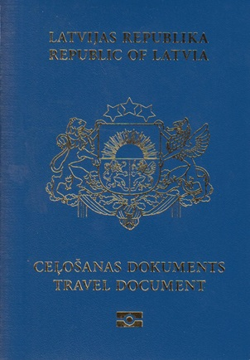

Picture 1

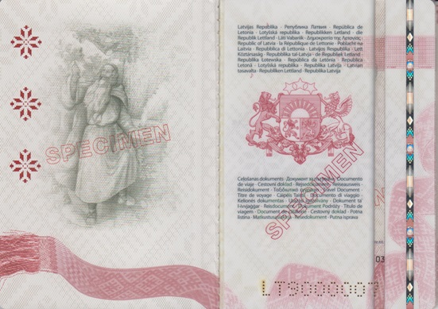

Pictures 2a and 2b

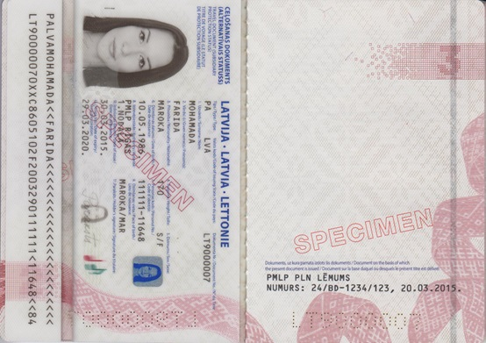

Pictures 3a and 3b

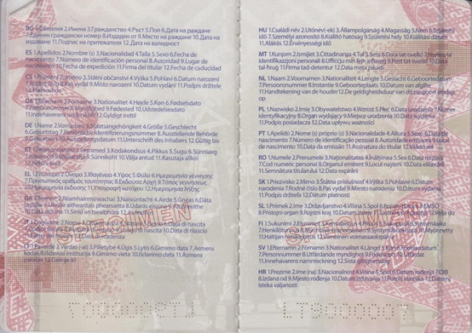

Pictures 4a and 4b

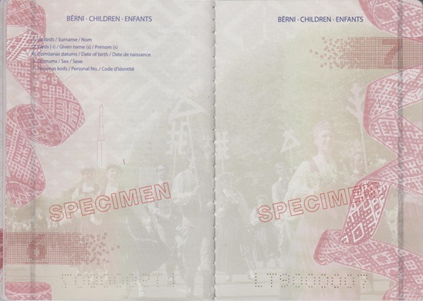

Pictures 5a and 5b

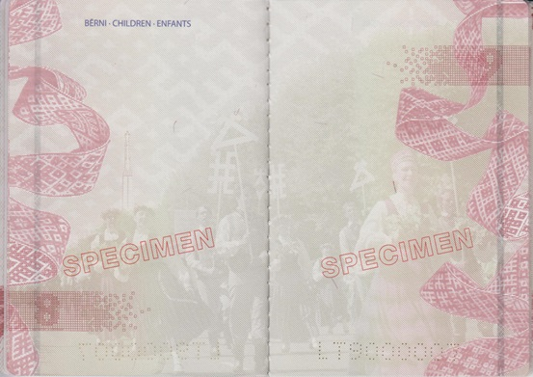

Pictures 6a and 6b

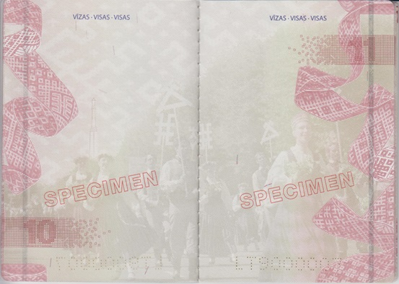

Pictures 7a and 7b

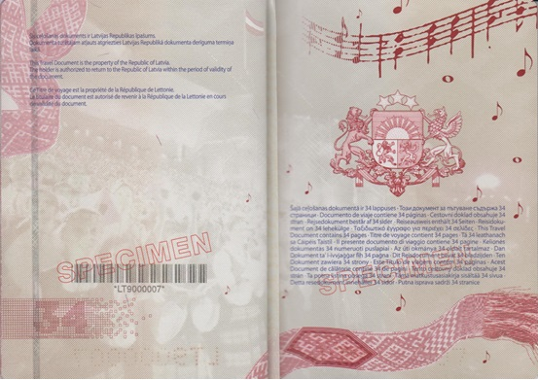

Pictures 8a and 8b

Annex 7
Cabinet Regulation No. 134
21 February 2012

Specimen of an Identity Card of a Citizen of Latvia
[27 August 2019; 12 October 2021]

I. The front of the identity card (Picture 1)

The text visible on the front of the identity card

LATVIJAS REPUBLIKA PERSONAS APLIECĪBA

REPUBLIC OF LATVIA IDENTITY CARD/

REPUBLIQUE DE LETTONIE CARTE D’IDENTITE

Number of the identity card – two letters, seven digits

Uzvārds/Surname/Nom

Vārds(-i)/Given name(s)/Prénom(s)

Pilsonība/Nationality/Nationalité

LATVIJAS

Personas kods/Personal No./Num. personnel

Dzimšanas datums/Date of birth/Date de naissance

Derīga līdz/Date of expiry/Date d'expiration

Card access number – six digits

Paraksts/Holder's signature/Signature du titulaire

II. The back of the identity card (Picture 2)

The text visible on the back of the identity card

Augums/Height/Taille

Izdošanas datums/Date of issue/Date de délivrance

Dzimums/Sex/Sexe

Izdevējiestāde/Authority/Autorité

If the person wishes:

Personvārda oriģinālforma latīņalfabētiskajā transliterācijā/

The original person`s name transliterated to Latin

or

Personvārda vēsturiskā forma/The historical form of the person’s name

QR code

Machine readable zone

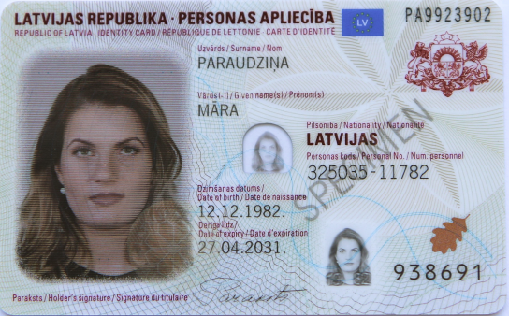

Picture 1

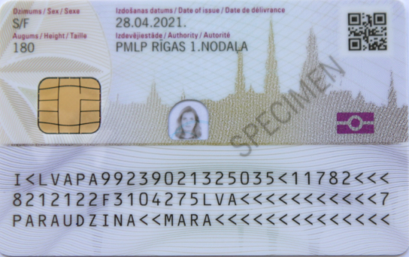

Picture 2

Annex 8
Cabinet Regulation No. 134
21 February 2012

Specimen of an Identity Card of a Non-citizen of Latvia
[27 August 2019; 12 October 2021]

I. The front of the identity card (Picture 1)

The text visible on the front of the identity card

LATVIJAS REPUBLIKA PERSONAS APLIECĪBA

REPUBLIC OF LATVIA IDENTITY CARD/

REPUBLIQUE DE LETTONIE CARTE D’IDENTITE

Number of the identity card – two letters, seven digits

Uzvārds/Surname/Nom

Vārds(-i)/Given name(s)/Prénom(s)

Tiesiskais statuss/Legal status/Statut juridique

LATVIJAS NEPILSONIS

Personas kods/Personal No./Num. personnel

Dzimšanas datums/Date of birth/Date de naissance

Derīga līdz/Date of expiry/Date d'expiration

Card access number – six digits

Paraksts/Holder's signature/Signature du titulaire

II. The back of the identity card (Picture 2)

The text visible on the back of the identity card

Augums/Height/Taille

Dzimums/Sex/Sexe

Izdošanas datums/Date of issue/Date de délivrance

Izdevējiestāde/Authority/Autorité

If the person wishes:

Personvārda oriģinālforma latīņalfabētiskajā transliterācijā/

The original person`s name transliterated to Latin

or

Personvārda vēsturiskā forma/The historical form of the person’s name

QR code

Machine readable zone

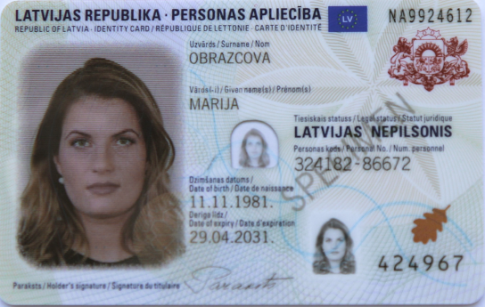

Picture 1

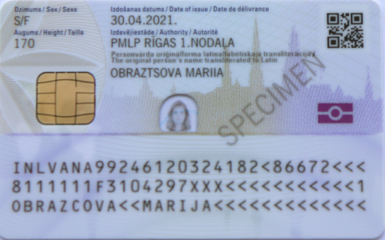

Picture 2

Annex 9
Cabinet Regulation No. 134
21 February 2012

Specimen of an Identity Card of a Citizen of the European Union
[27 August 2019; 12 October 2021]

I. The front of the identity card (Picture 1)

The text visible on the front of the identity card

LATVIJAS REPUBLIKA PERSONAS APLIECĪBA

REPUBLIC OF LATVIA IDENTITY CARD/

REPUBLIQUE DE LETTONIE CARTE D’IDENTITE

Number of the identity card – two letters, seven digits

Uzvārds/Surname/Nom

Vārds(-i)/Given name(s)/Prénom(s)

Pilsonība/Nationality/Nationalité

Personas kods/Personal No./Num. personnel

Dzimšanas datums/Date of birth/Date de naissance

Derīga līdz/Date of expiry/Date d'expiration

Card access number – six digits

Paraksts/Holder's signature/Signature du titulaire

II. The back of the identity card (Picture 2)

The text visible on the back of the identity card

Augums/Height/Taille

Dzimums/Sex/Sexe

Izdošanas datums/Date of issue/Date de délivrance

Izdevējiestāde/Authority/Autorité

Piezīmes/Remarks/Remarques

QR code

Machine readable zone

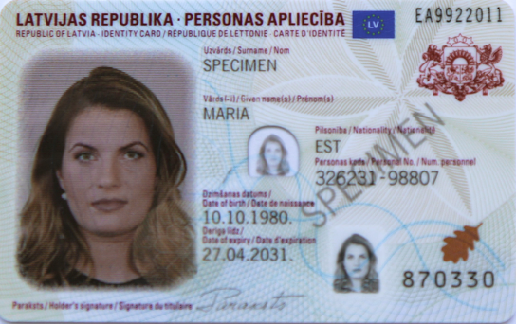

Picture 1

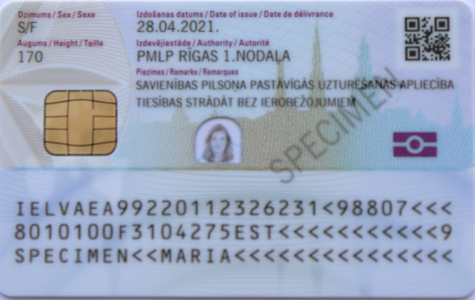

Picture 2

Annex 10
Cabinet Regulation No. 134
21 February 2012

Specimen of a Residence Permit
[7 January 2021]

I. The front of the identity card (Picture 1)

The text visible on the front of the identity card

RESIDENCE PERMIT

Number of the identity card – two letters, seven digits

Surname, given name(s)

Gender

Citizenship

Date of birth

Type of the permit

Valid until

Notes

Signature

Card access number – six digits

Name of the residence permit in English

II. The back of the identity card (Picture 2)

The text visible on the back of the identity card

Notes

QR code

Date of the issuance

Place of issue

Place of birth

Personal identity number

Machine readable zone

III. The front of the identity card (PERMANENT RESIDENCE PERMIT) (Picture 3)

The text visible on the front of the identity card

PERMANENT RESIDENCE PERMIT

Number of the identity card – two letters, seven digits

Surname, given name(s)

Gender

Citizenship

Date of birth

Type of the permit

Valid until

Notes

Signature

Card access number – six digits

Name of the residence permit in English

IV. The back of the identity card (PERMANENT RESIDENCE PERMIT) (Picture 4)

The text visible on the back of the identity card

Notes

QR code

Date of the issuance

Place of issue

Place of birth

Personal identity number

Machine readable zone

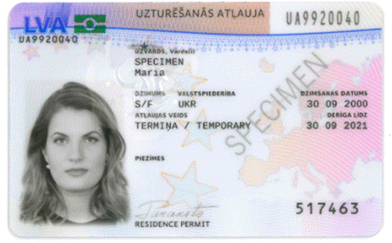

Picture 1

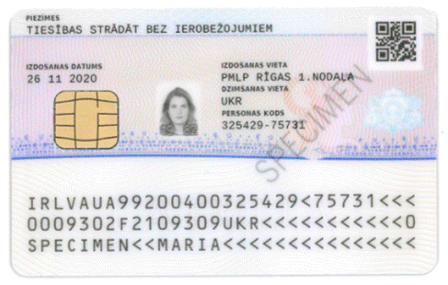

Picture 2

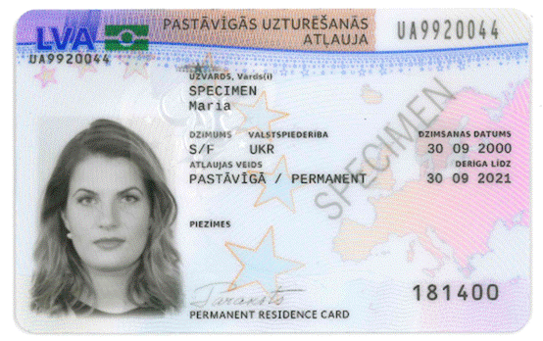

Picture 3

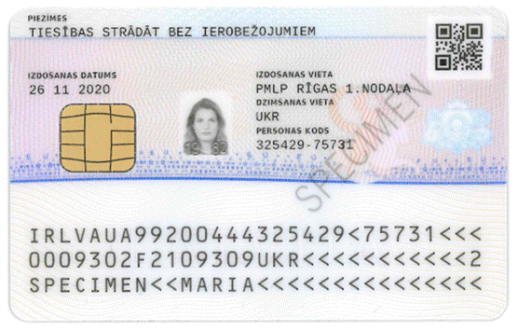

Picture 4

Annex 11
Cabinet Regulation No. 134
21 February 2012

Requirements for the Picture of a Person in a Personal Identification Document

In order to ensure that a qualitative personal identification document is issued, the photographs submitted by the person and the appearance of the person therein or the digital image of the person must conform to the following requirements:

1. The appearance of the person in the picture:
1.1. position of the head — front view;
1.2. the eyes shall be open, not covered by hair;
1.3. facial expression — natural, ordinary, neutral;
1.4. look — neutral, directed at the camera;
1.5. both sides of the face shall be illuminated equally and equally clearly visible;
1.6. paintings and decorations of the face and head that make it difficult to recognise the person shall not be permissible;
1.7. there shall be no reflective glare on the face of the person;
1.8. there shall be no shadows on the face;
1.9. if the person wears glasses, then in the picture visible in the passport:
1.9.1. the eyes of the person shall be clearly visible, they shall not be covered with the frames of the glasses;
1.9.2. the frames of the glasses shall not be heavy, they shall not cover a part of the face;
1.9.3. there shall be no reflection in the lenses of the glasses;
1.9.4. the lenses of the glasses shall not be shaded;
1.9.5. the glasses shall not be slipped down on the nose;
1.10. the person shall be without any headgear, except the case if the person daily wears a headgear due to religious reasons and the headgear does not cover the face or a part thereof;
1.11. the clothing of the person shall not cover the face or a part thereof.

2. Physical indicators of the picture:
2.1. the background of the picture shall be light;
2.2. the supposed line through the midpoints of the eyes shall be parallel with the horizontal side of the picture;
2.3. the picture of the face of the person shall be in the centre of the picture;
2.4. the picture of the face of the person from the chin line until the hair line (also the supposed hair line if the person does not have any hair or if hair covers the hair line) shall take up 70–80 % from the vertical height of the picture;
2.5. other persons or objects shall not be seen;
2.6. no shadows shall be visible in the background.

3. Quality of the picture of the person:
3.1. the picture shall be clear;
3.2. the picture shall be of good resolution;
3.3. the picture shall be contrasting and bright.

4. Requirements for the photograph:
4.1. a smooth, bright or semi-matt photographic paper of high quality shall be used;
4.2. if the picture is in colour, the skin tone of the person therein shall be natural and the eyes shall not be red;
4.3. the person shall be photographed not longer than three months ago;
4.4. the photograph has not been used for making of the previous personal identification document;
4.5. the size of the photograph shall be by 1–3 mm larger than 35×45 mm; the photograph shall be stainless and without the white corner;
4.6. the seal of the photographer's studio shall be on the other side of the photograph, in which the date of taking the photograph shall be indicated;
4.7. the seal of the photographer's studio shall not be visible through the photograph;
4.8. the photograph shall be clearly focused, clean, without any creases and folding;
4.9. the picture shall not be retouched.

Minister for the Interior R. Kozlovskis

Annex 12
Cabinet Regulation No. 134
21 February 2012

Specimen of a Contract Regarding the Provision of Certification Services
[12 May 2015]

Annex 13
Cabinet Regulation No. 134
21 February 2012
[25 October 2022]

Specimen of an Identity Card of a Foreigner

I. The front of the identity card (Picture 1)

The text visible on the front of the identity card

LATVIJAS REPUBLIKA PERSONAS APLIECĪBA

REPUBLIC OF LATVIA IDENTITY CARD/

REPUBLIQUE DE LETTONIE CARTE D’IDENTITE

Number of the identity card – two letters, seven digits

Uzvārds/Surname/Nom

Vārds(-i)/Given name(s)/Prénom(s)

Pilsonība/Nationality/Nationalité

Personas kods/Personal No./Num. personnel

Dzimšanas datums/Date of birth/Date de naissance

Derīga līdz/Date of expiry/Date d'expiration

Card access number – six digits

Paraksts/Holder's signature/Signature du titulaire

NAV DERĪGS CEĻOŠANAI

NOT VALID FOR TRAVEL

II. The back of the identity card (Picture 2)

The text visible on the back of the identity card

Dzimums/Sex/Sexe

Izdošanas datums/Date of issue/Date de délivrance

Augums/Height/Taille

Izdevējiestāde/Authority/Autorité

Piezīmes/Remarks/Remarques

QR code

ŠIS DOKUMENTS NAV DERĪGS CEĻOŠANAI

THIS DOCUMENT IS NOT VALID FOR TRAVEL

III. The front of the identity card (Picture 3)

The text visible on the front of the identity card

LATVIJAS REPUBLIKA PERSONAS APLIECĪBA

REPUBLIC OF LATVIA IDENTITY CARD/

REPUBLIQUE DE LETTONIE CARTE D’IDENTITE

Number of the identity card – two letters, seven digits

Uzvārds/Surname/Nom

Vārds(-i)/Given name(s)/Prénom(s)

Pilsonība/Nationality/Nationalité

Personas kods/Personal No./Num. personnel

Dzimšanas datums/Date of birth/Date de naissance

Derīga līdz/Date of expiry/Date d'expiration

Card access number – six digits

Paraksts/Holder's signature/Signature du titulaire

NAV DERĪGS CEĻOŠANAI

NOT VALID FOR TRAVEL

IV. The back of the identity card (Picture 4)

The text visible on the back of the identity card

Dzimums/Sex/Sexe

Izdošanas datums/Date of issue/Date de délivrance

Augums/Height/Taille

Izdevējiestāde/Authority/Autorité

Piezīmes/Remarks/Remarques

QR code

ŠIS DOKUMENTS NAV DERĪGS CEĻOŠANAI

THIS DOCUMENT IS NOT VALID FOR TRAVEL

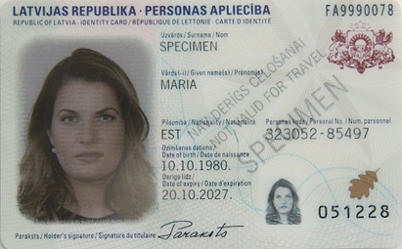

Picture 1

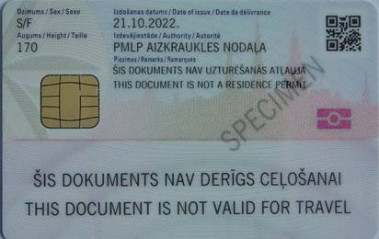

Picture 2

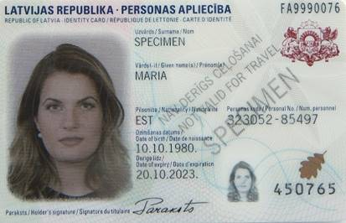

Picture 3

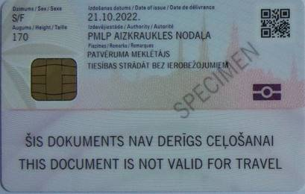

Picture 4

