Text consolidated by Tulkošanas un terminoloģijas centrs (Translation and Terminology Centre) with amending regulations of:
3 July 2001 (No. 304).
If a whole or part of a paragraph has been amended, the date of the amending regulation appears in square brackets at the end of the paragraph. If a whole paragraph or sub-paragraph has been deleted, the date of the deletion appears in square brackets beside the deleted paragraph or sub-paragraph.

Republic of Latvia

Cabinet
Regulation No. 179
Adopted 30 April 2001

Procedures for Issuing Guarantees by the Minister for Finance in the Name of the State

Issued pursuant to Section 37, Paragraph two of the Law on Budget and Financial Management

1. These Regulations prescribe the procedures by which the Minister for Finance shall issue guarantees in the name of the State.

2. The legal person in respect of whose liabilities the guarantee is being issued (hereinafter – borrower) shall submit the documents prescribed by these Regulations to the Ministry of Finance by 15 October of the financial year. If after the relevant date amendments to the annual State budget law are made which amendments provide for the issuing of new guarantees, the documents referred to shall be submitted after coming into force of the law on the relevant amendments but not later than by 1 December of the financial year.

3. In order to receive a guarantee a borrower shall submit to the Ministry of Finance the following documents:
3.1. an application for the issuing of a guarantee;
3.2. audited annual accounts of the previous year and the financial statement for the last quarter;
3.3. the business plan of the project for the implementation of which the loan to be guaranteed shall be used;
3.4. an opinion of the ministry of the sector in which the project is of economic significance, and which ministry has expressed support for the implementation of the project and for the issuing of a guarantee and has provided information on the policy of the sectoral ministry regarding support for the implementation of the project;
3.5. information regarding the expected security for the guarantee;
3.6. articles of association and registration certificate of the company or other documents that regulate the operation of the organisation;
3.7. audit opinion in respect of the quality of the business plan for the project, project implementation possibilities, financial status of the borrower and ability to repay the loan to be guaranteed; and
3.8. a draft agreement with the borrower who has been selected by means of a competition (before the competition, the by-laws thereof shall be harmonised with the Ministry of Finance and a representative from the Ministry of Finance shall be included in the competition committee).

4. The Ministry of Finance, if necessary, has the right to request from the borrower the following additional documents:
4.1. agreements entered into in order to facilitate implementation of the project (co-operation agreements, purchase agreements, letters of intent and any other type of agreement with suppliers, purchasers and co-operation partners);
4.2. valuation of the property of the borrower in order to determine the market value of the borrower's property which is intended to be used as security for the guarantee; and
4.3. a statement regarding encumbrances on the borrower's property.

5. The borrower shall submit the documents referred to in Paragraph 4 of these Regulations within a period of 20 days from receipt of a relevant request.

6. After examination of the justification required for the issuing of the guarantee, the Ministry of Finance shall analyse the credit risk, determine the interest rate of the risk, and notify the borrower thereof.

7. After evaluation of the documents submitted, the Minister for Finance shall sign a guarantee agreement with the borrower and a guarantee servicing agreement, or take a decision not to issue a guarantee.

8. A guarantee to credit institutions for liabilities of students in accordance with the conditions of Cabinet Regulation No. 220 of 29 May 2001, Procedures for Granting, Re-paying and Cancelling of Study Credits and Student Credits from Funds of Credit Institutions by Means of Guarantees Issued in the Name of the State, shall be issued upon receipt in the Ministry of Finance of a summary list of credit recipients, approved by the Ministry of Education and Science.
[3 July 2001]

9. The Ministry of Education and Science shall include in the summary list of credit recipients the following information:
9.1. information regarding the credit recipients;
9.2. information regarding the amount of credit; and
9.3. information regarding the guarantors (indicating the given name, surname, personal identity number of a natural person, or name and taxpayer registration number of the local government), or information regarding pledges (indicating the name, number and market value of securities, but in respect of immovable property– market value ).
[3 July 2001]

10. After receipt of the summary list of credit recipients the Minister for Finance shall sign a guarantee agreement with the credit institution and a guarantee servicing agreement which shall be entered into by the Ministry of Finance, the Ministry of Education and Science and the credit institution.
[3 July 2001]

Prime Minister A. Bērziņš

{0><}97{>Acting for the Minister for Finance,
Minister for Special Assignments –
Co-operation with International Financial Agencies<0} R. Zīle
Annex 1
Cabinet Regulation No. 179
30 April 2001

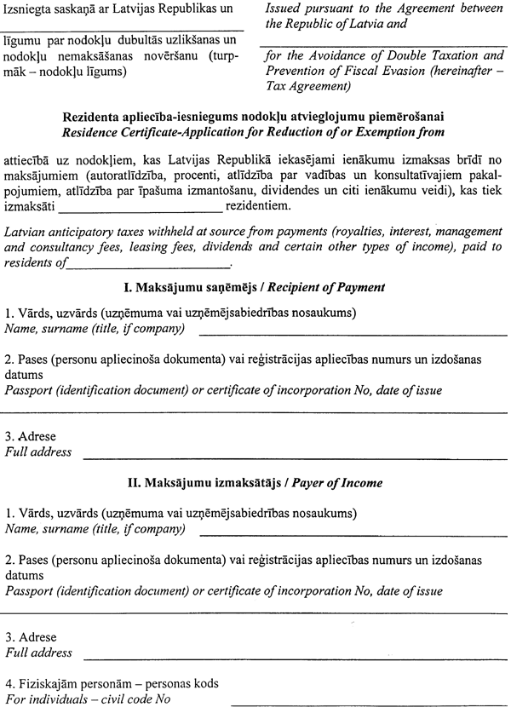
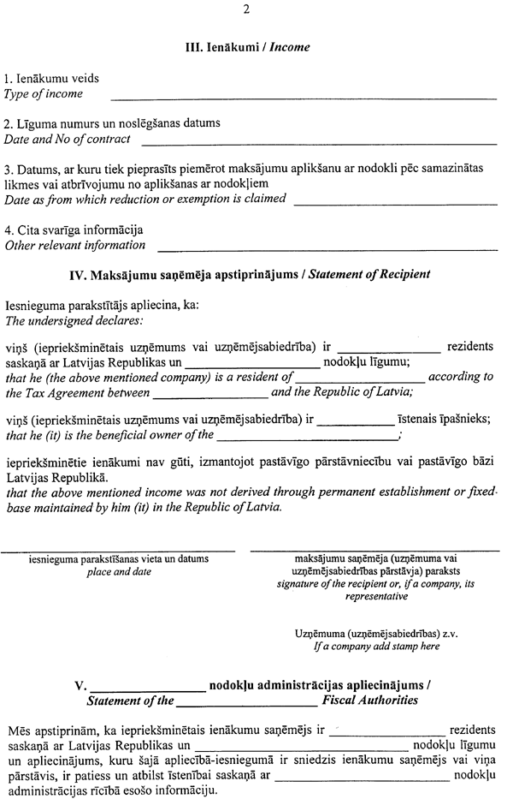
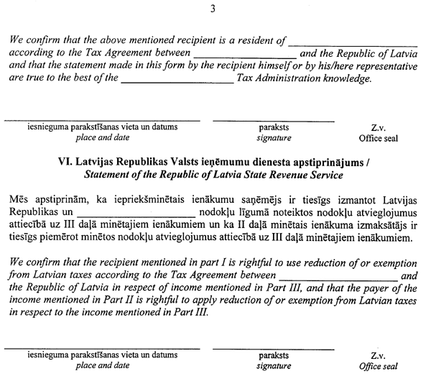

Acting for the Minister for Finance,
Minister for Special Assignments –
Co-operation with International Financial Agencies R.Zīle
Annex 2
Cabinet Regulation No. 179
30 April 2001

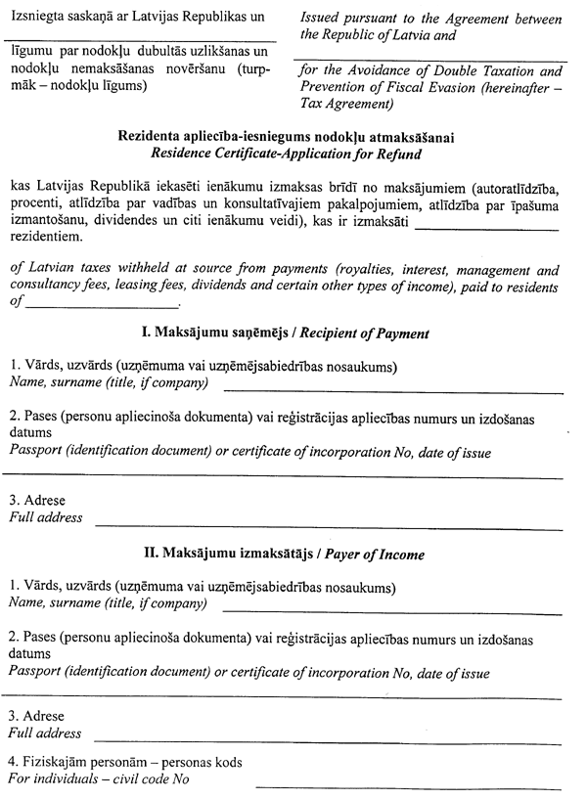

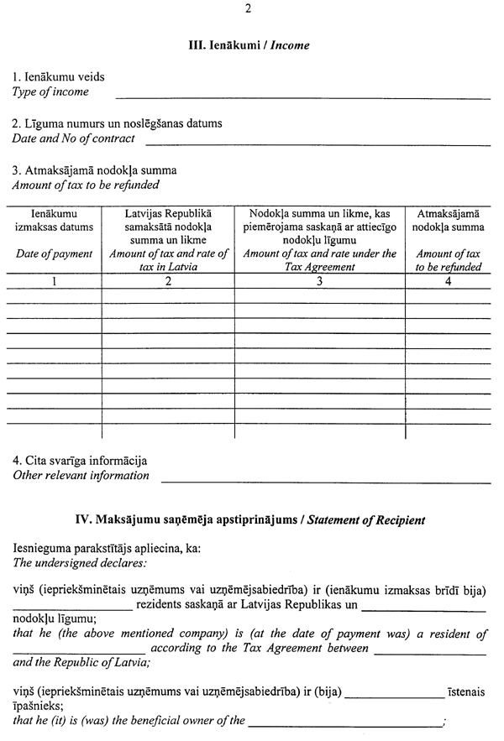

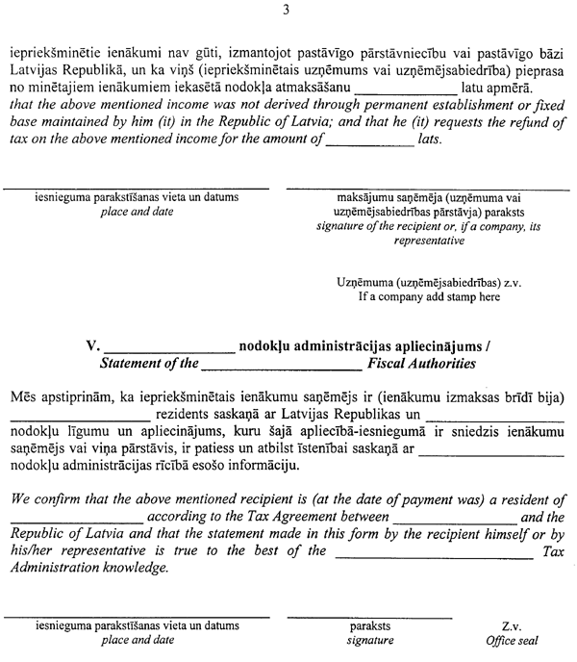

Acting for the Minister for Finance,
Minister for Special Assignments –
Co-operation with International Financial Agencies R.Zīle
