Republic of Latvia

Cabinet
Regulation No. 208
Adopted 28 May 2002

Regulations Regarding Labelling of Household Refrigerators and Freezers, and Information to be Included in Distance Contracts

Issued pursuant to Section 10, Paragraph four and Section 21, Paragraph one of the Consumer Rights Protection Law

1. These Regulations determine the household refrigerators, freezers and combinations thereof placed on the Latvian market which require particular labelling, procedures for the labelling of such appliances and information to be included in distance contracts.

2. These Regulations apply to household refrigerators, frozen food storage cabinets, food freezers and combinations thereof which operate utilising electricity (hereinafter - appliances), except appliances that may operate utilising batteries, accumulators or other similar sources of energy. These Regulations are also applicable to the appliances used in other areas of activities, not in the household.

3. It is prohibited to distribute appliances that do not conform to the requirements prescribed by these Regulations.

4. In order to inform consumers regarding the consumption of electricity, other types of energy and essential resources by appliances, and to provide the information necessary in order to evaluate the consumption by appliances of energy or other essential resources, the manufacturer, its authorised representative or importer shall label and provide with a fiche the appliances intended for sale, hire, sale on credit or for demonstration.

5. Labelling of used appliances or appliances, the manufacture of which has been suspended prior to the coming into force of these Regulations, shall not be necessary.

6. The Ministry of Economics shall co-operate with the relevant technical committee for standardisation and recommend to the non-profit-making organisation State limited liability company Latvijas standarts [Latvian Standard] a list of adaptable standards. The non-profit-making organisation State limited liability company Latvijas standarts shall submit a list of those harmonised European standards which may be applied to the performance of these Regulations for publication in the newspaper Latvijas Vēstnesis [the official Gazette of the Government of Latvia].

7. In order to determine the veracity of the information provided by labelling, the manufacturer, its authorised representatives or importer shall develop technical documentation for appliances. The following information shall be included in the documentation:
7.1. the name and address of the manufacturer, its authorised representative or importer;
7.2. a general description of the model, for it to be precisely identified;
7.3. drawings with the main features of the model and technical drawings of those parts that affect the consumption of electricity;
7.4. tests performed in accordance with the standards referred to in Paragraph 6 of these Regulations; and
7.5. instructions for use (if such exist).

8. It is permitted to substitute the documentation referred to in Paragraph 7 of these Regulations with technical documentation that has been developed regarding the appliance on the basis of other regulatory enactments, if all the information specified in Paragraph 7 of these Regulations has been included in such documentation.

9. The manufacturer, its authorised representative or importer shall ensure that the technical documentation is available to a market supervision institution for inspection for five years after the manufacture of the last appliance.

10. The label referred to in Paragraph 4 of these Regulations shall be made in conformity with the sample set out in Annex 1 of these Regulations, including the information specified in explanatory notes. The label shall be attached on the outside of the front or upper part of the appliance in a clearly visible place. The label shall contain the explanatory part that shall be the same for all appliances of a specific type, and product information stickers that shall be prepared for each appliance.

11. The fiche referred to in Paragraph 4 of these Regulations shall be indicated in all brochures and information sheets on the appliance. If a brochure or information sheet is not added to the appliance, the manufacturer, its authorised representative or importer shall specify the fiche in any other document on the appliance. The fiche shall be freely accessible.

12. The fiche shall contain the following information in a specified form:
12.1. the name or trade mark of the manufacturer, its authorised representative or importer;
12.2. the identifier of the specific model;
12.3. the type and category of the appliance in conformity with Cabinet Regulation No. 92 of 7 March 2000, Regulations Regarding Energy Efficiency and Conformity Assessment of Household Electric Refrigerators and Freezers (for category 10 appliances the supplier may choose the description of the type of the appliance);
12.4. the energy efficiency class of the model in accordance with Annex 2 of these Regulations. It shall be indicated as follows: "Energoefektivitātes klase ... uz skalas no A (efektīvāk) līdz G (mazāk efektīvi)” [Energy efficiency class … on a scale from A (more efficient) to G (less efficient)];
12.5. the mention of "Eiropas Kopienas ekomarķējums” [European Community Eco-label]. It shall be indicated if the Eco-label may be utilised for the labelling of the relevant appliance and if the information is provided in a table (the heading of the relevant column shall be "Eiropas Kopienas ekomarķējums” [European Community Eco-label] and the entry shall contain the Eco-label mark (flower));
12.6. energy consumption in kilowatt-hours per year (24 hours x 365). It shall be indicated as follows: "Enerģijas patēriņš XYZ kWh/gadā, pamatojoties uz 24 stundu testa rezultātiem. Faktiskais enerģijas patēriņš atkarīgs no iekārtas atrašanās vietas un izmantošanas” [Energy consumption XYZ kWh/year, based on test results for 24h. Actual energy consumption depends on the location and utilisation of the appliance];
12.7. the volume of fresh food storage compartment (5ºC), except categories 8 and 9 appliances; for the appliances of categories 2 and 10 the volume of each compartment shall be specified separately;
12.8. the volume of frozen food storage compartment, except categories 1, 2, and 3 appliances (for category 3 appliances the volume of the compartment "Leduskaste” [icebox] shall be specified); for categories 2 and 10 appliances the volume of each compartment shall be specified separately;
12.9. star rating of frozen food storage compartment (if such rating exists);
12.10. the mention of "Neapsarmo” [no frost]. It may be utilised if the appliance conforms to the standards referred to in Paragraph 6 of these Regulations;
12.11. safety against the interruptions of energy supply. It shall be indicated with the words "Temperatūras paaugstināšanās laiks (Z) h” [Temperature rise time (Z) h];
12.12. freezing capacity (kg/24 h);
12.13. climate class (if the appliance is intended for the operation in the temperate climate zone, this class need not be specified); and
12.14. level of noise (if the manufacturer or importer wishes to indicate such).

13. If an appliance contains more than one single fresh food storage compartment and a single frozen food storage compartment, in addition to the information referred to in Sub-paragraphs 12.7, 12.8, 12.9, 12.10, 12.11, 12.12 and 12.13 of these Regulations, information regarding the relevant compartments may be indicated in a specified sequence. If the temperature of a compartment of an appliance does not conform to the temperature specified by the star rating, or to the standard temperature of fresh food storage compartments (5ºC), the relevant temperature of the compartment of the appliance shall be specified.

14. The fiche may contain a copy of the label in colour or in black and white. In addition, the information shall be provided that in accordance with Paragraph 12 of these Regulations it is necessary to specify in the fiche.

15. The information specified in the fiche may be provided as a description of the appliance or in a table, in which the information with respect to several appliances of one manufacturer shall be provided in the sequence specified in Paragraph 12 of these Regulations.

16. The manufacturer, its authorised representative or importer shall be liable for the accuracy of the data provided.

17. The manufacturer, its authorised representative or importer shall supply labels and fiches free of charge to the retail traders and other persons that sell, hire, sell on credit or demonstrate the relevant appliances. If the labels have not been supplied, the persons referred to shall send a relevant request to the manufacturer, its authorised representative or importer.

18. If appliances are offered for sale, hire or sale on credit by utilising distance communication means, the distance contract shall include and the offer expressed to the consumer shall provide, in addition to the information determined by Cabinet regulations regarding distance contracts, the following information:
18.1. energy efficiency class;
18.2. energy consumption;
18.3. the volume of fresh food storage compartment;
18.4. the volume of frozen food storage compartment;
18.5. star rating in accordance with Sub-paragraph 12.9 of these Regulations; and
18.6. level of noise in accordance with Sub-paragraph 12.14 of these Regulations.

19. The information referred to in Paragraph 18 of these Regulations shall be provided in a form that is appropriate for the relevant distance communication means. The information shall be specified in a clearly visible place and clearly legible form in accordance with the procedures prescribed by Cabinet regulations regarding distance contracts.

20. If in addition to the information referred to in Paragraph 18 of these Regulations other information specified in the fiche is provided, such information shall be specified in accordance with Paragraph 12 of these Regulations.

21. If the labelling does not conform to the requirements prescribed by these Regulations, the manufacturer, its authorised representative or importer shall rectify the non-conformity and distribute the corrected label.

22. The manufacturer, its authorised representative or importer, shall cover if the information provided in the labelling does not conform to the information obtained in a test, the expenses related to the performance of the test.

23. Cabinet Regulation No. 30 of 23 January 2001, Regulations Regarding Labelling of Household Refrigerators and Freezers (Latvijas Vēstnesis, 2001, No. 15) is repealed.

Prime Minister A. Bērziņš

Minister for Economics A. Kalvītis

Annex 1
Cabinet Regulation No. 208
28 May 2002

Sample Label

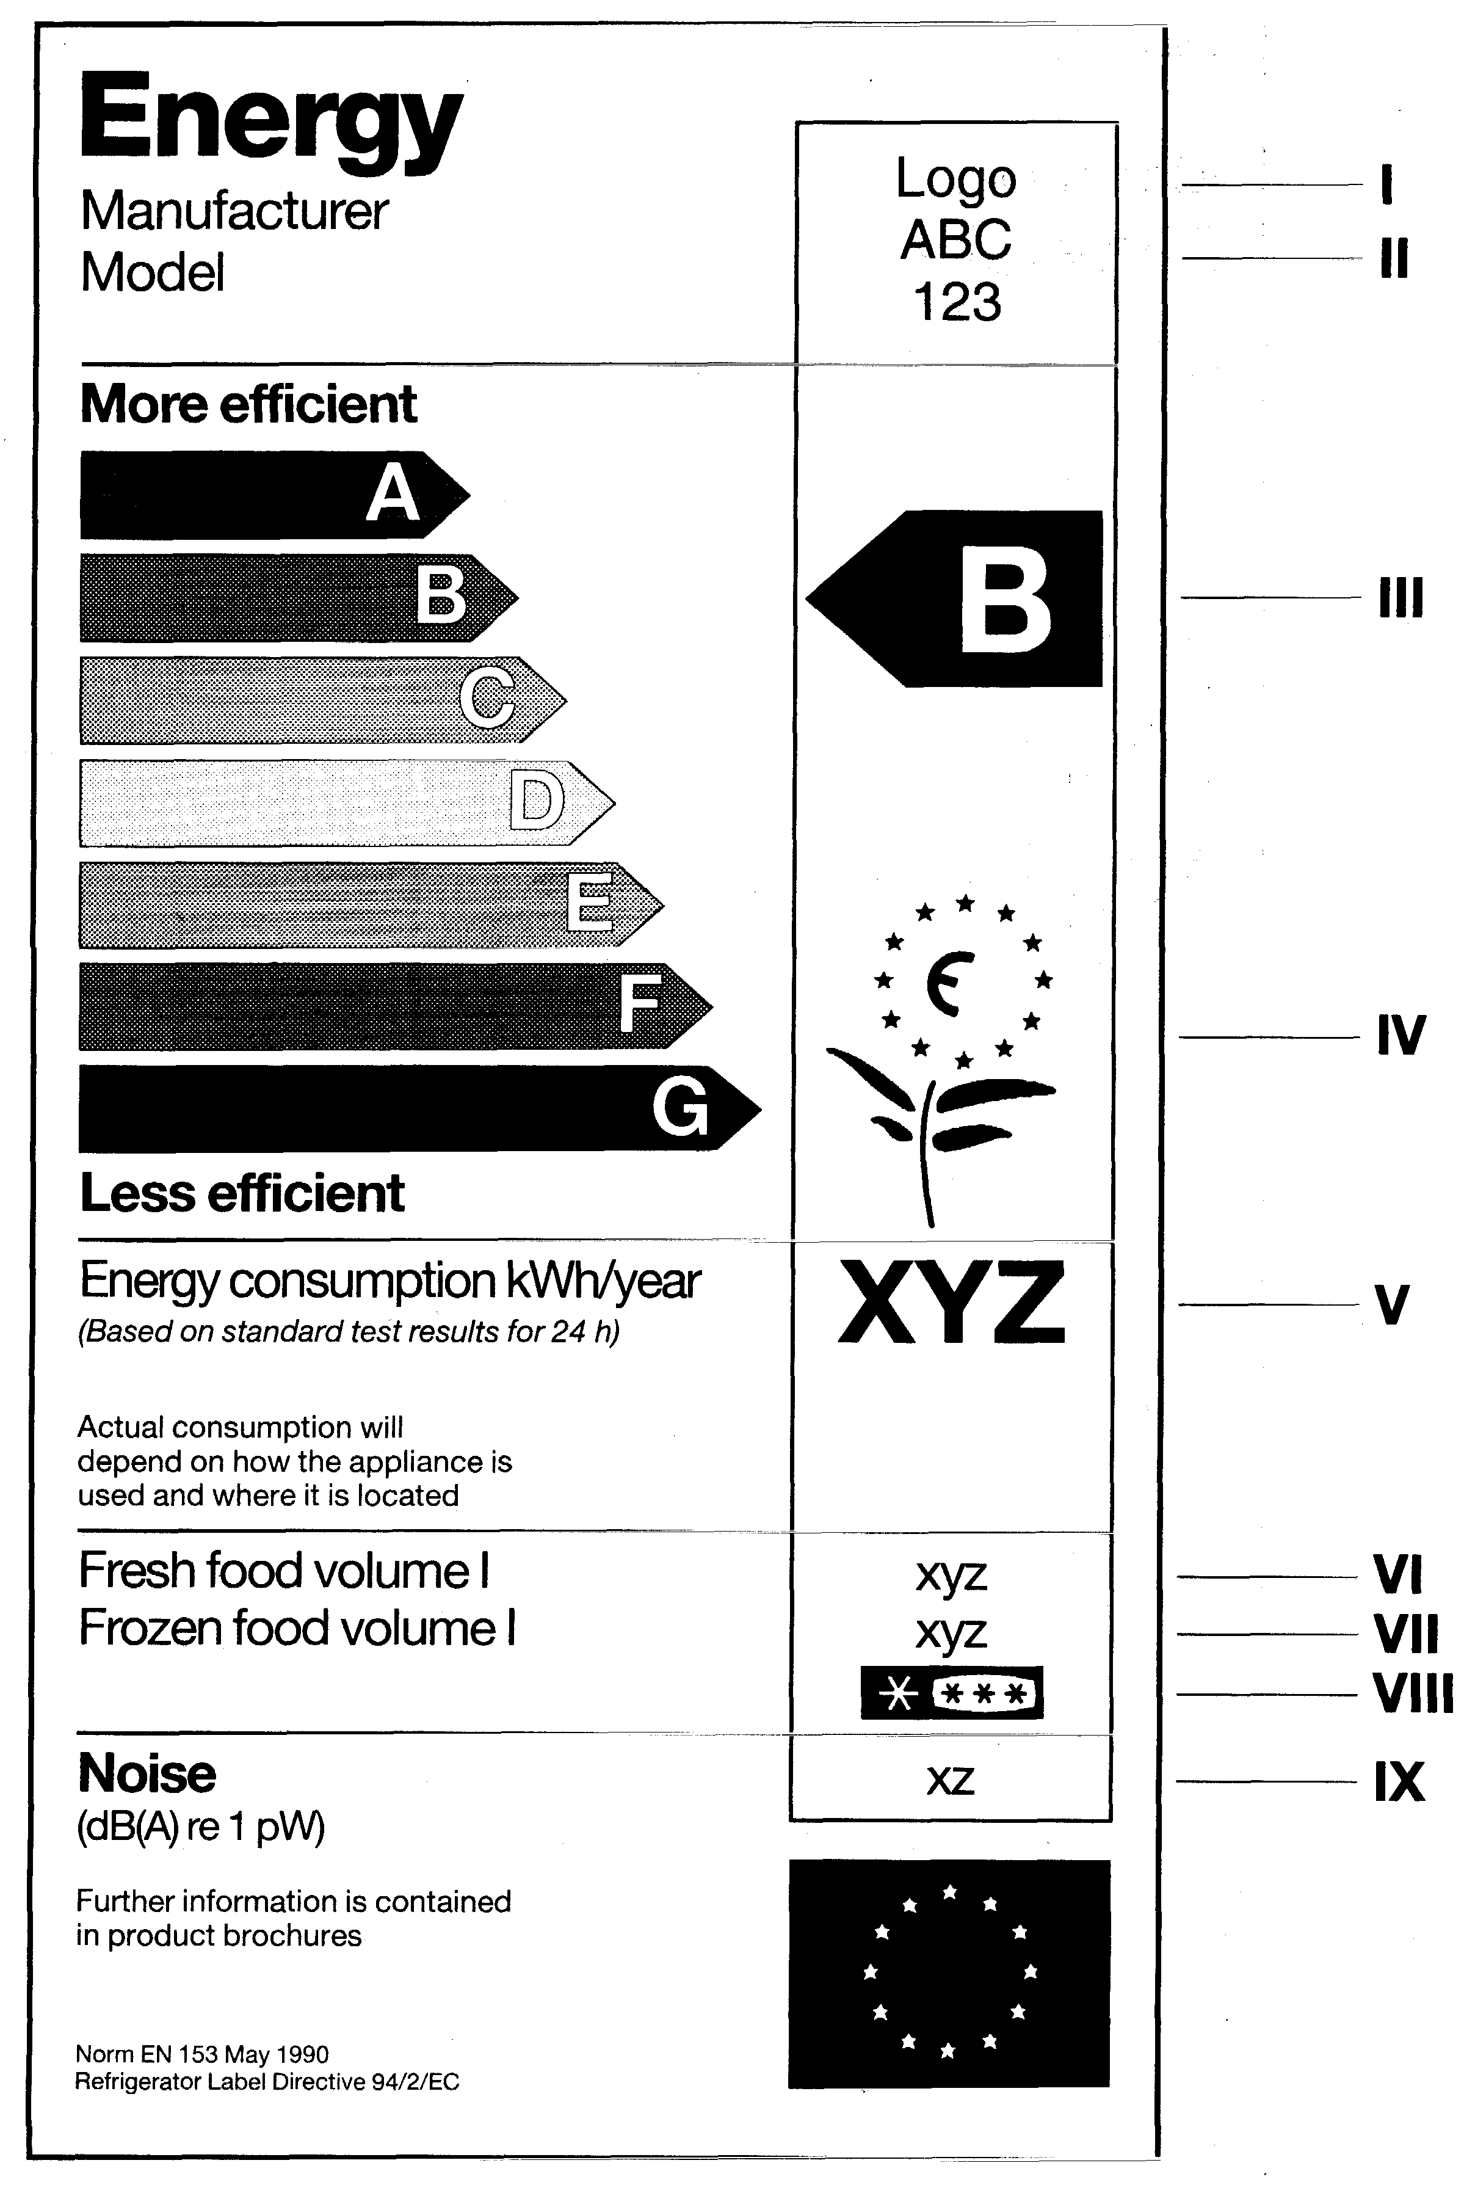
1. Explanatory notes

I — the name or trade mark of the manufacturer, its authorised representative or importer;

II — the identifier of the specific model;

III — energy efficiency class determined in accordance with Annex 2 of these Regulations. The arrow shall be placed at the same level as the relevant letter;

IV — European Community Eco-label mark (flower) if the Eco-label may be utilised for the labelling of the relevant appliance;

V — energy consumption kWh/year (24 hours x 365);

VI — the total volume of food storage compartments (which do not conform to the star rating (i.e., operation temperature > - 6ºC));

VII — the volume of frozen food storage compartments (which do conform to the star rating (operation temperature <= - 6ºC));

VIII — the star rating of frozen food storage compartments. If such compartment does not conform to the star rating, the place shall be left empty; and

IX — level of noise (if the manufacturer or importer wishes to indicate such).

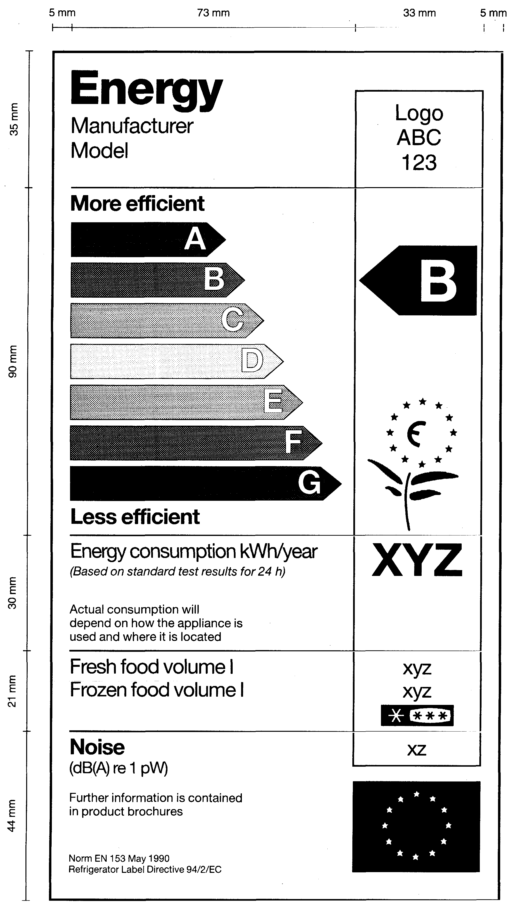
2. Dimensions of Label

3. Colours:

3.1. arrow A: 100% cyan, 0% magenta, 100% yellow, 0% black;
3.2. arrow B: 70% cyan, 0% magenta, 100% yellow, 0% black;
3.3. arrow C: 30% cyan, 0% magenta, 100% yellow, 0% black;
3.4. arrow D: 0% cyan, 0% magenta, 100% yellow, 0% black;
3.5. arrow E: 0% cyan, 30% magenta, 100% yellow, 0% black;
3.6. arrow F: 0% cyan, 70% magenta, 100% yellow, 0% black;
3.7. arrow G: 0% cyan, 100% magenta, 100% yellow, 0% black;
3.8. contours: 100% cyan, 0% magenta, 70% yellow, 0% black;
3.9. the text shall be in black, the background of the label shall be white.

Minister for Economics A. Kalvītis
Annex 2
Cabinet Regulation No. 208
28 May 2002

Energy Efficiency Class

1. Determination of energy efficiency class of an appliance:
Table 1
No. | Energy efficiency class | Energy efficiency index I
1. | A | I < 55
2. | B | 55 ² I < 75
3. | C | 75 ² I < 90
4. | D | 90 ² I < 100
5. | E | 100 ² I < 110
6. | F | 110 ² I < 125
7. | G | 125 ² I

Energy efficiency index I (in percentage) is annual energy consumption by an appliance, divided by standard annual energy consumption by the appliance.

2. Standard annual energy consumption by an appliance (kWh/year) is the value M specified for the relevant type of appliance in Table 2 of this Annex multiplied by the adjusted volume Vadj, to which result the value N specified in Table 2 of this Annex is added.

3. The adjusted volume Vadj (in litres) is the volume (in litres) of fresh food storage compartment plus the index Ω specified for the relevant type of appliance in Table 2 of this Annex, multiplied by the volume (in litres) of frozen food storage compartment. For refrigerator/chillers the adjusted volume (in litres) is the volume of fresh food storage compartment (in litres) plus the index Ω specified in Table 2 of this Annex, multiplied by the volume (in litres) of the chiller compartment (10ºC).

Table 2
No. | Category of appliance | Characteristics | Ω | M | N
1. | 1. | Refrigerators without low temperature compartments | — | 0.233 | 245
2. | 2. | Refrigerator/chillers | 0.75 | 0.233 | 245
3. | 3. | Refrigerators (without stars) | 1.25 | 0.233 | 245
4. | 4. | Refrigerators * | 1.55 | 0.643 | 191
5. | 5. | Refrigerators ** | 1.85 | 0.450 | 245
6. | 6. | Refrigerators *** | 2.15 | 0.657 | 235
7. | 7. | Refrigerator/freezers * (***) | See Note 2 | 0.777 | 303
8. | 8. | Food freezers, upright | 2.15  (see Note 2) | 0.472 | 286
9. | 9. | Food freezers, chest | 2.15  (see Note 2) | 0.446 | 181
10. | 10. | Refrigerators with more than two doors or other appliances referred to | See Note 2 | See Table 3 | See Table 3

Notes.
1. In accordance with the standards referred to in Paragraph 6 of these Regulations, for no frost upright freezers and chest freezers the index Ω shall be increased by utilising the factor 1.2. The specified index shall be 2.58. (The possible non-objectivity of the measuring method is taken into account. When utilising a refrigerator, the accumulation of ice slightly increases energy consumption.)

2. The adjusted volume Vadj of all compartments shall be calculated by utilising the following formula:
(25 – Tc)
Vadj = ² ––––--–––– x Vc x Fc, where
20
Tc —temperature (ºC) of each compartment provided for by the project;
Vc — net volume (in litres) of the specific compartment; and
Fc — the factor of no frost compartment is 1.2, the factor of the remaining compartments is 1.

4. The values M and N in conformity with the temperature and the indicated number of stars of the coldest compartment is specified in Table 3.
Table 3
No. | Temperature in the coldest compartment | Equivalent class | M | N
1. | > – 6°C | categories 1, 2 or 3 refrigerators without low temperature compartments/ refrigerators without star rating/ refrigerator/chillers | 0.233 | 245
2. | ² – 6°C * | category 4 refrigerators (*) | 0.643 | 191
3. | ² – 12°C ** | category 5 refrigerators (**) | 0.450 | 245
4. | ² – 18°C *** | category 6 refrigerators (***) | 0.657 | 235
5. | ² – 18°C * (***) with freezing capacity | category 7 refrigerator/freezers  * (***) | 0.777 | 303

