Republic of Latvia

Cabinet
Regulation No. 212
Adopted 28 May 2002

Regulations Regarding Labelling of Household Dishwashers and Information to be Included in Distance Contracts

Issued pursuant to Section 10, Paragraph four and Section 21, Paragraph one of the Consumer Rights Protection Law

1. These Regulations determine household dishwashers placed on the Latvian market which require particular labelling, procedures for the labelling of dishwashers and the information to be included in distance contracts.

2. These Regulations apply to household dishwashers, which operate utilising electricity (hereinafter – appliances), except appliances that may operate utilising batteries, accumulators or other similar sources of energy. These Regulations are also applicable to appliances used in other areas of activities, not in the household.

3. It is prohibited to distribute appliances that do not conform to the requirements prescribed by these Regulations.

4. In order to inform consumers regarding the consumption by appliances of electricity, other types of energy and essential resources, and to provide the information necessary in order to evaluate the consumption of electricity or other essential resources by appliances, the manufacturer, its authorised representative or importer shall label and provide with a fiche the appliances intended for sale, hire, sale on credit or for demonstration.

5. Labelling of used appliances or appliances, the manufacturing of which has been terminated prior to the coming into force of these Regulations, shall not be necessary.

6. The Ministry of Economics shall co-operate with the relevant technical committee for standardisation and recommend to the non-profit-making organisation State limited liability company Latvijas standarts [Latvian Standard] a list of adaptable standards. The non-profit-making organisation State limited liability company Latvijas standarts shall submit for publication in the newspaper Latvijas Vēstnesis [the official Gazette of the Government of Latvia] a list of those harmonised European standards, which may be applied to the performance of these Regulations.

7. In order to determine the veracity of the information provided by labelling, the manufacturer, its authorised representative or importer shall develop technical documentation. The following information shall be included in the documentation:
7.1. the name and address of the manufacturer, its authorised representative or importer;
7.2. a general description of the model, for it to be precisely identified;
7.3. drawings with the main characteristics of the model and technical drawings of those parts that affect the consumption of electricity;
7.4. information regarding the tests performed in accordance with the standards referred to in Paragraph 6 of these Regulations; and
7.5. instructions for use (if such exist).

8. It is permitted to substitute the documentation referred to in Paragraph 7 of these Regulations with technical documentation that has been developed regarding the appliance on the basis of other regulatory enactments, if all the information specified by Paragraph 7 of these Regulations has been included in such documentation.

9. The manufacturer, its authorised representative or importer shall ensure that the technical documentation is available to a market supervision institution for inspection for five years after the manufacture of the last appliance.

10. The label referred to in Paragraph 4 of these Regulations shall be made in conformity with the sample set out in Annex 1 of these Regulations, including the information specified in the explanatory notes. The label shall be attached on the outside of the front or upper part of the appliance in a clearly visible place. The label shall consist of the explanatory part that is identical for all appliances of a specific type, and product information stickers that shall be prepared for each appliance.

11. The fiche referred to in Paragraph 4 of these Regulations shall be indicated in all brochures and information sheets on the appliance. If a brochure or information sheet is not added to the appliance, the manufacturer, its authorised representative or importer shall specify the fiche in any other document of the appliance. The fiche shall be freely accessible.

12. The fiche shall contain the following information in a specified form:
12.1. the name or trade mark of the manufacturer, its authorised representative or importer;
12.2. the identifier of the specific model;
12.3. the energy efficiency class of the model in accordance with Annex 2 of these Regulations. It shall be indicated as follows: "Energoefektivitātes klase ... uz skalas no A (efektīvāk) līdz G (mazāk efektīvi)” [Energy efficiency class … on a scale from A (more efficient) to G (less efficient)]. If this information is provided in a table, it shall be clearly indicated that the measurement scale is from A (more efficient) to G (less efficient);
12.4. the mention of “Eiropas Kopienas ekomarķējums” [European Community Eco-label]. It shall be indicated if the Eco-label may be utilised for the labelling of the relevant appliance and if the information is provided in a table (the heading of the relevant column shall be " Eiropas Kopienas ekomarķējums” [European Community Eco-label] and the entry shall contain the Eco-label mark (flower));
12.5. the name, code or another indication assigned by the manufacturer for a standard cycle, to which the information included in the label or mark applies. This information may also be provided in respect of cycles of other types;
12.6. energy consumption in kilowatt-hours per standard cycle. It shall be indicated as follows: "Enerģijas patēriņš XYZ kWh standarta testēšanas ciklam, izmantojot aukstu ūdeni. Faktiskais enerģijas patēriņš atkarīgs no iekārtas izmantošanas”. [Energy consumption XYZ kWh per standard test cycle, utilising cold water. The actual energy consumption will depend on how the appliance is used]. This information may also be provided in respect of cycles of other types;
12.7. cleaning performance class in accordance with Annex 2 of these Regulations. It shall be indicated as follows: “Mazgāšanas izpildes klase ... uz skalas no A (labāka) līdz G (sliktāka)”. [Cleaning performance class … on a scale from A (higher) to G (lower)]. If this information is expressed differently, it shall be clearly indicated that the measurement scale is from A (higher) to G (lower). This information may also be provided in respect of cycles of other types;
12.8. drying performance class in accordance with Annex 2 of these Regulations. It shall be indicated as follows: “Žāvēšanas izpilde ... uz skalas no A (labāka) līdz G (sliktāka)” [Drying performance class … on a scale from A (higher) to G (lower)]. If this information is expressed differently, it shall be clearly indicated that the measurement scale is from A (higher) to G (lower). This information may also be provided in respect of cycles of other types;
12.9. capacity of the appliance in standard place settings. This information may also be provided in respect of cycles of other types;
12.10. water consumption (in litres) per standard cycle. This information may also be provided in respect of cycles of other types;
12.11. programme time for a standard cycle. This information may also be provided in respect of cycles of other types;
12.12. the average annual consumption of energy and water calculated on the basis of 220 times the consumption, with respect to energy - in accordance with Sub-paragraph 12.6 of these Regulations, with respect to water - in accordance with Sub-paragraph 12.10 of these Regulations. It shall be indicated as follows: "Paredzamais gada patēriņš (220 cikli)” [Estimated annual consumption (220 cycles)]; and
12.13. level of noise (if the manufacturer or importer wishes to indicate such).

13. The fiche may contain a copy of the label in colour or in black and white. In such case, the information shall be additionally provided that in accordance with Paragraph 12 of these Regulations is necessary to be specified in the fiche.

14. The information specified in the fiche may be provided as a description of the appliance or in a table, which contains the information with respect to several appliances of one manufacturer, in such case providing the information in the sequence specified by Paragraph 12 of these Regulations.

15. The manufacturer, its authorised representative or importer shall be liable for the accuracy of the data provided.

16. The manufacturer, its authorised representative or importer shall supply labels and fiches free of charge to the retail traders and other persons that sell, hire, sell on credit or demonstrate appliances to users. If the labels have not been supplied, the persons referred to shall send a relevant request to the manufacturer, its authorised representative or importer.

17. If appliances are offered for sale, hire or sale on credit by utilising distance communication means, the distance contract shall include and the offer expressed to the consumer shall provide, in addition to the information specified by Cabinet regulations regarding distance contracts, the following information:
17.1. energy efficiency class;
17.2. name of standard cycle;
17.3. energy consumption;
17.4. cleaning performance class;
17.5. drying performance class;
17.6. capacity in standard place settings;
17.7. water consumption;
17.8. estimated annual consumption of energy and water (220 cycles); and
17.9. level of noise (if the manufacturer or importer wishes to indicate such).

18. The information referred to in Paragraph 17 of these Regulations shall be provided in a form that is appropriate for the relevant distance means of communication. The information shall be specified in a clearly visible place and a clearly legible form in accordance with the procedures prescribed by Cabinet regulations regarding distance contracts.

19. If in addition to the information referred to in Paragraph 17 of these Regulations also other information specified in the fiche is provided, such information shall be provided in conformity with the requirements and sequence specified by Paragraph 12 of these Regulations.

20. If the labelling does not conform to these Regulations, the manufacturer, its authorised representative or importer shall rectify the non-conformity and distribute the corrected label.

21. The manufacturer, its authorised representative or importer, shall cover if the information provided in the labelling does not conform to the information obtained in a test, the expenses related to the performance of the test.

22. Cabinet Regulation No. 32 of 23 January 2001, Regulations Regarding Labelling of Household Dishwashers (Latvijas Vēstnesis, 2001, NO. 15) is repealed.

Prime Minister A. Bērziņš

Minister for Economics A. Kalvītis

Annex 1
Cabinet Regulation No. 212
28 May 2002

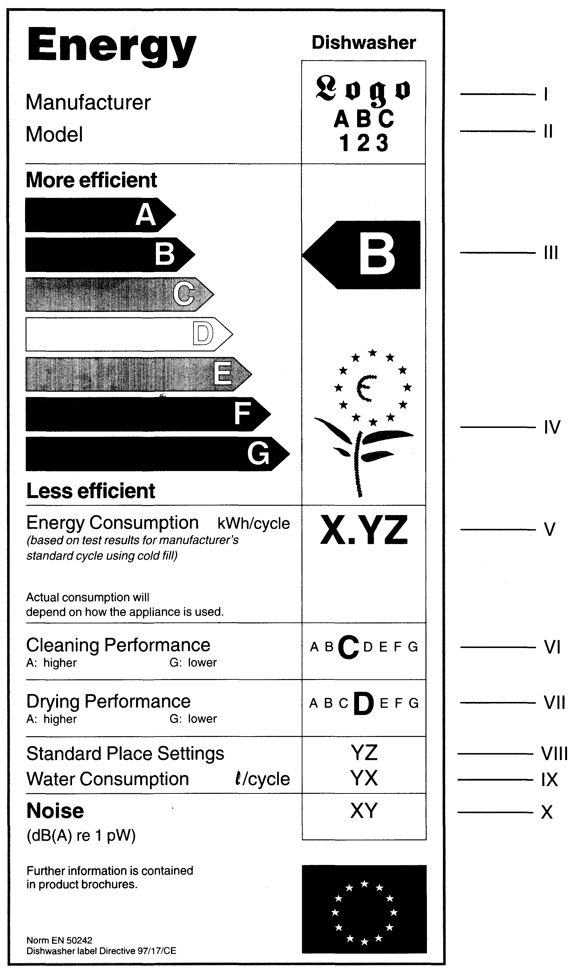
Sample Label

1. Explanatory notes:

I — the name or trade mark of the manufacturer, its authorised representative or importer;

II — the identifier of the specific model;

III — energy efficiency class in conformity with Annex 2 of these Regulations (the measurements scale is from A (more efficient) to G (less efficient)). The arrow shall be placed at the same level as the relevant letter;

IV — European Community Eco-label mark (flower) if the Eco-label may be utilised for the labelling of the relevant appliance;

V — energy consumption in kWh per cycle, utilising a standard cycle;

VI — cleaning performance class in conformity with Annex 2 of these Regulations (the measurement scale is from A (higher) to G (lower));

VII — drying performance class in conformity with Annex 2 of these Regulations (the measurement scale is from A (higher) to G (lower));

VIII — capacity of the appliance in standard place settings;

IX — water consumption (in litres) per cleaning cycle, utilising standard cycle; and

X — level of noise (if the manufacturer or importer wishes to indicate such).
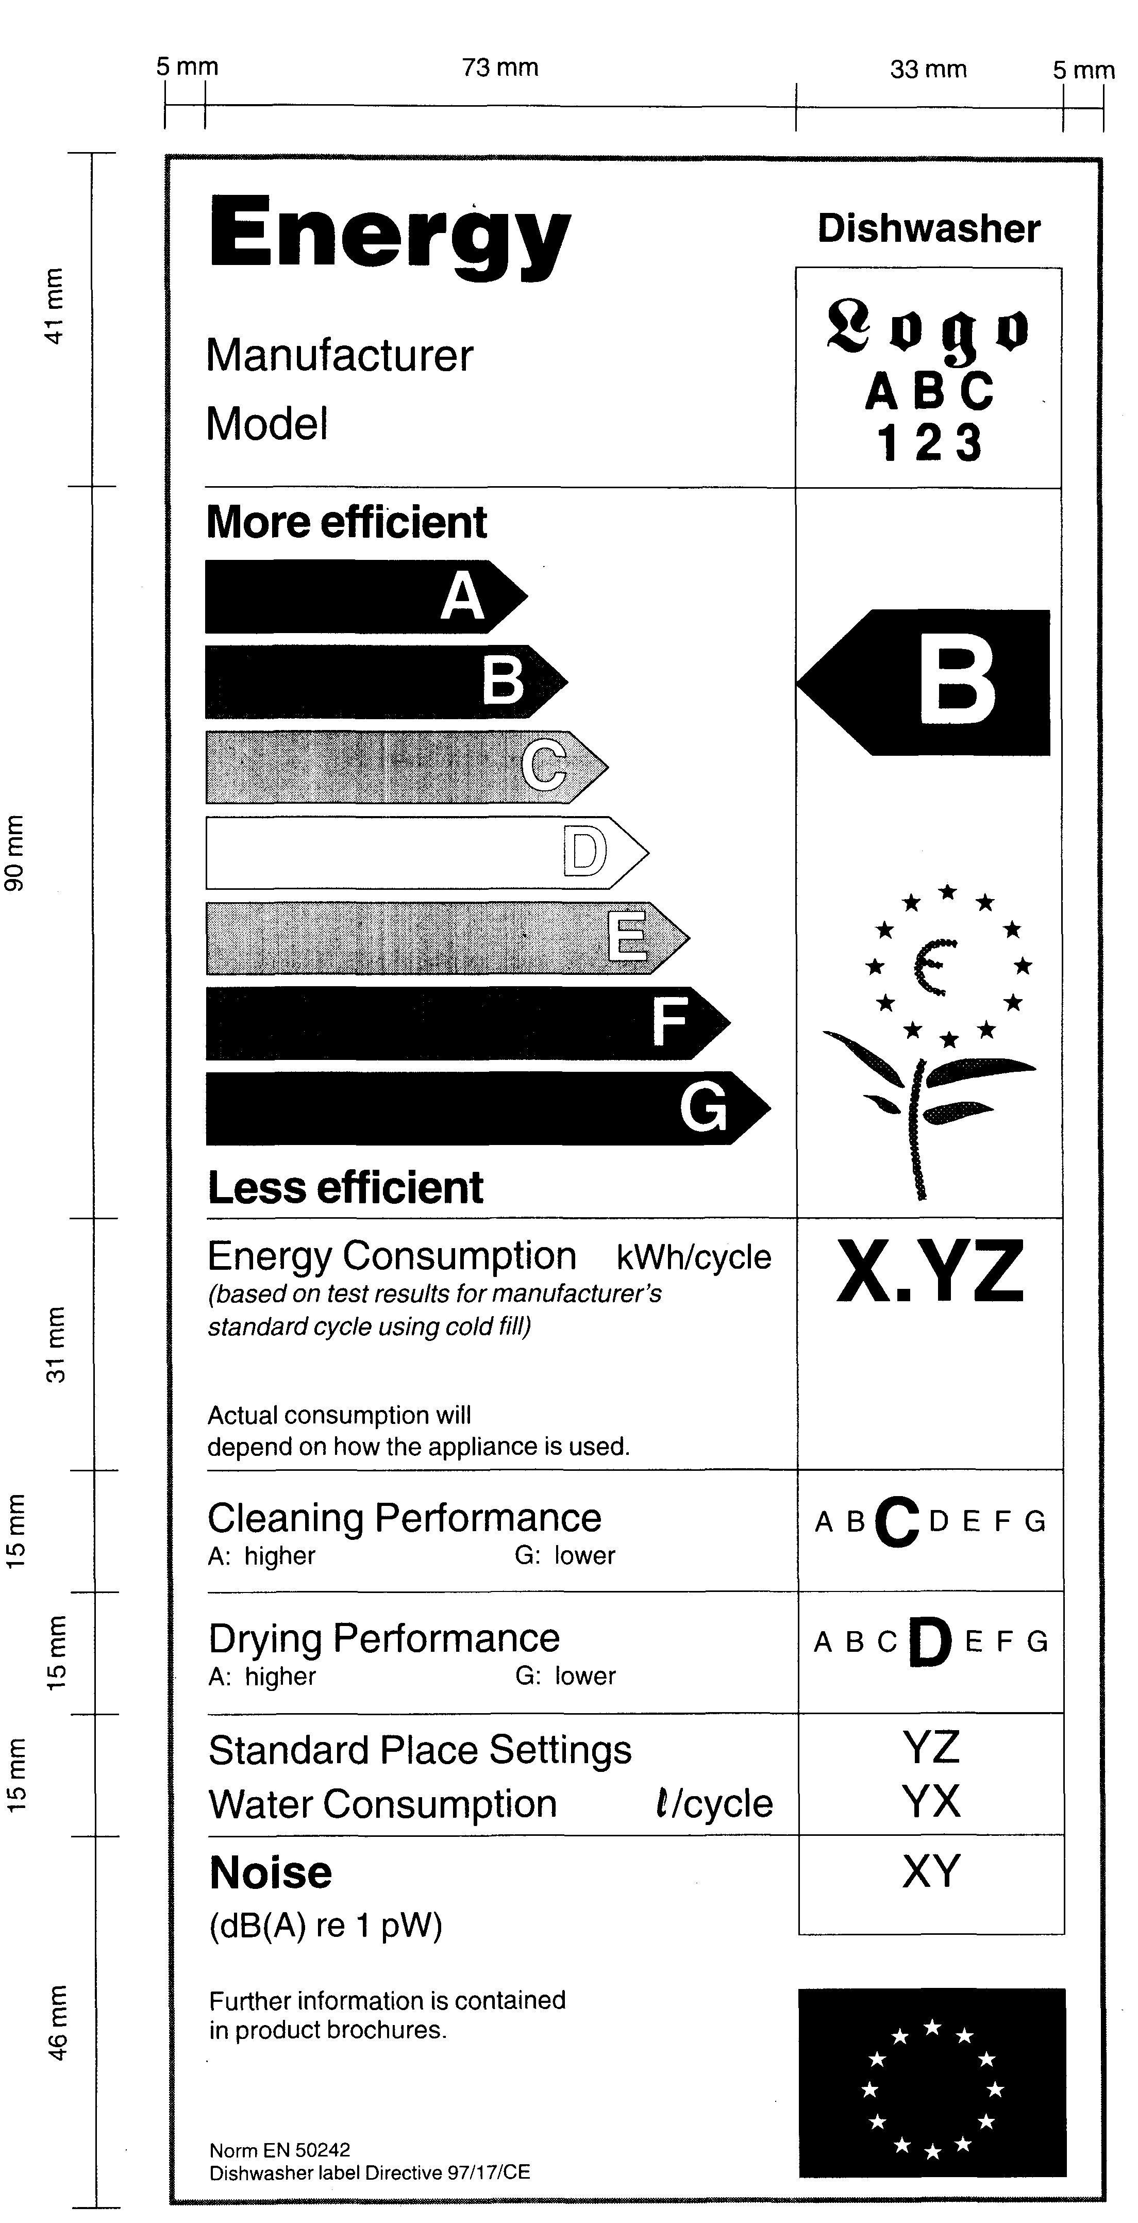
2. Dimensions of Label

3. Colours:

3.1. arrow A: 100% cyan, 0% magenta, 100% yellow, 0% black;

3.2. arrow B: 70% cyan, 0% magenta, 100% yellow, 0% black;

3.3. arrow C: 30% cyan, 0% magenta, 100% yellow, 0% black;

3.4. arrow D: 0% cyan, 0% magenta, 100% yellow, 0% black;

3.5. arrow E: 0% cyan, 30% magenta, 100% yellow, 0% black;

3.6. arrow F: 0% cyan, 70% magenta, 100% yellow, 0% black;

3.7. arrow G: 0% cyan, 100% magenta, 100% yellow, 0% black;

3.8. contours: 100% cyan, 0% magenta, 70% yellow, 0% black;

3.9. the text shall be in black , the background of the label — white.

Minister for Economics A. Kalvītis
Annex 2
Cabinet Regulation No. 212
28 May 2002

Efficiency Class
1. Energy efficiency class

No. | Energy efficiency class | Energy efficiency index EI
1.1. | A | EI < 0.64
1.2. | B | 0.64 ² EI < 0.76
1.3. | C | 0.76 ² EI < 0.88
1.4. | D | 0.88 ² EI < 1.00
1.5. | E | 1.00 ² EI < 1.12
1.6. | F | 1.12 ² EI < 1.24
1.7. | G | EI ³ 1.24

Energy efficiency index EI shall be determined by utilising the following formula:
C
E1 = -––, where
CR
C - energy consumption by the appliance in kWh per cycle.
Reference consumption CR:
CR = 1.35 + 0.025 x S, if S ³ 10
CR = 0.45 + 0.09 x S, if S ² 9, where
S - capacity of the appliance in standard place settings.

2. Cleaning performance class

No. | Cleaning performance class | Cleaning performance index PC determined in tests of the standards referred to in Paragraph 6 of these Regulations by utilising standard cycle
2.1. | A | PC > 1.12
2.2. | B | 1.12 ³ PC > 1.00
2.3. | C | 1.00 ³ PC > 0.88
2.4. | D | 0.88 ³ PC > 0.76
2.5. | E | 0.76 ³ PC > 0.64
2.6. | F | 0.64 ³ PC > 0.52
2.7. | G | 0.52 ³ PC

3. Drying performance class

No. | Drying performance class | Drying performance index PD determined in tests of the standards referred to in Paragraph 6 of these Regulations
3.1. | A | PD > 1.08
3.2. | B | 1.08 ³ PD > 0.93
3.3. | C | 0.93 ³ PD > 0.78
3.4. | D | 0.78 ³ PD > 0.63
3.5. | E | 0.63 ³ PD > 0.48
3.6. | F | 0.48 ³ PD > 0.33
3.7. | G | 0.33 ³ PD

Minister for Economics A. Kalvītis

