Republic of Latvia

Cabinet
Regulation No. 221
Adopted 27 March 2012

Regulations Regarding Return Certificates

Issued pursuant to
Section 7, Paragraph eight
of the Personal Identification Documents Law

1. This Regulation prescribes the sample and content of a return certificate, the procedures and conditions for the issue, as well as the term of validity thereof.

2. A return certificate (Annex 1) shall be issued to the person referred to in Section 7, Paragraph three of the Personal Identification Documents Law (hereinafter – person) by the diplomatic or consular representation of the Republic of Latvia (hereinafter – representation). If there is no representation in the foreign state, the return certificate shall be issued by the Consular Department of the Ministry of Foreign Affairs (hereinafter – Department).

3. In order to request a return certificate, a person shall submit the following to the representation or the Department:
3.1. a filled-out and signed application for the issue of the return certificate (Annex 2) (hereinafter – application);
3.2. two photos (35 x 45 mm);
3.3. an explanation regarding the circumstances of the theft, loss or destruction of the personal identification document;
3.4. the travel document not valid for use or another personal identification document or a copy thereof (if such is at the disposal of the person).

4. If a person has not reached 15 years of age, the documents referred to in Paragraph 3 of this Regulation shall be submitted by the legal representative thereof or by an authorised person of the legal representative.

5. The representation or the Department shall issue a return certificate within a working day after receipt of the application, if, upon examining the submitted information in the Population Register and the Information System of Personal Identification Documents, identification of the person has been performed and legal status thereof in the Republic of Latvia (hereinafter – status) has been determined.

6. If it is not possible to identify the person, using the submitted information, or status of the person has not been determined, the representation or the Department shall send copies of the documents referred to in Paragraph 3 of this Regulation to the Office of Citizenship and Migration Affairs (hereinafter – Office) and shall request an opinion thereof.

7. The Office shall, within two working days after receipt of the relevant request, provide an opinion to the representation or the Department in electronic form.

8. A return certificate shall be filled-out in Latvian and English, French, Russian or German.

9. The following information shall be included in a return certificate:
9.1. eye colour;
9.2. height (cm);
9.3. the signature of the holder of the certificate. The person need not sign and the signature space need not be filled-out if the person has not reached 10 years of age or is not able to sign because of physical disabilities, state of health or inability to write;
9.4. surname;
9.5. given name (names);
9.6. code of identity;
9.7. legal status;
9.8. place of birth;
9.9. date of birth;
9.10. place of issue;
9.11. date of issue;
9.12. term of validity;
9.13. signature, position of the official of the representation or the Department and seal with the State coat of arms of the issuing authority;
9.14. remarks.

10. A photo of the person shall be in the indicated space in the return certificate. The seal with the State coat of arms of the issuing authority shall be pressed partially on the photo, without covering face of the person.

11. The term of validity of a return certificate shall not exceed 30 days.

12. A return certificate shall be handed over to the representation after return to the state of residence. If the return certificate has not been used in order to return to the Republic of Latvia or to the state of residence, it shall be returned to the issuing authority.

13. An invalid return certificate at the disposal of the representation or the Office shall be annulled, making a note “Anulēts” [Annulled] on it, and shall be destroyed.

14. Return certificates issued until the date of coming into force of this Regulation shall be valid until the expiry date indicated therein.

Prime Minister V. Dombrovskis

Acting for the Minister of Foreign Affairs,
Minister for Transport A. Ronis

Annex 1
Cabinet Regulation No. 221
27 March 2012

Sample Return Certificate

1. Page 1 of the document - cover (Picture 1.c)

1.1. LATVIJAS REPUBLIKA

REPUBLIC OF LATVIA

REPUBLIQUE DE LETTONIE

1.2. Greater State coat of arms in brown colour

1.3. Atgriešanās apliecība

Return certificate

Certificat du retour

2. Page 2 of the document (Picture 2.a)

2.1. Acis/Eyes/Yeux

2.2. Augums/Height/Taille

2.3. Turētāja paraksts/Signature of bearer/Signature du titulaire

2.4. Uzvārds/Surname/Nom

2.5. Vārds/Name/Prénom

2.6. Personas kods/Code of identity/Code d’identité

2.7. Tiesiskais statuss/Legal status/État de droit

2.8. Photograph of the person

2.9. Hologram picture of the greater State coat of arms of Latvia with the inscription LATVIJAS REPUBLIKAS ATGRIEŠANAS APLIECĪBA [Return Certificate of the Republic of Latvia]

2.10. Certificate number

3. Page 3 of the document (Picture 2.b)

3.1. Dzimšanas vieta/Place of birth/Lieu de naissance

3.2. Dzimšanas datums/Date of birth/Date de naissance

3.3. Apliecība izsniegta/Issued by/Délivré par

3.4. Certificate number

4. Page 4 of the document (Picture 2.c)

4.1. Izsniegšanas datums/Date of issue/Date de délivrance

4.2. Derīga līdz/Date of expiry/Valable jusqu’au

4.3. Amatpersonas paraksts un zīmogs/Signature and stamp of authority/Signature et cachet de l’autorité

4.4. Certificate number

5. Page 5 of the document (Picture 1.a)

5.1. Īpašas atzīmes/Remarks/Remarques

6. Page 6 of the document (Picture 1.b)

Specimen

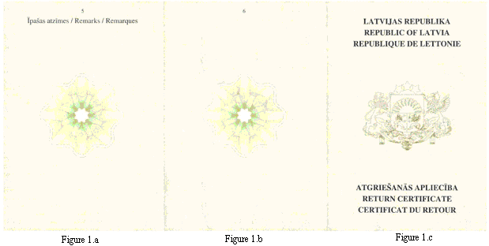

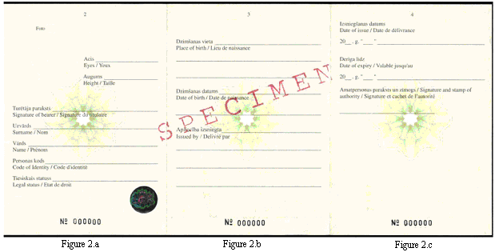

Acting for the Minister of Foreign,
AffairsMinister for Transport A. Ronis

Annex 2
Cabinet Regulation No. 221
27 March 2012

Application for Receipt of a Return Certificate

1. | Given name, surname
2. | Date and place of birth |  |  |  |  |  |  |  |  |  |  |  |  |  |  |  |  |  |  |  |  |  |  |  |  |  |  |  |  |  |  |  |  |  |  |  |  |  |  |  |  |  | Photo
3. | Height |  |  |  |  |  |  | cm |  |  |  |  |  |  |  |  |  |  |  |  | eye colour
4. | Address of the permanent place of residence
5. | Code of identity |  |  |  |  |  |  |  |  |  |  |  |  |  |  |  | -
6. | Legal status in Latvia
7. | Document, which was used to depart from Latvia
8. | Number of the referred to document* |  |  |  |  |  |  |  |  |  |  |  |  |  |  |  |  |  |  |  |  |  |  |  |  |  |  |  |  | , date of issue
 | and place of issue
9. | When and under what conditions the document became invalid
10. | Place of residence in a foreign state (address)*
11. | Information regarding persons under the age of 18 years, who are being accompanied (surname, given name, date of birth)
12. | Date, when it is planned to return to Latvia

13. | States intended to be crossed when returning to Latvia
Signature of the submitter** |  |  | Date**

Notes.
1. * To be filled out, if the required information is at the disposal of the person.
2. **The details of the document “signature” and “date” shall not be filled out if the document has been prepared in accordance with the regulatory enactments regarding drawing up of electronic documents.

Acting for the Minister of Foreign Affairs,
Minister for Transport A. Ronis

