Republic of Latvia

Cabinet
Regulation No. 222
Adopted 27 March 2012

Regulations Regarding Emergency Travel Documents

Issued pursuant to
Section 7, Paragraph eight
of the Personal Identification Documents Law

1. This Regulation prescribes the sample and content of an emergency travel document, the procedures and conditions for the issue, as well as the term of validity thereof.

2. An emergency travel document (Annex 1) shall be issued to the person referred to in Section 7, Paragraph four of the Personal Identification Documents Law (hereinafter – person) by the diplomatic or consular representation of the Republic of Latvia (hereinafter – representation).

3. In order to request an emergency travel document, a person shall submit the following to the representation:
3.1. a filled-out and signed application for the receipt of the emergency travel document (Annex 2) (hereinafter – application);
3.2. two photos (35 x 45 mm);
3.3. an explanation regarding the circumstances of the theft, loss or destruction of the personal identification document;
3.4. the travel document not valid for use or other documents and copies thereof confirming the identity of the person (if such are at the disposal of the person).

4. If a person has not reached 15 years of age, the documents referred to in Paragraph 3 of this Regulation shall be submitted by the legal representative thereof or by an authorised person of the legal representative.

5. The representation shall, within one working day, send copies of the documents referred to in Paragraph 3 of this Regulation in electronic form to the competent authority of the state of citizenship of the person, which is responsible for identification of the person and provision of an opinion on the issue of emergency travel document (hereinafter – responsible authority).

6. The representation shall issue an emergency travel document within one working day after receipt of the permit from the responsible authority.

7. Two copies shall be prepared for an emergency travel document. One copy shall be kept by the representation, which issued the emergency travel document, the other copy shall be sent to the responsible authority.

8. An emergency travel document shall be filled out in English or French.

9. The following information shall be included in an emergency travel document:
9.1. the name of the representation;
9.2. surname;
9.3. given name (names)
9.4. date of birth;
9.5. place of birth;
9.6. height (cm);
9.7. citizenship;
9.8. the signature of the holder of the document. The person need not sign and the signature space need not be filled out if the person has not reached 10 years of age or is not able to sign because of physical disabilities, state of health or inability to write;
9.9. the anticipated State of return and the anticipated States to be crossed in transit;
9.10. term of validity;
9.11. date of issue;
9.12. registration number;
9.13. position and signature of the official.

10. A photo of the person shall be attached in the indicated space in the emergency travel document. The seal with the State coat of arms of the issuing authority shall be pressed partially on the photo and partially on the emergency travel document, without covering face of the person.

11. The term of validity of an emergency travel document shall not exceed 30 days.

12. An invalid emergency travel document at the disposal of the representation shall be annulled, making a note “Anulēts” [Annulled] on it, and shall be destroyed.

13. Emergency travel documents issued until the date of coming into force of this Regulation shall be valid until the expiry date indicated therein.

Prime Minister V. Dombrovskis

Acting for the Minister of Foreign Affairs,
Minister for Transport A. Ronis

Annex 1
Cabinet Regulation No. 222
27 March 2012

Sample Emergency Travel Document

Section 1a.

1. The Embassy/Consulate of ... at ... has issued this Emergency Travel Document to the holder who is a citizen of the European Union (the following are particulars of the holder (Glossary see page 4)) (and rendering of the text in French)

2. (1) Surname (and rendering of the text in French)

3. (2) Name (s) (and rendering of the text in French)

4. (3) Date of birth (and rendering of the text in French)

5. (4) Place of birth (and rendering of the text in French)

6. (5) Height (and rendering of the text in French)

7. (6) Nationality (and rendering of the text in French)

8. (7) Signature of the holder (and rendering of the text in French)

Section 1b.

9. (8) For one journey to–via (and rendering of the text in French)

10. (9) Date of expiry (and rendering of the text in French)

11. (10) Date of issue (and rendering of the text in French)

12. (11) Registration number (and rendering of the text in French)

13. (12) Signature of the issuing officer (and rendering of the text in French)

14. (13) Seal of the issuing authority (and rendering of the text in French)

15. Photo

Section 1c.

16. Cover Page (and rendering of the text in French)

17. The following is added after "EUROPEISKA UNIONEN" (and rendering of the text in French)

18. EUROPSK? UNIE (and rendering of the text in ten languages of the European Union states)

19. Last Page (and rendering of the text in French)

20. The following is added after ''PROVISORISKT RESEDOKUMENT" (and rendering of the text in French)

21. N?HRADN? CESTOVN? DOKLAND (and rendering of the text in ten languages of the European Union states)

22. The following is added after ''ORDLISTA" (and rendering of the text in French)

23. ?DAJE (and rendering of the text in ten languages of the European Union states)

24. The following is added after ''13) UTFÄRDANDE MYNDIGHETS STÄMPEL" (and rendering of the text in French)

25. (1) Příjmení (2) Jméno (3) Datum narozen? (4) M?sto narozen? (5) V?ška (6) Státní příslušnost (7) Podpis držitele (8) Pro jednu cestu do … přes... (9) Platnost do (10) Datum vyd?n? (11) Registrační číslo (12) Podpis úřední osoby (13) Raz?tko vyd?vaj?c?ho org?nu (and rendering of the text in one language of the European Union state)

Section 2a.

1. (1) Uzvārds (2) Vārds (3) Dzimšanas datums (4) Dzimšanas vieta (5) Augums (6) Pilsonība (7) Turētāja paraksts (8) Vienam braucienam uz ... caur... (9) Derīga līdz (10) Izdošanas datums (11) Apliecības numurs (12) Izdevēja paraksts (13) Izdevējiestādes zīmogs (and rendering of the text in eight languages of the European Union states)

Section 2b.

2. EMERGENCY TRAVEL DOCUMENT (and rendering of the text in eleven languages of the European Union states)

3. GLOSSARY (and rendering of the text in eleven languages of the European Union states)

4. (1) Apellidos (2) Nombre(s) (3) Fecha de nacimiento (4) Lugar de nacimiento (5) Estatura (6) Nacionalidad (7) Firma del titular (8) Para un viaje a … via … (9) Fecha de expiraci ón (10) Fecha de expedición (11) N?mero de registro (12) Firma del funcionario expedidor (13) Sello de la autoridad expedidora (and rendering of the text in nine languages of the European Union states)

5. Number of the temporary travel document form

Section 2c.

6. EUROPEAN UNION (and rendering of the text in eleven languages of the European Union states)

7. EMERGENCY TRAVEL DOCUMENT (and rendering of the text in French)

8. Number of the emergency travel document form

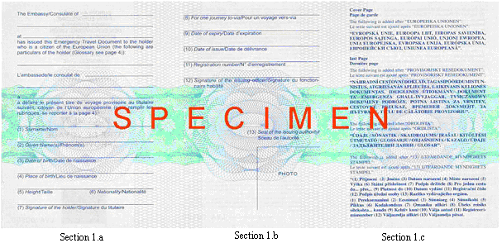

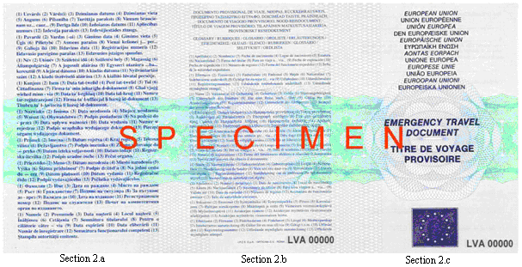

Acting for the Minister of Foreign Affairs – Minister for Transport A. Ronis

Annex 2
Cabinet Regulation No. 222
27 March 2012

Iesniegums pagaidu ceļošanas dokumenta saņemšanai
Application Form for Emergency Travel Document

1. Vārds, uzvārds _________________________________________________________
Name, surname
Fotogrāfija/
Photo

2. Pilsonība ____________________________________________
Nationality

3. Dzimšanas datums ______________________________________
Date of birth

4. Dzimšanas vieta _________________________________________________________
Place of birth

5. Augums (cm) ______________________
Height (cm)
6. Pastāvīgās dzīvesvietas adrese
Address of permanent residence
________________________________________________________________________

7. Ceļošanas dokuments, kas kļuvis lietošanai nederīgs___________________________
Invalid travel document

8.* Minētā dokumenta numurs _____________________, izsniegšanas datums ___________
Number of the above-mentioned travel document | Date of issue

un izsniegšanas vieta ______________________________________________________
Place of issue

9. Kad un kādos apstākļos dokuments kļuvis lietošanai nederīgs
When and under which circumstances the travel document has become invalid
________________________________________________________________________
________________________________________________________________________
________________________________________________________________________

10. * Uzturēšanās vieta ārvalstī (adrese)
Place of residence in foreign country (address)
_______________________________________________________________________

11. Valsts, kurā plānots atgriezties _____________________________________________
Country of destination

12. Valstis, kuras paredzēts šķērsot tranzītā ______________________________________
Countries of transit

13. Plānotais izceļošanas datums _____________________________________________
Date of departure

Iesniedzēja paraksts ____________________________ Datums ____________________
Applicant’s signature | Date

Note. * Aizpilda, ja personas rīcībā ir nepieciešamā informācija/Have to be filled out if the person has the necessary information.

Acting for the Minister of Foreign Affairs,
Minister for Transport A. Ronis

