Republic of Latvia

Cabinet
Regulation No. 245

Adopted 18 June 2002

Regulations Regarding Latvian Citizen Passports, Alien’s Passports and Stateless Persons Travel Documents

Issued pursuant to Section 5, Paragraph eight and Section 6, Paragraph three of the Personal Identification Documents Law

1. These Regulations prescribe the specimens, procedures for the issuance and return, and terms of validity of Latvian citizen passports, alien’s passports and stateless persons travel documents (hereinafter – passports), and the additional information to be included in passports, in order to improve security against counterfeiting, to extend the functionality and to facilitate the utilisation of the passports.

2. Passports shall be made in conformity with the specimens prescribed by these Regulations:
2.1. specimen of a citizen's passport (Annex 1);
2.2. specimen of an alien's passport (Annex 2); and
2.3. specimen of a stateless person’s travel document (Annex 3).

3. On page 3 of the passport the information prescribed by regulatory enactments regarding a Latvian citizen, a non-citizen of Latvia or a person, to whom the status of a stateless person has been granted in accordance with the Law On the Status of Stateless Persons in the Republic of Latvia (hereinafter – persons), which persons are registered in the Population Register of Latvia, and the information regarding the passport shall be entered.

4. The given name or names and surname (hereinafter – personal name) shall be entered in the passport in conformity with the requirements prescribed by regulatory enactments regarding the orthography of given names and surnames in the Latvian language.

5. The following shall be entered when specifying the place of birth in a passport:
5.1. if a person has been born in Latvia – the name of the administrative territory in conformity with the State administrative territorial division prescribed by regulatory enactments at the time of the issuance of the passport or (if a person wishes so and can confirm it documentarily) the name of the administrative territory at the time of birth of the person; or
5.2. if a person has been born in a foreign state – the name of the State at the time of the issuance of the passport, in which the person has been born.

6. If the orthography of the personal name on page 3 of the passport differs from the orthography thereof in a document in which the personal name has been written in the original form of another language, or differs from the historical form of the personal name or the family surname of the person, then on page 4 the historical form of the personal name or the family surname, or the original form in another language of the personal name written in transliteration of the Roman alphabet shall be specified if a person or the parents of a minor wish so and can confirm it documentarily. Transliteration in the Roman alphabet shall be performed in accordance with Annex 4 of these Regulations.

7. According to the wishes of a person, the nationality of the person shall be entered on page 4 of the passport.

8. The machine-readable zone of the passport shall be made in conformity with the requirements prescribed for the travel documents in Document No. 9303, "Machine Readable Passports" of the International Civil Aviation Organisation. In the machine-readable zone of the passport personal names shall be written in conformity with the orthography of such names in Latvian, without diacritical marks.

9. On pages 6 and 7 of the passport, according to the wish of a person, the Office of Citizenship and Migration Affairs shall enter the following information regarding a person's child (children) under the age of 18 :
9.1. personal name;
9.2. date of birth;
9.3. sex; and
9.4. personal identity number if the child is registered in the Population Register.

10. All the entries referred to in Paragraphs 3, 4, 5, 6, 7 and 9 of these Regulations shall be made in the passport in accordance with the information of the Population Register regarding the person.

11. In order to improve the safety of passports against counterfeit, to extend the functionality and facilitate the utilisation of passports, the information regarding the height of a person, and the translation of the headings of the main data page shall be included and the number of pages shall be additionally specified in the passports. A place shall be provided in passports for the entering of the addresses of two relatives or friends of the holder of the passport, which friends or relatives may be informed in case of an accident.

12. A person has the right to express a wish to make the entries referred to in Paragraphs 6 and 7 of these Regulations only when submitting the documents for the receipt of a passport.

13. Citizen passports and alien’s passports shall be issued with the following term of validity:
13.1. to persons under five years of age – for one year or for the period of travel if it is more than one year long;
13.2. to persons from five years of age until 20 years of age – for five years;
13.3. to persons from 20 years of age until 60 years of age – for ten years; and
13.4. to persons who have reached 60 years of age – for 50 years.

14. The stateless persons travel document shall be issued with a term of validity from three months to two years. If a person resolves the issues related to the acquisition of citizenship and he or she has guarantees from a state regarding admission to citizenship, a travel document of a stateless person, the term of validity of which is less than two years, shall be issued to such person.

15. A passport shall be issued if:
15.1. a passport has not been issued to the person;
15.2. the previous passport has been lost;
15.3. the previous passport has become invalid for use:
15.3.1. the term of validity of the passport has expired;
15.3.2. notes not provided for by regulatory enactments have been made in the passport;
15.3.3. the personal name has changed;
15.3.4. the legal status of the person has changed;
15.3.5. other information entered in the passport regarding the person has changed or inaccuracies of the entries in the passport have been determined;
15.3.6. the passport has mechanical or other damage, due to which it is not possible to identify the person or to read the information indicated in the passport;
15.3.7. the passport does not conform to the specified specimen; or
15.3.8. the person has informed an office of the State Police or the State Border Guard, the issuing authority of the document or a Diplomatic or Consular Representation of the Republic of Latvia in writing regarding the loss of the passport, but the passport has been found;
15.4. the appearance of the person has changed;
15.5. the passport is not valid for travelling (there is no place for new entries, for example, visas, notes regarding border crossings or the term of validity of the passport is shorter than the time necessary for the travel or for the receipt of a visa); or
15.6. the person wishes to receive a passport to replace a valid Latvian citizen passport of the specimen of the year 1992, a valid alien's passport of Latvia of the specimen of the year 1997 or a valid identity card of a stateless person of the specimen of the year 1999.

16. In order to receive a passport in connection with the reason referred to in Sub-paragraph 15.1 of these Regulations, a person shall submit the following documents:
16.1. a birth certificate if a person has not reached 16 years of age or if a passport has not been issued to a person after reaching 16 years of age;
16.2. two photographs, made in accordance with Annex 5 of these Regulations (hereinafter – photographs);
16.3. a personal identification document issued by a foreign state if such document is in the possession of the person; and
16.4. a written submission of one of the parents of the child for the receipt of a passport for a child under 16 years of age.

17. In order to receive a passport in connection with the reason referred to in Sub-paragraph 15.2 of these Regulations, a person shall submit the following documents:
17.1. an explanation regarding the circumstances of the theft, loss or destruction of a passport;
17.2. the reply of a police office to the report submitted by the person, if a passport has been stolen;
17.3. three photographs; and
17.4. a written submission of one of the parents of a child for the receipt of a passport for a child under 16 years of age.

18. In order to receive a passport in connection with the coming into effect or determination of the circumstances referred to in Sub-paragraphs 15.3, 15.4, 15.5 or 15.6 of these Regulations, a person shall submit the following documents:
18.1. the passport to be replaced;
18.2. two photographs; and
18.3. a written submission of one of the parents of a child for the receipt of a passport for a child under 16 years of age.

19. If the receipt of a passport is related to amendments to the entries of the previous passport or to a change of the personal name, a person shall, in addition, submit the documents specified by regulatory enactments, which documents attest to the referred to changes.

20. If the non-conformity of the information possessed by the Population Register to the information provided by a person has been determined, the person shall submit the documents specified by regulatory enactments, which documents attest to such information.

21. A person shall submit the documents for the receipt of a passport and receive a passport in the territorial division of the Office of Citizenship and Migration Affairs in conformity with the registered place of residence, but if a person does not have a registered place of residence – in the territorial office of the Office of Citizenship and Migration Affairs in conformity with the verbally indicated place of residence.

22. Documents for the receipt of a passport by accelerated procedure shall be submitted and a passport shall be received in the specified division of the Office of Citizenship and Migration Affairs.

23. A person whose place of residence is in a foreign state or who resides in a foreign state, may submit the documents for the receipt of a passport and receive a passport through a Diplomatic or Consular Representation of the Republic of Latvia or in the specified division of the Office of Citizenship and Migration Affairs. If a person submits the documents for the receipt of a passport to a Diplomatic or Consular Representation of the Republic of Latvia, the date when the documents have been delivered to the Office of Citizenship and Migration Affairs shall be considered as the date of submission of the documents. The Office of Citizenship and Migration Affairs shall prepare the passport within the time period referred to in Paragraph 26 of these Regulations and deliver it to the Ministry of Foreign Affairs.

24. Persons who have reached 16 years of age shall submit the documents in person. If a person has not reached 16 years of age, the documents for the receipt of a passport shall be submitted by one of the parents.

25. When accepting the documents, the official shall verify the identity of the person.

26. After the submission of all the necessary documents to the Office of Citizenship and Migration Affairs, a passport shall be prepared and issued in the following time periods:
26.1. by ordinary procedure – within 30 days; or
26.2. by accelerated procedure – within two or four working days.

27. If the previous passport has been lost, a decision regarding the issuance of a passport by accelerated procedure shall be taken by the head of the Office of Citizenship and Migration Affairs or by an official authorised by him or her.

28. If a person receives a passport in connection with the reason referred to in Clauses 15.3.1, 15.3.2, 15.3.3, 15.3.4, 15.3.5, or 15.3.8, and Sub-paragraphs 15.4, 15.5 or 15.6 of these Regulations, according to the wishes of a person or, if the person has not reached 14 years of age, according to the wishes of one of the parents, the passport to be replaced, after being annulled and perforated, shall be left for the keeping by the person or the parents respectively.

29. The Office of Citizenship and Migration Affairs shall deliver to the State Archives the passports returned by persons or institutions.

30. Latvian citizen passports of the specimen of the year 1992, alien’s passports of Latvia of the specimen of the year 1997 and identity cards of stateless persons of the specimen of the year 1999 shall be deemed to be valid for use in Latvia until the receipt of identity cards if such documents have not become invalid for use.

31. Latvian citizen passports of the specimen of the year 1992, alien’s passports of Latvia of the specimen of the year 1997 and identity cards of stateless persons of the specimen of the year 1999 shall be valid for travelling to foreign states until the receipt of a new passport if such documents have not become invalid for use.

32. Paragraph 9 of these Regulations applies also to Latvian citizen passports of Latvia of the specimen of the year 1992, alien’s passports of Latvia of the specimen of the year 1997 and identity cards of stateless persons of the specimen of the year 1999.

33. Until the introduction of identity cards, persons who have reached 16 years of age or are more than 16 years of age have an obligation to receive a passport if a valid passport is not in the possession of such persons.

34. Until the introduction of identity cards, persons who have reached 16 years of age or are more than 16 years of age and who do not have a valid passport in their possession, shall submit the documents referred to in Paragraph 16 of these Regulations within 30 days after reaching 16 years of age or after the acquisition of Latvian citizenship, or after the granting of a status of a stateless person in accordance with the Law On the Status of Stateless Persons in the Republic of Latvia.

35. Until the introduction of identity cards, if the previous passport has been lost, a person shall submit the documents referred to in Paragraph 17 of these Regulations within 30 days after the fact of loss has been determined. . This condition does not apply to persons who have not reached 16 years of age.

36. Until the introduction of identity cards, if the previous passport has become invalid for use, a person shall submit the documents referred to in Paragraph 18 of these Regulations within 30 days after the passport has become invalid for use or after he or she has determined that the passport has become invalid for use.. This rule does not apply to persons who have not reached 16 years of age.

37. The following are repealed:
37.1. Cabinet Regulation No. 310 of 24 October 1995, Regulations Regarding Latvian Citizen Passports (Latvijas Vēstnesis, 1995, No. 169; 1997, No. 184/185, 280; 2000, No. 454/457; 2001, No. 187);
37.2. Cabinet Regulation No. 297 of 24 August 1999, Regulations Regarding the Specimen of Stateless Persons Personal Identification Documents and Procedures for the Issuance and Stateless Persons Return of Personal Identification Documents (Latvijas Vēstnesis, 1999, No. 274); and
37.3. Cabinet Regulation No. 42 of 30 January 2001, Regulations Regarding Alien’s Passports of Latvia (Latvijas Vēstnesis, 2001, No. 19).

38. These Regulations shall come into force on 1 July 2002.

Prime Minister A. Bērziņš

Minister for the Interior M. Segliņš
Annex I
Cabinet Regulation No. 245
18 June 2002

Contents and Specimen of Latvian Citizen Passports of Latvia

I. Cover of the Passport (Picture 1)

In a dark blue colour

REPUBLIC OF LATVIA

Greater State coat of arms in golden colour

PASSPORT

II. First Inside Page of the Cover of Passport (Picture 2a)

Coats of arms of the four regions of Latvia – Kurzeme, Zemgale, Vidzeme and Latgale.

III. Title Page (Picture 2b)

LATVIJAS REPUBLIKA / REPUBLIC OF LATVIA

Greater State coat of arms in colours

PASE / PASSPORT

Passport number

IV. Page 2 (Picture 3a)

Šīs pases turētājs ir Latvijas Republikas aizsardzībā.

Latvijas Republikas valdība lūdz visus, no kuriem tas atkarīgs, ļaut šīs pases turētājam brīvi pārvietoties, kā arī sniegt viņam tādu palīdzību un aizsardzību, kāda varētu būt nepieciešama.

Šī pase ir derīga ceļošanai uz visām valstīm.

Šīs pases turētājam ir tiesības izbraukt no Latvijas Republikas un atgriezties Latvijas Republikā.

The holder of this passport is under protection of the Republic of Latvia. The Government of the Republic of Latvia requests all those whom it may concern to allow the holder to pass freely without let or hindrance and to afford such assistance and protection as may be necessary.

This passport is valid for travel to all countries. The holder of this passport is entitled to depart and enter the Republic of Latvia.

V. First Side of the Main Data Page (Page 3) (Picture 3b)

PASE / PASSPORT

LATVIJA / LATVIA

Tips / Type

Valsts kods / Code of issuing state

Pases Nr. / Passport No.

1. Uzvārds / Surname

2. Vārds (vārdi) / Given name (names)

3. Pilsonība / Nationality

LATVIJAS

4. Personas kods / Identity No.

5. Dzimšanas datums / Date of birth

6. Dzimšanas vieta / Place of birth

7. Dzimums / Sex

8. Augums (cm) / Height (cm)

9. Izdošanas datums / Date of issue

10. Izdevējiestāde / Authority

11. Derīga līdz / Date of expiration

12. Personas paraksts / Holder’s signature

Holder's signature (scanned)

Holder's photograph (scanned)

Machine readable part of the passport

VI. The Other Side of the Main Data Page (Page 4) (Picture 4a)

Two-dimensional bar code.

Notes referred to in Paragraphs 6 and 7 of these Regulations (according to the choice of a person).

VII. Page 5 (Picture 4b)

The obligation of the holder of the passport is to keep the passport with care and accurately.

For negligent keeping of a passport, a person shall be held liable in accordance with the procedures provided for by law.

VIII. Page 6 (Picture 5)

BĒRNI / CHILDREN

Uzvārds / Surname

Vārds (vārdi) / Given name (names)

Dzimšanas datums / Date of birth

Dzimums / Sex

Personas kods / Identity No.

IX. Page 8 (Picture 6)

Names of Headings 1 to 12 of the main data page in the German, French, Spanish, Polish, Estonian, Lithuanian and Russian languages.

X. From Page 10 to 31 (Picture 7)

VĪZAS / VISAS

XI. Page 32 (Picture 8a)

THE PAGE SHALL BE COMPLETED ONLY WITH A PENCIL

Personas adrese / Holder’s address

Telefons / Telephone

Divi radinieki vai draugi, kuriem paziņot nelaimes gadījumā /

Particulars of two relatives or friends who may be contacted in case of emergency

XII. Second Inside Page of the Cover of Passport (Picture 8b)

Šajā pasē ir 32 lappuses.

Šī pase ir Latvijas Republikas īpašums.

This passport contains 32 pages. This passport is the property of the Republic of Latvia.

Picture 1
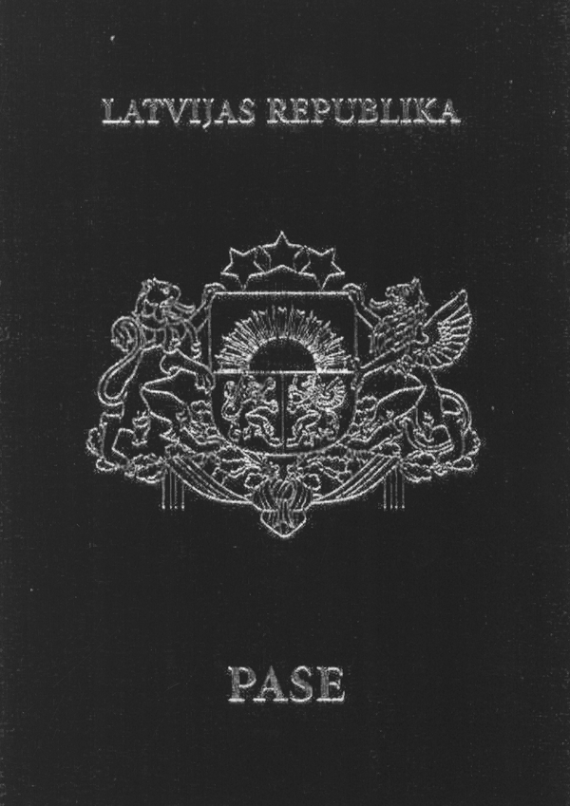

Pictures 2a and 2b
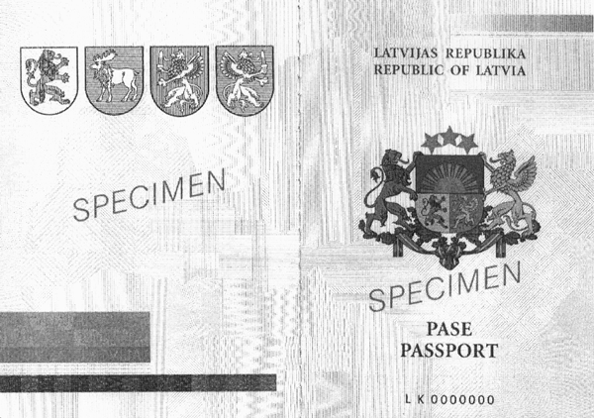

Pictures 3a and 3b
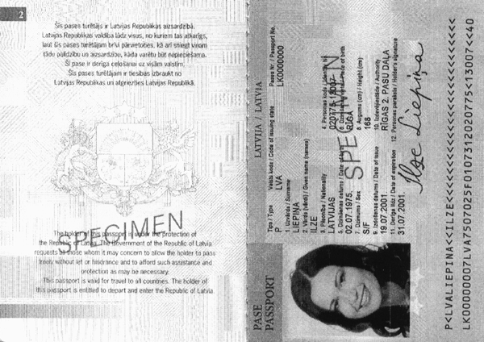

Pictures 4a and 4b
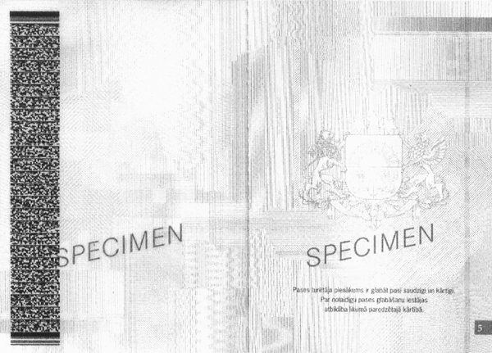

Picture 5
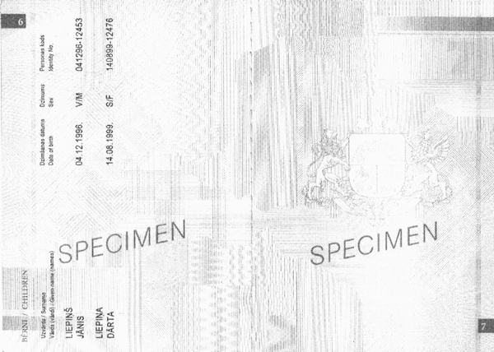

Picture 6
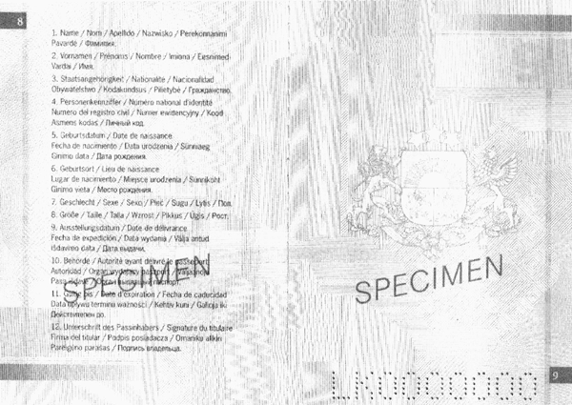

Picture 7
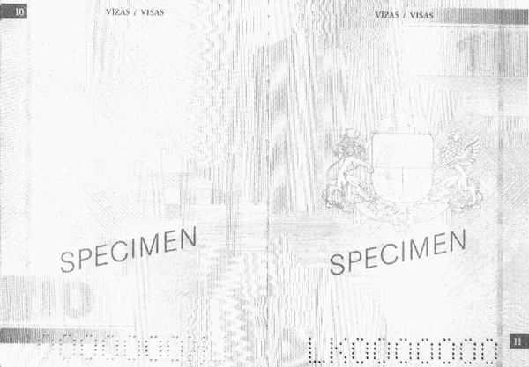

Pictures 8a and 8b
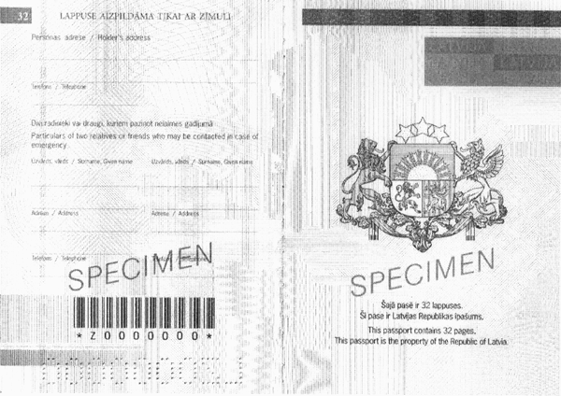

Minister for the Interior M. Segliņš

Annex 2
Cabinet Regulation No. 245
18 June 2002

Contents and Specimen of Alien’s Passport of Latvia

I. Cover of the Passport (Picture 1)

In violet colour

REPUBLIC OF LATVIA

Greater State coat of arms in golden colour

ALIEN'S PASSPORT

II. Inside of the Cover of Passport (Picture 2a)

Coats of arms of the four regions of Latvia – Kurzeme, Zemgale, Vidzeme and Latgale.

III. Title Page (Picture 2b)

LATVIJAS REPUBLIKA / REPUBLIC OF LATVIA

Greater State coat of arms in colours

NEPILSOŅA PASE / ALIEN`S PASSPORT

Passport number

IV. Page 2 (Picture 3a)

Šīs pases turētājs ir Latvijas Republikas aizsardzībā.

Latvijas Republikas valdība lūdz visus, no kuriem tas atkarīgs, ļaut šīs pases turētājam brīvi pārvietoties, kā arī sniegt viņam tādu palīdzību un aizsardzību, kāda varētu būt nepieciešama.

Šī pase ir derīga ceļošanai uz visām valstīm.

Šīs pases turētājam ir tiesības izbraukt no Latvijas Republikas un atgriezties Latvijas Republikā./

The holder of this passport is under protection of the Republic of Latvia. The Government of the Republic of Latvia requests all those whom it may concern to allow the holder to pass freely without let or hindrance and to afford such assistance and protection as may be necessary.

This passport is valid for travel to all countries. The holder of this passport is entitled to depart from and enter the Republic of Latvia.

V. First Side of the Main Data Page (Page 3) (Picture 3b)

NEPILSOŅA PASE / ALIEN`S PASSPORT

LATVIJA / LATVIA

Tips / Type

Valsts kods / Code of issuing state

Pases Nr. / Passport No.

1. Uzvārds / Surname

2. Vārds (vārdi) / Given name (names)

3. Dzimšanas datums / Date of birth

4. Dzimšanas vieta / Place of birth

5. Personas kods / Identity No.

6. Dzimums / Sex

7. Augums (cm) / Height (cm)

8. Izdošanas datums / Date of issue

9. Izdevējiestāde / Authority

10. Derīga līdz / Date of expiration

11. Personas paraksts / Holder’s signature

Holder's signature (scanned)

Holder's photograph (scanned)

Machine readable part of the passport

VI. The Other Side of the Main Data Page (Page 4) (Picture 4a)

Two-dimensional bar code.

Notes referred to in Paragraphs 6 and 7 of these Regulations (according to the choice of a person).

VII. Page 5 (Picture 4b)

The obligation of the holder of the passport is to keep the passport with care and accurately.

For negligent keeping of a passport, a person shall be held liable in accordance with the procedures provided for by law.

VIII. Page 6 (Picture 5)

BĒRNI / CHILDREN

Uzvārds / Surname

Vārds (vārdi) / Given name (names)

Dzimšanas datums / Date of birth

Dzimums / Sex

Personas kods / Identity No.

IX. Page 8 (Picture 6)

Names of Headings 1 to 11 of the main data page in the German, French, Spanish, Polish, Estonian, Lithuanian and Russian languages.

X. Pages 9 to 31 (Picture 7)

VĪZAS / VISAS

XI. Page 32 (Picture 8a)

THIS PAGE SHALL BE COMPLETED ONLY WITH A PENCIL

Personas adrese / Holder’s address

Telefons / Telephone

Divi radinieki vai draugi, kuriem paziņot nelaimes gadījumā /

Particulars of two relatives or friends who may be contacted in case of emergency

XII. Second Inside Page of the Cover of Passport (Picture 8b)

Šajā pasē ir 32 lappuses.

Šī pase ir Latvijas Republikas īpašums. /

This passport contains 32 pages. This passport is the property of the Republic of Latvia.
Picture 1
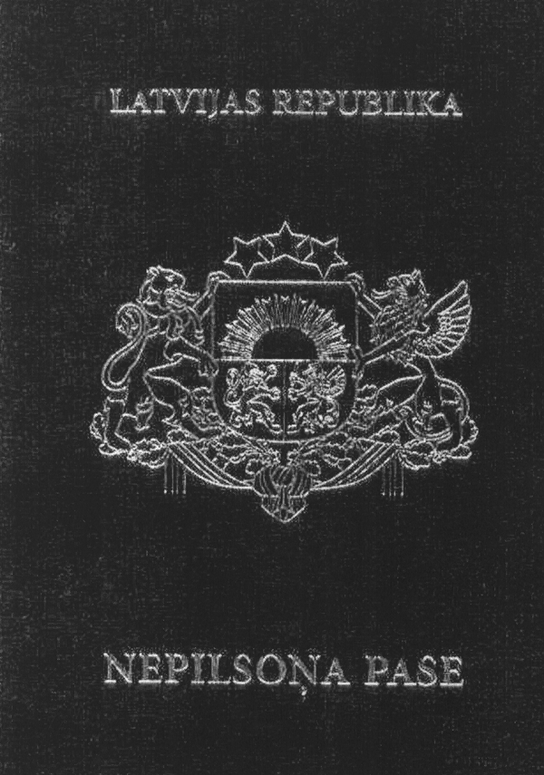

Pictures 2a and 2b
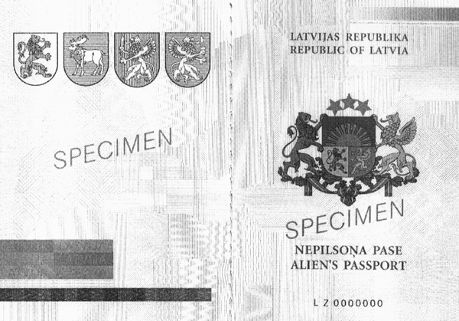

Pictures 3a and 3b
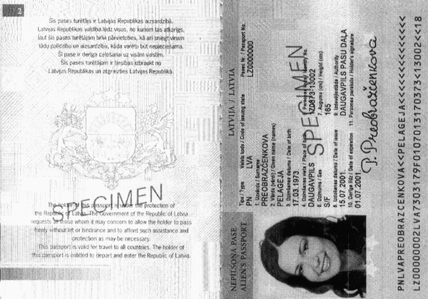

Pictures 4a and 4b
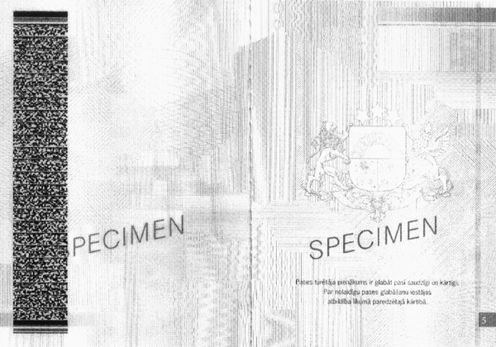

Picture 5
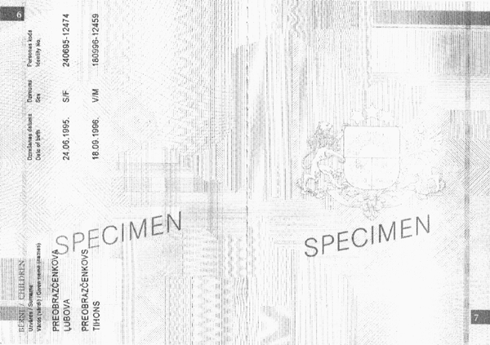

Picture 6
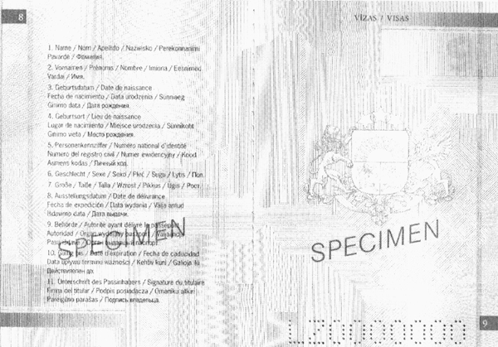

Picture 7
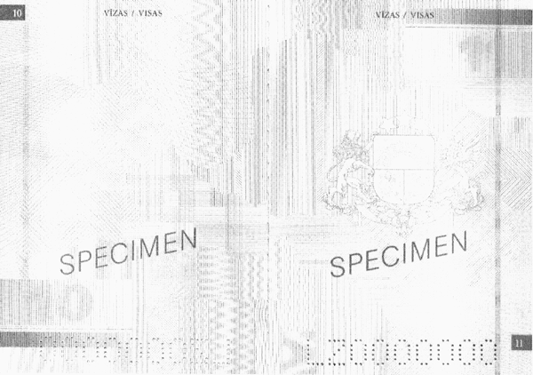

Pictures 8a and 8b
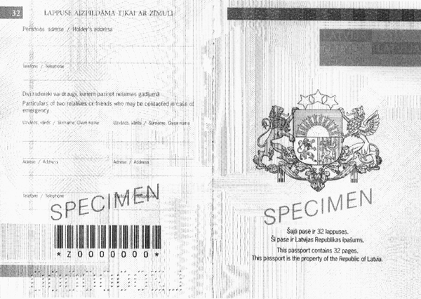

Minister for the Interior M. Segliņš

Annex 3
Cabinet Regulation No. 245
18 June 2002

Contents and Specimen of Stateless Persons Travel Document

I. Cover of the Document (Picture 1)

In dark brown colour

LATVIJAS REPUBLIKA

REPUBLIC OF LATVIA

Greater State coat of arms in golden colour

CEĻOŠANAS DOKUMENTS

TRAVEL DOCUMENT

(CONVENTION OF 28 SEPTEMBER 1954)

II. First Inside Page of the Cover of Document (Picture 2a)

Coats of arms of the four regions of Latvia – Kurzeme, Zemgale, Vidzeme and Latgale.

III. Title Page (Picture 2b)

LATVIJAS REPUBLIKA

REPUBLIC OF LATVIA

Greater State coat of arms in colours

CEĻOŠANAS DOKUMENTS

TRAVEL DOCUMENT

(CONVENTION OF 28 SEPTEMBER 1954)

Document number

IV. Page 2 (Picture 3a)

The obligation of the holder of the document is to keep the document with care and accurately.

For negligent keeping of a document, a person shall be held liable in accordance with the procedures provided for by law.

V. First Side of the Main Data Page (Page 3) (Picture 3b)

CEĻOŠANAS DOKUMENTS / TRAVEL DOCUMENT

LATVIJA / LATVIA

Tips / Type

Valsts kods / Code of issuing state

Dokumenta Nr. / Document No.

1. Uzvārds / Surname

2. Vārds (vārdi) / Given name (names)

3. Dzimšanas datums / Date of birth

4. Dzimšanas vieta / Place of birth

5. Personas kods / Identity No.

6. Dzimums / Sex

7. Augums (cm) / Height (cm)

8. Izdošanas datums / Date of issue

9. Izdevējiestāde / Authority

10. Derīga līdz / Date of expiration

11. Personas paraksts / Holder’s signature

Holder's signature (scanned)

Holder's photograph (scanned)

Machine readable part of the passport

VI. The Other Side of the Main Data Page (Page 4) (Picture 4a)

Two-dimensional bar code.

Notes referred to in Paragraphs 6 and 7 of these Regulations (according to the choice of a person).

VII. Page 5 (Picture 4b)

Šis dokuments ir izdots, lai tā turētāju nodrošinātu ar ceļošanas dokumentu, kuru varētu lietot nacionālās pases vietā. Dokumenta izdošananekādā veidā neiespaido un neietekmē tā turētāja statusu, it īpaši attiecībā uz tautību.

Ja šī dokumenta turētājs ir apmeties uz pastāvīgu dzīvi valstī, kas nav šī dokumenta izdevējvalsts, un vēlas ceļot, viņam jāgriežas pie mītnes zemes kompetentām iestādēm, lai saņemtu jaunu dokumentu. Iestāde, kas izsniedz jaunu dokumentu, iepriekšējo ceļošanas dokumentu izņem un nogādā izdevējvalstij.

Dokumenta turētājs ir tiesīgs atgriezties Latvijas Republikā līdz _________________, kamēr nav noteikts cits vēlāks termiņš. (Termiņš, kurā turētājam ir atļauts atgriezties, nedrīkst būt mazāks par trīs mēnešiem.)

This document is issued in order to provide the holder with a travel document, which could serve instead of a national passport. The issue of document in no way affects the holder’s status, particularly as regards nationality.

In case when the holder has taken up residence in a country other than which issued the present document, he must, if he wishes to travel again, apply to the competent authorities of the country of residence for a new document. The authority issuing a new document shall withdraw the old document and shall return it to the country of issue.

The holder is authorised to return to the Republic of Latvia until _________________ unless some later date is hereafter specified. (The period during which the holder is allowed to return must not be less than three months.)

VIII. Page 6 (Picture 5)

BĒRNI / CHILDREN

Uzvārds / Surname

Vārds (vārdi) / Given name (names)

Dzimšanas datums / Date of birth

Dzimums / Sex

Personas kods / Identity No.

IX. Page 8 (Picture 6)

Name of Headings 1 to 11 of the main data page in the German, French, Spanish, Polish, Estonian, Lithuanian and Russian languages.

X. From Page 9 to 31 (Picture 7)

VĪZAS / VISAS

(CONVENTION OF 28 SEPTEMBER 1954)

XI. Page 32 (Picture 8a)

THIS PAGE SHALL BE COMPLETED ONLY WITH A PENCIL

Personas adrese / Holder’s address

Telefons / Telephone

Divi radinieki vai draugi, kuriem paziņot nelaimes gadījumā /

Particulars of two relatives or friends who may be contacted in case of emergency

XII. Second Inside Page of the Cover of Passport (Picture 8b)

Šajā dokumentā ir 32 lappuses.

Šis dokuments ir Latvijas Republikas īpašums. /

This document contains 32 pages. This document is the property of the Republic of Latvia.
Picture 1
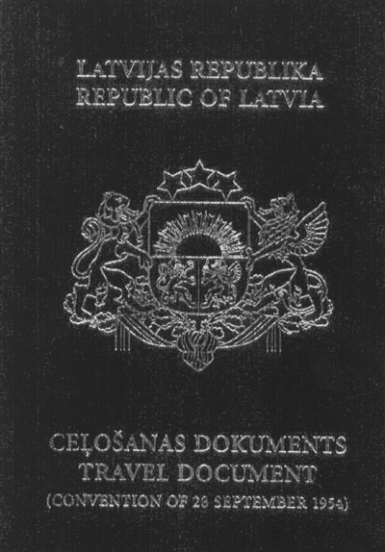

Pictures 2a and 2b
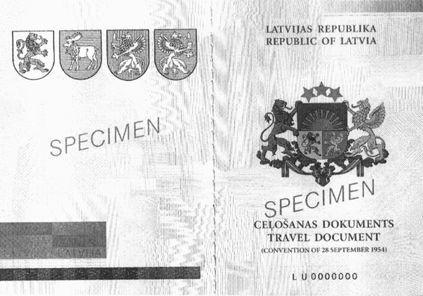

Pictures 3a and 3b
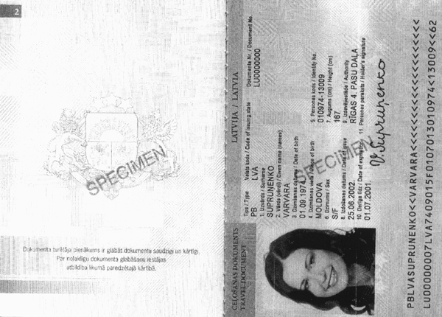

Pictures 4a and 4b
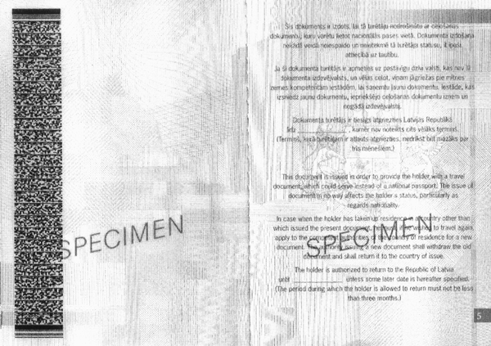

Picture 5
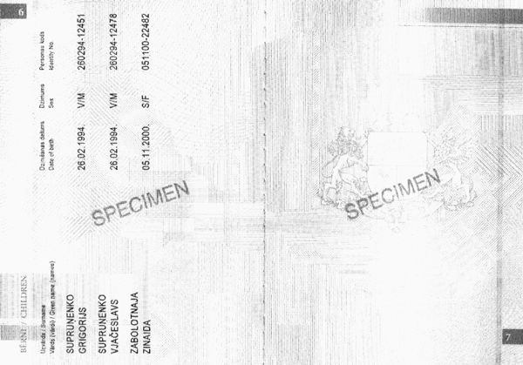

Picture 6
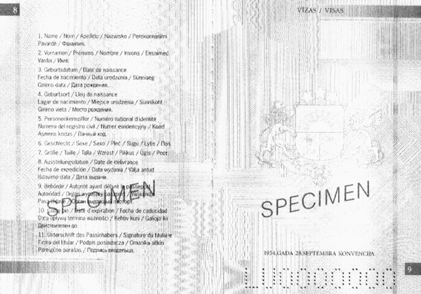

Picture 7
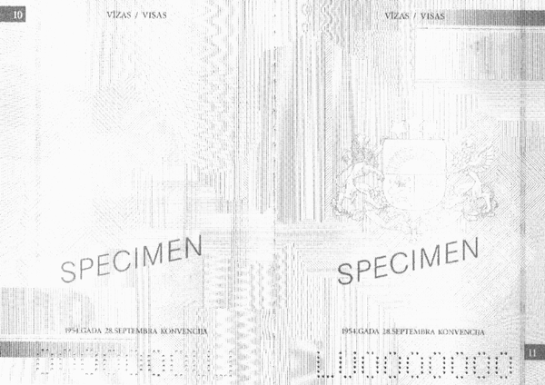

Pictures 8a and 8b
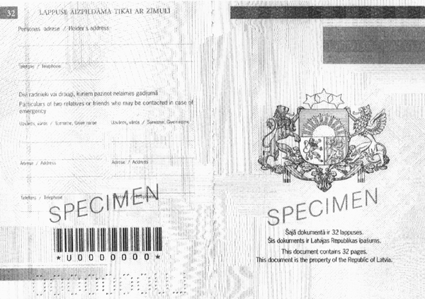

Minister for the Interior M. Segliņš

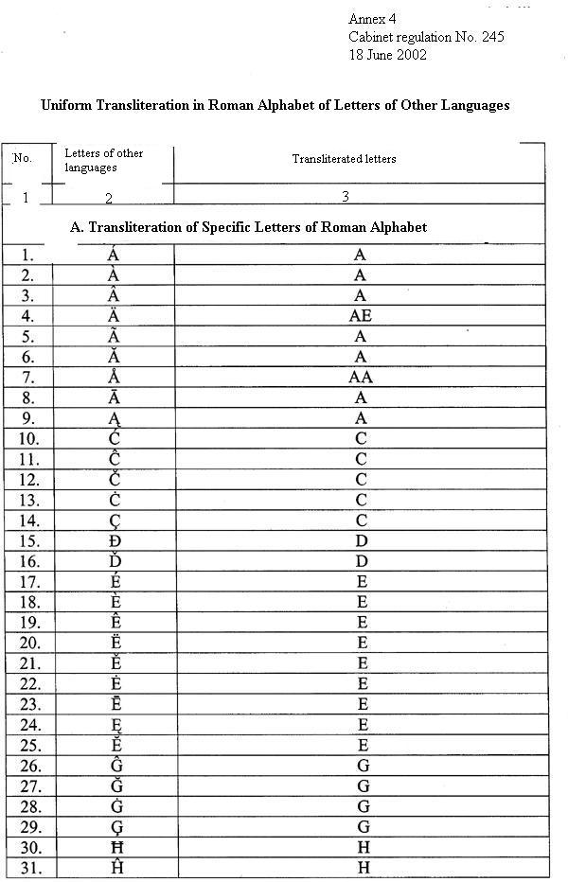
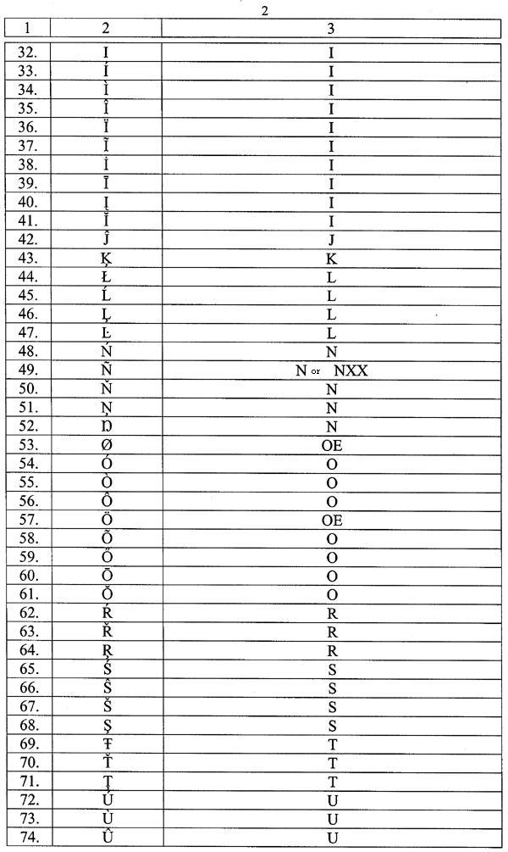
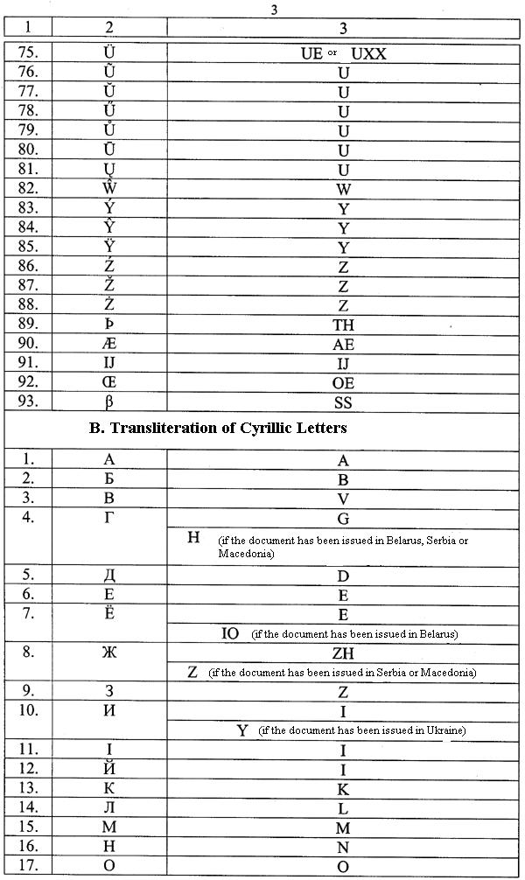
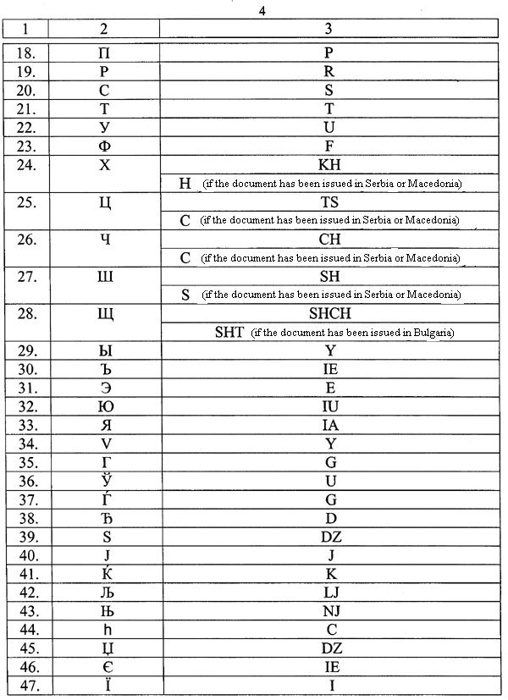
Annex 5
Cabinet Regulation No. 245
18 June 2002

Instructions Regarding Photographs for the Issue of Passports

In order to ensure that high quality passports are issued, photographs shall conform to the following requirements:

1. The dimensions of photographs shall be 45 x 35 mm ± 1 mm. Photographs shall be made of one photo-negative, in one block (not cut), without the white corner.

2. Dimensions of face on photographs – distance between the pupils of the eyes shall be 6 ± 3 mm, distance between the centre line of the eyes to the chin line (extreme points) shall be 15 ± 2 mm. Distance from the head to the upper edge of the photograph shall be 6 ± 2 mm.

3. Photographs may be black and white or coloured.

4. Photographic paper shall be smooth, bright or semi-matt, without a surface raster or relief.

5. Background of the photographs shall be homogeneous, the background of black and white photographs shall be white, and the background of colour photographs shall be white or light grey. If the background of a photograph is in another colour or dark, such photograph shall be invalid.

6. Position of the head – front view or head a little turned.

7. Natural facial expression (smile permissible).

8. Clothing everyday, correct. It is prohibited to be photographed in outdoor clothes (for example, coats, jackets) and with a headgear, as well as with an uncovered upper part of the body.

9. Lighting shall be equal for both sides of the face. If the luminous effects (for example, overhead lighting) intended for artistic photography are utilised when taking a photograph, such photograph shall not be valid.

10. Changes in a photograph as compared to the photo-negative are not permissible.

11. Any of the colours that have been created as a result of technologies for the making of photographs may not prevail in a colour photograph.

12. The picture shall be in high quality – sharp, without scratches and defects.

13. If a person wears glasses, he or she may be photographed with glasses. Being photographed with dark glasses or glasses that have slipped on the nose is not permitted. Reflections in the lenses of glasses may not cover up the eyes.

14. The seal of the photographer's studio, on which the date when the photograph was made is specified, shall be placed on the other side of the block of photographs. The seal may not be visible on the front side of the photograph. Photographs shall be made not earlier than three months prior to submitting the documents for the receipt of a passport.

Minister for the Interior M. Segliņš

