Republic of Latvia

Cabinet
Regulation No. 257
Adopted 13 July 1999

Regulations regarding Consumer Credit Agreements

Issued in accordance with Section 8, Paragraph 4 of
Consumer Rights Protection Law .

I. General Provision

1. These regulations determine the annual percentage rate calculation method, the information to be included in a consumer credit agreement (hereinafter – credit agreement) and the equitable reduction in the total cost of credit.

II. Calculating of the Annual Percentage Rate

2. The annual percentage rate shall be an equivalent to the present value (during a year) of all the future commitments (loans, repayments and charges) agreed to by the person who is engaged in consumer credit (hereinafter – grantor of credit) and the consumer. The annual percentage rate includes the total cost of the credit, including interest and other charges, which the consumer is obliged to pay, except the charges referred to in Paragraph 4 of these Regulations.

3. The annual percentage rate is calculated in accordance with the formula set out in the Annex to these Regulations taking into account the following conditions:
3.1. the amount paid by both parties may differ at various times and may be paid at different time intervals;
3.2. the starting date for interest calculation is the first day of the issuing of the loan;
3.3. intervals between dates used in calculations shall be expressed in years or in fractions of a year, and a year shall be presumed to have 365 days, 52 weeks or 12 equal months (an equal month shall have 30,411666 days (365/12)); and
3.4. The results of the calculation shall be expressed to an accuracy of two decimal places (if the third figure after the decimal point is greater than or equal to 5, the second figure after the decimal point shall be rounded up by one).

4. In calculating the annual percentage rate the following charges shall not be taken into account:
4.1. charges which the consumer is obliged to pay for non-compliance with any of the commitments specified by the credit agreement;
4.2. charges (except the purchase price) which the consumer is obliged to pay in case of the purchase of goods or services (irrespective of whether the transaction is paid for immediately or by utilising credit).
4.3. charges for the transfer of funds and charges for keeping of an account which is intended for receiving credit payments, the payment of interest and other charges except:
4.3.1. if in the relevant issue the freedom of choice for consumer has not been taken into account or if such charges are abnormally high; and
4.3.2. special charges for such repayments or the making of other payments (whether made in cash or otherwise);
4.4. membership subscriptions to associations or groups which are determined by other agreements (even though such membership subscriptions have an effect on credit conditions); and
4.5. charges for insurance or guarantees (except special insurance provided for to ensure payment to the creditor in the event of death, invalidity, illness or unemployment of the consumer).

5. The annual percentage rate is calculated at the time the credit agreement is being entered into.

6. The calculation shall be made on the assumption that the credit agreement is in effect for the time period for which it has been entered into and that the grantor of the credit and the consumer fulfil their obligations in accordance with the conditions and time periods regarding which both parties have agreed upon..

7. In credit agreements which allow variations in the rate of interest and other charges which are contained in the annual percentage rate, but are not specifiable at the time when it is calculated, the annual percentage rate shall be calculated on the assumption that interest and other charges remain fixed and shall be applied until the end of the agreement being in effect, and it is included in the credit agreement as the initial annual percentage rate.

8. If the timetable for repayment of the credit has not been specified and it cannot be determined on the basis of the conditions of the credit agreement and the means for repaying the credit granted, the duration of the credit may be deemed to be one year.

9. If it is not specified otherwise in the credit agreement and the credit agreement provides for one or more repayment dates, it can be considered that the credit will be granted and the repayments made at the shortest time period provided for in the credit agreement.

III. Information to be Included in the Credit Agreement

10. If an offer of the possibility to grant credit to a consumer indicating rate of interest or information relating to the cost of the credit is made in an advertisement or in sales locations or places where services are provided , the following shall also be indicated:
10.1. the price for which the goods or services are offered to the consumer for immediate payment;
10.2. the annual percentage rate; and
10.3. the amount of first instalment;

11. The credit agreement shall indicate:
11.1. the annual percentage rate or the initial annual percentage rate;
11.2. the conditions at which the annual percentage rate or other charges may be amended, as well as the procedure by which the consumer shall be informed regarding amendments in the annual percentage rate or other charges.
11.3. the initial instalment (if such exists), other amounts and payments which the consumer is obliged to pay in order to repay the credit, the number and frequency or definite dates of payments of interest and other costs, as well as the total amount of payments. If the total amount of payments is not known at the moment of entering into the agreement, the method for calculation shall be indicated;
11.4. a statement of credit cost items (including interest and other charges included into the annual percentage rate). If exact amounts are known, those sums shall be indicated. If exact amounts are not known, either the method for calculation or as accurate estimate as possible shall be provided;
11.5. the condition that the customer has the right to an equitable reduction of total cost of the credit, if he or she makes the repayment before the time period specified;
11.6. a description (if such exists) of the required guarantee type;
11.7. the amount of the credit limit (if such exists) or the method of the determination thereof;
11.8. the provisions for the setting aside the credit agreement; and
11.9. the liability for violations of the contractual obligations.

12. Information referred to in Paragraph 11 of these Regulations regarding the financing of the acquisition of particular goods or services shall be indicated in the credit agreement, as well as:
12.1. a precise description of the subject-matter (goods or services) of the agreement;
12.2. a price for which the goods or services are offered to the consumer for immediate payment and the price if the goods or services are paid for in accordance with the credit agreement;
12.3. a disclaimer regarding the owner of the goods, if ownership does not pass immediately to the consumer, as well as the conditions on which the consumer becomes the owner of the goods;
12.4. required the insurance requested (if such exists) and the cost thereof (if the insurer is chosen by the grantor of the credit); and
12.5. the duty of the consumer to deposit a certain amount of money in a separate account.

13. Credit agreements which are operated by utilising payment cards shall indicate the information referred to in Paragraph 11 of these Regulations, as well as the provisions of the usage and repayment of the credit or the method of the determination thereof.

14. Credit agreements which are operated by utilising current accounts shall indicate the information referred to in Sub-paragraphs 11.1, 11.2, 11.7, 11.8 and 11.9 of these Regulations.

15. All amendments and supplements to a credit agreement shall be made in written form and shall be signed by both parties.

IV. Equitable Reduction of Total Cost of the Credit

16. A consumer has a duty to pay only those payments indicated in the credit agreement.

17. A consumer has a duty to pay interest and other charges only for the time period up to which the consumer has settled his or her credit obligations.

18. If the credit agreement provides for monthly payments, but the consumer exercises the right to fulfil the credit obligations before the set time period and makes the current payment on a day other than indicated in the agreement, the payment day shall be considered the day when following payment should have been made in accordance with the credit agreement.

19. The grantor of the credit does not have the right to request compensation for the fulfilment of credit obligations before the set time period.

20. If misleading information regarding the annual percentage rate or other charges has been provided in the credit agreement or the annual percentage rate is not calculated in conformity with the requirements of these Regulations, the consumer has the right to pay only the interest set by law.

21. The observance of these Regulations shall be supervised by the Consumer Rights Protection Centre.

22. These Regulations shall come into force on 1 September 1999.

Prime Minister V. Krištopans

Deputy Prime Minister,
Minister for Transport A. Gorbunovs

Annex
Cabinet Regulations No. 257
13 July 1999

Method for Calculating the Annual Percentage Rate

The basic equation expressing the equivalence of loans on the one hand and repayments and charges on the other is the following:
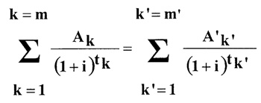

k – the number of loans;
k’ - the number of repayments or payments of charges;
Ak – the amount of loan number k;
A’k’ – the amount of repayment number k';
m – the last loan;
m’ – the last repayment or payment of charges;
tk – the interval, expressed in years and fractions of a year between loan No. 1 and the subsequent loan from No. 2 to number m;
tk’ – the interval expressed in years and fractions of a year between loan No. 1 and repayments or payments of charges from No. 1 to number m’;
i – the annual percentage rate that can be calculated (either by algebra, by approximations, or by a computer program), where the other quantities are known from the credit agreement or otherwise.

The annual percentage rate shall be calculated in accordance with the following examples of calculations:

Example 1

Sum loaned LVL 1000. The total cost of the credit is LVL 1200. The credit is repaid in a single instalment of LVL 1200 made after 1,5 years (1,5 x 365 = 547,5 days, 11,5 x 52 = 78 weeks or 1,5 x 12 = 18 months) after the day of the loan.
Ak ‘ A1 = 1000
A'k' ‘ A'1' = 1200
547,5 78 18
tk’ ‘ tl’ = 1,5 or -------- or ------ or -----
365 52 12
The equation is the following:
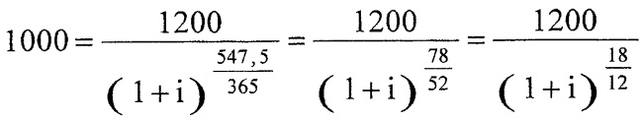
or (1 + i)1,5 = 1,2
1 + i =1,129243
i = 0,129243
This amount will be rounded up to 12,92%.

Example 2

The sum loaned is LVL 1000 but the creditor retains LVL 50 for administrative expenses, so the actual amount of the loan is LVL 950. The total cost of the credit is LVL 1200. The repayment of the credit is made as in the first example.
Ak ‘ A1 = 950
A'k’ ‘ A'1' = 1200
547,5 78 18
tk’ ‘ tl’ = 1,5 or ----- or ----- or -----
365 52 12
The equation is the following:
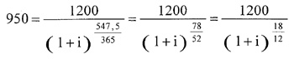
1200
or (1 + i)1,5 = ––––– = 1,263157
950
1 + i = 1,168526
i = 0,168526
This amount is rounded up to 16, 85%.

Example 3

Sum loaned is LVL 1000. The repayment of the credit is made in two instalments each of LVL 600, paid after one year and two years respectively.
Ak ‘ A1 = 1000
A'k’ ‘ A'1' = 600
A'2' = 600
365 52 12
tk’ ‘ tl’ = 1 or ----- or ---- or -----
365 52 12
730 104 24
t2’ = 2 or ------ or ------ or ------
365 52 12
The equation is the following:
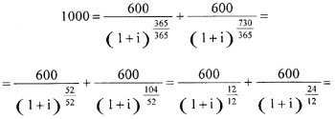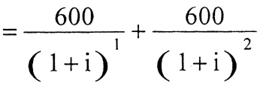
The equation is solved using algebra.
It produces i = 0,13066.
This amount is rounded up to 13,07%.

Example 4

Sum loaned is LVL 1000. The repayment of the credit is made as follows:
after three months (0,25 years/13 weeks/91,25 days) LVL 272
after six months (0,5 years/26 weeks/182,5 days) LVL 272
after twelve months (1 year/52 weeks/365 days) LVL 544
The total credit cost is LVL 1088.
Ak ‘ A1 = 1000
A'k' ‘ A'1' = 272
A'2' = 272
A'3' = 544
91,25 13 3
tk' ‘ t1' = 0,25 or –––– or –– or ––
365 52 12
182,5 26 6
t2' = 0,5 or –––– or –– or ––
365 52 12
365 52 12
t3' = 1 or ––– or –– or ––
365 52 12
The equation is the following:
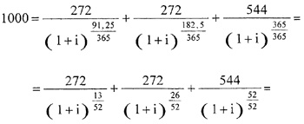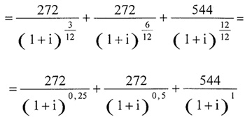
The equation allows i to be calculated by approximations, which can be programmed on a pocket calculator.
It produces i = 0,13185.
This amount is rounded up to 13,19%.

Deputy Prime Minister,
Minister for Transport A. Gorbunovs

