Text consolidated by Tulkošanas un terminoloģijas centrs (Translation and Terminology Centre) with amending regulations of:
7 February 2006 (No. 104);
10 October 2006 (No. 832).
If a whole or part of a paragraph has been amended, the date of the amending regulation appears in square brackets at the end of the paragraph. If a whole paragraph or sub-paragraph has been deleted, the date of the deletion appears in square brackets beside the deleted paragraph or sub-paragraph.

Republic of Latvia

Cabinet
Regulation No 455
Adopted 28 June 2005

Procedures to be followed for the Approval of Measuring Instrument Types, Initial Verification and Supervision of the Market

Issued pursuant to
Section 6, Paragraph two, Section 9, Paragraph 4.¹
of the Law On Uniformity of Measurements and
Section 7, Paragraph two
of the Law On Conformity Assessment

I. General Provisions

1. These Regulations prescribe:
1.1. procedures for the metrological control of measuring instruments subject to State metrological control (approval and initial verification of type);
1.2. procedures for the performance of supervision of the marketing of measuring instruments subject to State metrological control.

2. These Regulations shall be applicable to measuring instruments, components of measuring instruments, additional installations and measuring equipment, but shall not be applicable to the following measuring instruments:
2.1. non-automatic weighing instruments;
2.2. water consumption meters;
2.3. gas consumption meters and correctors;
2.4. active electricity meters;
2.5. thermal energy meters;
2.6. liquid (except for water) measuring systems;
2.7. automatic weighing instruments (except for automatic road transport weighing instruments);
2.8. taximeters;
2.9. material measures (for the measurement of length and measurement of the quantity of beverage in trade);
2.10. dimensional measuring instruments;
2.11. exhaust gas analysers.
[10 October 2006]

3. Measuring instruments complying with the requirements specified in regulatory enactments regarding metrological control, which include the uniform metrological requirements for measuring instruments specified in the European Union, shall be placed on the internal market. Measuring instruments complying with metrological requirements specified in regulatory enactments regarding metrological control shall be placed on the national market. Approval of measuring instrument type (hereinafter – type approval) confirmed by a type approval certificate and sign of type approval shall ensure the compliance with metrological requirements prior to placement of measuring instruments on the market. Initial verification of measuring instruments (hereinafter – initial verification) confirmed by an initial verification mark shall ensure compliance with metrological requirements upon putting the measuring instruments into service. Procedures for type approval and initial verification are specified in Annex 1 and 2 of these Regulations.

4. National and the European Economic Community (hereinafter – EEC) type approval, as well as national and EEC initial verification shall be carried out for measuring instruments. EEC type approval and EEC initial verification shall be carried out for measuring instruments for which uniform metrological requirements have been specified in the European Union. Measuring instruments for which the referred to examinations have been performed and which have been marked with a sign of EEC type approval and on which the EEC initial verification mark has been placed, shall be placed on the internal market and put into service.

5. Type approval shall be performed by the State agency Latvian National Metrology Centre and conformity assessment institutions, which conform to the requirements of Paragraph 6 of these Regulations and regarding which accreditation the Ministry of Economics has published a notice in the newspaper Latvijas Vēstnesis [the official Gazette of the Government of Latvia] (hereinafter – certification institutions). Initial verification shall be performed by conformity assessment institutions, which conform to the requirements of Paragraph 6 of these Regulations and regarding which accreditation the Ministry of Economics has published a notice in the newspaper Latvijas Vēstnesis (hereinafter – inspection institutions)
[10 October 2006]

6. The certification institutions of Latvia, which perform type approval shall be accredited by the State agency Latvian National Accreditation Bureau pursuant to the standard LVS EN 45011:2004, General Requirements for Bodies Operating Product Certification Systems. Latvian inspection institutions, which perform initial verification, shall be accredited by the State agency Latvian National Accreditation Bureau pursuant to the standard LVS EN ISO/IEC 17020:2005, General criteria for the operation of various types of bodies performing inspection. The referred to institutions shall have insured civil legal liability.
[7 February 2006]

7. The requirements for measuring instruments upon placement thereof on the market (hereinafter – metrological requirements) shall be specified in regulatory enactments for particular measuring instruments.

8. The Ministry of Economics in co-operation with the technical committee of the relevant standards shall recommend to the limited liability company Latvian Standard a list of the standards to be adapted.

9. The limited liability company Latvian Standard shall submit for publication in the newspaper Latvijas Vēstnesis a list of the applicable standards – a list of those national standards of Latvia, which are applicable for the fulfilment of metrological requirements. The State agency Latvian National Metrology Centre shall submit for publication in the newspaper Latvijas Vēstnesis a list of documents of the International Organisation of Legal Metrology that have been adapted for the fulfilment of metrological requirements.
[10 October 2006]

10. Fulfilment of metrological requirements shall be approved in accordance with the procedures for type approval and initial verification specified in these Regulations.

11. Decisions of certification institutions and inspection institutions may be contested in accordance with Section 15 of the Law On Conformity Assessment.
[7 February 2006]

II. Type Approval

12. Type approval is a precondition for initial verification. If pursuant to metrological requirements initial verification is not required for particular measuring instruments, the manufacturer or authorised representative thereof shall place the measuring instruments on the market or put them into service after type approval. If pursuant to metrological requirements type approval is not required for the measuring instruments, initial verification shall be performed.

13. The manufacturer or the authorised representative thereof (hereinafter – submitter) shall submit a submission regarding type approval to only one certification institution.

14. If the measuring instrument type complies with metrological requirements, the certification institution shall issue a national type approval certificate or EEC type approval certificate.

15. National type approval certificate shall be issued for a time period of three years. EEC type approval certificate shall be issued for a time period of ten years. Period of validity of the type approval certificate may be extended repeatedly for a time period equal to the previous one. The submitter shall ensure that a type approval mark is put on each measuring instrument approving compliance thereof with the approved type and is indicated in the type approval certificate.

16. If the measuring instrument type does not comply with metrological requirements, the certification institution shall refuse to issue a type approval certificate.

17. The submitter shall inform the certification institution which has issued the type approval certificate about any changes or additions to the measuring instruments performed by the manufacturer in writing.

18. The certification institution shall examine how the relevant changes affect the measuring instrument type. If changes performed by the manufacturer affect the measurement results of the approved type measuring instrument or conditions for use specified for measuring instruments, the relevant certification institution shall issue a supplement to the type approval certificate. If substantial changes have been made to the measuring instrument (for example, design, metrological characteristics, material has been changed),the certification institution shall issue a new type approval certificate.

19. The following shall be determined by an EEC type approval certificate for additional installations:
19.1. measuring instrument types in which the relevant additional installations are included or which are equipped with them;
19.2. general conditions for the operation of measuring instruments.

20. If a certification institution does not extend the period of validity of the type approval certificate, type approval for measuring instruments, which are put into service until termination of the period of validity of the certificate, shall be valid.

21. In performing EEC type approval to measuring instruments in which new technologies are used which are not provided for in metrological requirements, the certification institution shall issue a limited EEC type approval certificate after consultation with other certification institutions of the European Union Member States. The following may be specified in the certificate:
21.1. limitation of the number of measuring instruments;
21.2. an obligation for the submitter to inform the certification institution about all places where the measuring instruments are installed in writing;
21.3. limitation of the use of the measuring instruments;
21.4. special limitations for additional installations.

22. A limited EEC type approval certificate shall be issued for a time period of two years.

23. The manufacturer shall place the mark specified in Annex 1, Clause 22 of these Regulations on the measuring instruments which comply with metrological requirements and for which EEC type approval is not required.

24. The certification institution, which has approved the type, may withdraw the type approval certification in the following cases:
24.1. measuring instruments do not comply with the approved type or metrological requirements;
24.2. the requirements specified in the type approval certificate or Paragraph 21 of these Regulations are not being met;
24.3. the type approval certificate has been issued without a valid reason;
24.4. faults characteristic to the type due to which the measuring instrument is unfit for the intended use are detected in the operation of measuring instruments manufactured pursuant to the approved type.

25. Placing of the relevant measuring instruments on the market and putting them into service is prohibited after withdrawal of the type approval certificate. The Certification institution shall inform the Ministry of Economics about the withdrawal of EEC type approval. The Ministry of Economics shall inform official representative offices of the European Commission and European Union Member States.

III. Initial Verification

26. Initial verification shall be an evaluation of a new measuring instrument in accordance with the approved type of metrological requirements.

27. Initial verification may be performed, using validated methods, which are not specified in metrological requirements.

28. In performing initial verification, the inspection institution shall:
28.1. ascertain whether type approval has been performed on the measuring instrument and the type approval mark has been put on it;
28.2. determine whether the measuring instrument complies with the approved type;
28.3. examine whether it complies with the characterisation of the measuring instrument and technical composition and operational conditions specified in the metrological requirements if type approval is not required to the measuring instrument,
28.4. evaluate metrological characterisation of measuring instruments and maximum admissible inaccuracy pursuant to metrological requirements;
28.5. examine the compliance of construction with the conditions for the use of the measuring instrument, compliance as to the marking and existence of a place for a seal;
28.6. put on the national initial verification mark or EEC primary verification mark in accordance with metrological requirements (Annex 2).
[7 February 2006]

29. Manufacturer may put measuring instruments bearing the EEC initial verification mark on the market or put them into service until the end of the following year.

30. Manufacturer shall put a special mark on measuring instruments for which EEC initial verification is not required in accordance with Annex 1, Clause 23 of these Regulations.

IV. Market Supervision (Metrological Control)

31. The Consumer Rights Protection Centre shall perform supervision of the marketing of measuring instruments, ensuring that such measuring instruments are offered on the market, which comply with metrological requirements and do not endanger the health and life of human beings and do not cause damage to the environment if properly installed, maintained and used.
[10 October 2006]

32. If the Consumer Rights Protection Centre determines that measuring instruments do not comply with metrological requirements, it shall perform measures specified in regulatory enactments regarding metrological control in order not to permit the placement of the relevant measuring instruments on the market and use thereof.
[10 October 2006]

33. If the Consumer Rights Protection Centre determines that the measuring instrument that has a sign of type approval and an initial verification mark endangers the health and life of human beings or causes damage to the environment although it is used properly pursuant to the intended purposes, it shall suspend the placing of the relevant measuring instrument on the market, prohibit the use thereof and send a justified notification to the manufacturer of the measuring instrument or to his or her authorised representative, as well as inform the Ministry of Economics. The Ministry of Economics shall notify the European Commission and official representative offices of the European Union Member States regarding cases of non-compliance and the performed measures.
[10 October 2006]

34. The Consumer Rights Protection Centre shall perform the relevant measures in order to prevent the use of such marking of measuring instruments which might be confused with EEC marks or marking.
[10 October 2006]

35. Decisions of the Consumer Rights Protection Centre may be contested pursuant to the procedures specified in the Administrative Procedure Law.
[10 October 2006]

V. Closing Provisions

36. Sub-paragraphs 2.2, 2.3, 2.4, 2.5, 2.6, 2.7, 2.8, 2.9, 2.10 and 2.11 of these Regulations shall come into force beginning with 30 October 2006.
[7 February 2006]

37. EEC type approval certificate, which has been conferred in accordance with the procedures specified in these Regulations and pursuant to metrological requirements, may not be extended and supplemented after amendments have been made to these Regulations.

38. Upon repeated verification of measuring instruments the maximum admissible inaccuracy shall be determined to be the same as in the initial verification. For measuring instruments in exploitation a larger inaccuracy may be specified in regulatory enactments regulating metrological control determining metrological requirements for measuring instruments.

39. Laboratories, which have certified their competence in conformity with the standard LVS EN ISO/IEC 17025:2001, General requirements for the competence of testing and calibration laboratories, and regarding the accreditation of which the Ministry of Economics has published a notice in the newspaper Latvijas Vēstnesis, are entitled to perform measurement instrument type approvals and initial verification up to 1 June 2006. The initial verification mark shall indicate the existing institution’s accreditation number.
[7 February 2006]

40. Up to 31 December 2006, the State limited liability company Latvian National Metrology Centre shall perform the initial verification of measuring instruments without accreditation and in conformity with the requirements specified in these Regulations, but the verification marks and certificates shall indicate its own identification sign.
[10 October 2006]

Informative Reference to European Union Directives

These Regulations contain legal norms arising from:
1) Council Directive 71/316/EEC of 26 July 1971 on the approximation of the laws of the Member States relating to common provisions for both measuring instruments and methods of metrological control;
2) Council Directive 72/427/EEC of 19 December 1972 amending the Council Directive 71/316/EEC on the approximation of the laws of the Member States relating to common provisions for both measuring instruments and methods of metrological control;
3) Council Directive 83/575/EEC of 26 October 1983 amending the Council Directive 71/316/EEC on the approximation of the laws of the Member States relating to common provisions for both measuring instruments and methods of metrological control;
4) Council Directive 87/354/EEC of 25 June 1987 amending certain directives on the approximation of the laws of the Member States relating to industrial products with respect to the distinctive numbers and letters indicating the Member States;
5) Council Directive 87/355/EEC of 25 June 1987 amending the Council Directive 71/316/EEC on the approximation of the laws of the Member States relating to common provisions for both measuring instruments and methods of metrological control;
6) Council Directive 88/665/EEC of 21 December 1988 amending several Directives concerning the approximation of the laws of Member States where there is provision in those Directives for publication in the Official Journal of the European Communities of attestations and certificates; and
7) Directive 2004/22/EC of the European Parliament and of the Council of 31 March 2004 on measuring instruments.
[7 February 2006]

Prime Minister A. Kalvītis

Minister for Economics A. K. Kariņš

Annex 1
Cabinet Regulation No. 455
28 June 2005

Type Approval

I. Submission for Type Approval

1. Submission for type approval (hereinafter – submission) shall be drawn up in accordance with the requirements specified in these Regulations and shall be submitted to certification institution together with the associated documents. A submitter shall send a copy of the submission regarding EEC type approval to the Ministry of Economics. The Ministry of Economics shall send copies of the submission to the official representative offices of European Union Member States.

2. The following information shall be specified in the submission:
2.1. the name and legal address of the manufacturer and the authorised representative thereof;
2.2. the category of measurement instruments;
2.3. the intended field of use;
2.4. metrological characteristics of measurement instrument type;
2.5. designation (if such exists) of type of measurement instrument series.

3. The following documents shall be attached to the submission (in two copies):
3.1. description of the measurement instrument:
3.1.1. the construction and principles of operation of the measurement instrument;
3.1.2. protecting measures ensuring correct working of the measurement instrument;
3.1.3. the devices for installation and adjustment of the measurement instrument;
3.1.4. place of initial verification mark on the measurement instrument (Annex 2, Chapter III of these Regulations);
3.2. general technical drawings of construction and, if necessary, detailed technical drawings of main components;
3.3. a scheme illustrating the principles of operation of the measurement instrument, as well as, where necessary, a photograph of the measurement instrument;
3.4. if national type approval has already been performed to the measurement instrument, the relevant documents shall be attached to the submission regarding EEC type approval.

II. Type Evaluation

4. Certification institution shall perform examination of measurement instrument type and evaluation of metrological parameters (for measurement instrument to which evaluation of metrological parameters is performed only examination of documents shall be performed).

5. Type approval shall be performed in conditions in which metrological parameters of measurement instrument must comply with metrological requirements.

6. Conditions for type approval shall be specified in metrological requirements.

7. Certification institution may request the submitter to transfer standards, technical equipment and auxiliary staff at its disposal.

8. If necessary, certification institution shall request to submit a sample of measurement instrument to which type approval has been assigned. After co-ordination with certification institution the sample of measurement instrument may be substituted with components of measurement instrument, down-scaled models or technical drawings and information about it shall be indicated in the approval certificate.

III. Type Approval Certificate and Sign of Approval

9. Type evaluation results and requirements that shall be followed in manufacturing measurement instruments shall be indicated in the type approval certificate. Descriptions, pictures and diagrams necessary in order to identify the approved type and principles of operation of the measurement instrument shall be included in Annex of the certificate.

10. Samples of signs of type approval are specified in Chapter V of this Annex. Sign of national type approval (Clause 19 of this Annex) shall be a quadrangle in which identification mark of Latvia, number of certificate and year of issue is indicated.

11. Sign of EEC type approval (Clause 20 of this Annex) shall be a stylised letter “e” containing the following information:
11.1. in the upper part – the distinguishing capital letter of the State which has issued the approval (B for Belgium; D for Germany; DK for Denmark; E for Spain; F for France; EL for Greece; I for Italy; IRL for Ireland; L for Luxembourg; NL for Netherlands; P for Portugal; UK for Great Britain; A for Austria; S for Sweden; FI for Finland; CZ for the Czech Republic; EST for Estonia; CY for Cyprus; LT for Lithuania; H for Hungary; M for Malta; PL for Poland; SI for Slovenia; SK for Slovakia; LV for Latvia) and the two last digits of the year of approval;
11.2. in the lower part – identification number of the type approval conferred upon registration of the approved type.

12. Sign of approval for EEC limited type approval (Clause 21 of this Annex) shall be letter “P” dimensions of which shall be the same as for the stylised letter “e” and which shall be placed before the sign of EEC type approval.

13. Sign of EEC type approval in which the stylised letter “e” is reversed symmetrically about a vertical axis (Clause 22 of this Annex) shall be used in marking of measurements instruments to which EEC type approval is not required.

14. Sign of EEC type approval in a hexagon (Clause 23 of this Annex) shall be used for measurement instrument to which EEC initial verification is not required.

15. The sign of type approval shall be affixed at a visible point of each measurement instrument. The sign of type approval shall be legible and indelible.

IV. Announcement regarding EEC Type Approval

16. Certification institution shall issue to the submitter the original of type approval certificate and send the copies of EEC type approval certificate to the Ministry of Economics. The Ministry of Economics shall send the referred to information to the European Commission and official representative offices of European Union Member States (where necessary, the referred to representative offices may request Annex of the certificate).

17. Certification institution shall send the information regarding withdrawal of EEC type approval certificate or other information related to EEC type approval to the Ministry of Economics. The Ministry of Economics shall send the referred to information to the European Commission and other official representative offices of European Union Member States.

18. Certification institution shall inform the manufacturer or its authorised representative about the decision to refuse type approval, indicating the reason of refusal and procedures for appeal of decision. Certification institution shall inform the Ministry of Economics about the refusal of EEC type approval. The Ministry of Economics shall send the referred to information to the European Commission and other official representative offices of European Union Member States.

Signs of Type Approval

19. The sign of national type approval shall be as follows:

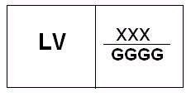

Designations.
LV – Latvia.
XXX – number of type approval certificate.
GGGG – year of type approval assignment.

20. The sign of EEC type approval shall be as follows:

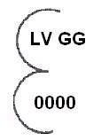

Designations.
LV – Latvia.
GG – time of the type approval (the last two digits of the year).
0000 – identification number of type approval.

21. The sign of approval of the limited EEC type approval shall be as follows:

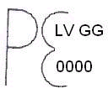

Designations.
LV – Latvia.
GG – time of the type approval (the last two digits of the year).
0000 – identification number of type approval.

22. Marking on measurement measures to which EEC type approval is not required shall be as follows:

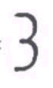

23. The sign of EEC type approval for measurement instrument to which primary verification is not required shall be as follows:

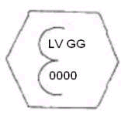

Designations.
LV – Latvia.
GG – time of the type approval (the last two digits of the year).
0000 – identification number of type approval.

Minister for Economics A. K. Kariņš

Annex 2
Cabinet Regulation No. 455
28 June 2005

Initial Verification

I. General Provisions

1. Initial verification shall be carried out in one or more (usually two) stages.

2. Initial verification in one stage shall be carried out for measurement instruments, which are to be transferred to the place of installation without being dismantled.

3. Initial verification shall be carried out in two or more stages for measurement instruments whose correct functioning depends on the conditions of installation and use thereof.

4. In the first stage of initial verification (hereinafter – partial initial verification) the inspection institution shall make sure about the compliance of the measurement instrument with the approved type or, if type approval is not required to measurement instrument, compliance with metrological requirements.
[7 February 2006]

II. Place of Initial Verification

5. If metrological requirements do not specify the place of verification, the inspection institution shall determine the place of verification of the measurement instruments, which have to be verified in one stage.
[7 February 2006]

6. As regards measurement instruments to which initial verification is carried out in two or more stages:
6.1. final stage of verification shall be carried out in the place of installation;
6.2. other stages of verification shall be carried out in accordance with Clause 5 of this Annex.

7. If initial verification is carried out outside the premises of an inspection institution, the inspection institution may request the submitter:
7.1. to put at its disposal the standards, technical equipment and auxiliary staff;
7.2. to issue a copy of the type approval certificate.
[7 February 2006]

III. Initial Verification Marks

8. EEC initial verification marks:
8.1. if initial verification is carried out in one stage, the verification mark shall be composed of two stamps: the first stamp (Picture 1 and 3a of this Annex) contains the letter “e” containing in the upper part the distinguishing capital letter of the State (B for Belgium; D for Germany; DK for Denmark; E for Spain; F for France; EL for Greece; I for Italy; IRL for Ireland; L for Luxembourg; NL for Netherlands; P for Portugal; UK for Great Britain; A for Austria; S for Sweden; FI for Finland; CZ for the Czech Republic; EST for Estonia; CY for Cyprus; LT for Lithuania; H for Hungary; M for Malta; PL for Poland; SI for Slovenia; SK for Slovakia; LV for Latvia), where necessary, with one or two numbers which indicate the territorial division; in the lower part – identification number of the inspection institution. The second stamp (Picture 2 and 3b of this Annex) shall consist of a hexagon including the last two digits of the year of verification;
8.2. the mark of partial initial verification shall consist solely of the first stamp;
8.3. different parts of EEC initial verification seals (shape, dimension and outline of the letters) are shown in Pictures 1 and 2 of this Annex, samples of seals – in Pictures 3a and 3b of this Annex. The dimensions given in the drawings (the diameter of the circle described about the small letter “e”, the hexagon and the ellipse) are relative values. The actual diameters of the circles may be 1: 6 mm, 3: 2 mm, 6: 3 mm, and 12: 5 mm.
[7 February 2006]

9. National initial verification mark (Picture 4) shall be in the shape of ellipse containing identification sign of centre or number of accreditation of the inspection institution, serial number of the mark and time of verification.
[7 February 2006]

10. Inspection institutions of Member States shall mutually exchange the originals of the EEC initial verification drawings.
[7 February 2006]

11. Affixing the initial verification marks:
11.1. if the measurement instrument is verified and recognised as complying with metrological requirements, the initial verification mark shall be affixed to the measurement instrument on the provided place;
11.2. partial initial verification marks shall be affixed:
11.2.1. at the place where the stamp-date is affixed or in the place specified in metrological requirements if initial verification of the measurement instrument is carried out in several stages or the last stage is carried out at the place of installation of the measurement instrument;
11.2.2. as a seal on the measurement instrument in the place specified in metrological requirements.

IV. Graphical Presentation of Initial Verification Marks

12. EEC initial verification marks shall be as follows:

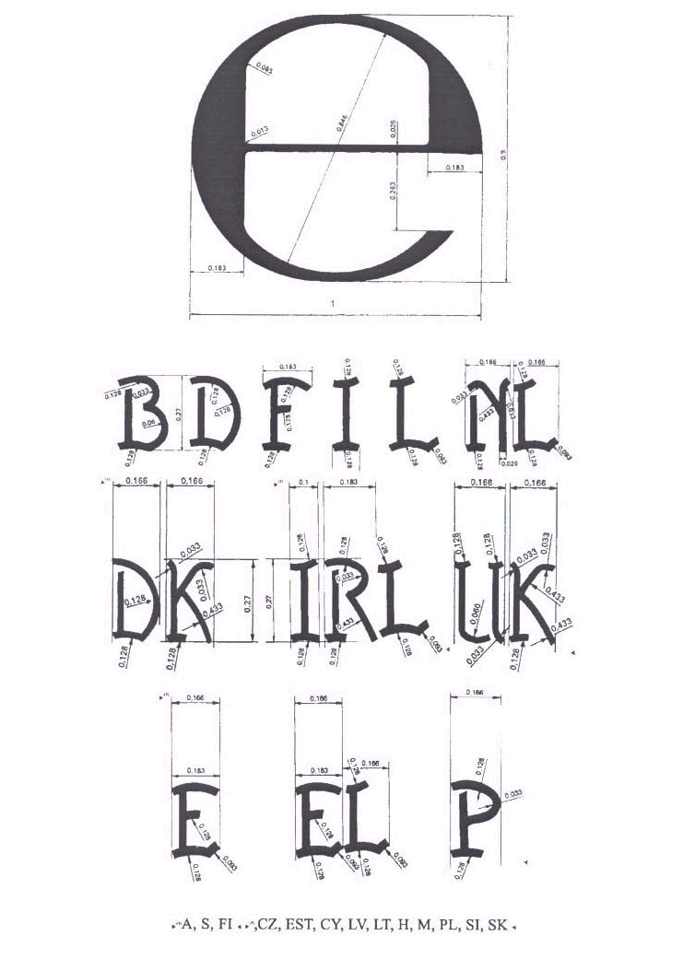
Picture 1

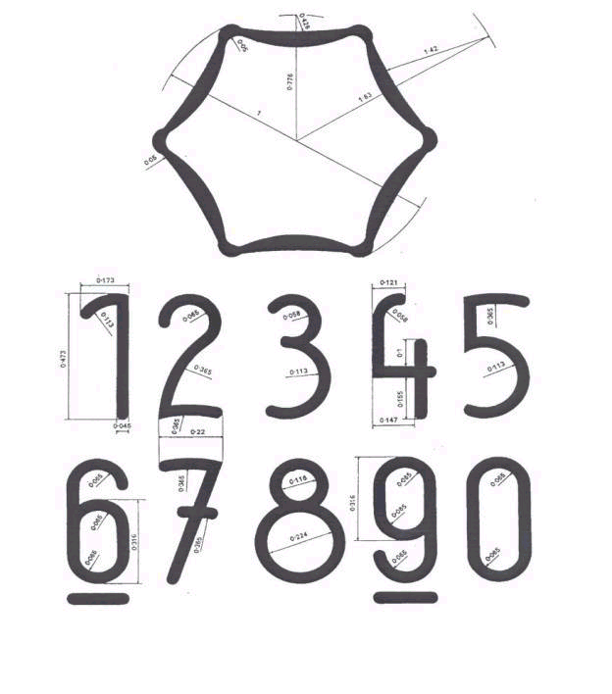
Picture 2

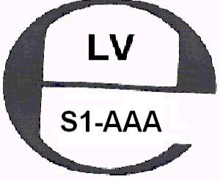  Picture 3a |   Picture 3b

Designations.

LV – Latvia.

S1-AAA – number of accreditation of the inspection institution.

GG – time of initial verification (the last two digits of the year).

13. National initial verification mark shall be as follows:

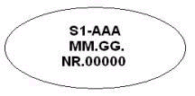
Picture 4

Designations.

S1-AAA – number of accreditation of the inspection institution.

MM.GG – time of verification (month, the last two digits of the year).

No. 00000 – serial number of the verification mark.
[7 February 2006; 10 October 2006]

Minister for Economics A. K. Kariņš

