Text consolidated by Valsts valodas centrs (State Language Centre) with amending regulations of:

29 January 2013 [shall come into force from 8 February 2013];

28 January 2014 [shall come into force from 31 January 2014];

14 October 2014 [shall come into force from 17 October 2014];

12 May 2015 [shall come into force from 20 May 2015].

If a whole or part of a paragraph has been amended, the date of the amending regulation appears in square brackets at the end of the paragraph. If a whole paragraph or sub-paragraph has been deleted, the date of the deletion appears in square brackets beside the deleted paragraph or sub-paragraph.

Republic of Latvia

Cabinet

Regulation No. 820

Adopted 19 October 2011

**Doping Control Procedures**

*Issued pursuant to*

*Section 6, Paragraph five, Clause 4 of the Sports Law*

**I. General Provisions**

1. This Regulation prescribes the doping control procedures.

2. Doping control for athletes shall be carried out in order to detect the use of prohibited doping substances or doping method referred to in Annex 1 to this Regulation. The prohibited doping substances and doping methods shall be approved in conformity with Annex 1 to the International Convention Against Doping “Prohibited List – International Standard”.

**II. Institutions Involved in Doping Control and Their Operation**

3. Doping control measures shall be co-ordinated by the Anti-doping Committee which is an advisory body in the field of doping control.

4. Representatives from the Ministry of Education and Science, the Ministry of Health, the association “Latvian Olympic Committee” (hereinafter – the Latvian Olympic Committee) and the association “Council of the Latvian Sports Federations” (hereinafter – the Council of the Latvian Sports Federations) shall be in the composition of the Anti-doping Committee. The Minister for Health shall approve the personnel of the Anti-doping Committee. The work of the Anti-doping Committee shall be managed by the chairperson of the Anti-doping Committee who is a representative of the Ministry of Health. Experts with advisory rights may be invited to a meeting of the Anti-doping Committee.

5. The Anti-doping Committee shall have a quorum if at least half of members of the Committee with the right to vote participate in the meeting thereof. Each member of the Anti-doping Committee has one vote.

6. Decisions of the Anti-doping Committee shall be taken by open ballot. Decisions shall be taken with a simple majority vote. In the event of a tied vote, the vote of the chairperson of the Anti-doping Committee shall be the deciding vote.

7. Secret ballot shall take place if it is requested by at least one third of members of the Anti-doping Committee.

8. Minutes shall be taken during meetings of the Anti-doping Committee.

9. The Anti-doping Committee shall approve the Commission of Therapeutic Use of the Anti-doping Committee (hereinafter – the Commission of Therapeutic Use), composed of three sports doctors. The Commission of Therapeutic Use has the right to provide an opinion on a permission for an athlete to use doping substances or doping methods referred to in Annex 1 to this Regulation, if the use thereof is the only therapeutic alternative and setting in of a condition dangerous for the life of the athlete is possible, and if the athlete does not obtain additional advantages or possibilities to present better sports results. The athlete shall submit a completed application questionnaire (Annex 2) to the Commission of Therapeutic Use and the relevant medical documentation. The Commission of Therapeutic Use shall act in conformity with the principles laid down in Annex 2 “Standards for Granting Therapeutic Use Exemptions” to the International Convention against Doping in Sport.

10. The Anti-doping Committee has the right to propose to carry out doping control for athletes in-competition and out-of competition:

10.1. upon its own initiative in conformity with the doping control plan developed by the State Sports Medicine Centre (hereinafter – the Centre). The Centre shall submit the abovementioned plan to the Anti-doping Committee twice a year for the evaluation and provision of an opinion;

10.2. on the basis of the submission submitted by the relevant sports federation of the sports type represented by the athlete and recognised in Latvia or international federation, the Latvian Olympic Committee, the Council of the Latvian Sports Federations or the Ministry of Education and Science.

*[29 January 2013]*

11. The Centre, in developing the doping control plan referred to in Sub-paragraph 10.1 of this Regulation, shall include the following athletes therein:

11.1. the athletes included in the register of athletes to be tested (hereinafter – the Register) regarding whom the Anti-doping Committee shall provide an opinion twice a year. The Anti-doping Committee shall include athletes of the Latvian Olympic unit and those athletes, who have committed doping infringement during the preceding year, in the Register. In order to facilitate the performance of the doping control plan, the athletes included in the Register shall, once in a quarter, submit data to the doping control database of the Centre regarding his or her place of location and time on each day, when they will be available for control one hour a day. The athletes included in the Register have the right to carry out changes to information at any time regarding their place of location and time. The data submitted to the doping control database of the Centre regarding the place of location and time of athletes shall be subject to the data protection requirements;

11.2. other athletes, when evaluating place of venues and time of trainings and competitions, achievements in sports, doping controls previously carried out and results thereof, possible connection of representatives of the relevant sports type with doping use, and other information.

*[29 January 2013]*

12. Upon receipt of the submission referred to in Sub-paragraph 10.2 of this Regulation, the Anti-doping Committee shall, within two working days after receipt of the submission, provide an opinion to the Centre on necessity of doping control.

*[29 January 2013]*

13. In order to carry out a doping control, the Centre, on the basis of the doping control plan referred to in Sub-paragraph 10.1 of this Regulation or the submission referred to in Sub-paragraph 10.2 of this Regulation, shall obtain blood or urine samples from the relevant athlete in accordance with the procedures laid down in this Regulation.

*[29 January 2013]*

14. Urine sample of an athlete shall be taken by an official authorised by the Director of the Centre (hereinafter – the doping controller), but a blood sample shall be taken by a doping controller who concurrently is also a certified medical practitioner.

*[29 January 2013]*

15. The Director of the Centre shall submit a written authorisation to the doping controller for the performance of doping control. The Centre shall provide data regarding place and time to the doping controller, when the relevant athlete may be contacted, as well as also issue inventory and documents necessary for the doping control.

*[29 January 2013]*

**III. Doping Control Measures**

16. The doping controller shall acquaint the athlete with the submission referred to in Sub-paragraph 10.2 of this Regulation or an extract from the doping control plan, present an authorisation, as well as also hand over an invitation to the athlete to carry out doping control. The athlete shall present a personal identification document and sign for receipt of the invitation. A legal representative or sports specialist authorised by the legal representative of a minor person or of a person without the capacity to act shall sign the invitation to carry out doping control instead of him or her.

17. The doping controller shall inform the athlete regarding the doping control procedures, the location of the doping control, as well as also regarding the rights to invite one person to participate in the doping control. Where appropriate, the athlete has the right to invite an interpreter. The doping control for a minor person or a person without the capacity to act shall be carried out only in the presence of his or her legal representative or sports specialist authorised by the legal representative.

18. If the doping controller does not meet the athlete at the place and time indicated by the Centre, the doping controller shall notify the Centre thereof in writing.

*[29 January 2013]*

19. The doping controller shall request the athlete to arrive at the place of the doping control without delay and shall ensure continuous supervision of the athlete during the doping control. If the athlete is participating in a press conference or in the awarding ceremony, the athlete is allowed to arrive at the place of the doping control later.

20. The doping controller shall mark the time of arrival of the athlete at the place of doping control.

21. The doping controller shall make sure whether the place of doping control conforms to the following criteria:

21.1. there is a room for the performance of the doping control;

21.2. there is a room where the athlete can make himself or herself ready for the doping control and where the possibility to have a drink is ensured;

21.3. there is a toilet if it is necessary to take urine sample.

22. After obtaining of samples, they shall be encoded, using a temporary packaging set on which a seal may be put and a doping control set for urine or blood sample with a code. Each item shall be placed in a separate industrially manufactured packaging, and the packaging must be closed so as items cannot have contact with the environment and inviolability thereof shall be ensured (hereinafter – the individual packaging).

23. If the athlete is avoiding sample giving, the doping controller shall inform the Centre thereof without delay in writing.

*[29 January 2013]*

**IV. Obtaining of Urine Sample**

24. In order to obtain a urine sample, the doping controller shall ask the athlete to choose one urine collection container in the individual packaging and ascertain that the packaging is not damaged. If the athlete considers that the packaging is damaged, he or she has the right to choose another container.

25. The athlete shall transfer the urine sample in a toilet under the supervision of the doping controller of the same gender.

26. Volume of the urine sample shall be at least 90 millilitres. If the sample volume is less than 90 millilitres, the urine container with the sample shall be placed in a temporary packaging set, chosen by the athlete from several sets, on which a seal may be put. After collection of sufficient amount of urine both urine samples shall be poured together.

27. After collection of the urine sample, the doping controller shall ask the athlete to choose one of several empty doping control sets for urine sample and ascertain that code numbers are the same on all parts of the set (bottles or containers of part A and part B of the sample) and that individual packaging is not damaged. If the athlete considers that the code numbers are not the same or the packaging is damaged, he or she has the right to choose another set.

28. According to the instruction of the doping controller the athlete shall pour approximately two thirds of the urine sample in the bottle of part A and one third – in the bottle of part B, close the bottles and encode them, screwing up the lid or placing them in a container.

29. The doping controller, by using the remaining urine sample in the collection container, carry out urine specific weight measurements. If specific weight of urine is less than 1,005, a sample shall be taken repeatedly and both obtained samples shall be considered as the doping control sample.

**Obtaining of Blood Sample**

30. Before obtaining a blood sample the doping controller shall ensure that the athlete is in a comfortable position in a still state for at least 10 minutes.

31. The doping controller shall ask the athlete to choose one of several blood sample doping control sets and ascertain that code numbers on all parts of the set are the same and that the individual packaging is not damaged. If the athlete considers that the code numbers are not the same or the packaging is damaged, he or she has the right to choose another set.

32. The doping controller shall clean the athlete's skin with a sterile disinfecting tampon in the part of the athlete's body where a venipuncture carried out will affect the activity of the athlete as less as possible. The doping controller shall take blood sample in two test-tubes of the set for doping control collection (where appropriate, by using a tourniquet) from surface vein and put a bandage on a puncture point. If a tourniquet is used, it shall be taken off immediately after venipuncture and a bandage shall be put on a puncture point.

33. The volume of a blood sample shall be at least three millilitres in each test-tube.

34. If the blood sample obtained in the first time is less than three millilitres, the doping controller shall take a blood sample repeatedly, however, no more than three times. If the volume of the obtained blood sample is not sufficient, sample taking shall be interrupted and the doping controller shall inform the Centre thereof in writing.

*[29 January 2013]*

35. The athlete shall place the test-tubes of part A and part B of blood sample in special containers or boxes and encode them in the presence of the doping controller, placing them in a container or otherwise sealing them in conformity with the instructions by the doping controller.

**VI. Measures Following Doping Control**

36. The doping controller shall complete a doping control questionnaire (original and three copies thereof) regarding the course of the doping control by using the doping control questionnaire form referred to in Annex 3 to this Regulation. The doping controller shall, without delay, issue one copy of the completed doping control questionnaire to the athlete.

37. The doping controller shall submit a doping control questionnaire (original and other two copies thereof) to the Centre during the next working day following the day of performance of the doping control and attach samples obtained during the doping control, and also other documents related to the control.

*[29 January 2013]*

38. The Centre shall send a sample, cover letter and a part of the copy of the doping control questionnaire, without presenting personal data of the athlete, to a doping control laboratory which has been accredited in accordance with the criteria laid down by the monitoring group of the Anti-Doping Convention of the Council of Europe (hereinafter – the laboratory).

*[29 January 2013]*

39. The analysis of part A shall be carried out in the laboratory and the presence of all doping substances and use of doping method shall be determined in the sample if the doping control is carried out in-competition. If the doping control is carried out-of-competition, the use of the doping substances referred to in Paragraphs 1, 2, 3, 4, 5, and 6 of Annex 1 to this Regulations and the use of the doping methods referred to in Paragraph 7 of Annex 1 to this Regulation shall be determined. If the institution, which has requested the doping control, does not indicate it specifically, the laboratory shall carry out analysis in order to determine the presence of other substances. After performance of the sample analysis the laboratory shall send an opinion to the Centre.

*[29 January 2013]*

40. If it is indicated in the opinion of the laboratory that doping substances have not been detected in part A of the sample, the Centre shall inform the institution, which has requested the doping control, thereof and send it one copy of the doping control questionnaire and the opinion of the laboratory.

*[29 January 2013]*

41. The Centre shall send a submission to the Anti-doping Committee regarding possible doping infringement (the opinion of the laboratory, the doping control questionnaire or other information shall be appended for the submission), if:

41.1. it is indicated in the opinion of the laboratory that a doping substance has been detected in part A of the sample or there is proof regarding administration of a doping method;

41.2. the doping controller has informed the Centre that the athlete is avoiding giving a sample for doping control;

41.3. the Centre detects that the athlete has no justifiable reason (for example, accident or sudden illness) in order to justify his or her absence at the indicated place and time according to the report of the doping controller referred to in Paragraph 18 of this Regulation;

41.4. the Centre detects that the athlete included in the Register referred to in Sub-paragraph 11.1 of this Regulation has failed to provide data regarding his or her location after receipt of two reminders sent in a registered letter;

41.5. the Centre detects that the athlete has administered doping substances or used doping methods or that the athlete, athlete's employee or sports specialist has participated in administration of doping substances or use of doping methods for the athlete.

*[29 January 2013]*

42. The Anti-doping Committee shall, not later than within two working days after receipt, examine the submission referred to in Paragraph 41 of this Regulation and the documents appended thereto and provide an opinion to the Centre on doping infringement.

*[29 January 2013]*

43. If the arguments referred to in the submission of the Centre are not sufficient grounds for the provision of an opinion on infringement, the Anti-doping Committee shall examine the explanations provided by the involved persons or, upon request of the athlete, propose to carry out analysis of part B in the laboratory. In this case the relevant athlete or his or her authorised representative has the right to be present when carrying out analysis of part B in the laboratory.

*[29 January 2013]*

44. If during examining a case regarding possible doping infringement the Anti-doping Committee considers that the infringement has not occurred, the Anti-doping Committee shall provide an opinion thereon to the Centre. The responsible official of the Centre shall inform the institution, which has requested the doping control, that the doping infringement has not occurred and send it one copy of the doping control questionnaire, opinion of the laboratory and opinion of the Anti-doping Committee.

*[29 January 2013]*

45. If it is indicated in the opinion of the Anti-doping Committee that a doping infringement has occurred, the Anti-doping Committee shall send one copy of the doping control questionnaire and opinion of the laboratory or other information to the athlete and the sports federation of the sports type represented by the athlete and recognised in Latvia. If the substances referred to in Paragraph 8, 9 or 10 of Annex 1 to this Regulation are detected in the blood or urine sample of the athlete, the Anti-doping Committee shall send a report to law enforcement authorities in a registered letter.

46. If it is indicated in the opinion of the Anti-doping Committee that the athlete has avoided carrying out the doping control, the Anti-doping Committee shall send the information thereon to the State Education Quality Service in a registered letter.

47. If a submission for performance of the doping control has been submitted by a sports federation recognised in Latvia, an international sports federation, the Latvian Olympic Committee, the Council of the Latvian Sports Federations or the Ministry of the Education and Science, the expenses related to the doping control shall be covered by the submitter.

48. If the doping control is carried out upon initiative of the Anti-doping Committee or according to a doping control plan, the expenses related to the doping control shall be covered by the Centre from the State budget resources granted for it.

*[29 January 2013]*

**VII. Supervision and Control of Conformity with this Regulation and Liability for Infringement Thereof**

49. The Centre shall organise and coordinate implementation of anti-doping measures of the State, local government and public organisations and take doping control measures in accordance with this Regulation.

*[29 January 2013]*

50. The State Education Quality Service shall impose an administrative punishment on athletes for infringements of the doping control procedures.

*[12 May 2015]*

51. A sports federation recognised in Latvia shall, after receipt of the information referred to in Paragraph 45 of this Regulation, apply a punishment to an athlete for a doping infringement in conformity with the provisions of the relevant international sports federation.

51.1 If the athlete is able to prove that the substance found in his or her organism is not used to improve his or her sports condition or to hide the presence of a prohibited substance, such substance shall be regarded as a special substance. The substances referred to in Paragraphs 2 and 3, Sub-paragraphs 5.4, 5.5, and 8.1 of Annex 1, as well as also the methods referred to in Paragraph 7 of Annex 1 to this Regulation shall not be regarded as special substances.

*[29 January 2013]*

51.2 The substances referred to in Paragraphs 1, 2, 3, 4, 5, and 6 of Annex 1 and the methods referred to in Paragraph 7 of Annex 1 to this Regulation are prohibited during competition and out-of competition, but the substances referred to in Paragraphs 8, 9, 10, 11, 12, and 13 of this Annex are prohibited only during competition.

*[29 January 2013]*

**VIII. Closing Provision**

52. Cabinet Regulation No. 974 of 30 November 2004, Doping Control Regulations (*Latvijas Vēstnesis*, 2004, No. 192; 2006, No. 49; 2007, No. 121; 2008, No. 134; 2009, No. 184; 2010, No. 8).

Prime Minister V. Dombrovskis

Minister for Health J.Bārzdiņš

**Annex 1**

Cabinet Regulation No. 820

19 October 2011

**Prohibited Doping Substances and Doping Methods**

*[12 May 2015]*

1. S0. Non-approved substances.

Any pharmacological substance which is not addressed by any of the subsequent sections of the List and with no current approval by any governmental regulatory health authority for human therapeutic use (e.g. drugs under pre-clinical or clinical development or discontinued, designer drugs, substances approved only for veterinary use) is prohibited at all times.

2. S1. Anabolic agents:

2.1. S1.1. anabolic androgenic steroids (AAS):

2.1.1. exogenous anabolic androgenic steroids1:

*1-androstenediol (5α-androst-1-ene-3β,17β-diol)*

*1-androstendione (5α-androst-1-ene-3,17-dione)*

*bolandiol (estr-4-ene-3β,17β-diol)*

*bolasterone*

*boldenone*

*boldione (androsta-1,4-diene-3,17-dione)*

*calusterone*

*clostebol*

*danazol ([1,2]oxazolo[4',5':2,3]pregna-4-en-20-yn-17α-ol)*

*dehydrochlormethyltestosterone (4-chloro-17β-hydroxy-17α-methylandrosta-1,4-dien-3-one)*

*desoxymethyltestosterone (17α-methyl-5α-androst-2-en-17β-ol)*

*drostanolone*

*ethylestrenol (19-norpregna-4-en-17α -ol)*

*fluoxymesterone*

*formebolone*

*furazabol (17α-methyl[1,2,5]oxadiazolo[3',4':2,3]-5α-androstan-17β-ol)*

*gestrinone*

*4-hydroxytestosterone (4,17β-dihydroxyandrost-4-en-3-one)*

*mestanolone*

*mesterolone*

*metandienone (17β-hydroxy-17α-methylandrosta-1,4-dien-3-one)*

*metenolone*

*methandriol*

*methasterone (17β-hydroxy-2α,17α-dimethyl-5α-androstan-3-one)*

*methyldienolone (17β-hydroxy-17α-methylestra-4,9-dien-3-one)*

*methyl-1-testosterone (17β-hydroxy-17α-methyl-5α-androst-1-en-3-one)*

*methylnortestosterone (17β-hydroxy-17α-methylestr-4-en-3-one)*

*methyltestosterone*

*metribolone (methyltrienolone,17β-hydroxy-17α-methylestra-4,9,11-trien-3-one)*

*mibolerone*

*nandrolone*

*19-norandrostenedione (estr-4-ene-3,17-dione)*

*norboletone*

*norclostebol*

*norethandrolone*

*oxabolone*

*oxandrolone*

*oxymesterone*

*oxymetholone*

*prostanozol (17β-[(tetrahydropyran-2-yl)oxy]-1'H-pyrazolo[3,4:2,3]-5α-androstane)*

*quinbolone*

*stanozolol*

*stenbolone*

*1-testosterone (17β-hydroxy-5α-androst-1-en-3-one)*

*tetrahydrogestrinone (17-hydroxy-18a-homo-19-nor-17α-pregna-4,9,11-trien-3-one)*

*trenbolone (17β-hydroxyestr-4,9,11-trien-3-one)*

other substances with a similar chemical structure or similar biological effect;

2.1.2. endogenous anabolic androgenic steroids2:

*androstenediol (androst-5-ene-3β,17β-diol)*

*androstenedione (androst-4-ene-3,17-dione)*

*dihydrotestosterone (17β-hydroxy-5α-androstan-3-one)*

*prasterone (dehydroepiandrosterone, DHEA, 3β-hydroxyandrost-5-en-17-one)*

*testosterone* and their metabolites and isomers, including but not limited to:

*5α-androstane-3α,17α-diol*

*5α-androstane-3α,17β-diol*

*5α-androstane-3β,17α-diol*

*5α-androstane-3β,17β-diol*

*5β-androstane-3α,17β-diol*

*androst-4-ene-3α,17α-diol*

*androst-4-ene-3α,17β-diol*

*androst-4-ene-3β,17α-diol*

*androst-5-ene-3α,17α-diol*

*androst-5-ene-3α,17β-diol*

*androst-5-ene-3β,17α-diol*

*4-androstenediol (androst-4-ene-3β,17β-diol)*

*5-androstenedione (androst-5-ene-3,17-dione)*

*androsterone (3β-hydroxy-5α-androstan-17-one)*

*epi-dihydrotestosterone*

*epitestosterone*

*etiocholanolone*

*7α-hydroxy-DHEA*

*7β-hydroxy-DHEA*

*7-keto-DHEA*

*19-norandrosterone*

*19-noretiocholanolone*

2.2. S1.2. other anabolic agents including, but not limited to:

*clenbuterol*

selective androgen receptor modulators (SARMs, e.g. *andarine* and *ostarine*)

*tibolone*

*zeranol*

*zilpaterol*.

3. S2. Peptide hormones, growth factors, related substances and mimetics:

3.1. Erythropoietin-Receptor agonists:

3.1.1. Erythropoiesis-Stimulating Agents (ESAs) including erythropoietins (EPO), darbepoietin (dEPO), EPO-Fc, methoxy polyethylene glycol-epoetin beta (CERA)EPO-mimetic peptides (EMP) (e.g. CNTO 530 and *peginesatide*);

3.1.2. Non-erythropoietic EPO-Receptor agonists, including ARA-290, asialo EPO and carbamylated EPO;

3.2. Hypoxia-inducible factor (HIF) stabilizers (e.g. cobalt and FG-4592), HIF activators, (e.g. argon and xenon);

3.3. Chorionic Gonadotrophin (CG) and Luteinizing Hormone (LH) and their releasing factors, (e.g. *buserelin*, *gonadorelin* and *triptorelin*) in males;

3.4. Corticotrophins and their releasing factors (e.g. *corticorelin*);

3.5. Growth Hormone (GH) and its releasing factors including Growth Hormone Releasing Hormone (GHRH) and its analogues (e.g. CJC-1295, *sermorelin*, *tesamorelin*), Growth Hormone Secretagogues (GHS), ghrelin and ghrelin mimetics (e.g. *anamorelin* and *ipamorelin*), growth hormone releasing peptides (GHRPs) (e.g. *alexamorelin*, GHRP-6, *hexarelin* and *pralmorelin* (GHRP-2));

3.6. Insulin-like Growth Factor-1 (IGF-1) and its analogues, Fibroblast Growth Factors (FGFs), Hepatocyte Growth Factor (HGF), Mechano Growth Factors (MGFs), Platelet-Derived Growth Factor (PDGF), Vascular-Endothelial Growth Factor (VEGF) and any other growth factor, affecting muscle, tendon or ligament protein synthesis, degradation, vascularisation, energy utilization, regenerative capacity or fibre type switching;

3.7. other substances with a similar chemical structure or biological effect.

4. S3. Beta-2 agonists, including all optical isomers, (e.g. *d-* and *l-*)3, 4.

5. S4. Hormones and metabolic modulators:

5.1. aromatase inhibitors including, but not limited to *aminoglutethimide, anastrozole, androsta-1,4,6-triene-3,17-dione (androstatrienedione), 4-androstene-3,6,17 trione (6-oxo), exemestane, formestane, letrozole, testolactone*;

5.2. Selective estrogen receptor modulators (SERMs) including, but not limited to *raloxifene, tamoxifen, toremifene*;

5.3. other anti-estrogenic substances including, but not limited to *clomiphene, cyclofenil, fulvestrant*;

5.4. agents modifying myostatin functions including, but not limited, to: myostatin inhibitors;

5.5. metabolic modulators:

5.5.1. insulins;

5.5.2. Peroxisome Proliferator Activated Receptor δ (PPARδ) agonists (e.g. GW 1516) and activators of the AMP-activated protein kinase (AMPK) (e.g. AICAR);

5.5.3. *trimetazidine*.

6. S5. Diuretics and masking agents5, 6:

*acetazolamide*

*amiloride*

*bumetanide*

*canrenone*

*chlortalidone*

*etacrynic acid*

*furosemide*

*indapamide*

*metolazone*

*spironolactone*

thiazides (e.g. *bendroflumethiazide, chlorothiazide, hydrochlorothiazide)*

*triamterene*

vaptans (e.g.*, tolvaptan*)

*desmopressin*

plasma expanders (e.g. intravenous administration of albumin, dextran, hydroxyethyl starch and mannitol, and also glycerol)

*probenecid*

other substances with a similar chemical structure or similar biological effect.

7. M/ Doping methods:

7.1. M1. manipulations with blood and blood components:

7.1.1. the administration or reintroduction of any quantity of autologous, allogenic (homologous) or heterologous blood, or red blood cell products of any origin into the circulatory system;

7.1.2. artificially enhancing the uptake, transport or delivery of oxygen. Including, but not limited to: perfluorochemicals; *efaproxiral* (RSR13) and modified haemoglobin products (e.g. haemoglobin-based blood substitutes and microencapsulated haemoglobin products) excluding supplemental oxygen;

7.1.3. any form of intravascular manipulation of the blood or blood components by physical or chemical means;

7.2. M2. chemical and physical manipulations:

7.2.1. tampering, or attempting to tamper, to alter the integrity and validity of samples collected during doping control. Including, but not limited to urine substitution and(or) adulteration (e.g. proteases) and other manipulations;

7.2.2. intravenous infusions and(or) injections of more than 50 ml per six hour period except for those legitimately received in the course of hospital admissions, surgical procedures or clinical investigations;

7.3. M3. gene doping methods with the potential to enhance sport performance:

7.3.1. the transfer of polymers of nucleic acids or nucleic acid analogues;

7.3.2. the use of normal or genetically modified cells.

8. S6. Stimulants.

All stimulants, including all optical isomers (e.g. *d-* and *l-*), are prohibited, except imidazole derivatives for local or ophthalmic use and those stimulants included in the 2015 Monitoring Program (*bupropion, caffeine, nicotine, phenylephrine, phenylpropanolamine, pipradol* and *synephrine*) *.

8.1. non-specific stimulants:

*adrafinil*

*amfepramone*

*amfetamine*

*amfetaminil*

*amiphenazole*

*benfluorex*

*benzylpiperazine*

*bromantan*

*clobenzorex*

*cocaine*

*cropropamide*

*crotetamide*

*fencamine*

*fenetylline*

*fenfluramine*

*fenproporex*

*fonturacetam (4-phenylpiracetam (carphedon))*

*furfenorex*

*mefenorex*

*mephentermine*

*mesocarb*

*metamfetamine (d-)*

*p-methylamphetamine*

*modafinil*

*norfenfluramine*

*phendimetrazine*

*phentermine*

*prenylamine*

*prolintane*;

8.2. specific stimulants, for example:

*benzfetamine*

*cathine7*

*cathinone* and its analogues (e.g. *mephedrone, methedrone, α-pyrrolidinovalerophenone*)

*dimethylamphetamine*

*ephedrine8*

*epinephrine9* (*adrenaline*)

*etamivan*

*etilamfetamine*

*etilefrine*

*famprofazone*

*fenbutrazate*

*fencamfamin*

*heptaminol*

*hydroxyamfetamine (parahydroxyamphetamine)*

*isometheptene*

*levmetamfetamine*

*meclofenoxate*

*methylenedioxymethamphetamine*

*methylephedrine8*

*methylhexaneamine (dimethylpentylamine)*

*methylphenidate*

*nikethamide*

*norfenefrine*

*octopamine*

*oxilofrine (methylsynephrine)*

*pemoline*

*pentetrazol*

*phenethylamine* un its derivatives

*phenmetrazine*

*phenpromethamine*

*propylhexedrine*

*pseudoephedrine10*

*selegiline*

*sibutramine*

*strychnine*

*tenamfetamine (methylenedioxyamphetamine)*

*tuaminoheptane*

other substances with a similar chemical structure and similar biological effect.

9. S7. Narcotics:

*buprenorphine*

*dextromoramide*

*diamorphine (heroin)*

*fentanyl* and its derivatives

*hydromorphone*

*methadone*

*morphine*

*oxycodone*

*oxymorphone*

*pentazocine*

*pethidine*.

10. S8. Cannabinoids.

Natural (e.g. *cannabis*, hashish and marijuana) or synthetic delta 9-tetrahydrocannabinol (THC) and cannabimimetics (e.g. "Spice", JWH-018, JWH-073, HU-210) are prohibited.

11. S9. Glucocorticoids.

All glucocorticoids are prohibited when administered by oral, rectal, intravenous or intramuscular routes.

12. P1. Alcohol11 (ethanol) in the following sports:

air sports (*FAI*)

archery (*WA*)

automobile (*FIA*)

motorcycling (*FIM*)

power boating (*UIM*).

13. P2. Beta-blockers

13.1. for example as follows:

*acebutolol*

*alprenolol*

*atenolol*

*betaxolol*

*bisoprolol*

*bunolol*

*carteolol*

*carvedilol*

*celiprolol*

*esmolol*

*labetalol*

*levobunolol*

*metipranolol*

*metoprolol*

*nadolol*

*oxprenolol*

*pindolol*

*propranolol*

*sotalol*

*timolol*;

13.2. in the following sports:

13.2.1. archery (*WA*) (also outside competition);

13.2.2. automobile (*FIA*);

13.2.3. billiards (all disciplines) (*WCBS*);

13.2.4. darts (*WDF*);

13.2.5. golf (*IGF*);

13.2.6. shooting (*ISSF*, *IPC*) (also out-of competition);

13.2.7. skiing sports (*FIS*), ski jumping, freestyle (*aerials*/*halfpipe*) and snowboarding (*halfpipe*/*big air*);

13.2.8. underwater sports (CMAS) – in constant-weight apnoea with or without fins, dynamic apnoea with and without fins, free immersion apnoea, Jump Blue apnoea, spearfishing, static apnoea, target shooting and variable weight apnoea.

Notes.

1 Exogenous – refers to a substance which is not ordinarily produced by the body.

2 Endogenous – refers to a substance which is ordinarily produced by the body.

3 Except inhaled salbutamol (maximum 1600 micrograms over 24 hours), inhaled formoterol (maximum delivered dose 54 micrograms over 24 hours); and inhaled salmeterol in accordance with the manufacturers' recommended therapeutic regimen.

4 The presence in urine of salbutamol in excess of 1000 nanograms per millilitre (ng/mL) or formoterol in excess of 40 nanograms per millilitre (ng/ml) is presumed not to be an intended therapeutic use of the substance and will be considered as an Adverse Analytical Finding (unless the Athlete proves, through a controlled pharmacokinetic study, that the abnormal result was the consequence of the use of the therapeutic inhaled dose up to the maximum indicated above).

5 The detection in an Athlete's Sample at all times or In-Competition, as applicable, of any quantity of the prohibited substances subject to threshold limits (for example, *formoterol, salbutamol, cathine, ephedrine, methylephedrine* un *pseudoephedrine*), in conjunction with a diuretic or masking agent, requires a permit for therapeutic use exemption for that substance in addition to the one granted for the diuretic or masking agent.

6 Except*drosperinone, pamabrom* and local administration of *dorzolamide* and *brinzolamide*, and also*fenylpressin*in dental anaesthesia.

7 When concentration of *cathine* in urine is greater than 5 micrograms per millilitre.

8 When concentration of *ephedrine* or *methylephedrine* in urine are greater than10 micrograms per millilitre.

9 *Epinephrine (adrenaline)*: not prohibited in co-administration with local anaesthetic agents or local administration (e.g. nasal, ophthalmologic).

10 When concentration of *pseudoephedrine* in urine is greater than 150 micrograms per millilitre.

11 Detection of alcohol (ethanol) will be conducted by analysis of breath and (or) blood. The doping violation threshold (a blood alcohol concentration)\ is equivalent 0.1 per mille (0.10 g/L).

**Annex 2**

Cabinet Regulation No. 820

19 October 2011

*[12 May 2015]*

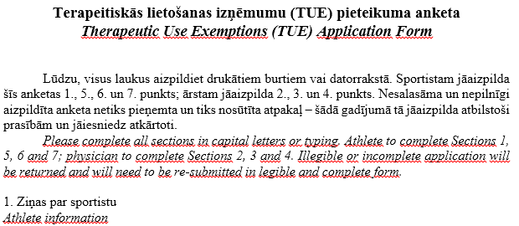

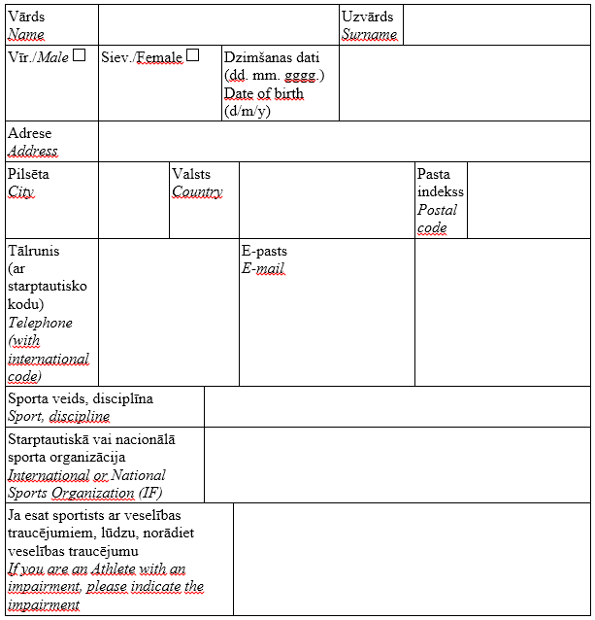



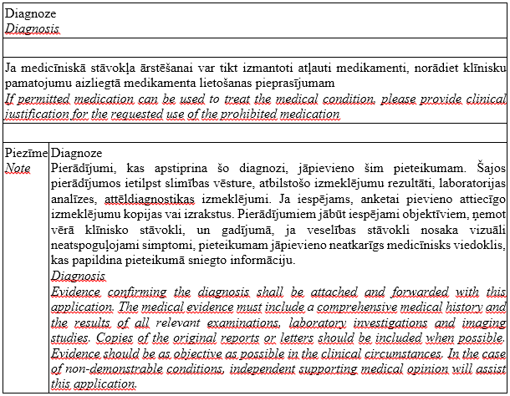



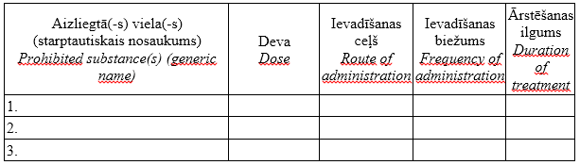



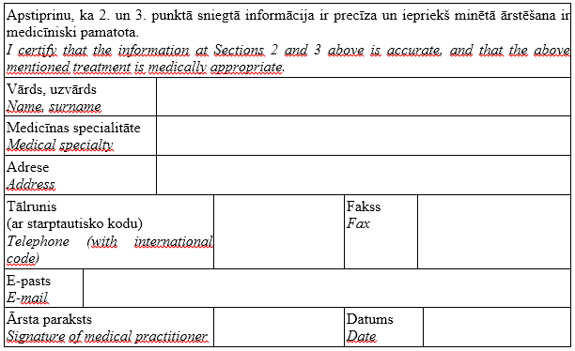



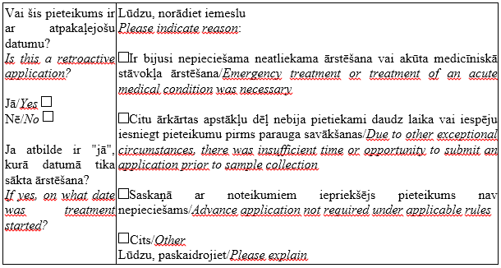



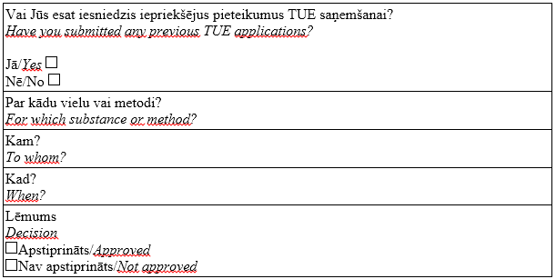



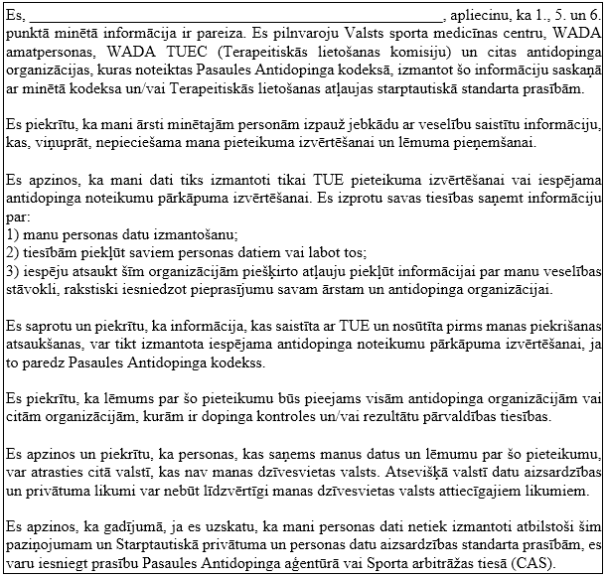

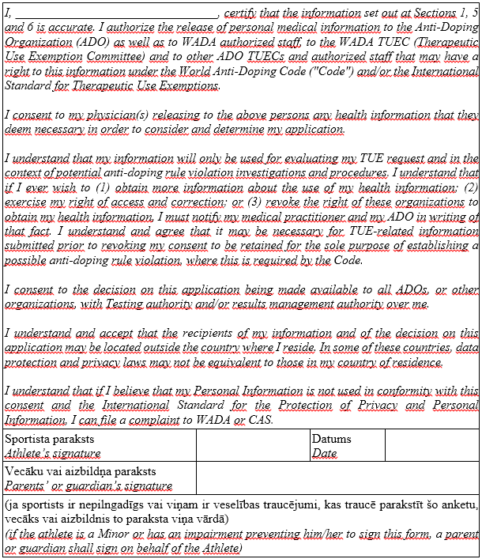

|  |
| --- |
| State Sports Medicine Centre  Raiņa bulvāris 27, Riga, LV-1050  Phone 67226164, mobile phone 29296236, fax 67226164, e-mail: info@antidopings.lv |

**Annex 3**

Cabinet Regulation No. 820

19 October 2011

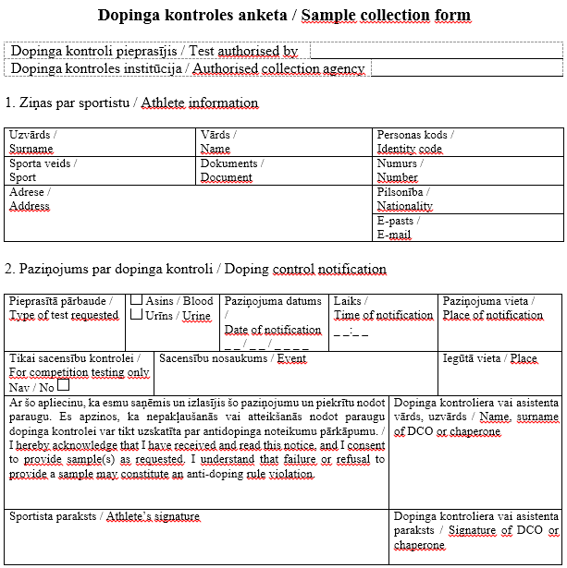

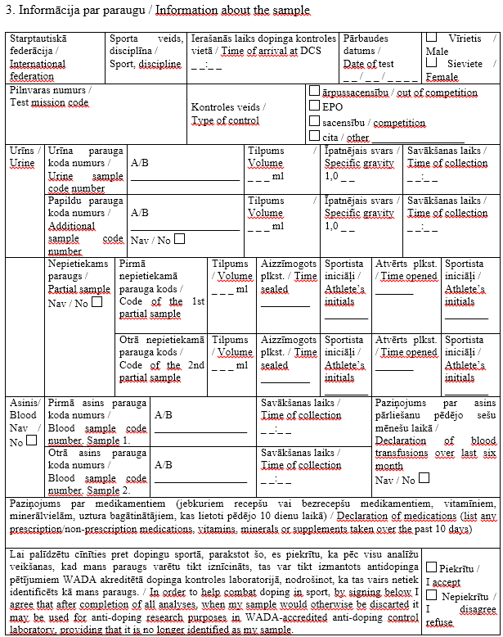

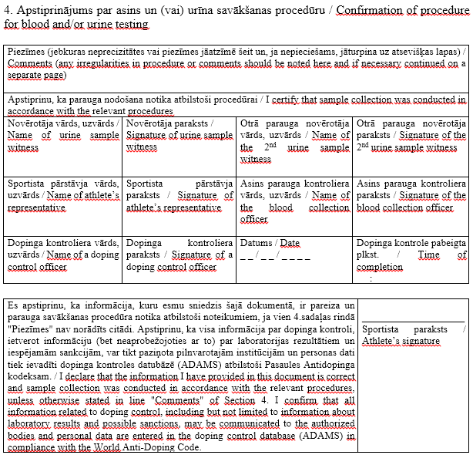

Minister for Health J.Bārzdiņš