Republic of Latvia

Cabinet
Regulation No. 879
Adopted 15 November 2011

Regulations Regarding the Geodetic Reference System and the Topographic Map System

Issued pursuant to
Section 11, Paragraph three and Section 12, Paragraph four
of the Geospatial Information Law

I. General Provisions

1. This Regulation prescribes:
1.1. the procedures for the creation, use and maintenance of the geodetic reference system;
1.2. the parameters of the geodetic co-ordinate system of Latvia (1992) (hereinafter – LKS-92) and the procedures for the application thereof;
1.3. the procedures for the application of the normal heights system of the Baltic States (1977) (hereinafter – BAS-77); and
1.4. the parameters of the topographic map system (1993) (hereinafter – TKS-93) and the procedures for the application thereof.

2. LKS-92 and BAS-77 shall form the geodetic reference system. Implementation of the model of the geodetic reference system in an area shall be ensured by the national geodetic network, including the system of permanent global positioning base stations “Latvian Positioning System” (hereinafter – LatPos).

3. A geodetic network shall be divided into network types according to the characteristics of the geodetic network and in classes according to the accuracy of characteristics of the geodetic network.

4. A local geodetic network shall be created on the basis of the national geodetic network.

II. Parameters of LKS-92 and Procedures for the Application Thereof

5. LKS-92 shall be created on the basis of the World Geodetic System 1984 with the Earth rotational ellipsoid of the Geodetic Reference System 1980 (hereinafter – GRS80) ratified in the XVII General Assembly of the International Union of Geodesy and Geophysics, with the following parameters:
5.1. equatorial radius a = 6 378 137 m;
5.2. geocentric gravitational constant of the Earth (including the atmosphere) GM = 3 986 005 x 10⁸m³s⁻²;
5.3. dynamical form factor of the Earth (excluding the permanent tidal deformation) J₂ = 108 263 x 10⁻⁸;
5.4. angular velocity of the Earth ω = 7 292 115 x 10⁻¹¹ rad s⁻¹;
5.5. ellipsoid flattening f = 1/298.257222101.

6. Linking of LKS-92 with the European Terrestrial Reference System 1989 (hereinafter – ETRS89) shall be ensured by Class 0 markers of the global positioning network Rīga, Kangari, Indra and Arājs, the co-ordinates of which have been determined in the ERTS89 co-ordinate system with realization at epoch 1992.75 of the EUREF89.

7. LKS-92 shall be realized by Class 0, Class 1 and Class 2 markers of the global positioning network and LatPos.

8. LKS-92 co-ordinates shall be determined:
8.1. as spatial rectangular co-ordinates designated with LKS-92 XYZ where:
8.1.1. abscissa is located in the equatorial plane and Greenwich mean meridian plane, designated with X;
8.1.2. ordinate axis is located in the equatorial plane in 90° angle in Eastern direction from Greenwich meridian plane, designated with Y;
8.1.3. applicate axis is pointed in the direction of the North Pole, designated with Z;
8.1.4. abscissa, ordinate and applicate is expressed in metres;
8.2. as geospatial co-ordinates on rotational ellipsoid, designated with LKS-92 BLh, where:
8.2.1. northern latitude is designated with B;
8.2.2. eastern longitude is designated with L;
8.2.3. geodetic (ellipsoid) height is designated with h;
8.2.4. northern latitude and eastern longitude is expressed in degrees (°), minutes (’) and seconds (");
8.2.5. height is expressed in metres;
8.3. as Transverse Mercator projections in plane co-ordinates, designated with LKS-92 TM where:
8.3.1. co-ordinates in a plane are calculated using the rule of Transverse Mercator projection;
8.3.2. abscissa is pointed towards North, designated with x;
8.3.3. ordinate axis is pointed towards East, designated with y;
8.3.4. abscissa and ordinate is expressed in metres.

9. Parameters of Transverse Mercator projection plane shall be determined as follows:
9.1. plane with one axis meridian 24ºE (eastern longitude);
9.2. projection scale coefficient 0.9996 on axis meridian;
9.3. abscissa pointed towards North, and abscissa value reduced by 6 000 000 m;
9.4. ordinate axis pointed towards East, and ordinate value increased by 500 000 m.

10. For the calculation of projection scale coefficient in LKS-92 TM the following formula shall be used:

m = 0,9996 + | 0,9996 × y₀² | , where
m = 0,9996 + | 2 R ² | , where

R – rotational ellipsoid surface curvature radius (for the territory of Latvia R = 6386.8 km);
y₀ – mean unaltered ordinate (y₀ = y_{km} – 500, where y_{km} – location ordinate expressed in kilometres).

III. Procedures for the Application of BAS-77

11. Heights in the territory of the Republic of Latvia shall be determined in the normal heights system.

12. The model of the geodetic reference system shall be implemented by Class 1 and Class 2 markers of the levelling network.

13. The normal heights of markers shall be determined in metres and designated with an H.

14. The normal value of the field of gravity on rotational ellipsoid GRS80 shall be used in calculation of normal heights.

15. Gravimetric measurements in the territory of the Republic of Latvia shall be reduced to the International Gravity Standardization Net 1971 (hereinafter – IGSN71).

16. IGSN71 in the Republic of Latvia shall be realized by Class 1 and Class 2 markers of the gravimetric network.

17. In determining height in BAS-77 with global positioning, the quasigeoid height model LV'98 shall be used, the accuracy of which versus Class 2 of the global positioning network of the national geodetic network and Class 1 of the levelling network is up to eight centimetres, or another quasigeoid height model, the accuracy of which is higher than that of the quasigeoid model LV'98.

18. If, upon acquiring geospatial basic data as a result of geodetic work for the carrying out of State or local government functions and tasks, another model of quasigeoid height is used, accuracy thereof shall be validated by the State agency “Latvian Geospatial Information Agency” (hereinafter – Agency). The assessment of accuracy of the quasigeoid height model shall be determined in validation of the model, carrying out control measurements and office work. The quasigeoid height model shall be validated versus the national geodetic network.

19. The Agency shall carry out validation of the quasigeoid height model according to a written request, in which the geodetic data used in calculations and the assessment of accuracy of the model is indicated.

20. The Agency shall receive access to the quasigeoid height model referred to Paragraph 19 of this Regulation for carrying out of validation for a specific period of time.

21. The results obtained in validation referred to in Paragraph 18 of this Regulation and the assessment of accuracy of the model shall be published in the Internet home page of the Agency.

22. The Agency shall ensure public access to data of the quasigeoid model of Latvia LV'98 and updating thereof.

IV. Parameters of TKS-93 and Procedures for Application Thereof

23. TKS-93 map sheets shall be created by the rectangular co-ordinate network LKS-92 TM.

24. TKS-93 map sheets shall be created, complying with the following conditions:
24.1. division of map sheets covers a territory, the left bottom corner abscissa (x) of which is 100 kilometres and ordinate (y) – 300 kilometres, and the right top corner abscissa (x) of which is 500 kilometres and ordinate (y) – 800 kilometres (Annex 2);
24.2. the basis of TKS-93 is created in map sheet scale 1:200 000 with edges of 100 x 100 km in width and nomenclature designation consisting of two digits – designation of row and box;
24.3. map division of all other scales in sheets is created, dividing a map sheet in greater detail in scale 1:200 000, according to the schemes shown in Annexes 1, 2 and 3 to this Regulation;
24.4. scale line of TKS-93 standard scales are scales 1:200 000, 1:100 000, 1:50 000, 1:25 000, 1:10 000, 1:5000, 1:2000, 1:1000 and 1:500;
24.5. if the scale exceeds 1:500, division of map sheets is created in conformity with the principles specified in Annexes 1, 2 and 3 to this Regulation.

V. Creation of the National Geodetic Network

25. Division of the national geodetic network in types and classes according to the parameters and accuracy thereof shall be as follows:
25.1. Class 0 of the global positioning network (G0) with an accepted standard deviation 0 mm;
25.2. Class 1 of the global positioning network (G1) with the standard deviation 20 mm versus a network of Class G0;
25.3. Class 2 of the global positioning network (G2) with the standard deviation 25 mm versus a network of Class G1;
25.4. Class 1 of the levelling network (N1) with the standard deviation 1.0 mm/km;
25.5. Class 2 of the levelling network (N2) with the standard deviation 2.0 mm/km;
25.6. Class 1 of the gravimetric network (Gr1) with the standard deviation 10 µGal;
25.7. Class 2 of the gravimetric network (Gr2) with the standard deviation 25 µGal versus a network of Class Gr1;
25.8. Class 1 of the geomagnetic network (Mg1) with declination 0,5-1', inclination 0,5-1' and total field intensity 0,5-1nT;
25.9. LatPos base stations with the standard deviation of co-ordinates 20 mm versus a network of Class G0.

26. Markers of Class 1 of the geomagnetic network shall ensure the linking of the territory of the Republic of Latvia with the global geomagnetic model.

27. The Agency shall ensure the creation of the national geodetic network, including the installation of markers of the national geodetic network, in accordance with the division of and accuracy requirements for the national geodetic network specified in Paragraph 25 of this Regulation.

28. Markers of the national geodetic network shall be fixed in an area with a geodetic mark, which has an underground (except a wall sign and global positioning base stations) and surface part. A geodetic sign with a centre shall be the underground part. A wall sign with a centre, a cairn, an indicator post, a geodetic signal, fencing may be the surface part.

29. The Agency shall ensure public access to the album of geodetic signs in the Information System of the National Geodetic Network.

30. The Agency shall issue an internal regulatory enactment regarding the procedures for the designing, installation and surveying of markers of the national geodetic network.

VI. Creation and Use of the LatPos System

31. The Agency shall ensure the operation of LatPos in the area with permanently installed global positioning base stations throughout the territory of the Republic of Latvia.

32. LatPos shall generate and transmit real-time data correction and accumulate post-processing data for the carrying out of geodetic measurements with global positioning instruments in the territory of the Republic of Latvia.

33. Public persons and private individuals shall receive LatPos real-time data correction for a fee upon a request, entering into a contract with the Agency regarding subscribing to data correction of the real-time global positioning system.

34. The Agency shall ensure the storage of LatPos post-processing data with one-second-interval of entry for two months and permanent storage of data with 30-second-interval of entry.

35. In order to obtain geospatial basic data for the carrying out of State or local government functions and tasks, LatPos or other permanent global positioning base stations or their systems may be used, if the standard deviation of errors in relation to specification of co-ordinates of the permanent global positioning base stations does not exceed 20 mm versus the national geodetic network.

36. If as a result of geodetic works geospatial basic data is obtained for the carrying out of State or local government functions and tasks, other permanent global positioning base stations or their systems shall be used, and they shall be validated by the Agency.

37. The Agency shall perform validation of permanent global positioning base stations or their systems according to a written request, in which the permanent global positioning base stations, the LKS-92 XYZ co-ordinates thereof, the standard deviations of errors in relation to specification of co-ordinates versus the national geodetic network, the geodetic data used in calculations and the standard deviations of measurements for the use of the system in the planned territory are indicated.

38. For the performance of validation the Agency shall, for a specific period of time, receive access to the permanent global positioning base stations referred to in Paragraph 37 of this Regulation or their systems. In validation of the permanent global positioning base stations or their systems the actual standard deviation of errors in relation to specification of co-ordinates thereof versus the national geodetic network and the actual standard deviations of measurements for the use of the system in the planned territory shall be determined by carrying out control measurements and office work.

39. The results obtained in validation referred to in Paragraph 38 of this Regulation and the standard deviations shall be published in the Internet home page of the Agency.

VII. Use of the Geodetic Reference System

40. The geodetic reference system shall be used, determining the characteristics of markers in a single co-ordinate, height, gravimetric and geomagnetic system.

41. Information regarding geodetic networks shall be accumulated in the Information System of the National Geodetic Network.

42. The Information System of the National Geodetic Network shall consist of the National Geodetic Network Data Base and the Local Geodetic Network Data Base.

43. The Agency shall accumulate and update information regarding the national geodetic network in the National Geodetic Network Data Base.

44. The Agency shall ensure public access to and updating of the National Geodetic Network Data Base.

VIII. Maintenance of the Geodetic Reference System

45. Maintenance of the geodetic reference system shall include:
45.1. the inspection and arranging of markers of the geodetic network;
45.2. the surveying of the geodetic network;
45.3. the maintenance and updating of the system model;
45.4. the accumulation of information regarding the geodetic network.

46. The Agency shall, according to the financing allocated from the State budget, ensure the monitoring, arranging, surveying of markers of the national geodetic network and the maintenance of the model of the geodetic reference system.

47. If a geodetic marker is arranged or restored, the location of the geodetic marker shall be co-ordinated with owners or legal possessors of the immovable property and the local government.

48. The national geodetic network shall be surveyed repeatedly in order to maintain current values of characteristics thereof according to the criteria specified in Paragraph 25 of this Regulation.

49. The frequency of repeated surveying of the national geodetic network shall be determined by the Agency, complying with the following factors:
49.1. changes, which are caused by horizontal and vertical deformations of the Earth’s crust and the speed of changes thereof;
49.2. campaigns of geodetic measurements carried out at international level;
49.3. activities of the national economy in a specific State or local government territory.

50. In creating the national heights system, the initial marker thereof shall be secular ground benchmark “fr 002” in Sloka.

51. After inspecting, arranging or surveying of markers of the national geodetic network information shall be updated in the National Geodetic Network Data Base.

52. The Agency shall issue an internal regulatory enactment regarding the procedures for the monitoring, arranging and surveying of markers of the national geodetic network and for the accumulation of information of the national geodetic network in the National Geodetic Network Data Base.

53. If the planned economic activity or construction may affect the use, long-term storage or stability of a marker of the national geodetic network or the permanence of the structure thereof, the performer or commissioning party of activities must co-ordinate the planned activities with the Agency in advance. In order to co-ordinate the planned economic or construction activity, the performer or commissioning party thereof shall submit a description of the situation and planned activities to the Agency. Upon the request of the Agency the performer or commissioning party of economic or construction activity has a duty to provide additional information for the assessment of situation, as well as to inform regarding termination of the planned activities.

54. If movement of a marker of the national geodetic network is necessary, the performer or commissioning party of economic or construction activity shall cover the expenses of movement and surveying of the marker of the national geodetic network, entering into a contract with the Agency regarding movement of the marker of the national geodetic network.

IX. Closing Provisions

55. The Agency shall insert information regarding markers of Class 1-4 of the triangulation network, Class 3 of the levelling network and Class 3 of global positioning in the Local Geodetic Network Data Base within six months after the day of the coming into force of this Regulation.

56. The Agency shall hand over information at the disposal thereof regarding markers of Class 1-4 of the triangulation network, Class 3 of the levelling network, Class 3 of global positioning and the poligonometry network to local governments in digital form by 31 December 2011.

57. The existing markers of Class 1-4 of the triangulation network, Class 3 of the levelling network, Class 3 of global positioning and the poligonometry network shall be used in the creation of a local geodetic network in accordance with the regulatory enactments regarding installation and maintenance of markers of a local geodetic network, as well as the procedures for the provision of information.

58. Fee for the validation referred to in Paragraphs 18 and 36 of this Regulation shall be determined according to the price list of paid services of the Agency.

59. Application of the requirements referred to in Paragraph 9 of this Regulation shall be commenced not later than on 1 January 2014.

60. After the time period referred to in Paragraph 59 of this Regulation another cartographic projection may be used in information systems, which have been created and operate until the day of the coming into force of this Regulation and are related to the circulation of geospatial information at international scale, if transformation of co-ordinates in the Transverse Mercator projection plane in accordance with Paragraph 9 of this Regulation is ensured.

61. The norms of regulatory enactments, which have come into force until the day of the coming into force of this Regulation and determine the designations of LKS-92 co-ordinates, shall be applied, interpreting in accordance with the requirements referred to in Paragraph 8 of this Regulation.

Prime Minister V. Dombrovskis

Acting for the Minister for Defence –
Minister for Justice G. Bērziņš

Annex 1
Cabinet Regulation No. 879
15 November 2011

Territory of TKS-93 Map Sheets and Nomenclature Division of Map Sheets

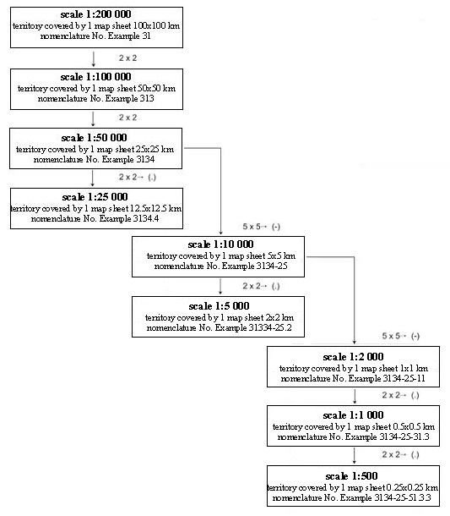

Acting for the Minister for Defence –
Minister for Justice G. Bērziņš

Annex 2
Cabinet Regulation No. 879
15 November 2011

Division of TKS-93 Map Sheets for Maps in Scale 1:200 000, 1:100 000 and 1:50 000

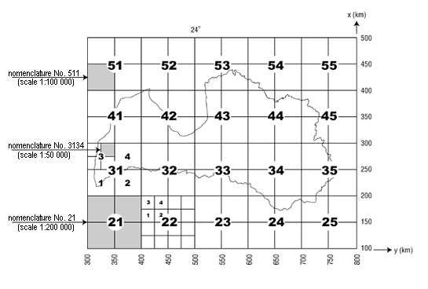

Acting for the Minister for Defence –
Minister for Justice G. Bērziņš

Annex 3
Cabinet Regulation No. 879
15 November 2011

Division of TKS-93 Map Sheets in Scale for Maps in Scale 1:25 000, 1:10 000, 1:5000, 1:2000, 1:1000 and 1:500

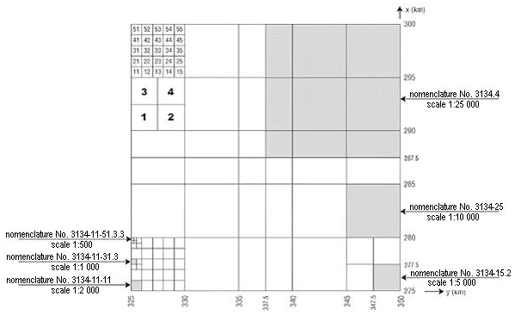

Acting for the Minister for Defence –
Minister for Justice G. Bērziņš

