Cabinet

Regulation No. 418
Adopted 31 May 2011

Regulations Regarding Water Bodies at Risk

Issued pursuant to
Section 5, Paragraph ten, Clause 11 of
the Water Management Law

1. This Regulation prescribes:
1.1. surface water bodies which are at risk of failing to meet good surface water status specified in the Water Management Law within the period of time provided for in the referred to law (hereinafter – water bodies at risk); and
1.2. the requirements for the protection of water bodies at risk.

2. List of the water bodies at risk – rivers and channel – and information concerning the municipalities and territorial units thereof (rural territories of a municipality and towns) included in the catchment area of these water bodies is provided for in Annex 1 to this Regulation.

3. List of the water bodies at risk – lakes and reservoirs – and information concerning in the territory of which municipalities and territorial units thereof (rural territories of a municipality and towns) these water bodies are located is provided for in Annex 2 to this Regulation.

4. List of the water bodies at risk – coastal waters or transitional waters – and information concerning the territory of which municipalities and territorial units thereof (rural territories of a municipality and towns) borders on these water bodies is provided for in Annex 3 to this Regulation.

5. Location of the water bodies at risk – rivers, channel, stretches of coastal waters or transitional waters – is specified:
5.1. for the river basin district of Daugava – in Annex 4 to this Regulation;
5.2. for the river basin district of Gauja – in Annex 5 to this Regulation;
5.3. for the river basin district of Lielupe – in Annex 6 to this Regulation; and
5.4. for the river basin district of Venta – in Annex 7 to this Regulation.

6. Public persons and private persons shall use or manage water resources in the water bodies referred to in Paragraphs 2, 3 and 4 of this Regulation, as well as use or plan to use the territories in the catchment area thereof so as to prevent or reduce the possible adverse impact on the water body concerned and improve the status thereof gradually, taking into account the requirements specified in the regulatory enactments:
6.1. regarding emission of polluting substances into water;
6.2. regarding the protection of water and soil from pollution with nitrates caused by agricultural activity;
6.3. regarding special environmental requirements for performance of polluting activities in animal housing;
6.4. regarding environmental impact assessment and regarding technical regulations for the activities for which the environmental impact assessment is not required;
6.5. regarding plant protection products and regarding activities with biocides;
6.6. regarding utilisation, monitoring and control of sewage sludge and the compost thereof;
6.7. regarding a permit for the use of water resources;
6.8. regarding amelioration and the operation and maintenance of amelioration systems;
6.9. regarding procedures for construction of amelioration systems and hydrotechnic structures;
6.10. regarding procedures for the cleaning and deepening of surface water bodies and port basins;
6.11. regarding nature protection regulations in forest management;
6.12. regarding the procedures for industrial accident risk assessment and reduction measures;
6.13. regarding protection zones;
6.14. regarding reduction and control of pollution and procedures for performance of polluting activities;
6.15. regarding rivers (stretches of rivers) on which for the purpose of protection of fish resources it is prohibited to build and renew dams of hydroelectric power plants and make any mechanical obstacles; and
6.16. regarding the construction, the management, closure and re-cultivation of landfill sites.

7. The State authorities shall develop development planning documents and plan and approve the commencement of activities intended for the implementation of the documents concerned so as to prevent or reduce adverse impact of the most significant causes of risks specified in Annex 1, 2 and 3 to this Regulation on the water bodies referred to in Paragraphs 2, 3 and 4 of this Regulation and thus facilitate the improvement of the status therein. Upon request of the State authorities the Ministry of Environmental Protection and Regional Development shall provide the information on whether particular objects or territories are located in the catchment area of water bodies at risk and what additional measures it is recommended to implement for the reduction of risk in each catchment area of a water body at risk.

8. In order to prevent or reduce possible adverse impact on chemical or ecological status of water bodies at risk (including hydrological and morphological status) and improve it gradually, the environment protection authorities (for example, the State Environmental Service) shall observe the most significant causes of risk specified in Annex 1, 2 and 3 to this Regulation and the following general protection requirements (the requirements referred to in this Paragraph are not applicable to internal water of port territories):
8.1. in compliance with regulatory enactments regarding surface water and groundwater quality and regarding requirements for the monitoring of surface water, groundwater and protected areas and the development of monitoring programmes shall review provisions, which have been included in the permit for Category A or B polluting activity or in the permit for the use of water resources in a water body at risk, assessing the necessity to reduce the determined emission limits or change the provisions for use of water resources;
8.2. in compliance with regulatory enactments regarding surface water and groundwater quality shall review the monitoring programme for water status and the permit provisions regarding the monitoring performed by the operator or user of water resources and, if necessary, shall make amendments therein in order to ensure the acquisition of the information specified in the regulatory enactments regarding the requirements for the monitoring of surface water, groundwater and protected areas and the development of monitoring programmes;
8.3. in compliance with regulatory enactments regarding environmental impact assessment shall evaluate the necessity to amend environmental protection requirements specified in the issued technical regulations for the intended activity at the place of occurrence thereof, if the technical regulations have been issued, but the referred to activity is not commenced up to the time when this Regulation comes into force; and
8.4. when setting provisions in the permit for Category A or B polluting activity, permit for use of water resources or technical regulations for new activities in the territory of water bodies at risk, shall observe the information regarding the status of water bodies at risk, causes of risk and objectives of the environmental quality which are specified in compliance with the Water Management Law.

9. In order to promote the achievement of the objectives specified in the Water Management Law in water bodies at risk, when developing policy planning documents for the attraction of the European Union financing in the planning period of finances of the European Union for 2013-2020, the measures allowing to reduce adverse impact on water bodies at risk quantitatively shall be included therein.

Prime Minister V. Dombrovskis

Minister for Environmental Protection and
Regional Development R.Vējonis

Annex 1
Cabinet Regulation
No. 418
31 May 2011

Water Bodies of Rivers and Channel which are at Risk of Failing to Meet Good Surface Water Status Specified in the Water Management Law within the Period of Time Provided for in the Law

Table 1
Rivers – water bodies at risk in the river basin district of Daugava
No. | Code | Name | Description of a stretch | Cities and municipalities in the catchment area of a water body (the rural territories of these municipalities and towns of municipalities)¹ | Most significant causes of risk
1. | D407 | (the River) Suda | From river source up to the mouth in (the River) Lielā Jugla | The municipality of Amata (the rural territory of Nītaure), the municipality of Līgatne (the rural territory of Līgatne), the municipality of Mālpils, the municipality of Sigulda (the rural territory of Allaži, the rural territory of More, the rural territory of Sigulda) | Diffuse pollution, hydromorphological modifications
2. | D413 SP | (the River) Daugava | From (the River) Ogre up to (the River) Langa | The municipality of Baldone, the municipality of Ikšķile, the municipality of Ķegums, the municipality of Ķekava, the municipality of Mārupe, the municipality of Ogre (the town of Ogre, the rural territory of Ogresgals), the municipality of Olaine, the city of Rīga, the municipality of Stopiņi, the municipality of Salaspils, the municipality of Vecumnieki (the rural territory of Vecumnieki) | Point source pollution (biogenic elements present in waste-water)
3. | D419 | (the River) Ogre | From (the River) Līčupe up to (the River) Lobe | The municipality of Aizkraukle (the rural territory of Aizkraukle), the municipality of Ērgļi (the rural territory of Sausnēja), the municipality of Koknese (the rural territory of Bebri, the rural territory of Irši, the rural territory of Koknese), the municipality of Lielvārde (the rural territory of Lēdmane), the municipality of Ogre (the rural territory of Krape, the rural territory of Mazozoli, the rural territory of Ķeipene, the rural territory of Madliena, the rural territory of Meņģele, the rural territory of Taurupe), the municipality of Skrīveri | Diffuse pollution, hydromorphological modifications
4. | D427 SP | (the River) Daugava | From (the River) Aiviekste up to (the River) Ogre | The municipality of Aizkraukle, the municipality of Jaunjelgava (the town of Jaunjelgava, the rural territory of Jaunjelgava, the rural territory of Sērene, the rural territory of Sece, the rural territory of Staburags, the rural territory of Sunākste), the municipality of Koknese (the town of Koknese, the rural territory of Koknese), the municipality of Ķegums, the municipality of Lielvārde, the municipality of Ogre (the rural territory of Krape, the town of Ogre, the rural territory of Ogresgals), the municipality of Pļaviņas (the rural territory of Aiviekste, the rural territory of Klintaine, the town of Pļaviņas), the municipality of Sala (the rural territory of Sēlpils), the municipality of Skrīveri, the municipality of Vecumnieki (the rural territory of Valle, the rural territory of Vecumnieki), the municipality of Viesīte (the town of Viesīte, the rural territory of Viesīte) | Point source pollution (biogenic elements present in waste-water) and diffuse pollution
5. | D437 | (the River) Kuja | From (the River) Padauklis up to (the River) Aiviekste | The municipality of Lubāna (the rural territory of Indrāni), the municipality of Madona (the rural territory of Dzelzava, the rural territory of Ļaudona, the rural territory of Prauliena, the rural territory of Sarkaņi) | Diffuse pollution, hydromorphological modifications
6. | D438 | (the River) Kuja | From the river source up to (the River) Padauklis | The municipality of Cesvaine, the municipality of Madona (the rural territory of Arona, the rural territory of Dzelzava, the rural territory of Lazdona, the rural territory of Liezēre, the town of Madona, the rural territory of Mārciena, the rural territory of Prauliena, the rural territory of Sarkaņi) | Point source pollution (biogenic elements present in waste-water) and diffuse pollution
7. | D439 | (the River) Isliena | From the river source up to the mouth in (the River) Aiviekste | The municipality of Krustpils (the rural territory of Atašiene), the municipality of Madona (the rural territory of Barkava, the rural territory of Mētriena), the municipality of Varakļāni (the rural territory of Murmastiene) | Point source pollution (biogenic elements present in waste-water) and diffuse pollution
8. | D451 | (the River) Bolupe | From the river source up to the mouth in (the River) Vecpededze | The municipality of Alūksne (the rural territory of Liepna), the municipality of Balvi (the town of Balvi, the rural territory of Balvi, the rural territory of Bērzkalne, the rural territory of Kubuli, the rural territory of Lazduleja, the rural territory of Vectilža, the rural territory of Vīksna), the municipality of Gulbene (the rural territory of Litene, the rural territory of Stradi), the municipality of Lubāna (the rural territory of Indrāni), the municipality of Rugāji, the municipality of Viļaka (the rural territory of Kuprava, the rural territory of Medņeva, the rural territory of Susāji, the rural territory of Žīguri) | Point source pollution (biogenic elements present in waste-water) and diffuse pollution, hydromorphological modifications
9. | D462 SP | (the River) Rēzekne | From (the River) Sūļupe up to (the Lake) Lubāna ezers | The municipality of Rēzekne (the rural territory of Gaigalava, the rural territory of Nagļi) | The impact of the water bodies present in the upstream
10. | D463 | (the River) Rēzekne | From (the Brook) Taudejāņi up to (the River) Sūļupe | The municipality of Rēzekne (the city of Rēzekne, the rural territory of Audriņi, the rural territory Čornaja, the rural territory of Gaigalava, the rural territory of Griškāni, the rural territory of Ilzeskalns, the rural territory of Kantinieki, the rural territory of Nagļi, the rural territory of Ozolaine, the rural territory of Ozolmuiža, the rural territory of Rikava, the rural territory of Sakstagals, the rural territory of Silmala, the rural territory of Vērēmi), the municipality of Viļāni (the rural territory of Sokolki, the rural territory of Viļāni) | Point source pollution (biogenic elements present in waste-water) and diffuse pollution
11. | D476 | (the River) Daugava | From (the River) Ūša/Oša up to (the River) Ziemeļsusēja | The town of Jēkabpils, the municipality of Jēkabpils (the rural territory of Ābeles, the rural territory of Dignāja), the municipality of Krustpils (the rural territory of Krustpils, the rural territory of Kūkas, the rural territory of Varieši, the rural territory of Vīpe), the municipality of Līvāni (the rural territory of Turki, the town of Līvāni), the municipality of Sala (the rural territory of Sala) | Point source pollution (biogenic elements present in waste-water) and diffuse pollution
12. | D480 SP | (the River) Feimanka | From the river source up to the mouth in (the River) Dubna | The municipality of Līvāni (the rural territory of Rožupe, the rural territory of Sutri), the municipality of Preiļi (the rural territory of Preiļi, the rural territory of Sauna), the municipality of Rēzekne (the rural territory of Feimaņi), the municipality of Riebiņi (the rural territory of Riebiņi, the rural territory of Rušona, the rural territory of Silajāņi), the municipality of Vārkava (the rural territory of Vārkava) | Diffuse pollution
13. | D494 | (the River) Līksna | From the river source up to the mouth in (the River) Daugava | The city of Daugavpils, the municipality of Daugavpils (the rural territory of Ambeļi, the rural territory of Biķernieki, the rural territory of Kalupe, the rural territory of Līksna, the rural territory of Maļinova, the rural territory of Naujene, the rural territory of Svente, the rural territory of Vabole, the rural territory of Višķi) | Diffuse pollution

Table 2
Rivers – water bodies at risk in the river basin district of Gauja
No. | Code | Name | Description of a stretch | Cities and municipalities in the catchment area of a water body (the rural territories of these municipalities and towns)¹ | Most significant causes of risk
1. | G205 | (the River) Gauja | From (the River) Brasla up to (the River) Lorupe | The municipality of Krimulda (the rural territory of Krimulda), the municipality of Līgatne (the rural territory of Līgatne), the municipality of Sigulda (the town of Sigulda, the rural territory of Sigulda) | Diffuse pollution
2. | G206 | (the River) Brasla | From the river source up to the mouth in (the River) Gauja | The municipality of Aloja (the rural territory of Brīvzemnieki), the municipality of Kocēni (the rural territory of Dikļi), the municipality of Krimulda, the municipality of Limbaži (the rural territory of Katvari, the rural territory of Limbaži, the rural territory of Umurga), the municipality of Pārgauja | Diffuse pollution and hydromorphological modifications
3. | G209 | (the River) Gauja | From (the River) Amata up to (the River) Brasla | The municipality of Amata (the rural territory of Amata, the rural territory of Drabeši, the rural territory of Nītaure), the municipality of Cēsis, the municipality of Līgatne, the municipality of Pārgauja, the municipality of Priekuļi (the rural territory of Priekuļi), the municipality of Sigulda (the rural territory of More, the rural territory of Sigulda) | Diffuse pollution
4. | G220 | (the River) Abuls | From the river source up to the mouth in (the River) Gauja | The municipality of Smiltene (the rural territory of Blome, the rural territory of Branti, the rural territory of Launkalne, the town of Smiltene, the rural territory of Smiltene), the municipality of Beverīna (the rural territory of Brenguļi, the rural territory of Trikāta), the municipality of Priekuļi (the rural territory of Mārsnēni), the municipality of Strenči (the rural territory of Plāņi), the municipality of Rauna | Point source pollution (biogenic elements present in waste-water) and diffuse pollution, hydromorphological modifications
5. | G229 | (the River) Vija | From the river source up to (the River) Kamalda | The municipality of Smiltene (the rural territory of Bilska, the rural territory of Grundzāle, the rural territory of Launkalne, the rural territory of Palsmane, the rural territory of Smiltene), the municipality of Strenči (the rural territory of Plāņi), the municipality of Valka (the rural territory of Vijciems, the rural territory of Zvārtava) | Diffuse pollution and hydromorphological modifications
6. | G242 | (the River) Vizla (Jaunpalsa) | From the river source of (the River) Palsa up to the mouth in (the River) Gauja | The municipality of Ape (the rural territory of Vireši), the municipality of Gulbene (the rural territory of Ranka), the municipality of Rauna (the rural territory of Drusti), the municipality of Smiltene (the rural territory of Grundzāle, the rural territory of Launkalne, the rural territory of Palsmane, the rural territory of Variņi), the municipality of Vecpiebalga (the rural territory of Dzērbene) | Hydromorphological modifications
7. | G261SP | (the River) Aģe | From (the River) Mazupīte up to the mouth | The municipality of Limbaži (the rural territory of Skulte), the municipality of Saulkrasti | Point source pollution (biogenic elements present in waste-water)
8. | G262 | (the River) Pēterupe | From the river source up to the mouth in the sea | The municipality of Limbaži (the rural territory of Vidriži), the municipality of Krimulda, the municipality of Saulkrasti, the municipality of Sēja | Point source pollution (biogenic elements present in waste-water) and hydromorphological modifications
9. | G264 | (the River) Aģe | From the river source up to (the River) Mazupīte | The municipality of Krimulda, the municipality of Salacgrīva (the rural territory of Liepupe), the municipality of Limbaži (the rural territory of Limbaži, the rural territory of Skulte, the rural territory of Vidriži) | Hydromorphological modifications
10 | G268 | (the River) Svētupe | From the river source up to the mouth in the sea | The municipality of Aloja (the rural territory of Aloja, the rural territory of Brīvzemnieki), the municipality of Limbaži (the rural territory of Katvari, the town of Limbaži, the rural territory of Limbaži, the rural territory of Pāle, the rural territory of Umurga, the rural territory of Viļķene), the municipality of Salacgrīva (the rural territory of Salacgrīva) | Point source pollution (biogenic elements present in waste-water), hydromorphological modifications
11. | G306 | (the River) Salaca | From the river source up to (the River) Iģe | The municipality of Aloja (the rural territory of Aloja, the rural territory of Braslava), the municipality of Burtnieki (the rural territory of Vecate), the municipality of Mazsalaca (the town of Mazsalaca, the rural territory of Mazsalaca, the rural territory of Ramata, the rural territory of Skaņkalne) | Point source pollution (biogenic elements present in waste-water), hydromorphological modifications
12. | G312 | (the River) Rūja | From the river source up to (the River) Sapraša | The municipality of Naukšēni, the municipality of Rūjiena, the municipality of Valka (the rural territory of Ērģeme, the rural territory of Kārķi) | Point source pollution (biogenic elements present in waste-water), flood risk

Table 3
Rivers and channel – water bodies at risk in the river basin district of Lielupe
No. | Code | Name | Description of a stretch | Cities and municipalities in the catchment area of a water body (the rural territories of these municipalities and towns)¹ | Most significant causes of risk
1. | L100 SP | (the River) Lielupe | From the bypass of the polder of (the River) Vecbērze up to (the River) Vecslocene | The municipality of Babīte, the municipality Engure (the rural territory of Lapmežciems), the municipality of Jelgava (the rural territory of Kalnciems, the rural territory of Valgunde), the city of Jūrmala, the city of Rīga, the municipality of Tukums (the rural territory of Džūkste, the rural territory of Slampe) | Diffuse pollution
2. | L106 SP | The bypass of the polder of (the River) Vecbērze | The entire river | The municipality of Dobele (the rural territory of Bērze, the rural territory of Dobele, the rural territory of Jaunbērze), the municipality of Jelgava (the rural territory of Kalnciems, the rural territory of Līvbērze, the rural territory of Valgunde), the municipality of Tukums (the rural territory of Degole, the rural territory of Džūkste, the rural territory of Irlava, the rural territory of Lestene, the rural territory of Slampe) | Diffuse pollution
3. | L107 | (the River) Lielupe | From (the River) Mēmele up to the bypass of the polder of (the River) Vecbērze | The municipality of Dobele (the rural territory of Jaunbērze), the municipality of Jelgava (the rural territory of Kalnciems, the town of Kalnciems, the rural territory of Līvbērze, the rural territory of Valgunde), the municipality of Ozolnieki (the rural territory of Cenas), the municipality of Babīte (the rural territory of Babīte), the municipality of Olaine (the rural territory of Olaine) | Hydromorphological modifications
4. | L108 SP | (the River) Svēte | From (the River) Tērvete up to (the River) Lielupe | The city of Jelgava, the municipality of Jelgava (the rural territory of Līvbērze) | Point source pollution (biogenic elements present in waste-water) and diffuse pollution
5. | L109 | (the River) Bērze | From (the River) Sesava up to (the River) Svēte | The municipality of Auce (the rural territory of Bēne, the rural territory of Īle), the municipality of Dobele (the rural territory of Auri, the rural territory of Bērze, the town of Dobele, the rural territory of Krimūni, the rural territory of Naudīte, the rural territory of Penkule), the municipality of Jelgava (the rural territory of Glūda, the rural territory of Līvbērze), the municipality of Tērvete (the rural territory of Tērvete) | Diffuse pollution
6. | L111 | (the River) Bērze | From the river source up to (the River) Sesava | The municipality of Dobele (the rural territory of Annenieki, the rural territory of Auri, the rural territory of Bērze, the rural territory of Biksti, the town of Dobele, the rural territory of Dobele, the rural territory of Krimūni, the rural territory of Naudīte, the rural territory of Zebrene), the municipality of Auce (the rural territory Īle, the rural territory of Lielauce, the rural territory of Vītiņi), the municipality of Brocēni (the rural territory of Blīdene, the rural territory of Remte), the municipality of Saldus (the rural territory of Zvārde), the municipality of Tukums (the rural territory of Džūkste), the municipality of Jaunpils (the rural territory of Jaunpils) | Point source pollution (biogenic elements present in waste-water) and diffuse pollution, hydromorphological modifications
7. | L114 | (the River) Bikstupe | From the river source up to the mouth in (the River) Bērze | The municipality of Brocēni (the rural territory of Blīdene, the rural territory of Remte), the municipality of Dobele (the rural territory of Annenieki, the rural territory of Biksti), the municipality of Jaunpils (the rural territory of Jaunpils), the municipality of Tukums (the rural territory of Džūkste) | Diffuse pollution
8. | L117 SP | (the River) Auce | From (the River) Rīgava up to (the River) Svēte | The municipality of Auce (the rural territory of Bēne), the municipality of Dobele (the rural territory of Auri, the rural territory of Bērze, the rural territory of Krimūni, the rural territory of Penkule), the municipality of Jelgava (the rural territory of Glūda, the rural territory of Līvbērze, the rural territory of Zaļenieki), the municipality of Tērvete (the rural territory of Bukaiši, the rural territory of Tērvete) | Diffuse pollution
9. | L118 | (the River) Auce | From the river source up to (the River) Rīgava | The municipality of Auce (the rural territory of Bēne, the rural territory of Īle, the rural territory of Lielauce, the rural territory of Vītiņi), the municipality of Dobele (the rural territory of Penkule, the rural territory of Zebrene) | Point source pollution (biogenic elements present in waste-water) and diffuse pollution
10. | L120 | (the River) Tērvete | From the river source up to the mouth in (the River) Svēte | The municipality of Dobele (the rural territory of Krimūni), the municipality of Tērvete, the municipality of Auce (the rural territory of Ukri), the municipality of Jelgava (the rural territory of Glūda, the rural territory of Līvbērze, the rural territory of Svēte, the rural territory of Vilce, the rural territory of Zaļenieki) | Point source pollution (biogenic elements present in waste-water), diffuse and transboundary pollution, hydromorphological modifications
11. | L121 | (the River) Skujaine | From the river source up to the mouth in (the River) Tērvete | The municipality of Auce (the rural territory of Bēne, the rural territory of Ukri, the rural territory of Vītiņi), the municipality of Dobele (the rural territory of Krimūni, the rural territory of Penkule), the municipality of Tērvete (the rural territory of Bukaiši, the rural territory of Tērvete) | Diffuse pollution, hydromorphological modifications
12. | L123 | (the River) Svēte | From the State border up to (the River) Svēte | The city of Jelgava, the municipality of Jelgava (the rural territory of Glūda, the rural territory of Līvbērze, the rural territory of Svēte, the rural territory of Vilce, the rural territory of Zaļenieki), the municipality of Tērvete (the rural territory of Augstkalne) | Point source pollution (biogenic elements present in waste-water) and transboundary pollution, hydromorphological modifications
13. | L124 | (the River) Vilce | From the river source up to the mouth in (the River) Svēte | The municipality of Jelgava (the rural territory of Vilce), the municipality of Tērvete (the rural territory of Augstkalne) | Transboundary pollution
14. | L143 | (the River) Lielupe | From the confluence of (the River) Mūsa and (the River) Mēmele up to (the River) Svēte | The municipality of Bauska (the town of Bauska, the rural territory of Code, the rural territory of Gailīši, the rural territory of Īslīce, the rural territory of Mežotne), the municipality of Iecava, the city of Jelgava, the municipality of Jelgava (the rural territory of Jaunsvirlauka, the rural territory of Līvbērze, the rural territory of Valgunde), the municipality of Ozolnieki, the municipality of Rundāle (the rural territory of Rundāle, the rural territory of Viesturi) | Point source pollution (biogenic elements present in waste-water) and diffuse pollution
15. | L144 SP | (the River) Platone | From (the Channel) Lielplatones Grāvis up to (the River) Lielupe | The city of Jelgava, the municipality of Jelgava (the rural territory of Eleja, the rural territory of Lielplatone, the rural territory of Platone, the rural territory of Svēte, the rural territory of Vilce, the rural territory of Vircava, the rural territory of Zaļenieki) | Diffuse pollution, hydromorphological modifications
16. | L146 | (the River) Platone | From the State border up to (the Channel) Lielplatones Grāvis | The municipality of Jelgava (the rural territory of Eleja, the rural territory of Lielplatone, the rural territory of Vilce) | Diffuse and transboundary pollution, hydromorphological modifications
17. | L147 | (the River) Vircava | From the river source up to the mouth in (the River) Lielupe | The city of Jelgava, the municipality of Jelgava (the rural territory of Eleja, the rural territory of Jaunsvirlauka, the rural territory of Lielplatone, the rural territory of Platone, the rural territory of Sesava, the rural territory of Vircava) | Diffuse and transboundary pollution, hydromorphological modifications
18. | L148 SP | (the River) Sesava | From the river source up to the mouth in (the River) Lielupe | The municipality of Jelgava (the rural territory of Jaunsvirlauka, the rural territory of Sesava, the rural territory of Vircava), the municipality of Ozolnieki (the rural territory of Cenas), the municipality of Rundāle (the rural territory of Viesturi) | Diffuse and transboundary pollution, hydromorphological modifications
19. | L149 | (the River) Svitene | From the river source up to the mouth in (the River) Lielupe | The municipality of Jelgava (the rural territory of Jaunsvirlauka, the rural territory of Sesava, the rural territory of Vircava), the municipality of Ozolnieki (the rural territory of Salgale), the municipality of Rundāle | Diffuse and transboundary pollution, hydromorphological modifications
20. | L153 | (the River) Īslīce | From the river source up to the mouth in (the River) Lielupe | The municipality of Bauska (the rural territory of Gailīši, the rural territory of Īslīce), the municipality of Jelgava (the rural territory of Jaunsvirlauka), the municipality of Rundāle | Point source pollution (biogenic elements present in waste-water) and transboundary pollution, hydromorphological modifications
21. | L159 | (the River) Mērmele | From the State border up to the confluence with (the River) Mūsa | The municipality of Aknīste (the rural territory of Aknīste, the rural territory of Gārsene), the municipality of Bauska (the town of Bauska, the rural territory of Brunava, the rural territory of Ceraukste, the rural territory of Code, the rural territory of Dāviņi, the rural territory of Vecsaule), the municipality of Nereta, the municipality of Rundāle (the rural territory of Rundāle), the municipality of Vecumnieki (the rural territory of Kurmene, the rural territory of Skaistkalne), the municipality of Viesīte (the rural territory of Elkšņi, the rural territory of Rite) | Diffuse and transboundary pollution, flood risk
22. | L169 | (the River) Dienvidsusēja | (The River) Dienvidsusēja from the State border up to (the River) Salāte | The municipality of Nereta (the rural territory of Nereta), the municipality of Ilūkste (the rural territory of Prode), the municipality of Aknīste, the municipality of Viesīte, the municipality of Jēkabpils (the rural territory of Kalns, the rural territory of Leimaņi, the rural territory of Rubene, the rural territory of Zasa) | Point source pollution (biogenic elements present in waste-water), diffuse and transboundary pollution, flood risk
23. | L176 | (the River) Mūsa | From the State border up to the confluence with (the River) Mēmele | The municipality of Bauska (the town of Bauska, the rural territory of Brunava, the rural territory of Ceraukste, the rural territory of Code, the rural territory of Gailīši, the rural territory of Īslīce), the municipality of Rundāle (the rural territory of Rundāle) | Point source pollution (biogenic elements present in waste-water), diffuse and transboundary pollution

Table 4
Rivers – water bodies at risk in the river basin district of Venta
No. | Code | Name | Description of a stretch | Cities and municipalities in the catchment area of a water body (the rural territories of these municipalities and towns)¹ | Most significant causes of risk
1. | V004 | (the River) Ālande | From the river source up to the mouth in (the Lake) Liepājas ezers | The municipality of Durbe (the rural territory of Tadaiķi), the municipality of Grobiņa (the rural territory of Gavieze, the town of Grobiņa, the rural territory of Grobiņa, the rural territory of Medze), the city of Liepāja, the municipality of Pāvilosta (the rural territory of Vērgale) | Point source pollution (biogenic elements present in waste-water) and diffuse pollution
2. | V010 | (the River) Bārta | From (the River) Apše up to (the River) Vārtāja | The municipality of Priekule (the rural territory of Kalēti), the municipality of Rucava (the rural territory of Dunika) | Transboundary pollution, flood risk
3. | V015 | (the River) Alokste | From the river source up to the mouth in (the River) Tebra | The municipality of Aizpute (the rural territory of Kalvene, the rural territory of Kazdanga, the rural territory of Laža), the municipality of Kuldīga (the rural territory of Laida, the rural territory of Turlava), the municipality of Skrunda (the rural territory of Rudbārži) | Point source pollution (biogenic elements present in waste-water) and diffuse pollution
4. | V041 | (the River) Viesata | From the river source up to the mouth in (the River) Abava | The municipality of Brocēni (the rural territory of Blīdene, the rural territory of Remte), the municipality of Tukums (the rural territory of Irlava), the municipality of Jaunpils, the municipality of Kuldīga (the rural territory of Zante, the rural territory of Zemīte) | Diffuse pollution
5. | V043 | (the River) Venta | From (the River) Eda up to (the River) Abava | The municipality of Kuldīga (the rural territory of Ēdole, the rural territory of Īvande, the town of Kuldīga, the rural territory of Kurmāle, the rural territory of Padure, the rural territory of Pelči, the rural territory of Renda, the rural territory of Rumba) | The impact of water bodies in the upstream
6. | V046 | (the River) Ēda | From the river source up to the mouth in (the River) Venta | The municipality of Kandava (the rural territory of Vāne), the municipality of Kuldīga (the rural territory of Kabile, the rural territory of Rumba, the rural territory of Vārme), the municipality of Saldus (the rural territory of Jaunlutriņi, the rural territory of Lutriņi, the rural territory of Šķēde, the rural territory of Zirņi) | Diffuse pollution, hydromorphological modifications
7. | V049 | (the River) Venta | From (the River) Ciecere up to (the River) Ēda | The municipality of Aizpute (the rural territory of Kalvene), the municipality of Kuldīga (the rural territory of Laidi, the rural territory of Pelči, the rural territory of Snēpele, the rural territory of Turlava, the rural territory of Vārme), the municipality of Saldus (the rural territory of Jaunlutriņi, the rural territory of Lutriņi, the rural territory of Zirņi), the municipality of Skrunda (the rural territory of Raņķi, the rural territory of Rudbārži, the town of Skrunda, the rural territory of Skrunda) | Diffuse pollution, hydromorphological modifications, flood risk, the impact of a water body in the upstream
8. | V060 | (the River) Zaņa | From the river source up to the mouth in (the River) Venta | The municipality of Saldus (the rural territory of Ezere, the rural territory of Kursīši, the rural territory of Novadnieki, the rural territory of Pampāļi, the rural territory of Zaņa, the rural territory of Zvārde) | Diffuse pollution, hydromorphological modifications
9. | V082 | (the River) Roja | From (the River) Mazroja up to (the River) Vecupe | The municipality of Dundaga (the rural territory of Dundaga), the municipality of Roja, the municipality of Talsi (the rural territory of Ārlava, the rural territory of Īve, the rural territory of Lube) | Point source pollution (biogenic elements present in waste-water) and diffuse pollution, hydromorphological modifications
10. | V089 SP | (the River) Roja with (the River) Mazupīte | From (the River) Vecupe up to the mouth | The Municipality of Roja | Point source pollution (biogenic elements present in waste-water), flood risk, the impact of water body in the upstream
11. | V091 | (the River) Slocene | From (the River) Vašleja up to (the Lake) Kaņiera ezers | The municipality of Engure, the municipality of Tukums (the rural territory of Sēme, the rural territory of Slampe, the town of Tukums, the rural territory of Tume) | Point source pollution (biogenic elements present in waste-water) and diffuse pollution
12. | V093 | (the River) Slocene | From the river source up to (the River) Vašleja | The municipality of Engure (the rural territory of Smārde), the municipality of Tukums (the rural territory of Degole, the rural territory of Jaunsāti, the rural territory of Slampe, the town of Tukums, the rural territory of Tume) | Diffuse pollution, hydromorphological modifications
Notes.
1. Rural territories of municipalities and towns of municipalities shall be specified, if all territorial units of the municipality are not located in the catchment area of a water body.
2. The words “biogenic elements” mean inorganic and organic nitrogen and phosphorus compounds (in lakes – mostly phosphorus compounds).

Minister for Environmental Protection and
Regional Development R.Vējonis

Annex 2
Cabinet Regulation
No. 418
31 May 2011

Water Bodies of Lakes and Reservoirs which are at Risk of Failing to Meet Good Surface Water Status Specified in the Water Management Law within the Period of Time Provided for in the Law

Table 1
Lakes – water bodies at risk in the river basin district of Daugava
No. | Name | Cities and municipalities (rural territories of the municipality and towns of the municipality)¹ in the territory of which such water bodies are located | Most significant causes of risk
1. | (the Lake) Šuņezers | The city of Daugavpils | Point source pollution (biogenic elements present in waste-water), point and diffuse pollution sources not yet surveyed are possible
2. | (the Lake) Ķīšezers | The city of Rīga | Diffuse pollution
3. | (the Lake) Lielais Baltezers | The municipality of Ādaži, the municipality of Garkalne
4. | (the Lake) Mazais Baltezers | The municipality of Ādaži
5. | (the Lake) Gulbēra ezers | The municipality of Madona (the rural territory of Liezēre) | Diffuse pollution
6. | (the Lake) Lielais Līdēra ezers | The municipality of Madona (the rural territory of Arona) | Diffuse pollution
7. | (the Lake) Ineša ezers | The municipality of Vecpiebalga (the rural territory of Ineši) | Diffuse pollution
8. | (the Lake) Kaņepēnu ezers | The municipality of Madona (the rural territory of Bērzaune, the rural territory of Vestiena) | Point source pollution (biogenic elements present in waste-water)
9. | (the Lake) Sāvienas ezers | The municipality of Madona (the rural territory of Ļaudona) | Point source pollution (biogenic elements present in waste-water) and diffuse pollution
10. | (the Lake) Ludza ezers | The municipality of Gulbene (the rural territory of Stāmeriena)
11. | (the Lake) Lubāna ezers | The municipality of Madona (the rural territory of Barkava, the rural territory of Ošupe), the municipality of Rēzekne (the rural territory of Gaigalava, the rural territory of Nagļi) | Pollution brought by (the River) Rēzekne
12. | (the Lake) Tiskādu ezers (Ciskada ezers) | The municipality of Rēzekne (the rural territory of Silmala) | Point source pollution (biogenic elements present in waste-water)
13. | (the Lake) Virtūkšņa ezers (Vertūkšņas ezers) | The municipality of Rēzekne (the rural territory of Lūznava, the rural territory of Malta) | Point source pollution (biogenic elements present in waste-water)
14. | (the Lake) Bižas ezers | The municipality of Ludza (the rural territory of Cirma), the municipality of Rēzekne (the rural territory of Griškāni)
15. | (the Lake) Križutu ezers | The municipality of Ludza (the rural territory of Cirma), the municipality of Rēzekne (the rural territory of Griškāni)
16. | (the Lake) Pārtavas ezers | The municipality of Rēzekne (the rural territory of Kaunata)
17. | (the Lake) Ismeru-Žogotu ezers | The municipality of Rēzekne (the rural territory of Čornaja, the rural territory of Lūznava) | Diffuse pollution
18. | (the Lake) Baļotes ezers | The municipality of Krustpils (the rural territory of Kūkas) | Point source pollution (biogenic elements present in waste-water)
19. | (the Lake) Vīķu ezers | The municipality of Sala (the rural territory of Sēlpils) | Point source pollution (biogenic elements present in waste-water)
20. | (the Lake) Salmeja ezers | The municipality of Riebiņi (the rural territory of Rušona) | Diffuse pollution
21. | (the Lake) Feimaņu ezers | The municipality of Rēzekne (the rural territory of Feimaņi), the municipality of Riebiņi (the rural territory of Rušona)
22. | (the Lake) Lielais Kalupes ezers (Salenieku ezers) | The municipality of Daugavpils (the rural territory of Kalupe), the municipality of Vārkava (the rural territory of Rožkalni)
23. | (the Lake) Mazais Kalupes (Keišu) ezers | The municipality of Daugavpils (the rural territory of Kalupe) | Hydromorphological modifications
24. | (the Lake) Eikša ezers | The municipality of Riebiņi (the rural territory of Rušona) | Diffuse pollution
25. | (the Lake) Pelēča ezers | The municipality of Preiļi (the rural territory of Aizkalne, the rural territory of Pelēči) | Diffuse pollution, hydromorphological modifications
26. | (the Lake) Vīragnas ezers | The municipality of Daugavpils (the rural territory of Višķi, the rural territory of Dubna), the municipality of Preiļi (the rural territory of Pelēči) | Diffuse pollution, hydromorphological modifications
27. | (the Lake) Ciriša ezers | The municipality of Aglona (the rural territory of Aglona) | Point source pollution (biogenic elements present in waste-water)
28. | (the Lake) Rušona ezers | The municipality of Aglona (the rural territory of Aglona, the rural territory of Kastuļina), the municipality of Rēzekne (the rural territory of Feimaņi, the rural territory of Puša), the municipality of Riebiņi (the rural territory of Rušona) | Diffuse pollution
29. | (the Lake) Černostes ezers | The municipality of Rēzekne (the rural territory of Feimaņi, the rural territory of Malta) | Diffuse pollution
30. | (the Lake) Aksenavas ezers | The municipality of Aglona (the rural territory of Šķeltova) | Diffuse pollution, hydromorphological modifications
31. | (the Lake) Šēnheidas ezers | The municipality of Daugavpils (the rural territory of Skrudaliena) | Point source pollution (biogenic elements present in waste-water)
32. | (the Lake) Dagdas ezers | The municipality of Dagda (the rural territory of Svariņi, the rural territory of Dagda, the town of Dagda, the rural territory of Asūne) | Point source pollution (biogenic elements present in waste-water)
33. | (the Lake) Viļakas ezers | The municipality of Viļaka (the town of Viļaka) | Point source pollution (biogenic elements present in waste-water)
34. | (the Lake) Pildas ezers | The municipality of Ludza (the rural territory of Isnauda, the rural territory of Ņukši) | Diffuse pollution
35. | (the Lake) Lielais Ludzas Ezers | The municipality of Cibla (the rural territory of Zvirgzdene), the municipality of Ludza (the rural territory of Cirma, the town of Ludza, the rural territory of Isnauda) | Point source pollution (biogenic elements present in waste-water)
36. | (the Lake) Dziļezers | The municipality of Ludza (the rural territory of Istra) | Point source pollution (biogenic elements present in waste-water)
37. | (the Lake) Plisūna ezers (Plusons, Dunduru ezers) | The municipality of Dagda (the rural territory of Šķaune), the municipality of Ludza (the rural territory of Istra)
38. | (the Lake) Zilezers | The municipality of Cibla (the rural territory of Līdumnieki), border with Russia

Table 2
Lakes – water bodies at risk in the river basin district of Gauja
No. | Name | Municipalities (rural territories of the municipality)¹ in the territory of which such water bodies are located | Most significant causes of risk
1. | (the Lake) Sārumezers | The municipality of Pārgauja (the rural territory of Straupe)
2. | (the Lake) Katvaru ezers | The municipality of Limbaži (the rural territory of Katvari) | Point source pollution (biogenic elements present in waste-water) and diffuse pollution
3. | (the Lake) Vaidavas ezers | The municipality of Alūksne (the rural territory of Ziemers) | Point source pollution (biogenic elements present in waste-water)
4. | (the Lake) Riebezers | The municipality of Limbaži (the rural territory of Limbaži) | Hydromorphological modifications
5. | (the Lake) Lādes ezers | The municipality of Limbaži (the rural territory of Limbaži) | Point source pollution (biogenic elements from waste-water)
6. | (the Lake) Dūņezers | The municipality of Limbaži (the rural territory of Limbaži) | Point source pollution (biogenic elements from waste-water)
7. | (the Lake) Burtnieku ezers | The municipality of Burtnieki (the rural territory of Burtnieki, the rural territory of Matīši, the rural territory of Vecate) | Diffuse and historical pollution

Table 3
Lakes – water bodies at risk in the river basin district of Lielupe
No. | Name | Cities and municipalities (rural territories of the municipality)¹ in the territory of which such water bodies are located | Most significant causes of risk
1. | (the Lake) Babītes ezers | The municipality of Babīte (the rural territory of Babīte, the rural territory of Sala), the city of Jūrmala | Point source pollution (biogenic elements present in waste-water) and diffuse pollution, hydromorphological modifications
2. | (the Lake) Zebrus ezers | The municipality of Dobele (the rural territory of Biksti, the rural territory of Zebrene) | Hydromorphological modifications
3. | (the Lake) Viesītes ezers | The municipality of Viesīte (the rural territory of Viesīte)
4. | (the Lake) Saukas ezers | The municipality of Viesīte (the rural territory of Elkšņi, the rural territory of Sauka) | Point source pollution (biogenic elements present in waste-water)
5. | (the Lake) Garais ezers (Akmeņu ezers, Ilzes ezers) | The municipality of Viesīte (the rural territory of Rite) | Transboundary pollution
6. | (the Lake) Krīgānu ezers | The municipality of Viesīte (the rural territory of Rite) | Diffuse pollution

Table 4
Lakes and reservoirs – water bodies at risk in the river basin district of Venta
No. | Name | Cities and municipalities (rural territories and towns of the municipality)¹ in the territory of which such water bodies are located | Most significant causes of risk
1. | (the Lake) Liepājas Ezers | The municipality of Grobiņa (the rural territory of Grobiņa), the city of Liepāja, the municipality of Nīca | Point source pollution (biogenic elements present in waste-water), the impact of sea water possible
2. | (the Lake) Tosmares ezers | The municipality of Grobiņa (the rural territory of Medze), the city of Liepāja | Point source pollution (biogenic elements present in waste-water)
3. | The reservoir of Prūši | The municipality of Priekule (the rural territory of Virga) | Point source pollution (biogenic elements present in waste-water), hydromorphological modifications
4. | (the Lake) Sepenes ezers | The municipality of Aizpute (the rural territory of Kalvene), the municipality of Vaiņode (the rural territory of Embūte) | Diffuse pollution
5. | (the Lake) Durbes Ezers | The municipality of Durbe | Diffuse pollution
6. | (the Lake) Remtes ezers | The municipality of Brocēni (the rural territory of Remte) | Diffuse pollution
7. | The reservoir of Pakuļi HPP | The municipality of Saldus (the rural territory of Zirņi, the rural territory of Lutriņi) | The impact of flowthrough river possible
8. | (the Lake) Cieceres ezers | The municipality of Brocēni (the town of Brocēni, the rural territory of the town of Brocēni), the municipality of Saldus (the rural territory of Novadnieki) | Point source pollution (biogenic elements present in waste-water)
9. | (the Lake) Lubezers | The municipality of Talsi (the town of Valdemārpils) | Point source pollution (biogenic elements present in waste-water)
10. | (the Lake) Sasmakas ezers (Valdemārpils ezers, Ārlavas ezers) | The municipality of Talsi (the rural territory of Laidze, the town of Valdemārpils) | Point source pollution (biogenic elements present in waste-water) and diffuse pollution
11. | (the Lake) Laidzes ezers | The municipality of Talsi (the rural territory of Laidze) | Point source pollution (biogenic elements present in waste-water) and historical pollution, hydromorphological modifications
12. | (the Lake) Valguma ezers | The municipality of Engure (the rural territory of Smārde) | Point source pollution (biogenic elements present in waste-water), the impact of flowthrough river Slocene
Notes.
1. Rural territories of municipalities and towns of municipalities shall be specified, if all territorial units of the municipality are not located in the catchment area of a water body.
2. The words “biogenic elements” mean inorganic and organic nitrogen and phosphorus compounds (in lakes – mostly phosphorus compounds).

Minister for Environmental Protection and
Regional Development R.Vējonis

Annex 3
Cabinet Regulation
No. 418
31 May 2011

Transitional Water Body and Coastal Water Bodies which are at Risk of Failing to Meet Good Surface Water Status Specified in the Water Management Law within the Period of Time Provided for in the Law

Table 1
Transitional water body – body at risk
No. | Name | Borders of a water body |  |  | Cities and municipalities (rural territories of such municipalities)³ the territory of which borders with such water body | Most significant causes of risk
No. | Name | description | longitude¹ | latitude² |  | Most significant causes of risk
1. | Transitional water body | The length of coastline – 64.63 km. The sea border is formed by a curved line which connects the points with the following coordinates: |  |  | The municipality of Saulkrasti,  the municipality of Carnikava  the city of Rīga,  the city of Jūrmala,  the municipality of Engure (the rural territory of Lapmežciems) | Pollution brought by rivers, transboundary pollution
1. | Transitional water body | 1.1. coast at the village of Bigauņciems | 23°33.50’ | 56°58.80’ |  | Pollution brought by rivers, transboundary pollution
1. | Transitional water body | 1.2. | 23°38.50’ | 57°04.25’ |  | Pollution brought by rivers, transboundary pollution
1. | Transitional water body | 1.3. | 23°53.80’ | 57°14.00’ |  | Pollution brought by rivers, transboundary pollution
1. | Transitional water body | 1.4. | 24°22.20’ | 57°15.45’ |  | Pollution brought by rivers, transboundary pollution
1. | Transitional water body | 1.5. coast at the mouth of (the River) Inčupe in the town of Saulkrasti | 24°24.10’ | 57°15.20’ |  | Pollution brought by rivers, transboundary pollution
Notes.
1. Geographic coordinates of the sea borders of a transitional water body: East longitude (GGMMSS ) – degrees (G), minutes (M), seconds (S)).
2. Geographic coordinates of the sea borders of a transitional water body: North latitude (GGMMSS ) – degrees (G), minutes (M), seconds (S)).
3. Rural territories of municipalities shall be specified if all territorial units of the municipality do not border with a water body.

Table 2
Coastal water bodies – bodies at risk
No. | Name | Borders of a water body |  |  | Cities and municipalities (rural territories of such municipalities and towns of municipalities)³ the territory of which borders with such water body | Most significant causes of risk
No. | Name | description | longitude¹ | latitude² |  | Most significant causes of risk
1. | Coastal water body A | The length of coastline – 88.81 km. Borders with a coastline and line which connects the points with the following geographic coordinates: |  |  | The municipality of Rucava (the rural territory of Rucava), the municipality of Nīca (the rural territory of Nīca), the city of Liepāja, the municipality of Pāvilosta | Transboundary pollution, flood risk, inland water status
1. | Coastal water body A | 1.1. coast at the border with Lithuania | 21°03.80’ | 56°04.20’ |  | Transboundary pollution, flood risk, inland water status
1. | Coastal water body A | 1.2. | 21°02.00’ | 56°03.90’ |  | Transboundary pollution, flood risk, inland water status
1. | Coastal water body A | 1.3. | 20°56.90’ | 56°13.30’ |  | Transboundary pollution, flood risk, inland water status
1. | Coastal water body A | 1.4. | 20°56.30’ | 56°22.40’ |  | Transboundary pollution, flood risk, inland water status
1. | Coastal water body A | 1.5. | 20°57.20’ | 56°31.30’ |  | Transboundary pollution, flood risk, inland water status
1. | Coastal water body A | 1.6. | 21°01.50’ | 56°41.65’ |  | Transboundary pollution, flood risk, inland water status
1. | Coastal water body A | 1.7. | 21°01.30’ | 56°50.60’ |  | Transboundary pollution, flood risk, inland water status
1. | Coastal water body A | 1.8. coast at the lighthouse of (the Cape) Akmeņrags | 21°03.40’ | 56°49.90’ |  | Transboundary pollution, flood risk, inland water status
2. | Coastal water body B | The length of coastline – 156.76 km. Borders with a coastline and line which connects the points with the following geographic coordinates: |  |  | The municipality of Pāvilosta (the rural territory of Saka), the municipality of Ventspils (the rural territory of Jūrkalne, the rural territory of Užava, the rural territory of Vārve, the rural territory of Tārgale), the city of Ventspils, the municipality of Dundaga (the rural territory of Kolka) | Flood risk, inland water status
2. | Coastal water body B | 2.1. Coast at the lighthouse of (the Cape) Akmeņrags | 21°03.40’ | 56°49.90’ |  | Flood risk, inland water status
2. | Coastal water body B | 2.2. | 21°01.30’ | 56°50.60’ |  | Flood risk, inland water status
2. | Coastal water body B | 2.3. | 21°21.80’ | 57°01.95’ |  | Flood risk, inland water status
2. | Coastal water body B | 2.4. | 21°22.80’ | 57°16.10’ |  | Flood risk, inland water status
2. | Coastal water body B | 2.5. | 21°23.60’ | 57°18.50’ |  | Flood risk, inland water status
2. | Coastal water body B | 2.6. | 21°40.50’ | 57°35.20’ |  | Flood risk, inland water status
2. | Coastal water body B | 2.7. | 22°37.10’ | 57°46.90’ |  | Flood risk, inland water status
2. | Coastal water body B | 2.8. coast at (the Cape) Kolkasrags | 22°36.20’ | 57°45.50’ |  | Flood risk, inland water status
3. | Coastal water body C | The length of coastline – 40.91 km. Borders with a coastline and line which connects the points with the following geographic coordinates: |  |  | The municipality of Dundaga (the rural territory of Kolka), the municipality of Roja | Flood risk, inland water status
3. | Coastal water body C | 3.1. coast at (the Cape) Kolkasrags | 22°36.20’ | 57°45.50’ |  | Flood risk, inland water status
3. | Coastal water body C | 3.2. | 22°37.10’ | 57°46.90’ |  | Flood risk, inland water status
3. | Coastal water body C | 3.3. | 22°52.00’ | 57°30.20’ |  | Flood risk, inland water status
3. | Coastal water body C | 3.4. | 22°55.30’ | 57°28.90’ |  | Flood risk, inland water status
3. | Coastal water body C | 3.5. coast at the village of Kaltene | 22°53.00’ | 57°27.65’ |  | Flood risk, inland water status
4. | Coastal water body D | The length of coastline – 45.69 km. Borders with a coastline and line which connects the points with the following geographic coordinates: |  |  | The municipality of Roja, the municipality of Mērsrags, the municipality of Engure (the rural territory of Engure) | Flood risk, inland water status
4. | Coastal water body D | 4.1. coast at the village of Kaltene | 22°53.00’ | 57°27.65’ |  | Flood risk, inland water status
4. | Coastal water body D | 4.2. | 22°55.30’ | 57°28.90’ |  | Flood risk, inland water status
4. | Coastal water body D | 4.3. | 23°09.00’ | 57°22.45’ |  | Flood risk, inland water status
4. | Coastal water body D | 4.4. | 23°15.40’ | 57°00.60’ |  | Flood risk, inland water status
4. | Coastal water body D | 4.5. coast at the lighthouse of the village of Engure | 23°13.95’ | 57°10.00’ |  | Flood risk, inland water status
5. | Coastal water body E | The length of coastline – 32.8 km. Borders with a coastline and line which connects the points with the following geographic coordinates: |  |  | The municipality of Engure | Inland water status
5. | Coastal water body E | 5.1. coast at the lighthouse of the village of Engure | 23°13.95’ | 57°10.00’ | The municipality of Engure | Inland water status
5. | Coastal water body E | 5.2. | 23°15.40’ | 57°00.60’ | The municipality of Engure | Inland water status
5. | Coastal water body E | 5.3. | 23°25.10’ | 57°03.20’ | The municipality of Engure | Inland water status
5. | Coastal water body E | 5.4. | 23°38.50’ | 57°04.25’ | The municipality of Engure | Inland water status
5. | Coastal water body E | 5.5. coast at the village of Bigauņciems | 23°33.60’ | 56°58.80’ | The municipality of Engure | Inland water status
6. | Coastal water body F | The length of coastline – 73.83 km. Borders with a coastline and line which connects the points with the following geographic coordinates: |  |  | The municipality of Saulkrasti, the municipality of Limbaži (the rural territory of Skulte), the municipality of Salacgrīva (the rural territory of Liepupe, the rural territory of Salacgrīva, the town of Salacgrīva, the town of Ainaži, the rural territory of Ainaži) | Transboundary pollution, inland water status
6. | Coastal water body F | 6.1. coast at the mouth of (the River) Inčupe in the town of Saulkrasti | 24°24.10’ | 57°15.20’ |  | Transboundary pollution, inland water status
6. | Coastal water body F | 6.2. | 24°22.20’ | 57°15.45’ |  | Transboundary pollution, inland water status
6. | Coastal water body F | 6.3. | 24°19.40’ | 57°42.00’ |  | Transboundary pollution, inland water status
6. | Coastal water body F | 6.4. | 24°18.10’ | 57°49.50’ |  | Transboundary pollution, inland water status
6. | Coastal water body F | 6.5. | 24°19.35’ | 57°53.25’ |  | Transboundary pollution, inland water status
6. | Coastal water body F | 6.6. coast at the border of Estonia | 24°21.10’ | 57°52.50’ |  | Transboundary pollution, inland water status
Notes.
1. Geographic coordinates of the sea borders of coastal water bodies: East longitude (GGMMSS ) – degrees (G), minutes (M), seconds (S)).
2. Geographic coordinates of the sea borders of coastal water bodies: North latitude (GGMMSS ) – degrees (G), minutes (M), seconds (S)).
3. Rural territories of municipalities and towns of municipalities shall be specified if all territorial units of the municipality do not border with a water body.

Minister for Environmental Protection and
Regional Development R.Vējonis

Annex 4
Cabinet Regulation
No. 418
31 May 2011

River Basin District of Daugava
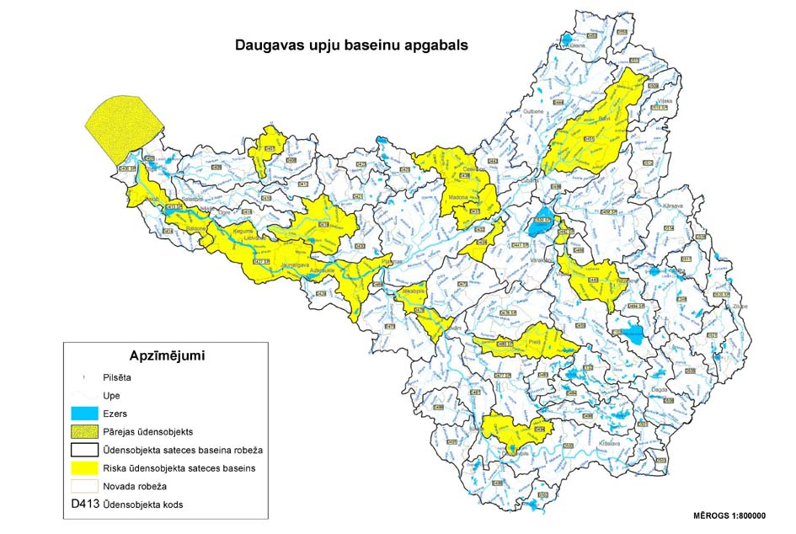

Designations | Apzīmējumi
Town/city | Pilsēta
River | Upe
Lake | Ezers
Transitional water body | Pārejas ūdensobjekts
Boundary of catchment area of a water body | Ūdensobjekta sateces baseina robeža
Catchment area of a water body at risk | Riska ūdensobjekta sateces baseins
Border of the municipality | Novada robeža
Code of a water body | Ūdensobjekta kods
Scale | Mērogs

Minister for Environmental Protection and
Regional Development R.Vējonis

Annex 5
Cabinet Regulation
No. 418
31 May 2011

River Basin District of Gauja
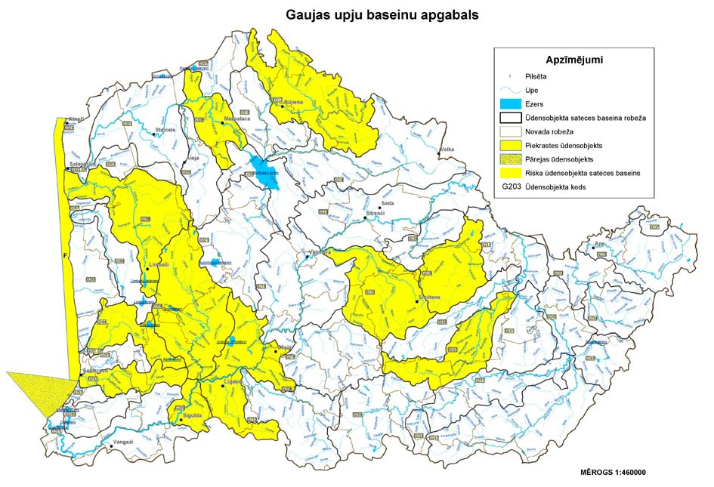

Designations | Apzīmējumi
Town/city | Pilsēta
River | Upe
Lake | Ezers
Boundary of catchment area of a water body | Ūdensobjekta sateces baseina robeža
Border of the municipality | Novada robeža
Coastal water body | Piekrastes ūdensobjekts
Transitional water body | Pārejas ūdensobjekts
Catchment area of a water body at risk | Riska ūdensobjekta sateces baseins
Code of a water body | Ūdensobjekta kods
Scale | Mērogs

Minister for Environmental Protection and
Regional Development R.Vējonis

Annex 6
Cabinet Regulation
No. 418
31 May 2011

River Basin District of Lielupe
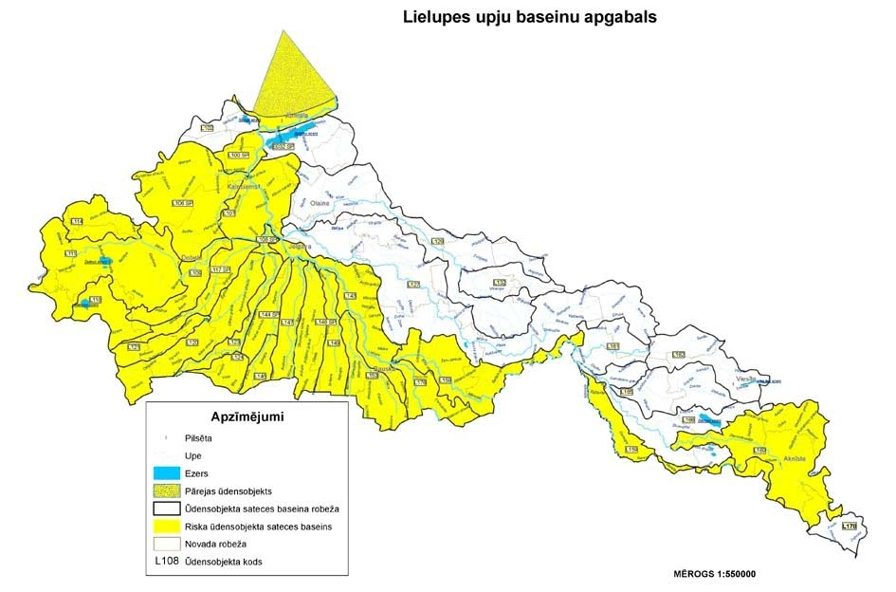
Designations | Apzīmējumi
Town/city | Pilsēta
River | Upe
Lake | Ezers
Transitional water body | Pārejas ūdensobjekts
Boundary of catchment area of a water body | Ūdensobjekta sateces baseina robeža
Catchment area of a water body at risk | Riska ūdensobjekta sateces baseins
Border of the municipality | Novada robeža
Code of a water body | Ūdensobjekta kods
Scale | Mērogs

Minister for Environmental Protection and
Regional Development R.Vējonis

Annex 7
Cabinet Regulation
No. 418
31 May 2011

River Basin District of Venta
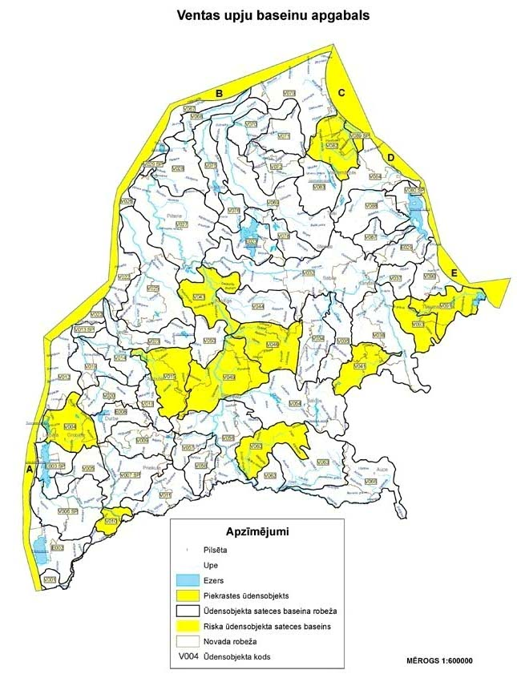

Designations | Apzīmējumi
Town/city | Pilsēta
River | Upe
Lake | Ezers
Coastal water body | Piekrastes ūdensobjekts
Boundary of catchment area of a water body | Ūdensobjekta sateces baseina robeža
Catchment area of a water body at risk | Riska ūdensobjekta sateces baseins
Border of the municipality | Novada robeža
Code of a water body | Ūdensobjekta kods
Scale | Mērogs

Minister for Environmental Protection and
Regional Development R.Vējonis

