Republic of Latvia

Cabinet
Regulation No 450
Adopted 26 June 2012

Regulations Regarding the Document Specimen Certifying Disability, the Procedures for the Issuance and Record-keeping of the Document

Issued pursuant to
Section 5, Paragraph three of the Disability Law

1. This Regulation prescribes the document specimen certifying disability, as well as the procedures for the issuance and record-keeping of the document.

2. A document certifying disability is the disability certificate (hereinafter – certificate) (Annex 1).

3. The certificate shall be a numbered document of strict accountability.

4. The certificate shall be issued by the State Medical Commission for the Assessment of Health Condition and Working Ability (hereinafter – Commission). The certificate shall be issued or sent by registered mail within five working days after taking of a decision on determination of disability or receipt of the submission referred to in Paragraph 9 of this Regulation. If the submitted photograph or digital image of a person does not comply with the requirements referred to in Annex 2 to this Regulation, the certificate shall be issued or sent by registered mail within five working days after receipt of a corresponding photograph or digital image.

5. In order to acquire the facial digital image of a person:
5.1. the person shall be photographed at the office of the Commission, at which the disability expert-examination of the person is conducted or at which a submission for the issuance of a repeated certificate has been received;
5.2. if a person is unable to arrive at the Commission due to his or her health condition, a representative of the person shall submit to the Commission a photograph, which complies with the requirements referred to in Annex 2 to this Regulation. The photograph submitted by the representative of the person after scanning thereof or the data carrier after copying of the digital image shall be returned to the representative of the person.

6. For a child up to the age of three years a photograph shall not be necessary on the certificate.

7. The certificate shall be issued free of charge.

8. A certificate shall be re-issued if it has been lost, damaged, destroyed, unlawfully alienated, the personal data or appearance have changed, as well as if the term of validity of the certificate has expired or if the child has reached the age of three years.

9. In order to receive a repeat certificate, the person or his or her representative shall file a submission at any office of the Commission with a request to issue a certificate, indicating the reason for issuance. The submission may be submitted in printed form by submitting it to the Commission or sending it by mail, or in the form of an electronic document, if it has been prepared in accordance with the regulatory enactments regarding the drawing up and circulation of electronic documents.

10. If a submission with a request to issue a repeat certificate is sent by mail or submitted in the form of an electronic document, a photograph complying with the requirements referred to in Annex 2 to this Regulation shall be appended to the submission.

11. In order to receive a repeat certificate, if the personal data or appearance have changed, the term of validity of the certificate has expired, or the certificate is damaged, the person or his or her representative shall also append the previously issued certificate to the submission referred to in Paragraph 9 of this Regulation.

12. When filing the submission referred to in Paragraph 9 of this Regulation, the person or his or her representative shall indicate the preferred form of further communication (telephone number, electronic mail address or address of the declared place of residence).

13. The term of validity of a certificate for a person whose disability has been determined temporarily, is the date until which the disability is determined for the person.

14. The term of validity of a certificate issued to a person for whom disability has been determined without a repeat time period for expert-examination (for life) shall be 10 years.

15. A person or his or her representative shall sign in the Register of the Issued Disability Certificates (hereinafter – Register) (Annex 3) regarding the receipt of the certificate. When sending a certificate by registered mail, the postal consignment number shall be entered in the Register.

16. The pages of the Register shall be numbered, bound with a string and stamped with the stamp of the Commission.

17. The Commission shall keep the Register in accordance with the approved file nomenclature.

18. The Commission shall destroy certificates deemed to be invalid.

19. Certificates issued up to the day of coming into force of this Regulation shall be valid until expiry of the term of validity indicated therein.

20. Cabinet Regulation No. 1169 of 21 December 2010, Regulations Regarding the Document Specimen Certifying Disability, the Procedures for the Issuance and Record-keeping Thereof (Latvijas Vēstnesis, 2010, No. 206), is repealed.

21. This Regulation shall come into force on 1 November 2012.

Prime Minister V. Dombrovskis

Minister for Welfare I. Viņķele

Annex 1
Cabinet Regulation No. 450
26 June 2012

Specimen of the Disability Certificate

1. General Structure of the Disability Certificate

The format of the certificate shall conform to ID-1 format.

Length 85,47-85,72 mm

Width 53,92-54,03 mm

Thickness 0,76±0,08 mm

Rounding radius of corners 3,18±0,30 mm

Multi-layered polyvinylchloride (PVC) laminated card shall be used for the certificate

2. Front of the Disability Certificate (Figure 1)

Visible text on the front of the certificate:

DISABILITY CERTIFICATE

1. GIVEN NAME

2. SURNAME

3. Personal identity number

4. Disability group (for adults only)

5. Term of validity

6. Number of the disability certificate (combination of digits)

Anti-forgery elements on the front of the certificate

Fine-line anti-copy and anti-forgery pattern on a background in two Pantone colours.

Negative micro-print line with micro-text “DISABILITY CERTIFICATE”

Background printing integrated on the facial image, using vector lines without raster.

Transparent, protective film to be put on following laminating, which ensures increased mechanical and anti-forgery protection of the personalised data of the certificate.

3. Reverse of the Disability Certificate (Figure 2)

Visible text on the reverse of the certificate:

IDENTITY CARD OF THE DISABLED PERSON

7. Issuer of the disability certificate – STATE MEDICAL COMMISSION FOR THE ASSESSMENT OF HEALTH CONDITION AND WORKING ABILITY

Itemised list of positions 1-7 in English:

1. NAME

2. SURNAME

3. PERSONAL ID

4. DISABILITY GROUP

5. VALID UNTIL

6. CARD No

7. AUTHORITY

In case of finding this certificate please phone (telephone number in digits)

Anti-forgery elements on the front of the certificate

Fine-line anti-copy and anti-forgery pattern on a background in two Pantone colours.

Negative micro-print line with micro-text “DISABILITY CERTIFICATE”

The supplemented lesser State coat of arms shall be visible in ultraviolet light integrated in the background printing

Optically changeable element – a metallic hot-pressed hologram 15 x 15 mm – a two-dimensional original holographic security matrix.

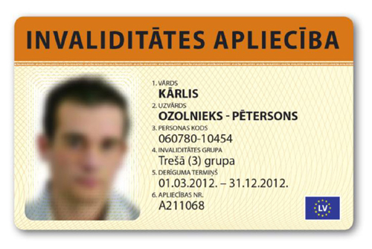

Figure 1.

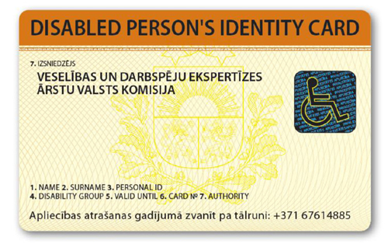
Figure 2.

Minister for Welfare I.Viņķele

Annex 2
Cabinet No. 450
26 June 2012

Requirements for the Picture of the Person Visible on the Disability Certificate

In order to ensure a qualitative preparation of the certificate, the photograph of the person, the appearance of the person therein or the digital image of the person shall comply with the following requirements:

1. The appearance of the person in the picture:
1.1. position of the head – front view;
1.2. eyes open, not covered by hair;
1.3. facial expression – natural, ordinary, neutral;
1.4. look – neutral, directed at the camera;
1.5. both sides of the face illuminated equally and equally clearly visible;
1.6. facial and head tattoos and decorations that make it difficult to recognise the person shall not be permissible;
1.7. no reflective glare on the face of the person;
1.8. if the person wears glasses, then in the picture visible in the certificate:
1.8.1. the eyes of the person shall be clearly visible, they shall not be covered with the frames of the glasses;
1.8.2. the frames of the glasses shall not be heavy, they shall not cover a part of the face;
1.8.3. there shall be no reflection in the lenses of the glasses;
1.8.4. the lenses of the glasses shall not be shaded;
1.8.5. the glasses shall not be slipped down on the nose;
1.9. the person shall be without any headgear, except the case if the person wears a headgear daily due to religious reasons and the headgear does not cover the face or a part thereof;
1.10. the clothing of the person shall not cover the face or a part thereof.

2. Physical indicators of the picture:
2.1. the background of the picture is light;
2.2. the imgarinary line through the midpoints of the eyes shall be parallel with the horizontal side of the picture;
2.3. the face of the person shall be in the centre of the picture;
2.4. the picture of the face of the person from the chin line to the hair line (also the supposed hair line if the person does not have any hair) shall occupy 70-80% from the vertical height of the picture;
2.5. other persons or objects shall not be visible;
2.6. there shall be no shadows visible in the background.

3. Quality of the picture:
3.1. the picture shall be clear;
3.2. the picture shall be with a good resolution;
3.3. the picture shall be contrasting and bright.

4. The photograph shall comply with the following requirements:
4.1. smooth, bright or semi-matt photographic paper of high quality shall be used;
4.2. if the picture is in colour, it shall reflect the natural skin tone of the person and the eyes shall not be red;
4.3. the person has been photographed not more than three months ago;
4.4. the photograph has not been used for the making of the previous certificate;
4.5. the size of the photograph is from 1 to 3 mm larger than 35 x 45 mm; the photograph shall have no smears and no white corner;
4.6. the seal of the photographer’s studio shall be on the other side of the photograph, containing the date of taking of the photograph;
4.7. the seal of the photographer’s studio shall not be visible through the photograph;
4.8. the photograph shall be clearly focused, clean, without any creases and folding;
4.9. the picture shall not be retouched.

Minister for Welfare I. Viņķele

Annex 3
Cabinet No. 450
26 June 2012

Register of the Issued Disability Certificates

No. | Person with disability |  | Certificate |  | Personal data of the representative of the person (if the certificate is being received by another person) | Signature of the person or his or her representative regarding the receipt of the certificate or a note regarding sending of the certificate by mail | Responsible official of the State Medical Commission for the Assessment of Health Condition and Working Ability (SMCAHCWA)
No. | given name, surname | personal identity number | number | date of issue |  |  | given name, surname | signature

Minister for Welfare I. Viņķele

