Text consolidated by Valsts valodas centrs (State Language Centre) with amending regulations of:
18 September 2018 [shall come into force from 21 September 2018].
If a whole or part of a paragraph has been amended, the date of the amending regulation appears in square brackets at the end of the paragraph. If a whole paragraph or sub-paragraph has been deleted, the date of the deletion appears in square brackets beside the deleted paragraph or sub-paragraph.

Republic of Latvia

Cabinet
Regulation No. 624
Adopted 14 October 2014

Regulations Regarding the Procedures for the Metrological Control of Measuring Instruments and the Initial Verification Marks

Issued pursuant to
Section 6, Paragraph two, Section 9, Paragraph six of the law On Uniformity of Measurements and Section 7, Paragraph two of the law On Conformity Assessment

I. General Provisions

1. The Regulation prescribes:
1.1. the procedures for the metrological control of the measuring instruments subject to the State metrological control (type approval and initial verification);
1.2. the samples of initial verification marks of measuring instruments;
1.3. the procedures for the performance of market surveillance of the measuring instruments subject to the State metrological control.

2. The Regulation shall not apply to measuring instruments for which conformity assessment is performed in accordance with the procedures laid down in the laws and regulations regarding the metrological requirements for measuring instruments.
[18 September 2018]

3. Measuring instruments shall be placed on the market, marketed, and put into use if they conform to the requirements laid down in the laws and regulations regarding the metrological requirements for measuring instruments and their metrological control (hereinafter – the metrological requirements). The conformity with the metrological requirements before placing of measuring instruments on the market shall be ensured by the type approval of measuring instruments (hereinafter – the type approval) attested by the type approval certificate and the type approval mark. The conformity with the metrological requirements, upon putting measuring instruments into use, shall be ensured by the initial verification of measuring instruments (hereinafter – the initial verification) attested by the initial verification mark.

4. The national or European Community (hereinafter – the EC) type approval and also the national or EC initial verification are carried out for measuring instruments. An EC type approval shall be performed and an EC initial verification shall be carried out for measuring instruments for which uniform metrological requirements have been laid down in the European Union which have been transposed in the national laws and regulations of Latvia regarding the metrological requirements for the particular measuring instruments. Measuring instruments for which the abovementioned checks have been performed and which are labelled with the type-approval mark, and which bear the initial verification mark shall be placed on the market and put into use.

5. National type approval of measuring instruments shall be performed by the National Metrology Authority.

6. EC type approval of measuring instruments shall be performed by the certification authorities which have been accredited with the National Accreditation Authority and regarding which it has published a notification on its official website.

7. National initial verification and EC initial verification shall be carried out by the inspection authorities which have been accredited with the National Accreditation Authority and regarding which it has published a notification on its official website.

8. The requirements for measuring instruments, upon placing them on the market, shall be laid down in the laws and regulations regarding the metrological requirements for the particular measuring instruments and also in the national standards of Latvia and in the documents of the International Organization of Legal Metrology which may be applied to the fulfilment of the requirements of this Regulation.

9. The Ministry of Economics shall, in cooperation with the National Metrology Authority and the relevant technical committee for standardisation, recommend the National Standardisation Authority a list of standards that need to be developed, adapted, and applied in relation to this Regulation.

10. The National Standardisation Authority shall publish on its official website a list of such national standards of Latvia which may be applied to the fulfilment of the requirements of this Regulation (hereinafter – the applicable standards).

11. The national metrology authorities shall publish on their official website a list of such documents of the International Organization of Legal Metrology (hereinafter – the international documents) which may be applied to the fulfilment of the requirements of this Regulation.

12. If measuring instruments have been manufactured in accordance with the requirements of the published applicable standards or international documents, it shall be considered that measuring instruments conform to the metrological requirements.

II. Type Approval

13. Type approval is a precondition for the initial verification. If, in accordance with the metrological requirements, the initial verification is not required for measuring instruments, the manufacturer or its authorised representative shall place measuring instruments on the market or put them into use after the type approval. The initial verification shall be carried out if the type approval is not required in accordance with the metrological requirements for measuring instruments.

14. The manufacturer or its authorised representative (hereinafter – the applicant) shall submit the application for the national type approval to the National Metrology Authority, in turn, the application for the EC type approval shall be submitted to one certification authority only.

15. If the type of measuring instruments conforms to the technical requirements, the National Metrology Authority shall issue the national type approval certificate, in turn, the certification authority shall issue the EC type approval certificate.

16. The national type approval certificate shall be issued for three years. The EC type approval certificate shall be issued for 10 years. The term of validity of the type approval certificate may be repeatedly extended for the previous term of validity. The applicant shall ensure that a type approval mark is attached to each measuring instrument certifying its conformity with the approved type and being indicated in the type approval certificate.

17. The applicant shall inform in writing the National Metrology Authority or the certification authority which has issued the type approval certificate of modifications or additions made by the manufacturer to the measuring instruments.

18. The National Metrology Authority or the certification authority shall check how the relevant modifications affect the type of measuring instruments. If the modifications performed by the manufacturer affect the measurement results of measuring instruments of the approved type or the conditions for use specified for measuring instruments, the National Metrology Authority or the relevant certification authority shall issue a supplement to the type approval certificate. If significant modifications have been performed for the measuring instrument (for example, construction, metrological characteristics, material have been modified), the National Metrology Authority or the certification authority shall issue a new type approval certificate.

19. The following shall be determined for ancillary equipment in the type approval certificate:
19.1. the types of measuring instruments to which the relevant ancillary equipment may be attached or in which it may be incorporated;
19.2. the general conditions for the functioning of measuring instruments.

20. If the National Metrology Authority or the certification authority does not extend the term of validity of the type approval certificate, the type approval shall be in effect for the measuring instruments which have been put into use until expiry of the term of validity of the certificate.

21. Upon performing type approval for the measuring instruments in which new technologies not provided for in the metrological requirements are used, the National Metrology Authority shall, after consultation with the Ministry of Economics, issue the national type approval certificate with limited effect. In such cases the certification authority shall issue the EC type approval certificate with limited effect after consultation with the Ministry of Economics and other European Union Member States. The following may be specified in the certificate with limited effect:
21.1. a limit on the number of measuring instruments;
21.2. an obligation for the applicant to notify the National Metrology Authority or the certification authority in writing of all the places of installation of measuring instruments;
21.3. restrictions on use of measuring instruments;
21.4. special restrictions concerning the technique used.

22. EC type approval certificates with limited effect may be issued only after the metrological requirements laid down for the particular measuring instruments enter into effect and only if no derogation from the maximum permissible errors has been made in these requirements.

23. The type approval certificate with limited effect shall be issued for a period not exceeding two years. The certification authority or the National Metrology Authority may extend its term of validity for up to three years.

24. The manufacturer is entitled to place the mark specified in Annex 1 to this Regulation on the measuring instruments which conform to the metrological requirements and which do not require the EC type approval.

25. The National Metrology Authority or the certification authority which has approved the type may withdraw the type approval certificate in the following cases:
25.1. measuring instruments do not conform to the approved type or metrological requirements;
25.2. the requirements referred to in the type approval certificate and Paragraph 21 of this Regulation are not fulfilled;
25.3. the type approval certificate has been issued without justification;
25.4. the functioning of measuring instruments constructed according to an approved type reveal defects characteristic to the type which make the measuring instrument unsuitable for its intended use.

26. After withdrawal of the type approval certificate, placing of the relevant measuring instruments on the market and putting thereof into use is prohibited. The certification authority shall inform the Ministry of Economics of the withdrawal of the EC type approval. The Ministry of Economics shall inform the European Commission and the official representations of the European Union Member States.

III. Application for the Type Approval

27. The application for the type approval (hereinafter – the application) shall be drawn up in accordance with the requirements laid down in this Regulation and together with the related documents submitted to the National Metrology Authority or the certification authority. The applicant shall send a copy of the application for the EC type approval to the Ministry of Economics. The Ministry of Economics shall send copies of the application to all official representations of the European Union Member States.

28. The following information shall be indicated in the application:
28.1. the name and legal address of the manufacturer or its authorised representative;
28.2. the category of measuring instruments;
28.3. the intended field of use;
28.4. the metrological characteristics of the type of measuring instruments;
28.5. the trade mark or type designation.

29. The following documents (in case of the EC type approval in two copies) shall be appended to the application:
29.1. a description of the measuring instrument:
29.1.1. the construction and principles of the functioning of the measuring instrument;
29.1.2. the protecting arrangements ensuring correct functioning of the measuring instrument;
29.1.3. the devices for regulation and adjustment of the measuring instrument;
29.1.4. the intended locations for the initial verification marks and seals, where applicable;
29.2. general arrangement drawings and, where necessary, detailed drawings of the main components;
29.3. a schematic drawing illustrating the principles of the functioning of the measuring instrument and also, where necessary, a photograph of the measuring instrument;
29.4. if national type approval has already been performed for the measuring instrument, the relevant documents shall be appended to the application for the EC type approval.

IV. Type Evaluation

30. The National Metrology Authority or the certification authority shall perform a check of the documents and an evaluation of the metrological parameters of measuring instruments. Only the check of the documents shall be performed for measuring instruments for which the metrological parameters have been evaluated.

31. The type shall be evaluated, taking into account the conditions for use in conformity with which the metrological parameters of the measuring instrument must meet the metrological requirements.

32. The conditions for the type evaluation shall be specified in the metrological requirements.

33. The certification authority may request that the applicant hands over the standards, technical equipment, and auxiliary staff at the disposal thereof for the performance of tests. The National Metrology Authority may request that the applicant appends the test results to the application.

34. The certification authority shall request to submit a sample of the measuring instrument to which the type approval has been granted if it is provided for in the metrological requirements. Upon coordinating with the certification authority, the sample of the measuring instrument may be replaced with components, down-scaled models, or technical drawings of the measuring instrument, indicating information thereof in the type approval certificate.

V. Type Approval Certificate and Approval Mark

35. The results of the type evaluation and other requirements to be conformed to upon manufacturing measuring instruments shall be indicated in the type approval certificate. Descriptions, drawings, and diagrams necessary to be able to identify the approved type and the principles of the functioning of the measuring instruments shall be included in annex to the certificate.

36. Samples of the type approval marks are specified in Annex 1 to this Regulation. The national type approval mark shall be a quadrangle in which the distinguishing sign of Latvia, the number and year of issue of the certificate are indicated.

37. The EC type approval mark shall be a stylised letter “ε” containing the following information:
37.1. in the upper part – the distinguishing mark of the state which granted the approval (B – Belgium, BG – Bulgaria, CZ – the Czech Republic, DK – Denmark, D – Germany, EST – Estonia, IRL – Ireland, EL – Greece, E – Spain, F – France, I – Italy, CY – Cyprus, LV – Latvia, LT – Lithuania, L – Luxembourg, H – Hungary, M – Malta, NL – Netherlands, A – Austria, PL – Poland, P – Portugal, RO – Romania, SI – Slovenia, SK – Slovakia, FI – Finland, S – Sweden, UK – the United Kingdom) and the last two digits of the year of approval;
37.2. in the lower part – the identification number of the type approval granted upon registration of the approved type.

38. The letter “P”, having the same dimensions as the stylised letter “ε” and placed before the EC type approval mark, shall be the approval mark for the EC type approval with limited effect.

39. For measuring instruments which do not require the EC type approval, the EC type approval mark in which the stylised letter “ε” is reversed symmetrically about a vertical axis may be used in the marking.

40. The EC type approval mark in a hexagon shall be used for the measuring instruments which do not require the EC initial verification.

41. The type approval mark shall be placed at a visible point of each measuring instrument and all ancillary equipment. The type approval mark shall be legible and indelible.

VI. Announcement of Type Approval

42. The certification authority shall issue the original copy of the type approval certificate to the applicant and send a copy of the EC type approval certificate to the Ministry of Economics. The Ministry of Economics shall send the abovementioned information to the European Commission and the official representations of other European Union Member States which, where necessary, may request additional documents related to the conformity assessment of the metrological requirements.

43. The certification authority shall send the information on withdrawal of an EC type approval certificate or other information related to the EC type approval to the Ministry of Economics. The Ministry of Economics shall send the abovementioned information to the European Commission and the official representations of other European Union Member States.

44. The certification authority shall inform the Ministry of Economics of the refusal of the EC type approval. The Ministry of Economics shall send the abovementioned information to the European Commission and the official representations of other European Union Member States.

VII. Initial Verification

45. Initial verification is the evaluation of a new or restored measuring instrument according to the approved type or metrological requirements.

46. Upon carrying out the initial verification, the inspection authority shall:
46.1. ascertain whether the type approval has been performed for the measuring instrument and a type approval mark has been affixed thereto;
46.2. determine whether the measuring instrument conforms to the type approved;
46.3. if type approval is not necessary for the measuring instrument, check whether it conforms to the characteristics of the measuring instrument and the technical construction and functioning conditions specified in the metrological requirements;
46.4. evaluate the metrological characteristics of measuring instruments and the maximum permissible error according to the metrological requirements;
46.5. check the conformity of the construction with the conditions for use of the measuring instrument, the conformity of the marking, the existence of the sites intended for the initial verification mark and seals;
46.6. attach the national initial verification mark or the EC initial verification mark (Annex 2) according to the metrological requirements.

47. Measuring instruments bearing the EC initial verification mark shall be placed on the market or put into use without limitations in the European Union Member States until the end of the following year, unless another time period has been specified for the relevant measuring instrument in the metrological requirements.

48. The manufacturer shall affix a special mark in accordance with Annex 1 to this Regulation on the measuring instruments which do not require the EC initial verification.

VIII. Stages of Initial Verification

49. Initial verification shall be carried out in one or several (usually two) stages.

50. The initial verification in one stage shall be carried out for the measuring instruments which after their production ought to be transferred to their place of installation without first having to be dismantled.

51. The initial verification in two or more stages shall be carried out for the measuring instruments the correct functioning of which depends on the conditions in which they are installed and used.

52. In the first stage of the initial verification (hereinafter – the partial initial verification) the inspection authority shall ascertain the conformity of the measuring instrument with the approved type or if type approval is not required for the measuring instrument, the conformity with the metrological requirements.

IX. Place of Initial Verification

53. If the place of verification is not specified in the metrological requirements, the place of verification for the measuring instruments for which the initial verification is carried out in one stage shall be determined by the inspection authority.

54. In respect of the measuring instruments for which the initial verification is carried out in two or more stages:
54.1. the last stage of verification shall be carried out at the place of installation;
54.2. other stages of verification shall be carried out in accordance with Paragraph 52 of this Regulation.

55. If the initial verification is carried out outside the premises of the inspection authority, the inspection authority may request that the applicant:
55.1. hands over the standards, technical equipment, and auxiliary staff at its disposal;
55.2. issues a copy of the type approval certificate.

X. Initial Verification Marks

56. The EC initial verification marks:
56.1. if the initial verification is carried out in one stage, the verification mark shall consist of two stamps:
56.1.1. the first stamp (Figures 1 and 3.a of Annex 2) shall consist of a letter “e” containing in the upper part the distinguishing mark of the country (B – Belgium, BG – Bulgaria, CZ – the Czech Republic, DK – Denmark, D – Germany, EST – Estonia, IRL – Ireland, EL – Greece, E – Spain, F – France, I – Italy, CY – Cyprus, LV – Latvia, LT – Lithuania, L – Luxembourg, H – Hungary, M – Malta, NL – Netherlands, A – Austria, PL – Poland, P – Portugal, RO – Romania, SI – Slovenia, SK – Slovakia, FI – Finland, S – Sweden, UK – the United Kingdom) together, where necessary, with one or two figures identifying a territorial subdivision. The lower part of the stamp shall contain the identification number of the inspection authority;
56.1.2. the second stamp (Figures 2 and 3.b of Annex 2) shall consist of the last two digits of the year of the verification, in a hexagon;
56.2. the partial initial verification mark shall consist of the first stamp (Figures 1 and 3.a of Annex 2) referred to in Sub-paragraph 56.1.1 of this Regulation;
56.3. Figures 1 and 2 of Annex 2 to this Regulation show different parts of the EC initial verification stamps (shape, dimensions, and outline of the letters), in Figures 3.a and 3.b – samples of stamps. The dimensions indicated in the figures (the diameter of the circle described about the letter “e” and about the field of the hexagon) are relative values. The actual diameters of the circles may be 1 : 6 mm, 3 : 2 mm, 6 : 3 mm, 12 : 5 mm.

57. The national initial verification mark (Figure 4 of Annex 2) shall be in the shape of an ellipsis in which the accreditation number of the inspection authority, the sequential number of the mark, and the time of verification are indicated.

58. The inspection authorities of Member States shall exchange the original copies of the EC initial verification figures.

59. Affixing of the initial verification marks:
59.1. if the measuring instrument has been verified and recognised as conforming to the metrological requirements, the initial verification mark shall be affixed at the appointed location on the measuring instrument;
59.2. the partial initial verification marks shall be affixed:
59.2.1. when the initial verification of the measuring instrument is carried out in several stages or the last stage is carried out at the place of installation of the measuring instrument, at the place where the stamp-date is affixed or at a place specified in the metrological requirements;
59.2.2. as a stamp for the measuring instrument at a place specified in the laws and regulations regarding the metrological requirements.

XI. Market Surveillance (State Metrological Supervision)

60. The Consumer Rights Protection Centre shall perform the market surveillance of the measuring instruments, ensuring that only such measuring instruments are placed on the market, marketed, and put into use which conform to the metrological requirements and, having been appropriately installed, maintained, and used, do not endanger human health and life and do not cause losses to the environment.

61. If the Consumer Rights Protection Centre establishes that a measuring instrument bearing the type approval mark and the initial verification mark is being used correctly for the intended purposes, however, does not conform to the metrological requirements or endangers human health and life, or causes losses to the environment, it shall suspend the placing on the market and marketing of the relevant measuring instrument, prohibit its use, and send a justified notification to the manufacturer of the measuring instrument or its authorised representative, and also inform the Ministry of Economics. In relation to the measuring instruments with the EC type approval, the Ministry of Economics shall notify the European Commission and the official representations of the European Union Member States of the cases of non-conformity and the measures taken.

62. If the Consumer Rights Protection Centre establishes that such marking of measuring instruments is used on the measuring instrument which could be confused with EC marks or marking, it shall suspend the placing on the market and marketing of the relevant measuring instrument.

XII. Closing Provisions

63. Cabinet Regulation No. 455 of 28 June 2005, Procedures to be followed for the Approval of Measuring Instrument Types, Initial Verification and Supervision of the Market (Latvijas Vēstnesis, 2005, No. 102; 2006, No. 25, No. 163; 2007, No. 72; 2008, No. 41), is repealed.

Informative Reference to European Union Directives

The Regulation contains legal norms arising from:
1) Directive 2009/34/EC of the European Parliament and of the Council of 23 April 2009 relating to common provisions for both measuring instruments and methods of metrological control;
2) Directive 2011/17/EU of the European Parliament and of the Council of 9 March 2011 repealing Council Directives 71/317/EEC, 71/347/EEC, 71/349/EEC, 74/148/EEC, 75/33/EEC, 76/765/EEC, 76/766/EEC and 86/217/EEC regarding metrology.

Prime Minister Laimdota Straujuma

Minister for Economics Vjačeslavs Dombrovskis

Annex 1
Cabinet Regulation No. 624
14 October 2014

National Type and EC Type Approval Marks

Designations.
LV – Latvia.
XXX – number of the type approval certificate.
YYYY – year when type approval was granted.
The EC type approval mark is as follows:
Designations.
LV – Latvia
YY – time of the type approval (last two digits of the year).
0000 – identification number of the type approval.
The approval mark for the EC type approval with limited effect is as follows:

Designations.
LV – Latvia.
YY – time of the type approval (last two digits of the year).
0000 – identification number of the type approval.
The marking for the measuring instruments which do not require EC approval is as follows:
The EC type approval mark for the measuring instruments which do not require initial verification is as follows:
Designations.
LV – Latvia.
YY – time of the type approval (last two digits of the year).
0000 – identification number of the type approval.

Minister for Economics Vjačeslavs Dombrovskis

Annex 2
Cabinet Regulation No. 624
14 October 2014

Graphic Depiction of the Initial Verification Marks

1. The EC initial verification marks are as follows:
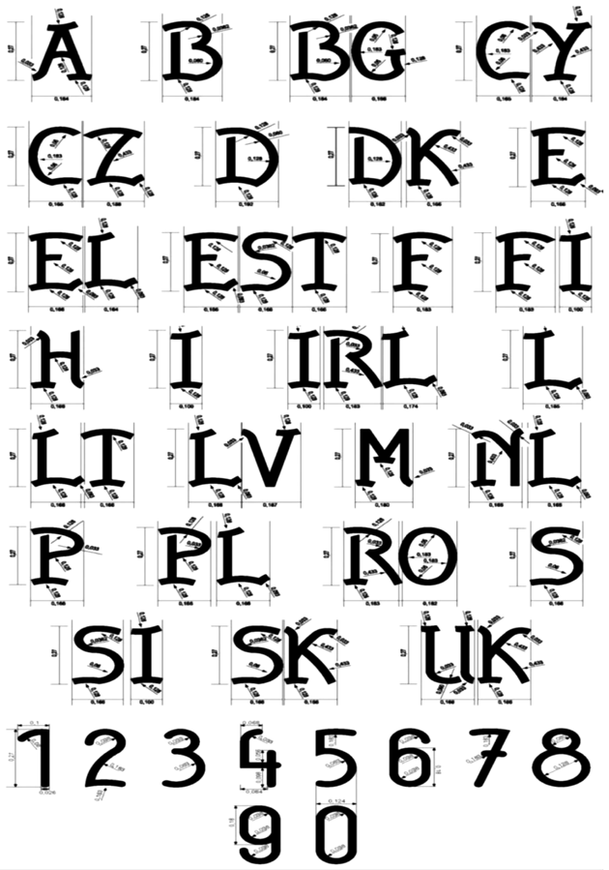
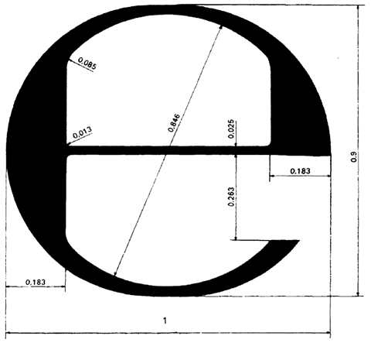

Figure 1
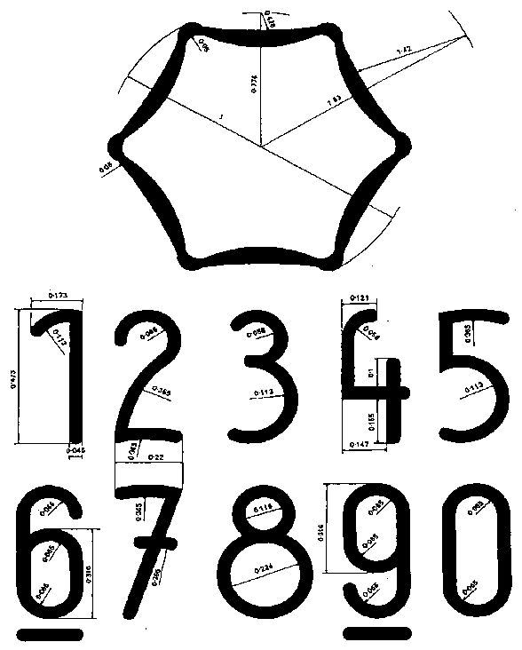

Figure 2

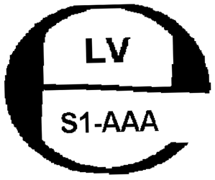  Figure 3.a | Figure 3.b

Designations.
LV – Latvia.
S1-AAA – the accreditation number of the inspection authority.
YY – time of the initial verification (last two digits of the year).

2. The national initial verification mark is as follows:

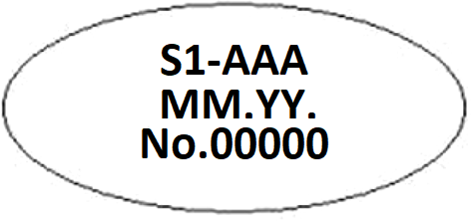

Figure 4

Designations.
S1-AAA – the accreditation number of the inspection authority.
MM.YY. – time of verification (month, last two digits of the year).
No. 00000 – the sequential number of the verification mark.

Minister for Economics Vjačeslavs Dombrovskis

