Text consolidated by Valsts valodas centrs (State Language Centre) with amending regulations of:
23 December 2014 [shall come into force on 31 December 2014];
26 May 2015 [shall come into force on 29 May 2015];
15 December 2015 [shall come into force on 30 December 2015];
10 January 2017 [shall come into force on 13 January 2017];
18 December 2018 [shall come into force on 22 December 2018];
10 December 2020 [shall come into force on 16 December 2020].
If a whole or part of a paragraph has been amended, the date of the amending regulation appears in square brackets at the end of the paragraph. If a whole paragraph or sub-paragraph has been deleted, the date of the deletion appears in square brackets beside the deleted paragraph or sub-paragraph.

Republic of Latvia

Cabinet
Regulation No. 95
Adopted 11 February 2014

Regulations Regarding Technical Requirements for Electronic Devices and Equipment for the Registration of Taxes and Other Payments

Issued pursuant to
Section 28.¹, Paragraph four of the law On Taxes and Fees

I. General Provisions

1. This Regulation prescribes the technical requirements for electronic devices and equipment for the registration of taxes and other payments.

2. Electronic devices and equipment for the registration of taxes and other payments – cash registers, hybrid cash registers, cash register systems, specialised devices and equipment – shall be used to register the payment that has been received for transactions in cash, with payment cards, smart cards or by other means for the confirmation of payment (for example gift cards, receipts, vouchers) by drawing up documents in electronic form and by ensuring the calculation and accounting of taxes and other payments.
[15 December 2015]

3. Cash registers, hybrid cash registers, cash register systems, specialised devices and equipment shall be used for the calculation and recording of taxes and other payments that ensure compliance with the technical requirements for fiscal surveillance specified in this Regulation and also the requirements that are specified in the laws and regulations regarding:
3.1. electrical safety of equipment;
3.2. electromagnetic compatibility of equipment;
3.3. metrological requirements for measuring instruments;
3.4. repeated verification of measuring instruments, verification certificates, and verification marks;
3.5. taxi service.

II. Mandatory Technical Requirements for Cash Registers, Hybrid Cash Registers, and Cash Register Systems
[15 December 2015]

4. A cash register is a specialised one-piece electronic device with a built-in program that ensures the registration of tax and other payment transactions and the saving and storing of the sum total of registered transactions in monetary terms in the non-volatile memory or fiscal memory module thereof, and also the printing of documents and reports. Only the cash register software, which is protected against the introduction of changes therein, has access to these memories. The registered software of the cash register, which is submitted to the State Revenue Service upon the registration of the model (modification), shall not be subject to any updates or changes, but shall be replaced entirely by opening the design of the cash register and removing the numbered strict accounting seals received at the State Revenue Service (hereinafter – the seal) that is done either by the manufacturer or an authorised representative thereof.
[15 December 2015]

4.¹ A cash register with an electronic control tape – a cash register with an electronic control tape corresponding to the definition referred to in Paragraph 4 of this Regulation.
[15 December 2015]

4.² A cash register with a paper control tape – a cash register with a paper control tape corresponding to the definition referred to in Paragraph 4 of this Regulation.
[15 December 2015]

4.³ A cash register with an electronic control tape and a fiscal memory module – a cash register with an electronic control tape and a fiscal memory module that can be connected to a computer and corresponding to the definition referred to in Paragraph 4 of this Regulation.
[15 December 2015]

4.⁴ A cash register with a paper control tape and a fiscal memory module – a cash register with a paper control tape and a fiscal memory module that can be connected to a computer and corresponding to the definition referred to in Paragraph 4 of this Regulation.
[15 December 2015]

5. A hybrid cash register is a specialised computer system that ensures the registration and processing of tax and other payment transactions by using the built-in software that saves and stores this information in the non-volatile memory, ensuring the printing of documents and reports and the saving of the sum total of the registered transactions in monetary terms in the non-volatile memory and fiscal memory module of the hybrid cash register.
[15 December 2015]

5.¹ A hybrid cash register has a fiscal memory module and a non-volatile memory that saves the information recorded therein without supplying voltage input (electricity for such memory is necessary only in the recording, reading, or deletion process). The hybrid cash register has at least a USB (Type A) or Firewire 800/400, or RS232 port.
[15 December 2015]

6. A cash register system is a specialised computer system that ensures the registration and processing of tax and other payment transactions by using the built-in software, ensuring the printout of documents and reports and also the saving of the sum total of the registered transactions in monetary terms and the storage thereof in its non-volatile memory and fiscal memory module.
[15 December 2015]

6.¹ A cash register system has a fiscal memory module and a non-volatile memory and also a USB (Type A) or Firewire 800/400, or RS232 port. The information saved in the non-volatile memory is readable (downloadable) in the external data carrier by using a USB (Type A) or Firewire 800/400, or RS232 port.
[15 December 2015]

6.² An integrated information system is an autonomously functioning information system that has its own data carrier and functional tasks (a part of the system extracted from the cash register system due to technical reasons is not an integrated information system):
6.² 1. prior to data processing (use) in a cash register with the fiscal memory module, in a hybrid cash register and a cash register system, the data are prepared in successive order in another external system and sent to the cash register, to the hybrid cash register and to the cash register system;
6.² 2. in the course of processing the transactions, a cash register with the fiscal memory module, a hybrid cash register and a cash register system send the data to another information system for processing and information purposes;
6.² 3. following the registration of transactions in a cash register with a fiscal memory module, in a hybrid cash register and in a cash register system, the data are sent to another information system.
[15 December 2015]

6.³ An integrated information system can be serviced by a user. The operation of an integrated information system shall be described in separate documentation and registered in the State Revenue Service prior to the integration and use of such integrated information system with a cash register with an electronic control tape and a fiscal memory module, a hybrid cash register and a cash register system.
[15 December 2015]

7. Backup copies (hereinafter – the backup data) shall be created for a hybrid cash register and a cash register system. The backup data shall contain such information so that by using the data and the registered software submitted to the State Revenue Service it would be possible to restore a completely functional hybrid cash register or a cash register system with data for which the specific backup copy was created. The information stored in the backup data shall be stored in full extent in a data carrier. A backup copy need not be created for a program registered for a hybrid cash register and cash register system that complies with Paragraph 12 of this Regulation.
[15 December 2015]

7.¹ The backup data shall be created for the following information:
7.¹ 1. collected information (electronic control tape, control data, data on events in the system – in audit files);
7.¹ 2. software that complies with Sub-paragraph 12.² of this Regulation;
7.¹ 3. database or data copies that comply with the software referred to in Sub-paragraph 12.² of this Regulation and with the databases and parameter files of the registered program.
[15 December 2015]

7.² The backup data for the collected information shall be created not less than once a day after the Z report of the day (period) (hereinafter – the Z report) has been prepared. The backup data shall be created for:
7.² 1. software or a new software version (if such is installed) that complies with Sub-paragraph 12.² of this Regulation. The backup copy shall be created once within a period of one week after its installation in a way to ensure the restoration of the functionality of the specific program (and the respective version thereof) from the backup copy;
7.² 2. database or data copies that comply with the software referred to in Sub-paragraph 12.² of this Regulation and for the databases and parameter files of the registered program in compliance with the procedures determined by the user, but not less than once every three months.
[15 December 2015]

7.³ The backup data shall be stored:
7.³ 1. for a period of three years;
7.³ 2. outside the cash register, hybrid cash register or cash register system in non-volatile data carriers located in the territory of Latvia, including in the servers of data centres (non-volatile data carriers) in the territory of Latvia.
[15 December 2015]

8. Any other computer hardware or software, which is not related to ensuring the cash register, hybrid cash register and cash register system and the functionality whereof has not been described in the documentation of the cash register, hybrid cash register or cash register system, must not be present in the cash register, hybrid cash register and cash register system.
[15 December 2015]

8.¹ The hybrid cash register and cash register system shall ensure the following:
8.¹ 1. integrity of the information referred to in this Regulation (retention of complete and unaltered information) and also protection against unauthorised access;
8.¹ 2. authentication of the employees of the user;
8.¹ 3. prevention of either deliberate or accidental alteration or deletion of already registered information;
8.¹ 4. division of employees into roles and access rights thereof in the cash register system or the hybrid cash register, ensuring that all roles are audited in a separate audit file by registering data on events in the system (name of the employee, time, the activity related to the creation or deletion of a new user “employee”, “administrator”, “virtualisation administrator” or “establishment administrator”, granting of rights or change of rights and also the creation or change of rights to objects (program files and catalogue)):
8.¹ 4.1. role “administrator” – a fully entitled employee of the support service for the cash register system or the hybrid cash register;
8.¹ 4.2. role “virtualisation administrator” – an administrator of the virtualisation platform (hypervisor) – a fully entitled employee of the support service of the cash register system or the hybrid cash register if the virtualisation referred to in Paragraph 12.² of this Regulation is used;
8.¹ 4.3. role “establishment administrator” – an establishment administrator of the user with the right to change the tax rates and add new users (operators) in the cash register system or the hybrid cash register;
8.¹ 4.4. role “employee” – an employee of an establishment who is the operator of the cash register system or the hybrid cash register;
8.¹ 5. authorisation of an employee;
8.¹ 6. roles “administrator”, “virtualisation administrator”, “establishment administrator” and “employee” with a protection system – a password of at least eight symbols (including upper and lower case letters, digits, and special characters) that prevents arbitrary interference in the software (without the relevant permit or by using the rights granted to another person). If another type of identification is ensured to the role “employee”, magnetic cards, smart cards or other means of identification may be used.
[15 December 2015]

9. The design of a cash register, hybrid cash register and cash register system ensures the reading of the installed registered software for the comparison thereof with the registered program submitted to the State Revenue Service (program version) and Hash SHA-256 checksum thereof.
[15 December 2015]

10. The fiscal memory module of the cash register, hybrid cash register and cash register system shall comply with the following requirements:
10.1. it has been placed in the housing as an autonomously functioning memory module for data storage that can be removed from the cash register, hybrid cash register and cash register system and can be replaced with another one if it is damaged or full;
10.2. it has a non-volatile data carrier and protection solution as well as one communication plugin. The module is designed in one piece, without the possibility to remove the memory or any other micro-chip or component and without the possibility to connect to the contacts of these individual elements;
10.3. its data protection solution consists of a control scheme with software that technically is no longer possible to rewrite or exchange with another program;
10.4. it has a built-in unique read-only, mechanically and logically unchangeable identification code of at least 48 bits;
10.5. its unique identifier is permanently recorded on the fiscal memory module;
10.6. if the fiscal memory data carrier is full or damaged, the protection solution of the fiscal memory module transmits a warning to the program of the cash register, hybrid cash register or cash register system that the recording in the fiscal memory has failed or its content is damaged or it is not possible to make further recordings in the data carrier;
10.7. only the information referred to in Sub-paragraphs 10.¹ 1, 10.¹ 2, and 10.¹ 3 of this Regulation shall be kept in the data carrier with the capacity of ensuring data storage for not less than three years in compliance with the description specified in Annex 4 to this Regulation;
10.8. it is constructively protected by a protection solution against deleting or overwriting its contents by using the communication plug-in in the module. To save and read information, access to the fiscal memory module is only from the cash register, hybrid cash register and cash register system program;
10.9. the entire content of its data carrier and also the protection solution program and the unique identifier must be readable (downloadable) in an external computer by using the cash register, hybrid cash register and cash register system program and external ports. If additional software is required for such operation, then it shall be submitted to the State Revenue Service upon registration of the cash register, hybrid cash register and cash register system, together with the instructions for use. The solution, which provides the possibility to read the content of the fiscal memory module by using the port of the cash register, hybrid cash register and cash register system, is protected against the option to make recordings in the fiscal memory module by using the external port of the cash register, hybrid cash register and cash register system;
10.10. it has a built-in control that forbids recording in its data carrier with a date and time less than the last date and time saved in the data carrier as well as a Grand Total value less than that last saved in the data carrier. If the fiscal memory module has received document data, the date and time or Grand Total value of which is less than the last date and time or Grand Total value saved in the module data carrier, a warning is transmitted to the registered program of the cash register, hybrid cash register, cash register system that the recording in the fiscal memory has failed and it is not possible to make further recordings in the data carrier.
[15 December 2015]

10.¹ The following shall be recorded in the fiscal memory module of the cash register, hybrid cash register and cash register system:
10.¹ 1. after each prepared document – the number of the relevant document, date and time, document checksum (SHA-1), Grand Total; for the document type “transaction” – transaction sum in monetary terms;
10.¹ 2. after printing the Z report – Z report number, printout date and time, sum total of registered (positive) transaction “receipt” in the accounting period, sum total of repayment, sum total of cancellations, sum total of purchases in monetary terms, the rate of the applied value added tax, division of the sum taxable with value added tax according to the applied rates and the relevant tax sums, the checksum of the control tape calculated for the accounting period (SHA-1) and Grand Total;
10.¹ 3. prior to the use of the cash register – name, registration number or personal identity number of the user, chassis number of the cash register, hybrid cash register or cash register system and also the date and time of recording.
[15 December 2015]

10.² For the purpose of calculating the sum total of the transactions in the Z reporting period, the registered program of the cash register, hybrid cash register and cash register system shall use the information stored in the fiscal memory on positive transactions in the specific accounting period that are saved in the fiscal memory module.
[15 December 2015]

11. The non-volatile memory of the cash register, hybrid cash register and cash register system shall comply with the following requirements:
11.1. it is located in the cash register, hybrid cash register or cash register system and is protected against unauthorised access in compliance with Paragraph 20.¹ of this Regulation;
11.2. if there has been an interruption of or disturbances in the supply of electricity, the software shall save the necessary information in the non-volatile memory so that after the restoration of the supply of electricity the data on all registered transactions are unified, without information gaps and interruptions;
11.3. if the data carrier of the non-volatile memory is full, the software blocks the activities of the equipment related to the drawing up of documents and reports and the recording of their information in the non-volatile memory;
11.4. the information from the control data, audit trails and electronic control tapes shall be stored separately in the non-volatile memory (data compression method may be applied for data storage, ensuring access to the original data), ensuring that the user is denied the right to alter and delete the stored information pack. The administration rights of the abovementioned information pack are granted to the support service only, whereas the access rights – only to the registered program referred to in Paragraph 12 of this Regulation, thereby ensuring logical protection of the registered transaction data (protection of data or information resources that is implemented by the means of software by identifying the user of the information system, verifying the compliance of its authorisation for the relevant activities in the information system and protecting information from either deliberate or accidental alteration or deletion);
11.5. it ensures data storage for not less than three years.
[15 December 2015]

12. The registered program of the hybrid cash register and cash register system shall comply with the following requirements:
12.1. it is modular, the calculation of the Hash checksum is separated from it in a separate module with the possibility to replace it with another module that implements another algorithm for calculating the checksum;
12.2. it ensures the saving of document and report information in the electronic control tape and fiscal memory module (for the cash register system – also in the control file) after each preparation of documents or reports in the non-volatile memory. The hybrid cash register creates a control file upon request of the State Revenue Service (for the last three years) or once a day;
12.3. it blocks the activities of the hybrid cash register and the cash register system related to the recording of information in the non-volatile memory if the cash register receipt printing device is disconnected or it (the software) does not have access to the non-volatile memory;
12.4. it ensures at least the following functions:
12.4.1. performs the calculation of Hash checksum for document printouts and reports;
12.4.2. creates control data files and records them in the non-volatile memory;
12.4.3. creates the electronic control tape and ensures its recording in the non-volatile memory;
12.4.4. ensures that printouts and reports of all documents are sent to the printing device after the relevant files have been recorded in the non-volatile memory;
12.4.5. performs control of transaction tax calculations in accordance with the taxes set in the parameters;
12.4.6. ensures warnings and blocking of the activity of the hybrid cash register and cash register system in the cases provided for in this Regulation.
[15 December 2015]

12.¹ In addition to the provisions laid down in Paragraph 12 of this Regulation, the registered program of the cash register with the fiscal memory module, hybrid cash register and cash register system shall comply with the following requirements:
12.¹ 1. it performs control (verification) of the data to be saved in the fiscal memory module, allowing to save only the increasing Grand Total value and to save only the increasing date and time when making an entry in the fiscal memory;
12.¹ 2. it warns the employee if there is space remaining for 3000 or less entries in the data carrier of the fiscal memory module;
12.¹ 3. it performs the calculation of Hash checksum for the control tape of the accounting period;
12.¹ 4. it automatically blocks the activity of the cash register, hybrid cash register and cash register system, if the non-volatile memory or the fiscal memory module is disconnected or a program or memory error has been detected that prevents or hinders the performance of the provisions of this Regulation.
[15 December 2015]

12.² Additional programs of the hybrid cash register and cash register system:
12.² 1. are the functions that have not been specified in Sub-paragraph 12.4 of this Regulation, which have not been included in the registered program (sales management, preparation of reports and others) and functions that are not directly linked with cash operations that are necessary to the user for the sales process (accounting program and warehouse accounting program). Also the operating system with its utility programs may be distributed in separate additional programs;
12.² 2. conforms to the programs submitted in the description of the specific model or modification. Additional programs, including the data and databases of these programs that are located in the hybrid cash register or cash register system, are included in the mandatory backup copies, except for the operating system and its utility programs.
[15 December 2015]

12.³ The support service may create a virtual machine in the cash register system and hybrid cash register and make it available to the user on a virtualisation platform that by its design architecture prevents the virtual machine from communicating with physical communication ports and equipment physically connected to them as specified in Paragraph 16 of this Regulation. If the solution provides for data exchange between the basic machine and the virtual machine, the support service shall be responsible for such a connection solution. The description of such a solution shall be included in the documentation of the cash register system or hybrid cash register and its functionality shall comply with the requirements of this Regulation.
[15 December 2015]

13. When installing a new cash register, hybrid cash register or cash register system or also when changing an already installed registered program, the support service shall perform SHA-256 checksum calculations in accordance with the Secure Hash Standard (SHS) (FIPS PUB 180-4) for the program of the cash register, hybrid cash register or cash register system that is separated from data and parameters.
[15 December 2015]

13.¹ The registered program of a cash register, hybrid cash register or cash register system is designed so that the program does not change during its entire operation. The data stored and the variable parameters of the program are stored separately from the program.
[15 December 2015]

13.² The parameters of the registered program of a cash register, hybrid cash register or cash register system must not be stored outside the relevant cash register, hybrid cash register or cash register system.
[15 December 2015]

14. The non-volatile memory of a cash register shall comply with the following requirements:
14.1. [15 December 2015]
14.2. [15 December 2015]
14.3. its operation is ensured by an autonomous energy source, it is not deleted if the supply of electricity from the electricity supply network is interrupted and it shall store the recorded information for at least 60 days;
14.4. memory storage capacity ensures data storage for not less than three years.
[15 December 2015]

15. A cash register shall be equipped with:
15.1. a cashier display and a customer display (mobile and also self-service cash registers may be equipped with one display) – to indicate the price of goods and services, received payments and other information. The customer display is positioned so that the customer can see the information on the display;
15.2. a printing device with a paper tape – to print documents and reports. The device is integrated or connected to one of the external ports of the cash register, except for the computer network connection;
15.3. a printing device – to print a control tape (the printing device referred to in Sub-paragraph 15.2 of this Regulation may be used). This includes a paper control tape and its installation mechanism and a receiver mechanism or an electronic control tape;
15.4. input device (a keyboard or a touch-sensitive display);
15.5. a till. If the cash register design does not provide for a till, a separate till shall be installed at the place of use of the abovementioned cash register, but if payments are made only in non-cash form, the till is not necessary;
15.6. additional external devices – a scanner of goods, scales, printing device, magnetic or smart card reader, additional customer display and non-cash payment terminal – that can be connected to the cash register and the functionality of which is described in the cash register documentation.
[15 December 2015]

15.¹ Cash register equipment specified in Sub-paragraphs 15.1, 15.3, and 15.4 of this Regulation is located in the same housing as its control unit (processor and all electronic devices).
[15 December 2015]

16. A hybrid cash register and cash register system shall be equipped with:
16.1. a cashier display and a customer display – to indicate the price of goods and services, received payments and other information. The customer display is positioned so that the customer can see the information on the display. Portable as well as self-service hybrid cash registers and cash register systems may be equipped with a single display;
16.2. electronic control tape (a paper control tape may be used additionally);
16.3. a printing device with a paper tape – to print documents and reports. The device is integrated or connected to one of the external ports of a hybrid cash register or cash register system, except for computer network connection;
16.4. input device (a keyboard or a touch-sensitive display);
16.5. a till. If the hybrid cash register or cash register system design does not provide for a till, a separate till shall be installed at the place of use of the abovementioned devices, but if payments are made only in non-cash form, the till is not necessary;
16.6. additional external input-output devices that are connected to the hybrid cash register or cash register system and the functionality of which is described in the documentation of the device;
16.7. devices or peripheral devices that ensure that the transaction is completed and saved in the non-volatile memory if supply of electricity is not ensured or if there are disturbances in the supply of electricity (if such functionality is not ensured by the design of the cash register system or hybrid cash register);
16.8. a security solution that does not allow the operating system to be switched on from another source, different from the one set by the support service – the non-volatile memory of the hybrid cash register or cash register system, both after switching on and restarting as well as during its entire operation.
[15 December 2015]

17. In addition to the provisions specified in Paragraphs 15 and 16 of this Regulation, the cash register, hybrid cash register and cash register system may be equipped with a mechanism for recording the nominal amount received in cash.

18. The cash register, hybrid cash register and cash register system shall be connectible to an electricity supply network. Mobile cash registers, hybrid cash registers and cash register systems may operate from an autonomous energy source.
[15 December 2015]

19. There is an indelible chassis number on the housing of the cash register, hybrid cash register and cash register system.
[15 December 2015]

20. Seals have been affixed in a way to prevent unauthorised access to the following components of the cash register, hybrid cash register and cash register system:
20.1. processor and all electronic components that operate with the registered program;
20.2. Random Access Memory;
20.3. clock;
20.4. program memory;
20.5. external plugins that can be used to access RAM (Random Access Memory), non-volatile memory and other devices by circumventing the software.
[15 December 2015]

20.¹ The seal shall be fixed on the fiscal memory module.
[15 December 2015]

20.² A seal shall be affixed to the non-volatile memory if no non-volatile memory identification (serial) number of the manufacturer has been assigned thereto.
[15 December 2015]

21. The program and design of the cash register, hybrid cash register and cash register system shall ensure the following:
21.1. the printing of the following documents and preparation of the following types of reports in the official language: “initialisation” – the start of a registered program, “transaction” – sale, purchase and repayment, “cash” – inserting, collection, pay-out, and exchange money, “control financial report” (hereinafter – X report”), “Z report”, “non-fiscal document” – preparation of various informative documents. It is forbidden to make other types of document printouts and reports;
21.2. any document printout or report that is planned to be created or printed out complies with any of the types of document printouts or reports referred to in Sub-paragraph 21.1 of this Regulation;
21.3. the word “receipt” or its combination with other words, symbols or characters would not be depicted or represented in such types of document printouts as “initialisation”, “cash” and “non-fiscal document”;
21.4. administering of the value added tax and other tax rate classifiers in compliance with the economic activity;
21.5. printing of cash register receipts, repayment receipts, cancellation receipts, purchase receipts – “transaction” type documents – that certify the registration of a transaction in the cash register, hybrid cash register or cash register system;
21.6. that it is not possible to prepare the non-fiscal document “receipt copy” or another type of non-fiscal document where the sum total of the transaction in monetary terms, division according to applicable value added tax rates and the relevant tax values are specified;
21.7. printing the X and Z reports;
21.8. simultaneous and precise indication of the details of all printed documents, X report and Z report (except for the details referred to in Sub-paragraphs 22.1 and 23.1 of this Regulation) in the electronic control tape of the cash register, hybrid cash register, and cash register system or in the paper control tape of the cash register, except for the cases when a unique code or password is printed on the document. If a unique code or password is printed on the document and Hash checksum is calculated, each character of the code may be replaced with the sequence of the same type of symbols and in such case the replaced (covered) information of the code is included in Hash checksum calculation;
21.9. simultaneous and precise indication of the details of all printed documents, X report and Z report in the control tape;
21.10. document printout and the printing of reports in a technically enduring form so that the information contained therein would not disappear during the entire storage period;
21.11. for the hybrid cash register – the recording of control data, electronic control tape and audit trail data in a data carrier upon request of the State Revenue Service;
21.12. for the cash register system – the recording of control data, audit trail and electronic control tape data in a data carrier upon request of the State Revenue Service;
21.13. indication of the initialisation and exclusion date (YYYY-MM-DD) (the first four digits indicate the year, the next two – the month, the last two – the day) and time (hh:mm:ss (optional for the cash register with the electronic control tape) (the first two digits indicate the hours, the next two – the minutes, the last two – the seconds)) of the program of the cash register, hybrid cash register and cash register system in the electronic control tape, X report and Z report;
21.14. that a uniform consecutive numbering in ascending order is used for cash registers with the electronic control tape, hybrid cash register and cash register system document printouts and reports (including document printouts not related to the registration of a transaction). It must not repeat at least within one calendar year;
21.15. that the user cannot delete or alter the data of registered transactions;
21.16. only the use of the production environment for the registration of transactions and saving of the sum total of the registered transactions in monetary terms, without allowing the use of a training, test or another environment for the registration of transactions.
[15 December 2015]

22. The software and design of the cash register, hybrid cash register or cash register system shall ensure the indication of the following details in the X report and Z report:
22.1. the name of the user of a cash register, hybrid cash register or cash register system (for a natural person – given name and surname), the taxpayer registration code (for a person subject to value-added tax – the number of the person subject to value added tax assigned by the State Revenue Service) and the legal address (for a natural person – the address of the place of residence);
22.2. the type of report (X report or Z report), the date and time of electronically created information, the sequential number of the document, the unique identification code of the fiscal memory module and report number;
22.3. the sum total in monetary terms of the transactions registered during the day (period);
22.4. the division of sum total of the registered transactions in monetary terms according to the goods (service) sections;
22.5. the division of the sum total of the registered transactions of the day (period) according to the type of account (in cash, in non-cash payments with other confirmations of the settlement of accounts). If accounts are settled in a foreign currency, an equivalent thereof in monetary units of the Republic of Latvia shall be specified;
22.6. the division of the sum total of the registered transactions in monetary terms according to applicable value added tax rates and the sum total of the registered transactions that are not subject to the application of the value added tax;
22.7. the amount of the calculated value added tax in breakdown by the rates applied;
22.8. exchange money – the amount of money registered in the cash register, hybrid cash register or cash register system for ensuring the registration of transactions;
22.9. [15 December 2015]
22.10. [15 December 2015]
22.11. collected money – the amount of money withdrawn, which is registered in the cash register, hybrid cash register or cash register system, and paid in the cashier’s office or bank or transferred to the collector;
22.12. the amount of cash in the till of the cash register, hybrid cash register or cash register system at the time of printing of a report;
22.13. sum total in monetary terms (Grand Total) of all registered transactions for which the type of document “receipt” has been issued, starting from the moment of commencing the use that is increased by sum total of each such transaction:
22.13.1. sum total in monetary terms of all repaid transactions at the moment of creating the X report or Z report;
22.13.2. sum total in monetary terms of all cancelled transactions at the moment of creating the X report or Z report and sum total in monetary terms of all corrected goods or services registered during the drawing up of the document;
22.13.3. sum for each type of cash pay-out in a separate counter at the moment of creating the X report or Z report;
22.14. [15 December 2015]
22.15. for cash registers, hybrid cash registers and cash register systems that have been equipped with a till – the number of times the till has been opened;
22.16. if the user registers foreign currency purchase and sale transactions in the cash register, hybrid cash register or cash register system, the following shall be indicated additionally:
22.16.1. the amount of all foreign currencies purchased during the day (period) recalculated in the monetary units of the Republic of Latvia;
22.16.2. the amount of all foreign currencies sold during the day (period) recalculated in the monetary units of the Republic of Latvia;
22.16.3. the result of foreign currency purchase and sale transactions during the day (period);
22.17. only for the Z report – the checksum (SHA-1) of the electronic control tape in the accounting period.
[15 December 2015]

22.¹ The type of document printout “non-fiscal document”, if it is intended as an intermediate invoice that is issued to the client for the provided services or goods for information purposes prior to the transaction, shall be registered in compliance with Annex 1 to this Regulation by specifying the sum total thereof in monetary terms and the sum total in monetary terms of all intermediate invoices issued during the Z reporting period shall be included in the Z report.
[15 December 2015]

23. The design and software of a cash register, hybrid cash register and cash register system shall ensure the indication of the following details on the cash register receipt:
23.1. the name of the user of a cash register, hybrid cash register or cash register system (for a natural person – given name and surname), the taxpayer registration code (for a person subject to value-added tax – the number of the person subject to value added tax assigned by the State Revenue Service) and the legal address (for a natural person – the address of the declared place of residence);
23.2. document name “receipt”, the sequential number of the document, the unique identification code of the fiscal memory module and the date and time of electronically created information;
23.3. [15 December 2015]
23.4. the name of the goods (service) or the name of the section and value added tax indication (a digit, letter or another sign that indicates that the relevant goods (service) or the section thereof is subject to a certain rate of tax or not subject to tax) and also the quantity (including if the quantity is equal to “1”) and price;
23.5. the applied value added tax rates;
23.6. the amount of the registered goods (services) in monetary terms (separately by the applied value added tax rates) excluding the value added tax;
23.7. the amount of value added tax (separately according to the applied value added tax rates);
23.8. the sum total of the registered goods (services) in monetary terms;
23.9. the discounts granted in monetary terms, if any;
23.10. the type of payment;
23.11. the amount of money received upon payment;
23.12. the amount in cash given as a change upon payment (balance);
23.13. complete chassis number of the cash register, hybrid cash register or cash register system;
23.14. Hash SHA-1 checksum calculated for each document of the cash register with a fiscal memory module, cash register with an electronic control tape, hybrid cash register and cash register system by indicating Hash SHA-1 checksum of the previous (in the printed document) and current document. Hash SHA-1 checksum of the document shall be calculated from the total amount of information contained in the document (including non-fiscal documents).
[15 December 2015]

23.¹ If a payment, which is not a payment for the goods or service (for example, remuneration for activities specified in laws and regulations), is registered in the cash register, hybrid cash register or cash register system, it shall be indicated in the cash register receipt in the place of the goods (service) for what the payment is registered.
[15 December 2015]

24. The following information shall be specified in all documents that have been prepared and printed by the cash register, hybrid cash register and cash register system:
24.1. name, number and date of the document;
24.2. details referred to in Sub-paragraph 23.1 of this Regulation;
24.3. document checksum (SHA-1) that is calculated in compliance with the description referred to in Paragraph 31.¹ of this Regulation and SHA-1 checksum specified in the previous printed document.
[15 December 2015]

25. The cash register, hybrid cash register and cash register system shall ensure separate accounting for each type of cash settlement.
[15 December 2015]

26. Upon performing cash register receipt cancellation operations, the cash register, hybrid cash register and cash register system shall ensure the printout of the cancellation cash receipt. The details referred to in Paragraph 23 of this Regulation (except for Sub-paragraphs 23.7, 23.8, 23.10, and 23.11) shall be specified in the printout of the cancellation cash receipt. The document name “the cancellation cash receipt” shall be specified in this document in addition to the information specified in Sub-paragraph 23.2 of this Regulation.
[15 December 2015]

26.¹ The cash register, hybrid cash register and cash register system that perform cash register receipt cancellation operations shall ensure a printout of the repayment receipt. The details referred to in Paragraph 23 of this Regulation shall be indicated on the receipt printout. Instead of the document name “receipt” referred to in Sub-paragraph 23.2 of this Regulation, the document name “repayment receipt” shall be specified.
[15 December 2015]

27. [15 December 2015]

28. [15 December 2015]

29. Software that ensures the electronic handling of a hybrid cash register, cash register system, specialised device or equipment log shall comply with the requirements specified in laws and regulations regarding accounting and organisation thereof and ensures the indication of the information stored in the memory in the computerised log.

30. For security reasons, cash registers, hybrid cash registers and cash register systems may be equipped with an additional till at the specific point of use of the cash register, hybrid cash register or cash register system.
[15 December 2015]

31. The design and software of the hybrid cash register and cash register system shall ensure the saving of control data in chronological order in electronic form (in the form of XML or CSV files) for each document and report created (in compliance with the procedures referred to in Annexes 1, 2, and 3 to this Regulation), ensuring the possibility to record control data in a data carrier. The description of fields for XML and CSV control file is specified in Annexes 1, 2, and 3 to this Regulation.
[15 December 2015]

31.¹ In all control files, the calculated Hash SHA-1 or SHA-256 checksums of all document printouts and reports shall form an uninterrupted chain of Hash checksums, and the disruption of the chain is not permissible. The Hash SHA-1 or SHA-256 checksum shall be calculated for each document and report printout of the cash register, hybrid cash register and cash register system that comply with Paragraphs 4.¹, 4.³, and 4.⁴ of this Regulation in accordance with Secure Hash Standard (SHS) (FIPS PUB 180-4) by including in the calculation Hash SHA-1 or SHA-256 checksum of the previous document. The SHA-1 or SHA-256 checksum shall be calculated from the aggregate of information of data fields specified in Annex 1 to this Regulation or from the entire information contained in the document (report) by including in the calculation SHA-1 or SHA-256 checksum specified in the previous printed out document (report). A precise Hash checksum calculation algorithm shall be submitted upon registering the cash register, hybrid cash register or cash register system that is to be verified and repeated.
[15 December 2015]

32. Control data shall be stored according to data groups in compliance with Annex 1 to this Regulation. The line of each group shall start with the following assigned identification code: “Cash register system document data” – 0, “Cash register system control file” – 1, “Link to the initialisation document of the included fuelling cash control file” – 2, “Link to the document of the included fuelling cash control file” – 3, “Information on the document client (customer)” – 4, “Description of all goods/services in the receipt” – 5, “Cash operations” – 6, “Information of the sum total of receipt purchases” – 7, “Z report information” – 8, “Additional user information about the document that is not listed in the individual data fields” – 9, “Document Hash” – 10, “Electronic signature” – 11. The control file is updated every time the cash register system creates (prints) a document or report.
[15 December 2015]

32.¹ If control data in the hybrid cash register and cash register system have been created in compliance with the format specified in Annex 3 to this Regulation, data conversion shall be ensured in accordance with the format specified in Annex 2 to this Regulation upon request of an official of the State Revenue Service for the period of time necessary for verification.
[15 December 2015]

32.² The control file is closed at the end of the reporting period by printing the Z report.
[15 December 2015]

33. [15 December 2015]

34. [15 December 2015]

35. [15 December 2015]

36. If the cash register system is connected in a network with other cash register systems, the user thereof shall ensure separate accounting of control data for each cash register system connected in the network.
[15 December 2015]

III. Special Technical Requirements for Cash Register Systems Used in the Retail Trade of Fuel

37. The cash register system of a gas station shall comply with the technical requirements specified in Chapter II and this Chapter of this Regulation and also with the laws and regulations regarding the procedures for the circulation of excise goods and laws and regulations regarding the metrological requirements for liquid measuring systems, except for water.

38. The software and design of the cash register system of the gas station shall ensure the registration of transactions as well as the accounting of the fuel stocks at the gas station and the automatic control of the fuel dispensing process with devices and equipment connected in a single system.

39. The cash register system of an automatic gas station (a closed cash register system of the gas station) shall ensure fuel dispensing and the registration of the payment without the assistance of a cashier.

40. The cash register system of a gas station shall have the following additional equipment:
40.1. software that ensures centralised control of the cash register system of the gas station;
40.2. automatic fuel pumps to which a number in the cash register system of the gas station is granted and the connection cables of which, connecting them with the cash register system of the gas station, shall be affixed with a seal. An automatic fuel pump is a re-fuelling device the self-service capability of which controls the authorised dispensing of fuel based on the customer’s activity;
40.3. the cash register system program of a gas station that ensures the turning on of the fuel pump concurrently with the registration of the transaction in the cash register system of the gas station and also printing a cash register receipt;
40.4. programs that ensure that the change of rates of value added tax, fuel price and also the configuration of the automatic fuel pumps set up in the cash register system of the gas station may be performed only after the printout of the Z report prior to resuming transactions. The price for one litre of fuel may be changed without printing the Z report in automatic gas stations and gas stations that indicate in the Z report all prices for one litre of fuel that are applied in the period by specifying the period from which (date, time) until which (date, time) the price was effective;
40.5. control mechanism that automatically blocks the printing of cash register receipt and reports, if the paper tape referred to in Sub-paragraph 15.2 of this Regulation has run out. Control mechanism shall be created in such a way that a cashier or other persons may not arbitrarily switch off this mechanism.
[15 December 2015]

41. The cash register system of an automatic gas station shall be equipped with one of the displays referred to in Sub-paragraph 15.1 of this Regulation.

42. In addition, the cash register system of a gas station shall ensure the following:
42.1. the accounting of the received fuel and automatically dispensed fuel separately from the accounting of other goods and services (a combination of letters and numbers in accordance with ASCII or UTF-8 encoding, it is forbidden to use other symbols, space is used as a separator of words and digits (ASCII code 32));
42.2. configuration in which the compliance of the automatic fuel pump number with the type of fuel to be sold, price for one litre of fuel and number of pulses on one litre of fuel shall be ensured, if the cash register system of the gas station works in the pulse read-out mode;
42.3. turning on of a fuel pump and dispensing of fuel simultaneously with the registration of the transaction in the cash register system of the gas station and also the printing of a cash register receipt from the work place of the operator of the cash register system of the gas station;
42.4. blocking of all fuel pumps and interruption of fuel dispensing, if the operation of the cash register system of the gas station is interfered with or any of the stages of the operation of the cash register system of the gas station is disconnected, and also if unauthorised interference in the program of the cash register system of the gas station has occurred;
42.5. a special procedure in a program that controls saving of the data registered in the cash register system of the gas station each time the cash register system of the gas station is turned on, after each finished operation, and also in the case of the current voltage emergency decline. If the data saving is interfered with, the cash register system of the gas station shall be automatically blocked;
42.6. saving of information specified for the Z report in the non-volatile memory, if during the operation of the cash register system of the gas station the supply of electricity is interrupted unexpectedly;
42.7. information on the change of fuel prices on the control tape (except for the cash register system of an automatic gas station);
42.8. information on the resupply of fuel on the electronic control tape;
42.9. that data regarding software change or modification would be registered in the cash register system of the gas station or in XML format in the control data carrier of an automatic gas station (Annexes 1 and 2);
42.10. printout of the changes in the configuration parameters specified in Sub-paragraph 42.2 of this Regulation on the cash register receipt, X report, Z report, and electronic control tape;
42.11. the compliance of the information indicated on cash register receipts, electronic control tapes and reports with the actual amount of fuel dispensed and registered in the cash register system of the gas station and with prices;
42.12. operation in the advance or cash on delivery mode;
42.13. additional types of cash register system – autonomous, central or integrated – are determined upon compiling control data in compliance with Sub-paragraph 1.5.3 in the second column of the table in Annex 1 to this Regulation. Depending on whether the gas station cash register system consists of one or multiple cash register systems, one of the cash register systems shall be set as the central cash register system. For each cash register receipt (transaction), along with the creation and saving thereof in the control file, the integrated cash register system shall also save the information referred to in Sub-paragraphs 3.1, 3.2, 3.3, and 3.4 in the second column of the table in Annex 1 to this Regulation.
[15 December 2015]

43. The cash register system of a gas station, operating in the advance payment mode, shall ensure the following:
43.1. turning on of the automatic fuel pump and issue of fuel in accordance with the amount of fuel ordered by the customer and registered (ordered) in the cash register system of the gas station;
43.2. automatic calculation of the amount of fuel issued after the cashier (automatic fuel pump of the cash register system of the automatic gas station) has registered the number of the automatic fuel pump and the amount of money received or the calculation of the value of fuel issued after the cashier (automatic fuel pump of the cash register system of the automatic gas station) has registered the number of the automatic fuel pump, the price and amount of fuel;
43.3. cancellation of a registered transaction (cash register receipt printed out originally) by the simultaneous printout of a cash register receipt indicating the actual amount of fuel issued if the customer cannot receive the amount of fuel ordered (except for the cash register systems of an automatic gas station).

44. If in the cash register system of a gas station there is an automatic fuel pump with an independent program, the cash register system of the gas station shall ensure the control and registration of the actual amount of fuel issued by this automatic fuel pump.

45. The cash register system of a gas station shall ensure the indication of the following additional details in the X report, Z report and the non-volatile memory:
45.1. the name and address of the gas station;
45.2. the balance of each type of fuel in litres at the beginning of the Z reporting period;
45.3. supplement of each type of fuel stock and also any changes (corrections) in the amount during the Z reporting period at the time of the X report or Z report printout respectively;
45.4. the balance of each type of fuel in litres at the time of the printout of the X report or Z report respectively;
45.5. the sum total of fuel sold (dispensed) in monetary terms;
45.6. the value of each type of fuel sold (dispensed) in monetary terms and the amount in litres by types of payment and also the sum total of the registered transactions in monetary terms regarding each type of payment;
45.7. the sum total in monetary terms of the registered transactions for the goods sold and services provided (except for fuel) if the provision of other goods and services in the gas station is registered by using several integrated cash register systems.
[15 December 2015]

46. The cash register system of a gas station shall ensure the indication of the following additional details on the cash register receipt:
46.1. the name and address of the gas station;
46.2. the automatic fuel pump number;
46.3. the name, amount and unit price of the fuel sold.

47. The cash register system of an automatic gas station shall ensure the issue of a cash register receipt to a customer upon his or her request. The cash register system of an automatic gas station shall ensure the indication of the details to be included in the cash register receipt, X report and Z report in the electronic control tape regardless of whether the customer has received a cash register receipt. In addition to the requirements specified for the cash register systems of gas stations, the cash register system of an automatic gas station shall ensure also a record of face values received in cash.

48. [15 December 2015]

IV. Special Technical Requirements for Cash Registers, Hybrid Cash Registers and Cash Register Systems to be Used in Passenger Vehicles

49. Cash registers, hybrid cash registers and cash register systems that comply with the provisions specified in Chapter II of this Regulation (optional application of Paragraph 31) and the following technical requirements shall be used in passenger vehicles, except for taxis:
49.1. the document name “ticket” shall be specified instead of the document name “receipt” referred to in Sub-paragraph 23.2 of this Regulation;
49.2. ensure the indication of mandatory details in the ticket that are specified in the laws and regulations governing the field;
49.3. the details referred to in Sub-paragraphs 22.7 and 23.7 of this Regulation need not be indicated separately in the ticket, X report and Z report, but shall be included in the sum of a transaction if it is determined by the laws and regulations governing the value added tax.

V. Technical Requirements for Specialised Devices and Equipment

50. A specialised device or equipment (electronic device or equipment) shall ensure the registration of a taxable transaction in separate types of economic activities and also the registration of taxes and other payments.

51. A specialised device or equipment to ensure fiscal surveillance – a taximeter – shall comply with the requirements specified in the laws and regulations regarding metrological requirements for measuring instruments and the procedures for the metrological control thereof, regarding taxi services, regarding the verification of measuring instruments, verification certificates and verification marks, and shall be included in the State Register of Measuring Instruments (if a national type approval procedure has been performed for the taximeter).

52. An automatic vending machine shall ensure the selling of goods or the provision of services and the registration of a payment without the participation of a cashier. An automatic vending machine and the money counter inserted therein or attached thereto shall comply with the requirements specified in this Regulation.

53. There shall be the following types of automatic vending machines:
53.1. automatic vending machines of piece-goods – automatic machines that issue piece-goods or pre-packaged goods for charge;
53.2. automatic vending machines of portions – automatic machines that issue portions of non-packed food products for charge;
53.3. automatic vending machines for the provision of services – automatic machines that provide services for charge.

54. An automatic vending machine shall have the following equipment:
54.1. at least one of the money counters referred to in Paragraph 55 of this Regulation that complies with the requirements specified in Paragraphs 56 and 57 of this Regulation;
54.2. a display for the indication of the price for goods and services, the received payment and other information. The display is positioned so that the customer (recipient of a service) can see the information on the display;
54.3. a key that ensures the issuance of a cash balance to a customer if the money counter inserted in the automatic vending machine operates with cash face values;
54.4. a program that ensures the storage of information registered in the money counter inserted in the automatic vending machine, or attached thereto, in the aggregate memory.

55. The types of money counters of automatic vending machines are as follows:
55.1. money counters of coins and tokens;
55.2. money counters of banknotes;
55.3. money counters of magnetic stripe cards;
55.4. money counters of smart cards;
55.5. other money counters of non-cash payments.

56. The money counter of an automatic vending machine shall be equipped with a mechanism that ensures the issuance of a cash balance if the money counter operates with two or more cash face values.

57. The money counter of an automatic vending machine shall ensure:
57.1. the storage of the following information in the aggregate memory if the money counter operates with two or more face values:
57.1.1. a sum total of payments received during the whole day (period) (aggregate) – in 99 999.99 monetary units of the Republic of Latvia;
57.1.2. a sum total regarding each type of goods sold (services provided) during a day (period) – in 99 999.99 monetary units of the Republic of Latvia;
57.1.3. the total summary memory indicator – in 99 999.99 monetary units of the Republic of Latvia;
57.2. the storage of the following information in the aggregate memory if the money counter operates with one face value:
57.2.1. the total number of units sold (services provided) during a day (period) – 999 999 pieces;
57.2.2. one reference value;
57.2.3. the total aggregate memory indicator – 999 999 pieces;
57.3. appropriate record of all issued goods (services provided) in the aggregate memory if the money counter records the units sold;
57.4. an appropriate record of all payments received in the aggregate memory if the money counter records the total amount of received payments;
57.5. identification of the payment instrument;
57.6. irrevocability and indelibility of the readings without damaging the seals;
57.7. a special procedure for the control of data saving in the aggregate memory each time an automatic vending machine (automatic machine for the provision of a service) is switched on after the current voltage emergency decline.

58. A specialised device or equipment shall ensure the reading of data stored in the aggregate memory of the money counter from the display of an automatic vending machine or printout thereof (if it is provided for in the design thereof).

59. A specialised device or equipment (if it is provided for in a design) shall print out a cash register receipt in which the details referred to in Paragraph 23 of this Regulation, except for the details referred to in Sub-paragraphs 23.11 and 23.12, are indicated. A taximeter shall print out the cash register receipt, ensuring the indication of details specified in the laws and regulations regarding taxi services.

60. The seals shall be placed on an automatic vending machine in such a way that it is not possible to arbitrarily change the design of the automatic vending machine and to make unauthorised adjustments of the money counter and they are attached to:
60.1. the money counter;
60.2. all connections to the money counter.

61. The seals shall be placed on a taximeter in such a way that it is not possible to arbitrarily change the design thereof and perform unauthorised adjustments of the counter.

62. There shall be an indelible chassis number on the money counter of an automatic vending machine assigned by the manufacturer or a number assigned by a maintenance service if it has not been assigned by the manufacturer.

63. An indelible chassis number shall be on the housing of a specialised device or equipment.

VI. Technical Requirements for Electronic Control Tape
[15 December 2015]

64. The data of the electronic control tape shall be stored in the non-volatile memory of the cash register, hybrid cash register or cash register system.
[15 December 2015]

64.¹ The electronic control tape file name is formed by the date of the creation of the electronic control tape checksum consisting of eight digits (the first four digits indicate the year, the next two – the month, the last two – the day) and the number of the Z report.
[15 December 2015]

65. The electronic control tape of the cash register, hybrid cash register and cash register system shall ensure the following:
65.1. precise indication and recording, saving and storage of all created and printed documents and events, including cash register receipts, X reports and Z reports, on the electronic control tape simultaneously with the creation of cash register receipts, X report and Z report and other documents;
65.2. the capacity of the data carrier for the storage of information on the electronic control tape for at least three years;
65.3. the ability to copy the electronic control tape data stored in the equipment, and also to display them on a computer screen (display) and to print in text format in accordance with the printed documents upon request of an official of the State Revenue Service for the period of time necessary for inspection.
[15 December 2015]

66. There shall be the following requirements for a cash register:
66.1. the electronic control tape shall be kept in the non-volatile data carrier of the cash register that is located in the cash register with an electronic control tape;
66.2. the backup copy of the electronic control tape for the accounting period shall be created at least once a day after the printing of the Z report;
66.3. the design shall ensure the saving of the data of the electronic control tape saved and stored in its non-volatile memory on the data carrier by using a USB (Type A) or Firewire 800/400 or RS232 port or on the computer connected to the cash register. If the cash register with an electronic control tape has a RS232 port, it shall be ensured that, when connecting the computer, it would be possible to copy the information stored in the cash register with electronic control tape and also to display it on the computer display (screen) and print out in standard text format upon request of an official of the State Revenue Service for the period of time necessary for inspection.
[15 December 2015]

67. The precise recording, saving and storage of all printed cash register receipts, X reports and Z reports on the electronic control tape of the cash register, hybrid cash register and cash register system shall be ensured simultaneously with the printing of cash register receipts, X reports and Z reports.

68. The data of the electronic control tape shall be saved in at least two such permanent electronic information repositories:
68.1. the non-volatile electronic control tape memory of the cash register, hybrid cash register and cash register system;
68.2. the external non-volatile memory device that is located outside the cash register and hybrid cash register, whereas for the cash register system – on a backup copy on the non-volatile memory outside the cash register system.

69. [15 December 2015]

70. The backup copy of the electronic control tape (in external non-volatile memory) for cash registers, hybrid cash registers and cash register systems shall provide:
70.1. saving of a reproduction of the printed documents in text format to ensure the possibility to verify the conformity of the SHA-1 checksum calculated for documents and reports from the saved information on the control tape;
70.2. calculation of the Hash SHA-1 checksum of each document and report of the saved electronic control tape by using a Hash calculator, display of data on a computer screen (display) and copying and printing in text format upon the request of an official of the State Revenue Service for the period of time necessary for inspection.
[15 December 2015]

71. The operation of the cash register with an electronic control tape, hybrid cash register and cash register system shall be automatically blocked if:
71.1. the function that ensures the saving of the control tape data in the non-volatile memory has been deactivated or a technical problem has occurred and it is not possible to save the data in the electronic control tape data carrier;
71.2. the non-volatile memory is completely full.
[15 December 2015]

VII. Closing Provisions

72. Cabinet Regulation No. 133 of 20 February 2007, Regulations Regarding Technical Requirements for Electronic Devices and Equipment for the Registration of Taxes and Other Payments (Latvijas Vēstnesis, 2007, No. 33; 2009, No. 133; 2012, No. 106; 2013, No. 198), is repealed.

73. The use of cash registers, hybrid cash registers or cash register systems in accordance with the requirements specified in this Regulation shall be commenced not later than on 1 January 2017.
[15 December 2015]

73.¹ The participants of the In-depth Cooperation Programme shall commence the use of cash registers, hybrid cash registers or cash register systems in accordance with the requirements specified in this Regulation not later than on 1 January 2019.
[10 January 2017; 18 December 2018]

73.² The use of cash registers, hybrid cash registers or cash register systems and specialised devices and equipment in accordance with the requirements specified in this Regulation in passenger transport vehicles (except for taxis) and ticket marketplaces shall be commenced not later than on 1 January 2022.
[18 December 2018; 10 December 2020]

74. Cash registers and cash register systems that comply with the requirements specified in Cabinet Regulation No. 133 of 20 February 2007, Regulations Regarding Technical Requirements for Electronic Devices and Equipment for the Registration of Taxes and Other Payments, may be registered at the State Revenue Service and used by 31 December 2016, except for the cases referred to in Paragraphs 74.¹ and 74.² of this Regulation.
[15 December 2015; 10 January 2017]

74.¹ The participants of the In-depth Cooperation Programme may register cash registers and cash register systems that comply with the requirements specified in Cabinet Regulation No. 133 of 20 February 2007, Regulations Regarding Technical Requirements for Electronic Devices and Equipment for the Registration of Taxes and Other Payments, at the State Revenue Service and use them until 31 December 2018.
[15 December 2015; 10 January 2017]

74.² Cash registers and cash register systems for the registration of transactions in passenger transport vehicles (except for taxis) and ticket marketplaces that comply with the requirements specified in Cabinet Regulation No. 133 of 20 February 2007, Regulations Regarding Technical Requirements for Electronic Devices and Equipment for the Registration of Taxes and Other Payments, may be registered at the State Revenue Service and used until 31 December 2021.
[10 January 2017; 18 December 2018; 10 December 2020]

75. [15 December 2015]

76. A user may use, by 31 December 2016, cash registers with a paper control tape referred to in Paragraph 4.² of this Regulation that comply with the requirements specified in this Regulation and that are registered in the unified database (register) of the State Revenue Service.
[15 December 2015]

Informative Reference to European Union Directives

The legal norms have been coordinated with the European Commission and European Union Member States in accordance with Directive 98/34/EC of the European Parliament and of the Council of 22 June 1998 laying down a procedure for the provision of information in the field of technical standards and regulations and Directive 98/48/EC of the European Parliament and of the Council of 20 July 1998 amending Directive 98/34/EC laying down a procedure for the provision of information in the field of technical standards and regulations.

Prime Minister Laimdota Straujuma

Minister for Finance Andris Vilks

Revised by the Ministry of Finance
Annex 1
Cabinet Regulation No. 95
11 February 2014

Description of Control Data Fields by Using UNICODE UTF-8 Encoding
[15 December 2015]

1. The control file shall be created in accordance with the table (see the table below) in one of the following formats: XML or CSV.

2. The possible types of documents are as follows: initialisation, transaction, cash, Z report, X report, non-fiscal document.

3. The file shall be always created by using the document “initialisation” that is created after closing the previous file, using the Hash and the entry number of the last document. The file shall be closed after the Z report is prepared. The file name shall be formed in accordance with the eight digits of the creation date of the file (the first four digits indicate the year, the next two – the month, the last two – the day) and the number of Z report.

4. The file shall be supplemented every time the cash register system creates (prints) a document printout or a report (documents of other types cannot be created, any document or printout that is intended to be created or printed must comply with any of the specified document printout or report types).

5. Hash calculation for the document printout and report shall be made from all fields linked with the relevant document and specified in the field SHA of the table, and additionally from the fields of the first section from 1.4 to 1.5.3 and 8.1 (the calculations shall be made in ascending sequence of the field numbers of Annex 1) or also from the total volume of the entire information included in the document (in such case, upon registering the cash register system, it is necessary to submit a precise Hash calculation algorithm that must be verifiable and repeatable and also Hash calculation shall be made in accordance with this algorithm).

6. Additional cash register system types have been determined for gas stations – autonomous, central or integrated. Depending on whether the gas cash register system consists of one or multiple cash register systems, one of the cash register systems shall be set as the “central” cash register system. For each cash register receipt (transaction), an integrated cash register system, along with the creation and saving thereof in the control file, shall send additionally the information specified in sub-paragraphs 3.1 to 3.4 of the fields in the third section to the cash register system that has been set as the “central” cash register system.

7. In all control files, Hash of all document printouts and reports shall form an uninterrupted Hash chain that cannot be disrupted.

Description for Saving Control Data in CSV Format

1. The information shall be stored in files. An individual file shall be created for each accounting period.

2. Data stored in files shall be arranged in lines.

3. The end of the line shall be indicated by using the control code 10 (LF) or 13 and 10 (LF CR) of the ASCII table.

4. Each line shall consist of a single entry.

5. Each entry shall consist of multiple data fields separated by a comma (ASCII code 44).

6. If the data field contains quotation marks (ASCII code 34), they shall be replaced with double quotation marks (ASCII code 34 twice).

7. If the information of the data field contains a comma (ASCII code 44), the entire content of this field shall be inserted in quotation marks (ASCII code 34).

8. The value of each data field byte cannot be placed outside the range of ASCII codes 32 and 255.

9. The zero position of each entry shall contain an entry identification number followed by data fields in the subsequent fields in accordance with the position specified in line “ID No. / Entry position” of the table.

10. Upon initiating the drawing up (printing) of a document by a cash register system, the completion of the file is started with an entry with an identification number equal to zero (0). Upon concluding the drawing up (printing) of a document, an entry with an identification number equal to ten (10) shall be made in the file.

11. All entries between entries with the identification number zero (0) and ten (10) must be positioned in accordance with the sequence specified in the table.

# | No. | ID No. / Entry position | Description | Field | Format | Possible values | Mandatory nature | SHA
1 | 0. |  | Data of a cash register system document | dokuments | – | – | Mandatory, 1-... copies
2 | 0.1. | 0 / 1 | Sequential number of a cash register system control file document | ieraksta_nr | positiveInteger |  | Mandatory | X
3 | 0.2. | 0 / 2 | Date and time of drawing up the document | dok_laiks | dateTime |  | Mandatory | X
4 | 0.3. | 0 / 3 | Type of document: initialisation, cash, transaction, non-fiscal document, X report or Z report | dok_veids | string(16) | "inicializācija" | "nauda"  | "darījums" | "nefiskāls"  | "Z pārskats" | "X pārskats" | Mandatory | X
5 | 0.4. | 0 / 4 | Title of the document that is printed in the header of the receipt. May coincide with the document operation. | dok_nosaukums | string(25) |  | Mandatory | X
6 | 0.5. | 0 / 5 | Activity name depending on the type of document, in the case of “non-fiscal” if it is determined by the user, if the type is “cash”, the activity name shall be “insert”, “collection”, “pay-out” or “exchange money” if the type is “transaction”, respectively “sale” or “return” | dok_operacija | string(16) | ja dok_veids="Z pārskats"  vai "X pārskats": <vērtība netiek norādīta>  ja dok_veids="inicializācija": "patstāvīga"|"galvenā"|"iekļautā"|  "ks_ieslēgšana"|"ks_izslēgšana"  ja dok_veids="nefiskāls":  "starprēķins"|<*>  ja dok_veids="nauda": "ielikšana"|"inkasācija"|"izmaksa"  |"maiņas nauda"  ja dok_veids="darījums": "pārdošana"|"atgriešana" | Mandatory | X
7 | 0.6. | 0 / 6 | Document (initialisation, cash, transaction, X report, Z report or non-fiscal document) number | dok_numurs | positiveInteger |  | Mandatory | X
8 | 1. |  | Cash register system control file | kases_sistema | – | – | ja dok_veids="inicializācija" & dok_operacija=  "patstāvīga"| "galvenā" – Mandatory, 1 copy, first document.
9 | 1.1. | 1 / 1 | After saving the previous cash register system file when it contains the Z report, the file name is formed of identifier, date of eight digits (the first four digits indicate the year, the next two – the month, the last two – the day) and the number of the Z report | datnes_nosaukums | string(16) |  | Mandatory | X
10 | 1.2. | 1 / 2 | Date and time of creating the file | datnes_datums | dateTime |  | Mandatory | X
11 | 1.3. | 1 / 3 | Name (code) of the currency of the Republic of Latvia in ISO format | uzskaites_valuta | string(3) |  | Mandatory | X
12 | 1.4. |  | User information | lietotajs | – |  | Mandatory, 1 copy
13 | 1.4.1. | 1 / 4 | User taxpayer registration code | reg_numurs | string(11) |  | Mandatory | X
14 | 1.4.2. | 1 / 5 | The number of a person taxable with value added tax assigned to the user by the State Revenue Service, if such has been assigned | nod_numurs | string(13) |  | Mandatory | X
15 | 1.4.3. | 1 / 6 | Username (for a natural person – given name, surname) | uzn_nosaukums | string(256) |  | Mandatory | X
16 | 1.4.4. |  | Information on the user addresses | adreses | – |  | Mandatory, 1 copy
17 | 1.4.4.1. | 1 / 7 | User legal address (declared place of residence for a natural person) | reg_adrese | string(256) |  | Mandatory | X
18 | 1.4.4.2. | 1 / 8 | The address of the place of trade or provision of a service of the user, name of the gas station | veikala_adrese | string(256) |  | Mandatory | X
19 | 1.5. |  | Cash register system data | kases_dati | – | – | Mandatory, 1 copy
20 | 1.5.1. | 1 / 9 | Name of the cash register system specified by the user | kases_nosaukums | string(16) |  | Mandatory
21 | 1.5.2. | 1 / 10 | Cash register system identification code | kases_sistemas_nr | string(25) |  | Mandatory | X
22 | 1.5.3. | 1 / 11 | Type of cash register system: The type to be specified for a gas station cash register system may be autonomous, central or integrated, in all other cases – autonomous | kases_veids | string(16) | "patstāvīga" |"galvenā"|"iekļautā" | Mandatory | X
23 | 1.5.4. |  | Software information | kases_sistemprogr | – |  | Mandatory, 1 copy
24 | 1.5.4.1. | 1 / 12 | Software name | progr | string(256) |  | Mandatory | X
25 | 1.5.4.2. | 1 / 13 | Software developer name | prog_autors | string(256) |  | Mandatory
26 | 1.5.4.3. | 1 / 14 | Software version | modif | string(16) |  | Mandatory | X
27 | 1.5.4.4. | 1 / 15 | Date and time of software installation or modification | prog_modif_datums | dateTime |  | Mandatory | X
28 | 1.5.4.5. | 1 / 16 | SHA-256 checksum of software | prog_SHA | hexBinary(64) |  | Mandatory
29 | 2. |  | Link to the initialisation document of the integrated gas station cash control file | ieklauta_sistema_init | – |  | ja dok_veids="inicializācija" &dok_operacija="iekļauta"  – Not mandatory, 1 copy
30 | 2.1. | 2 / 1 | Sequential number of the initialisation document of the integrated gas station cash control file (Sequential number of the relevant cash file No. 0.1 respectively) | iekl_datnes_nr | positiveInteger |  | Mandatory | X
31 | 2.2. | 2 / 2 | Integrated file name | datnes_nosaukums | string(256) |  | Mandatory | X
32 | 2.3. | 2 / 3 | Identifier of the integrated gas station cash register system assigned by the user | iekl_kases_nosaukums | string(16) |  | Mandatory | X
33 | 2.4. | 2 / 4 | Integrated cash initialisation document Hash | iekl_SHA | hexBinary(64) |  | Mandatory | X
34 | 3. |  | Link to the document of the integrated gas station cash control file | ieklauta_sistema_dok | – |  | Not mandatory, 1–... copies
35 | 3.1. | 3 / 1 | Sequential number of the initialisation document of the integrated gas station cash control file (Sequential number of the relevant cash file No. 0.1 respectively) | init_saite_ieraksta_nr | positiveInteger |  | Mandatory | X
36 | 3.2. | 3 / 2 | Sequential number of the document of the integrated gas station cash control file | iekl_ieraksta_nr | positiveInteger |  | Mandatory | X
37 | 3.3. | 3 / 3 | Document sum | summa | decimal(15.2) |  | Mandatory | X
38 | 3.4. | 3 / 4 | Integrated document Hash | iekl_SHA | hexBinary(64) |  | Mandatory | X
39 | 4. |  | Information on the document client (customer) | klients | – |  | ja dok_veids="nauda"| "darījums" vai  dok_operacija="starprēķins"  – Not mandatory, 1 copy
40 | 4.1. | 4 / 1 | Client taxpayer registration code | reg_numurs | string(11) |  | Mandatory | X
41 | 4.2. | 4 / 2 | The number of a person taxable with value added tax assigned to the client by the State Revenue Service, if such has been assigned | nod_numurs | string(13) |  | Mandatory | X
42 | 4.3. | 4 / 3 | Client enterprise name (for a natural person – given name, surname) | klient_nosaukums | string(256) |  | Mandatory | X
43 | 4.4. | 4 / 4 | Legal address of the client enterprise (for a natural person – declared place of residence) | klient_adrese | string(256) |  | Mandatory | X
44 | 5. |  | Description of all goods/services in the receipt | ceka_preces | – | – | ja dok_veids="darījums" vai  dok_operacija="starprēķins"  – Mandatory, 1 copy
45 | 5.1. |  | Goods/service (information on each) | prece | – | – | Mandatory, 1... copy
46 | 5.1.1. | 5 / 1 | Name of the remuneration for goods/services or position for the activities specified in laws and regulations | preces_nosaukums | string(250) |  | Mandatory | X
47 | 5.1.2. | 5 / 2 | Goods/service code, if such is used | preces_kods | string(25) |  | Not mandatory | X
48 | 5.1.3. | 5 / 3 | Section number or name to which the relevant goods/service apply | nodala | string(25) | – | Mandatory | X
49 | 5.1.4. | 5 / 4 | Price per unit | cena | decimal(15.4) |  | Mandatory | X
50 | 5.1.5. | 5 / 5 | Quantity of items | daudzums | decimal(15.4) |  | Mandatory | X
51 | 5.1.6. | 5 / 6 | Name of the quantitative unit (unit of measurement) | mervieniba | string(5) |  | Mandatory | X
52 | 5.1.7. | 5 / 7 | Multiplication of the quantity and price of goods/service | preces_summa | decimal(15.2) |  | Mandatory | X
53 | 5.1.8. | 5 / 8 | Cash discounts granted for goods/services, if any | atlaide | decimal(15.2) |  | Not mandatory | X
54 | 5.1.9. | 5 / 9 | In accordance with the requirements specified in Section 18, Paragraph five, Clause 5 of the Value Added Tax Law, the cash discounts granted, if any. | akcize | decimal(15.2) |  | Not mandatory | X
55 | 5.1.10. |  | VAT on goods/services | pvn | – | – | Not mandatory
56 | 5.1.10.1. | 5 / 10 | The value added tax mark (number, letter or other feature indicating that the specific tax rate is applicable to the relevant goods (service) or group of goods (services) or the tax is not applicable | pvn_nosaukums | string(1) |  | Mandatory | X
57 | 5.1.10.2. | 5 / 11 | The applied value added tax rate | pvn_likme | decimal(15.2) |  | Mandatory | X
58 | 5.2. | 5 / 12 | Additional user-defined data on the specific goods/service that is printed on the receipt, in the case of a gas station cash register system – the pump number and other user-specified information at the discretion of the user, if any | preces_parametri | – | – | Not mandatory, 1 copy | X
59 | 6. |  | Cash operations | dok_valutas | – | – | ja dok_veids="nauda" – Mandatory, 1 copy
60 | 6.1. |  | Cash operation | dok_valuta | – |  | Mandatory, 1... copy
61 | 6.1.1. | 6 / 1 | Cash operation sum | summa | decimal(15.2) |  | Mandatory | X
62 | 6.1.2. | 6 / 2 | Currency name (code) in ISO format | valutas_kods | string(3) |  | Mandatory | X
63 | 7. |  | Information of the sum total of receipt purchases | ceka_kopsumma | – | – | ja dok_veids="darījums" vai  dok_operacija="starprēķins"  – Mandatory, 1 copy
64 | 7.1. | 7 / 1 | The state of the GrandTotal meter, including the value of the specific transaction | grand_total | decimal(15.2) |  | Mandatory | X
65 | 7.2. | 7 / 2 | Sum total of discounts | atlaide | decimal(15.2) |  | Not mandatory | X
66 | 7.3. | 7 / 3 | The amount of cash given as a change upon payment (in the currency of the Republic of Latvia) | ceka_atlikums | decimal(15.2) |  | Not mandatory | X
67 | 7.4. | 7 / 4 | Sum total of the transaction | ceka_summa | decimal(15.2) |  | Mandatory | X
68 | 7.5. |  | Taxes | nodokli | – | – | Mandatory, 1 copy
69 | 7.5.1. |  | VAT (for each rate) | pvn | – | – | Not mandatory, 1–... copies
70 | 7.5.1.1. | 75 / 1 | The value added tax mark (number, letter or other feature indicating that the specific tax rate is applicable to the relevant goods (service) or group of goods (services) or the tax is not applicable | pvn_nosaukums | string(1) |  | Mandatory | X
71 | 7.5.1.2. | 75 / 2 | The applied value added tax rate | pvn_likme | decimal(15.2) |  | Mandatory | X
72 | 7.5.1.3. | 75 / 3 | Sum total of all value added tax amounts (goods, service) registered in a single transaction in monetary terms | pvn_summa | decimal(15.2) |  | Mandatory | X
73 | 7.6. |  | Types of transaction payments | ceka_norekinu_veidi | – | – | Mandatory, 1 copy
74 | 7.6.1. |  | Type of transaction payment | ceka_norekinu_veids | – | – | Mandatory, 1–... copies
75 | 7.6.1.1 | 76 / 1 | Type of payment: cash or non-cash | ceka_norekinu_veids | string(16) | "skaidra"|"bezskaidra" | Mandatory | X
76 | 7.6.1.2. | 76 / 2 | Name of the type of payment defined by the user | apmaksas_nosaukums | string(16) |  | Mandatory | X
77 | 7.6.1.3. |  | Information on the currency of the transaction | ceka_valuta | – | – | Mandatory, 1 copy
78 | 7.6.1.3.1. | 76 / 3 | Currency sum of the purchase transaction for the given payment type | valutas_summa | decimal(15.2) |  | Mandatory | X
79 | 7.6.1.3.2. | 76 / 4 | Currency name (code) in ISO format | valutas_kods | string(3) |  | Mandatory | X
80 | 7.6.1.3.3. | 76 / 5 | Currency rate | valutas_kurss | decimal(15.6) |  | Not mandatory, 1 copy
81 | 7.6.1.3.4. | 76 / 6 | Sum total of an equivalent of the currency in the monetary units of the Republic of Latvia | valutas_ekv | decimal(15.2) |  | Mandatory, 1 copy | X
82 | 8. |  | Z report information | z_parskats | – | – | ja dok_veids="Z pārskats" – Mandatory, 1 copy
83 | 8.1. | 8 / 1 | The total amount of the saved registered payments (Grand Total) from the moment the use of the cash register system began, which is supplemented after each transaction (receipt), except for return transactions and receipt cancellation | grand_total | decimal(15.2) |  | Mandatory | X
84 | 8.2. | 8 / 2 | Sum total of discounts | atlaides | decimal(15.2) |  | Mandatory | X
85 | 8.3. | 8 / 3 | Sum total of return transactions | atgriezts | decimal(15.2) |  | Mandatory | X
86 | 8.4. | 8 / 4 | Sum total of cancelled transactions, including the refunds for cancelled transactions | anulets | decimal(15.2) |  | Mandatory | X
87 | 8.5. | 8 / 5 | Sum total of the issued intermediate invoices | starprekini | decimal(15.2) |  | Mandatory | X
88 | 8.6. | 8 / 6 | The number of times the till has been opened | naudas_kastes_atv_reiz_sk | positiveInteger |  | Mandatory
89 | 8.7 |  | Taxes | nodokli | – | – | Mandatory, 1 copy
90 | 8.7.1 |  | VAT (for each rate) | pvn | – | – | Not mandatory, 1... copy
91 | 8.7.1.1. | 87 / 1 | The value added tax mark (number, letter or other feature indicating that the specific tax rate is applicable to the relevant goods (service) or group of goods (services) or the tax is not applicable | pvn_nosaukums | string(1) |  | Mandatory | X
92 | 8.7.1.2. | 87 / 2 | Value added tax rate applied | pvn_likme | decimal(15.2) |  | Mandatory | X
93 | 8.7.1.3. | 87 / 3 | VAT sum | pvn_summa | decimal(15.2) |  | Mandatory | X
94 | 8.7.1.4. | 87 / 4 | VAT taxable sum | pvn_apliek_summa | decimal(15.2) |  | Mandatory | X
95 | 8.8. |  | Information on currencies | valutas | – | – | Mandatory, 1 copy
96 | 8.8.1. |  | Information on the specific currency (for each currency) | valuta | – | – | Not mandatory, 1... copy
97 | 8.8.1.1. | 88 / 1 | Currency name | valutas_kods | string(3) |  | Mandatory | X
98 | 8.8.1.2. |  | Cash operations | naudas_operacijas | – | – | Mandatory, 1 copy
99 | 8.8.1.2.1. | 88 / 2 | total exchange money deposited in the Z reporting period which has not been received from the performed transactions but is intended to ensure the registration of transactions | mainas_nauda | decimal(15.2) |  | Mandatory | X
100 | 8.8.1.2.2. | 88 / 3 | total amount of money collected during the Z reporting period which is paid into the cash register of the establishment or that is transferred to the account of the establishment in a credit institution, or transferred to the collector | inkas_nauda | decimal(15.2) |  | Mandatory | X
101 | 8.8.1.2.3. | 88 / 4 | total money deposited in the Z reporting period which was not received for performed transactions, excluding exchange money | ielikts | decimal(15.2) |  | Mandatory | X
102 | 8.8.1.2.4. | 88 / 5 | Total amount of money paid out during the Z reporting period, if any | izmaksa | decimal(15.2) |  | Mandatory | X
103 | 8.9. |  | Information on Z report payment types | z_norekinu_veidi | – | – | Mandatory, 1 copy
104 | 8.9.1. |  | Z report payment types (for each type) | z_norekinu_veids | – | – | Mandatory, 1... copy
105 | 8.9.1.1. | 891 / 1 | Type of payment: cash or non-cash | z_norekinu_veids | string(16) | "skaidra"|"bezskaidra" | Mandatory | X
106 | 8.9.1.2. | 891 / 2 | Name of the payment type | z_apmaksa_nosauk | string(16) |  | Mandatory | X
107 | 8.9.1.3. | 891 / 3 | Sum total of the transactions registered in the respective payment type | kopsumma | decimal(15.2) | – | Mandatory, 1 copy | X
108 | 8.9.1.4. |  | Division of sum total of the registered transactions in monetary terms by sections | z_nodalas | – | – | Not mandatory, 1... copy
109 | 8.9.1.4.1. | 892 / 1 | Section number or name | z_nodala | string(25) |  | Mandatory | X
110 | 8.9.1.4.2. | 892 / 2 | Sum total of the registered transactions in monetary terms in the relevant section | kopsumma | decimal(15.2) | – | Mandatory | X
111 | 8.10. |  | Additional information for fuel systems | degvielas | – | – | Not mandatory, 1 copy
112 | 8.10.1. | 810 / 1 | Configuration in which the compliance of the automatic fuel pump number with the type of fuel to be sold, price for one litre of fuel and number of pulses on one litre of fuel shall be ensured, if the cash register system of the gas station works in the pulse read-out mode | degv_aut_konf | string(256) |  | Mandatory | X
113 | 8.10.2. |  | Information on the relevant fuel type for each fuel type | degviela | – | – | Mandatory, 1... copy
114 | 8.10.2.1. | 8102 / 1 | Name of fuel | degv_nosaukums | string(5) |  | Mandatory | X
115 | 8.10.2.2. | 8102 / 2 | Balance of the type of fuel in litres at the beginning of the Z reporting period | degv_sakums | decimal(15.2) |  | Mandatory | X
116 | 8.10.2.3. | 8102 / 3 | Balance of the type of fuel in litres at the moment of printing the Z report | degv_beigas | decimal(15.2) |  | Mandatory | X
117 | 8.10.2.4. | 8102 / 4 | Replenishment of fuel stocks and also any changes (corrections) in the amount during the Z reporting period in litres | degv_korekcija | decimal(15.2) |  | Mandatory | X
118 | 8.10.2.5. |  | Price periods | cenas_periodi | – |  | Mandatory, 1 copy
119 | 8.10.2.5.1. |  | Price period | cenas_periods | – |  | Mandatory, 1... copy
120 | 8.10.2.5.1.1. | 81025 / 1 | Date and time of the start of the price period | laiks_no | dateTime |  | Mandatory | X
121 | 8.10.2.5.1.2. | 81025 / 2 | Date and time of the end of the price period | laiks_lidz | dateTime |  | Mandatory | X
122 | 8.10.2.5.1.3. | 81025 / 3 | Fuel price | degv_cena | decimal(15.4) |  | Mandatory | X
123 | 8.10.2.6. |  | Information on payment types | norekinu_veidi | – | – | Not mandatory, 1 copy
124 | 8.10.2.6.1. |  | Payment types (for each payment type) | norekinu_veids | – | – | Mandatory, 1... copy
125 | 8.10.2.6.1.1. | 81026 / 1 | Type of payment: cash or non-cash | norekinu_veids | string(16) | "skaidra"|"bezskaidra" | Mandatory | X
126 | 8.10.2.6.1.2. | 81026 / 2 | Name of the payment type | apmaks_nosaukums | string(16) |  | Mandatory | X
127 | 8.10.2.6.1.3. |  | Fuel throughput | z_apgrozijums | – | – | Mandatory, 1 copy
128 | 8.10.2.6.1.3.1. | 81026 / 3 | Value of the type of fuel sold (dispensed) in monetary terms | z_summa | decimal(15.2) |  | Mandatory | X
129 | 8.10.2.6.1.3.2. | 81026 / 4 | Quantity of the type of fuel sold (dispensed) in litres | z_apjoms | decimal(15.2) |  | Mandatory | X
130 | 8.10.2.7. | 8102 / 5 | Discounts in monetary terms | z_akcize | decimal(15.2) |  | Not mandatory, 1 copy | X
131 | 8.11. |  | Accounting of returned receipts | atgrieztie_ceki | – |  | Not mandatory, 1 copy
132 | 8.11.1. |  | Returned receipt | atgriezts_ceks | – |  | Mandatory, 1... copy
133 | 8.11.1.1. | 811 / 1 | Returned receipt number | dok_numurs | positiveInteger |  | Mandatory | X
134 | 8.12. |  | Accounting of cancelled receipts | anuleti_ceki | – |  | Not mandatory, 1 copy
135 | 8.12.1. |  | Cancelled receipt | anulets_ceks | – |  | Mandatory, 1... copy
136 | 8.12.1.1. | 812 / 1 | Cancelled receipt number | dok_numurs | positiveInteger |  | Mandatory | X
137 | 8.12.1.2. | 812 / 2 | Cancellation date and time | anul_laiks | dateTime |  | Mandatory | X
138 | 8.13. |  | Accounting of receipt forms issued for receipts | cekam_kvits | – |  | Not mandatory, 1 copy
139 | 8.13.1. |  | Receipt form issued to for a receipt | ceka_kvits | – |  | Mandatory, 1... copy
140 | 8.13.1.1. | 813 / 1 | Receipt number for which a receipt form has been issued | dok_numurs | positiveInteger |  | Mandatory | X
141 | 8.13.1.2. | 813 / 2 | Date and time of the issuing of the receipt form | kvits_laiks | dateTime |  | Mandatory | X
142 | 8.14. |  | Currency purchase and sale transactions | valutas_darijumi |  |  | Not mandatory, 1 copy
143 | 8.14.1. | 814 / 1 | The sum of all currencies purchased during the Z report period recalculated in the monetary units of the Republic of Latvia | pirk_ekv | decimal(15.2) |  | Mandatory | X
144 | 8.14.2. | 814 / 2 | The sum of all currencies sold during the Z report period recalculated in the monetary units of the Republic of Latvia | pard_ekv | decimal(15.2) |  | Mandatory | X
145 | 8.14.3. | 814 / 3 | Result of currency purchase and sale transactions | dienas_rez | decimal(15.2) |  | Mandatory | X
146 | 8.15. |  | System initialisation accounting | init_dokumenti | – |  | Mandatory, 1 copy
147 | 8.15.1. |  | Initialisation document | init_dokuments | – |  | Mandatory, 1... copy
148 | 8.15.1.1. | 815 / 1 | Initialisation document number | dok_numurs | positiveInteger |  | Mandatory | X
149 | 8.15.1.2. | 815 / 2 | Date and time of the initialisation document | init_laiks | dateTime |  | Mandatory | X
150 | 9. | 9 / 1 | Additional user information about the document that is not listed in the individual data fields. | parametri | – | – | Not mandatory, 1 copy  Mandatory, 1 copy ja dok_veids=  "nefiskālais dokuments"|"X pārskats" | X
151 | 10. |  | Document Hash | dokumenta_SHA | – |  | Mandatory, 1 copy
152 | 10.1. | 10 / 1 | Previous document Hash | iepr_dok_SHA | hexBinary(64) |  | Mandatory, 1 copy | X
153 | 10.1.1. | 10 / 2 | Entry number of the previous document | iepr_ieraksta_nr | positiveInteger |  | Mandatory | X
154 | 10.2. | 10 / 3 | Document Hash | dok_SHA | hexBinary(64) |  | Mandatory, 1 copy
155 | 11. |  | Electronic signature | e_paraksts | - |  | Not mandatory.  (Mandatory after  a specialised device issued by the State Revenue Service is placed in the cash register system (smart card module)).

Revised by the Ministry of Finance
Annex 2
Cabinet Regulation No. 95
11 February 2014
[15 December 2015]

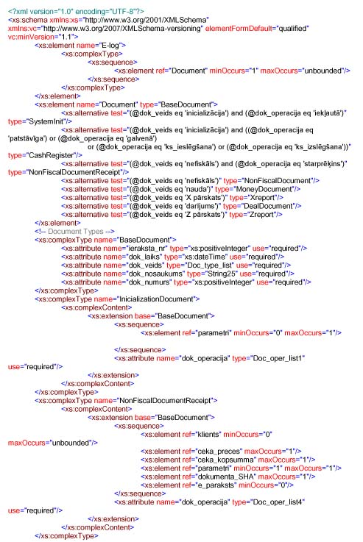
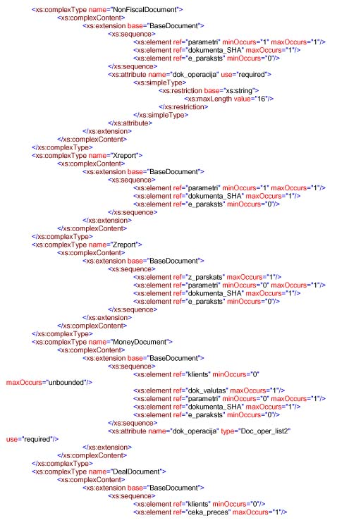
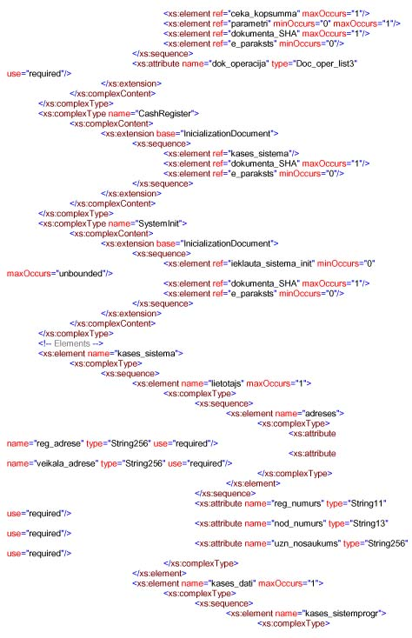
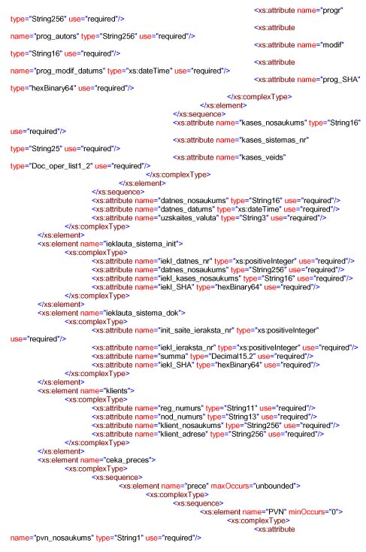
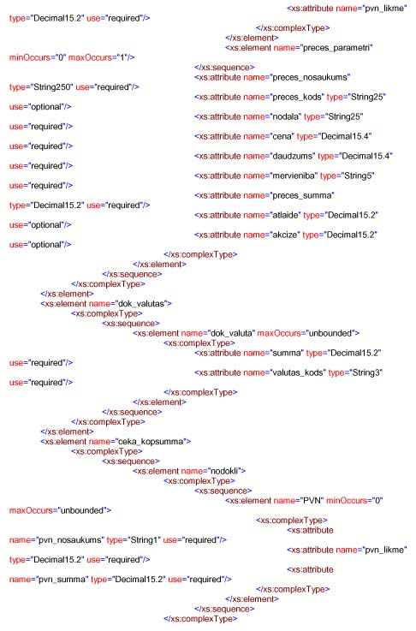
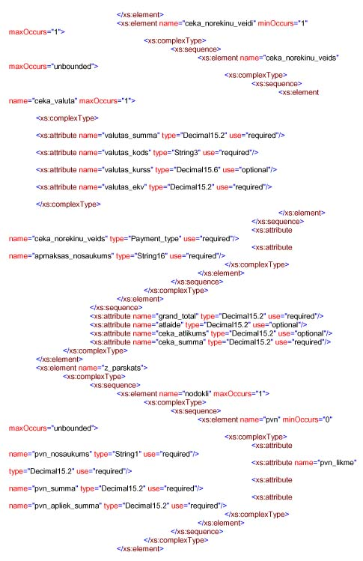
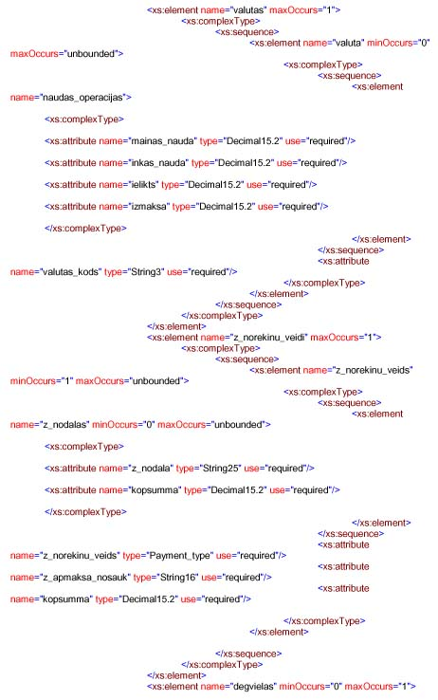
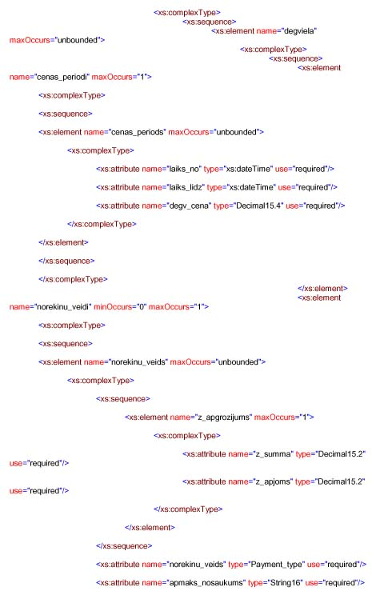
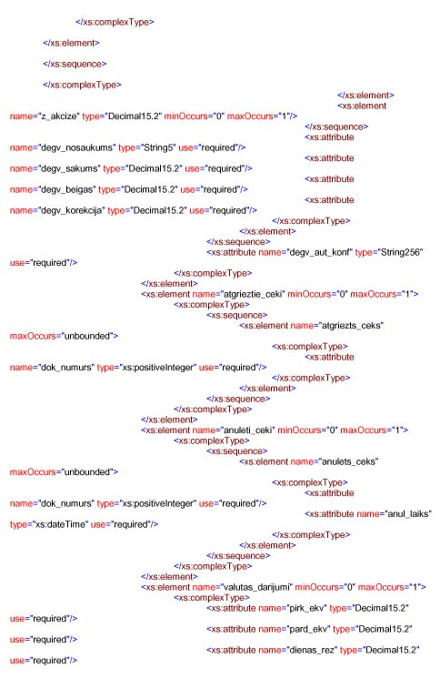
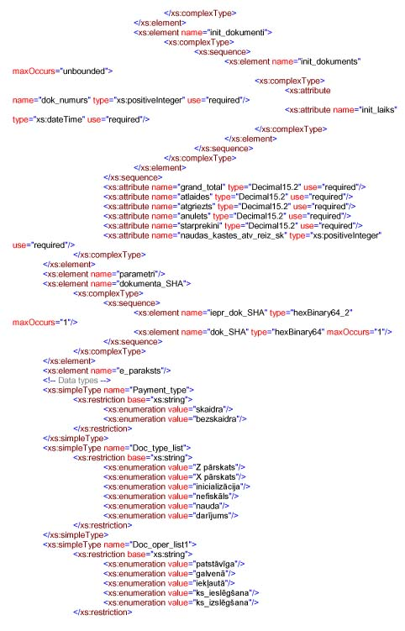
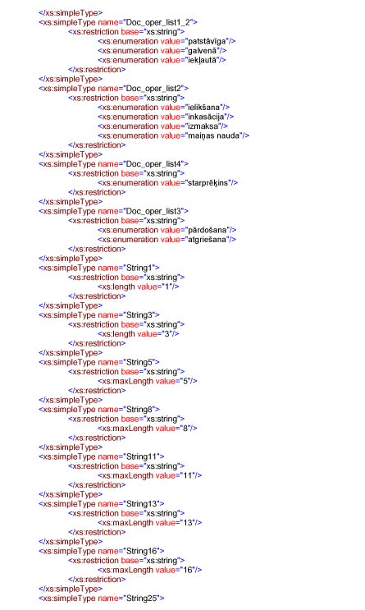
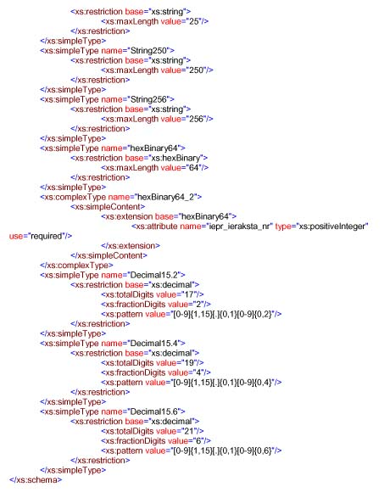

Revised by the Ministry of Finance
Annex 3
Cabinet Regulation No. 95
11 February 2014
[15 December 2015]

0,<ieraksta_nr>,<dok_laiks>,<dok_veids>,<dok_nosaukums>,<dok_operacija>,<dok_numurs>
1,<datnes_nosaukums>,<datnes_datums>,<uzskaites_valuta>,<reg_numurs>,<nod_numurs>,<uzn_nosaukums>,<reg_adrese>,<veikala_adrese>,<kases_nosaukums>,<kases_sistemas_nr>,<kases_veids>,<progr>,<prog_autors>,<modif>,<prog_modif_datums>,<prog_SHA>
2,<iekl_datnes_nr>,<datnes_nosaukums>,<iekl_kases_nosaukums>,<iekl_SHA>
3,<init_saite_ieraksta_nr>,<iekl_ieraksta_nr>,<summa>,<iekl_SHA>
4,<reg_numurs>,<nod_numurs>,<klient_nosaukums>,<klient_adrese>
5,<preces_nosaukums>,<preces_kods>,<nodala>,<cena>,<daudzums>,<mervieniba>,<preces_summa>,<atlaide>,<akcize>,<pvn_nosaukums>,<pvn_likme>,<preces_parametri>
6,<summa>,<valutas_kods>
7,<grand_total>,<atlaide>,<ceka_atlikums>,<ceka_summa>
75,<pvn_nosaukums>,<pvn_likme>,<pvn_summa>
76,<ceka_norekinu_veids>,<apmaksas_nosaukums>,<valutas_summa>,<valutas_kods>,<valutas_kurss>,<valutas_ekv>
8,<grand_total>,<atlaides>,<atgriezts>,<anulets>,<starprekini>,<naudas_kastes_atv_reiz_sk>
87,<pvn_nosaukums>,<pvn_likme>,<pvn_summa>,<pvn_apliek_summa>
88,<valutas_kods>,<mainas_nauda>,<inkas_nauda>,<ielikts>,<izmaksa>
891,<z_norekinu_veids>,<z_apmaksa_nosauk>,<kopsumma>
892,<z_nodala>,<kopsumma>
810,<degv_aut_konf>
8102,<degv_nosaukums>,<degv_sakums>,<degv_beigas>,<degv_korekcija>,<z_akcize>
81025,<laiks_no>,<laiks_lidz>,<degv_cena>
81026,<norekinu_veids>,<apmaks_nosaukums>,<z_summa>,<z_apjoms>
811,<dok_numurs>
812,<dok_numurs>,<anul_laiks>
813,<dok_numurs>,<kvits_laiks>
814,<pirk_ekv>,<pard_ekv>,<dienas_rez>
815,<dok_numurs>,<init_laiks>
9,<parametri>
10,<iepr_dok_SHA>,<iepr_ieraksta_nr>,<dok_SHA>

Example:
Initialisation
==========
0,1,07.01.2015 08:09:12,inicializācija,init,patstāvīga,1
1,201501071,07.01.2015 08:09:12,EUR,4000054321,4000054321,SIA MICRO,"Rīga, Smilšu iela",Smilšu iela 16,POS,1234567890,patstāvīga,POS,SIA,1.0.0,12.12.2014 10:23:52,123456ABCDEF1234
10,0000000000000000,0,1111111111111111
Pirkums 1
==========
0,2,07.01.2015 09:27:20,darījums,čeks,pārdošana,1
4,4000012345,4000012345,SIA ABC,"Rīga, Dārzu 320"
5,Prece Test 1,1111,1,1.00,2,gab,2.00,0.00,0.00,A,21.00,
5,Prece Test 2,2222,1,1.23,1,gab,1.23,0.00,0.00,B,12.00,
7,0.00,0.00,1.77,3.23
75,A,21.00,0.35
75,B,12.00,0.13
76,skaidra,Cash,5.00,EUR,1.00000,5.00
10,1111111111111111,1,0123456789ABCDEF
Pirkums 2
==========
0,3,07.01.2015 09:41:20,darījums,čeks,pārdošana,2
5,Prece Test 3,3333,1,2.00,1,gab,2.00,0.00,0.00,A,21.00,
7,3.23,0.00,0.00,2.00
75,A,21.00,0.35
76,skaidra,Cash,2.00,EUR,1.00000,2.00
10,0123456789ABCDEF,2,FEDCBA9876543210
Z-pārskats
==========
0,4,07.01.2015 10:03:12,Z pārskats,Z1,,1
8,5.23,0.00,0.00,0.00,0.00,2
87,A,21.00,0.70,4.00
87,B,12.00,0.13,1.23
891,skaidra,Cash,5.23
10,FEDCBA9876543210,3,FEDCBA1111111111

Revised by the Ministry of Finance
Annex 4
Cabinet Regulation No. 95
11 February 2014
[15 December 2015]

Address | Entry | Bytes | Number of entries | Total number of bytes | Explanation
 | Initialisation
0 | version of the fiscal memory module structure (for example, 0x0001) | 2 |  |  | for example, version 0x0001 shall be stored in the memory as follows: 0x01, 0x00
 | initialisation date/time (YYMMDDHHMMSS) | 6 |  |  | 0xYY, 0xMM, 0xDD, 0xHH, 0xMM, 0xSS
 | name, registration No. and other information of the fiscal memory module owner | 116 |  |  | name, registration code (personal identity number) of the user, chassis number of the cash register, hybrid cash register, cash register system
 |  | 124 | 1 | 124
 | Status
7C | status – the module has been fiscalised | 1 |  |  | 0xFF -> 0x00, indication of the fiscal memory module initialisation
 | status – Z report table of the day is full | 1 |  |  | 0xFF -> 0x00, indication of completing the last free Z report entry
 | status – receipt table is full | 1 |  |  | 0xFF -> 0x00, indication of completing the data of the last free document
 | status – device error | 1 |  |  | 0xFF -> 0x00, indication of a typing error that causes the problem of data integrity
 |  | 4 | 1 | 4
80 | Reserved (for example, for factory quality control tests or for the verification of module functionality) | 128
 |  | 128 | 1 | 128
 | Z report entry
100 | checksum (XOR from other Z entry bytes) | 1 |  |  | 0x?? XOR 0x?? XOR … XOR 0x?? is checksum of the entry
 | Date/time (YYMMDDHHMMSS) | 6 |  |  | 0xYY, 0xMM, 0xDD, 0xHH, 0xMM, 0xSS
 | Z counter (positive value only) | 2 |  |  | for example, Z 0027 shall be stored in the memory as follows: 0x1B, 0x00
 | tax 1; rate (2 bytes) (positive value only) | 2 |  |  | tax rate in per cent; for example, 15.00 % shall be stored in the memory as follows: 0xDC 0x05
 | tax 1; taxable value (6 bytes) (positive value only) | 6 |  |  | sum in EUR and cents: for example, € 2700.18 shall be stored in the memory as follows: 0xC2 0x1E, 0x04, 0x00, 0x00, 0x00
 | tax 1; amount of tax (6 bytes) (positive value only) | 6 |  |  | sum in EUR and cents
 | tax 2; rate (2 bytes) (positive value only) | 2 |  |  | tax rate in per cent
 | tax 2; taxable value (6 bytes) (positive value only) | 6 |  |  | sum in EUR and cents
 | tax 2; amount of tax (6 bytes) (positive value only) | 6 |  |  | sum in EUR and cents
 | tax 3; rate (2 bytes) (positive value only) | 2 |  |  | tax rate in per cent
 | tax 3; taxable value (6 bytes) (positive value only) | 6 |  |  | sum in EUR and cents
 | tax 3; amount of tax (6 bytes) (positive value only) | 6 |  |  | sum in EUR and cents
 | tax 4; rate (2 bytes) (positive value only) | 2 |  |  | tax rate in per cent
 | tax 4; taxable value (6 bytes) (positive value only) | 6 |  |  | sum in EUR and cents
 | tax 4; amount of tax (6 bytes) (positive value only) | 6 |  |  | sum in EUR and cents
 | sum excluding tax (positive value only) | 6 |  |  | sum in EUR and cents
 | number of returns (positive value only) | 4 |  |  | for example, if 12 return transactions have been recorded during a day, 12 shall be stored in the memory as follows: 0x0C, 0x00, 0x00, 0x00
 | return sum (negative value) | 6 |  |  | sum in EUR and cents with a sign; MSB 0 – “+”, 1 – “-”
 | number of cancellations (positive value only) | 4 |  |  | see the explanatory note next to the field “number of returns”
 | cancellation sum (negative value) | 6 |  |  | sum in EUR and cents with a sign. For example, € -2700.18 shall be stored in the memory as follows: 0xC2 0x1E, 0x04, 0x00, 0x00, 0x80
 | number of purchases (positive value only) | 4 |  |  | see the explanatory note next to the field “number of returns”
 | purchase sum (negative value) | 6 |  |  | sum in EUR and cents with a sign. For example, € -2700.18 shall be stored in the memory as follows: 0xC2 0x1E, 0x04, 0x00, 0x00, 0x80
 | number of pay-outs (positive value only) | 4 |  |  | see the explanatory note next to the field “number of returns”
 | pay-out sum (negative value) | 6 |  |  | sum in EUR and cents with a sign
 | sum of positive transactions (positive value only) | 6 |  |  | sum in EUR and cents
 | Grand Total (positive value only) | 6 |  |  | sum in EUR and cents
 | SHA-1 or SHA-256 | 20 |  |  | SHA-1 occupies 20 bytes, SHA-256 occupies 32 bytes; if SHA-1, the first 20 bytes of the field shall be completed respectively
 |  | 143 | 1096 | 156728 | 1096 Z report (366+365+365)
 | Receipt entry
20F98 | checksum (XOR from other receipt entry bytes) | 1 |  |  | 0x?? XOR 0x?? XOR … XOR 0x?? is checksum of the entry
 | Date/time (YYMMDDHHMMSS) | 6 |  |  | 0xYY, 0xMM, 0xDD, 0xHH, 0xMM, 0xSS
 | receipt number (positive value only) | 4 |  |  | for example, receipt number 125798 shall be saved in the memory as follows 0x66, 0xEB, 0x01, 0x00
 | receipt sum (positive value only) | 6 |  |  | sum in EUR and cents
 | Grand Total (positive value only) | 6 |  |  | sum in EUR and cents
 | SHA-1 or SHA-256 | 32 |  |  | SHA-1 occupies 20 bytes, SHA-256 occupies 32 bytes; if SHA-1, the first 20 bytes of the field shall be completed respectively
 |  | 55 | 1096000 | 60280000 | 1096000 document ((366+365+365)*1000
 | Total |  |  | 60436856 | Memory capacity for three years (1000 documents per day)

