Text consolidated by Valsts valodas centrs (State Language Centre) with amending regulations of:
30 October 2018 [shall come into force on 1 January 2019].
If a whole or part of a paragraph has been amended, the date of the amending regulation appears in square brackets at the end of the paragraph. If a whole paragraph or sub-paragraph has been deleted, the date of the deletion appears in square brackets beside the deleted paragraph or sub-paragraph.

Republic of Latvia

Cabinet
Regulation No. 153
Adopted 21 March 2017

Procedures by Which the Police Carry out Monitoring by Using Technical Means, and also the Processing of the Data Obtained as a Result of Such Monitoring

Issued pursuant to
Section 12, Paragraph four of the law On Police

1. The Regulation prescribes the procedures for monitoring buildings, premises, and territory of police institutions, public places and persons therein, and objects to be guarded by the police using technical means (hereinafter – monitoring), and also the procedures for processing the data obtained as a result of such monitoring.

2. Monitoring may be carried out by the State Police, port police, or municipal police (hereinafter – the police institution). Monitoring shall be carried out permanently or temporarily.
[30 October 2018]

3. The head of the police institution or an official authorised by him or her shall determine the monitoring and the technical means to be used for monitoring upon considering a possible threat to public order and safety. Monitoring of the objects to be guarded by the police shall be coordinated with the head of administration of a relevant object to be guarded or a person authorised by him or her.

4. A person placed in a place of temporary detention shall be monitored for 48 hours from the moment when the person is placed in the place of temporary detention (except for the arrested and convicted persons who have been transferred from a remand prison or a prison).

5. Persons who have been placed in a place of temporary detention for more than 48 hours and arrested and convicted persons who have been transferred from a remand prison or a prison shall be monitored if there are grounds to believe that a person may escape, inflict harm on himself or herself, employees of the place of temporary detention, or other persons or property.

6. Monitoring of the persons referred to in Paragraph 5 of this Regulation shall be registered by indicating the following:
6.1. the grounds for monitoring;
6.2. the times when monitoring has been started and completed.

7. Monitoring shall not be carried out in places where persons expect particularly high protection of privacy.

8. An informative sign (Annex) consisting of an image of a surveillance video camera at a 35 degree angle on a white background with a red frame in the shape of an equilateral triangle shall warn of monitoring. One side of the triangle shall be 145 mm long and 12 mm wide. The inscription “VIDEONOVĒROŠANA” [Video Surveillance] in black lettering shall be located below the triangle. The purpose of the video surveillance, the name, address, and contact telephone number of a controller shall be indicated under it. The size of the informative sign may be proportionally increased or reduced.

9. The informative sign shall be placed:
9.1. at the building, territory of the police institution, public place, and an entrance of the object to be guarded by the police if the building, territory of the police institution, public place, and object to be guarded by the police is confined;
9.2. in a clearly visible place if the building, territory of the police institution, public place, and object to be guarded by the police is not confined;
9.3. in a clearly visible place on a vehicle of the police institution or uniform of an officer.

10. The police institution shall retain the data obtained from monitoring for three months.

11. The data obtained from monitoring in which a threat to public order, a criminal offence, a wanted person or vehicle, and also a threat to safety of the building, premises, and territory of the police institution, detained persons, and object to be guarded has been established shall be retained until completion of criminal proceedings, administrative offence proceedings, administrative proceedings, or departmental examination within the police institution but no longer than for three years.

12. The head of the police institution or an official authorised by him or her shall take the decision to transfer the data obtained from monitoring.

13. In transferring the data obtained from monitoring, the police institution shall ensure retention of the following information:
13.1. the date of transfer of the data obtained from monitoring;
13.2. a short description of the data obtained from monitoring;
13.3. the person who has transferred the data obtained from monitoring;
13.4. the person who has received the data obtained from monitoring.

14. After expiry of the retention period referred to in Paragraphs 10 and 11 of this Regulation, the data obtained from monitoring shall be deleted.

15. The data obtained from monitoring before 1 January 2019 shall be retained for one month.

Prime Minister Māris Kučinskis

Minister for the Interior Rihards Kozlovskis

Annex
Cabinet Regulation No. 153
21 March 2017

Sign Informing of Monitoring

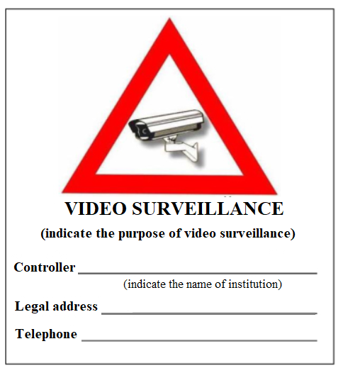

Minister for the Interior Rihards Kozlovskis

