Republic of Latvia

Cabinet
Regulation No. 727
Adopted 2 November 2021

Regulations Regarding the Personal Document of an Asylum Seeker

Issued pursuant to
Section 8, Paragraph two of the Asylum Law

1. The Regulation prescribes the specimen of the personal document of an asylum seeker (hereinafter – the document) and the procedures for the issuance thereof.

2. The dimensions of the document shall be 10.5 x 7.5 cm. The document shall be produced by using the functionality of the Register of Asylum Seekers in conformity with the specified specimen (Annex). After production the document shall be laminated.

3. The document shall contain:
3.1. the information on an asylum seeker by retrieving such information from the Register of Asylum Seekers:
3.1.1. the given name (names) (the original form transliterated in Latin alphabet);
3.1.2. the surname (the original form transliterated in Latin alphabet);
3.1.3. the personal identify number (if any);
3.1.4. the date and place of birth;
3.1.5. the nationality and type thereof;
3.2. if an asylum seeker is under the age of 18 years or an asylum seeker requires establishment of the guardianship for ensuring defence of his or her rights and legal interests – the information on the legal representative or guardian of the asylum seeker (the given name (names), surname, date of birth and personal identity number (if any));
3.3. if an asylum seeker is under the age of one year – a reference to the eye colour and height of the asylum seeker;
3.4. the image of an asylum seeker (the person shall be without any headgear on the image, except the case if the person wears a headgear on a daily basis for religious reasons and the headgear does not cover the face or a part thereof);
3.5. the information on the document:
3.5.1. the number;
3.5.2. the place of issue;
3.5.3. the date of issue;
3.5.4. the name of the issuing authority and phone number intended for communication with it.

4. If an asylum seeker is subject to a restriction or prohibition of residence or movement in a particular territory of the State, the reference “Residence or movement restrictions” shall be included in the document.

5. The document shall be issued by the State Border Guard.

6. The document shall be issued within three days after receipt of the submission of an asylum seeker on granting refugee or alternative status (hereinafter – the submission of an asylum seeker). The document shall be valid as from the day it has been issued until the day the administrative proceedings concerning the application of an asylum seeker have ended.

7. Prior to issuing the document, the official of the State Border Guard shall inform an asylum seeker in the language which the asylum seeker can understand or which is regarded to be understandable by him or her (where necessary by using interpreter services) that:
7.1. liability for the intentional provision of false information has been stipulated in the Republic of Latvia;
7.2. the issued document confirms that the person has the status of an asylum seeker and the person has the right to reside in the Republic of Latvia during the asylum procedure;
7.3. if the document is missing due to robbery, has been, stolen, lost, or damaged, the asylum seeker has the obligation to inform the following thereof within one working day:
7.3.1. the State Border Guard;
7.3.2. an employee of the accommodation centre for asylum seekers if the asylum seeker resides in the abovementioned centre.

8. The document shall be issued repeatedly if:
8.1. the document issued previously is missing due to robbery, has been stolen or lost;
8.2. the document issued previously is damaged or has become invalid for use because:
8.2.1. notes not provided for by laws and regulations have been made therein;
8.2.2. the information specified therein on the identity of an asylum seeker or the information on the persons referred to in Sub-paragraph 3.2 of this Regulation has changed;
8.2.3. inaccuracies in the information included therein have been established;
8.2.4. there are damages therein due to which it is not possible to visually identify the holder of the document or to read the information specified in the document;
8.2.5. the reference referred to in Paragraph 4 of this Regulation is required to be included therein.

9. In order to receive the document repeatedly, an asylum seeker shall submit to the State Border Guard the relevant submission and the document issued previously (if any).

10. Prior to issuing the document repeatedly, the official of the State Border Guard shall:
10.1. ascertain the identity of the recipient of the document;
10.2. make a note in the Register of Asylum Seekers that the document issued to the asylum seeker previously has become invalid for use, and specify the reason.

11. The State Border Guard shall issue the document repeatedly within three working days after receipt of the submission referred to in Paragraph 9 of this Regulation.

12. Upon conclusion of the administrative proceedings in respect of the submission of an asylum seeker, the State Border Guard shall ensure the fulfilment of the requirements referred to in Sub-paragraph 10.2 of this Regulation.

Prime Minister A. K. Kariņš

Minister for the Interior M. Golubeva

Annex
Cabinet Regulation No 727
2 November 2021

Specimen of the Personal Document of an Asylum Seeker

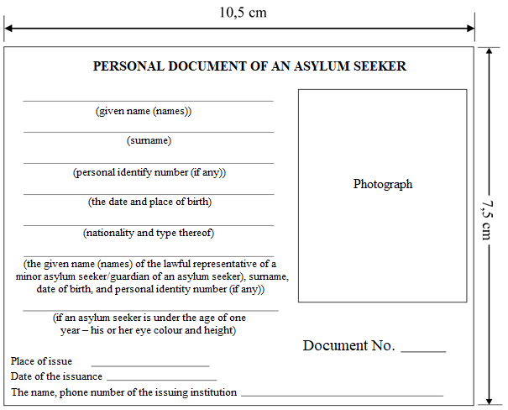

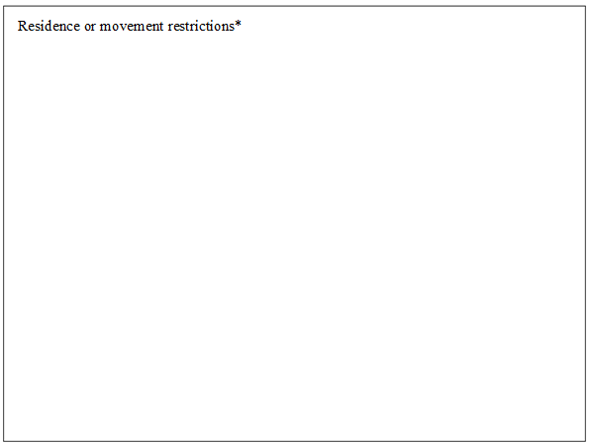

Note. * The reference “Residence or movement restrictions” shall be provided if the asylum seeker is subject to a restriction or prohibition of residence or movement in a particular territory of a State.

Minister for the Interior M. Golubeva

