Text consolidated by Valsts valodas centrs (State Language Centre) with amending laws of:
30 April 2009 [shall come into force on 3 June 2009];
16 December 2010 [shall come into force on 1 January 2011].
If a whole or part of a section has been amended, the date of the amending law appears in square brackets at the end of the section. If a whole section, paragraph or clause has been deleted, the date of the deletion appears in square brackets beside the deleted section, paragraph or clause.

The Saeima ¹ has adopted and
the President has proclaimed the following law

Grīņi Strict Nature Reserve Law

Section 1.

The Grīņi Strict Nature Reserve (hereinafter – the Reserve) is a specially protected nature territory of State significance.

Section 2.

The Reserve has been established for the purpose of preserving the historically formed natural ecosystems in an untouched state and studying the processes occurring therein, and also for ensuring the protection of endangered and rare plants, fungi, lichens, and animals.

Section 3.

The total area of the Reserve is 1 454.9 hectares and its borders have been determined in accordance with the Grīņi Strict Nature Reserve plan (Annex 1) and the description of borders of the Grīņi Strict Nature Reserve (Annex 2).

Section 4.

(1) In order to ensure the preservation of the diversity of the ecosystems, landscapes, and species of the Reserve, the regulatory regime zone has been established in the entire territory of the Reserve which shall be protected and managed in accordance with the nature protection plan and individual protection and use regulations of the Reserve.
(2) It is prohibited within the territory of the Reserve to:
1) stay without an authorisation issued by the administration of the Reserve;
2) use any chemical plant protection products;
3) carry out forest management, except for felling for the preservation of the protected species and biotopes.

Section 5.

The administration of the Reserve shall be implemented by the Nature Conservation Agency (hereinafter – the Agency) that is an institution of direct administration subordinate to the Minister for Environmental Protection and Regional Development.
[30 April 2009; 16 December 2010]

Section 6.

The nature protection interests and economic activity at the Grīņi Strict Nature Reserve shall be harmonised by the Advisory Council of Slītere National Park.

Transitional Provisions

1. With the coming into force of this Law, Cabinet Regulation No. 421, Regulations Regarding the Grīņi Strict Nature Reserve (Latvijas Republikas Saeimas un Ministru Kabineta Ziņotājs, 2000, No. 2), issued in accordance with Section 81 of the Constitution is repealed.

2. Amendment to Annex 2 to this Law regarding the replacement of the words “Liepāja district” with the words “Pāvilosta municipality” shall come into force on 1 July 2009.
[30 April 2009]

3. The administration of the Reserve shall be implemented by the administration of Slītere National Park until 1 June 2009.
[30 April 2009]

The Law has been adopted by the Saeima on 16 March 2000.

President V. Vīķe-Freiberga

Rīga, 5 April 2000

Grīņi Strict Nature Reserve Law
Annex 1

Grīņi Strict Nature Reserve Plan

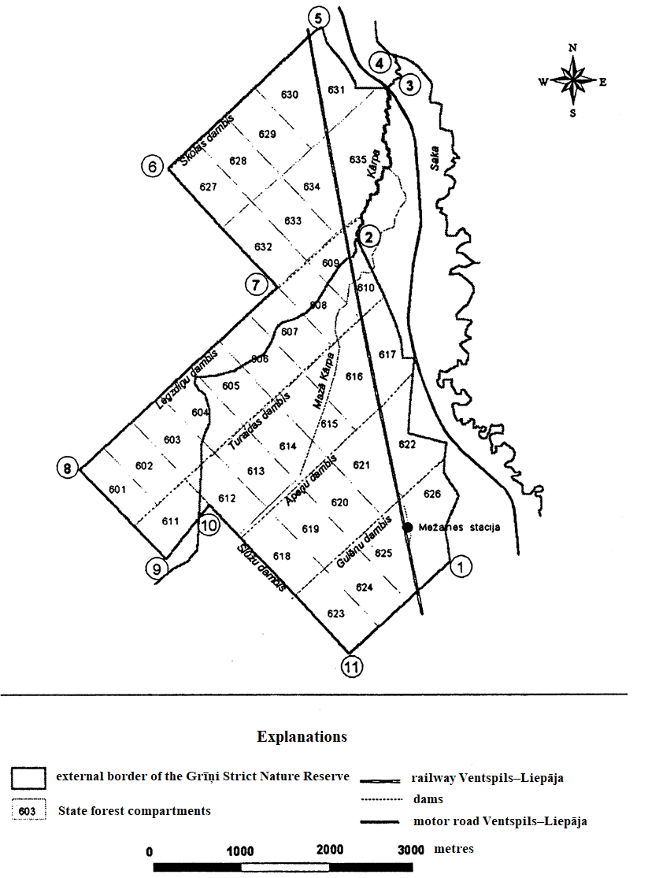

Grīņi Strict Nature Reserve Law
Annex 2

Description of Borders of the Grīņi Strict Nature Reserve
[30 April 2009 / Amendment regarding the replacement of the words “Liepāja district” with the words “Pāvilosta municipality” shall come into force on 1 July 2009. See Transitional Provisions]

Pāvilosta municipality Saka rural territory Vērgale forestry of Aizpute forest office
The Grīņi Strict Nature Reserve shall have the following borders:

from 1 to 2 - | from the south-eastern corner of State forest compartment No. 626 (hereinafter – c.) along the eastern delimiting boundary of cc. No. 626, 622, 617, and 610 due north to the River Kārpa;
from 2 to 3 - | along the bank of the River Kārpa due north to the motor road Ventspils–Liepāja;
from 3 to 4 - | from the bridge of the River Kārpa over the motor road Ventspils–Liepāja along the eastern and northern delimiting boundary of c. No. 635 to the south-eastern corner of c. No. 631;
from 4 to 5 - | from the south-eastern corner of c. No. 631 along the eastern delimiting boundary of this c. due north to Skola dam;
from 5 to 6 - | along the Skola dam in the south-western direction to the western corner of c. No. 627;
from 6 to 7 - | from the western corner of c. No. 627 along the south-western delimiting boundary of this c. and c. No. 632 due south to the northern corner of c. No. 607;
from 7 to 8 - | from the northern corner of c. No. 607 along the Legzdiņi dam due south-west to the western corner of c. No. 601;
from 8 to 9 - | from the western corner of c. No. 601 along the south-western delimiting boundary of this c. and c. No. 611 due south-east to the southern corner of c. No. 611;
from 9 to 10 - | from the southern corner of c. No. 611 along the south-eastern delimiting boundary of this c. due north-east to Slūžu dam;
from 10 to 11 - | along the Slūžu dam due south-east to the southern corner of c. No. 623;
from 11 to 1 - | from the southern corner of c. No. 623 along the south-eastern delimiting boundary of this c. and cc. No. 624, 625, and 626 due north-east to the starting point in the south-eastern corner of c. No. 626.

