Decision No. 1/24 of the Board of the Public Utilities Commission

Adopted 15 September 2022

Regulations Regarding Unbundled Access to the Subscriber Line

Issued pursuant to
Section 80, Paragraph three and Section 83, Paragraph one, Clause 2 of the Electronic Communications Law

I. General Provisions

1. The regulations prescribe:
1.1. the technical and operational conditions of an electronic communications network for an electronic communications merchant with a significant market power who has a specific access obligation to ensure unbundled access to a subscriber line (hereinafter – the owner) for the following types of access:
1.1.1. full unbundled access to the subscriber line – an electronic communications service provided by the lessee to the end-user, using the subscriber line over its whole length;
1.1.2. shared access to the subscriber line – an electronic communications service provided concurrently by the lessee and the owner to the end-user, using the subscriber line over its whole length;
1.1.3. full unbundled access to the part of the subscriber line, including to the subscriber sub-line or terminating segment – an electronic communications service provided by the lessee to the end-user, using the segment of the subscriber line from the distribution point to the termination point unless the owner and the lessee have agreed otherwise;
1.1.4. shared access to the part of the subscriber line, including to the subscriber sub-line or terminating segment – an electronic communications service provided concurrently by the lessee and the owner to the end-user, using the segment of the subscriber line from the distribution point to the termination point unless the owner and the lessee have agreed otherwise;
1.2. the technical information to be included in a reference offer for unbundled access to the subscriber line and the level of detail thereof.

2. The following terms are used in the regulations:
2.1. unbundled access to the subscriber line (hereinafter – the unbundled access) – an access service provided by the owner to another electronic communications merchant for the provision of the electronic communications service, using the subscriber line or part thereof fully or jointly;
2.2. backhaul – the following service established between the unbundled access point and the electronic communications network facility of the lessee:
2.2.1. Ethernet backhaul – a connection established at the Ethernet OSI Layer 2;
2.2.2. access to cable ducts or poles;
2.3.3. lease of dark fibre;
2.3. lessee – an electronic communications merchant who has entered into a contract for the unbundled access with the owner;
2.4. central office – a place where the access network and the core network interconnect;
2.5. unbundled access point – a physical point collocated at the central office of the owner or another place over the electronic communications network, if technically possible, at which the owner provides the lessee with unbundled access to the subscriber line to provide the electronic communications services to the end-user over the subscriber line of the owner;
2.6. backhaul access point – a physical point collocated at the central office of the owner or another place over the electronic communications network, if technically possible, at which the owner provides the lessee with the backhaul;
2.7. Ethernet backhaul access point – an interface of the electronic communications network facility of the owner at which the owner provides the lessee with the Ethernet backhaul;
2.8. applicant – an electronic communications merchant who wishes to obtain unbundled access;
2.9. distribution point – a cable distribution device for the public electronic communications network which is intended for the distribution of metallic or optical fibre cables. The distribution point is a cable distribution cabinet, distribution box, small distribution box, or cable closure;
2.10. distribution cabinet – a cable cabinet, electronic communications facility cabinet or container;
2.11. dark fibre – an optical fibre in an installed or built cable line which is not active, i.e. its both ends are not connected to operating optoelectronic devices;
2.12. virtual unbundled local access (VULA) – an active access product which is a connection established at the Ethernet OSI Layer 2 between the connection point of the subscriber line of the owner and the unbundled access point and which is physically collocated at the central office of the owner or another place over the electronic communications network.

3. The following abbreviations are used in the regulations:
3.1. Ethernet P2P – Ethernet Point to Point Technology;
3.2. FTTB (Fibre to the Building) – ensuring of optical fibre cables to the building;
3.3. FTTH (Fibre to the Home) – ensuring of optical fibre cables to the premises of an end-user;
3.4. FTTN (Fibre to the Node) – ensuring of optical fibre cables to the distribution cabinet;
3.5. Gbit/s – gigabits per second;
3.6. GPON – Gigabit-capable Passive Optical Network;
3.7. IGMP – Internet Group Multicast Protocol;
3.8. ITU-T – International Telecommunications Union, Telecommunication Standardization Sector;
3.9. MDF – Main Distribution Frame;
3.10. NTU – Network Termination Unit;
3.11. ODF – Optical Fibre Distribution Frame;
3.12. OSI – Open Systems Interconnection;
3.13. POTS – Plain Old Telephone Service;
3.14. TP – termination point;
3.15. P2P (Point to Point) – access network point-to-point architecture;
3.16. RJ – Registered Jack;
3.17. VDSL – Very High Speed Digital Subscriber Line;
3.18. VDSL2 Vectoring – Very High Speed Digital Subscriber Line 2 Vectoring;
3.19. VLAN – Virtual Local Area Network;
3.20. VULA – Virtual Unbundled Local Access;
3.21. xDSL – Digital Subscriber Line Technologies.

4. Technological solutions for unbundling refer to the subscriber line established in accordance with the general organisation chart of the access network indicated in Annex 1 to these regulations and the access network architecture of shielded twisted pairs and optical fibre cables indicated in Annex 2 to these regulations.

5. The owner shall include in the reference offer for unbundled access to the subscriber line at least the following technological solutions used over its access network and indicated in Annex 3 to these regulations:
5.1. access network architecture;
5.2. access network technology;
5.3. type of unbundled access;
5.4. unbundling technology;
5.5. place for the implementation of unbundled access.

6. The owner shall use at least the following unbundling technologies for the implementation of unbundled access:
6.1. physical switching:
6.1.1. physical switching over the shielded twisted pair cable subscriber line is mechanical switching of the shielded twisted pairs at the central office or distribution point by using the terminator, connector module, or connector; it also includes switching of the free pair over the access network at the unbundling place necessary for the applicant – at the MDF of the central office or distribution point of the subscriber line;
6.1.2. physical switching over the optical fibre cable subscriber line is mechanical switching of the optical fibres at the central office or distribution point by using the optical plug and coupler or fibre connection; it also includes switching of the dark fibre over the access network at the unbundling place necessary for the applicant – at the ODF of the central office, distribution point of the subscriber line, or termination point, and also connection for the drawable fibre cable fibre;
6.2. ensuring of unbundled access, using xDSL, except for VDSL2 Vectoring;
6.3. VULA.

7. In the reference offer for unbundled access to the subscriber line, the owner shall include the technical requirements for the shielded twisted pair cable subscriber line which are applicable to unbundled access, covering at least the following conditions:
7.1. electrical parameter standards:
7.1.1. extraneous voltage for the whole subscriber line;
7.1.2. insulation resistance (MΩ/km);
7.1.3. loop resistance (Ω/km);
7.1.4. capacity between the shielded twisted pair wires (nF/km);
7.1.5. attenuation (dB/km) depending on the length of the subscriber line and the frequency within a frequency range of 25 kHz to 2.2 MHz. If the applicant intends to use a VDSL, except for VDSL2 Vectoring, facility, the owner shall, upon request of the applicant, within five days, provide the applicant individually with attenuation (dB/km) depending on the length of the subscriber line and the frequency within a frequency range of 25 kHz to 30 MHz;
7.2. the requirements for lightning and over-voltage protection equipment and the procedures for the installation thereof;
7.3. the number of shielded twisted pairs in one cable intended for operational reserves which does not exceed 10 % of the cable volume and is at least one shielded twisted pair;
7.4. the restrictions on the use of different technologies and on the number of facilities used for unbundling in one cable if it is necessary for ensuring the protection of the electronic communications network or the quality of the electronic communications services, and also restriction principles and algorithms for the calculations thereof.

8. In the reference offer for unbundled access to the subscriber line, the owner shall include the technical requirements for the shielded optical fibre cable subscriber line and dark fibre which are applicable to unbundled access, covering at least the following conditions:
8.1. the requirements for the optical fibre, indicating the European standard and ITU-T recommendation to which the optical fibre conforms;
8.2. attenuation in optical fibre (dB/km) at wavelengths of electromagnetic waves of 1310 nm, 490 nm, and 1550 nm if the applicant intends to use a facility operating at other wavelengths of electromagnetic waves, the owner shall, upon request of the applicant, within five working days, provide the applicant individually with attenuation in optical fibre (dB/km) at the requested wavelengths of electromagnetic waves;
8.3. the requirements for the optical plug and coupler;
8.4. the requirements for lightning and over-voltage protection equipment and the procedures for the installation thereof.

9. For unbundled access to the shielded twisted pair subscriber line, FTTH P2P or GPON, FTTB and FTTNT access network architectures and technology, except for terminating segment, the owner shall provide, upon request of the lessee, the backhaul for Ethernet, lease of dark fibre, or access cable ducts. In case of other access network technologies, the owner shall provide the backhaul upon agreement with the lessee.

10. For unbundled access to the shielded twisted pair subscriber line, FTTH P2P or GPON, FTTB and FTTNT access network architectures and technology, except for terminating segment, the following additional requirements shall be complied with by the owner when providing the Ethernet backhaul:
10.1. an access point shall be established for the Ethernet backhaul as the optical fibre connector of the Ethernet OSI Layer 2 distribution frame where the following maximum download and upload data transmission speed (hereinafter – the transmission speed) shall be ensured: 1*n Gbit/s where n is a natural figure which is greater than 0 and the value of which is determined upon agreement between the lessee and the owner;
10.2. it shall be ensured at the access point for the Ethernet backhaul that the lessee has a possibility to control the transmission speed of the service provided to the end-users;
10.3. the quality requirements in accordance with Paragraph 20 of these regulations.

11. The owner shall ensure the guaranteed transmission speed for the Ethernet backhaul which is not less than 80 % of the connection speed.

12. The owner and the lessee shall agree upon the technical requirements for the subscriber line, and also upon the wavelength of electromagnetic wave to be used, the range of frequency spectrum, the level of signal transmission, the line code to be used in the signal transmission, or any other conditions, taking into account the technical requirements for the facility to be used if other or additional parameters are applicable to the connection of the facility used by the lessee, and also if it is indented to use such technology or technical solution for unbundled access which does not correspond to the technical parameters ensured for the subscriber line.

13. In the reference offer for unbundled access to the subscriber line, the owner shall include the technical requirements for electrical interfaces for virtual unbundling at the following points of the electronic communications network:
13.1. termination point;
13.2. unbundled access point;
13.3. access point for the Ethernet backhaul.

14. The owner shall ensure the applicant with the following interfaces for NTUs at the network termination point for unbundled access:
14.1. without an active NTU. At the termination point of twisted pair cables, a physical NTU is an outlet with an appropriate RJ type socket. At the termination point of optical fibre cables, a physical NTU is an optical plug;
14.2. with an active NTU. If chosen by the applicant, the owner shall ensure an active NTU at the termination point.

15. In the reference offer for unbundled access to the subscriber line, the owner shall include a list of compatible active NTUs, indicating the manufacturer and the name of facility assigned by the manufacturer, and shall update the list once a year. If the owner ensures an active NTU, then the brand of the owner or other information identifying the owner shall not be indicated on the NTU.

16. In the case of virtual unbundling, the owner shall ensure an Ethernet access point for unbundled access with the following physical interfaces and the maximum transmission speeds, offering the lessee a possibility to control the transmission speed of the service provided to the end-user:
16.1. an RJ type socket in which the following transmission speed is ensured: 0.1*n Gbit/s where n is a natural figure which is greater than 0 and the value of which is determined upon agreement between the lessee and the owner;
16.2. an optical fibre connector in which the following transmission speed is ensured: 1*n Gbit/s where n is a natural figure which is greater than 0 and the value of which is determined upon agreement between the lessee and the owner;
16.3. the quality requirements in accordance with Paragraph 20 of these regulations.

17. The owner shall ensure the guaranteed transmission speed at the Ethernet access point for unbundled access which is not less than 80 % of the connection speed.

18. The owner shall ensure the access point for the Ethernet backhaul for the unbundled access voice service, Internet access service, and television programme distribution service with a contention ratio in accordance with the agreement between the lessee and the owner.

19. In the case of virtual unbundling, the owner shall include in the reference offer for unbundled access to the subscriber line at least the following service categories for the Ethernet backhaul for download and upload:
19.1. voice telephony service category;
19.2. Internet access service category;
19.3. television programme distribution service category.

20. In the case of virtual unbundling, the owner shall include in the reference offer for unbundled access to the subscriber line at least the following quality requirements for the Ethernet backhaul for each service category which shall not be lower than those for the service provided by the owner in retail:
20.1. traffic transmission priorities in the network of the owner, indicating the methods for setting priorities which have been specified in the priority frame and offering a possibility for the lessee to determine the priority for the traffic;
20.2. one-way frame delay;
20.3. inter-frame delay variation;
20.4. frame loss;
20.5. availability.

21. In the case of virtual unbundling, the owner shall, upon request of the lessee, provide multicast in the following manner:
21.1. by using the IGMP protocol with replication of television flow for the end-user in the owner’s central office facilities of the local level;
21.2. by assigning the lessee a separate VLAN for the television programme distributions service.

22. In the case of virtual unbundling and if requested by the lessee, the owner shall provide each end-user of the lessee with its own VLAN when providing the voice service or Internet access service. In the case of virtual unbundling, the lessee shall determine security requirements in its electronic communications network.

23. In the case of virtual unbundling and Ethernet backhaul, the owner shall ensure the lessee with a possibility to apply security measures.

24. In the case of virtual unbundling and Ethernet backhaul, the owner shall provide the lessee with a possibility to identify its end-users on the level of central office facilities or VLAN.

25. Decision No. 1/11 of the Public Utilities Commission of 18 June 2014, Regulations Regarding Unbundled Access to the Subscriber Line or Part Thereof (Latvijas Vēstnesis, 2014, No. 120; 2018, No. 199), is repealed.

26. The regulations shall come into force on 1 October 2022.

Chair of the Board of the Public Utilities Commission A. Ozola

Annex 1
Decision No. 1/24 of the Public Utilities Commission
15 September 2022

General Organisation Chart of the Access Network

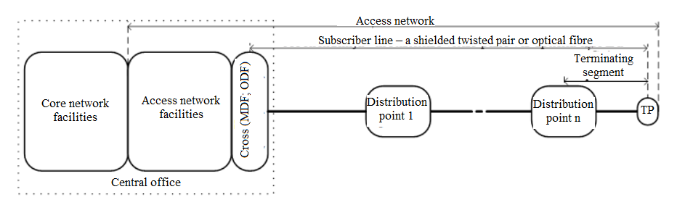

Annex 2
Decision No. 1/24 of the Public Utilities Commission
15 September 2022

Access Network Architecture of Shielded Twisted Pairs and Optical Fibre Cables

1. Division of access network architectures

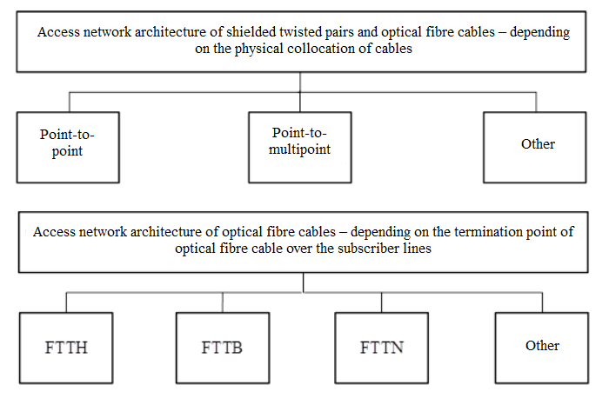

2. Access network point-to-point architecture

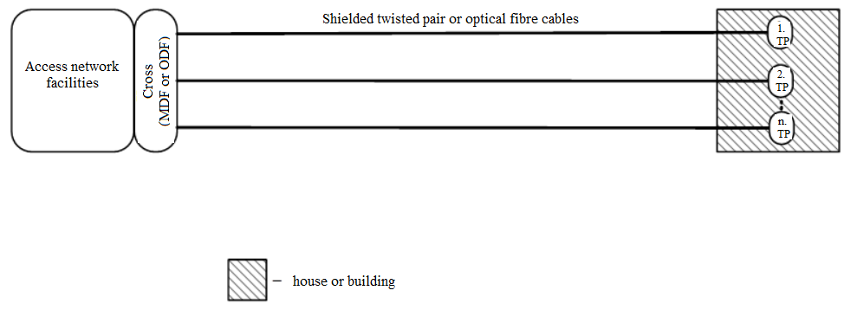

3. Access network point-to-multipoint architecture and three basic options of the placement of a point-to-multipoint facility

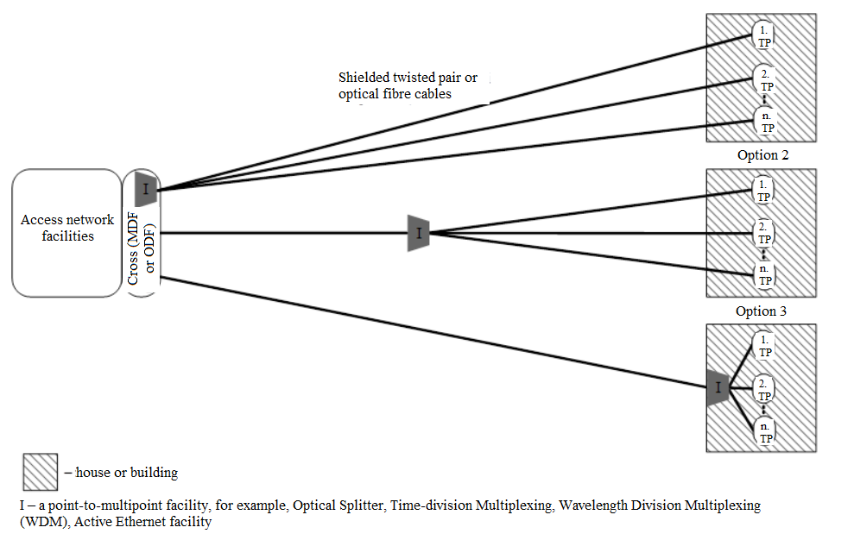

4. Access network architecture of optical fibre cables – depending on the termination point of optical fibre cable over the subscriber line

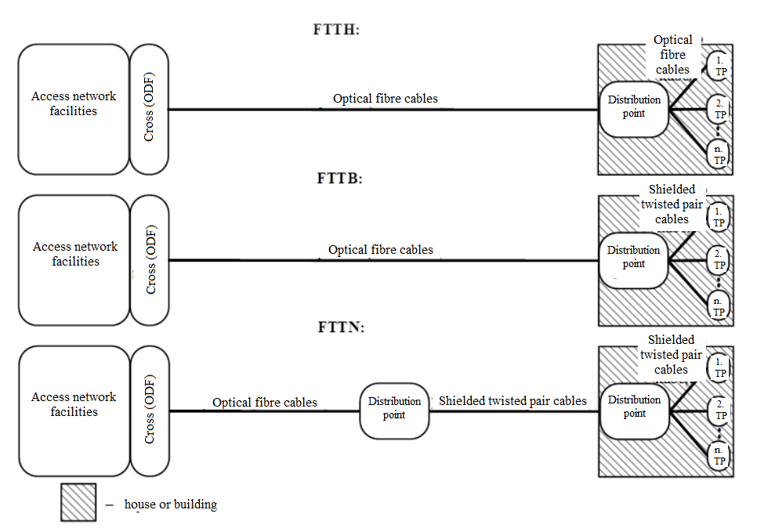

Annex 3
Decision No. 1/24 of the Public Utilities Commission
15 September 2022

Technological Solutions for Unbundled Access

1. Unbundled access in the shielded twisted pair cable access network

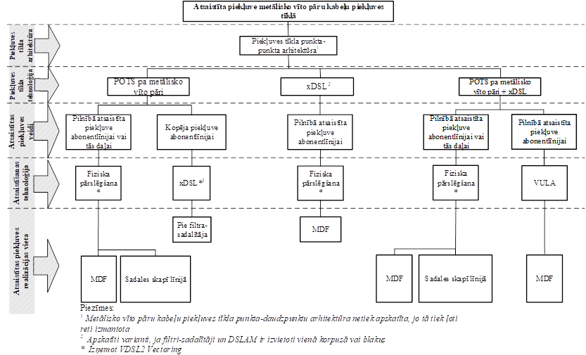

Latviešu val. | Angļu val.
Atsaistīta piekļuve metālisko vīto pāru kabeļu piekļuves tīklā | Unbundled access in the shielded twisted pair cable access network
Piekļuves tīkla arhitektūra | Access network architecture
Piekļuves tīkla tehnoloģija | Access network technology
Atsaistītas piekļuves veidi | Types of unbundled access
Atsaistīšanas tehnoloģija | Unbundling technology
Atsaistītas piekļuves realizācijas vieta | Place for the implementation of unbundled access
Piekļuves tīkla punkta-punkta arhitektūra¹ | Access network point-to-point architecture¹
POTS pa metālisko vīto pāri | POTS over the shielded twisted pair
xDSL² | xDSL²
POTS pa metālisko vīto pāri + xDSL | POTS over the shielded twisted pair + xDSL
Pilnībā atsaistīta piekļuve abonentlīnijai vai tās daļai | Full unbundled access to the subscriber line or its part
Kopēja piekļuve abonentlīnijai | Shared access to the subscriber line
Pilnībā atsaistīta piekļuve abonentlīnijai | Full unbundled access to the subscriber line
Fiziska pārslēgšana* | Physical switching*
xDSL*² | xDSL*²
VULA | VULA
Pie filtra-sadalītāja | At the filter-splitter
MDF | MDF
Sadales skapī līnijā | In the distribution cabinet in the line
Piezīmes:  1. Metālisko vīto pāru kabeļu piekļuves tīkla punkta-daudzpunktu arhitektūra netiek apskatīta, jo tā tiek ļoti reti izmantota  2 Apskatīti varianti, ja filtri-sadalītāji un DSLAM ir izvietoti vienā korpusā vai blakus  * Izņemot VDSL2 Vectoring | Notes:  1. Shielded twisted pair cable access network point-to-multipoint architecture shall not be considered, since it is used very rarely  2. Options have been considered where filters-splitters and DSLAM are physically collocated in a single case or next to each other  * Except for VDSL2 Vectoring

2. Unbundled access in the optical fibre cable access network (FTTH)

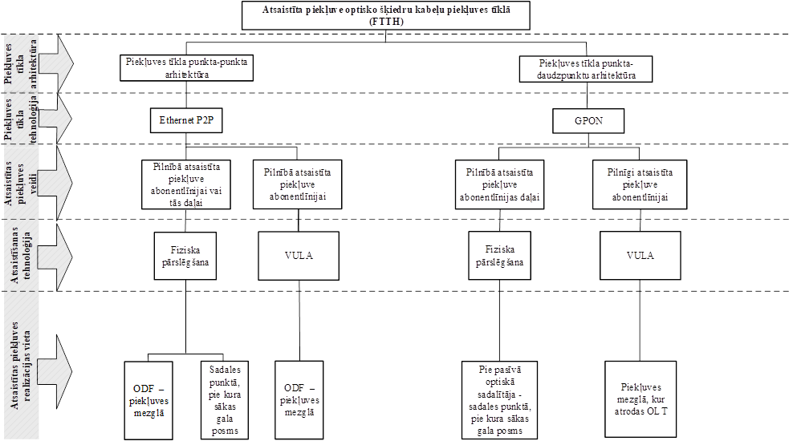

Latviešu val. | Angļu val.
Atsaistīta piekļuve optisko šķiedru kabeļu piekļuves tīklā (FTTH) | Unbundled access in the optical fibre cable access network (FTTH)
Piekļuves tīkla arhitektūra | Access network architecture
Piekļuves tīkla tehnoloģija | Access network technology
Atsaistītas piekļuves veidi | Types of unbundled access
Atsaistīšanas tehnoloģija | Unbundling technology
Atsaistītas piekļuves realizācijas vieta | Place for the implementation of unbundled access
Piekļuves tīkla punkta-punkta arhitektūra | Access network point-to-point architecture
Piekļuves tīkla punkta-daudzpunktu arhitektūra | Access network point-to-multipoint architecture
Ethernet P2P | Ethernet P2P
GPON | GPON
Pilnībā atsaistīta piekļuve abonentlīnijai vai tās daļai | Full unbundled access to the subscriber line or its part
Pilnībā atsaistīta piekļuve abonentlīnijai | Full unbundled access to the subscriber line
Pilnībā atsaistīta piekļuve abonentlīnijas daļai | Full unbundled access to the part of the subscriber line
Fiziska pārslēgšana | Physical switching
VULA | VULA
ODF – piekļuves mezglā | ODF – at the central office
Sadales punktā, pie kuras sākas gala posms | At the distribution point at which the terminating segment starts
Pie pasīvā optiskā sadalītāja – sadales punktā, pie kura sākas gala posms | At the passive Optical Splitter – at the distribution point at which the terminating segment starts
Piekļuves mezglā, kur atrodas OLT | At the central office where OLT is located

3. Unbundled access in the optical fibre cable access network (FTTB)

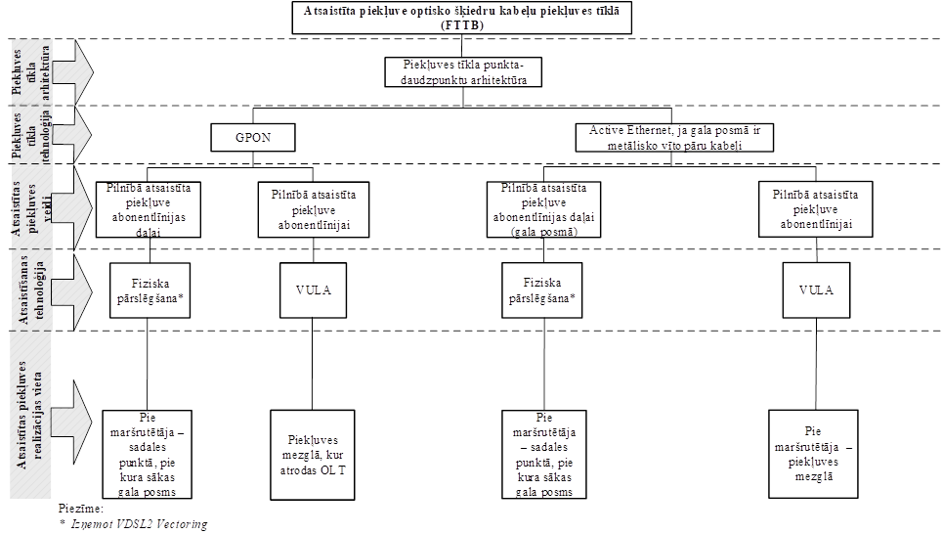

Latviešu val. | Angļu val.
Atsaistīta piekļuve optisko šķiedru kabeļu piekļuves tīklā (FTTH) | Unbundled access in the optical fibre cable access network (FTTH)
Piekļuves tīkla arhitektūra | Access network architecture
Piekļuves tīkla tehnoloģija | Access network technology
Atsaistītas piekļuves veidi | Types of unbundled access
Atsaistīšanas tehnoloģija | Unbundling technology
Atsaistītas piekļuves realizācijas vieta | Place for the implementation of unbundled access
Piekļuves tīkla punkta-daudzpunktu arhitektūra | Access network point-to-multipoint architecture
GPON | GPON
Active Ethernet, ja gala posmā ir metālisko vīto pāru kabeļi | Active Ethernet if shielded twisted pair cables are at the terminating segment
Pilnībā atsaistīta piekļuve abonentlīnijas daļai | Full unbundled access to the part of the subscriber line
Pilnībā atsaistīta piekļuve abonentlīnijai | Full unbundled access to the subscriber line
Pilnībā atsaistīta piekļuve abonentlīnijas daļai (gala posmā) | Full unbundled access to the part of the subscriber line (at the terminating segment)
Fiziska pārslēgšana* | Physical switching*
VULA | VULA
Pie maršrutētāja – sadales punktā, pie kura sākas gala posms | At the router – at the distribution point at which the terminating segment starts
Piekļuves mezglā, kur atrodas OLT | At the central office where OLT is located
Pie maršrutētāja – sadales punktā, pie kura sākas gala posms | At the router – at the distribution point at which the terminating segment starts
Pie maršrutētāja – piekļuves mezglā | At the router – at the central office
Piezīme:  * Izņemot VDSL2 Vectoring | Note:  * Except for VDSL2 Vectoring

4. Unbundled access in the optical fibre cable access network (FTTN)

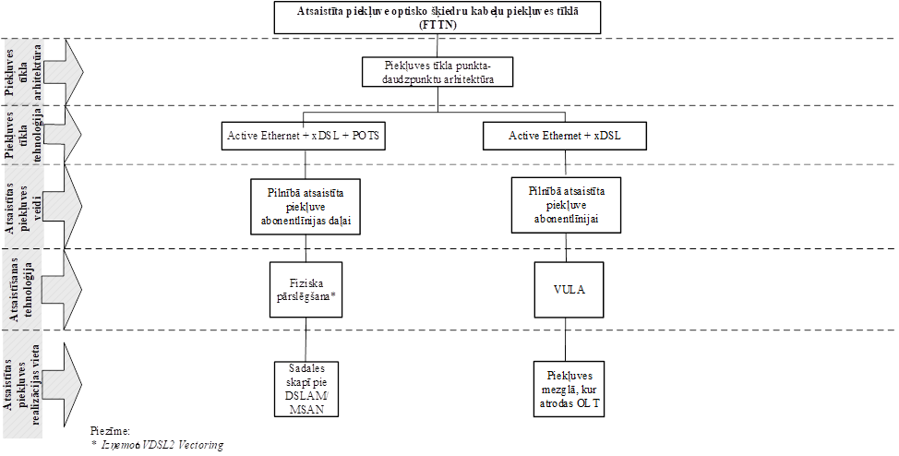

Latviešu val. | Angļu val.
Atsaistīta piekļuve optisko šķiedru kabeļu piekļuves tīklā (FTTN) | Unbundled access in the optical fibre cable access network (FTTN)
Piekļuves tīkla arhitektūra | Access network architecture
Piekļuves tīkla tehnoloģija | Access network technology
Atsaistītas piekļuves veidi | Types of unbundled access
Atsaistīšanas tehnoloģija | Unbundling technology
Atsaistītas piekļuves realizācijas vieta | Place for the implementation of unbundled access
Piekļuves tīkla punkta-daudzpunktu arhitektūra | Access network point-to-multipoint architecture
Active Ethernet + xDSL + POTS | Active Ethernet + xDSL + POTS
Active Ethernet + xDSL | Active Ethernet + xDSL
Pilnībā atsaistīta piekļuve abonentlīnijas daļai | Full unbundled access to the part of the subscriber line
Pilnībā atsaistīta piekļuve abonentlīnijai | Full unbundled access to the subscriber line
Fiziska pārslēgšana* | Physical switching*
VULA | VULA
Sadales skapī pie DSLAM/MSAN | In the distribution cabinet at DSLAM/MSAN
Piekļuves mezglā, kur atrodas OLT | At the central office where OLT is located
Piezīme:  * Izņemot VDSL2 Vectoring | Note:  * Except for VDSL2 Vectoring

