Republic of Latvia

Cabinet
Order No. 712
Adopted 6 October 2021

On Road Traffic Safety Plan for 2021–2027

1. To support the Road Traffic Safety Plan for 2021–2027 (hereinafter – the Plan).

2. To determine the Ministry of Transport, the Ministry of the Interior, the Ministry of Health, the Ministry of Education and Science, the Ministry of Economics, and the Ministry of Environmental Protection and Regional Development as the responsible authorities for the introduction of the Plan.

3. For the Ministry of Transport to prepare and for the Minister for Transport to submit, by 1 January 2025, the interim impact assessment of the Plan to the Cabinet in accordance with specific procedures.

Acting Prime Minister – Deputy Prime Minister, Minister for Justice J. Bordāns

Minister for Transport T. Linkaits

(Cabinet Order No. 712
6 October 2021)

Road Traffic Safety Plan for 2021–2027

Rīga
2021

Contents

Abbreviations Used

Definitions

Summary

1. Characterisation of the Existing Situation
1.1. Objectives Identified in the International Policy Documents
1.1.1. Stockholm Declaration of 2020
1.1.2. ITF OECD Road Safety Annual Report, 2019
1.1.4. UN Decade of Action for Road Safety 2021–2030
1.2. Objectives Identified in the European Union Policy Documents
1.2.1. EU Road Safety Policy Framework 2021–2030 – Next Steps Towards “Vision Zero”
1.2.2. White Paper: Roadmap to a Single European Transport Area – Towards a Competitive and Resource Efficient Transport System
1.2.3. Sustainable and Smart Mobility Strategy
1.3. Road Safety Key Performance Indicators (KPI)
1.4. Objectives Identified in the Policy Planning Documents of Latvia
1.4.1. National Development Plan of Latvia for 2021–2027
1.4.2. Transport Development Guidelines for 2021–2027

2. Road Traffic Safety Situation
2.1. Statistics of Road Traffic Accidents, the Assessment Thereof and Losses for National Economy
2.1.1. Losses for National Economy Caused by Road Traffic Accidents
2.1.2. Statistics of Road Traffic Accidents
2.2. Safety of Vulnerable Road Users
2.3. Road Traffic Violations
2.3.1. Exceeding of the Permitted Driving Speed
2.3.2. Driving a Vehicle under the Influence of Alcohol, Narcotic or Other Intoxicating Substances
2.3.3. Non-use of Seat Belts
2.3.4. Driver Fatigue
2.3.5. Driver Distraction and Use of Mobile Devices Behind the Wheel
2.3.6. Imposing of Fines for Road Traffic Violations
2.4. Education of Road Users
2.4.1. Shaping of Correct Understanding in Children and Adolescents Regarding Road Traffic Safety
2.4.2. Training of Drivers
2.4.3. Road Traffic Safety Campaigns
2.5. Mitigation and Prevention of the Consequences of Road Traffic Accidents
2.6. Control of Road Users
2.6.1. New Development Concept
2.7. Databases and Importance Thereof in the RTA Risk Assessment
2.8. Existing Road Infrastructure
2.8.1. Road Traffic Intensity
2.8.2. Technical Condition and Conformity of Road Infrastructure with Safety Requirements
2.8.3. Micromobility Infrastructure (Including Pedestrian and Cycling Infrastructure)
2.8.4. Long-term Road Infrastructure Development Directions
2.9. Impact of the Technical Condition of the Vehicle on the Road Traffic Safety
2.10. Impact Assessment of the Road Traffic Safety Plan for 2017–2020
2.10.1. Overall Road Traffic Safety Dynamics
2.10.2. Safe Environment
2.10.3. Safe Vehicle
2.10.4. Safe Road User
2.10.5. All Elements
2.10.6. Policy Planning Efficiency Assessment
2.10.7. Efficiency and Impact Assessment of the Achievement of the Road Traffic Safety Policy of Latvia and Efficiency Assessment of the Use of the Financing
2.11. Direct Operational Results and Assessment of the Current Policy Planning Efficiency
2.12. Further Alternative Development Scenarios and Assessment of the Most Appropriate Scenario

3. Objective and Lines of Action of the Plan

4. Measures for the Improvement of Road Traffic Safety
4.1. Safe Road User
4.2. Safe Vehicle
4.3. Safe Environment

5. Planning of the Financing for the Measures Included in the Plan, Impact Assessment on the State and Local Government Budgets

Abbreviations Used

UN | United Nations Organization
CAIS | Information System for the Analysis of Locations of Road Traffic Accidents and Violations
RTSD | Valsts akciju sabiedrība “Ceļu satiksmes drošības direkcija” [State joint-stock company Road Traffic Safety Directorate]
RTA | Road traffic accident
PRTA | Budget financing for the prevention of road traffic accidents which is allocated from insurance resources transferred by insurers into the account of the association “Motor Insurers’ Bureau of Latvia” for taking measures for the prevention of road traffic accidents in accordance with Section 57 of the Compulsory Civil Liability Insurance of Owners of Motor Vehicles Law
RTL | Road Traffic Law
RTR | Road Traffic Regulations
RTSC | Road Traffic Safety Council
eCall | A vehicle technology which contacts an interoperable eCall service in case of an accident and builds on 112 line.
EC | European Commission
MoE | Ministry of Economics
EU | European Union
MoF | Ministry of Finance
MoI | Ministry of the Interior
ICoMoI | Information Centre of the Ministry of the Interior
IRTAD | International Road Traffic and Accident Database
MoES | Ministry of Education and Science
ITS | Intelligent transport systems
MoW | Ministry of Welfare
LALRG | Latvian Association of Local and Regional Governments
MIBoL | Motor Insurers’ Bureau of Latvia
LSR | Valsts sabiedrība ar ierobežotu atbildību “Latvijas Valsts ceļi” [State limited liability company Latvian State Roads]
MAIS | Maximum Abbreviated Injury Scale
NDP 2027 | National Development Plan for 2021–2027
NCAP | New Car Assessment Programme
SEMS | State Emergency Medical Service
NHS | National Health Service
NGOs | Non-governmental organisations
CCLI | Compulsory civil liability insurance of vehicles
CRPC | Consumer Rights Protection Centre
LCA | Association “Latvian Cyclists’ Union”
RTU | Riga Technical University
TDoRCC | Traffic Department of the Riga City Council
TDG 2027 | Transport Development Guidelines for 2021–2027
Vehicle | Vehicle
RT | State Roadworthiness Testing of Vehicles
MoJ | Ministry of Justice
MoT | Ministry of Transport
MoEPRD | Ministry of Environmental Protection and Regional Development
NCE | National Centre for Education
SFRS | State Fire and Rescue Service
SP | State Police
SBG | State Border Guard
MoH | Ministry of Health

Definitions

Serious RTA – an RTA with at least one casualty.
Casualty – a person who has died or suffered an injury as a result of an RTA (medical assistance has been provided).
Seriously injured person – a person for whom the most serious injury suffered in an accident corresponds to Maximum Abbreviated Injury Scale (MAIS) score of 3 or more¹.
Mildly injured person – a person for whom the most serious injury suffered in an accident corresponds to MAIS score of 1 or 2.
Driver of a vehicle – a person who is driving a motor vehicle; however, cyclists, moped drivers, motorcyclists, quadricyclists, and cart drivers should be set apart from drivers.
Vulnerable road users – a pedestrian, a cyclist and its passengers, a driver of an electric scooter, a moped driver and its passengers, a motorcyclist and its passengers, a tricyclist and its passengers, a quadricyclist and its passengers.

Summary

The Road Traffic Safety Plan for 2021–2027 (hereinafter – the Plan) has been developed to achieve the policy results brought forward in the EU policy planning documents, including the policy planning document EU Road Safety Policy Framework 2021–2030 – Next Steps Towards “Vision Zero”, i.e. to reduce the number of fatalities and serious injuries from road traffic accidents by 50 % by 2030 in comparison to 2020. Thus, the objective of the Plan is to reduce the number of fatalities and serious injuries from road traffic accidents by 35 % by 2027 in comparison to 2020.
The Plan envisages specific lines of action to improve the road traffic safety by determining the responsible authorities and the deadlines for the implementation of lines of action, and the necessary financing.
The Plan especially focuses on the factors directly affecting road traffic safety (the statistical data characterising it – the number of RTAs, the numbers of fatalities and casualties in RTAs). It should be indicated that road traffic safety depends on three major factors: a person (a road user), a vehicle (its condition and equipment), and environment (road infrastructure).
In order to achieve the objective brought forward in the Plan, three lines of actions have been determined:
‒ safe road user;
‒ safe environment;
‒ safe vehicle.
For the implementation of the measures included in the Plan for a period of seven years, financial resources in the amount of EUR 19 026 959 are necessary, including financing from the EU funds in the amount of EUR 64 000, and it is planned to allocate EUR 18 962 959 from the financing available from the PRTA.

1. Characterisation of the Existing Situation

Road traffic safety is relevant for all inhabitants regardless of whether they are pedestrians, cyclists, or drivers or passengers of a vehicle. Similarly, the subsequent development rates of the modern transport system pose serious challenges for the future road traffic safety policy makers. On a global scale, these challenges are mainly related to the following aspects: rapid urbanisation rates, insufficient safety standards both in vehicles and for the infrastructure, insufficient control of the execution of various essential decisions that have been taken previously, insufficient resources, knowledge and attitude of road users (driving of a vehicle while fatigued, under the influence of alcohol or narcotic substances, exceeding of the permitted driving speed, non-use of seat belts, and other road traffic violations that have been committed intentionally or unintentionally).
Globally, there have been more than 50 million fatalities from RTAs since the very beginning of automobilisation. According to the data of the World Health Organization (WHO)², there are approximately 3700 deaths on average per day caused by RTAs worldwide, meaning that a lethal RTA is happening on average every 25 seconds. Thus, every year on average 1.3 million people die in RTAs in the world¹ and additional 50 million people suffer injuries¹. Importantly, trends also show that in subsequent years RTAs will become the main cause of death among children and young persons (in the age from 5 to 29 years). It should also be noted that the risk of dying in an RTA is three times higher in low-income countries than in high-income countries¹. At the same time, globally more than half of all persons who have died in RTAs are vulnerable road users: pedestrians, cyclists, and motorcyclists and their passengers. The proportion of vulnerable road users is also higher in the countries with lower income and, therefore, they are subject to a greater risk. Another aspect that should be considered is the increasing number and popularity of bicycles, motorcycles, and various other individual means of transport, including electric scooters, over the last years.
The active involvement of all road users and the right attitude of them towards essential factors affecting traffic safety are of great importance to the improvement of road traffic safety. The use of seat belts can also be added to these factors. The use of seat belts reduces the risks of injuries and death for front-seat passengers by up to 45–50 % and by up to 25–75 % for back-seat passengers². Similarly, the use of smart devices, including mobile phone, while driving (even using the hands-free mode) increases the risk of an RTA by four times, in turn the use of other means of mobile communication, for example, sending of text messages, increases the risk by approximately 23 times. It should be noted that the response time of a driver while using a mobile phone increases by 50 %².
The practical experience of several countries of the world, including Latvia, shows that systematic speed control (compliance with the speed limit) significantly reduces the number of RTAs and there is also a decrease in the number of accidents with seriously injured persons or fatalities. Thus, an increase in the average speed also means an increased RTA risk and the severity of its consequences. If the average speed increases by 1 %, the risk of lethal RTAs increases by 4 %³. As a result of an RTA, the most vulnerable road user, i.e. a pedestrian who has been hit by a passenger car moving at the speed of 65 km per hour, is subject to the risk of death that is four times higher than in the case if this passenger car moves at the speed of 50 km per hour.
Such factors as vehicle safety standards and the safety equipment installed therein also have a significant role both in the prevention of RTAs and in the reduction of the degree of severity of RTAs. The World Forum for Harmonization of Vehicle Regulations of the United Nations recommends the installation of several new vehicle safety systems in new vehicles, including the electronic stability control, protection against front and lateral impacts, and frontal protection of pedestrians. Taking into account the technical condition of the vehicle fleet and its age, including in Latvia, several more years are needed until vehicles equipped with such safety systems will form a significant part of the overall vehicle fleet.
The road infrastructure should be built in a way to mitigate the potential traffic safety risks and to generally improve traffic safety for the most vulnerable road users, i.e. pedestrians, cyclists which is an essential factor, particularly taking into account that comprehensive decarbonisation of the transport sector, including promotion of the micromobility proportion in the overall transport system, is planned according to the European Green Deal.

1.1. Objectives Identified in the International Policy Documents

1.1.1. Stockholm Declaration of 2020

The Stockholm Declaration⁵ was adopted during the Third Global Ministerial Conference on Road Safety “Achieving Global Goals 2030” of 19–20 February 2020⁴. It includes measures which are planned to be addressed to achieve the objectives of 2030. Among other things, it provides for the following:
‒ to call upon Member States to contribute to reducing road traffic deaths by at least 50 % from 2020 to 2030 in line with the United Nations High-Level Political Forum on Sustainable Development’s commitment. To set targets for the reduction of fatalities and serious injuries, in line with this commitment, for all groups of road users and especially vulnerable road users such as pedestrians, cyclists and also motorcyclists and users of public transport;
‒ to call upon Member States and the international community to address the reduction of RTAs among children and young people;
‒ to encourage Member States that have not yet done so to consider becoming contracting parties to the United Nations legal instruments on road safety and also applying, implementing, and promoting their provisions or safety regulations, and to ensure that legislation and standards for road design and construction, vehicles, and road use are consistent with safe system principles and are enforced;
‒ to include the Safe System approach as an integral element of street design, transport system planning and governance, especially directed towards the protection of the vulnerable road users;
‒ to speed up the shift toward safer, cleaner, more energy efficient and affordable modes of transport and to promote higher levels of physical activity such as walking and cycling and also integrating these modes with the use of public transport to achieve sustainability;
‒ to encourage and incentivise the development, application, and deployment of existing and future technologies and also other innovations to improve accessibility and all aspects of road safety from the prevention of RTAs to emergency response and trauma care, with special attention given to the safety needs of those road users who are the most vulnerable including pedestrians, cyclists, motorcyclists and passengers, and users of public transport;
‒ to focus on speed management to prevent exceeding of the permitted driving speed;
‒ to ensure that all vehicles produced and sold for every market by 2030 are equipped with appropriate levels of safety performance, and that incentives for the use of vehicles with enhanced safety performance are provided where possible;
‒ to call upon public organisations at all levels to procure safe and sustainable transport services and vehicles and to encourage the private sector to follow this example, including the purchase of safe and sustainable vehicle fleets.

1.1.2. ITF OECD Road Safety Annual Report, 2019

As indicated in the report of the OECD International Transport Forum, Road Safety Annual Report 2019⁶, progress in reducing fatalities from RTAs has been slow since 2013. In the time period from 2010–2013, the overall average annual reduction in the number of fatalities from RTAs in IRTAD countries was 2.6 %. The period 2013–2017, by contrast, saw an average annual increase of 0.5 % in the number of fatalities from RTAs. Although improvement in the field of road traffic safety was observed in 2017 and 2018, the average annual reduction in the number of fatalities from RTAs in 2017 and 2018 was significantly higher in the time period from 2010 to 2013 than from 2013 to 2017.
In assessing the statistical data characterising road traffic safety in other countries analysed in the report, the long-term trend is positive, yet far from sufficient to achieve international road safety objectives. The 50 % reduction target for fatalities from RTAs by 2020 set out by the international community in the context of the United Nations Decade of Action for Road Safety and in the United Nations Sustainable Development Goals remains out of reach, considering the current trends. In order to achieve a 50 % reduction between 2010 and 2020, a reduction by at least 38 % by 2017 (i.e. an annual average reduction of 6.7 %) would have been necessary. Only two countries, Norway and Greece, have achieved this.
All IRTAD countries have observed a reduction in the number of fatalities from RTAs among young people aged 18–24. This can be explained by several factors: the success of road safety education and training policies, the trend in some countries for young people to start driving at a later age when their risk in traffic is lower. It is also indicated in the report that the use of bicycles in traffic has increased. This development is related to a significantly higher number of lethal RTAs involving cyclists in several countries.

1.1.3. ITF OECD Road Safety Annual Report, 2020

Among other things, the Road Safety Annual Report 2020⁷ (hereinafter – the Report) of the OECD International Transport Forum also includes the up-to-date information from IRTAD participating countries on road traffic safety. It is indicated in the report that significant events in the field of road traffic safety took place in 2020, for example, the Third Global Ministerial Conference on Road Safety in Stockholm in February 2020 during which the Stockholm Declaration was adopted that includes several important markers in the improvement of the road traffic safety policy, including a more extensive speed limit of 30 km/h in towns.
Another important marker for road safety in 2020 was the Coronavirus COVID-19 pandemic. In some countries COVID-19, for all its negative impact around the world, also brought with it an unexpected, significant decrease in the number of RTAs which is directly related to a decrease in traffic volume. However, the overall statistics show that the number of fatalities from RTAs has not diminished in direct proportion to the decrease in traffic volume.
The report also mentions several factors which may help in the assessment of the trends for changes in road traffic safety during the last years:
‒ demographic changes in recent years, coupled with greater mobility among the senior population, result in a higher proportion of senior citizens and a lower proportion of younger age groups among traffic fatalities;
‒ driver distraction is reported to be a growing issue in many countries, it has also been established that it is difficult to control it. Negligence in road traffic (usually through mobile phone use) concerns not only drivers of passengers cars and heavy goods vehicles, but also cyclists, pedestrians, and motorcyclists;
‒ speeding and driving under the influence of alcohol, narcotic, psychotropic, or toxic substances remain two key factors in fatal RTAs;
‒ the development of new mobility forms, including increase in popularity of different micromobility solutions, entails new road safety challenges.

1.1.4. UN Decade of Action for Road Safety 2021–2030

On 18 August 2020, the UN published a declaration by which the time period from 2021 to 2030 is declared as the new road safety decade by the UN – the UN Decade of Action for Road Safety 2021–2030⁸. The declaration reiterates the commitment of the UN to work tirelessly in order to implement new lines of action and ambitious goals by 2030 which would be implemented in accordance with the UN Resolution 70/1, Transforming our world: the 2030 Agenda for Sustainable Development⁹.
With the Declaration, UN Decade of Action for Road Safety 2021–2030, the time period from 2021 to 2030 is declared as the second road safety decade (the first decade from 2011 to 2020) with the objective of reducing the number of RTAs and the injuries suffered therein by at least 50 % in the time period from 2021 to 2030. In the Declaration, the Member States are invited to continue activities in all road traffic safety issues, including in relation to the Sustainable Development Goal No. 3.6: - “halve the number of global deaths and injuries from road traffic accidents”¹⁰.
The UN acknowledges, among other things, that the abovementioned objective has not been achieved by 2020 when the number of deaths and injuries from RTAs had to be halved. This leads to a conclusion that the objective can be achieved by stricter national policy, global cooperation, implementation of evidence-based strategies, and involvement with the relevant interested persons.
The UN also appreciates the global attempts the goal of which is safer roads and sustainable transport development. The UN Member States have put in a great deal of work to adopt a comprehensive legal act laying down road traffic safety measures. The UN continuously implements and supervises different attempts of support to the implementation of road traffic safety projects and programmes; similarly, the UN Member States which work on road traffic safety are encouraged to continue this work, while the Member States which have not committed to it are invited to join these commitments in order to work together towards the achievement of common goals.
Thus, the UN Member States are encouraged to take action, focusing attention on 40 main points of action covering the following areas:
‒ strengthening the introduction of the road traffic laws and legal acts;
‒ supervision and evaluation of the road traffic laws and their introduction;
‒ signing and introduction of the UN road traffic safety policy and regulations;
‒ integration of road traffic safety in planning;
‒ organisation of public information campaigns on road traffic safety;
‒ strengthening care for persons injured in RTAs;
‒ provision of rehabilitation and care for casualties in RTAs;
‒ exchanging best practices bilaterally, regionally, and internationally;
‒ inviting the UN Member States and all interested parties to increase investments in road traffic safety.
The abovementioned Declaration also invites the UN Member States which have not yet done so to consider the possibility of adopting comprehensive legal acts regarding main risk factors, for example, non-use of seat belts, child car seats, and safety helmets, impact of alcohol on driving a vehicle, and also speeding, which means that the governments should also do more in relation to policies related to the use of alcohol in order to prevent related RTAs, injuries, and fatalities.

1.2. Objectives Identified in the European Union Policy Documents

Although the roads in the EU are considered to be the safest roads in the world¹¹ and significant improvements in the field of road traffic safety have been observed in the EU Member States during the last decades, the number of fatalities and casualties from RTAs is still too high and therefore unacceptable. Therefore, the EU Member States have undertaken to gradually implement the necessary measures for the introduction of the Vision Zero¹² and the Safe System¹³.
As indicated by the European Commission, eight Member States registered their historically lowest fatality rates in 2019. These countries were: Croatia, Finland, France, Germany, Greece, Latvia, Luxembourg, and Sweden. However, the progress has slowed down in the majority of countries. Therefore, the objective of the EU – to halve the number of fatalities from RTAs in the time period from 2010 until the end of 2020 – most likely will not be achieved. In 2019, approximately 22 800 people died in RTAs in the EU which is by almost 7000 or 23 % less than in 2010, i.e. 2.6 % per year. It means that approximately 63 people die every day on the roads of the EU. Although road traffic safety rates of Member States move closer to the objective, the number of fatalities from road traffic accidents in the country with the worst rates is still four times higher than in the country with the best rates. The safest roads were in Sweden (22 fatalities per million of inhabitants) and Ireland (29 per million), in turn Romania (96 per million), Bulgaria (89 per million), and Poland (77 per million) had the highest fatality rates in 2019. The average indicator of the EU was 51 fatalities per million of inhabitants. However, great progress has been achieved in some countries: the number of fatalities in Greece, Spain, Portugal, Ireland, Latvia, Lithuania, Estonia, and Croatia decreased more than on average (from 30 to 40 %)¹⁴.
The EU Member States also cooperate closely among themselves in the implementation of different road traffic safety measures and initiatives, thus addressing all factors which are of great significance for the prevention of RTAs (road infrastructure, safety of vehicles, control of a driver, response of rescue services after RTAs, and other factors).
In the last decade, the policy planning documents and studies of different countries refer to various models which could be applied to improve road traffic safety. One of them is the Safe System approach which is based on a holistic (comprehensive) and active action model. The essence of the system is that each element of the system plays a very important role in the overall assessment, yet in the case of the failure of one element the system is not significantly damaged and continues working. According to this approach the main emphasis is put on complete prevention of fatal RTAs and accidents resulting in severe injuries. The Safe System includes control, education and informing of road users, safe road infrastructure, traffic flow and speed control, safe vehicles and appropriate response to RTAs.
The Safe System is based on the following four basic principles:
• People make mistakes which lead to RTAs.
• The human body has a limited physical ability to tolerate the overload which occurs at the moment of RTA.
• A shared responsibility should be ensured among the authorities involved in ensuring road traffic safety, i.e. the authority responsible for safe road infrastructure, the authority responsible for the technical condition of vehicles, the authority responsible for rescue operations after RTAs, etc.
• All parts of the system should be strengthened in a unified and coordinated manner, at the same time it should be ensured that the failure of one part does not cause significant risks to other parts.
It should be taken into account in subsequent introduction of the road traffic safety policy that any serious injury resulting from RTAs and any fatal RTAs are unacceptable, therefore it is necessary to progress towards future vision (Vision Zero) by completely preventing RTAs involving casualties and fatalities. According to this approach, the solutions and technologies (also road infrastructure) involved in road traffic should be completely safe, i.e. “forgiving” of human mistakes. This means that in this case human errors are and will remain acceptable; however, fatalities and casualties in RTAs are not acceptable. In order to create such a system, the approach must be complete and comprehensive, also responsibility must be shared among the involved authorities, as each of them fully assumes responsibility for its area. The aim of a safe road traffic system is to ensure that human errors, negligence, or deliberate actions do not lead to fatal or injurious consequences in road traffic.

1.2.1. EU Road Safety Policy Framework 2021–2030 – Next Steps Towards “Vision Zero”

In May 2018, the European Commission proposed a new approach towards further EU road traffic safety policy in the next decade and also presented its vision regarding the medium-term strategic action plan for road traffic safety. The objective of the policy planning document “EU Road Safety Policy Framework 2021–2030 – Next Steps Towards “Vision Zero””¹⁵ is to lay out the implementation of the new policy in action. This plan also re-approves the ambitious EU long-term objective providing for gradual moving towards Vision Zero in order to achieve it by 2050. Also an objective for the time period from 2020 to 2030 is defined, i.e. to halve the number of fatalities and seriously injured persons from RTAs by 2030 in comparison to 2020.
Both compliance with the basic principles of Vision Zero and the Safe System will be of essential role for the achievement of these objectives; however, an increasingly essential role will have to be intended for new challenges – rapid development of micromobility, automation of the transport system and vehicles, and also transition to the use of sustainable (environment friendly and safe) solutions and technologies in vehicles, transport systems. For example, more rapid increase in the number of electrical vehicles is already occurring currently and also such technologies are being introduced and such systems are being installed in vehicles which make the vehicle fully or partly automated. At the same time, it should be kept in mind that a large proportion or the majority of vehicles will still not be automated in the nearest future and conventional types of fuel will be used in them. Therefore, it should be taken into account that the road traffic safety policy should be directed towards not causing additional safety risks by the introduction of new solutions and technologies and not resulting in conflicts between systems which are automated and in which the human error factor will still play the most essential role.
The simplest and most important things in the assessment of the progress achieved are different indicators, inter alia, the number of fatalities and the number of seriously injured persons. However, upon reduction of the number of fatalities and seriously injured persons, clear additional indicators are necessary to help identify all risks related to RTAs, particularly risks involving seriously injured persons or fatalities.

1.2.2. White Paper: Roadmap to a Single European Transport Area – Towards a Competitive and Resource Efficient Transport System

The White Paper of 28 March 2011 of the European Commission, Roadmap to a Single European Transport Area – Towards a competitive and resource efficient transport system¹⁶, sets a very ambitious objective regarding the road traffic safety, i.e. by 2050, to move close to zero fatalities in road transport. According to this task, the objective of the EU is to halve the number of fatalities every decade which means also for the time period from 2020 to 2030, continuing proportionate reduction in the number of fatalities until 2050 when the number of fatalities should be close to zero.
In order to progress towards the objective identified in the White Paper, complex solutions are required for the promotion of road traffic safety, therefore in the achievement of the objective to move close to zero fatalities and seriously injured persons from RTAs by 2050 the White Paper emphasises the following:
‒ it is necessary to introduce and use the latest road traffic safety technologies to a greater extent;
‒ it is necessary to develop a comprehensive strategy of action on road injuries resulting from RTAs;
‒ focus should be made on training and education of all road users, also the use of safety equipment (seat belts, safety helmets, protective clothes, etc.) should be promoted;
‒ particular attention should be paid to vulnerable road users such as pedestrians, cyclists, and other users of micromobility vehicles, motorcyclists.
On 10 December 2020, the European Commission published an evaluation¹⁷ on the current impact of the White Paper until 2020 and also on further directions of development in the achievement of the objectives of the White Paper. Among other things, it has been indicated in this report in relation to Goal 9 of the White Paper (by 2050, move close to zero fatalities and seriously injured persons from RTAs) that the EU still is the global leader in road traffic safety and also in safety in all other modes of transport. Thus, the number of fatalities from RTAs has decreased by 43 % in the time period from 2001 to 2010 and by another 23 % in the time period from 2010 to 2019. This attests that the EU progress in terms of consequences from RTAs and their number has slowed down during the last years. In 2019, 22 800 people died on roads of the EU and approximately 135 000 people suffered severe injuries. This calls for the conclusion that, most likely, the medium-term goal, i.e. to halve the number of fatalities from RTAs from 2010 to 2020, will not be achieved.
It has also been indicated in the evaluation report that the needs of the EU transport policy which were determined during the adoption of the White Paper in 2011 are still topical to a large extent. It is particularly true in relation to environmental performance and the need to modernise the EU transport sector. Similarly, it is still necessary to increase competitiveness and to extend the unified market of transport services. Also, regardless of a certain progress achieved in the improvement of transport safety, this issue is still justifiably topical to the parties involved in addressing the safety problems. It has been concluded that a large part of activities carried out to implement the goals of the White Paper either would not have been possible without intervention at the EU level, or would have been less efficient and useful. Also certain progress could have been expected in some Member States; however, it would have been fragmented and uncoordinated in most cases.

1.2.3. Sustainable and Smart Mobility Strategy

On 9 December 2020, the European Commission published the communication material on the Sustainable and Smart Mobility Strategy¹⁸ the objective of which is open a way for new mobility challenges in the future. The Strategy is directed towards mitigating the negative environmental impact of the transport sector, concurrently also assessing the capacities and available resources of each Member State for the achievement of the objectives.
In relation to road transport, the Strategy emphasises support to undertakings and public transport in order to promote the development of a green vehicle fleet, taking into account that the society wishes to move towards more sustainable modes of transport, especially in everyday life, and the main conditions for such transition are costs, availability, and speed. The EU must provide help in creating the right conditions for more extensive use of safe, competitive sustainable alternatives which are also accessible in terms of price. If appropriate alternatives characterised by competitive prices, frequency of carriage, and level of comfort have been introduced, people will choose the most sustainable mode.
Also Flagship 10 of the Strategy is related to transport safety, i.e. enhancing transport safety and security, in which it is provided for that safety of the EU transport system has a paramount role and also the EU should remain a world leader in this field. Therefore, it is important to cooperate with international, national, and local authorities and other interested persons to achieve the objective which provides for striving towards road traffic without fatalities and seriously injured persons.
In further planning of the policy, such essential factors as speed, alcohol and drug consumption, and driver distraction while driving will be reviewed because they are closely linked both to the causation of road traffic accidents and the severity thereof. In cooperation with all Member States, the EC will have to perform a direct assessment of the lines of action which are necessary as a priority to solve the issues which are related, for example, to the protection of the most vulnerable road users, also more accurate collection and analysis of data. It should also be taken into account that upgrading of safety of the current road infrastructure and mitigation of the risks caused thereby will be a priority which will contribute to the prevention of fatalities and serious injuries of vulnerable road users.

1.3. Road Safety Key Performance Indicators (KPI)

Significant role in the formation and introduction of the subsequent road traffic safety policy will be placed on the impact of separate factors and risks because a broader view will be required for the impact assessment of the measures implemented and, therefore, the number of fatalities and seriously injured persons from RTAs will not be the only indicators but also such indicators which are related to compliance with the speed limit, use of safety means, for example, seat belts, etc. will be included. Also the Key Performance Indicators for road safety¹⁹ must conform to the Safe System⁵ approach. It is also possible that the current indicators (see below) might become less relevant in a few years, therefore these indicators should be applied, possibly changed, in order to tackle the most urgent problems and to apply the most suitable solutions.
The road traffic safety indicators include such indicators which characterise the behaviour of road users, the vehicle, and the infrastructure:
• behavioural indicators of road users – traffic volume proportion which conforms to speed restrictions (in different environments, i.e. urban environment, motor roads, etc.);
• indicators of the vehicle – the proportion of the vehicles sold with high level of safety (for example, EuroNCAP²⁰ assessment), possibly dividing vehicles according to the type of safety systems installed therein;
• indicators of the infrastructure – the proportion of roads which conform to the highest infrastructure safety management standards, also the proportion of the infrastructure with high safety rating (for example, EuroRAP²¹ rating) and also the proportion of roads with speed restrictions which have been determined at the relevant levels (for example, zones with the permitted speed 30 km per hour if the city roads are used jointly with vulnerable road users, cycling infrastructure is not extensively available).
On 4 March 2020, the European Commission published information on the call for the project Programme Support Action (PSA) to support Member States in collecting Key Performance Indicators (KPIs) for road safety²². The purpose of this project is to help Member States (their authorities) to aggregate and provide, in a coordinated manner, reports on key performance indicators (KPIs) for road safety. On 31 August 2020, the European Commission supported the joint application of the consortiums of 19 EU Member States (Belgium, Austria, Bulgaria, Cyprus, the Czech Republic, Finland, Germany, Greece, Ireland, Latvia, Lithuania, Luxembourg, Malta, the Netherlands, Poland, Portugal, Slovakia, Spain, Sweden) for the collection and processing of KPI data in 2020 and 2021.

Table 1. Road Safety Key Performance Indicators

 | Indicator | Explanation
1 | Speed | Number of vehicles (%) which do not comply with restrictions of the permitted speed
2 | Seat belts | Number of vehicle passengers (%) who do not use seat belts or child car seats
3 | Safety equipment | Number of motorcyclists and moped drivers and passengers (%) who do not use safety helmets
4 | Use of alcohol | Number of drivers of vehicles (%) who participate in road traffic while the blood alcohol content is above the permitted level
5 | Driver distraction | Number of drivers of vehicles (%) who use mobile smart devices while driving a vehicle
6 | Safety of the vehicle | Number of new vehicles (%) which correspond to the highest traffic safety class
7 | Safety of the infrastructure | Total length of roads (%) which correspond to the highest traffic safety requirements
8 | Liquidation of consequences from an RTA | Time (minutes and seconds) necessary for rescuers to arrive at the site of the RTA after the RTA and the call to the rescuers

1.4. Objectives Identified in the Policy Planning Documents of Latvia

The policy planning documents in the field of road traffic safety in Latvia have been developed since 1994 resulting in the reduction of the number of fatalities by approximately 1.5 times already in 1998 in comparison to 1991. The objectives defined in the National Road Traffic Safety Programme for 2000–2006 were overall implemented at the beginning of 2007 – the number of fatalities was reduced by 1.6 times in 2006 in comparison to 1999. In 2007, the Cabinet approved the Road Traffic Safety Programme for 2007–2013 the intermediate objective of which was to halve the number of fatalities by 2010 in comparison to 2001. Upon the end of the period of operation of the plan, it was concluded that this objective was also achieved.
In 2020, the direct action results to be achieved in the field of road traffic safety were defined in the Road Traffic Safety Plan for 2014–2016 and the Road Traffic Safety Plan for 2017–2020 in line with the objective brought forward by the European Commission, i.e. to halve the number of fatalities and seriously injured persons from RTAs by 2020. It means that the number of fatalities annually should have dropped by 7–10 % by 2020 in comparison to 2010.

1.4.1. National Development Plan of Latvia for 2021–2027

The National Development Plan of Latvia for 2021–2027²³ (NDP 2027) is the main medium-term development planning document in Latvia. It has been developed when implementing the Sustainable Development Strategy of Latvia until 2030 (Latvia 2030) and the UN Sustainable Development Goals so that each inhabitant of Latvia and the society of Latvia as a whole would achieve improvement in the quality of life over the next seven years. [2] Latvia 2030 defines Latvia’s long-term development vision. It is the highest national level long-term development document and the main planning document that defines the spatial development perspective – outlines an integrated view of the country’s balanced and sustainable development.
The NDP 2027 is directed towards the achievement of the vision included in Latvia2030, encompassing several indicators of the objective which are related to the quality of life, social protection and safety of inhabitants, and also other essential indicators, including the following:
• in 2030, Latvia will be a thriving country of active and responsible citizens;
• Rīga will be an important European cultural, tourism, and business centre and pre-conditions for the development of economic potential of all regions and for the reduction of socio-economic differences will be created for the promotion of regional development;
• Latvia – our home – is green and neat, creative and easy to reach in the global space, and we are accountable towards future generations for ensuring its sustainable development.
NDP 2027 is directed towards the implementation of the long-term concept document “Growth model for Latvia: People first” which determines human-centred growth of Latvia. NDP 2027 defines the strategic aims we commit to achieve in Latvia by 2027, outlines sectoral policy directions and key reforms, and also directions of public investments from investments of the State budget, local government budget, European Union (EU) funds, and other financial sources (including from foreign and national funds, programmes) in Latvia. The ambitious goals and needs of NDP 2027 are in line with the actual possibilities and available resources. Therefore, the plan is realistic and can be implemented.
Among other things, it is indicated in NDP 2027 that there are high premature mortality rates due to RTAs, lung cancer, and diseases caused by alcoholism in Latvia, particularly among men. Approximately 51 % of all deaths are related to unhealthy lifestyle – eating habits, smoking, use of alcohol, and low physical activity [Indicator 13 of the line of action “Physical and emotional well-being”]. Also the number of RTAs per 1 million inhabitants is the fifth highest indicator in the EU – 70 death cases per million inhabitants in 2017 in relation to the average indicator of the EU, i.e. 49 death cases [Indicator 94 of the line of action “Technological environment and services”]. Thus, an objective for the reduction in the number of fatalities from RTAs by 2027 in the amount of 35 % in relation to the value of 2020 has been determined in the indicator [306] of the objective of the line of action of NDP 2027 in the field of road traffic safety.

1.4.2. Transport Development Guidelines for 2021–2027

The Transport Development Guidelines for 2021–2027²⁴ (hereinafter – the TDG 2027) is a medium-term policy planning document for the development of the transport sector and the objective specified therein is aimed at meeting the mobility needs of people in a sustainable manner while contributing to national economic growth, including the development of business environment and ease of doing business.
The TDG 2027 have been developed, taking into account, inter alia, also the EU White Paper: Roadmap to a Single European Transport Area – Towards a competitive and resource efficient transport system²⁵ and the objectives defined in EU policies in relation to climate change, safety/security, and the use of possibilities provided by digitisation which changes the approach to planning of the transport policy²⁶ in a groundbreaking manner. The TDG 2027 bring forward the increase of transport safety and security as one of the policy results to be achieved.
The TDG 2027 identifies the following policy results to be achieved:
• improved mobility opportunities;
• reduced GHG emissions from transport, improved environmental quality, including air quality;
• a competitive and resource-efficient transport and logistics system is ensured;
• improved transport safety and security;
• promoting innovation and preparation of highly qualified sectoral professionals.
For each policy result, corresponding performance-based indicators have been identified, with a forecast of the target values for 2023 and 2027. The forecasts of the target values are based on the latest available information, taking into account the impact of the COVID-19 pandemic on the transport sector. In order to achieve the policy objective and results brought forward, a number of tasks and measures have been identified. The tasks are aimed at improving safe, comfortable, affordable, reliable mobility for people and heavy goods, and also at developing energy-efficient, co-modal transport and efficient, smart, sustainable solutions for transport and logistics services, including the development of climate-resilient infrastructure. At the same time, planning of the infrastructure development should be performed, taking into account the military mobility needs and, where appropriate, in accordance with the EU dual-use requirements.
In order to implement the tasks of TDG 2027 it is planned to use both State and local government budget financing and national co-financing for EU structural fund projects, and also to attract EU funds or other sources of funding and private capital, depending on the nature of the measure. In the introduction of measures qualifying as business support measures, their compliance with the business support framework will be ensured.

1.4.4. Road Traffic Safety Plan for 2017–2020

In order to assess the tasks included in the Road Traffic Safety Plan for 2017–2020, a study “Impact Assessment of the Road Traffic Safety Plan for 2017–2020”²⁷ has been developed. This study is used in the development of the plan, outlining the issues to be solved on a priority basis and the main lines of action. The objective of the study is to identify the priorities of the action policy for the subsequent policy planning document in the field of road traffic safety, thus also setting indicators of the objective for the time period of 2021–2030. The study analyses, in a comprehensive manner, the road traffic safety policy implemented, using the Safe System approach. It provides a framework for the improvement of the road traffic safety policy, taking into account the best practices of the European Union and paying increased attention to the prevention of fatalities and serious injuries. The Safe System approach examines, in a comprehensive manner, the elements of the road user, the vehicle, and the environment. The abovementioned elements are directly linked to the lines of action specified in the field of road traffic safety at the level of the European Union. The assessment encompasses sectors which are directly or indirectly related to road traffic safety (construction, education, health, ensuring of public order).
It has been concluded in the study that, in assessing the impact of all measures of the road traffic safety policy implemented in the time period of 2014–2020, the successful indicators of 2019 in relation to the previous years are the result of several planned activities – the project of fixed speed cameras completed in 2018 and the informative road traffic safety campaigns which are mainly oriented towards reduction in the number of seriously injured pedestrians (12.4 % reduction in comparison to 2018), seriously injured cyclists (36.8 %), dead pedestrians (22 %) and dead drivers and passengers of motorcycles (motorcycles, mopeds, quadricycles) (55.6 %). In assessing the impact of different factors on changes in the number of fatalities, it should be concluded that the following factors have affected reduction in the total number of fatalities:
• the use of seat belts has increased among drivers from approximately 60 % in 1992 to approximately 97 % in 2019. The use of seat belts for passengers sitting next to the driver and also in the back seats has also rapidly increased;
• preventive informative campaigns which change the behaviour of road users and are mainly based on reduction in the number of fatalities (for example, the use of safety equipment is increased, the number of cases when intoxicating substances are used and the number of invisible pedestrians are reduced);
• the model year and safety level of cars are gradually increasing although the overall age of the vehicle fleet increases. Different studies prove that, within a period of 30 years, cars have become on average twice safer due to seat belts, airbags, different technological improvements, and structural safety elements;
• efficiency of rescue operations has also been improved due to improvements in the response time and equipment of the SFRS and the SEMS.

2. Road Traffic Safety Situation

2.1. Statistics of Road Traffic Accidents, the Assessment Thereof and Losses for National Economy

In assessing the statistics of RTAs, it should be taken into account that improvement of road traffic safety is of significance to the whole society, thus lives are saved and the number of injured persons is reduced by preventing accidents.
Among other things, the EU Member States use different methodologies for recording the number of seriously injured persons. The abovementioned differences in recording preclude from acquiring an objective overview of the number of seriously injured persons per million of inhabitants at the EU level. Data comparability of seriously injured persons may improve the introduction of more accurate recording of statistical data regarding injuries from RTAs; however, upon introduction thereof, corrective factors which affect recording of data according to the type of accident and the types of injuries, and also compatibility of information with the current statistical recording systems for coding of diagnoses should be assessed.

2.1.1. Losses for National Economy Caused by Road Traffic Accidents

In assessing the losses caused by RTAs to national economy, it should be taken into account that the direct losses of national economy are the medical costs evaluated in monetary terms, the value of the lost and damaged property, and the administrative costs caused by road traffic accidents, in turn the indirect losses of national economy are the part of gross product which is not produced due to the fact that a person has died in a road traffic accident, has become disabled, or has suffered a serious injury as a result of which he or she has not participated in production for a certain period of time. The indirect costs constitute 75–80 % of the total amount of costs, thus it mainly affects the total losses of national economy. In turn, the amount of such costs depends on the average age of the deceased and injured persons, the economic situation of the State, the level of seriousness, and other factors.
It should also be taken into account that RTAs cause direct losses (expenditures) to the State budget and owners of vehicles, taking into account that medical costs are related to a medical treatment service the provision of which is included in the calculation of added value of the sector, in turn the value of the lost or damaged property is the loss of the owner thereof and it is not included in the added value created in national economy unless such property is restored or the damages caused thereto are eliminated. Administrative costs also cause additional burden to the State budget and they do not reduce the added value in national economy, moreover higher administrative costs may theoretically stimulate additional consumption in the private sector (for example, by increasing the summary consumption of vehicle fuel). As RTAs also cause congestions in towns and congestions result in higher emissions, RTAs have an indirect negative impact on decarbonisation objectives of the transport system.

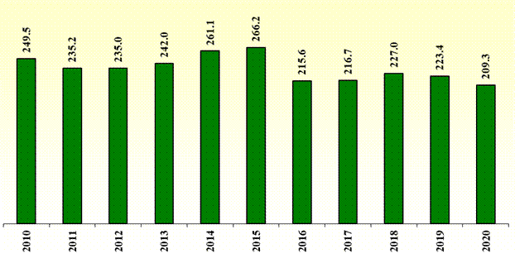

Figure 1. Total losses of national economy caused by RTAs (in millions of euros) [source: RTSD]

The cost benefit analysis is used for the evaluation of the efficiency of the road traffic safety improvement measures, i.e. it is evaluated what results are acquired by taking traffic improvement measures for the implementation of which it is necessary to invest certain financing. The cost benefit ratio for the determination of which it is necessary to know the benefits from the implementation of the measure, i.e. the average costs of one road traffic accident and one person with injuries of different levels of seriousness, is used in this evaluation. The Methodology for the Calculation of Losses of National Economy Caused to the State as a Result of Road Traffic Accidents is used for the calculation of losses. The calculations performed by the RTSD attest that in 2019 and 2020 the losses caused by one fatality from RTA to the State amounted to more than EUR 500 000. In turn, the total losses, adding together losses caused by one accident without casualties on average, one casualty on average, and one fatality on average, amounted to more than EUR 220 000 000 in 2019 and EUR 210 000 000 in 2020.

Table 2. Calculation of losses caused by one RTA and one casualty [source: RTSD]

Average losses (euros) | 2017 | 2018 | 2019 | 2020
Losses from RTAs without casualties | 2117.36 | 2178.46 | 2229.45 | 2215.78
Losses from one mildly injured casualty from RTA | 2647.83 | 2963.77 | 2986.46 | 2988.21
Losses from one seriously injured casualty from RTA | 15 825.00 | 16 909.79 | 17 444.54 | 17 320.45
Losses from one fatality from RTA | 473 948.36 | 488 673.96 | 502 718.23 | 502 935.81
Average losses from one serious RTA | 35 333.02 | 37 787.71 | 38 083.45 | 40 457.29

2.1.2. Statistics of Road Traffic Accidents

Since 2001, the number of fatalities from RTAs in Latvia has shown decreasing trends; however, at the same time the dynamics of the number of seriously injured persons keeps increasing. Looking at the actual results and the objectives pursued on a year-to-year basis, it may be concluded that 2014 was the only year when Latvia exceeded the set indicators of the objective in relation to the reduction of the number of seriously injured persons. At the same time, Latvia has not been able to present results in the reporting period which reach or exceed the objectives pursued in relation to the reduction of the number of fatalities.

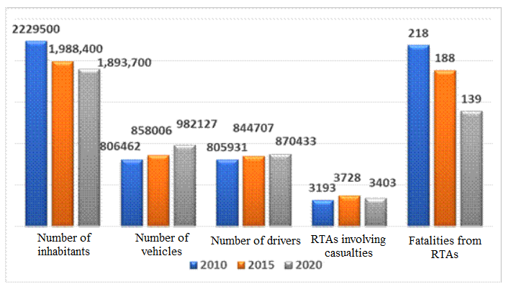

Figure 2. Changes in different characteristics within 10 years – number of inhabitants/number of vehicles/number of drivers/number of RTAs involving casualties/number of fatalities in 2010, 2015, and 2020 [source: RTSD]

The number of fatalities in the time period of 10 years from 2010 to 2020 has gradually decreased, except for the increase in 2014 and 2018 which could be partly explained by the discontinued use of fixed speed cameras on the roads of Latvia in 2014. In turn, in 2018, there were more RTAs with several casualties in one accident and, taking into account the small number of RTAs with fatalities, these few cases have deteriorated the statistical indicator.

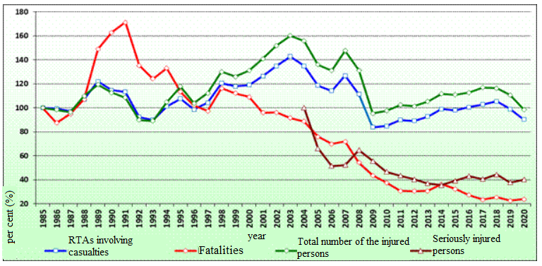

Figure 3. Dynamics of RTAs in Latvia – the number of RTAs with casualties, fatalities, total number of injured persons, seriously injured persons (100 % = year 1985) [source: RTSD]

In the time period from 2010 to 2019, in total 251 210 persons died in RTAs in 27 EU Member States and more than 1.7 million persons were seriously injured. In this period, the number of fatalities in the EU Member States has decreased by on average 23.7 %, in turn the number of seriously injured persons has increased by 2.0 %. This calls for a conclusion that Latvia exceeds the average indicators of 27 EU Member States in reduction of the number of fatalities and seriously injured persons from RTAs – reduction in the number of fatalities by 39.5 % is the second best indicator among 27 EU Member States.

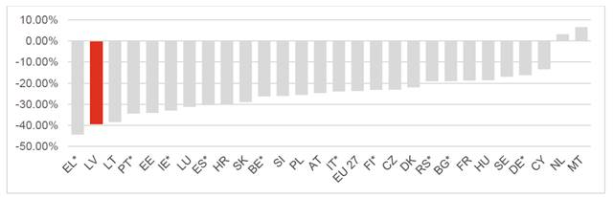

Figure 4. Changes in the number of fatalities from RTAs in the time period from 2010 to 2019 in 27 EU Member States
(*provisional data have been used) [source: study “Impact Assessment of the Road Traffic Safety Plan for 2017–2020”]

In 2010, there were 3193 RTAs involving casualties in Latvia where 218 persons died and 4023 persons suffered injuries. Since RTA statistics are being registered in Latvia, 218 fatalities has been the smallest number of fatalities until 2010 (it has been registered since 1970), in turn the number of fatalities in subsequent years has reduced to an even greater extent.
In the time period from 2010 to 2020, 1866 persons died in road traffic accidents in Latvia and 5473 persons were seriously injured. Within this time period, reduction in the number of fatalities by 35 % and seriously injured persons by 14 % has been achieved. Since 2001, the number of fatalities from RTAs in Latvia has shown decreasing trends; however, at the same time the dynamics of the number of seriously injured persons keeps increasing. Looking at the actual results and the objectives pursued on a year-to-year basis, it may be concluded that 2014 was the only year when Latvia exceeded the set indicators of the objective in relation to the reduction of the number of seriously injured persons. At the same time, Latvia has not been able to present results in the reporting period which reach or exceed the objectives pursued in relation to the reduction of the number of fatalities.

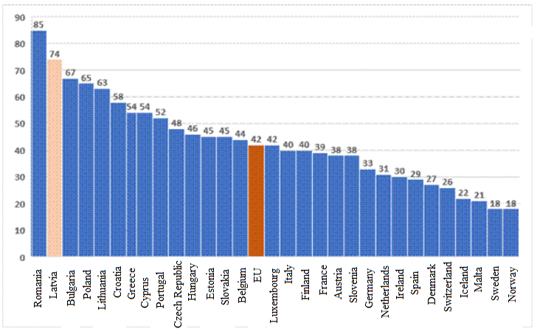

Figure 5. Number of fatalities from RTAs per million of inhabitants in the EU Member States in 2020 (provisional data) [source: European Commission²⁸]

In viewing the overall statistics of the EU Member States, it should be concluded that the number of fatalities in Latvia per million of inhabitants is still one of the highest numbers in the EU. According to the data of 2020, there were 74 fatalities per million of inhabitants in Latvia, meanwhile on average 42 persons died in 27 EU Member States. The best results have been achieved in Norway – 18 persons and in Sweden – 18 persons. The actual indicator in Latvia (74 persons) is the second worst indicator in the EU, there are more fatalities per million of inhabitants only in Romania – 85 persons.
The statistical data attest that 139 persons died in RTAs in 2020; thus in comparison to 2019 the number of fatalities from RTAs has increased by seven persons in 2020. In total, 4059 persons were injured in RTAs in 2020 which is by 500 persons less than in 2019. Similarly, 491 persons have been seriously injured in RTAs in 2020. In total, 39 167 RTAs have been registered in the country in 2020 (18 334 RTAs have been registered by the SP (in the subsystem “Traffic Police Register” of the Integrated Information System of the Interior)) and 20 833 RTAs without casualties have been registered with the MIBoL).

2.2. Safety of Vulnerable Road Users

Road users who are identified as vulnerable ones (for example, pedestrians and cyclists, drivers of electric scooters) do not have a protective “envelope” (for example, the body of an automobile) and also there is a mutually significant difference in mass at the moment of collision, for example, with a passenger car. There are different solutions for improving the safety of vulnerable road users; however, the reduction of the permitted driving speed, if vulnerable road users are not completely separated from the flow of other vehicles, and also complete separation of the flow of vehicles from the flow of vulnerable road users, should be mentioned as the most essential solutions, thus promoting pedestrian paths corresponding to the highest safety requirements, the micromobility infrastructure (including cycling paths or joint pedestrian/cycling paths).
It should also be mentioned that the structures of vehicles are also being improved, installing different safety systems which may reduce the seriousness of injuries to pedestrians at the moment of collision (for example, airbags intended for pedestrians which are installed in the front part of the vehicle and are activated at the moment of collision with the pedestrian²⁹). Introduction of such solutions is both time-consuming and only a small part of the new vehicles are being equipped with such or similar systems.
At the same time, it is also important to assess other solutions which are directed towards comprehensive education and information of road users (which includes all road users) on essential threats in road traffic. For example, hitherto a part of the vulnerable road users – a large part of pedestrians – has not been aware or has been only superficially aware of the road traffic regulation laid down in laws and regulations (the requirements of the RTR and the RTL) because they have not obtained a driver’s licence although road traffic safety issues have already been included in the content of the samples of general education standards and subject programmes for some time. One of the solutions for the education of vulnerable road users is to implement road traffic safety campaigns targeted for this very audience, paying attention to essential and topical themes in these campaigns.

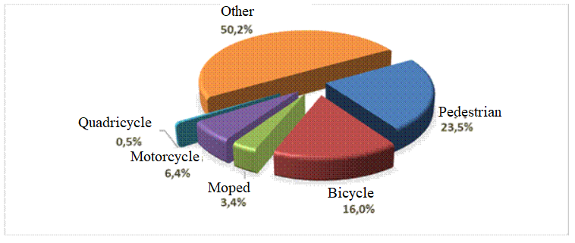

Figure 6. Number of serious RTAs according to the status of the road user (average in 2015–2019) [source: RTSD]

According to several studies conducted³⁰, pedestrians have a great chance of survival in a collision with the front part of a passenger car if the speed of the passenger car is 20 km/h at the moment of the collision. If, at the moment of the collision, the speed of the passenger car is already 40 km/h, approximately 90 % of pedestrians might survive in the collision; less than half of pedestrians (below 50 %) would survive at the speed of 80 km/h, and pedestrians die in more than 90 % of cases if the speed of the collision is 100 km/h. This is one of the reasons why it is essential to increase the distribution of such areas in the urban environment and populated areas where the permitted driving speed is 30 km/h, thus ensuring that the vulnerable road users do not suffer serious or lethal injuries in RTAs.

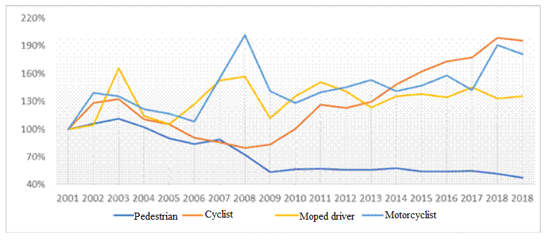

Figure 7. Dynamics of RTAs involving injured vulnerable road users (in 2001 = 100 %) [source: RTSD]

The use of reflective elements or vests with reflective elements requires less investments than significant changes in the traffic and urban environment. However, in forming new traffic solutions or renewing the existing ones, attention in any case should be paid in the future also to ensure as little connection of the flow of vulnerable road users (pedestrians, users of micromobility vehicles) with the other traffic flow.
Pedestrians is the most extensive group of road users because people may be divided into groups according to the vehicle or type of transport they choose – public transport, private automobile, bicycle, meanwhile at some point all road users participate in the road traffic as pedestrians. Although currently there is a unified awareness that the flow of pedestrians should be henceforth separated from the flow of other vehicles, recently direct risks of a threat to pedestrians have increased also on sidewalks. Taking into account that the infrastructure intended for micromobility vehicles has not yet been developed to a sufficient extent, the driving thereof is permitted also on sidewalks. Thus, pedestrians are also subject to a risk, moreover people driving micromobility vehicles must also remember that pedestrians have precedence on the sidewalk.
Taking into account that every road user is responsible for his or her safety, pedestrians should also take into account several recommendations (as also laid down by the RTR) which will aid in feeling safe on sidewalks, when walking along the roadside verge, when crossing the carriageway, and in other cases. Any road user should be visible – it is recommended to avoid rapid and unpredictable movements or change of the direction, also pedestrians should take into account traffic lights, corresponding traffic signs (for example, the sign indicating that the movement of pedestrians is prohibited, etc.), and other instructions. It should also be kept in mind that one cannot assume that the driver always sees you. It is clear that the driver has noticed the pedestrian only after an eye contact with the driver has been established. Therefore, it is recommended to be visible all the time, for example, by wearing bright clothing during the day, in turn clothing with reflective materials should be mandatorily worn or a portable light should be used at night.
Pedestrians should also keep in mind that the capacity to act and the speed of response are affected by alcohol, drugs, and other intoxicating substances, therefore it is recommended to assess whether too great a risk will be caused to oneself under the influence of intoxicating substances if one must be on a street or walk along a roadside verge.

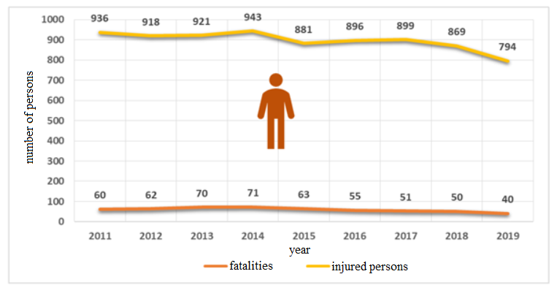

Figure 8. Number of fatalities and injured pedestrians in the time period from 2011 to 2019 [source: RTSD]

A decrease has been observed over the years in terms of the number of pedestrian fatalities (60 fatalities in 2011, 40 fatalities in 2019); however, it is insufficient. Approximately half of the pedestrians (in 2018 and 2019 – 50 %) have died on State motor roads and in 80 % of cases (in 2019) it has happened during the dark or twilight hours of the day.
It should be noted in relation to the dynamics in the number of injured and especially seriously injured pedestrians in the reviewed period that the majority of pedestrians were seriously injured in populated areas (for example, 92.2 % in 2019). The abovementioned shows that it is necessary to strengthen the implementation of targeted measures, inter alia, by making investments in the infrastructure. For example, lighting of pedestrian crossings, introduction of regulated crossings, creation of speed bumps in places where large pedestrian and vehicle flows meet.
Cyclists or drivers of bicycles are also the most vulnerable road users, it is permitted to drive a bicycle along the general purpose roads. Cyclists could feel the safest if cycling traffic was separated from road transport and cyclists could ride their bicycles on specially designed cycling paths.
According to the information included in the study “Study on Bicycle Traffic and the Infrastructure of Bicycle Traffic on National Scale”³¹ and the study “Impact Assessment of the Road Traffic Safety Plan for 2017–2020”, in 2019 there were in total 701.75 km of cycling paths, cycling lanes, joint pedestrian and cycling paths in Latvia. More than a third or 43 of all local governments have indicated that there is no such infrastructure therein, the total length of cycling paths, cycling lanes, joint pedestrian and cycling paths in 41 local governments is up to 5 km, the length of the infrastructure in 28 local governments is 5–20 km, and it exceeds 20 km in 7 local governments. In terms of amount, the longest cycling paths, cycling lanes, joint pedestrian and cycling paths in Latvia are in Rīga (68.2 km), Ventspils (65.3 km), Jūrmala (61.7 km), Liepāja (50.9 km), Jelgava (25.6 km), Sigulda municipality (23.4 km), Ogre municipality (23.3 km), Valmiera (18.5 km), Daugavpils (17.8 km), and Tukums municipality (17.4 km).
Taking into account the intensity of pedestrian and bicycle flows and the increase therein, it is economically feasible in most of the cases to build joint pedestrian and cycling paths which are separated from the carriageway intended for the road transport. In 2018, the LSR built 15.7 km of pedestrian and cycling paths, in turn on average 5 km of cycling paths are built every year in Rīga according to the information provided by the TDoRCC (except for 2019).

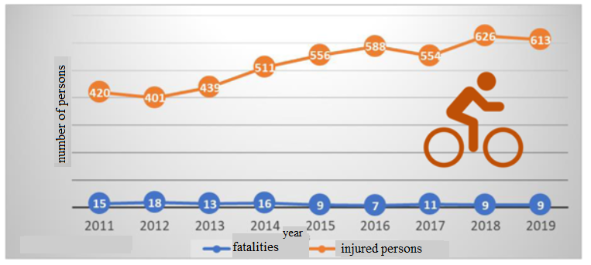

Figure 9. Number of fatalities and injured cyclists in the time period from 2011 to 2019 [source: RTSD]

In viewing the statistics of RTAs, it is apparent that the actual result of the number of deceased cyclists has a tendency to decrease, also it has been observed over the last years that on average 10 cyclists a year have died. In any case, such number is also unacceptable, moreover the number of fatalities has not changed over the last two years (in 2018 and 2019), i.e. 9 persons.
The situation in relation to the reduction of the number of injured cyclists, similarly to pedestrians, is worse. The average number of seriously injured cyclists is approximately 40 persons a year, and 61.5 % of these cyclists have been seriously injured in populated areas, including Rīga. The total number of injured cyclists has increased from 420 in 2011 to 613 in 2019. In viewing different State motor roads which are classified as the major, regional, and local State motor roads versus the total kilometres driven by cars, the number of cyclists involved in RTAs is similar on all State motor roads regardless of the division; however, the proportion of seriously injured persons versus the persons involved in RTAs is much higher – 65 of 329 cyclists or 19.8 % have suffered serious injuries on State motor roads in the time period from 2015 to 2019. In comparison, this indicator in Rīga in the same time period is 1.7 %; at the same time, it should be taken into account that there are no motor roads, only streets in Rīga.
Within the scope of the study, bicycle traffic in Rīga was analysed in detail because, in the time period from 2015 to 2019, on average 51.02 % of RTAs in which cyclists were involved happened in Rīga. Taking into account the measured correlation of the traffic volume with the number of RTAs, it may be concluded that the highest volume of bicycle traffic is in Rīga. The number of cyclists on the bridges of Rīga has increased by 40 % within a period of four years. This means that every year the number of cyclists increases by almost 9 % on average. This trend should be deemed as surprisingly positive, taking into account that no bicycle infrastructure has been arranged on any of the bridges in Rīga. The lack thereof and the increase in the number of cyclists means increasingly dangerous and less safe situation on the sidewalks of bridges where cyclists mostly travel.
Electric scooter is a vehicle equipped with an electric motor the maximum designed speed of which does not exceed 25 kilometres per hour, which does not have pedals, which is intended for one person and is equipped with a handle-bar that is mechanically connected to the surface of the foot pad.
There are different individual electric means of transport, including electric scooters which are used by people to get to work and elsewhere in their everyday life. People are increasingly using these ecologically clean means of transportation which do not cause pollution, having a positive assessment of them; however, compliance with the safety principles should not be forgotten.

Table 3. Statistics of RTAs involving drivers of electric scooters [source: SP]

 | RTAs IN TOTAL | RTAs INVOLVING CASUALTIES | INJURED PERSONS | FATALITIES
2018 | 3 | 2 | 2 | 0
2019 | 53 | 37 | 35 | 2
2020 | 88 | - | 62 | 2

However, it should be taken into account that, upon increase in the popularity of electric scooters, the risks of RTAs involving electric scooters also increase. Similarly to cyclists and pedestrians, drivers of electric scooters are vulnerable road users.
As attested by the statistics, in 2019 the SP recorded more than 50 RTAs in which more than 30 persons were injured and two persons died. Thus, it should be taken into account that electric scooter is mainly appropriate for use only in cities (on pedestrian sidewalks, bicycle lanes, carriageway, parks, squares, etc.) where priority should be given to pedestrians, public transport. As a priority, the users of electric scooters should use the infrastructure intended for cyclists; however, the lack of appropriate infrastructure in places where electric scooters are used extensively is the reason why such regulation has been introduced which includes direct requirements for the inclusion of electric scooters in the joint road traffic. In developing regulations for the use of electric scooters in traffic, the experience of other EU countries was also assessed.
Drivers and passengers of motorcycles (motorcycles, mopeds, quadricycles) are also considered the most vulnerable road users, moreover in recent years the popularity of motorcycles (motorcycles, mopeds, quadricycles) has increased most rapidly both in Latvia and also in other countries³². In 2020, more than 26 000 units of motorcycles (motorcycles, mopeds, quadricycles) and also approximately 23 000 active drivers of motorcycles (motorcycles, mopeds, quadricycles) have been registered in total in Latvia. In turn, 1500 drivers of motorcycles (motorcycles, mopeds, quadricycles) (approximately 6.5 % of the total number) have joined in organisations of motorcycles (motorcycles, mopeds, quadricycles).
As regards vehicles involved in RTAs with casualties, in 2019 they were motorcyclists in 4.9 % of the cases, moped drivers – 2.26 %, and quadricyclists – 0.36 %. The most essential problem among drivers of motor vehicles is involvement in RTAs under the influence of alcohol. In total, 5.2 % of the motorcyclists which have been involved in RTAs over the course of the last years were under the influence of alcohol (4.7 % in 2019). The situation in relation to quadricycles and mopeds is significantly worse. Over the course of the last years, 15.6 % of quadricyclists and 18.1 % of moped drivers who were involved in RTAs with casualties were under the influence of alcohol (20.0 % and 22.5 % in 2019 accordingly).

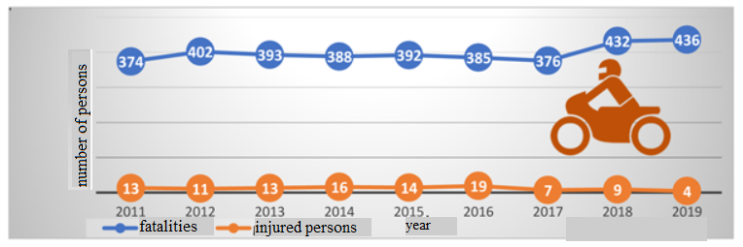

Figure 10. Number of deceased and injured drivers and passengers of motorcycles (motorcycles together with mopeds and quadricycles) in the time period from 2011 to 2019 [source: RTSD]

The contribution of non-governmental organisations of motorcycles (motorcycles, mopeds, quadricycles) may also be brought to attention in the improvement of road traffic safety as they have been disciplining their members (technical condition of vehicles, action on road) and organising informative campaigns. The percentage indicator in relation to involvement in RTAs among drivers of motorcycles (motorcycles, mopeds, quadricycles) belonging and not belonging to organisations of motorcycles (motorcycles, mopeds, quadricycles) differs by 10.3 times – the internal discipline of organisations of motorcycles (motorcycles, mopeds, quadricycles) ensures a much higher level of safety in traffic.

2.3. Road Traffic Violations

It is undeniable that exceeding of the permitted speed limit, driving a vehicle under the influence of alcohol, or negligent driving, non-use of seat belts are still essential factors affecting the course of RTAs and their consequences. Even taking into account that punishments for violations have been significantly increased over the course of years, many drivers of vehicles involved in RTAs were not complying with one or several requirements of the RTR before or at the moment of the RTA.
Experience of other countries attests that control of compliance with the RTR must be part of an integrated road traffic safety policy and it has also been observed that, upon application of the best practice, the number of fatalities and seriously injured persons from RTAs can be reduced rapidly.
Within the scope of the study “Road Traffic Safety Plan for 2017–2020”³³, the components of achieving the enforcement of the traffic regulations were analysed, focusing on compliance with the permitted speed, use of seat belts, reduction of the use of alcohol, and reduction of driver distraction. The measures included in the Road Traffic Safety Plan are directed towards changing the behavioural habits of road users. In order to evaluate the efficiency of preventive measures, analysis of the causes of RTAs in relation to RTAs involving fatalities and seriously injured persons was conducted. Information on the causes of RTAs in 46.4 % of cases involving fatalities and 33.7 % of cases involving seriously injured persons is not available in the reporting period. However, the data set available is sufficient for the impact evaluation of the measures implemented in relation to achieving the enforcement of the traffic regulations. It should be noted that the classification of the causes of RTAs has been changed in 2018, therefore some causes are not directly compatible.
Also, in analysing the data available in CAIS³⁴ within the scope of the study³³, it was established that the most frequent causes of RTAs involving fatalities include choosing of inappropriate speed, improper road traffic safety assurance – negligence and presence of pedestrians on the carriageway in places not intended for this purpose. Other causes are much less common.

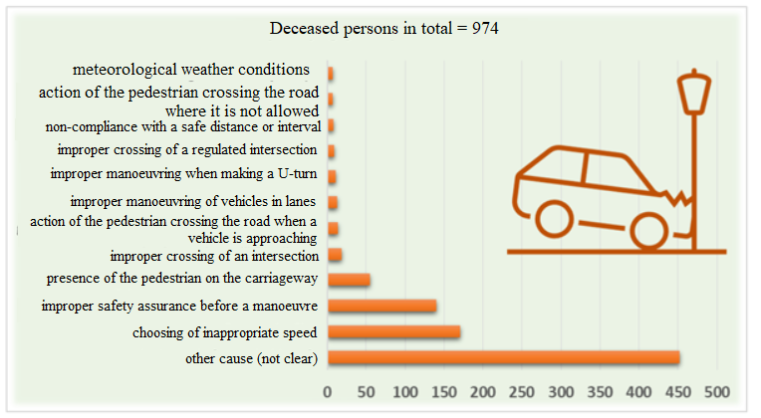

Figure 11. 12 most frequent reasons for RTAs with fatalities from 2014 to 2019 [source: study “Impact Assessment of the Road Traffic Safety Plan for 2017–2020”]

Also, in analysing RTAs involving seriously injured persons within the scope of the assessment of the study³³, the most frequent causes of RTAs involving seriously injured persons include improper road traffic safety assurance, choosing of inappropriate speed, and non-compliance with a safe distance or interval.
It should concurrently also be concluded that it is continuously necessary to improve the data recording of RTAs and the possibilities for processing information so that comprehensive information on the causes of RTAs would be available and it would be possible to use them as the basis for targeted planning of measures (for example, informative campaigns). It should be taken into account that, in order to understand the actual cause of RTAs, it should be analysed by specialists of different sectors. The course of RTAs is affected by both the action of each participant of the RTA and the surrounding environment (infrastructure, traffic organisation, visibility of surrounding objects, etc.). The probability of setting in of serious consequences as a result of an RTA is also affected by the health condition of participants of the RTA before the RTA and the time and quality of provision of emergency medical assistance. Therefore, in order to objectively determine both the actual cause of the RTA and for the setting in of serious consequences of the RTA, the circumstances affecting the course of the RTA and its consequences would be determined in a greater detail if the analysis of the RTA was conducted by specialists of different sectors, thus also helping to assess potentially new actions and measures in subsequent planning of the road traffic safety policy.

2.3.1. Exceeding of the Permitted Driving Speed

Compliance with the permitted driving speed will remain crucial until the speed problem is structurally solved through road design, engineering measures, and vehicle technologies. In relation to violations which are recorded using technical means and without stopping the vehicle, control of the permitted speed can be improved if processing of the information on the relevant violation and preparation of the decision on imposing a fine is mostly automated. In such case, efficiency is also higher if liability is imposed on the owner of the vehicle and not the driver of the vehicle because it is easier and quicker to identify the owner than the driver.
At the beginning of the reporting period of the study²⁸, choosing of inappropriate speed was the cause of at least 13.9 % of RTAs involving seriously injured persons and 20.7 % of RTAs involving fatalities. It should also be noted that different measures, for example, installation of fixed speed cameras, patrols of the SP with portable speed cameras, organising of several informative road traffic safety campaigns, have been introduced during the reporting period, thus achieving that speed is the cause of RTAs in increasingly less cases.
In assessing the basic indicators for recording a violation by speed cameras, it may be concluded that the use of speed cameras has significantly increased. At the same time, patrols of the SP have significantly decreased as reflected by reduction in the number of drawn-up cases of violations.

Table 4. Basic indicators of recording violations by fixed speed cameras and patrols of the SP from 2015 to 2019 [source: study “Impact Assessment of the Road Traffic Safety Plan for 2017–2020”]

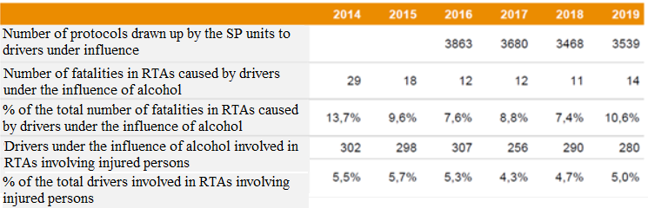

2.3.2. Driving a Vehicle under the Influence of Alcohol, Narcotic or Other Intoxicating Substances

Although driving a vehicle under the influence of alcohol in comparison with other violations of the RTR is observed in significantly less cases, it is still very dangerous in road traffic. It is estimated that on average even up to 2 % of the total kilometres covered in the EU are driven with impermissible blood alcohol content and approximately 25 % of all fatalities from RTAs in the EU are related to the use of alcohol while or before driving a vehicle.

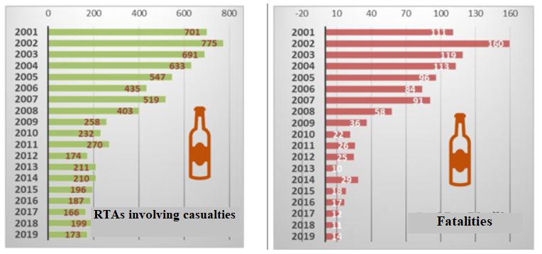

Figure 12. Statistics of RTAs caused by drivers under the influence of alcohol in 2001–2019 [source: RTSD]

Since the beginning of this century, Latvia has been successful in substantially reducing the number of fatalities (eight times) and seriously injured persons (four times) from RTAs caused under the influence of alcohol. It should be noted that Latvia displays one of the best results in this field in the EU – on average this indicator in Latvia in the reporting period was 9.6 % meanwhile in the EU – RTAs with fatalities on average 25 %.
In the reporting period, all indicators characterising driving of a vehicle under influence have displayed a stable trend of reduction regardless of the overall increase in traffic volume (by 16 %) and increase in the number of seriously injured persons (even by 6.4 %).

Table 5. Indicators characterising the frequency of driving of a vehicle under influence in Latvia [source: study “Impact Assessment of the Road Traffic Safety Plan for 2017–2020”]

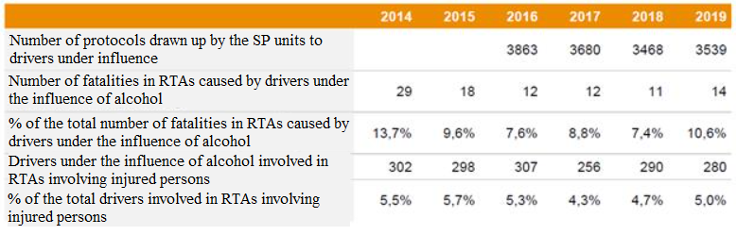

Driving of any vehicle (passenger car, heavy goods vehicle, motorcycle, or any other motor-driven vehicle) after the use of alcohol, narcotic or other intoxicating substances is a serious violation of the law because even a low content of alcohol or narcotic substances in the blood of the driver may cause critical situations in road traffic. Statistical data show that some drivers keep participating in road traffic under the influence of alcohol or narcotic substances. This fact is confirmed by the information provided by the SP on checks in road traffic detecting a number of drivers every day who drive while being under the influence of alcohol.
In assessing the indicators characterising the frequency of driving a vehicle under influence in Latvia, it may be concluded that the complex preventive actions and informative campaigns in relation to the reduction of the number of fatalities and seriously injured persons from RTAs caused under the influence of alcohol have been successful; however, they may not be discontinued because every driver who drives a vehicle under the influence of alcohol or other intoxicating substances creates grave danger in road traffic.
Although amendments to Section 22 of the Road Traffic Law regarding its supplementation with Paragraph 3.¹ are currently in force, harmonisation of draft Cabinet regulations providing for determination of the procedures for the organisation, course of, and payment for a behavioural correction programme still continues. Thus, the regulation which is in force in 2021 does not yet determine precisely the way of working with drivers of vehicles who have been punished for driving a vehicle under the influence of alcohol or narcotic or other intoxicating substances and for whom excessive, harmful use of or addiction to alcohol, narcotic or psychotropic substances is not detected in the early medical check-up. Therefore, in order to prevent driving under the influence of intoxicating substances more efficiently, it is necessary to ensure that, if a person has been punished for driving a vehicle under the influence of alcohol or narcotic or other intoxicating substances, his or her return in road traffic is permissible only after medical treatment and specific time period which would attest that the person has given up on excessive, harmful use of intoxicating substances. Thus, it is intended to introduce a new service which will ensure that drivers of vehicles who have been punished for driving a vehicle under the influence of alcohol or narcotic or other intoxicating substances and for whom excessive, harmful use of or addiction to alcohol, narcotic or psychotropic substances is not detected in the early medical check-up, upon recovery of the right to drive vehicles, will have to participate mandatorily in special classes directed towards behavioural correction of the person.
Also driving under the influence of alcohol or narcotic substances increases the risk of RTAs as the driver is not ready to react quickly enough in a critical situation in order to take the right decision and to complete a safe manoeuvre which could prevent an RTA. It should also be taken into account that driving under the influence of alcohol or narcotic substances increases the severity of consequences of RTAs. Such fact is also confirmed by statistics, as consequences of an RTA where one of the drivers or both drivers have been under the influence of alcohol or narcotic substances are often very serious and involve fatalities. In most cases this is caused by the fact that driving under the influence of alcohol (also narcotic substances) usually involves exceeding of the permitted speed, the failure to comply with other requirements of the RTR, ignorance towards traffic safety, the response time of the driver also undeniably deteriorates.

2.3.3. Non-use of Seat Belts

Regardless of the requirements laid down in the RTR to use seat belts, it is estimated that they are being used only in 90 % of the front seats and 71 % in the back seats in the EU countries in which the use of seat belts is actively controlled. The European Transport Safety Council (ETSC) estimates that 900 fatalities from RTAs in 2012 could have been prevented if 99 % of passengers had used a seat belt, moreover it would have been possible to achieve this by reminders warning the drivers regarding the use of seat belts in all seats of the vehicle.
It should be recognised that the use of seat belts is a major challenge; however, it should be critically assessed mainly in relation to passengers. According to the opinions of experts expressed in the think tank of the Road Traffic Safety Council, 86 to 94 % use seat belts in the front seats of the vehicle and 66 % – in the back seats. The proportion of violations recorded by the SP units regarding the use of safety equipment in 2018 in comparison to 2019 has decreased from 8.3 % from all decisions on violations drawn up by the units to 7.7 %.
Seat belts installed in vehicles are one of the most well-known safety devices of vehicles intended to hold the driver or passengers of a vehicle in their seat at the moment of an RTA or during a sudden stop. Seat belt reduces the possibility of death or serious injuries in an RTA, reducing the secondary impact force (impact of the driver or passengers against the front panel, the wheel, etc.), holding passengers in seats in order to achieve maximum efficiency of airbags as well (if such have been installed). It is also significant that airbags installed in a vehicle may only fulfil their function (to reduce injuries from RTAs) together with seat belts, therefore it is crucial to always fasten seat belts, especially if a car is fitted with airbags. Seat belts also prevent passengers of a vehicle from falling out if the vehicle falls over as a result of an RTA. When a vehicle moves, the driver and passengers are moving with the same speed. If the driver suddenly makes the vehicle stop or an RTA occurs, the driver and passengers continue movement with the same speed as before the vehicle stopped. For example, in driving at the speed of 50 km/h, at the moment of collision a person who has not fastened a seat belt will move forward with a force equivalent to at least a ton, will smash through the windshield, or will also break the chair of the person sitting in front. Thus, it should be indicated that seat belt holds the driver and passengers in their seats with an opposing force.

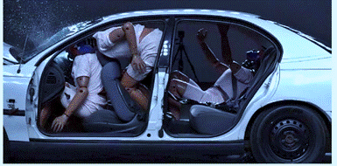

Figure 13. Passengers sitting at the back of the car at the moment of collision – using a seat belt/not using a seat belt [source: website “spanishsolutions.net”]

In 2019, in conducting a survey and implementing a study³⁵ on the use of seat belts in Latvia, it was concluded that there is a visible difference between the behaviour of passengers in the front seat and back seat of the vehicle. The majority or 86 % of passengers use the seat belt if they are sitting in the front seat row of the vehicle while less than a half of passengers use seat belts in the back – only 43 % of passengers always fasten their seat belts. It has also been concluded that in 53 % of cases passengers do not fasten their seat belts if a small distance needs to be covered. 40 % of passengers also use the excuse that the belt is uncomfortable, impractical and it is difficult to use it. In turn, 22 % of respondents do not fasten their seat belts because they are of the opinion that they fully trust the driver, meanwhile 18 % emphasise that the driver has not reminded them of the need to fasten their seat belts in the vehicle. It was also concluded in the study that only 28 % of drivers make sure their passengers have fastened their seat belts in the back seat of the vehicle. The study revealed that women and also inhabitants of Pierīga, Zemgale, and Vidzeme use the seat belt most often. In turn, seat belts in the back seat are more rarely used by men, particularly from Kurzeme and Latgale. Non-use of seat belts is more characteristic to drivers who rarely use their seat belts as passengers as well.
Concurrently, it should also be taken into account that it is laid down in the RTR that children (up to a certain height) may be transported in a vehicle if the child has been placed and appropriately fastened in a child car seat. Taking into account the statistics of child casualties and fatalities in RTAs (6 children died in 2017, 5 children – in 2018, 4 children – in 2019, 6 children – in 2020), it should be remembered that child safety, provided that he or she is a passenger of a vehicle, directly depends on additional factors which affect consequences of RTAs. Thus, it is determined in the RTR that children whose height does not exceed 150 cm shall be located in a child seat or on a pad which is installed in conformity with the instructions of its manufacturer, and shall be fastened with a seat belt. It should be kept in mind that it is mandatory for taller children to use adult seat belts. It is also important for the safety of children that a child car seat is not located in the front seats where a child sits facing the driving direction, except for the case when airbag has been deactivated.

2.3.4. Driver Fatigue

Driver fatigue and driving of a vehicle while fatigued, and also driver distraction from driving a vehicle are one of the most frequent and serious threats in road traffic which endanger all road users. Usually, driver fatigue is caused by one or several factors: physical fatigue, long working hours, or sleep deprivation. Driver fatigue may set in easily during long drives, particularly if drivers use rest periods incorrectly or do not take breaks while driving. Irregular work schedule may also promote driver fatigue. Sleep apnoea³⁶ is observed among drivers, causing high risk of falling asleep.
When a driver is fatigued, his or her response time, and also decision-making process is slower, similarly as after the use of alcohol. This factor may become a cause of an RTA or make the consequences of an RTA even more serious.
In 2018, a study was implemented within the scope of the RTSD campaign “Apstājies, pirms atslēdzies!”³⁷ [Stop before you zone out!], conducting it in cooperation with Rīga Stradiņš University and SIA “Miega slimību centrs”. As a result of the study, it was concluded that one third of drivers acknowledged that, within a year, they have experienced microsleep behind the wheel. Also one third of drivers suffer from chronic sleep deprivation which means that they continuously sleep less than seven hours in a day. It was also concluded that one eighth of drivers displays high risk of falling asleep. Moreover, 40 % of drivers for whom a high risk of falling asleep has been detected are of the opinion that they can drive a vehicle without problems.
In assessing the SP statistics regarding RTAs and analysing information on them, it may be concluded that the causes of more than 30 % of RTAs with lethal consequences are not clearly known. Negligence, the use of a mobile phone, technical problems with a vehicle may be regarded as the possible causes of RTAs; however, driver fatigue may also become the cause of an RTA. Unfortunately, it is quite difficult to detect and prove this cause of RTAs unlike being under the influence of alcohol or exceeding of the speed.
Continuous sleep deprivation is frequently a cause for driver fatigue. Continuously insufficient sleep is related to depression and anxiety which cause additional risk for traffic safety. Moreover, drivers of commercial transport are one of the categories identified as most vulnerable to fatigue and sleepiness. Fatigued drivers are at greater risk of making erroneous speed and distance estimations that can also result in an RTA.
Given that EU Member States and other countries of the world have brought greater attention to this problem only in the last decade, a comprehensive strategy is required to address this problem. Education would be the first step, i.e. education of all road users who might be associated with and exposed to the risk of fatigue while driving. Accordingly, this covers provision of information on ways how to recognise conditions that increase the risk of driver fatigue and making aware of the ways to prevent them.
Another component of policy-making for the reduction of risks related to driver fatigue is the emphasis on compliance with the working hours specified in laws and regulations and the necessary rest periods of drivers. Heads of vehicle fleets should remember that these are mandatory standards and should encourage drivers to avoid continuous driving (even if the limits set in laws and regulations are conformed to), if possible, according to achievement of their operational objectives.
It should be noted that technologies may also provide a valuable contribution in subsequent years to the prevention or mitigation of risks arising from driver fatigue. Different solutions of the management of a vehicle fleet provide the drivers of vehicle fleets with the possibility of monitoring the working hours of drivers and may give warnings regarding potential violations before their occurrence. Also telematic tools for the management of work schedules and for the coordination thereof with the working hours of a driver may help to distribute the working hours evenly in order to avoid stress and exhausting situations. Driver fatigue warning systems are also being installed in several cars, observing the driver during driving and warning him or her as necessary if signs of fatigue become apparent.

2.3.5. Driver Distraction and Use of Mobile Devices Behind the Wheel

Similarly to the driver fatigue, driver distraction from the road due to other reasons is an increasing occurrence within the last years and it is becoming one of the main factors in RTAs. There is an increasing trend towards the use of various comfort and entertainment systems in vehicles which can cause driver distraction and drivers also use different mobile devices, for example, mobile phones, behind the wheel. Taking into account that causes of driver distraction can be very different, the following four major causes have been identified:
- visual driver distraction (for example, when driver looks away from the road, looks at the view, passengers etc.);
- acoustic driver distraction (for example, a phone call, music, etc.);
- biomechanical driver distraction (for example, when driver changes radio station etc.);
- cognitive³⁸ driver distraction (for example, daydreaming, etc.).
As attested by the survey³⁹ conducted by the RTSD, more than 80 % of drivers use mobile phones behind the wheel in everyday life, while being aware that this constitutes a serious problem. According to the data of the survey, the most typical user of a mobile phone while driving a vehicle in Latvia is a man up to 50 years of age, with higher education and medium high or high income. Also observations of road users attest that, during the last five years, the use of mobile devices behind the wheel keeps increasing, therefore making it necessary to raise broader public awareness of this problem through social campaigns and enhanced road controls. Another survey⁴⁰ also shows that the majority of violations of the RTR by drivers are committed behind the wheel – by making calls (72 % of drivers), messaging (43 %), and also using the Internet and social media (17 %). Moreover, the majority of violations in this area are committed by younger and less experienced drivers.
At large, the measures for reducing driver distraction are usually divided into several categories:
– introduction of stricter requirements in laws and regulations and control of the enforcement thereof;
– improvement of the training process of drivers;
– different advertisements and implementation of social campaigns;
– implementation of different measures and activities which are related to road infrastructure technologies so that they would assist in reducing the driver distraction (for example, rumble strips).
It should be taken into account that implementation of such measures involves drivers, transport companies, also road operators and managers, and manufacturers of vehicles.
Distraction from the road is most common among drivers; however, pedestrians, cyclists, and motorcyclists and their passengers also face a high risk of RTAs as a result of distraction from the road, as mobile devices become more widely used, moreover the popularity of their use keeps increasing as attested by the recently conducted surveys of drivers of vehicles. It should be noted that the attention hitherto paid to the solving of this problem has been insufficient. Only 2.4 % of the decisions drawn up by the SP are related to the use of mobile devices behind the wheel, 68 of these cases were recorded with unmarked police cars (8.0 % of all violations registered with these cars).
In order to reduce the use of mobile devices while driving, it is necessary to find additional possibilities for recording the use of mobile devices so that it would be possible to control it appropriately and to impose fines in the relevant cases. It is recommended to introduce changes in the regulatory framework in order to strengthen the use of speed cameras and to ensure a possibility for conducting technical analysis of the mobile devices themselves after RTAs, for example, mobile devices can save the history of activities of the user, both passive and active use of the mobile phone, including whether the conversation took place, using a hands-free system or using the phone in a prohibited way.

2.3.6. Imposing of Fines for Road Traffic Violations

Administrative fines for road traffic violations are imposed in accordance with the Law on Administrative Liability and Chapter IX “Administrative Offences in Road Traffic and Competence in the Administrative Offence Proceedings” of the Road Traffic Law. In accordance with the current procedures, the fine imposed on the punished person must be paid in full amount not later than within one month from the day when the ruling on the fine has entered into effect. In accordance with Section 43 of the Road Traffic Law, it is prohibited, until payment of the fine imposed in an administrative offence case specified in this Law, to issue a driver’s licence to a person to whom the relevant administrative penalty has been applied, to undergo the roadworthiness testing of a vehicle owned (possessed, held) by the person and the registration activities thereof in the State Register of Vehicles and Drivers Thereof or the State Information System of Tractor-type Machinery and Drivers Thereof, except for writing-off of the vehicle or temporary suspension of the vehicle registration by handing over the number plates.
In accordance with Section 263, Paragraph six of the Law on Administrative Liability, it has been laid down that fines that have been applied for administrative offences provided for in laws shall be transferred to the State budget, unless the law prescribes otherwise. Fines that have been applied for administrative offences provided for in binding regulations of local governments shall be transferred to the budgets of local governments. Fines that have been applied by officials of local governments for administrative offences provided for in laws shall also be transferred to budgets of local governments.

2.4. Education of Road Users

2.4.1. Shaping of Correct Understanding in Children and Adolescents Regarding Road Traffic Safety

It cannot be denied that parents of children are partly responsible for the behaviour and attitude of children towards road traffic safety, and also compliance with the road traffic regulations. By complying with the road traffic safety regulations, parents set a positive example for children. Improvements of education process of young road users should start with a family, as the family is the one that raises a child and instils attitude towards traffic safety and observance of road traffic regulations. It should be taken into account that the existing level of knowledge of road traffic regulations may not be completely attributed to practical behaviour and conduct when participating in road traffic, as it is very important to have the right attitude and create the right behaviour in children from early childhood. Therefore, such solutions should be sought which encompass all children in different age groups and which would ensure that children are taught to behave and feel safe on the road. It is also important to change the attitude of the whole society towards compliance with safety issues at large because quite often the example shown by adults is the cause behind the action of the child.
It should be noted that the Road Traffic Safety Plan for 2017–2020 included a measure within the scope of which it was intended to ensure that the content of general education includes a human safety module which, in turn, includes road traffic safety issues and as a result of the operation of which it is intended to promote the development of a harmonious, socially active, and responsible personality. It is provided for in the human safety module that human safety issues have been currently determined in the planned results to be achieved by a pupil at all levels of education. Acquisition of various safety issues is very important at all levels of education. For educatees to acquire all necessary knowledge, skills, and attitudes in safety-related issues, they are included in the basic requirements of the content of standards of the fields of study. The purpose of acquiring these issues is to promote and improve the understanding and actions of educatees regarding the necessity of acquiring safety issues and the introduction thereof in everyday life for safeguarding their and other people’s safety and health.
The Ministry of Education and the institutions subordinate thereof have also implemented several tasks intended in the medium-term education policy planning document “Education Development Guidelines for 2014–2020” approved by the Saeima on 22 May 2014 which include the development of a modern study content that is based on the competency-based approach at all levels of general education, including also therein the human safety issues and the development of supporting materials for teachers for the implementation of this approach. Several legal acts determining the procedures for the improvement of education skills of children, including regarding road traffic safety, have also been developed: Cabinet Regulation No. 716 of 21 November 2018, Regulations Regarding the State Guidelines for Pre-school Education and the Model Pre-school Education Programmes, (hereinafter – the Pre-school Education Guidelines), and also Cabinet Regulation No. 747 of 27 November 2018, Regulations Regarding the State Basic Education Standard and Model Basic Education Programmes, (hereinafter – the Basic Education Standard) and Cabinet Regulation No. 416 of 3 September 2019, Regulations Regarding the State General Secondary Education Standard and Model General Secondary Education Programmes.
It is determined in the Pre-school Education Guidelines that, for example, in the field of social and civic studies, the child is self-aware, explains and distinguishes between good and bad behaviour, evaluates actions chosen and carried out independently, forecasts the effects of various actions in daily situations related to personal health and safety (communication with a known person and a stranger, reducing the risks of the use of substances hazardous to health and of the domestic injuries at home, in an educational institution, on the street, while playing outdoors, near water bodies and on playgrounds, and also fire safety, road traffic safety, electrical safety rules), follows the rules, understands where and when to ask for help when feeling unwell or unsafe, knows emergency number 112.
The content of the standards of the fields of study is laid out in detail in the sample programmes of subjects or courses (in secondary education). For example, the NCE has developed a study and methodological material in the field of study health and physical activities within the scope of the project “Competency-based Approach in the Study Content” of the European Social Fund for the implementation of the pre-school education programme. Its content includes descriptions of the study process for both actions of the child, for example, the child observes distance when riding a bicycle or scooter in a manner that is safe for the child and others, uses personal protective equipment, explains why it is necessary, and for actions of the teacher, for example, the teacher explains the safety rules to the child in a simple and comprehensible manner, using examples and visual aids, organises interactive simulation games, monitors that the child uses personal protective equipment when riding a bicycle or scooter, discusses the safety regulations with parents/guardians of the child, agrees on unified requirements in relation to the compliance therewith.
The purpose of education is targeted towards forming of socially responsible members of the society who are able to choose an action model that is the most appropriate for the situation and are aware of the consequences of their actions:
• a pupil has to acquire different basic skills in the pre-school education programme, inter alia, in relation to safety in different everyday situations. For example, street behaviour, playing outdoors, and also road traffic safety regulations. Pupils must be able to distinguish between good and bad behaviour, follow the rules, understand where and when to ask for help;
• a child has to acquire readiness for socially responsible stance in the basic education programme. The aggregate of the knowledge and skills to be acquired has been divided according to grades:
– in finishing grade 3, the child has the knowledge in relation to safeguarding his or her own safety and the safety of other people, including on a street, knows and complies with the RTR which ensure safety of pedestrians and passengers;
– in finishing grade 6, the child knows and complies with the RTR (also regarding safety of cyclists) and other safety regulations;
– in finishing grade 9, the child knows and complies with the RTR (also regarding safety of cyclists and drivers of motor-driven vehicles) and other safety regulations.
The road traffic safety issues are included in the standard for grades 1–9 of the subject “Social Sciences”. From 1 September 2020, Cabinet Regulation No. 747 of 27 November 2018, Regulations Regarding the State Basic Education Standard and Model Basic Education Programmes, is in force, determining that outside the overall subject load the educational programme includes such class lessons which are planned according to the study and upbringing work needs, including therein, for example, the issues of health education and RTS;
• a child must become a mentally, emotionally, and physically developed personality in the general secondary education programme, including must be aware of and learn the ability to take care of his or her health and safety. The road traffic safety issues are included in the subject “Health Education”. From 1 September 2020, Cabinet Regulation No. 416 of 3 September 2019, Regulations Regarding the State General Secondary Education Standard and Model General Secondary Education Programmes, is in force which determines, in the stage of general secondary education, the intended results to be achieved by a pupil, including in the field of study of health, security, and physical activity – the pupil acts intentionally in his or her everyday life according to the habits of healthy lifestyle, is able to identify danger and risks in different environments and situations, takes preventive safety measures, identifies steps for safe action, choosing the most appropriate problem-solving strategies.
In addition to that mentioned above, in accordance with Cabinet Regulation No. 1338 of 24 November 2009, Procedures for Ensuring Safety of Educatees in Educational Institutions and at Events Organized by Them, according to the needs of the educational institution and local conditions, the educational institution shall develop the safety rules which include information on actions in extreme and non-standard situations, information on road safety, etc. Introduction of educatees with safety rules shall be recorded in the class or group register.
The abovementioned measures demonstrate that an extensive range of measures is ensured in the context of formal education. However, in order to ensure in practice that pupils not only are aware of but also apply the knowledge acquired in practice, the family of the pupil and social networks also have an essential role.
In assessing the statistics of RTAs in the study³³, it should be noted that in the reporting period (2001–2019) persons up to 18 years of age constitute 3.0 % of the total number of fatalities and 10.3 % of injured persons. Persons up to 18 years of age have been injured in RTAs in the reporting period as passengers (in 48.0 % of cases), pedestrians (31.4 %), cyclists (19.1 %), drivers (1.4 %). The highest increase is observed in terms of the number of injured cyclists and moped drivers – their proportion has increased from 15.5 % in 2014 to 23.2 % in 2019. In the reporting period, the number of injured persons up to 18 years of age has not been lower in any year than the number of injured persons in 2010.

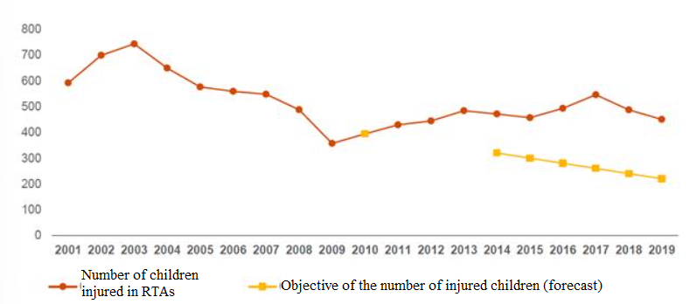

Figure 14. Dynamics in the number of persons injured in RTAs up to 18 years of age (fatalities and casualties) from 2001 to 2019 [source: study “Impact Assessment of the Road Traffic Safety Plan for 2017–2020”]

2.4.2. Training of Drivers

New drivers with up to 2 years of driving experience get into RTAs with casualties³³ by 77.1 % more often than all drivers on average. Since 2016, improvements in relation to this indicator are being observed – the proportion of the new drivers with up to 2 years of driving experience in the total number of RTAs involving casualties was 11.3 % in 2016 and only 8.8 % in 2019. Although, according to the EC summary data³³, Latvia held the 3rd place in Europe in 2016 in terms of the fatality index of joint road users from 15–17 years of age. Thus, it is very important to pay attention to training of the new drivers.
There have been various improvements in the field of examining drivers over the last years – examination of driving mopeds in actual traffic environment has been commenced, evaluation of examinations is moving towards competency assessment, placing particular emphasis on the ability to blend in the traffic flow, to anticipate a traffic situation, and to foresee danger. According to the information provided by the RTSD, Latvia is the third country in the world which has introduced video questions.
In accordance with Section 5 of the RTL, the RTSD controls the training process of drivers of vehicles, in turn it is determined in Sub-paragraph 14.3 of Cabinet Regulation No. 358 of 13 April 2010, Regulations Regarding Training of Drivers and Training Programmes of Drivers of Vehicles, that the success percentage value of a driving school in a driving examination must be above 50 %. The statistics demonstrate that 47.9 % of drivers passed the driving examination in the time period from 1 December 2019 to 30 May 2020. A total of 106 of 206 driving schools have not been able to meet this requirement of 50 %. Thus, it may be concluded that increased control of driving training in driving schools is also necessary, concurrently considering the need to increase the number of mandatory driving lessons even more.

2.4.3. Road Traffic Safety Campaigns

Each year, various educational and informative campaigns regarding road traffic safety are being developed and implemented in order to achieve more active involvement of the society and to help it change its attitude towards road traffic safety. Unlike other types of transport, for example, rail transport or air traffic, from the very beginning road traffic was not developed as safe environment which is appropriate for everyone. Therefore, the danger of road traffic or the opposite – safety – is created by the people themselves. Therefore, unlike other types of transport where certain procedures or safety measures or deviations have already been introduced both to limit the occurrence of human errors and to mitigate their impact, reliance on the users of road traffic, i.e. for them not to make mistakes, plays a larger role in road traffic.
It should be acknowledged that people tend to make mistakes, therefore the frequency of such mistakes or consequences of mistakes can only be mitigated by different methods. One of these methods is also road traffic safety campaigns which have a preventive role. Road traffic safety campaigns are used together with other measures improving road traffic safety as the means for influencing the society to behave in a more responsible and safe manner in road traffic.
Road traffic safety campaigns may also be defined as targeted attempts to inform, convince, and motivate road users to change their attitude and conduct in order to improve road traffic safety. Campaigns may also have specific objectives, for example, to inform the society of new or less known requirements of the RTR, to improve understanding of problems, or to convince people to abstain from dangerous, ill-considered behaviour.
It is not easy at all to draw conclusions regarding the impact of campaigns on road traffic safety, moreover the impact of campaigns may be observed only in long-term, sometimes evaluating over the course of several years. Taking into account the large number of road traffic safety campaigns, only part of these campaigns is being currently evaluated in a formal and careful manner.
Over the course of time, various campaigns regarding topical themes are being created in relation to road traffic safety.
Educational awareness campaigns on the current road traffic safety problems for all road users also play an important role, including the following problems:
– against driving a vehicle under the influence of alcohol, narcotic or other intoxicating substances; driving under influence;
– on observing safe speed;
– on the use of seat belts, safety helmets, and child car seats;
– on the safety of vulnerable road users (pedestrians, cyclists, drivers of electric scooters, mopeds, and motorcycles);
– on aggressive driving style that is disrespectful of other road users;
– on fatigue and microsleep of drivers behind the wheel;
– on appropriate actions after an RTA;
– on a dangerous manoeuvre and carrying out of overtaking manoeuvres;
– on different topics related to the condition of the road infrastructure and the impact of weather conditions on driving a vehicle;
– on the impact of the technical condition of vehicles, for example, tires, on driving a vehicle;
– on the lack of mutual understanding and respect of road users and similar topics.
At the same time, by informing and inviting the society to act in a proper and responsible manner, the resources of the responsible authorities are being saved, for example, by not calling a unit of the State Police to an insignificant road traffic accident without casualties.

2.5. Mitigation and Prevention of the Consequences of Road Traffic Accidents

After an RTA, it is crucial to take action as quickly as possible in accordance with the procedures laid down in laws and regulations because every second is of the essence for saving persons who have been injured in the accident. If people have suffered in an RTA or damage has been caused to the property of a third person, and also if damage has been caused to vehicles due to which they cannot or are prohibited to travel, the driver of a vehicle must stop and stay at the scene of the accident, switch on emergency lights, and set up an emergency hazard sign. The driver must do all that is possible in order to provide first aid to a victim, call for emergency medical service or rescue service, notify the police, and act further according to their instructions.
In turn, if people have not suffered in an RTA, damages to the property of a third person have not been committed, and also damage to vehicles has not been caused due to which they could not or would be prohibited to travel, the driver of a vehicle must stop and stay at the scene of the accident, switch on emergency lights, and set up an emergency hazard sign, then agree with the driver of the other vehicle involved in the RTA on all significant circumstances of the accident, fill out the agreed statement of facts, and without reporting the police about the RTA leave the place of the RTA.
If an insignificant RTA (without casualties) has occurred, it is important to fill out an agreed statement of facts thereon because it makes the work of the State Police easier. Thus, police officers are relieved from driving to the place of an insignificant RTA and to perform the necessary administrative activities which is a time-consuming process, providing an opportunity to use this time for preventive work and allowing to increase the physical presence of officers of the State Police in the traffic monitoring process. Moreover, the version of a mobile agreed statement of facts which is regularly updated for easier use has been available to drivers from 2018. The use of the mobile agreed statement of facts facilitates the availability of the statement and quicker elimination of the consequences of the RTA because not every vehicle has a form of the agreed statement of facts readily available in it. As quick drawing up of the RTA as possible, elimination of consequences, and restoration of safe road traffic reduce congestions and prevent occurrence of new RTAs, thus reducing the number of casualties and fatalities on roads.
The reduction of the average number of days from the application of an insurance event until the disbursement of compensation is also an important task in relation to mitigating the consequences of RTAs. The statistics aggregated by the MIBoL attest that the average number of days from the application of insurance events until the disbursement of insurance compensation to the people involved in RTAs varies depending on the type of recording the accident. In 2020, the average number of days from the application of insurance events until the disbursement of insurance compensation in cases when RTAs were registered by a police decision on an offence was 43 days (in 2019 – 49 days), in turn, in cases of an agreed statement of facts – 32 days (in 2019 – 37 days). The statistics demonstrate that the agreed statement of facts (and particularly its mobile function) allows to reduce significantly the time period from the application of insurance events until the disbursement of insurance compensation. Accordingly the persons involved receive compensations more quickly which allows to eliminate the damages to the vehicle in a more efficient manner and to return to the road traffic in good technical order.
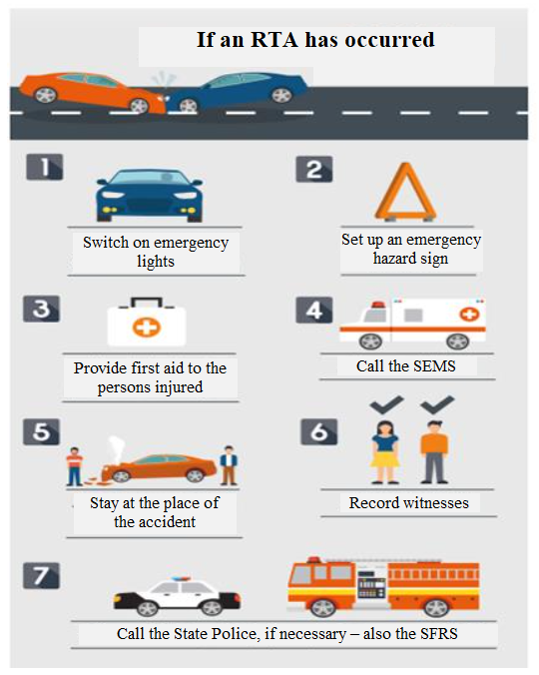

Figure 15. Infographic of the campaign “Education of Inhabitants Regarding Action after Road Traffic Accidents [source: website of the State limited liability company Latvijas Vēstnesis]

It is essential in the State policy planning in the field of road traffic safety for the reduction of seriously injured persons and fatalities from RTAs that the injuries causing disability or lethal consequences are surveyed and attention is paid to them. Saving of persons injured in RTAs and reduction of the rescue time are also undeniably very important factors in this aspect. The everyday experience of the rescue services shows that quite often people are not aware of proper actions after an RTA. Recent trends attest that people, particularly passers-by, do not call the rescue services but film or photograph the place of the accident. Seconds – the speed of calling the assistance – matter in every misfortune.
The statistics of the SFRS attest that every year fire-fighters respond on average to 800 rescue operations which are related to RTAs and the provision of assistance afterwards in relation to both rescuing of wedged people and cleaning up of the road after an RTA or, for example, liquidation of fuel spill.
Also, every year fire-fighters who are rescuers receive on average 200 calls to burning vehicles; however, upon arrival at the place of the accident, the vehicle has already burned down almost completely. It should be noted that, if smoke coming from under the hood of the vehicle is noticed, people can liquidate or at least restrict igniting fairly quickly using a fire extinguisher; however, experience shows that, in the majority of cases, drivers do not have fire extinguishers or they are not in working order.
It should also be noted that one of the main measures which could henceforth help to reduce the time necessary for calling rescue services to the place of RTAs is the introduction of the eCall system; however, it should be taken into account that this system is available to new automobiles only (manufactured after 2018). Mobile network operators of Latvia have been ensuring eCall identification in public mobile networks since 1 January 2017 and call routing of eCalls to the single emergency telephone number “112” – since 1 March 2017; in turn, the SFRS has been ensuring call acceptance and processing of eCalls since 1 October 2017.
In order to ensure the provision of medical assistance in an appropriate manner, the SEMS has defined the golden hour principle³³ – the person injured must be delivered to a medical treatment institution within an hour after the accident. In order to ensure that, the SEMS has carefully assessed the network of locations of the SEMS bases, covering the whole territory of Latvia accordingly. The arrival time of emergency medical assistance units on calls to RTAs has decreased in the reporting period in all territorial units analysed. The arrival time at the place of an RTA is by 25 % shorter than the arrival time to the calls of the highest and high priority in towns and by 33 % shorter than in rural areas.
In order to improve the capacity of the SEMS to arrive quickly at the place of an RTA, the following activities have been carried out over the last years:
• the maximum driving speed of the SEMS units has been set in the internal regulatory enactment of the SEMS, i.e. 50 % above the permitted driving speed in the relevant section of the road;
• giving up of staff units of drivers in 2018 in order to mitigate the impact of availability of the work force on the quality of the services provided. The SEMS unit is led by one member of the medical staff, having received a corresponding training for the improvement of driving skills.

Table 6. Average arrival time of the State Emergency Medical Service unit on calls to RTAs in the time period from 2014 to 2019 [source: study “Impact Assessment of the Road Traffic Safety Plan for 2017–2020”]

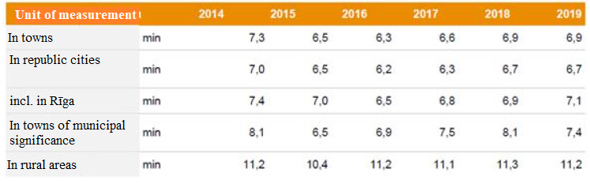

These activities have helped to ensure rapid arrival time of the SEMS unit to an RTA and also to reduce the number of cases of RTAs in which the SEMS units are involved – by 12 % in 2019 in comparison to 2018³³.
It would be possible to achieve additional improvement by carrying out improvements in the infrastructure as well. In planning them, it is important to take into account the road infrastructure elements necessary for the specific nature of emergency services:
• adequate possibilities for driving up to medical treatment institutions and base points of the SEMS, for example, Stradiņš Clinical Hospital, Children’s Clinical University Hospital, and the SEMS Rīga Centre;
• lanes for emergency transport which could be used by emergency transport in emergency cases or in transporting an injured person to a hospital;
• thought-out solutions for the edges of the road – shoulders, distance between traffic barriers, shallower ditches so that drivers of emergency vehicles could park their vehicles without endangering traffic safety;
• quality of the roads of lesser importance which hinders access to an accident.
Rapid arrival of the SEMS units to a site of an RTA in itself does not guarantee successful elimination of the consequences of the RTA. Frequently such situations arise when the SEMS units are the first to arrive at the site; however, they are unable to commence the provision of assistance because other emergency services have not arrived yet. For example, in 2019 there were approximately 20 calls where doctors had to wait until officers of the SFRS would free the patient. In expanding and strengthening the material and technical base of the SFRS for the performance of rescue operations, transition of the SFRS from the old-type hydraulic tools which are not capable of ensuring performance that corresponds to the current requirements to the new-type hydraulic tools with improved speed of operation and higher performance should be promoted as it could significantly improve this situation.
It is also important to improve the knowledge and skills of the society in relation to the provision of first aid in RTAs and also it is necessary to reduce the arrival time of rescuers to the place of the road traffic accident. In addition, it is necessary to conduct rescue operations more efficiently and to ensure efficient, timely, and high-quality emergency medical assistance to casualties in RTAs, their hospital treatment and rehabilitation.

2.6. Control of Road Users

Preventive measures for the elimination of road traffic accidents, including also control of road users, encompass several measures the objective of which is to control the road traffic flow in time and space in order to avoid RTAs or to mitigate their impact on the overall traffic flow, thus striving to make the traffic flow as even as possible. According to substance, direct control and indirect control measures can be distinguished:
– direct control measures – use of traffic lights, automatic barriers, and variable-message signs (VMS⁴¹) in order to divide the traffic priorities in time and space;
– enforcement measures against violations of control measures and road traffic regulations, for example, control by the State Police, speed cameras, red light cameras, etc.;
– indirect control measures – mainly various information and recommendations to drivers which influence the actions of individual drivers of vehicles, for example, radio transmissions, information before the drive (using the Internet and mobile devices), routing and navigation systems of the vehicle, etc.
It is undeniable that exceeding of the permitted driving speed causes substantial risk to other road users, therefore it is necessary to continue the improvement of control of road users in order to reduce non-compliance with the permitted driving speed in road traffic, expanding the use of different technical means for the control of road users.
The plan to create a network of fixed speed measuring devices containing 100 fixed speed cameras was implemented until 2018 in the entire Latvia in order to promote the improvement of the situation in traffic safety. Cabinet Order No. 678 of 14 November 2016, On the Conceptual Report “On Operational Performance of the Fixed Speed Cameras Installed by the State Stock Company Road Traffic Safety Directorate, Proposals for Further Use of Technical Means (Photo or Video Equipment), and Financing of the Purchase, Installation and Ensuring of Performance of Speed Cameras” envisaged to support the option of further introducing speed cameras contained in the conceptual report which provides for the introduction of 100 speed cameras in 4 stages within the following periods: stage 1 – 16 (implemented in 2015), stage 2 – 24 (implemented in 2016), stage 3 – 20 (in 2017), stage 4 – 40 (in 2018) by envisaging to cover expenditure from part of the dividends to be disbursed by the RTSD to the State.

Table 7. Violations of the permitted driving speed in 2020 recorded without stopping the vehicle [source: meeting of the RTSC on 25 February 2021]

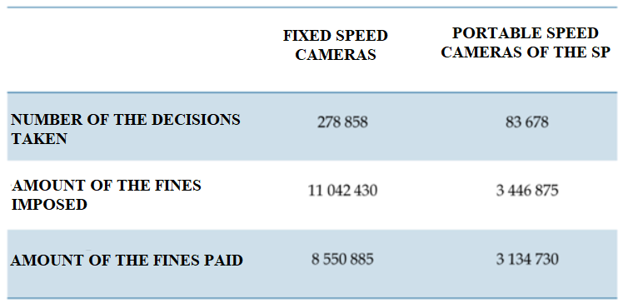

In assessing the basic indicators for recording a violation by speed cameras, it may be concluded that the use of fixed speed cameras has significantly increased. At the same time, patrols of the SP have significantly decreased as reflected by reduction in the number of drawn-up decisions. Taking into account that 100 fixed speed cameras are being used for speed control in road traffic since 2018, it should be indicated that their locations have been selected in cooperation with the MoT, the RTSD, the SP, the LSR, the LALRG, and the TDoRCC. The updated version of the map of fixed speed cameras is available on the website of the RTSD at www.csdd.lv. Also warning traffic signs are installed before each fixed speed camera. In developing the plan for the locations of fixed speed cameras, the following factors were analysed: analysis of road traffic accidents (numbers of accidents, casualties, and fatalities in a specific location), functional significance of a road section in traffic, threat to other road users caused as a result of potential exceeding of the permitted driving speed, traffic volume, and typical driving trends. Also these fixed speed cameras may not only control violations of the permitted driving speed but also, after recording violations of the permitted driving speed, check the existence of roadworthiness testing (RT) and compulsory civil liability insurance of vehicles (CCLI), and also the fact of paying the road toll in the information systems. Thus, in order to reduce violations, fixed speed cameras should be used for full control of the traffic flow in order to focus them not only on recording violations of the permitted driving speed, but also on control of validity of CCLI, and also whether a vehicle has a valid RT because there is a higher probability that vehicle owners/drivers who participate in road traffic without CCLI and RT are also committing other violations.
Concurrently also a conclusion can be drawn that, unfortunately, the number of fines imposed reflects the overall driving culture and attitude towards traffic safety. Taking also into account the limited capacity of the SP and the lack of technical means, the SP is actively using such technical means to the extent possible which will be granted and have been acquired, including a specially equipped vehicle with a 360-degree camera. The use of such vehicle has also allowed to detected that many vehicles are participating in traffic without a valid roadworthiness testing and compulsory civil liability insurance.

2.6.1. New Development Concept

In evaluating the subsequent development scenarios for the next years, it is necessary to highlight more extensive use of various technical means for the control of road users. Road managers already have such equipment at their disposal which can be supplemented with functionality, optimising costs and also expanding their operation, thus ensuring more efficient traffic monitoring, increasing the coverage of control, and ensuring control throughout the State territory. In 2020, there were 70 weather stations in the State motor road network, equipped with video cameras. It is possible to equip these video cameras with software that would ensure traffic monitoring and control.

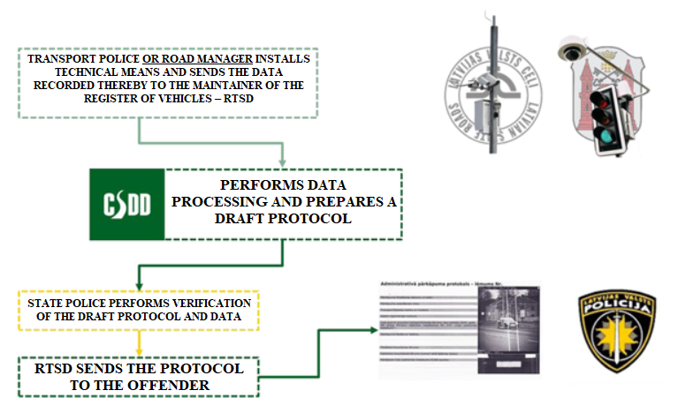

Figure 16. System for the placement of technical means [source: Ministry of Transport]

It is planned to create new weather stations in subsequent years in order to expand the quality and amount of data obtained from them for better forecasting of weather, to successively plan the motor road maintenance works, and to inform the society of the driving conditions.
Thus, the coverage of the major State motor roads with control devices together with the existing network of speed cameras, and also with the creation of the planned 18 new road toll control points would be dense, ensuring traffic control and monitoring.
Concurrently, it should be taken into account that it is also possible to use the technical means at the disposal of local governments for traffic control and monitoring.

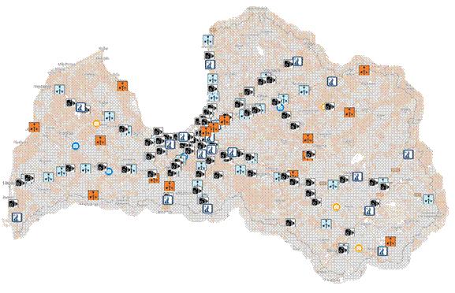

Figure 17. Existing, planned weather stations, existing speed cameras, possible special toll control sites in the State motor road network [source: Ministry of Transport]

In changing the approach to placement of technical means, it would be possible to expand the control and monitoring of road users, concurrently saving not only the State budget funds, but also local government budget funds and ensuring higher traffic safety throughout the State territory.
Taking into account the procedures laid down in laws and regulations until 2021, technical means could be installed only by the SP and the RTSD according to a delegation contract. The new approach will allow the technical means to be installed also by road managers. The data recorded by the technical means regarding violations would be sent to the maintainer of the register of vehicles, i.e. the RTSD, which would carry out data processing and prepare a draft decision to be sent to the police for verification which, in turn, would send the draft decision back to the RTSD and the latter would send the verified decision to the offender. In order to implement such approach, amendments to Section 43.⁷ of the Road Traffic Law (with amendments which have come into force until 12 July 2021) were made, determining delegation to install such technical means also to the road manager.

2.6.2. Development of the ITS

The topicality of the ITS also keeps increasing in the field of traffic. The impact of the implementation of the measures related thereto, contribution to the monitoring of road users and to the provision of information related to road traffic safety has increased in Latvia over the last years, and this can be explained with the fact that the transport systems of Latvia keep developing with arrival of smart technologies and data digitisation, and also with the implementation of significant projects which include individual elements of the ITS⁴². The ITS is based on data extraction and general use for the improvement of transport safety, efficiency, and availability. In accordance with the unified definition adopted in the EU legal acts, the ITS framework applies to road transport and also its interfaces with other types of transport.
Currently both the road managers and the specialists related to the managers, and also road users show an ever increasing general interest in the ITS services and modern traffic solutions related thereto on roads of Latvia. Thus, the introduction of the ITS applications and services and the enforcement of the requirements of the ITS Directive and the ITS delegated regulations have become inevitable. It has been identified that, as a priority, the National Access Point of the Transport-related Information (NAP) must be established in Latvia, and also the institutional capacities of the Traffic Information Centre of the LSR should be strengthened for the development and ensuring of ITS services. The LSR as the authority on the basis of the technical provisions and provision of human resources of which it is intended to establish the National Access Point has been selected according to the practice of the EU where such points are mostly under subordination of the State road administrators.

2.7. Databases and Importance Thereof in the RTA Risk Assessment

In order to be able to compare and evaluate the progress in the improvement of road traffic safety both in Latvia and throughout the EU, a joint methodology is necessary for the way of recording the statistical data of RTAs, including data regarding casualties or fatalities from RTAs. Most frequently, the main source of information on RTAs with casualties and the factors related thereto is the information registered by the police at the place of the RTA or the information obtained after the RTA. These are also the output data, used for ensuring unified recording of statistical data throughout the EU. Police data is usually very detailed on the circumstances which caused the RTA, particularly if people have been injured or died in the RTA. However, a police officer cannot evaluate the severity of injuries of persons in a credible way – this can only be done by a doctor. Therefore, the use of data based on the information provided by the police for the classification of injuries from RTAs does not provide the necessary information. Among other things, a representative of the SP records all other information at the place of the RTA – the weather conditions, the condition of the road covering, the condition of the tires of the vehicle, also other related factors.
The main source of information on RTAs recorded with an agreed statement of facts is the insurers and the MIBoL. These data ensure information on the place, date, and time of the RTA, and also information on participants of the RTAs and the decisions taken on the disbursement of the insurance compensation. The MIBoL ensures transfer of this information to other participants of the CCLI information system. On the basis of the information from the State Police and the MIBoL, an interactive map⁴³ is being created and regularly updated, and it is available to the public and reflects data on the RTAs that have occurred in Latvia, the way in which they have been recorded (with the help of the State Police or the agreed statement of facts), the type and amount of losses (data on the injured person).
On the basis of online statistics compiled by the SP, the MIBoL, and other authorities regarding the places where RTAs occur most frequently, it is necessary to develop and introduce informative recommendations to warn the drivers, using the possibilities of modern technologies and applications, in order to attract their attention to dangerous places, thus mitigating the risks of RTAs. It is also necessary to survey potentially dangerous road sections or places in Latvia.

Information System for the Analysis of Locations of Road Traffic Accidents and Violations (CAIS⁴⁴)

It was indicated in the audit report of 2017 of the State Audit Office “Is Planning and Implementation of the Road Traffic Safety Policy Efficient?” that the current approach to documenting the information on RTAs and the inclusion of such data in the register of the SP does not ensure quality data accumulation and a comprehensive analysis thereof because the data accumulated in the register of the SP regarding RTAs is not complete and therefore can be only partly used for the planning and monitoring of the policy and the measures for the improvement of road traffic safety. For solving this issue, the information system for the analysis of locations of RTAs and violations or CAIS³⁸ was developed, commencing its operation in 2018.
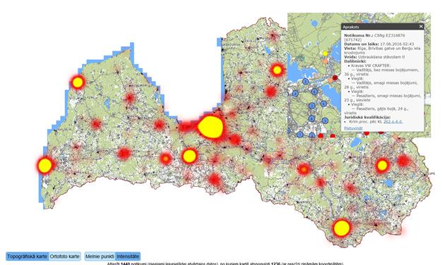

Latviešu val. | Angļu val.
Topogrāfiskā karte | Topographic map
Ortofoto karte | Orthophoto map
Melnie punkti | Accident blackspots
Intensitāte | Volume
Apraksts | Description
Notikuma Nr.: | Event No.:
Datums un laiks: | Date and time:
Veids: | Type:
Dalībnieki: | Participants:
Juridiskā kvalifikācija: | Legal qualification:

Figure 18. Information System for the Analysis of Locations of Road Traffic Accidents and Violations (CAIS) [source: http://gis.ic.iem.gov.lv/giswebcais/]

Data on the RTAs recorded within the last three months are presented after connecting to CAIS. As a default, the system shows intensity of RTAs on the map. Zooming in on the map, it is possible to view data of specific RTAs (the vehicles involved, sex and age of the persons involved, the type of RTA, and the degree of injury). It is possible to view the places of RTAs both in the topographic and orthophoto maps. RTAs and violations of the RTR can be selected according to different parameters – the date, place of the event, the type of the vehicle, the age of the person, the degree of injury, driving under influence, weather and road conditions, etc. Currently CAIS database contains information on a very large number of RTAs and violations of the RTR. Thus, this system may be useful in planning measures for the improvement of road traffic safety. The system also allows to download information in order to conduct the necessary analysis in other systems.

Unified Accounting of Statistical Data Regarding Persons Seriously Injured in Road Traffic Accidents (MAIS3+⁴⁵)

Recording of injuries from RTAs according to a unified methodology is a generally accepted element which may help to improve road traffic safety. An agreement on the creation of a unified methodology for recording the persons seriously injured in RTAs or MAIS3+⁴⁵ was made already in 2013 at the meeting of the leading officials of the EU regarding traffic safety on roads in which all EU Member States were represented.
In turn, the Tenth Revision of the International Statistical Classification of Diseases and Related Health Problems (ICD-10) which is a generally accepted standard tool for assigning codes to diagnoses to ensure statistical records is currently applied in Latvia. The introduction⁴⁶ of MAIS3+⁴⁵ is important to ensure further work on the implementation of the measures aimed at the reduction of the number of casualties and fatalities from RTAs. Although immediate link-up of the introduction of MAIS3+³⁹ with the reduction of the number of casualties and fatalities from RTAs is not observed, there is currently a lack of sufficient comparable data in Latvia regarding persons injured in RTAs for analysing reasons for the large number of persons injured in RTAs observed in Latvia. Thus, although the number of fatalities has decreased (it is significantly lower than 10 and more years ago), there is insufficient statistically comparable data to detect the reasons for injuries from RTAs – there are less RTAs with fatalities but there are still a lot of casualties. A conclusion may be drawn that currently all casualties are statistically incomparable among themselves – taking into account the current accounting procedures of statistical data regarding injuries, it is not possible to assess at the moment whether, in the majority of cases, there have been serious, less serious, or minor injuries only. It is also not possible to identify specific lines of action and measures to be implemented in order to prevent or eliminate the consequences of RTAs with fatalities or casualties. It will be possible to use statistically comparable data in organising traffic safety campaigns, in automotive industry, and in laying down additional requirements in laws and regulations – the specific injuries of persons from RTAs will be more obvious.
Taking into account the previously indicated information, an interdepartmental agreement on the exchange of information, using the data of the Management Information System (MIS) monitored by the National Health Service, and information entered in the register of the State Police⁴⁶ was entered into by and between the National Health Service and the ICoMoI. It is not planned to create a new information system for the implementation of the measure. In ensuring cooperation in the form of data exchange between the National Health Service and the Information Centre of the Ministry of the Interior, only information on the diagnoses of the persons injured in RTAs in accordance with the International Classification of Diseases ICD-10 would be used from fixed maps, converting it to MAIS3+ by the National Health Service accordingly.
Concurrently, it should be taken into account that the National Health Service in cooperation with the Information Centre of the Ministry of the Interior will ensure taking of the measures necessary for the implementation of data exchange only after making of corresponding necessary changes in two regulatory enactments: the Law on the Rights of Patients and Cabinet Regulation No. 75 of 26 January 2010, Regulations Regarding Registration and Accounting of Road Traffic Accidents, Casualties and Fatalities from Them. Amendments are being made to the Law on the Rights of Patients in order to provide for data exchange between different authorities regarding the health condition of the persons injured in RTAs. In turn, such norms are included in Cabinet Regulation No. 75 of 26 January 2010, Regulations Regarding Registration and Accounting of Road Traffic Accidents, Casualties and Fatalities from Them, which determine that data regarding injuries of the persons injured in RTAs would be registered according to the MAIS3+ classification, and also the RTSD is imposed the obligation to ensure statistics each calendar year and its analysis of injuries of the persons injured in road traffic accidents according to the MAIS3+ classification. The necessary amendments to Cabinet Regulation No. 75 of 26 January 2010, Regulations Regarding Registration and Accounting of Road Traffic Accidents, Casualties and Fatalities from Them, have been made in 2020 and the relevant amendments shall come into force on 1 August 2021.
The financing which is transferred each quarter by insurers to the account of the Motor Insurers’ Bureau of Latvia for taking of the measures for the prevention of RTAs has been specified as the source of financing for the implementation of measures, dividing it in accordance with Section 57, Paragraphs one, two, and three of the Compulsory Civil Liability Insurance of Owners of Motor Vehicles Law.
Thus, in introducing MAIS3+ in Latvia, it is also necessary to pay special attention to the quality of the data collected because the current experience of the EU countries shows very different results, for example, in Poland the ratio of casualties and fatalities according to MAIS3+ is 0.6, in turn in the Netherlands – there are 13.2 times more casualties than fatalities³³ in MAIS3+. Also, it is important to commence assessment of corrective factors after introduction of MAIS3+. According to the Safety Cube (EU-funded research framework programme operating in the field of the development of improvements in RTS) recommendations, the following corrective factors should be assessed during the introduction of MAIS3+: factor of data recording carried out by the police and medical institutions, the type and place of an RTA, the age, sex of the injured persons, and the type of the vehicle³³. During the assessment of corrective factors, it is not recommended to use the experience of other countries because it may vary significantly.

2.8. Existing Road Infrastructure

2.8.1. Road Traffic Intensity

Information on traffic volume is important for the introduction of the measures for the improvement of road traffic safety, in turn the forecasting thereof on roads is an integral component of the design process of road infrastructure objects outside and also inside populated areas. In assessing the average traffic volume on State roads, a conclusion may be drawn that traffic volume is increasing in direct proportion to economic growth.
Traffic volume is continuously measured in Latvia at 34 fixed points on the major State roads and in two places on regional roads characterised by higher traffic volume. On other roads characterised by lower traffic volume it is measured during separate periods in separate road sections.
In 2020, the highest traffic in the State road network had been observed on Jūrmala motorway (A10) where traffic volume on the warm summer days exceeds 70 000 transport units per day.
Sections of State motor roads with the highest traffic volume in 2020 are as follows:
– Jūrmala motorway (A10) in the section from Rīga to the intersection of Rīga bypass (A5) (Salaspils–Babīte) – 53 353 vehicles per day;
– Jūrmala motorway (A10) in the section from Rīga bypass (A5) (Salaspils–Babīte) to Jūrmala – 44 800 vehicles per day;
– Vidzeme motorway (A2) in the section from Rīga to the intersection with Tallinn motorway (A1) – 41 401 vehicles per day.

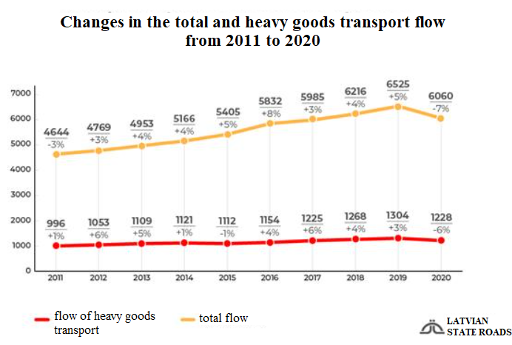

Figure 19. Changes in the traffic volume on State motor roads from 2011 to 2020 [source: SLLC Latvian State Roads]

In 2020, the average daily traffic volume or flow on the major State motor roads had been by 7 % lower than a year before due to the impact of COVID-19 pandemic – 6060 transport units per day per kilometre of road. In turn, the drop in traffic volume of heavy goods transport had been slightly lower – 6 %. The drop in traffic volume in Pierīga had been slightly lower than in the country as a whole. For example, traffic volume decreased, in April of the previous year, by 26.4 % in the country as a whole while decrease in Pierīga was by 20.6 %.
It should be indicated that the traffic volume data usually exhibit the economic situation of the country. In examining them in long-term, it is apparent that traffic volume underwent quite a rapid increase in the State road network in the time period from 2000 to 2008; however, it dropped almost as rapidly in 2009 alongside with the economic crisis. Traffic volume almost reached the level of 2008 only in 2015 and it exceeded this level already in 2016. The economic crisis caused by COVID-19 in 2020 was accompanied by a drop in traffic volume.
The study “Impact Assessment of the Road Traffic Safety Plan for 2017–2020”³³ provided an objective evaluation of the number of fatalities and seriously injured persons from RTAs, based on the information on the average traffic volume on the major State motor roads, regional State motor roads, and local State motor roads and the overall length of roads, thus evaluating the dynamics in the number of fatalities and seriously injured persons versus the conditional unit of measurement – one billion of kilometres covered. The current trends show that the number of fatalities, particularly on the major and regional State roads, decreases. It is mainly related to improvements in the infrastructure and also changes in the behaviour of drivers. At the same time, the dynamics in the number of seriously injured persons varies. In assessing the number of fatalities from RTAs in detail according to the road sections with the highest traffic volume, it has been concluded in the study²⁸ that the number of fatalities and RTAs with injured persons versus the kilometres covered may differ significantly, for example, the risk of death when driving along A4 (Rīga bypass from Baltezers to Salaspils) in comparison with driving along A2 where the road is equipped with the majority of the necessary safety equipment is 4.7 times higher.

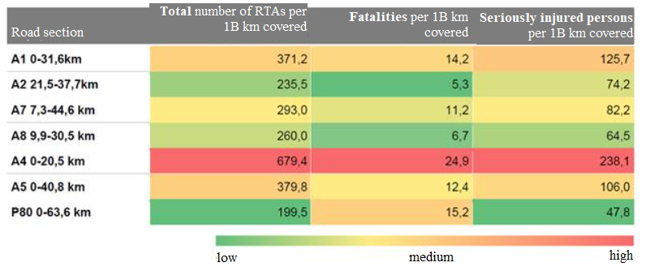

Figure 20. Dynamics in the number of RTAs, fatalities, and seriously injured persons versus one billion of kilometres covered on the State roads with the highest traffic volume [source: study “Impact Assessment of the Road Traffic Safety Plan for 2017–2020”]

2.8.2. Technical Condition and Conformity of Road Infrastructure with Safety Requirements

Road infrastructure (its technical condition, covering, conformity with the safety requirements, and other factors) directly or indirectly affect the risk of RTA occurrence or reduces or increases the degree of severity of an RTA accordingly. A road is an environment which must be perceived by the driver of a vehicle (road signs, markings, etc.), therefore the driver must respond accordingly depending on this perception. If any of these factors affect the perception of the driver incorrectly or also affect the controllability of the vehicle, it causes various risks in road traffic, i.e. occurrence of human errors is facilitated.
In terms of the traditional approach to the assessment of the road infrastructure risks, attention was mainly directed towards motor-driven vehicles⁴⁷ and quite often secondary attention was paid to vulnerable road users. Currently, pedestrians and cyclists are forced to share the road with other vehicles in the majority of countries even if cycling, walking, and other forms of activity are being promoted.
Thus, policy planning gives higher priority to such solutions in road design, standards, and introduction of new measures which conform to the highest traffic safety requirements. Policy planners and implementers must henceforth pay more extensive attention to the following factors⁴¹ in the field of road infrastructure:
– to create an infrastructure that is safe for all road users;
– to evaluate the possibility of more extensive integration of micromobility solutions in the overall traffic infrastructure as well;
– to promote the separation of the carriageways intended for vehicles with rumble strips, markings, also barriers, cables, and also to use the special road signs to warn the driver of leaving his or her lane or also to limit the possibility of the vehicle to drive into the opposite lane, to drive off the road, etc.;
– to create safer intersections, thus preventing collisions or mitigating their consequences;
– to create separate corridors for transit;
– to assign higher priority to pedestrians, cyclists, and other more vulnerable persons – to create pedestrian zones, pedestrian streets, to pay attention to persons with special needs, and to use the traffic infrastructure for their convenience;
– to create safe and thought-out speed control, concurrently using various solutions oriented towards compliance with the speed – road narrowings, road signs, horizontal markings, and other solutions.
In assessing the current situation in Latvia in relation to the quality of State motor roads, it should be noted that, over the previous years, the quality of State motor roads of Latvia has significantly improved overall due to the available financing from the European funds (651.7 million euros in the time period from 2014 to 2020) and also due to the increasing financing from the State budget (1133.7 million euros in the time period from 2014 to 2020), particularly in the period from 2014 when major State motor roads were in a good and very good condition in 36.2 % of cases to 76.3 % in 2020. At the same time, the bad weather conditions of 2018 significantly deteriorated the quality of roads with gravel covering – the proportion of the gravel roads in a bad condition increased from 42.3 % in 2017 to 46.4 % in 2018. It should be noted that this deterioration of the road condition did not have a visible impact on the number of RTAs on the relevant type of roads (main, regional, local, etc.). It should be indicated that each year the LSR must invest approximately 640 million euros in the maintenance of State motor roads and a repair deficit in the amount of 3.2 billion euros has accumulated since 1991. In assessing the quality of the infrastructure, a conclusion was drawn in the study²⁸ that the largest improvements in the infrastructure of State motor roads which are related to the road traffic safety are related to the following essential activities:
• building of pedestrian and cycling paths which ensures the separation of flows of pedestrians and cyclists, and also other micromobility tools from the flow of road traffic;
• arranging of lighting and introduction of regulated pedestrian crossings (particularly in places with high traffic volume or intersections), thus reducing the possibility of pedestrians being run over by vehicles due to poor visibility;
• building of roundabouts, thus taking measures for traffic calming and reducing the probability of collisions in the relevant intersections;
• building of metal barriers which ensure the separation of the flow of pedestrians and cyclists, and also other micromobility tools from the flow of road traffic;
• building of acoustic rumble strips (there have been the first pilot projects), reducing the possibility that a tired or distracted driver could drive off the road or collide with other road users by leaving his or her lane.

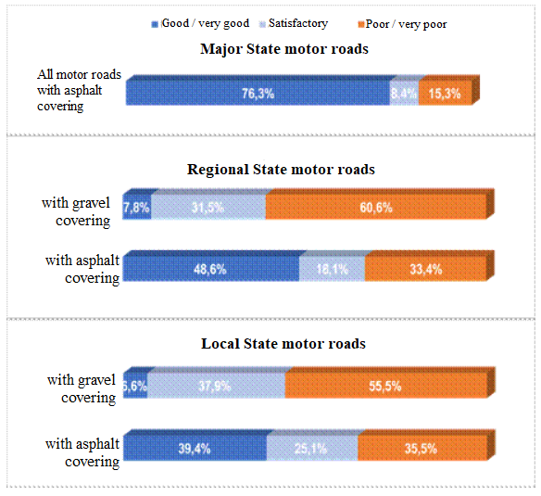

Figure 21. Technical condition of State motor roads in 2020 [source: SLLC Latvian State Roads]

The management of road infrastructure projects and the safety measures for the improvement of the road infrastructure are carried out according to the amount of the available financing and upon individual assessment of investments in separate sections of the motor road. For example, it is apparent from reconstruction of A2 motor road that they have resulted in obvious benefits. Concurrently, it can be observed that the policy implementers lack specific objectives and sufficient financing is not available.
At the same time, motor road designs, building designs, building designs of objects related to road traffic, and the current road network are assessed within the scope of the road traffic safety audit governed by Cabinet Regulation No. 972 of 25 November 2008, Regulations Regarding the Road Safety Audit. A road safety audit is mandatory for those projects only in relation to which the criteria referred to in Paragraph 7 of this Regulation have been fulfilled. The commissioning party of the audit has the obligation to comply with the recommendations provided in the audit opinion to the extent possible and to provide an explanation to the RTSD and the MoT in writing after receipt of the audit opinion as to which recommendations provided in the audit opinion have been taken into account and which have not been taken into account, justifying why it is not possible to take the recommendation into account. On the basis of the information provided by the RTSD, a conclusion may be drawn that approximately 70 % of the recommendations provided are assessed during subsequent development of the project or improvements are made/planned (in case of an existing road). Concurrently, it should be indicated that complete information on the average proportion of the recommendations taken into account is not available because answers from the commissioning parties of a road safety audit are received only in approximately 30 % cases³³.

Year | 2017 | 2018 | 2019 | 2020
Road safety audits carried out | 180 | 186 | 199 | 156
Answers received, % | 35 % | 37 % | 31 % | 28 %
Average proportion of recommendations taken into account, % | 73 % | 77 % | 74 % | 69 %

Figure 22. Number of road safety audits and average proportion of recommendations taken into account from 2017 to 2020

Meanwhile, in 2020, 156 road safety audit opinions were prepared and 43 letters of reply regarding recommendations of the road safety audit were received from the commissioning parties of audits. According to that indicated in the letters received, on average 69 % of the recommendations provided in the result part have been taken into account in designs. It should also be indicated that, although it is determined in Cabinet Regulation No. 972 of 25 November 2008, Regulations Regarding the Road Safety Audit, that replies must be provided within 30 days after receipt of the opinion, practice shows that replies are provided even throughout the following year.
The measures taken hitherto for quality improvement of the infrastructure show that increased attention is paid to the road sections where RTAs occur frequently. The classification of such road sections is governed by Cabinet Regulation No. 1240 of 28 December 2010, Procedures for the Classification of Road Sections where Road Traffic Accidents Occur Frequently and for the Safety of the Road Network in the Trans-European Road Network.
Meanwhile, a new map of the dangerous sections and intersections or the road sections of major State motor roads where RTAs occur frequently was created in June 2019 for the time period from 2017 to 2019⁴⁸. It includes 48 road sections where RTAs occur frequently. The previous map for the time period from 2014 to 2016 included 99 road sections. This means that the number of road sections where RTAs occur frequency has decreased by half. In the time period from 2014 to 2016, 44 road users or 7.9 % of all fatalities recorded in this period occurred in the road sections with high frequency of RTAs. However, only 19 persons (4.5 % of all fatalities) died in the time period from 2017 to 2019³³.
Analysis of statistical data shows that the road sections where RTAs occur frequently are mostly in traffic hubs with higher traffic volume. The most significant improvements have occurred on A2 motor road where reconstruction works of several sections have been carried out. They have helped to reduce the number of road sections where RTAs occur frequently by 20. Currently, there are only three road sections remaining on A2 motor road where RTAs occur frequently. At the same time, the situation on A4 motor road has deteriorated. Accordingly, two sections where RTAs occur frequently were classified in the time period from 2014 to 2016 and there were already seven such sections in the time period from 2017 to 2019. Results of the data analysis show that there is the highest risk of getting into an RTA on A4 motor road. This points towards the need to reconstruct Rīga bypass and to improve the infrastructure. The assessment on this road section, conducted by the SFSB, highlights two main causes of RTAs – overtaking without making sure that it is safe and leaving the main road without complying with the sign “Give way”. In addition, it should be noted that the number of small connections and the traffic volume in the new villages near the bypass rapidly increase in this road section. Meanwhile, heavy goods transport gets into RTAs because it is unable to react to the situation on the road in a timely manner and causes a collision with the vehicles in the front at traffic lights. This trend attests to the problem of driver fatigue which is increased by the lack of rest areas on the bypass.
In carrying out the improvement of traffic organisation in the road sections where RTAs occur frequently, higher dispersion of RTAs with fatalities is observed. Thus, investments in the infrastructure have a lower impact on the reduction in the number of fatalities because the absolute figure is lower.
Concurrently, RTAs which have occurred in public parking lots should not be overlooked. In most cases there are no serious consequences (no casualties and serious damages to the vehicle); however, problems are caused to the State Police, insurers, and owners of the parking lots who have to deal directly with the consequences because problems arise in relation to the identification of the guilty party, handling of the accident, and other administrative activities which unnecessarily waste the resources of all parties involved. Problems as a result of which RTAs occur in public parking lots have also been surveyed:
1) due to the layout of road signs, lack or non-conformity thereof with the standards;
2) out-of-date standard of parking lots in relation to the parameters of modern vehicles;
3) during the building process of parking lots, the owner has tried to increase, to the extent possible, the number of car parking spaces.
According to the statistics of the MIBoL, 4151 RTAs have occurred in parking lots of shopping malls in 2020 (it constitutes 2.54 % of all insurance events applied): 2678 RTAs in Rīga (2.84 %) and 1437 RTAs outside Rīga (2.13 %). However, these are just the registered or recorded accidents in parking lots of shopping malls because there is no specific classification that would allow to compile data on all RTAs in all public parking lots. Also a significant number of RTAs remains unrecorded because many people do not report on small accidents: RTA has resulted in slight damage or it is not possible to identify the guilty party.
Therefore, in order to reduce RTAs occurring in public parking lots and also to reduce the administrative burden on all parties involved, it is necessary to assess whether the current standard of parking lots should be changed.

2.8.3. Micromobility Infrastructure (Including Pedestrian and Cycling Infrastructure)

In assessing the condition of the infrastructure related to bicycle traffic, it should be indicated that, according to the Study on Bicycle Traffic and the Infrastructure of Bicycle Traffic on National Scale⁴⁹, in total there were 701.75 km of cycling paths, cycling lanes, joint pedestrian and cycling paths in Latvia in 2019. More than a third or 43 of all local governments have indicated that there is no such infrastructure therein, the total length of cycling paths, cycling lanes, joint pedestrian and cycling paths in 41 local governments is up to 5 km, the length of the infrastructure in 28 local governments is 5–20 km, and it exceeds 20 km in 7 local governments. In terms of amount, the longest cycling paths, cycling lanes, joint pedestrian and cycling paths in Latvia are in Rīga (68.2 km), Ventspils (65.3 km), Jūrmala (61.7 km), Liepāja (50.9 km), Jelgava (25.6 km), Sigulda municipality (23.4 km), Ogre municipality (23.3 km), Valmiera (18.5 km), Daugavpils (17.8 km), and Tukums municipality (17.4 km).
Taking into account the intensity of pedestrian and bicycle flows, it is economically feasible in most of the cases to build joint pedestrian and cycling paths which are separated from the carriageway intended for the road transport.
In 2018, the LSR built 15.7 km of pedestrian and cycling paths according to the RTS Plan, in turn on average 5 km of cycling paths are built every year in Rīga according to the information provided by the RTSD (except for 2019).
It should be pointed out that the improvement of pedestrian and micromobility infrastructure connections jointly with the public transport system would be an essential contribution to road traffic safety improvements, thus improving the possibilities for the use of micromobility tools. In such case, it should be taken into account that a change in the ratio of RTAs is possible, i.e. by reducing RTAs with cars involved, an increase in the number of RTAs where micromobility vehicles are involved is also possible due to a substantial increase in micromobility volume.
According to the study on bicycle traffic, the largest prospective connections of the bicycle traffic infrastructure in the amount of 131 km were surveyed, with the total approximate investment amount of 11.9 million euros. The majority of them consists of the infrastructure projects of Rīga and Mārupe cycling paths with the total length of 69.7 km.
According to the priority No. 2 brought forward in the study on bicycle traffic (infrastructure connecting populated areas and their reachability borders), the largest prospective connections of the bicycle traffic infrastructure in the amount of 815.69 km were surveyed, with the total approximate investment amount of 301.8 million euros.
Also the LSR have assessed all pedestrian crossings on the major State roads, ascertaining whether they conform to the necessary safety requirements, i.e. presence of lighting and relevant accesses in order to avoid, to the extent possible, that pedestrian flows reach crossings by moving along road shoulders.

2.8.4. Long-term Road Infrastructure Development Directions

It is stated in the informative report developed by the Ministry of Transport on the development of State motor roads from 2020 to 2040⁵⁰ that it is intended, in the subsequent years, to transform more than one thousand kilometres of major State motor roads into four-lane high-speed roads with the maximum driving speed above 100 kilometres per hour so that Rīga (Rīga bypass) could be reached from any major regional development centre within not more than two hours. It is intended to implement this development concept in three stages which will be continued until 2045.
In order to achieve the ambitious objectives of the concept, it is intended to gradually move towards the construction of high-speed roads. These main roads of State motor roads would connect Rīga with Ventspils, Liepāja, Jelgava, Bauska, Jēkabpils, and Daugavpils, Rēzekne, Cēsis, and Smiltene, and also Ainaži. Two carriageways with two lanes in each direction would be separated on high-speed roads, moreover the permitted maximum driving speed would be 130 kilometres per hour. Main roads would be equipped with noise barrier walls and also animals would be prevented from getting on the roads. They would have a much smaller number of connecting roads in the form of mainly two-level traffic viaducts and an entry road or exit road on the right side in individual cases.
The offered directions for the development of State motor roads would encompass as large number of inhabitants as possible, also it is planned to primarily develop the regional State motor road network, connecting the development centres with motor highways along the shortest route possible. It is planned to review the State motor road network, to assess its efficiency, to determine its strategic tasks, priority development directions, indicators, and target values for 2040 which serve as the basis for the sectoral management and budget planning in long-term and also as the justification for the attraction of other sources of financing. The pre-conditions for the fulfilment of the basic task are traffic volume, transit traffic flows, economic development, changes in migration and mobility of inhabitants, and also transport and traffic digitisation.
The financing for the fulfilment of the objective and tasks is planned in the annual law for the State budget and the law on the medium-term budget framework. Three potential sources of financing are currently intended for its implementation:
• the State budget;
• resources from the European Union funds;
• public-private partnership.
The priority of implementation is reconstruction of the major State motor roads and it is planned to implement it in three stages:
Stage 1 from 2020 to 2030 – 245.5 km of high-speed motor roads built;
Stage 2 from 2030 to 2035 – 298.5 km of high-speed motor roads built;
Stage 3 from 2035 to 2040 – 520.7 km of high-speed motor roads built.
After implementation of each stage, it is intended to perform an interim assessment and to analyse subsequent tasks to be performed, reviewing the priorities included in the subsequent stages of implementation as necessary. Thus, reduction of the time spent on the road, and also reduction of RTAs and benefit from the reduction of CO₂ emissions would be achieved in case of implementation.

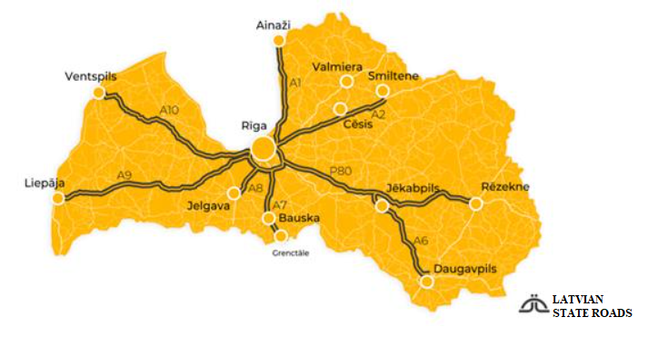

Figure 23. Intercity connections with separated carriageways and two-level overpasses included in the State motor road development directions for 2020–2040 [source: SLLC Latvian State Roads]

It should be indicated that the functional significance of the State motor road network is directly related to the administrative division of the territory of Latvia, taking into account that the division of State motor roads is determined in Section 3, Paragraph three of the law On Motor Roads and the functional significance is directly related to the administrative-territorial division of Latvia.
Taking into account the abovementioned and the task assigned in Activity 89.4 of the Action Plan of the Government approved by Cabinet Order No. 210 of 7 May 2019, On the Action Plan of the Government for the Implementation of the Declaration of the Intended Activities of the Cabinet Headed by Arturs Krišjānis Kariņš, in order to assess the possible change in the management form of sections of local State motor roads, and also taking into account the administrative-territorial reform which entered into effect from 1 July 2021, an assessment of State motor roads will be performed and a clear view of conformity of State motor roads with the division in Section 3, Paragraph three of the law On Motor Roads will be obtained. Within the scope of this assessment, major State motor roads in total length of 1673 km, regional State motor roads in total length of 5460 km, and local State motor roads in total length of 12 848 km will be assessed.

2.9. Impact of the Technical Condition of the Vehicle on the Road Traffic Safety

In relation to the impact of the technical condition of the vehicle on the road traffic safety and the consequences of RTAs, it is necessary to introduce a stricter framework better adapted to the changes in mobility resulting from societal trends (e.g. more cyclists and pedestrians, an ageing society) and technological developments. It is expected that without new road traffic safety initiatives, the impact on safety of the current approach will no longer be able to compensate for the increasing traffic volumes. In terms of vehicle safety, this implies mandating a broad range of advanced safety measures as standard equipment for the relevant vehicle categories and improved protection in RTAs against injuries of vulnerable road users, for example, pedestrians, cyclists, person of short stature, and elderly people. It should also be noted that certain in-vehicle systems, for example, the lane-keeping system and the intelligent speed assistance, rely on a well-maintained road infrastructure (road marking, signs, and cameras). Therefore, various road infrastructure and vehicle safety proposals should be examined jointly as to enable in-vehicle systems to realise their full safety potential.
It should be recognised that, over the past decades, developments in vehicle safety have contributed significantly to the overall reduction in the number of fatalities and serious injuries from RTAs. In addition to the safety measures protecting drivers in vehicles, special measures should be implemented to prevent fatalities and injuries of vulnerable road users, for example, cyclists and pedestrians. Without new initiatives in general road safety, current approaches will no longer be able to compensate for the increasing traffic volumes. The safety performance of vehicles needs to be further improved as part of an integrated road safety approach and in order to protect vulnerable road users better⁵¹.
At large, other road users which use or do not use motor vehicles and who might use individual mobility solutions without a protective body are also vulnerable road users alongside pedestrians and cyclists. Moreover, the current level of technological developments validates the expectations that modern systems under normal driving circumstances will also respond to other vulnerable road users regardless of the fact that they have not been especially tested. Although the technical requirements laid down in the EU legal acts might encompass all road users who use individual mobility solutions without a protective body, for example, electric scooters, self-balancing vehicles, and wheelchairs, they should be continuously adjusted to technical developments, carrying out an assessment and review process beforehand⁵¹.
Thus, technical progress in the area of advanced vehicle safety systems offers new possibilities for reducing consequences of RTAs. Improved vehicle systems may be more efficient in the reduction of the number of fatalities and RTAs, and also the severity of injuries and damages if they are designed to be user-friendly. Therefore, the manufacturers of vehicles should do everything in their power to ensure that new types of security systems and elements are designed in a way to assist the driver. Vehicle safety systems and warnings should be easy to understand for every driver, including elderly people and disabled persons⁵¹.

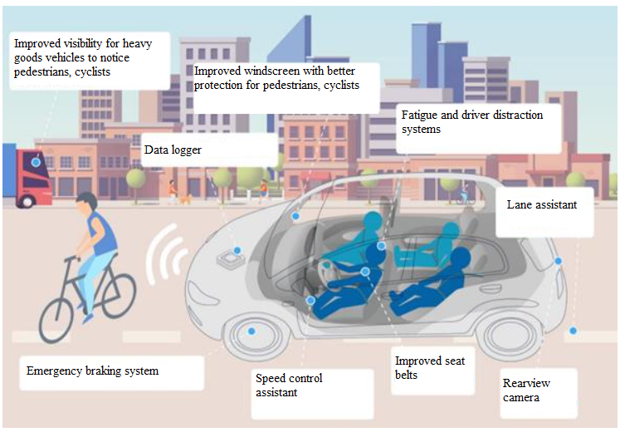

Figure 24. New safety requirements for new vehicles in accordance with EU Regulation 2019/2144⁴⁴ [source: European Commission, link: https://www.europarl.europa.eu/cmsdata/155060/PPT%20General%20Safety%20Regulation.pdf]

Also the advanced emergency braking systems, intelligent speed assistance devices, emergency lane-keeping systems, warning regarding driver drowsiness and attention, advanced warning regarding driver distraction, and reverse movement detection are safety systems which have a great potential to reduce the number of casualties. The use of intellectual transport systems, automation, and smart technologies both in the infrastructure and the vehicles themselves also improves transport efficiency, therefore a contribution to the promotion of transport decarbonisation is made.
It is undeniable that seat belts are one of the most important and efficient vehicle safety elements. Therefore, the seat belt reminder systems increase the frequency of use of seat belts throughout the EU and thus may help to prevent RTAs at an even greater rate⁵¹.
At the same time, the impact of passive and active safety solutions of new vehicles on the traffic safety is directly related to the age of the Latvian vehicle fleet and its ability to get renewed with newer cars which have a significantly higher level of passive and active safety. However, when looking at the statistics, a conclusion may be drawn that the age of the Latvian vehicle fleet does not decrease at large and the impression that an increasing number of new automobiles is bought is not true. The small changes are mainly driven by legal persons – the major buyers of new automobiles. The average age of automobiles for the vehicles registered in Latvia is still above 14 years (for passengers cars 14.44 years, for the road transport at large 14.19 years⁵²).

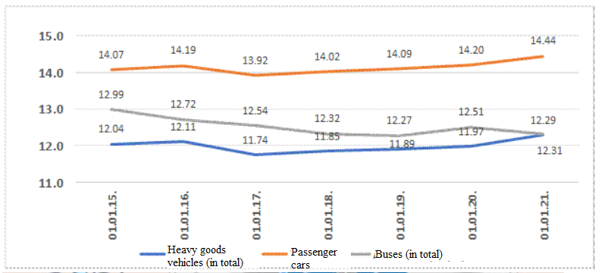

Figure 25. Average age of registered vehicles [source: RTSD]

The impact of the age of the vehicle fleet on traffic safety is related to the fact that the safety systems installed in older vehicles ensure less protection against injuries from RTAs and also different systems help to prevent RTAs or mitigate the consequences of their severity. When studying the condition of vehicles after an RTA between two vehicles out of which one has been manufactured approximately 20 years ago, while the other only a couple of years ago, the deformation of the newer vehicle is significantly smaller after collision – a life space of the driver and passengers has been preserved, while construction of older cars often fails to save the driver and passengers from severe injuries.
The changing weather conditions of Latvia, the current condition of the road infrastructure, and frequently also the careless attitude of vehicle owners towards the technical condition of the vehicle should be mentioned in relation to the technical condition of the current vehicle fleet as these vehicles which are on average 13 years old are not able to pass the roadworthiness testing (RT) at first attempt.
It should also be acknowledged that it is quite difficult to determine the exact number of RTAs in which the technical condition of the vehicle had been the cause of an RTA. In order to accomplish this, it is necessary to perform technical expert-examination for each vehicle involved in the RTA at a specialised centre. Specific conclusions regarding the role of the technical condition of the vehicle in the particular RTA could be drawn only after performance of the expert-examination. Currently, such expert-examinations are performed only for vehicles which have been involved in RTAs involving casualties if criminal proceedings have been initiated.
Inspection of the technical condition of vehicles on roads has been contributing to improvement of the road traffic safety situation for several years already. Such inspections are performed regularly in Latvia for heavy goods vehicles but passenger cars are also quite often subjected to inspections. Mainly control of the tire condition and control of lighting devices prohibited for use in road traffic have been performed hitherto in inspections of passenger cars.
Among other things, the impact of technical condition of the vehicle on the road traffic safety was analysed in depth in the study³³, focusing on the age of vehicles. The number of vehicles registered in the reporting period included in the study has increased by 16.2 % and constituted 960 996 units on 1 January 2020. In turn, the average age of the vehicle fleet has remained virtually unchanged, therefore it was 13.96 years in 2016 and 13.95 years at the beginning of 2020. The average age of vehicles in good technical order at the beginning of 2020 was 13.32 years. The heavy goods vehicles that are in good technical order are comparatively younger or 11.97 years, particularly the vehicles the laden mass of which exceeds 16 tons – 10.93 years.
Also the first registration in the reporting period included in the study³³ has been performed for 515 006 vehicles in total, the average age of vehicles registered for the first time is 7.93 years. At large, the age trends of the vehicles registered for the first time exhibit ascending dynamics. The age of vehicles registered for the first time in 2019 was by 9.7 % higher than in 2014.
It is indicated in the study³³ that 60 % of vehicles pass the RT at first attempt, in turn 90 % – at second attempt. The best average results are exhibited by buses above 3.5 tons which pass the RT at first attempt in 72.9 % of cases on average, meanwhile the worst results – by heavy goods vehicles above 3.5 tons which pass the RT at first attempt in 51.9 % of cases.

Table 8. Statistical data of roadworthiness testing in the time period from 2017 to 2019 [source: study “Impact Assessment of the Road Traffic Safety Plan for 2017–2020”]

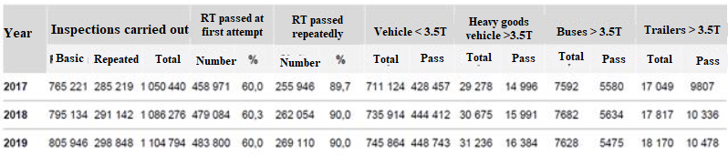

The measure introduced within the scope of the implementation of the Road Traffic Safety Plan for 2017–2020 which was oriented towards increasing technical control of vehicles on the road has been implemented, thus on average 1.8 % of vehicles up to 3.5 tons and 5.0 % of heavy goods vehicles above 3.5 tons have been inspected in road inspections of vehicles. The results of inspections are as follows³³:
• in road inspections of vehicles up to 3.5 tons, non-conformities of tires were recorded in 2.7 % of cases and non-conformities of lighting devices – in 0.2 % of cases;
• in road inspections of heavy goods vehicles above 3.5 tons, the score of 2 (significant damages of the vehicle have been detected and they may endanger traffic safety) was recorded in 7.4 % of cases and the score of 3 (it is prohibited for the vehicle to participate in traffic until elimination of deficiencies) was recorded in 2.0 % of cases.
The abovementioned points towards the necessity to increase road control of vehicles, paying special attention to heavy goods vehicles above 3.5 tons. As a result of the assessment of the causes of RTAs³³ in the time period from 2015 to 2019, a conclusion may be drawn than the technical condition of the vehicle had been the cause of an RTA in 480 cases (or 0.5 % of all RTAs).
It can therefore be concluded that the vehicle fleet of Latvia is behind the leading countries of the EU in terms of the technical condition of vehicles and the age of the vehicle fleet is one of the reasons for it. In performing an assessment of the risks to suffer mild injuries, serious injuries or to die in an RTA depending on the age of the vehicle, an assumption was used within the scope of the study that the probability of getting into an RTA is the same for all vehicles regardless of their age. The results show that the risk of getting into an RTA, suffering injuries, or dying therein significantly increases for vehicles which are more than seven years old. To a large extent, the explanation lies with the actual intensity of the use of the vehicles. Accordingly, the intensity of the use of vehicles that are one to seven years old is similar throughout all years. In turn, the intensity of the use of vehicles that are eight to 26 years old is significantly higher and the use of vehicles that are more than 26 years old is low.

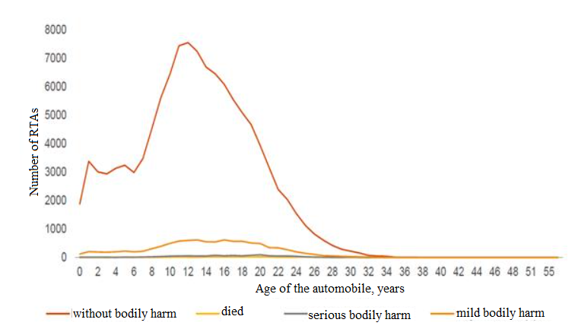

Figure 26. Assessment of severity of RTAs for the time period from 2014 to 2019 according to the age of automobiles that have gotten into RTAs [source: study “Impact Assessment of the Road Traffic Safety Plan for 2017–2020”]

In assessing the risk of death as a result of an RTA, it has been concluded in the study³³ that no person driving a vehicle that is up to one year old has died in the reporting period. The average risk indicator is exceeded only by vehicles that are 16 years old and vehicles that are from 25 to 35 years old are subject to the highest risk.
Also the risk of suffering serious bodily harm in RTAs is comparatively lower³³ in a vehicle that is less than 15 years old. The risk significantly increases in vehicles that are more than 30 years old. It should be noted that the number of vehicles in this age category is comparatively small. Thus, a conclusion may be drawn that these results show that it is of the essence to direct activities towards renewal of the vehicle fleet which would contribute to reduction of the number of fatalities and seriously injured persons from RTAs.

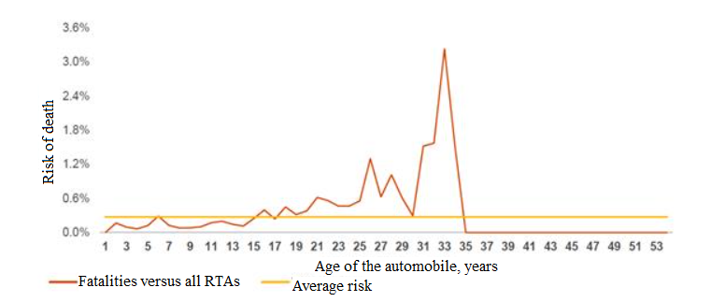

Figure 27. Risk of death in an RTA according to the age of the vehicle (assessment for the time period from 2014 to 2019) [source: study “Impact Assessment of the Road Traffic Safety Plan for 2017–2020”]

2.10. Impact Assessment of the Road Traffic Safety Plan for 2017–2020

2.10.1. Overall Road Traffic Safety Dynamics

In the time period from 2017 to 2020, the total number of fatalities in Latvia displays downward trends which are seemingly ensured by such factors as more extensive use of seat belts and safety systems in vehicles, changes in the behaviour of drivers, improvement in the quality and quantity of the structure and safety systems of vehicles, response time in relation to the liquidation of the consequences from RTAs, and the quality of rescue work. The dynamics in the number of seriously injured persons still displays upward trends³³ which can be explained by increase in the traffic volume following economic growth. Road traffic safety measures are primarily oriented towards the reduction of the number of fatalities, thus there is a greater possibility that the road users involved will stay alive in an RTA – the measures taken have yielded results. However, taking into account that the total number of RTAs with seriously injured persons was not reduced in the period of operation of the previous plan, it is necessary henceforth to invest in the road infrastructure and the safety of vulnerable road users, attaining as much improvement as possible with smaller investments.

2.10.2. Safe Environment

The measures included in the Road Traffic Safety Plan for 2017–2020 also encompass ensuring of road infrastructure improvements. The least number of the measures included are related to local government roads and streets the total length of which exceeds the total length of the State motor road network. It should also be concluded that the measures for the improvement of the State motor road infrastructure in the reporting period are primarily oriented towards such sections of the State motor roads where RTAs occur frequently. Reduction by half of such sections of motor roads has been achieved in the reporting period. Dispersion of RTAs with fatalities has also been observed and detailed analysis of information is necessary to determine the causes of RTAs.
Also the requirements laid down in the standard⁵³ are not being applied in the creation of the infrastructure intended for the traffic of cyclists, taking into account that the application of standards is voluntary in accordance with the provisions of Section 13, Paragraph one of the Standardisation Law. There are different solutions for the elimination of such differences, inter alia, different guidelines may be developed, exchange of good practice may be promoted, pilot projects may be implemented, etc.

2.10.3. Safe Vehicle

One measure has been included in the Road Traffic Safety Plan for 2017–2020 in relation to vehicles and their technical condition. Although the vehicle fleet of Latvia displays trends of ageing, it should be noted that the purchase of new vehicles with a higher NCAP rating would improve the overall safety of the vehicle fleet. The vehicle fleet of Latvia is behind the leading countries of the EU in terms of the technical condition of vehicles and the age of the vehicle fleet is one of the reasons for it. It is necessary to facilitate the change of the vehicle fleet in a purposeful manner if the risk of dying and suffering serious injuries in RTAs arises from driving older vehicles³³. The average risk predictor in relation to the probability of dying is exceeded by vehicles that are 16 years old, in relation to the risk of suffering serious injuries – vehicles that are 15 years old. Another conclusion may also be drawn that information on local government roads and streets is not being accumulated (including information on traffic volume, report on sections of the road where RTAs occur frequently). Also a possibility should be considered that registration and bringing in of such vehicles should be gradually promoted in which more modern safety systems have been installed and also it would be useful to assess different solutions for reducing the registration of such vehicles which are equipped with out-of-date safety systems. One of the solutions would be to consider a possibility of changing the regulation in relation to the application of the vehicle operation tax for older vehicles. It is provided for in the current regulation that the total rate for passenger cars dating before 2009 is determined by adding up the rates for its laden mass, engine capacity in cubic centimetres, and maximum capacity of the engine, meanwhile rates for passenger cars dating before 2005 are determined only by the laden mass. Accordingly, it should be necessary to review the amount of the current rates of the vehicle operation tax for these vehicles, assessing whether rates should be gradually increased in order to facilitate the habit of inhabitants to choose newer passenger cars which are equipped with newer vehicle safety systems. Also the RTSC should assess the possibilities of purposeful and comprehensive aggregation of information on the roads under supervision of local governments so that it would be possible to develop and implement the measures of the road traffic safety policy correspondingly. The road infrastructure should be comprehensible and intuitive in terms of perception.

2.10.4. Safe Road User

The introduction of fixed speed cameras included in the Road Traffic Safety Plan for 2017–2020 together with other preventive activities for reducing speeding offences has justified itself because speed has been the cause of an RTA in a smaller number of cases. Efficiency of the activities included in the Road Traffic Safety Plan for 2017–2020 and other related activities improving road traffic safety is higher for activities carried out in a complex and systematic manner. For example, the annual informative campaigns in the time period before Midsummer Day together with increased fines and regular police raids have partly reduced driving while intoxicated and the latter being the cause of RTAs. The current measures in relation to the reduction of the use of mobile devices have been insufficient. The decisions drawn up by the SP in relation to the use of mobile devices behind the wheel as the violation constitute only 2.4 % of the total number of decisions which should be assessed as insufficient, taking into account the scale of the problem. At the same time, the RT and CCLI also play a significant role. If a vehicle which is not in good technical order participates in road traffic, it endangers safety of other road users, while CCLI is a guarantee that the persons who have suffered losses as a result of an RTA will be compensated for the damage caused. Safe road user = insured road user. Compliance with all the requirements necessary for participation in road traffic increases safety and responsibility of road users. Education and training activities are targeted and comprehensive. The knowledge of pupils regarding RTAs is satisfactory; however, a comprehensive approach to acquisition of the RTR at school is necessary, not just in the form of individual projects. The success rate of driving examinations of new drivers is below 50 % indicating that the most essential challenges are related to practical application of the knowledge acquired. Involvement of family members in the education process of pupils is essential. Training of drivers should be directed towards acquisition of skills in actual traffic conditions.
Reduction of the number of fatalities and seriously injured persons from RTAs in the categories of vulnerable road users exhibits indicators to be assessed in various ways. The decrease in the fatality rate among pedestrians, drivers and passengers of single-track motor vehicles exceeds the target indicators mainly due to targeted investments in the infrastructure and education measures. At the same time, reduction in the number of dead cyclists does not reach the target indicator. The target indicators in relation to reduction in the number of seriously injured persons are not reached in any category. The Road Traffic Safety Plan for 2017–2020 does not include individual measures for drivers of electric scooters. Taking into account the increase in popularity and specific nature of this mode of transport, it was recommended to draw up changes in laws and regulations and to organise informative explanatory campaigns. The arrival time of the SEMS units in the reporting period has decreased in all territorial units analysed. It would be possible to achieve additional improvements by improving the infrastructure according to the elements necessary for the specific nature of emergency services and by expanding and improving the material and technical base of the SFRS, transitioning from old-type hydraulic tools to new-type hydraulic tools with more efficient operation.

2.10.5. All Elements

Currently, detailed research of RTAs and compilation of data regarding the type and causes of RTAs is not carried out systematically and regularly. Data of the investigation cases (administrative cases and criminal cases) conducted by the SP are not available to researchers. In making amendments to Cabinet Regulation No. 75 of 26 January 2010, Regulations Regarding Registration and Accounting of Road Traffic Accidents, Casualties and Fatalities from Them, in 2020, this Regulation was supplemented with Paragraph 15.1 in which it is provided for that the State Police updates the information on the causes of the accident according to rulings in cases regarding violations in the field of road traffic. Until adoption of these amendments, the State Police had no legal grounds for updating the information entered in the Register of the State Police which had been registered according to that recorded in the road traffic accident registration protocol.
Information on the actual mechanisms and reasons for RTAs which hinder efficient planning of road traffic safety measures is not available or is only partly available in Latvia. Also MAIS3+ has not been introduced yet (it is being planned in 2021) in order to ensure compilation and use of information on injuries in taking of decisions on the necessary improvements in road traffic safety. Retrieval of the causes of RTAs from the criminal and administrative cases available in the electronic environment should be ensured and information feedback on the causes of RTAs and the information on injuries, and also other information obtained during the course of investigation which is necessary for planning the activities for the prevention of RTAs in the future should be ensured. Also average speed cameras and red light cameras have not been introduced although they have demonstrated their efficiency – during the period of operation (from 1 April to 1 October 2019) of average speed cameras of P80 road, 3119 violations were recorded and no RTA has occurred on the section where the camera is operating, meanwhile the special cameras installed within the scope of different projects have recorded the red light violation in 10 % of cases.

2.10.6. Policy Planning Efficiency Assessment

The lines of action specified at the EU level in the field of road traffic safety are cascaded at the national level, providing for particular lines of action and measures in the Road Traffic Safety Plan for 2017–2020. At the same time, the lines of action specified at the EU level often provide for a more extensive set of activities than in the Road Traffic Safety Plan for 2017–2020.
It should be taken into account that it is prescribed in the Spatial Development Planning Law that planning regions develop and introduce spatial development planning documents – the sustainable development strategy and the development programme. These documents may also include traffic safety issues. In promoting a unified understanding of the link-up of sectoral policies with the development planning documents of planning regions, sectoral representatives may also become involved in drawing up the development programmes of planning regions of interest to them, providing written proposals or participating in any public involvement activity – survey, meetings of thematic working groups, or meetings of public discussion. Thus, a unified understanding of the link-up of sectoral policies with the development planning documents of planning regions would be shaped by also including road traffic safety issues therein.
A wide range of interested parties from the public, non-governmental, and private sectors which hold different roles according to the responsibility assignment matrix is involved in the planning and implementation of the road traffic safety policy. In relation to individual parties involved (State authorities, planning regions, local governments, educational institutions), the need to perform assessment of current assignments should be assessed henceforth in order to ensure the introduction of targeted and structured unified State policy in the field of road traffic safety and to fully use the potential of various parties involved. The activity and participation of each party involved in the overall planning of the road traffic safety policy is undeniable; however, efficient management over the overall State policy is also necessary. Thus, the basic task of the RTSC is also to promote the development of a unified State policy and the implementation thereof in the field of traffic safety. The think tank of the Road Traffic Safety Council is considered an existing example of a positive cooperation mechanism between several authorities, including also non-governmental organisations.
The financing for the improvement of road traffic safety consists of different sources (resources from the European Union funds, financing from the Road Traffic Safety Plan (resources for the prevention of RTAs in accordance with Section 57 of the Compulsory Civil Liability Insurance of Owners of Motor Vehicles Law), budget of sectoral ministries and their subordinate institutions, budget of local governments). The use of the financing for different activities related to road traffic safety is mutually poorly coordinated.

2.10.7. Efficiency and Impact Assessment of the Achievement of the Road Traffic Safety Policy of Latvia and Efficiency Assessment of the Use of the Financing

It should be concluded that the number of fatalities from RTAs in the reporting period in total displays downward trends, meanwhile the dynamics in the number of seriously injured persons displays upward trends. The abovementioned trends can be explained with increase in traffic volume which directly follows economic growth. Road traffic safety measures are primarily oriented towards the reduction of the number of fatalities. Therefore, if a road traffic accident occurs, there is a greater possibility that the road users involved will survive. However, the total number of road traffic accidents with seriously injured persons is not being reduced.
Efficiency of the activities included in the Road Traffic Safety Plan and other related activities improving road traffic safety is higher for activities carried out in a complex and systematic manner.
The financing allocated by the Road Traffic Safety Council has been used in the time period from 2017 to 2019 in the amount of 89.6 % for activities which are directed towards a Safe Road User, at the same time the financing has not been allocated to the activities related to a Safe Vehicle. The activities directed towards Safe Environment and Safe Vehicle lack consistency. The activities of the Council directed towards these elements of the Safe System could be more directed towards research, more coordinating and supervising because the majority of activities directed towards these elements are financed from other sources.

2.11. Direct Operational Results and Assessment of the Current Policy Planning Efficiency

A very ambitious objective has been determined for road traffic safety at the EU level to move close to zero fatalities in road transport by 2050 (“Zero Vision”). It is intended to reach the objective by ensuring gradual reduction in the number of fatalities and seriously injured persons in the time period from 2010 to 2050. It should be noted that, in order to achieve a considerable improvement in road traffic safety, one should be aware that it is important to create completely safe rather than safer roads and to ensure strong and sustainable management of road traffic safety. It is also crucial to create and ensure a shared responsibility for road traffic safety by determining the authorities responsible for specific lines of action. It should not be forgotten that it is essential to ensure complete data collection, analysis thereof, and studies on road traffic, and also the latest trends in data collection and analysis should be followed.
Undeniably, the laws and regulations governing road traffic or laying down requirements, procedures for road users or policy implementers (the RTR, the RTL, regulations regarding State roadworthiness testing, regulations regarding training of drivers of vehicles, regulations regarding health examinations of drivers of vehicles, etc.) must also be easy to understand and oriented towards road traffic safety as priority. In implementing the road traffic safety policy, it is important to assess whether the current regulation conforms to the highest and most topical road traffic safety requirements, taking into account that planning and implementation of the road traffic safety policy also regularly faces new challenges, for example, new micromobility solutions, the popularity of shared vehicles, etc.
Road traffic safety encompasses a large range of issues; however, it is most directly applicable to the road user, the surrounding environment, and the vehicle.
The most essential and main factors affecting road traffic safety are as follows:
– human factor (road user);
– the vehicle and the technical condition of its equipment;
– the surrounding environment (road infrastructure).
Still the human factor has the biggest impact in terms of significance (on average approximately 90 %), meanwhile the impact of other factors is smaller (on average – 5 % for vehicles and 5 % for the surrounding environment). It should be remembered that all three factors are closely interlinked, thus they should all be understood and taken into account in order to achieve the set objectives regarding improvement of the level of road traffic safety.

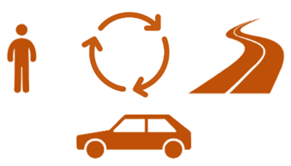

Figure 28. Road traffic safety as interaction between the road user, the vehicle, and the environment/infrastructure

At the same time, it should be indicated that the lines of action determined at the EU level in the field of road traffic safety are usually cascaded at the national level, providing for specific lines of action and measures in planning of the national policy where an aggregate of activities is often provided for that is more extensive than the one hitherto included in the policy planning documents of Latvia in the field of road traffic safety³³.
A wide range of interested parties from the public, non-governmental, and private sectors which hold different roles according to the responsibility assignment matrix is involved in the planning and implementation of the national road traffic safety policy. In relation to individual parties involved (State authorities, planning regions, local governments, educational institutions), the need to perform assessment of current assignments should be assessed henceforth in order to ensure the introduction of targeted and structured unified State policy in the field of road traffic safety and to fully use the potential of various parties involved. The activity and participation of each party involved in the overall planning of the road traffic safety policy is undeniable; however, efficient management over the overall State policy is also necessary. Such a role is held by the RTSC the direct objective of which is to promote the development and implementation of a unified State policy in the field of road traffic safety in order to improve the overall level of road traffic safety within the State⁵⁴.
The financing of the RTS Plan consists of the State budget and the CCLI resources. It has not been clearly defined in the circumstances of Latvia which measures should be supported from the fund of CCLI resources. In accordance with Section 57, Paragraph three of the Compulsory Civil Liability Insurance of Owners of Motor Vehicles Law, the purpose of the CCLI fund is to promote the development and implementation of a unified State policy in the field of road traffic safety in order to increase the overall level of road traffic safety within the State. However, practically various measures for the maintenance and development of the road infrastructure (for example, painting of the horizontal markings of roads and mounting of traffic bollards), purchase of road safety equipment (for example, police batons and whistles) which do not conform to the direct objective of the fund are being financed from this fund. Financing for such activities should have been provided for in the basic budget of the relevant institutions.

Table 9. Direct action results of the road traffic safety policy planning period of 2010–2020 – implementation of the objective providing for reduction in the amount of 50 % in 2020 versus 2010 [source: RTSD]

Direct action results | Year
 | 2010 | 2018 |  |  | 2019 |  |  | 2020
 |  | Objective | Practically | Implementation | Objective | Practically | Implementation | Objective | Practically | Implementation
 | Quantitative indicators of direct action results
Number of fatalities from RTAs | 218 | 124 | 148 | 19.4 % | 117 | 132 | 12.8 % | 109 | 139 | 27.5 %
Number of seriously injured persons from RTAs | 569 | 341 | 542 | 58.9 % | 313 | 461 | 47.3 % | 284 | 491 | 72.9 %
Reduction in the number of pedestrian fatalities from RTAs | 79 | 50 | 50 | 0.0 % | 45 | 40 | -11.1 % | 40 | 43 | 7.5 %
Reduction in the number of seriously injured pedestrians from RTAs | 145 | 87 | 121 | 39.1 % | 79 | 106 | 34.2 % | 73 | 85 | 16.4 %
Reduction in the number of cyclist fatalities from RTAs | 13 | 8 | 9 | 12.5 % | 7 | 9 | 28.6 % | 7 | 17 | 142.9 %
Reduction in the number of seriously injured cyclists from RTAs | 39 | 23 | 68 | 195.7 % | 21 | 43 | 104.8 % | 19 | 55 | 189.5 %
Reduction in the number of fatalities of drivers and passengers of single-track motor vehicles from RTAs | 22 | 13 | 9 | -30.8 % | 12 | 4 | -66.7 % | 11 | 9 | -18.2 %
Reduction in the number of seriously injured drivers and passengers of single-track motor vehicles from RTAs (motorcycles, mopeds, quadricycles) | 74 | 44 | 72 | 63.6 % | 41 | 63 | 53.7 % | 37 | 80 | 116.2 %
Reduction in the number of fatalities of passenger car drivers and passengers from RTAs | 91 | 55 | 70 | 27.3 % | 51 | 62 | 21.6 % | 46 | 64 | 39.1 %
Reduction in the number of seriously injured passenger car drivers and passengers from RTAs | 264 | 158 | 242 | 53.2 % | 145 | 215 | 48.3 % | 132 | 236 | 78.8 %
Reduction in the number of fatalities in RTAs in which commercial transport is involved (heavy goods vehicles and buses) | 65 | 39 | 51 | 30.8 % | 35 | 44 | 25.7 % | 33 | 42 | 27.3 %
Reduction in the number of seriously injured persons in RTAs in which commercial transport is involved (heavy goods vehicles and buses) | 124 | 94 | 103 | 9.6 % | 91 | 90 | -1.1 % | 87 | 85 | -2.3 %
Reduction in the number of child casualties from RTAs | 403 | 240 | 487 | 102.9 % | 220 | 452 | 105.5 % | 200 | 394 | 97.0 %
Reduction in the number of fatalities from RTAs resulting from the choice of inappropriate driving speed | 48 | 29 | 20 | -31.0 % | 26 | 27 | 3.8 % | 24 | 10 | -58.3 %
Reduction in the number of seriously injured persons from RTAs resulting from the choice of inappropriate driving speed | 126 | 76 | 74 | -2.6 % | 69 | 77 | 11.6 % | 63 | 60 | -4.8 %
Reduction in the number of fatalities from RTAs caused by drivers under the influence of alcohol | 22 | 13 | 11 | -15.4 % | 12 | 14 | 16.7 % | 11 | 7 | -36.4 %
Reduction in the number of seriously injured persons from RTAs caused by drivers under the influence of alcohol | 72 | 43 | 66 | 53.5 % | 40 | 48 | 20.0 % | 36 | 60 | 66.7 %
Reduction in the severity level of consequences of RTAs (the number of fatalities per 100 RTAs involving casualties) | 6.8. | 4.1 | 3.7 | -9.8 % | 3.7 | 3.5 | -5.4 % | 3.4 | 4.1 | 20.6 %

2.12. Further Alternative Development Scenarios and Assessment of the Most Appropriate Scenario

The assessment of the impact of the current measures included in the policy planning documents on road traffic safety shows that there is a risk that the measures for the improvement of road traffic safety in the current amount will not ensure the necessary reduction in the number of fatalities and seriously injured persons. In order for it to be possible to achieve the set objective by 2030, it is necessary to implement a scenario which provides for the continuation of the current measures, supplementing them with essential investments in the road infrastructure³³.
Also in order to achieve the set long-term objectives to reduce the number of fatalities and seriously injured persons to zero by 2050, the “Safe System” approach⁵⁵ has been brought forward as the basis. It provides a framework for the improvement of the road traffic safety policy, taking into account the best practices of the EU and paying increased attention to the prevention of fatalities and serious injuries. The “Safe System” approach is based on a comprehensive and active action model which determines the use of diverse elements of road traffic safety. The aggregate of all these elements should form layers of protection, creating a system which keeps being efficient in situations when any of the safety elements is not fulfilled. The “Safe System” approach takes into account that people make mistakes leading to RTAs and the human body has a limited physical ability to tolerate the overload which occurs at the moment of an RTA. Therefore, the road traffic safety system should be created in a way to successfully mitigate the consequences of human errors.
As a result of the assessment of the possible future development scenarios, it should be indicated that it is intended to introduce the “Safe System” approach in the planning and implementation of the road traffic safety policy, increasingly concentrating on the improvement of safety in relation to a person (road user), vehicle (its technical condition and equipment), and surrounding environment (infrastructure). Therefore, the future policy should be formed in a comprehensive manner because it is not possible to fully prevent RTAs by focusing on individual factors only.

Assessment of alternative scenarios

According to the analysis conducted in the study “Impact Assessment of the Road Traffic Safety Plan for 2017–2020”²⁸, the only scenario in which it would be possible to achieve the result of the objectives set, i.e. to halve the number of fatalities and casualties from road traffic accidents in the time period from 2021 to 2030, would be the scenario which would include a maximum programme of new measures with extensive attraction of financing for the implementation of such measures (Scenario D). A scenario with less extensive framework of measures, and also smaller financing should be assessed as the next alternative as a result of which the set objectives would not be achieved, particularly in terms of the number of seriously injured persons from RTAs; however, the result of benefits from financial costs would be larger (Scenario C).
In modelling four alternative scenarios within the scope of the study²⁸, conclusions were also drawn which can be directly linked to the impact of the possible measures on road traffic safety in long term.

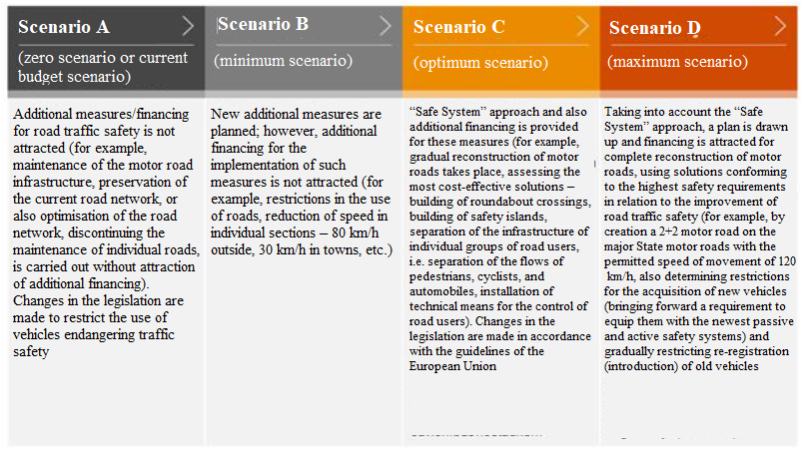

Figure 29. Survey of the modelled scenarios [source: study “Impact Assessment of the Road Traffic Safety Plan for 2017–2020”]

In modelling the future risks of RTAs and injured persons within the scope of the study³³, an assumption was used as the basis that the natural trend for the number of accidents is to follow the total number of kilometres covered. The number of kilometres covered historically follows the dynamics of GDP, falling behind in growth by approximately 1 % per year. This means that part of economic growth is not related to physical movement of goods and people; however, generally GDP has a decisive role in increase in the traffic volume. Analysis of historical data shows a close link between the total distance covered and the number of RTAs, meanwhile the number of seriously injured persons closely follows the number of RTAs. The number of fatalities does not follow the abovementioned indicators because the safety level of vehicles and the use of safety means (belts and bags), and also the reaction rate to liquidation of consequences improve significantly. If theoretically the safety level discontinued to improve, the number of fatalities would also increase the same as the number of RTAs and seriously injured persons regardless of the measures taken.

Scenario A (zero scenario or current budget scenario)

In modelling Scenario A, assumptions related to the fact that change of the vehicle fleet and increase in the safety level of vehicles according to historical trends continue were made in the study³³. It is also assumed that an improvement is occurring because older vehicles with lower level of safety are removed from circulation and are replaced with newer and safer vehicles.
Also measures for educating and informing the society are continued, directing them towards the cultivation of safer driving habits (particularly in relation to the use of seat belts in the current amount). Also development of the regulation and responsibility system is continued at the same rate as hitherto. Gradual improvement and development of the RTR and the normative regulation in the amount and direction of the current initiatives are occurring. Gradual introduction of the coverage of speed cameras and introduction of the average speed measurements are occurring. The measures for the maintenance and improvement of the road infrastructure continue in the current amount. Financing for road work does not undergo any significant increase or reduction and the road infrastructure improvement priorities do not undergo any significant changes.

Table 10. Forecast of result-based indicators according to Scenario A (2019–2030, actual data of 2019, forecast of 2020, improvement (–) or deterioration (+) in the following years versus 2020) [source: study “Impact Assessment of the Road Traffic Safety Plan for 2017–2020”]

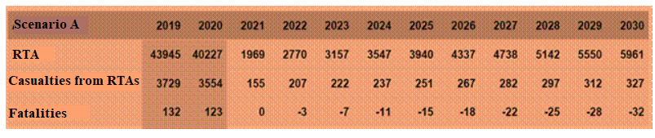

Thus, by implementing Scenario A it is possible to reduce the number of fatalities from RTAs which will be basically ensured by improvements in the safety level of vehicles. However, it is not possible to achieve the set objective, i.e. to halve the number of fatalities, without more intense safety improvement measures. At the same time, it should be noted that reduction in the number of seriously injured persons from RTAs and also child casualties from RTAs is not foreseeable because increase in GDP and traffic volume will compensate for and exceed the impact of the current measures.

Scenario B (minimum scenario)

In modelling Scenario B, it was assumed in the study³³ that in addition to the measures included in Scenario A (improvement of information, public education, safety measures and improvements of the infrastructure in the current amount) radical lower speed restrictions are introduced, transitioning from permitted speed limitations to 30 km/h in populated areas and 80 km/h outside populated areas within a period of five years.
By introducing speed limitation in cities up to 30 km/h, the permitted driving speed would be up to 70 km/h in the streets where lanes are separated, the infrastructure intended for pedestrians and cyclists in the streets is separated from the carriageway, or which is located outside intense building territories, assuming, according to the calculations, that the average speed in populated areas would be 40 km/h.
Meanwhile, by reducing the speed outside cities from 90 km/h to 80 km/h, it has been assumed that part of roads with separated lanes will retain the permitted speed of 90 km/h or more and part of roads where the restriction of 70 km/h or less has already been installed compensates for this difference, therefore it has been assumed that the average driving speed on all roads will decrease to 80 km/h. Currently, the driving speed of 80 km/h has been determined in the RTR for driving along gravel roads. In reducing the speed outside cities from 90 km/h to 80 km/h, it has been assumed for the purposes of calculations that the speed restriction on gravel roads will be reduced from 80 km/h to 70 km/h.
In Scenario B, basic assumptions from Scenario A are used; however, it is foreseen in relation to it that the number of RTAs versus kilometres covered decreases. Concurrently, it is foreseen that the proportion of victims from RTAs versus the whole number of RTAs decreases. It is assumed that, upon introduction of the maximum speed restrictions, the reduction of the actual average driving speed by 10 km/h would be achieved within five years because drivers would become used to the speed reduction gradually. Intense speed control may reduce this time period; however, it is foreseeable that a large part of drivers will resist the introduced speed reduction for a long time.
Taking into account that reduction of the average speed will mean a longer time on the road, losses caused by the introduction of such speed restriction were also assessed in the study³³ concurrently with the benefits of traffic safety.
Thus, by implementing Scenario B it is possible to achieve an improvement of 44 % in terms of reduction in the number of fatalities from RTAs and 28 % in terms of reduction in the number of seriously injured persons. Although the costs of the scenario are comparatively low for the State, losses to national economy are significant.
Losses from Scenario B caused by the speed reduction on State and local government roads were also calculated approximately within the scope of the study³³. The results of calculations show that the total amount of losses caused to national economy per year is approximately EUR 180 million and the total discounted value of losses in 30 years reaches approximately EUR 3 billion.
It should be taken into account that reduction of the permitted driving speed reduces the speed of movement of goods and other supplies, therefore potentially also economic activity if the offer of goods is not flexible. However, it should also be assumed that the offering party of goods can react flexibly, including also by increasing employment in the transport sector. It is anticipated that the increase in time consumption due to reduction of the permitted driving speed would seemingly affect the price level in sectors of manufacturing and supply of consumer goods, therefore the turnover of the number of goods in case of flexible demand might decrease.

Table 11. Forecast of result-based indicators according to Scenario B (2019–2030, actual data of 2019, forecast of 2020, improvement (–) or deterioration (+) in the following years versus 2020) [source: study “Impact Assessment of the Road Traffic Safety Plan for 2017–2020”]

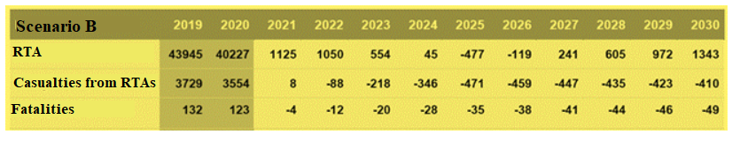

Scenario C (optimum scenario)

In modelling Scenario C, it was assumed in the study³³ that in addition to the measures included in Scenario A (improvement of information, public education, safety measures and improvements of the infrastructure in the current amount) investments in improvements of the road infrastructure safety are made. It is assumed that improvements for the measures which ensure safety of vulnerable road users and also for the measures for which the largest effect of safety improvements is foreseeable are necessary. It is assumed that the improvements indicated in Table 12 should be included in the plan of measures.

Table 12. Improvements to be included in Scenario C in the plan of road traffic safety measures [source: study “Impact Assessment of the Road Traffic Safety Plan for 2017–2020”]

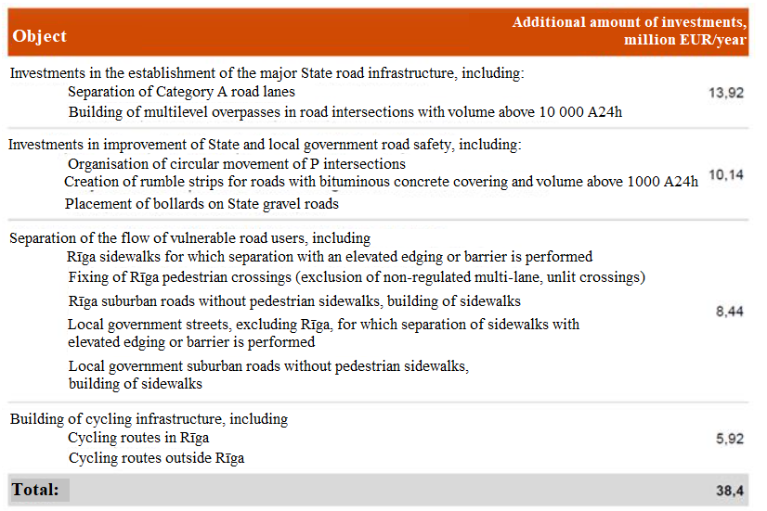

Thus, by implementing Scenario C it is possible to achieve improvements of 47 % in terms of reduction in the number of fatalities and reduction of 32 % in terms of seriously injured persons which is a slightly better result than in case of Scenario B. Although costs of State and local government investments are significantly higher than they have currently been in introduction of road traffic safety measures, they are significantly lower than the costs and losses to national economy in reducing the driving speed in Scenario B. Moreover, a large part of investments in improvements of the road infrastructure safety provide a result for a long time after occurrence of costs, thus the total amount of expenditures is much lower than upon continuous ensuring of lower driving speed.

Table 13. Forecast of result-based indicators according to Scenario C (2019–2030, actual data of 2019, forecast of 2020, improvement (–) or deterioration (+) in the following years versus 2020) [source: study “Impact Assessment of the Road Traffic Safety Plan for 2017–2020”]

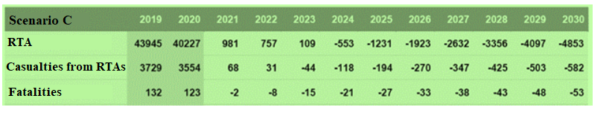

Scenario D (maximum scenario)

In modelling Scenario D, it was assumed in the study³³ that in addition to the measures included in Scenario A (improvement of information, public education, safety measures and improvements of the infrastructure in the current amount) substantial additional investments in improvements of the road infrastructure safety are made. It is assumed that the improvements to be made will affect safety of all road users and firstly investments with the highest effect of safety improvement should be made. It is assumed that the improvements in the amount indicated in Table 14 should be included in the plan of measures.

Table 14. Improvements to be included in Scenario D in the plan of road traffic safety measures [source: study “Impact Assessment of the Road Traffic Safety Plan for 2017–2020”]

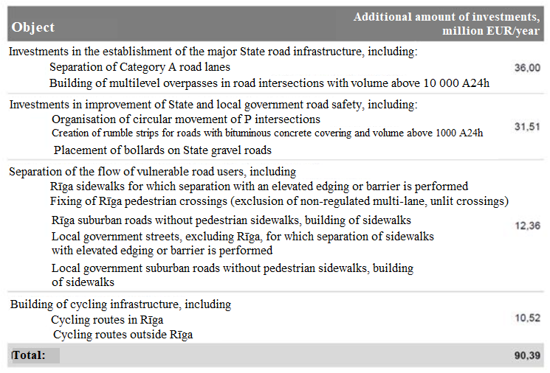

Thus, after implementing Scenario D, it is possible to achieve an improvement of 61 % in terms of reducing the number of fatalities from RTAs and 50 % in terms of reducing the number of seriously injured persons which conforms to the objectives set. Although costs of State and local government investments are significantly higher than they have currently been in measures for the improvement of road traffic safety, they are significantly lower than the costs and losses caused to national economy in reducing the driving speed in Scenario B. Also a part of investments in improvements of the road infrastructure safety provide a result for a long time after occurrence of costs, thus the total amount of expenditures is much lower than upon continuous ensuring of lower driving speed.
It should be indicated that, upon introduction to a larger extent of separated lanes in the road infrastructure for ensuring safe driving with the speed of 120 km/h, time savings will be achieved and benefits to national economy will arise. It is assumed in the model that 75 km of roads are thus reconstructed within six years. It should also be taken into account that, in building of roads with separated lanes (carriageways) and determining the driving speed below 120 km/h, the probability of RTAs on such roads would decrease to an even greater extent.

Table 15. Forecast of result-based indicators according to Scenario D (2019–2030, actual data of 2019, forecast of 2020, improvement (–) or deterioration (+) in the following years versus 2020) [source: study “Impact Assessment of the Road Traffic Safety Plan for 2017–2020”]

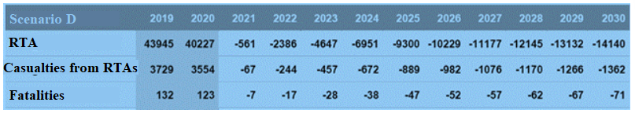

Comparison of alternative scenarios

In assessing the current trends in the field of road traffic safety, a conclusion may be drawn that it is increasingly difficult to achieve subsequent improvements in terms of the number of fatalities and seriously injured persons from RTAs. Historically, reduction in the number of fatalities has been largely improved by improvements in the safety of vehicles and the spread of the use of seat belts; however, at this point the potential of these factors has been exhausted to a large extent. The increase in the number of RTAs and casualties is affected by the ever increasing traffic volume which is related to increase in GDP. The abovementioned factors encumber the objectives related to the mitigation of the amount of consequences.
In modelling Scenarios A, B, C, and D within the scope of the study³³, it may be concluded that there is the most return on measures which are already currently being implemented in a purposeful manner, i.e. reconstruction of road sections where RTAs occur frequently, increasing of control mechanisms by installing new speed cameras and systems for recording average speed, and also change in the action of road users, using informative campaigns (Scenario A). These measures ensure continuous improvement in road traffic safety and their return is higher because these measures are directed towards solving of the most urgent problems.
Also the framework of measures in the current amount is not sufficient and significant improvements are necessary to achieve to set objective, i.e. halving of the number of fatalities and seriously injured persons from RTAs. In modelling scenarios, the possibilities of introducing significant restrictions on driving speed were assessed which would require comparatively low additional costs (Scenario B). The possibility of investing additional resources in improvements of the infrastructure (Scenarios C and D) was assessed alternatively.
It may be concluded as a result of the assessment of the study³³ that introduction of speed restrictions has insignificant impact on State and local government budgets and it is possible to achieve significant improvement in results therewith. At the same time, national economy will bear even higher costs if the whole traffic at large is slower and the value of time spent on the road is higher even than the investment plan in Scenario D.

Table 16. Comparison of alternative scenarios A, B, C, and D [source: study “Impact Assessment of the Road Traffic Safety Plan for 2017–2020”]

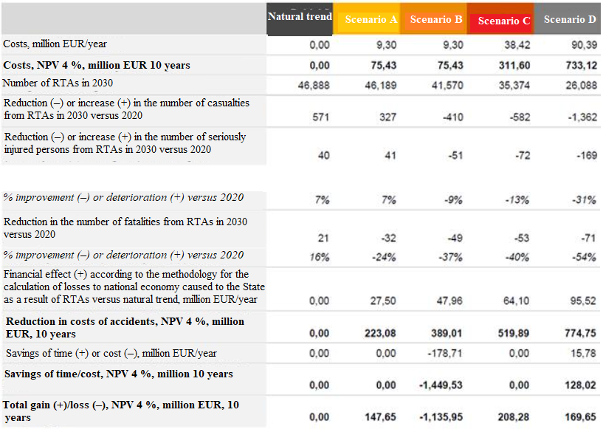

In aggregating the models of scenarios, medium-term and long-term forecasts for the number of fatalities from RTAs have been obtained – see Figure 30.

Figure 30. Alternative scenarios and forecasts of the number of fatalities from RTAs until 2050 [source: study “Impact Assessment of the Road Traffic Safety Plan for 2017–2020”]

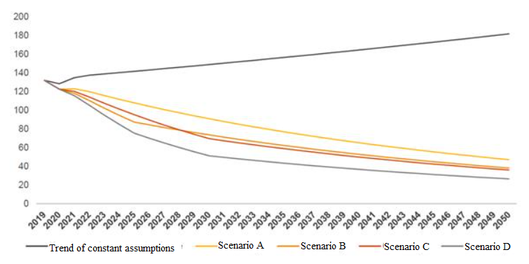

Also medium-term and long-term forecasts for the number of seriously injured persons from RTAs were obtained in performing similar modelling in the study³³, see Figure 31.

Figure 31. Alternative scenarios and forecasts of the number of seriously injured persons from RTAs until 2050 [source: study “Impact Assessment of the Road Traffic Safety Plan for 2017–2020”]

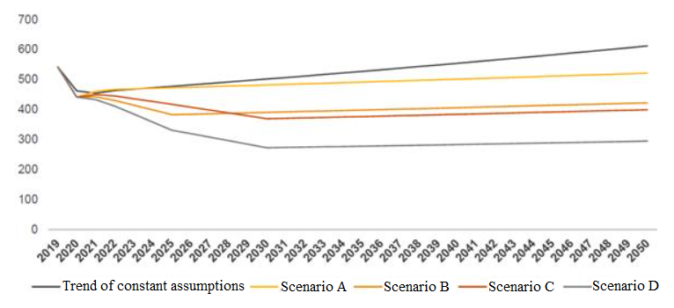

3. Objective and Lines of Action of the Plan

Lines of action:  ‒ Safe road user  ‒ Safe vehicle  – Safe environment | 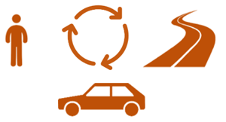

Safe road user

A road user is any inhabitant because the road infrastructure is used by drivers, pedestrians, and users of micromobility vehicles. Meanwhile action and behaviour of road users is the field with the highest potential of improving the overall road traffic safety. It is related to the fact that at large 90 % of all RTAs nowadays are related to human errors⁵⁶. Also one of the reasons for the majority of RTAs with fatalities had been speeding, meanwhile the impact of such risks as driver distraction from the road has been increasing lately. The fact that approximately a quarter of all the fatalities from RTAs in the EU is related to the use of alcohol and driving of a vehicle under the influence is also worrying.
Undeniably, education of road users and their training are also essential factors for promoting correct understanding of road users of appropriate behaviour and attitude. It is very important for drivers to be aware of their limitations, to assess risks, for example, the risks arising from the driving speed or the use of a mobile device while driving, also to be aware of the impact of alcohol or narcotic substances on their ability to drive a vehicle. The knowledge of a road user regarding correct action after an RTA to free the carriageway as quickly as possible and/or to provide aid to the victims also has a significant role.
The regulation laid down in laws and regulations also has a crucial role in relation to road traffic, including how the regulation included in the laws and regulations is directed towards ensuring of road traffic safety. The fulfilment of the current requirements of the RTR and failure to ensure conformity with the related requirements is frequently one of the main reasons for RTAs. Also the policy makers of the EU must decide in the subsequent years as to how the application of unified provisions and ensuring of compliance therewith could be achieved throughout the EU.

Safe vehicle

Although the aggregate of measures which is directly oriented towards a safer vehicle is comparatively smaller, its impact cannot be underestimated. Measures oriented towards technical control of automobiles should be implemented to ensure a safer vehicle fleet. Therefore, the normative regulation which applies to roadworthiness testing and inspections on the road should ensure that wholesome diagnostics of the safety systems of the vehicle is performed with the aim of ascertaining the serveability of the safety systems of the vehicle because the serveability of the active safety systems of automobiles is directly linked to the possibility of the automobile of getting into an RTA, while the serveability of the passive safety systems determines the level of injuries for victims of RTAs. Taking also into account the factor which is related to the age of the vehicle fleet, registration for vehicles which are not equipped with essential modern safety systems should be gradually restricted by amendments to laws and regulations.
The aggregate of measures is directed towards the creation of as safe environment for the driver and passenger of the vehicle as possible, i.e. by creating such conditions where life-endangering injuries would not occur in case of an RTA and also risks which may directly contribute to RTAs or the severity of their consequences would be prevented.

Safe environment

It is undeniable that improvements in the road infrastructure, including the design, building, and maintenance thereof, may significantly improve road traffic safety. Such factors as unclear road signs and difficult to notice, non-corresponding marking of lanes, uneven road covering and structure may affect or promote the impact of RTAs or their course. The weak points of the road infrastructure should be mitigated (the consequences of human errors should be eliminated or mitigated) and it should also ensure the best possible traffic flow. A smart infrastructure which promotes reasonable, careful driving would also reduce the number of RTAs. Generally, various solutions are applied all over the world, including more extensive introduction of circular intersections which improve, for example, safety of road intersections. Meanwhile, other considerations of road traffic safety should be taken into account in urban planning. Similarly, different standards, requirements in the design or rebuilding process, also requirements and procedures laid down in laws and regulations may facilitate achievement of the abovementioned objective regarding the creation of a completely safe environment – safe infrastructure – in long term.
The quality of road and its covering is undeniably another essential element of road traffic safety. The type of the road also has an important role: high-speed roads with separated carriageways are statistically the safest ones while roads without separated carriageways (roads with two carriageways) tend to present the highest risk. At the same time, the costs and also contributions of different safety solutions to national economy should be assessed upon introduction thereof. The most expensive solutions are not always the most efficient solutions, but the most efficient solutions may provide a more essential contribution to the improvement of road traffic safety.

Subsequent scenario of action

An aggregate of measures which encompasses a safe road user, safe environment, and safe vehicle should be implemented according to a scenario which provides for additional new measures conforming to the “Safe System” approach, and also additional financing is intended for these measures (for example, for the implementation of such measures as gradual rebuilding of roads, assessing the most cost-effective solutions, i.e. building of circular intersections, building of safety “islands”, separation of individual groups of road users, also separation of the flow of pedestrians, micromobility vehicles, and automobiles, installation of technical means for the control of road users. In addition, changes in laws and regulations are being made according to the EU guidelines in the field of road traffic safety (Scenario C)³³.
By implementing such scenario, it would be possible to achieve an improvement in the amount of approximately 50 % in terms of the reduction of fatalities from RTAs and also to attempt to reduce the number of seriously injured persons to the same extent. It should also be taken into account that investments in improvements of road infrastructure safety would provide a result continuously after occurrence of costs, therefore the amount of total expenditures is lower if assessed in long term.

Table 17. Performance-based indicators of the Road Traffic Safety Plan for 2021–2027

Objective of the Plan:
Reduction of fatalities and seriously injured persons from road traffic accidents in 2027 in the amount of 35 % versus 2020
(Objective of 2021–2030:⁵⁷
reduction of fatalities and seriously injured persons from road traffic accidents in 2030 in the amount of 50 % versus 2020)
Performance-based indicator (PBI) | Unit of measurement | Base year | Base year value | Target value 2021 | Target value 2022 | Target value 2023 | Target value 2024 | Target value 2025 | Target value 2026 | Target value 2027 | Target value 2030
Policy result No. 1 (PR1) – reduction in percentage of persons who have died in road traffic accidents
1. Reduction in percentage of the number of persons who have died in road traffic accidents⁵⁸ | %  (number of persons in the base year – 139) | 2020 | 100 | 5 | 10 | 15 | 20 | 25 | 30 | 35 | 50
Policy result No. 2 (PR2) – reduction in percentage of persons who have been seriously injured in road traffic accidents
2. Reduction in percentage of the number of persons who have been seriously injured in road traffic accidents⁵⁸ | %  (number of persons in the base year – 491) | 2020 | 100 | 5 | 10 | 15 | 20 | 25 | 30 | 35 | 50
Policy result No. 3 (PR3) – reduction in percentage of vulnerable road users who have died in road traffic accidents
3. Reduction in percentage of the number of vulnerable road users who have died in road traffic accidents⁵⁸ | %  (number of persons in the base year – 69) | 2020 | 100 | 5 | 10 | 15 | 20 | 25 | 30 | 35 | 50
Policy result No. 4 (PR4) – reduction in percentage of drivers and passengers of vehicles who have died in road traffic accidents
4. Reduction in percentage of the number of drivers and passengers of vehicles who have died in road traffic accidents (passenger car)⁵⁸ | %  (number of persons in the base year – 64) | 2020 | 100 | 5 | 10 | 15 | 20 | 25 | 30 | 35 | 50
Policy result No. 5 (PR5) – reduction in percentage of children who have been injured in road traffic accidents
5. Reduction in percentage of the number of children who have been injured in road traffic accidents⁵⁸ | %  (number of persons in the base year – 394) | 2020 | 100 | 5 | 10 | 15 | 20 | 25 | 30 | 35 | 50
Policy result No. 6 (PR6) – reduction in the level of severity of road traffic accidents is ensured (number of fatalities per 100 RTAs involving victims)
6. Reduction in percentage of the level of severity of road traffic accidents (number of fatalities per 100 RTAs involving victims)⁵⁸ | %  (base year value – ratio 4.1) | 2020 | 100 | 5 | 10 | 15 | 20 | 25 | 30 | 35 | 50
Road traffic safety key performance indicators (KPI)
Policy result No. 7 (PR7) – number of vehicles (%) which do not comply with restrictions of the permitted speed
7. Speed – reduction in the number of vehicles (%) which do not comply with restrictions of the permitted speed⁵⁹ | % | 2020 | 100 | 5 | 10 | 15 | 20 | 25 | 30 | 35 | 50
Policy result No. 8 (PR8) – number of vehicle passengers (%) who do not use seat belts or do not use child car seats
8. Seat belts – reduction in the number of vehicle passengers (%) who do not use seat belts or do not use child car seats⁵⁹ | % | 2020 | 100 | 5 | 10 | 15 | 20 | 25 | 30 | 35 | 50
Policy result No. 9 (PR9) – number of motorcycle and moped drivers and passengers (%) who do not use safety helmets
9. Safety equipment – reduction in the number of motorcycle and moped drivers and passengers (%) who do not use safety helmets⁵⁹ | % | 2020 | 100 | 5 | 10 | 15 | 20 | 25 | 30 | 35 | 50
Policy result No. 10 (PR10) – number of drivers of vehicles (%) who participate in road traffic while the blood alcohol content is above the permitted level
10. Use of alcohol – reduction in the number of drivers of vehicles (%) who participate in road traffic while the blood alcohol content is above the permitted level⁵⁹ | % | 2020 | 100 | 5 | 10 | 15 | 20 | 25 | 30 | 35 | 50
Policy result No. 11 (PR11) – number of drivers of vehicles (%) who use mobile smart devices while driving a vehicle
11. Driver distraction – reduction in the number of drivers of vehicles (%) who use mobile smart devices while driving a vehicle⁵⁹ | % | 2020 | 100 | 5 | 10 | 15 | 20 | 25 | 30 | 35 | 50
Policy result No. 12 (PR12) – number of new vehicles (%) which correspond to the highest traffic safety class
12. Safety of vehicles – increase in the number of new vehicles (%) which correspond to the highest traffic safety class⁵⁹ | % | 2020 | 100 | 5 | 10 | 15 | 20 | 25 | 30 | 35 | 50
Policy result No. 13 (PR13) – total length of roads (%) which correspond to the highest traffic safety requirements
13. Safety of the infrastructure – increase in the total length of roads (%) which correspond to the highest traffic safety requirements⁵⁹ | % | 2020 | 100 | 5 | 10 | 15 | 20 | 25 | 30 | 35 | 50
Policy result No. 14 (PR14) – time (minutes and seconds) necessary for rescuers to arrive at the site of the RTA after the RTA and the call to the rescuers
14. Liquidation of consequences from an RTA – reduction of time (minutes and seconds) necessary for rescuers to arrive at the site of the RTA after the RTA and the call to the rescuers⁵⁹ | % | 2020 | 100 | 5 | 10 | 15 | 20 | 25 | 30 | 35 | 50

4. Measures for the Improvement of Road Traffic Safety

Measures to be taken by each competent authority to improve the road traffic safety situation are identified in the lines of action of the Plan.
It should be pointed out that henceforth, in focusing on any specific road traffic safety problem, various other risks which would not be adequately assessed may arise. For example, in focusing on the fact that newer vehicles are equipped with active safety technologies in order to prevent occurrence of RTAs and passive safety systems to protect passengers and other road users from RTAs, when introducing measures directed towards more extensive spread of newer vehicles in the overall vehicle fleet, other significant factors will be forgotten, for example, behaviour of drivers and other road users, maintenance and design of safe infrastructure, road traffic regulations and the fulfilment thereof, and also different informative campaigns, and various other measures.
A conclusion may be drawn that focusing on one of the factors, while disregarding others, will not provide the greatest benefit to the society. Therefore, if the objective of the Plan is to achieve significant improvements in the field of road traffic safety, more attention should be paid to an integrated strategy. In other words, the measures included in the Plan must ensure that safe vehicles on safe roads are driven by safe drivers.

4.1. Safe Road User

It is worth mentioning that a safe road user encompasses a more extensive set of action than a road user who strictly complies with the requirements of the road traffic regulations. Therefore, a safe road user is also able to be aware of his or her abilities and limitations to these abilities, he or she takes common sense precautionary measures, and also is informed how different factors may affect appropriate action in road traffic, for example, how different medicinal products may affect driving of a vehicle. These very measures which are directed towards action of each road user both in everyday road traffic when travelling home from work, to a recreational site or elsewhere and also action in different unforeseeable and emergency situations are included in this section of the Plan.

Table 18. Measures of the line of action “Safe Road User” of the Road Traffic Safety Plan for 2021–2027

Objective of the Plan |  | Reduction in the number of fatalities and seriously injured persons from road traffic accidents in 2027 in the amount of 35 % versus 2020
Policy result and performance-based indicator |  | Number of fatalities and seriously injured persons from road traffic accidents has been reduced  (PR – policy result according to Table 17)
Action direction |  | 4.1. Safe road user
No. | Measure | Action result | Performance-based indicator | Responsible authority | Co-responsible authorities | Time limit for execution | Necessary financing (EUR) and its sources
1. | To implement measures for the control of road users.  (PR1, PR2, PR3, PR4, PR5, PR6, PR7, PR8, PR9, PR10, PR11)⁶⁰ | Such measures have been implemented which are directed towards comprehensive ensuring of the control of road users – comprehensive control of road users has been ensured, also by more extensive use of intellectual transport systems, automation and smart technologies in traffic control (including by more extensive implementation of campaign-type inspections of vehicle drivers which would also help to determine whether drivers (including drivers of electric scooters and bicycles) participate in road traffic under the influence of alcohol or other intoxicating substances and also whether they use mobile devices while driving a vehicle, whether child car seats are used, and other measures). | Each year an aggregate of measures is implemented (using technical means or by performing regular inspections of road users on site), thus expanding the number of road users who have been subject to control. | MoI (SP) | LSR, RTSD, MoT, SBG, local governments | 31 December 2021  31 December 2022  31 December 2023  31 December 2024  31 December 2025  31 December 2026  31 December 2027 | 1 000 000, PRTA funds  1 000 000, PRTA funds  1 000 000, PRTA funds  1 000 000, PRTA funds  1 000 000, PRTA funds  1 000 000, PRTA funds  1 000 000, PRTA funds  Total for the period:  7 000 000, PRTA
2. | To implement research measures for road traffic safety.  (PR1, PR2, PR3, PR4, PR5, PR6, PR7, PR8, PR9, PR10, PR11, PR12, PR13, PR14) | Such measures have been implemented which are directed towards impact assessment of the current road traffic safety policy, introduction of new solutions, analysis of good practice examples, and other research measures – impact assessment of policy planning has been ensured. | Each year 1–5 studies on the topic of road traffic safety have been implemented (including by implementing studies on the reasons for RTAs, on the impact of campaigns, on the action of road users, on fatigue during driving a vehicle, on solutions of the road infrastructure, on safe inclusion of micromobility solutions in the overall road traffic, and other topics). | MoT | MoI, RTSD, LSR, SP | 31 December 2021  31 December 2022  31 December 2023  31 December 2024  31 December 2025  31 December 2026  31 December 2027 | 100 000, PRTA funds  100 000, PRTA funds  100 000, PRTA funds  100 000, PRTA funds  100 000, PRTA funds  100 000, PRTA funds  100 000, PRTA funds  Total for the period:  700 000, PRTA
3. | To implement educational measures of road users.  (PR1, PR2, PR3, PR4, PR5, PR6, PR7, PR8, PR9, PR10, PR11, PR12, PR13, PR14) | The level of knowledge of road users regarding essential topics related to road traffic safety has been improved, including:  – educational measures of young road users in pre-school, basic education, and secondary education institutions;  – education of drivers of vehicles regarding the use of the agreed statement of facts (for the purpose of saving the resources of the SP);  – education of drivers of vehicles regarding the impact of alcohol and other intoxicating substances on driving of a vehicle;  – education of drivers of vehicles regarding the use of mobile devices while driving a vehicle and its impact on road traffic safety;  – education of drivers of vehicles regarding basic principles of safe driving of a car and safe driving of a motor vehicle;  – education of drivers of vehicles regarding impact of the technical condition of a vehicle on road traffic safety;  – on safe participation in road traffic with bicycles, electric scooters, and other modes of micromobility;  – on safe driving of heavy goods vehicles (on latitude, on their safety systems, on observance of a distance, etc.);  – and other educational measures | Each year 1–5 measures for educating road users regarding the topic of road traffic safety have been implemented. | MoT, MoI | RTSD, LSR, MIBoL, SP | 31 December 2021  31 December 2022  31 December 2023  31 December 2024  31 December 2025  31 December 2026  31 December 2027 | 300 000, PRTA funds  300 000, PRTA funds  300 000, PRTA funds  300 000, PRTA funds  300 000, PRTA funds  300 000, PRTA funds  300 000, PRTA funds  Total for the period:  2 100 000, PRTA
4. | To implement informative campaigns regarding road traffic safety.  (PR1, PR2, PR3, PR4, PR5, PR6, PR7, PR8, PR9, PR10, PR11, PR12, PR13, PR14) | Informing of road users (campaigns, booklets, various information channels, via mass media, etc.) on the most important and topical themes has been ensured, including:  – on the RTR norms, including observance of the permitted speed (by also creating study materials regarding explanation of the RTR norms);  – on driving of a vehicle under the influence of intoxicating substances;  – on driver fatigue and diversion;  – on the use of mobile devices while driving a vehicle;  – on the safety of the most vulnerable road users;  – on the use of safety means (seat belts, child car seats, protective helmets, etc.);  – on safe participation in road traffic with bicycles, electric scooters, and other tools of micromobility;  – against aggressive driving;  – on driving of a vehicle depending on the season, environment, weather conditions, and condition of the road covering;  – on the impact of meteorological conditions on the road infrastructure and the maintenance of the road network;  – on safe use of the public transport (exiting in a stop, actions of children, etc.);  – on the participation of emergency vehicles in road traffic;  – on correct actions after an RTA;  – on responsible behaviour in road traffic, including existence of CCLI and RT;  etc. | Each year 1–5 road traffic safety and educational campaigns have been implemented. | MoT, MoI | RTSD, LSR, SP, MIBoL, SFRS, SBG, LAMB | 31 December 2021  31 December 2022  31 December 2023  31 December 2024  31 December 2025  31 December 2026  31 December 2027 | 400 000, PRTA funds  400 000, PRTA funds  400 000, PRTA funds  400 000, PRTA funds  400 000, PRTA funds  400 000, PRTA funds  400 000, PRTA funds  Total for the period:  2 800 000, PRTA
5. | To introduce processing and analysis of the statistical data of RTAs according to the road traffic safety key performance indicators (KPI).  (PR7, PR8, PR9, PR10, PR11, PR12, PR13, PR14) | Processing and analysis of information of road traffic safety key performance indicators has been ensured. | Each year information on eight road traffic safety key performance indicators has been aggregated and published:  – speed restrictions;  – seat belts;  – protective helmets for drivers of motorcycles, mopeds;  – drivers under the influence of alcohol;  – use of smart mobile devices;  – number of vehicles which conform to the highest safety requirements;  – roads which conform to the highest safety requirements;  – time necessary for the liquidation of the consequences from RTAs. | RTSD | MoT | 31 December 2022  31 December 2023  31 December 2024  31 December 2024  31 December 2025  31 December 2026  31 December 2027 | 64 000, PRTA  64 000, financing from the EU CEF funds⁶¹  128 000, PRTA  128 000, PRTA  128 000, PRTA  128 000, PRTA  128 000, PRTA  128 000, PRTA  Total for the period:  896 000 (PRTA 832 000)
6. | To implement measures which are directed towards the acquisition and use of safe and sustainable transport services and means of vehicles.  (PR12) | Changes in the age structure of the overall vehicle fleet have been promoted – the number of newer vehicles in the overall vehicle fleet has increased in terms of percentage. | The current requirements in laws and regulations (amount of the vehicle operation tax rates, the RTR, etc.) have been reviewed, stricter requirements for the registration in Latvia of older vehicles brought into Latvia from other countries have been introduced. | MoT | RTSD, MoF | 31 December 2022 | Within the scope of the current State budget
7. | To ensure a unified accounting of statistical data of persons seriously injured in road traffic accidents according to the requirements of MAIS3+.  (PR1, PR2, PR3, PR4, PR5, PR6) | Comparative and credible statistical data regarding persons injured in road traffic accidents, i.e. the severity and type of their injuries, is available in the EU. A system in which the severity of the injuries from RTAs is determined by conversion of the data registered in a medical treatment institution according to the MAIS3+ classification has been introduced. | A unified accounting of statistical data of persons seriously injured in road traffic accidents according to the requirements of MAIS3+ has been introduced in the EU. | MoH (NHS), MoI (ICoMoI) | MoT, RTSD, SP | 31 December 2021 | 47 190, PRTA (NHS)  38 769, PRTA  (ICoMoI)
8. | To review the methodology for the calculation of losses from RTA, update as necessary.  (PR1, PR2, PR3, PR4, PR5, PR6) | Updating of corresponding and updated information on the losses to national economy caused by RTAs has been ensured. | New methodology for the calculation of losses caused to the national economy by RTAs has been reviewed and developed if necessary. | MoT | RTSD | 31 December 2022 | To be determined after assessment in 2022
9. | To ensure the implementation of preventive measures for the improvement of road traffic safety (issuing of reflectors, objects with elements reflecting light, reflective vests, protective helmets for cyclists).  (PR1, PR2, PR3, PR5, PR6, PR7, PR11, PR12, PR13, PR14) | Safety of the most vulnerable road users has been ensured – visibility, attention of other road users attracted, and also safety of such road users increased. | Each year such measures have been implemented which are directed towards the acquisition of safety means (reflectors, flashlights, objects with elements reflecting light, reflective vests, protective helmets of cyclists, etc.) for improving safety of road users, including the most vulnerable ones. | SP, RTSD, SBG | MoT, MoI | 31 December 2021  31 December 2022  31 December 2023  31 December 2024  31 December 2025  31 December 2026  31 December 2027 | 50 000, PRTA funds  50 000, PRTA funds  50 000, PRTA funds  50 000, PRTA funds  50 000, PRTA funds  50 000, PRTA funds  50 000, PRTA funds  Total for the period:  350 000, PRTA
10. | To create a unified structure for the analysis of RTAs or a system for the assessment thereof and for the use of information for the improvement of road traffic safety.  (PR1, PR2, PR3, PR4, PR5, PR6, PR7, PR8, PR9, PR10, PR11) | Systematic analysis of RTAs has been ensured, including by assessing the factors influencing their course, consistency, etc. | Systematic assessment of factors influencing RTAs has been introduced. | RTSD, SP | MoT, LSR | 31 December 2024 | To be determined after assessment in 2022–2024
11. | To increase the requirements for training of new drivers of vehicles in order to ensure higher training quality of drivers and also to ensure updating of the knowledge of the current drivers according to topical and essential issues in the field of road traffic safety.  (PR1, PR2, PR3, PR4, PR5, PR6, PR7, PR8, PR9, PR10, PR11, PR12) | Informing of the new and current drivers and updating of their theoretical and practical knowledge according to the current situation has been ensured. | Training programmes directed towards acquisition of practical driving skills under actual traffic conditions have been introduced and also a system in which the current drivers are informed of essential issues influencing road traffic safety has been introduced. | RTSD | MoT | 31 December 2024 | To be determined after assessment in 2022–2024
12. | To implement the change of the policy for punishments imposed in road traffic.  (PR1, PR2, PR3, PR4, PR5, PR6, PR7, PR8, PR9, PR10, PR11) | Systematic punishing of persons violating the norms laid down in the RTR and the RTL and aggressive drivers endangering other road users for dangerous violations has been ensured. | Amendments to laws and regulations directed towards expansion of control of road users and reviewing of the amount of punishment have been introduced, ensuring systematic punishing of aggressive drivers, such drivers who regularly violate the requirements of the RTR and the RTL and endanger other road users for violations:  – the requirements of the RTL;  – the requirements of the RTR;  – determination of stricter requirements and punishment for specific violations (for example, decreasing of the permissible border of punishing (revoked +10 km/h)) | MoT, MoI | MoJ | 31 December 2022 | Within the scope of the current State budget

4.2. Safe Vehicle

The requirements for vehicles and their safety have radically changed over the course of years, therefore modern vehicles are comparatively safer than ever before. At the same time, safety of the overall vehicle fleet is also characterised by the average age of the vehicle fleet, namely, the distribution of the various widespread safety systems in the vehicle fleet. If there are more newer vehicles in the vehicle fleet, then the spread of various newest safety systems also increases accordingly, but if the vehicle fleet is older, the opposite effect presents itself. Safety of a vehicle and the factors influencing it are related to technical control, various restrictions in operation, and also various technical solutions which are directed to restricting the use of technically less safe vehicles. Such measures have been included in this section of the Plan which are directed to the improvement of the technical condition of the vehicle fleet by implementing different measures.

Table 19. Measures of the line of action “Safe Vehicle” of the Road Traffic Safety Plan for 2021–2027

Objective of the Plan |  | Reduction in the number of fatalities and seriously injured persons from road traffic accidents in 2027 in the amount of 35 % versus 2020
Policy result and performance-based indicator |  | Number of fatalities and seriously injured persons from road traffic accidents has been reduced  (PR – policy result according to Table 17)
Action direction |  | 4.2. Safe vehicle
No. | Measure | Action result | Performance-based indicator | Responsible authority | Co-responsible authorities | Time limit for execution | Necessary financing (EUR) and its sources
1. | To implement measures directed towards the improvement of the technical condition of the vehicle fleet.  (PR1, PR2, PR3, PR4, PR5, PR6, PR12) | The vehicle fleet conforms to the highest safety requirements:  – it has been ensured that all vehicles which have been registered in Latvia for the first time by 2027 are equipped with corresponding safety indicators;  – incentives for the use of such vehicles the safety of which has been improved and also vehicles in which technologies of automated vehicles are being used have been ensured. | To ensure that the average age of the vehicle fleet is below 10 years. | MoT | RTSD | December 2027 | To be determined after assessment  in 2024–2027
2. | To expand the performance of technical control of vehicles on the road.  (PR12) | An assessment has been performed and expansion of possibilities for technical control of vehicles has been implemented, including more extensive requirements for the conformity of vehicles with the road safety requirements have been introduced. | The probability that vehicles which do not conform to the roadworthiness testing requirements are participating in road traffic has been reduced to the minimum and also the number of RTAs the influencing factor of which had been the technical condition of the vehicle has been at least halved. | RTSD | MoI, MoT, SP | 31 December 2027 | To be determined after assessment  in 2024–2027
3. | To assess the introduction of restrictions for the registration of vehicles previously registered in other countries which are not equipped with specific safety systems (anti-lock braking system, airbags, electronic stability system, tyre pressure control, etc.).  (PR12) | Various alternative solutions in relation to restrictions on registration of vehicles without specific vehicle safety systems have been assessed. | Solutions in relation to restrictions on registration of vehicles in Latvia have been assessed in order to reduce the number of such vehicles the passive and active safety level of which does not conform to the highest road traffic safety requirements. | MoT | RTSD | 31 December 2027 | Within the scope of the current State budget
4. | In accordance with the requirements laid down in the EU legal acts, to implement a more extensive technical control of vehicles during roadworthiness testing, inspecting specific safety systems in terms of technical and practical operation to the extent possible (anti-lock braking system, airbags, electronic stability system, tyre pressure control, etc.), and also limiting further operation for vehicles which have been involved in RTAs. (PR12) | Laws and regulations have been supplemented with requirements, determining more extensive restrictions during roadworthiness testing in relation to the technical condition of vehicles accordingly. | The probability that vehicles which do not conform to the roadworthiness testing requirements are participating in road traffic has been reduced and also the number of RTAs the influencing factor of which had been the technical condition of the vehicle has been at least halved. | RTSD | MoT | 31 December 2027 | To be determined after assessment in 2024–2027
5. | To assess solutions for equipping of such vehicles with alcohol interlocks which are used for the provision of sharing services.  (PR1, PR2, PR3, PR4, PR5, PR6, PR10) | Different alternative solutions have been assessed and requirements have been introduced in laws and regulations for the use of such shared vehicles which are not equipped with alcohol interlocks. | The use of shared vehicles under the influence of alcohol has been prevented. | MoT | RTSD | 31 December 2024 | Within the scope of the current State budget
6. | To assess solutions in relation to equipping of vehicles with mandatory/voluntary devices for controlling the speed of the vehicle, the driving style for drivers who have been punished for specific violations of the RTR.  (PR1, PR2, PR3, PR4, PR5, PR6, PR7) | Different alternative solutions for a system which would ensure more extensive control of aggressive drivers have been assessed. | The probability that drivers who systematically violate the requirements of the RTR (including the permitted driving speed, aggressive driving, etc.) commit repeated violations has been reduced. | MoT | RTSD | 31 December 2027 | Within the scope of the current State budget
7. | To assess solutions in relation to the introduction of the requirements for new drivers of vehicles to equip vehicles with devices for controlling the speed and driving style which would control speeding, aggressive driving, etc. in an automated manner.  (PR1, PR2, PR3, PR4, PR5, PR6, PR7) | Various alternative solutions for the system which controls new drivers have been assessed. | The number of new drivers who violate the requirements of the RTR (including the permitted driving speed, aggressive driving, etc.) has been reduced. | MoT | RTSD | 31 December 2027 | Within the scope of the current State budget
8. | To assess solutions in relation to the introduction of a requirement to gradually equip all commercial vehicles with automated devices for speed control and driving style of the driver within a period of five years.  (PR1, PR2, PR3, PR4, PR5, PR6, PR7) | Various alternative solutions for the system which controls the speed and driving style of commercial vehicles have been assessed. | The number of drivers of commercial vehicles who violate the requirements of the RTR (including the permitted driving speed, aggressive driving, etc.) has been reduced. | MoT | RTSD | 31 December 2027 | Within the scope of the current State budget
9. | To assess introduction of restrictions for trade in equipment of vehicles which does not conform to specific standards and also restriction of trade in used tires the age of which exceeds specific criteria.  (PR1, PR2, PR3, PR4, PR5, PR6) | Solutions which would preclude trade in equipment not conforming to the highest safety requirements have been assessed. | Probability that such vehicles are participating in road traffic the equipment installed in which does not conform to standards and technical requirements (lighting devices, aerodynamic elements, and other parts) has been reduced. | MoE, MoT | CRPC, RTSD | 31 December 2027 | Within the scope of the current State budget
10. | To develop an application for the control and supervision of road traffic which would determine different traffic violations and would give an opportunity for road users to inform, in an operative manner, the State of the violations detected.  (PR1, PR2, PR3, PR4, PR5, PR6, PR7, PR8, PR9, PR10, PR11) | A mobile application which allows other road users to inform the police of possible violations detected has been developed and introduced. | Control of road users has been extended, ensuring that other road users have the possibility to notify of drivers violating the requirements of the RTR (including the permitted driving speed, prohibiting signals of a traffic light, aggressive driving, etc.). | ICoMoI | SP, MoT | 31 December 2027 | To be determined after assessment in 2024–2027
11. | To implement control of full traffic flow of vehicles with the help of fixed speed cameras (existence of RT and CCLI).  (PR1, PR2, PR3, PR4, PR5, PR6, PR7, PR8, PR9, PR10, PR11) | “Zero tolerance” against owners/drivers of vehicles that have not been appropriately insured and are not in technical order has been introduced, increasing education and informing, and also ensuring stricter control with ancillary technical means. | It has been ensured that all drivers of vehicles who violate specific requirements of the RTR, including participate in road traffic without roadworthiness testing, CCLI, etc., are punished in places and road sections where technical means for the control of road users have been installed. | SP, MIBoL, RTSD | MoT, MoI | 31 December 2027 | To be determined after assessment in 2022–2027

4.3. Safe Environment

Creation of safe environment for all road users is directly applicable to an aggregate of different procedures which includes solutions for the creation of safe road infrastructure. This section of the Plan provides an overview of the necessary measures which are directed towards the creation of safe environment for all road users – pedestrians, drivers of motor vehicles, drivers of single-track motor vehicles, and also any other road user. Both managers of the State motor road network and also each local government and other road managers have an important role in the creation of a safer environment, therefore the aggregate of measures included in the section encompasses all abovementioned subjects.

Table 20. Measures of the line of action “Safe Environment” of the Road Traffic Safety Plan for 2021–2027

Objective of the Plan |  | Reduction in the number of fatalities and seriously injured persons from road traffic accidents in 2027 in the amount of 35 % versus 2020
Policy result and performance-based indicator |  | Number of fatalities and seriously injured persons from road traffic accidents has been reduced  (PR – policy result according to Table 17)
Action direction |  | 4.3. Safe environment
No. | Measure | Action result | Performance-based indicator | Responsible authority | Co-responsible authorities | Time limit for execution | Necessary financing (EUR) and its sources
1. | To improve road traffic safety on State motor roads.  (PR1, PR2, PR3, PR4, PR5, PR6) | Road traffic safety measures have been implemented, including:  – changing of the prohibition or warning signs;  – installation of the rumble strips;  – placement of the signal poles;  – improvement of safety of pedestrian crossings;  – calming of the traffic when entering populated areas;  – placement of the variable-message signs;  – placement of technical means for traffic monitoring and control;  – establishment of safe micromobility infrastructure, gradual improvement of the current infrastructure;  – promotion of the creation of rest areas for heavy goods vehicles (safe parking lots) in the vicinity of the major State motor roads;  – etc. | The number of RTAs and also casualties and fatalities from them on State motor roads has been reduced by introducing the safest traffic safety solutions in the road network which correspond to the highest requirements, including:  – changing of the prohibition or warning signs on all major and regional State motor roads, units;  – installation of the rumble strips, km;  – placement of the signal poles, km;  – improvement of safety of pedestrian crossings, units;  – taking of measures for calming of the traffic at the borders of populated areas, units;  – placement of the variable-message signs, units;  – placement of technical means for traffic monitoring and control;  – measures for the improvement of the micromobility infrastructure;  – measures for promoting the creation of safe parking lots in the vicinity of the major State motor roads;  – etc. | LSR | MoT | 31 December 2027 | To be determined after assessment  in 2022–2027
2. | To improve the infrastructure of roads and streets of towns and local governments.  (PR1, PR2, PR3, PR4, PR5, PR6) | – An assessment⁶² of the road network of towns and local governments has been performed every three years, determining the dangerous places where RTAs occur regularly.  – According to the assessment, a plan has been drawn up with a list which includes sections of roads to be improved on a priority basis or road infrastructure objects for which rebuilding or changes in traffic organisation must be performed. | The number of RTAs and also casualties and fatalities from them on roads has been reduced, ensuring improvement of the traffic infrastructure objects of dangerous roads. | Local governments | MoEPRD, MoT | 31 December 2027 | To be determined after assessment in 2022–2027, source: local government budget, partly financed from PRTA funds
3. | To ensure rescue services with the necessary equipment.  (PR1, PR2, PR3, PR4, PR5, PR6, PR14) | Hydraulic and electrohydraulic kits of rescue tools, mechanical instruments, medical sets, immobilisation boards, flow sealants, covers, absorbents, special blankets, first-aid kits and other equipment intended for the elimination of the consequences of RTAs have been purchased for carrying out rescue operations and for freeing the driving part of the road. | In ensuring the material and technical base of the SFRS for carrying out rescue operations and for freeing the driving part of the road in case of an RTA, up to 1000 units of specialised equipment have been purchased every year. | SFRS | MoI | 31 December 2021  31 December 2022  31 December 2023  31 December 2024  31 December 2025  31 December 2026  31 December 2027 | 250 000, PRTA funds  250 000, PRTA funds  250 000, PRTA funds  250 000, PRTA funds  250 000, PRTA funds  250 000, PRTA funds  250 000, PRTA funds  Total for the period:  1 750 000, PRTA
4. | To improve the audit system of road safety.  (PR1, PR2, PR3, PR4, PR5, PR6, PR13) | The audit principles of the new projects and current objects have been reviewed. | Amendments to laws and regulations which determine the procedures for the performance of the Road Traffic Safety Audit have been made. | MoT | RTSD | 31 December 2024 | Within the scope of the current State budget
5. | To ensure comprehensive conformity with the road traffic regulations.  (PR1, PR2, PR3, PR4, PR5, PR6, PR7, PR8, PR9, PR10, PR11) | By installing new technical means for the control of road users, such system has been introduced in which comprehensive control of road users with inevitable punishment has been ensured. | The number of RTAs and also casualties and fatalities from them on the roads has been reduced,  new technical means for the control of road users have been installed:  – speed control;  – control of compliance with the signals of traffic lights;  – control of the use of mobile devices;  – use of the public transport lanes;  – use of alcohol and intoxicating substances (“gate” in relation to alcohol measurement) | SP | Road managers | 31 December 2021  31 December 2022  31 December 2023  31 December 2024  31 December 2025  31 December 2026  31 December 2027 | 400 000, PRTA funds  400 000, PRTA funds  400 000, PRTA funds  400 000, PRTA funds  400 000, PRTA funds  400 000, PRTA funds  400 000, PRTA funds  Total for the period:  2 800 000, PRTA
6. | To educate the persons involved in road traffic planning, organisation, supervision, and building processes on traffic safety and the environment improving it and the creation thereof.  (PR1, PR2, PR3, PR4, PR5, PR6) | The persons involved in road traffic planning, organisation, supervision, and building processes have been educated on traffic safety and the environment improving it and the creation thereof. | Development of informative materials and good practice guidelines or recommendations regarding improvement of traffic safety, creating and planning a traffic space. | LSR, RTSD | MoT | 31 December 2021  31 December 2022  31 December 2023  31 December 2024  31 December 2025  31 December 2026  31 December 2027 | 50 000, PRTA funds  50 000, PRTA funds  50 000, PRTA funds  50 000, PRTA funds  50 000, PRTA funds  50 000, PRTA funds  50 000, PRTA funds  Total for the period:  350000 CSNPN
7. | To ensure involvement of planning regions and local governments in planning and introduction of road traffic safety measures.  (PR1, PR2, PR3, PR4, PR5, PR6) | Assessment of road traffic safety in the road network under management of local governments has been performed. | Section regarding planning of the traffic infrastructure, including assessment of road traffic safety, has been included in the local government planning documents (sustainable development strategies, development programmes). | MoT | local governments, planning regions, MoEPRD | 31 December 2022 | Within the scope of the current State budget
8. | To develop and introduce the local government road traffic safety index.  (PR1, PR2, PR3, PR4, PR5, PR6) | – To create a local government road traffic safety evaluation index, promoting competition for the honour of the safest local government.  – To promote exchange of the best experience in road traffic safety.  – To involve as many road users in addressing of traffic safety issues as possible. | A list of the local governments that are safest for traffic has been published each year, thus promoting competition and improving road traffic safety throughout the State. | MoT | LSR, RTSD, LALRG, MoEPRD | 31 December 2021  31 December 2022  31 December 2023  31 December 2024  31 December 2025  31 December 2026  31 December 2027 | 25 000, PRTA funds  25 000, PRTA funds  25 000, PRTA funds  25 000, PRTA funds  25 000, PRTA funds  25 000, PRTA funds  25 000, PRTA funds  Total for the period:  175 000, PRTA
9. | To ensure a comprehensive and systematic measuring of traffic volume on local government roads and also in local governments and populated areas.  (PR1, PR2, PR3, PR4, PR5, PR6, PR13, PR14) | A comprehensive measuring of traffic volume has been introduced, involving all possible technical means (speed cameras, surveillance cameras in populated areas, etc.). | New technical means have been installed and existing ones have been improved on local government roads and also in local governments and populated areas, determining road traffic volume. | Local governments | MoEPRD, MoT | 31 December 2024 | To be determined after assessment in 2022–2024, source: local government budget, partly financed from PRTA funds
10. | To ensure the purchase of the necessary corresponding technical means for road traffic organisation, for ensuring stopping and inspection of vehicles in the border area and inside the State, without causing situations that endanger or hinder traffic.  (PR1, PR2, PR3, PR4) | Performance of inspections which is safe for road traffic (by stopping a vehicle and performing inspections of documents or other inspections) has been ensured in the border area and inside the State. | The technical means necessary for ensuring road traffic organisation and performing border control in the State border area and inside the State have been purchased. | SBG | MoI | 31 December 2021 | 20 000, PRTA funds

5. Planning of the Financing for the Measures Included in the Plan, Impact Assessment on the State and Local Government Budgets

Table 21. Planning of the financing for the measures included in the Plan, impact assessment on the State and local government budgets

^{Line of action/measure} | ^{In 2021}  ^{(EUR)} |  | ^{In 2022}  ^{(EUR)} |  | ^{In 2023}  ^{(EUR)} |  | ^{In 2024}  ^{(EUR)} |  | ^{In 2025}  ^{(EUR)} |  | ^{In 2026}  ^{(EUR)} |  | ^{In 2027}  ^{(EUR)} |  | ^{Total}  ^{(EUR)}
 | Allocated financing, its source, and code and name of the budget programme (sub-programme) | Necessary additional financing and its source | Allocated financing, its source, and code and name of the budget programme (sub-programme) | Necessary additional financing and its source | Allocated financing, its source, and code and name of the budget programme (sub-programme) | Necessary additional financing and its source | Allocated financing, its source, and code and name of the budget programme (sub-programme) | Necessary additional financing and its source | Allocated financing, its source, and code and name of the budget programme (sub-programme) | Necessary additional financing and its source | Allocated financing, its source, and code and name of the budget programme (sub-programme) | Necessary additional financing and its source | Allocated financing, its source, and code and name of the budget programme (sub-programme) | Necessary additional financing and its source
^{4.1. Safe road user}
1. To implement measures for the control of road users. |  | ^{1 000 000, PRTA} |  | ^{1 000 000, PRTA} |  | ^{1 000 000, PRTA} |  | ^{1 000 000, PRTA} |  | ^{1 000 000, PRTA} |  | ^{1 000 000, PRTA} |  | ^{1 000 000, PRTA} | ^{7 000 000, PRTA}
2. To implement research measures for road traffic safety. |  | ^{100 000, PRTA} |  | ^{100 000, PRTA} |  | ^{100 000, PRTA} |  | ^{100 000, PRTA} |  | ^{100 000, PRTA} |  | ^{100 000, PRTA} |  | ^{100 000, PRTA} | ^{700 000, PRTA}
3. To implement educational measures of road users. |  | ^{300 000, PRTA} |  | ^{300 000, PRTA} |  | ^{300 000, PRTA} |  | ^{300 000, PRTA} |  | ^{300 000, PRTA} |  | ^{300 000, PRTA} |  | ^{300 000, PRTA} | ^{2 100 000, PRTA}
4. To implement informative campaigns regarding road traffic safety. |  | ^{400 000, PRTA} |  | ^{400 000, PRTA} |  | ^{400 000, PRTA} |  | ^{400 000, PRTA} |  | ^{400 000, PRTA} |  | ^{400 000, PRTA} |  | ^{400 000, PRTA} | ^{2 800 000, PRTA}
5. To introduce processing and analysis of the statistical data of RTAs according to the road traffic safety key performance indicators (KPI). |  | ^{64 000, PRTA} |  | 64 000, financing from the EU CEF funds |  | ^{128 000, PRTA} |  | ^{128 000, PRTA} |  | ^{128 000, PRTA} |  | ^{128 000, PRTA} |  | ^{128 000, PRTA} | ⁸⁹⁶ ⁰⁰⁰  ^{PRTA}  ^{(832 000, PRTA,}  64 000, financing from the EU CEF funds)
7. To ensure a unified accounting of statistical data of persons seriously injured in road traffic accidents according to the requirements of MAIS3+. |  | ^{47 190, PRTA (NHS)}  ^{38 769, PRTA (ICoMoI)} |  |  |  |  |  |  |  |  |  |  |  |  | ⁸⁵ ⁹⁵⁹  ^{PRTA}
8. To review the methodology for the calculation of losses from RTA, update as necessary. |  |  |  | To be determined after assessment |  |  |  |  |  |  |  |  |  |  | To be determined after assessment in 2022
9. To ensure the implementation of preventive measures for the improvement of road traffic safety (issuing of reflectors, objects with elements reflecting light, reflective vests, protective helmets for cyclists). |  | ^{50 000, PRTA} |  | ^{50 000, PRTA} |  | ^{50 000, PRTA} |  | ^{50 000, PRTA} |  | ^{50 000, PRTA} |  | ^{50 000, PRTA} |  | ^{50 000, PRTA} | ^{350 000, PRTA}
10. To create a unified structure for the analysis of RTAs or a system for the assessment thereof and for the use of information for the improvement of road traffic safety. |  |  |  |  |  |  |  | To be determined after assessment |  |  |  |  |  |  | To be determined after assessment in 2022–2024
11. To increase the requirements for training of new drivers of vehicles in order to ensure higher training quality of drivers and also to ensure updating of the knowledge of the current drivers according to topical and essential issues in the field of road traffic safety. |  |  |  |  |  |  |  | To be determined after assessment |  |  |  |  |  |  | To be determined after assessment in 2022–2024
^{4.2. Safe Vehicle}
1. To implement measures directed towards the improvement of the technical condition of the vehicle fleet. |  |  |  |  |  |  |  |  |  |  |  |  |  | To be determined after assessment | To be determined after assessment in 2024–2027
2. To perform an assessment and to introduce restrictions for the registration of vehicles previously registered in other countries which are not equipped with specific safety systems (anti-lock braking system, airbags, electronic stability system, tyre pressure control, etc.). |  |  |  |  |  |  |  |  |  |  |  |  |  | To be determined after assessment | To be determined after assessment in 2024–2027
4. In accordance with the requirements laid down in the EU legal acts, to implement a more extensive technical control of vehicles during roadworthiness testing, inspecting specific safety systems in terms of technical and practical operation to the extent possible (anti-lock braking system, airbags, electronic stability system, tyre pressure control, etc.), and also limiting further operation for vehicles which have been involved in RTAs. |  |  |  |  |  |  |  |  |  |  |  |  |  | To be determined after assessment | To be determined after assessment in 2024–2027
10. To develop an application for the control and supervision of traffic which would determine different traffic violations and would give an opportunity for road users to inform, in an operative manner, the State of the violations detected. |  |  |  |  |  |  |  |  |  |  |  |  |  | To be determined after assessment | To be determined after assessment in 2024–2027
11. To implement control of full traffic flow of vehicles with the help of fixed speed cameras (existence of RT and CCLI). |  |  |  |  |  |  |  |  |  |  |  |  |  | To be determined after assessment | To be determined after assessment in 2024–2027
^{4.3. Safe Environment}
1. To improve road traffic safety on State motor roads. |  |  |  |  |  |  |  |  |  |  |  |  |  | To be determined after assessment | To be determined after assessment in 2022–2027
2. To improve the infrastructure of roads and streets of towns and local governments. |  |  |  |  |  |  |  |  |  |  |  |  |  | To be determined after assessment | To be determined after assessment in 2022–2027, source: local government budget, partly financed from PRTA funds
3. To ensure rescue services with the necessary equipment. |  | ^{250 000, PRTA} |  | ^{250 000, PRTA} |  | ^{250 000, PRTA} |  | ^{250 000, PRTA} |  | ^{250 000, PRTA} |  | ^{250 000, PRTA} |  | ^{250 000, PRTA} | ¹ ⁷⁵⁰ ⁰⁰⁰  ^{PRTA}
5. To ensure comprehensive management of conformity with the road traffic regulations in order to prevent violations in road traffic. |  | ^{400 000, PRTA} |  | ^{400 000, PRTA} |  | ^{400 000, PRTA} |  | ^{400 000, PRTA} |  | ^{400 000, PRTA} |  | ^{400 000, PRTA} |  | ^{400 000, PRTA} | ^{2,800,000}  ^{PRTA}
6. To educate the persons involved in road traffic planning, organisation, supervision, and building processes on traffic safety and the environment improving it and the creation thereof. |  | ^{50 000, PRTA} |  | ^{50 000, PRTA} |  | ^{50 000, PRTA} |  | ^{50 000, PRTA} |  | ^{50 000, PRTA} |  | ^{50 000, PRTA} |  | ^{50 000, PRTA} | ³⁵⁰ ⁰⁰⁰  ^{PRTA}
8. To develop and introduce the local government road traffic safety index. |  | ^{25 000, PRTA} |  | ^{25 000, PRTA} |  | ^{25 000, PRTA} |  | ^{25 000, PRTA} |  | ^{25 000, PRTA} |  | ^{25 000, PRTA} |  | ^{25 000, PRTA} | ^{175 000, PRTA}
9. To ensure a comprehensive and systematic measuring of traffic volume on local governments roads and also in local governments and populated areas. |  |  |  |  |  |  |  | To be determined after assessment |  |  |  |  |  |  | To be determined after assessment in 2022–2024, source: local government budget, partly financed from PRTA funds
10. To ensure the purchase of the necessary corresponding technical means for road traffic organisation, for ensuring stopping and inspection of vehicles in the border area and inside the State, without causing situations that endanger or hinder traffic. |  | ^{20 000, PRTA} |  |  |  |  |  |  |  |  |  |  |  |  | ^{20 000, PRTA}
Total financing for the implementation of the Plan
Distribution of the State budget financing between ministries (EUR)
 | ^{In 2021} |  | ^{In 2022} |  | ^{In 2023} |  | ^{In 2024} |  | ^{In 2025} |  | ^{In 2026} |  | ^{In 2020} |  | ^{Total}
 | ^{Allocated} | ^{Additional} | ^{Allocated} | ^{Additional} | ^{Allocated} | ^{Additional} | ^{Allocated} | ^{Additional} | ^{Allocated} | ^{Additional} | ^{Allocated} | ^{Additional} | ^{Allocated} | ^{Additional}
^{Ministry of Transport} | ^{x} | ^{x} | ^{x} | ^{x} | ^{x} | ^{x} | ^{x} | ^{x} | ^{x} | ^{x} | ^{x} | ^{x} | ^{x} | ^{x} | ^{x}
^{Ministry of the Interior} | ^{x} | ^{x} | ^{x} | ^{x} | ^{x} | ^{x} | ^{x} | ^{x} | ^{x} | ^{x} | ^{x} | ^{x} | ^{x} | ^{x} | ^{x}
^{Ministry of Health} | ^{x} | ^{x} | ^{x} | ^{x} | ^{x} | ^{x} | ^{x} | ^{x} | ^{x} | ^{x} | ^{x} | ^{x} | ^{x} | ^{x} | ^{x}
Ministry of Education and Science | ^{x} | ^{x} | ^{x} | ^{x} | ^{x} | ^{x} | ^{x} | ^{x} | ^{x} | ^{x} | ^{x} | ^{x} | ^{x} | ^{x} | ^{x}
^{Total} | ^{x} | ^{x} | ^{x} | ^{x} | ^{x} | ^{x} | ^{x} | ^{x} | ^{x} | ^{x} | ^{x} | ^{x} | ^{x} | ^{x} | ^{X}
^{Total financing of the Plan}
^{State budget, amount (EUR)} |  |  |  |  |  |  |  |  |  |  |  | ⁰
^{CCLI budget, amount (EUR)} |  |  |  |  |  |  |  |  |  |  |  | ¹⁸ ⁹⁶² ⁹⁵⁹
Financing from the EU funds, amount (EUR) |  |  |  |  |  |  |  |  |  |  |  | ⁶⁴ ⁰⁰⁰
^{Other, amount (EUR)} |  |  |  |  |  |  |  |  |  |  |  | ⁰
^{TOTAL (EUR)} |  |  |  |  |  |  |  |  |  |  |  | ¹⁹ ⁰²⁶ ⁹⁵⁹

¹ In accordance with amendments of 11 August 2020 to Cabinet Regulation No. 75 of 26 January 2010, Regulations Regarding Registration and Accounting of Road Traffic Accidents, Casualties and Fatalities from Them.
² World Health Organization. (‎2018)‎. Global status report on road safety 2018. World Health Organization. https://apps.who.int/iris/handle/10665/276462. License: CC BY-NC-SA 3.0 IGO
³ World Health Organization. Publication “10 Facts about road safety”, 17 December 2018. https://www.who.int/news-room/facts-in-pictures/detail/road-safety
⁴ Website address of the conference: https://www.roadsafetysweden.com/about-the-conference/stockholm-declaration/
⁵ Text of the Stockholm Declaration in English is available at: https://www.roadsafetysweden.com/contentassets/b37f0951c837443eb9661668d5be439e/stockholm-declaration-english.pdf
⁶ Publication regarding the report: https://www.itf-oecd.org/road-safety-annual-report-2019
⁷ Publication regarding the report: https://www.itf-oecd.org/sites/default/files/docs/irtad-road-safety-annual-report-2020_0.pdf
⁸ UN Decade of Action for Road Safety 2021–2030, see the link: https://www.un.org/pga/74/wp-content/uploads/sites/99/2020/08/Draft-Resolution-Road-Safety.pdf
⁹ UN Resolution 70/1 “Transforming our world: the 2030 Agenda for Sustainable Development”, see the link: https://undocs.org/en/A/RES/70/1
¹⁰ Sustainable Development Goal No. 3.6: halve the number of global deaths and injuries from road traffic accidents. See the link: https://unstats.un.org/sdgs/metadata?Text=&Goal=3&Target=3.6
¹¹ Publication on the website of the European Commission: https://ec.europa.eu/transport/road_safety/home_en
¹² Vision Zero is a multinational road traffic safety concept the objective of which is to establish road traffic where road traffic accidents with fatalities would not occur or persons would not suffer serious injuries.
¹³ The Safe System approach is based on a holistic (comprehensive) and proactive behaviour pattern. The essence of the system is that each element of the system (in road traffic) plays a very important role in the overall assessment, yet in the case of the failure of one element the system is not significantly damaged and continues working. According to this approach, the main emphasis is put on complete prevention of fatal road traffic accidents and accidents resulting in severe injuries for persons. The Safe System includes control, education, and informing of road users, safe road infrastructure, traffic flow and speed control, safe vehicles, and appropriate response to road traffic accidents.
¹⁴ Source of information: European Commission
¹⁵ https://op.europa.eu/en/publication-detail/-/publication/d7ee4b58-4bc5-11ea-8aa5-01aa75ed71a1
¹⁶ https://eur-lex.europa.eu/legal-content/LV/TXT/?uri=CELEX:52011DC0144
¹⁷ Publication of 11 December 2020 of the European Commission, see the link: https://data.consilium.europa.eu/doc/document/ST-13974-2020-ADD-1/en/pdf
¹⁸ Publication of 9 December 2020 of the European Commission, see the link: https://ec.europa.eu/info/law/better-regulation/have-your-say/initiatives/12438-Sustainable-and-Smart-Mobility-Strategy
¹⁹ Key Performance Indicators (KPI) for road safety. Key Performance Indicators for road safety are different parameters additionally used for the evaluation and research of statistics on RTAs and road traffic safety. They may provide a more complete idea of road traffic safety and may help to identify different problems, and also they may be addressed in a timely manner, thus preventing RTAs. Key Performance Indicators for road safety may also help to expand the understanding of road traffic safety and to provide more comprehensive information on the causes of RTAs and the patterns related to them. Key Performance Indicators for road safety also provide a possibility for the policy planners to assess efficiency of the policy implemented and the results achieved, the fulfilment of the objectives set.
²⁰ European New Car Assessment Programme (EuroNCAP) is a European programme for the assessment of safety performance of cars (new car assessment programme) established in 1997. It includes several European Union Member States and also the European Union.
²¹ European Road Assessment Programme (EuroRAP) is an international non-profit organisation registered in Belgium which, in cooperation with the national car racing organisations and national authorities, assesses the road infrastructure in Europe in order to establish the level of its safety in case of RTAs. It has a similar objective to EuroNCAP – to improve road safety by increasing safety of the road infrastructure. EuroRAP is financially supported by the International Automobile Federation (FIA), the European Automobile Manufacturers’ Association, and other organisations, meanwhile programmes are usually financed by national automobile associations and governments. Special projects are financed by the World Bank, the UN Road Safety Fund, and such authorities as the European Commission.
²² Information on the Project: https://www.euro-access.eu/calls/call_for_proposals_for_the_collection_of_key_performance_indicators_kpis_for_road_safety
²³ Link to the plan: https://likumi.lv/ta/id/315879-par-latvijas-nacionalo-attistibas-planu-20212027-gadam-nap2027
²⁴ Draft planning document: http://tap.mk.gov.lv/lv/mk/tap/?pid=40499044
²⁵ European Commission, 2011. White Paper: Roadmap to a Single European Transport Area – Towards a Competitive and Resource Efficient Transport System. COM(2011) 144. https://eur-lex.europa.eu/legal-content/LV/TXT/PDF/?uri=CELEX:52011DC0144&from=LV
²⁶ European Commission, 2019. Commission Staff Working Document: EU Road Safety Policy Framework 2021–2030: Next steps towards “Vision Zero”. SWD(2019) 283 final. http://ec.europa.eu/transparency/regdoc/rep/1/2013/LV/1-2013-216-LV-F1-1.Pdf; European Commission. 2030 climate & energy framework. https://ec.europa.eu/clima/policies/strategies/2030_lv; European Commission, 2016. Communication from the Commission to the European Parliament, the Council, the European Economic and Social Committee and the Committee of the Regions: A European strategy on Cooperative Intelligent Transport Systems, a milestone towards cooperative, connected and automated mobility. COM(2016) 766 final. https://eur-lex.europa.eu/legal-content/LV/TXT/PDF/?uri=CELEX:52016DC0766&from=LV; European Commission, 2016. Communication from the Commission to the European Parliament, the Council, the European Economic and Social Committee and the Committee of the Regions: A European Strategy for Low-Emission Mobility. COM(2016) 501 final. https://eur-lex.europa.eu/resource.html?uri=cellar:e44d3c21-531e-11e6-89bd-01aa75ed71a1.0009.02/DOC_1&format=PDF, https://ec.europa.eu/transport/sites/transport/files/legislation/swd20190283-roadsafety-vision-zero.pdf; European Commission, 2019. Communication From the Commission to The European Parliament, The European Council, The Council, The European Economic and Social Committee and The Committee of the Regions: The European Green Deal. COM(2019) 640 final. https://ec.europa.eu/info/files/communication-european-green-deal_en
²⁷ Study “Impact Assessment of the Road Traffic Safety Plan for 2017–2020” © 2020. Developed by “PricewaterhouseCoopers SIA” under assignment of the Ministry of Transport (http://petijumi.mk.gov.lv/node/3395)
²⁸ Source: https://ec.europa.eu/transport/modes/road/news/2021-04-20-road-safety-statistics-2020_en
²⁹ Airbags intended for pedestrians: https://www.autoevolution.com/news/how-pedestrian-airbags-work-45419.html
³⁰ Source: https://ec.europa.eu/transport/road_safety/specialist/knowledge/speed/speed_is_a_central_issue_in_road_safety/speed_and_the_injury_risk_for_different_speed_levels_en
³¹ Study on Cycling Traffic and the Cycling Traffic Infrastructure on National Scale, 2020; link: http://veloplans.lv/wp-content/uploads/2017/08/Velo-petijums_15012020.pdf
³² Information included in the report of the European Commission “Traffic Safety Basic Facts 2018 – Motorcycles and Mopeds”, link: https://ec.europa.eu/transport/road_safety/sites/roadsafety/files/pdf/statistics/dacota/bfs2018_motomoped.pdf
³³ Study “Impact Assessment of the Road Traffic Safety Plan for 2017–2020”, Rīga, 2020, link: http://petijumi.mk.gov.lv/node/3395
³⁴ Link to CAIS database: https://gis.ic.iem.gov.lv/giswebcais/
³⁵ In June 2019, the RTSD in cooperation with the management consulting company “Civitta” conducted a study in municipalities and cities of Latvia on the behaviour of drivers and passengers in road traffic: https://www.csdd.lv/jaunumi/pieci-galvenie-iemesli-kapec-pasazieri-nelieto-drosibas-jostu-auto-aizmugureja-sedekli
³⁶ Obstructive sleep apnoea (OSA) is relatively widespread illness which significantly deteriorates the well-being of a person and affects up to 10 % of the population. OSA may affect a person at any age. During OSA, airways become obstructed, thus causing interruptions in breathing. OSA can be recognised by loud snoring and moments of quiet between snores. Nor only loud snoring but also snoring and choking and even desperate fighting for breath while the person is asleep can be observed by the partner or family members. [source: http://www.miegacentrs.lv/lv/81-kraksana-un-miega-apnoja/83-kraksana-un-miega-apnoja]
³⁷ Publication of the study and campaign on the website of the RTSD: https://www.csdd.lv/socialas-kampanas/kampana-apstajies-pirms-atsledzies
³⁸ Cognitive – something related to cognition (recognition and understanding); something based on cognition (recognition and understanding). Source: http://www.vardnica.lv/.
³⁹ The RTSD conducted a survey at the beginning of January 2019 in cooperation with the Internet survey panel Snapshot, surveying 505 drivers from 18 to 74 years of age.
⁴⁰ The study “Public Attitude Towards the Use of the Phone behind the Wheel” conducted in May 2018 by the RTSD was implemented in cooperation with the market and social study agency “Latvijas Fakti”. 1017 inhabitants of Latvia in the age from 18 to 74 years were surveyed in the study.
⁴¹ VMS – variable-message sign.
⁴² Conceptual report “On the Introduction of Intellectual Transport Systems in the Field of Road Transport and Their Interfaces with Other Types of Transport” (link: https://likumi.lv/ta/id/316187-par-konceptualo-zinojumu-par-intelektisko-transporta-sistemu-ieviesanu-latvijas-autotransporta-joma-un-to-saskarnem-ar-citiem)
⁴³ Map available at: https://www.ltab.lv/riki-autovaditajiem/csng-karte/
⁴⁴ CAIS is available on the website: http://gis.ic.iem.gov.lv/giswebcais/
⁴⁵ MAIS3+ – Maximum Abbreviated Injury Scale which is used in recording of data regarding persons injured in road traffic accidents.
⁴⁶ See informative report “Informative Report on the Unified Recording of Statistical Data of Persons Seriously Injured in Road Traffic Accidents According to the Requirements of MAIS3+” which has been examined by the Cabinet on 25 June 2019 (Protocol No. 30 of the Cabinet meeting) http://tap.mk.gov.lv/mk/tap/?pid=40465272.
⁴⁷ Publication of the World Health Organization on the campaign “Save Lives”. (Link: https://www.who.int/docs/default-source/infographics-pdf/road-safety/savelives-infrastructure-flyer.pdf?sfvrsn=eea02759_2)
⁴⁸ Publication of the website of the LSR: https://lvceli.lv/celu-tikls/celu-kartes/melnie-punkti/2017-2019/
⁴⁹ Study on Cycling Traffic and the Cycling Traffic Infrastructure on National Scale, 2020 (link: http://veloplans.lv/wp-content/uploads/2017/08/Velo-petijums_15012020.pdf)
⁵⁰ Materials of the 2021 conference of the LSR (link: https://lvceli.lv/aktualitates/konference-spriedis-par-celu-tikla-nakotni-satiksmes-drosibu-buvniecibu-un-tehnologiju-attistibu/).
⁵¹ In accordance with the information included in Preamble of Regulation (EU) 2019/2144 of the European Parliament and of the Council of 27 November 2019 on type-approval requirements for motor vehicles and their trailers, and systems, components and separate technical units intended for such vehicles, as regards their general safety and the protection of vehicle occupants and vulnerable road users, amending Regulation (EU) 2018/858 of the European Parliament and of the Council and repealing Regulations (EC) No 78/2009, (EC) No 79/2009 and (EC) No 661/2009 of the European Parliament and of the Council and Commission Regulations (EC) No 631/2009, (EU) No 406/2010, (EU) No 672/2010, (EU) No 1003/2010, (EU) No 1005/2010, (EU) No 1008/2010, (EU) No 1009/2010, (EU) No 19/2011, (EU) No 109/2011, (EU) No 458/2011, (EU) No 65/2012, (EU) No 130/2012, (EU) No 347/2012, (EU) No 351/2012, (EU) No 1230/2012 and (EU) 2015/166.
⁵² Statistics of the RTSD as on 1 January 2021.
⁵³ Latvian National Standard LVS 190-9:2015: Road Design Regulations. Part 9: Cycling Traffic (link: https://www.lvs.lv/lv/products/index?ProductsSearch%5Bproduct_number%5D=190-10&yt0=&Products%5Bstatus_code%5D%5B%5D=11&page=0&ProductsSearch%5Bproduct_number%5D=190-9&yt0=&page=0&ProductsSearch%5Bproduct_number%5D=LVS+190-9%3A2015&yt0=&page=0)
⁵⁴ Paragraph 1 of the by-laws of the RTSC: https://likumi.lv/ta/id/307492-celu-satiksmes-drosibas-padomes-nolikums
⁵⁵ More information on the “Safe System” approach at this link: http://www.towardszerofoundation.org/thesafesystem/
⁵⁶ Study “ROAD SAFETY ANNUAL REPORT 2019” International Transport Forum, 2019, link: https://www.itf-oecd.org/sites/default/files/docs/irtad-road-safety-annual-report-2019.pdf
⁵⁷ According to the EU Road Safety Policy Framework 2021–2030, see link: https://ec.europa.eu/transport/road_safety/sites/roadsafety/files/move-2019-01178-01-00-lv-tra-00_0.pdf
⁵⁸ Source of information: RTSD (https://www.csdd.lv/celu-satiksmes-negadijumi/celu-satiksmes-negadijumu-skaits)
⁵⁹ Performance-based results of 2021 will be determined in 2021 within the scope of the project “Collection of Key Performance Indicators (KPIs) for road safety” of the European Commission.
⁶⁰ PR – policy results according to Table 17.
⁶¹ The activity to be implemented is financed from the funds of the programme “CEF Programme Support Action in the field of Road Safety to support Members States in collecting Key Performance Indicators (KPIs)”.
⁶² In accordance with Paragraph 3.¹ of Cabinet Regulation No. 1240 of 28 December 2010, Procedures for the Classification of Road Sections where Road Traffic Accidents Occur Frequently and for the Safety of the Road Network in the Trans-European Road Network (link: https://likumi.lv/ta/id/224011-kartiba-kada-klasifice-celu-posmus-kuros-biezi-notiek-celu-satiksmes-negadijumi-un-celu-tikla-drosibu-eiropas-celu-tikla)

Minister for Transport T. Linkaits

