Text consolidated by Valsts valodas centrs (State Language Centre) with amending laws of:
28 September 2006 [shall come into force on 27 October 2006];
20 December 2007 [shall come into force on 23 January 2008];
1 December 2009 [shall come into force on 1 January 2010];
15 April 2010 [shall come into force on 1 May 2010].
If a whole or part of a section has been amended, the date of the amending law appears in square brackets at the end of the section. If a whole section, paragraph or clause has been deleted, the date of the deletion appears in square brackets beside the deleted section, paragraph or clause.

The Saeima ¹ has adopted and
the President has proclaimed the following law:

Law on State Honours

Chapter I. General Provisions

Section 1. This Law prescribes the procedures for the establishment, bestowal, and wearing of the State honours of Latvia (hereinafter – the State honours).

Section 2. (1) Such State honours exist in Latvia which are established by this Law and the law On the Commemorative Medal for Participants of the Barricades of 1991.
(2) State authorities, local governments, and public organisations may establish their own honours. The procedures for the establishment of the State authority and local government honours shall be determined by the Cabinet.

Section 3. The State honours are the orders specified in this Law and their medals of honour, and also the Commemorative Medal for Participants of the Barricades of 1991 (hereinafter also – the Commemorative Medal).

Section 4. (1) The order is the highest State honour bestowed for special merits for the benefit of Latvia. The order has several classes.
(2) The order’s medal of honour is the State honour bestowed for a significant contribution to the State, local government, public, or economic activities. The medal of honour has several levels.

Section 5. The State honours are as follows:
1) the Order of the Three Stars and its Medal of Honour;
2) the Order of Viesturs and its Medal of Honour;
3) the Cross of Recognition and its Medal of Honour;
4) the Commemorative Medal for Participants of the Barricades of 1991.
[15 April 2010]

Section 6. The bestowal of the order or its medal of honour and also of the Commemorative Medal does not constitute any advantage to the recipients of the honours.

Section 7. It is prohibited to establish or bestow an honour in Latvia the purpose, motto, description, or visual appearance whereof does not differ significantly from the State honours or which, by its nature, infringes the rights of other people, the democratic structure of the State, public safety, welfare, and morals.

Section 8. (1) The drawings of orders and their medals of honour, miniature versions, miniature medals of honour, ribbons, diplomas, and certificates, the drawings of the statutes of orders, the drawings of the stamps of orders and their medals of honour shall be assessed by the State Heraldry Commission and approved by its chairperson.
(2) The drawings of honours established by State authorities, local governments, and public organisations shall be assessed and approved by the State Heraldry Commission.
(3) The drawings of orders and their medals of honour, miniature versions, miniature medals of honour, ribbons, diplomas, and certificates, the drawings of the statutes of orders, the drawings of the stamps of orders and their medals of honour, and also the templates intended for creating the marks of orders are the work of an author and the author has exclusive rights to these drawings and templates.

Section 9. (1) The State shall cover the costs related to the production of orders and their medals of honour, miniature versions, miniature medals of honour, Commemorative Medals and their small badges, diplomas, certificates, and statutes, except for the case referred to in Section 61, Paragraph two of this Law.
(2) The Chancery of the President shall:
1) organise the production of the State honours, except for the Commemorative Medals for Participants of the Barricades of 1991, and control the production process thereof;
2) store the State honours which have not been bestowed and which are referred to in Section 61, Paragraph one of this Law, except for the Commemorative Medals for Participants of the Barricades of 1991.
(3) [15 April 2010]
[1 December 2009; 15 April 2010]

Chapter II. Statutes of the Order of the Three Stars and Its Medal of Honour

Section 10. (1) The Order of the Three Stars was established in 1924 in commemoration of the establishment of the State of Latvia and was reinstated in 1994.
(2) The Order of the Three Stars is the highest State honour.
(3) The motto for the Order of the Three Stars is “Per aspera ad astra” (“Through Hardships to the Stars”).
[15 April 2010]

Section 11. (1) The Order of the Three Stars (hereinafter in this Chapter also – the Order) is bestowed for meritorious service to the Fatherland. Meritorious service to the Fatherland for which the Order of the Three Stars is bestowed may be related to State, local government, public, cultural, educational, scientific, sports-related, or economic activities.
(2) Meritorious service refers to outstanding individual accomplishments, to long-term and exemplary achievements, and to particular merit during the period of restoring the independence of Latvia or during further strengthening of the State.
(3) The Order of the Three Stars and its Medal of Honour may be bestowed on natural persons, including military personnel and foreign natural persons.
(4) The Order of the Three Stars may be bestowed on the heads of foreign states and foreign governments, leaders of international organisations, foreign ambassadors, and other foreign officials.
[28 September 2006]

Section 12. (1) The Order of the Three Stars has five classes and three levels of Medals of Honour.
(2) A recipient of the Order of the First Class is appointed as the Commander of the Great Cross of the Order (Annexes 1 and 2 to this Law), a recipient of the Order of the Second Class – the Grand Officer of the Order (Annexes 3 and 4 to this Law), a recipient of the Order of the Third Class – the Commander of the Order (Annexes 5 and 6 to this Law), a recipient of the Order of the Fourth Class – the Officer of the Order (Annex 7 to this Law), a recipient of the Order of the Fifth Class – the Bearer of the Order (Annex 8 to this Law).
(3) The Commander of the Great Cross of the Order of particular distinction may be bestowed the Chain of the Order of the Three Stars (Annexes 9 and 10 to this Law).
[15 April 2010]

Section 13. (1) The mark of the Order of the Three Stars is a white enamel cross with a gilded edge. A blue enamel medallion with a gilded edge is at the obverse centre of the cross. There are three gold stars at the centre of the medallion (Annex 11 to this Law). A gilded medallion with the motto of the Order “PER ASPERA AD ASTRA” and the inscription “LATVIJAS/REPUBLIKA/1918.G.18.NO/VEMBRIS / 1994” is at the reverse centre of the cross (Annex 12 to this Law).
(2) The dimensions of the cross of the Order of the First Class are 54 mm x 54 mm, the dimensions of the cross of the Order of the Second Class and the Third Class are 49 mm x 49 mm, and the dimensions of the cross of the Order of the Fourth Class and the Fifth Class are 40 mm x 40 mm.
(3) The set of the Order of the First Class and the Second Class also includes a five-pointed silver star with a blue enamel medallion with a gilded edge at its centre. There are three gold stars at the centre of the medallion, and there is the inscription “PAR TĒVIJU” (“FOR THE FATHERLAND”) on the edge. The distance from the centre of the Order of the First Class star to the tips of the points of the star is 44 mm, while the distance from the centre of the Order of the Second Class star to the tips of the points of the star is 41 mm.
(4) The ribbon of the Order of the Three Stars is light blue, double-folded with gilded stripes. The mark and the ribbon of the Order are linked by a gilded silver wreath of oak leaves. The width of the ribbon of the Order for Commanders of the Great Cross is 110 mm for men and 75 mm for ladies; for Grand Officers it is 32 mm (tied in a bow for ladies); for Commanders it is 32 mm (tied in a bow for ladies); for Officers it is 32 mm with a rosette; for Bearers it is 32 mm.
[15 April 2010]

Section 14. The Chain of the Order of the Three Stars is 940 mm long and it consists of 10 gilded links; the medallion of the Order, images of a lion and a gryphon, and a double cross of fire are carved into the links.

Section 15. (1) The Medal of Honour of the Order of the Three Stars is a round medal with a diameter of 30 mm. On the obverse of the Medal of Honour there is an image of the cross of the Order (Annex 13 to this Law), whereas on the reverse there is the inscription “PAR/TĒVIJU” and a flaming heart below it. The medal is encircled with a wreath of oak leaves (Annex 14 to this Law).
(2) The Medal of Honour of the Order of the Three Stars of the First Level is gilded, that of the Second Level is silvered, and that of the Third Level is bronzed (Annex 13 to this Law).
(3) The width of the ribbon of the Medal of Honour of the Order of the Three Stars is 32 mm.
[15 April 2010]

Section 16. (1) Miniature versions of the Order of the Three Stars are identical for all classes of the Order (Annex 15 to this Law).
(2) The miniature versions are as follows:
1) a miniature mark of the Order with the dimensions of 14 mm x 14 mm linked to a ribbon of the Order that is 13 mm wide;
2) a rosette for the ribbon of the Order with a miniature mark of the Order with a diameter of 12 mm;
3) a piece of the ribbon of the Order with the dimensions of 9 mm x 32 mm.
[15 April 2010]

Section 17. The miniature versions for the Medal of Honour of the Order of the Three Stars are as follows:
1) a miniature Medal of Honour of the Order with a folded triangular ribbon, gilded for the First Level, silvered for the Second Level, and bronzed for the Third Level (Annexes 16 and 17 to this Law). The diameter of the miniature Medal of Honour of the Order is 12 mm and the width of the ribbon is 13 mm;
2) a piece of the ribbon of the Order with a five-pointed star, gilded for the First Level, silvered for the Second Level, and bronzed for the Third Level (Annex 16 to this Law). The dimensions of the piece of ribbon are 9 mm x 32 mm and the diameter of the star is 8 mm.
[15 April 2010]

Section 18. [15 April 2010]

Section 19. [15 April 2010]

Chapter III. Statutes of the Order of Viesturs and Its Medal of Honour

Section 20. (1) The Order of Viesturs (Vesthardus Rex) was established in 1938 in commemoration of the ancient might of Latvia and is reinstated by this Law.
(2) The motto for the Order is “Confortamini et pugnate” (“Be Strong and Fight”).

Section 21. (1) The Order of Viesturs (hereinafter in this Chapter also – the Order) is bestowed for outstanding military achievements, and also for outstanding achievements in the national resistance movement and defending the country’s independence, for maintaining and strengthening national security and public order, for protecting the country’s borders, for shaping the National Armed Forces and enhancing civic consciousness in citizens so as to train them to serve their country and their land, and for the constant defence of one’s country and land.
(2) The Order of Viesturs and its Medal of Honour are bestowed on military personnel, and also on other natural persons.
(3) The Order of Viesturs and its Medal of Honour may be bestowed on foreign military personnel for merits in training and educating the National Armed Forces of Latvia, for maintaining and strengthening national security and public order.
(4) The Order of Viesturs may also be bestowed on heads of foreign states and members of official foreign delegations, and also foreign ambassadors for notable contribution to shaping international relations.
(5) The Order of Viesturs may be bestowed posthumously if the Chapter of Orders takes the decision on recognition of a person as the Commander of the Great Cross of the Order of Viesturs. This provision shall not apply to the case referred to in Paragraph four of this Section.
[28 September 2006; 15 April 2010]

Section 22. (1) The Order of Viesturs has five classes and three levels of Medals of Honour.
(2) A recipient of the Order of the First Class is appointed as the Commander of the Great Cross of the Order (Annexes 18, 19, 20, and 21 to this Law), a recipient of the Order of the Second Class – the Grand Officer of the Order (Annexes 22, 23, 24, and 25 to this Law), a recipient of the Order of the Third Class – the Commander of the Order (Annexes 26, 27, 28, and 29 to this Law), a recipient of the Order of the Fourth Class – the Officer of the Order (Annexes 30 and 31 to this Law), a recipient of the Order of the Fifth Class – the Bearer of the Order (Annexes 32 and 33 to this Law).
[15 April 2010]

Section 23. (1) The mark of the Order of Viesturs is a white enamel cross with a gilded edge. There is a red enamel circle with a gilded edge and a gilded globule at the ends of the points of the cross, whereas on either side of the red enamel circle there are smaller red enamel circles with gilded edges. There is a white enamel medallion with a raised gilded edge at the obverse centre of the cross, whereas the letters “VR” with a gilded edge are in the centre of the medallion in red enamel (Annex 34 to this Law). A gilded medallion with the motto of the Order “CONFORTAMINI ET PUGNATE” is at the reverse centre of the cross. In the middle – the year “1219” (Annex 35 to this Law).
(2) The mark of the Order to be bestowed on military personnel bears crossed gilded spears between the points of the cross (Annex 34 to this Law), the mark of the cross in the mark of the Order to be bestowed on other natural persons bears a split white enamel cross with a gilded edge (Annex 34 to this Law).
(3) The dimensions of the cross of the Order of the First Class are 58 mm x 58 mm, the dimensions of the cross of the Order of the Second Class and the Third Class are 52 mm x 52 mm, and the dimensions of the cross of the Order of the Fourth Class and the Fifth Class are 40 mm x 40 mm.
(4) The set of the Order of the First Class and the Second Class also includes a four-pointed silver star with the mark of the Order at its centre. The star is 87 mm x 87 mm in dimensions for the Order of the First Class and 80 mm x 80 mm in dimensions for the Order of the Second Class.
(5) The ribbon for the Order is crimson. The cross and the ribbon are linked with the greater State coat of arms in the colours of heraldry. The width of the ribbon of the Order for Commanders of the Great Cross is 110 mm for men and 75 mm for ladies; for Grand Officers it is 32 mm (tied in a bow for ladies); for Commanders it is 32 mm (tied in a bow for ladies); for Officers it is 32 mm with a rosette; for Bearers it is 32 mm.
[15 April 2010]

Section 24. (1) The Medal of Honour of the Order of Viesturs is a round medallion with a diameter of 30 mm. There is a depiction of the Cross of the Order on the obverse of the Medal of Honour and the motto “CONFORTAMINI/ET/PUGNATE” is on the reverse with crossed oak branches underneath.
(2) The Medal of Honour of the Order of Viesturs of the First Level is gilded, that of the Second Level is silvered, and that of the Third Level is bronzed (Annexes 36 and 37 to this Law).
(3) The width of the ribbon of the Medal of Honour of the Order of Viesturs is 32 mm.
[15 April 2010]

Section 25. (1) Miniature versions of the Order of Viesturs are identical for all classes of the Order (Annexes 38 and 39 to this Law).
(2) The miniature versions are as follows:
1) a miniature mark of the Order the dimensions of which are 15 mm x 15 mm, the mark of the Order to be bestowed on military personnel bears crossed gilded spears between the points of the cross in the mark of the Order, while the mark of the cross in the mark of the Order to be bestowed on other natural persons has a split white enamel cross with a gilded edge. The miniature mark of the Order is linked to a ribbon of the Order that is 13 mm wide;
2) a rosette of the ribbon of the Order with a miniature mark of the Order at a diameter of 12 mm, the mark of the Order to be bestowed on military personnel bears crossed gilded spears between the points of the cross in the mark of the Order, while the mark of the cross in the mark of the Order to be bestowed on other natural persons has a split white enamel cross with a gilded edge;
3) a piece of the ribbon of the Order the dimensions of which are 9 mm x 32 mm, crossed 18 mm spears are on the ribbon of the Order bestowed on military personnel.
[15 April 2010]

Section 26. The miniature versions of the Medals of Honour of the Order of Viesturs are as follows (Annexes 40 and 41 to this Law):
1) a miniature Medal of Honour of the Order with a folded triangular ribbon, gilded for the First Level, silvered for the Second Level, and bronzed for the Third Level. The diameter of the miniature Medal of Honour of the Order is 12 mm and the width of the ribbon is 13 mm;
2) a piece of the ribbon of the Order with a five-pointed star, gilded for the First Level, silvered for the Second Level, and bronzed for the Third Level. The dimensions of the piece of ribbon are 9 mm x 32 mm and the diameter of the star is 4 mm.
[15 April 2010]

Section 27. [15 April 2010]

Section 28. [15 April 2010]

Chapter IV. Statutes of the Cross of Recognition and Its Medal of Honour

Section 29. (1) The Cross of Recognition (Croix de la reconnaissance) was established in Liepāja in 1710 and re-established in the Republic of Latvia in 1938 in commemoration of the glory days of the Duchy of Kurzeme and Zemgale and is reinstated by this Law.
(2) The motto for the Cross of Recognition is “Pour les honnêtes gens” (“For Honest People”).

Section 30. (1) The Cross of Recognition (hereinafter in this Chapter also – the Order) is bestowed for outstanding love of the Fatherland and for outstanding merits in national affairs, public work, culture, science, sports, and education. Loyal and faithful service to the State or a local government, exemplary and honest performance of work, any public services, and the development of the spirit of the people and their ability to do work and the strength of an economic nature are considered merits.
(2) The Cross of Recognition and its Medal of Honour may be bestowed on natural persons, also foreign natural persons.
(3) The Cross of Recognition may be bestowed on the heads of foreign states and foreign governments, leaders of international organisations, foreign ambassadors, and other foreign officials.
[28 September 2006]

Section 31. The Cross of Recognition has five classes and three levels of Medals of Honour.
[15 April 2010]

Section 32. A recipient of the Order of the First Class is appointed as the Commander of the Great Cross of the Order (Annexes 42 and 43 to this Law), a recipient of the Order of the Second Class – the Grand Officer of the Order (Annexes 44 and 45 to this Law), a recipient of the Order of the Third Class – the Commander of the Order (Annexes 46 and 47 to this Law), a recipient of the Order of the Fourth Class – the Officer of the Order (Annex 48 to this Law), a recipient of the Order of the Fifth Class – the Bearer of the Order (Annex 49 to this Law).
[15 April 2010]

Section 33. (1) The Cross of Recognition is a white enamel Maltese cross with a gilded edge. There is a globule at each corner, with eight rings linking the joints. The greater State coat of arms and the year “1938” are on the obverse of the cross of the medallion (Annex 50 to this Law). On the reverse – the coat of arms of the duchy, along with the year “1710” (Annex 51 to this Law). Both coats of arms are presented in their heraldic colours. The motto is engraved at the ends of the three points of the cross as follows: “pour / les — honn / êtes — ge / ns”.
(2) The dimensions of the cross of the Order of the First Class, the Second Class, and the Third Class are 49 mm x 49 mm, the dimensions of the cross of the Order of the Fourth Class and the Fifth Class are 40 mm x 40 mm.
(3) The set of the Order of the First Class and the Second Class is accompanied by an eight-pointed silver star with the mark of the Order at its centre. The star is 75 mm x 75 mm in dimensions for the Order of the First Class and 70 mm x 70 mm in dimensions for the Order of the Second Class.
(4) The cross and the ribbon of the Order are linked with eight gilded rings.
(5) The ribbon of the Order is red with silver edging. The width of the ribbon of the Order for Commanders of the Great Cross is 110 mm for men and 75 mm for ladies; for Grand Officers it is 32 mm (tied in a bow for ladies); for Commanders it is 32 mm (tied in a bow for ladies); for Officers it is 32 mm with a rosette; for Bearers it is 32 mm.
[15 April 2010]

Section 34. (1) The Medal of Honour of the Cross of Recognition is a round medal with a raised image of the Cross of Recognition on the obverse (Annex 52 to this Law), and there is an emblem on the reverse – a crown with a ring and the inscription “DOMAS – UN – DARBUS – LATVIJAI” (“THOUGHTS – AND – WORK – FOR – LATVIA”) (Annex 53 to this Law).
(2) The Medal of Honour of the Cross of Recognition of the First Level is gilded, that of the Second Level is silvered, and that of the Third Level is bronzed (Annex 52 to this Law). The diameter of the Medal of Honour is 36 mm.
(3) The width of the ribbon of the Medal of Honour of the Cross of Recognition is 32 mm.
[15 April 2010]

Section 35. (1) The miniature versions of the Cross of Recognition are identical for all classes of the Order (Annex 54 to this Law).
(2) The miniature versions are as follows:
1) a miniature mark of the Order with the dimensions of 14 mm x 14 mm linked to a ribbon of the Order that is 13 mm wide;
2) a rosette of the ribbon of the Order with a miniature mark of the Order with a diameter of 12 mm.
[15 April 2010]

Section 36. The miniature Medal of Honour of the Cross of Recognition is a miniature Medal of Honour of the Order with a folded triangular ribbon, gilded for the First Level, silvered for the Second Level, and bronzed for the Third Level (Annex 55 to this Law). The diameter of the miniature Medal of Honour of the Order is 12 mm and the width of the ribbon is 13 mm.
[15 April 2010]

Section 37. [15 April 2010]

Section 38. [15 April 2010]

Chapter V. Commemorative Medal for Participants of the Barricades of 1991

Section 39. The Commemorative Medal for Participants of the Barricades of 1991 was established in 1999 in order to honour the active defenders of the independence of Latvia – participants of the Barricades.

Section 40. (1) The Commemorative Medal is bestowed on participants of the Barricades for their courage, selflessness, and initiative shown in January and August of 1991, for their contribution to organisational and supplies-related activities, and also to people who provided moral and material support to participants of the Barricades of 1991.
(2) The Commemorative Medal shall be bestowed in accordance with the procedures laid down in the law On the Commemorative Medal for Participants of the Barricades of 1991.

Chapter VI. Chapter of Orders

Section 41. (1) The Chapter of Orders is responsible for matters related to State honours.
(2) The Chapter of Orders shall review the proposals for the bestowal of the State honours and other matters related to the State honours.
(3) The Chapter of Orders shall take the decision on bestowal of the State honours to a person and the decision on withdrawal of the State honours. The decisions taken by the Chapter of Orders shall be signed by the President.
(4) The decision of the Chapter of Orders on bestowal of the State honours to a person and also the decision on withdrawal of the State honours shall be published in the official gazette Latvijas Vēstnesis free of charge.

Section 42. (1) The composition of the Chapter of Orders shall include the Chancellor of the Chapter of Orders who has received at least one of the highest State honours and six members of the Chapter of Orders: two must have the Order of the Three Stars, two must have the Order of Viesturs, and two must have the Cross of Recognition.
(2) The Chancellor and members of the Chapter of Orders shall be appointed by the President for the period of time equal to the term of office thereof.
[15 April 2010]

Section 43. Only citizens of Latvia may become the Chancellor and members of the Chapter of Orders.

Section 44. The President may release the Chancellor and members of the Chapter of Orders from their duties before the term specified in Section 42 of this Law upon his or her own initiative or upon a personal request of the respective member of the Chapter. The term of office of the Chancellor and members of the Chapter of Orders shall expire in the event of the death thereof.

Section 45. (1) Meetings of the Chapter of Orders shall be convened by the Chancellor of the Chapter.
(2) A meeting of the Chapter of Orders shall have a quorum if the President or the Chancellor of the Chapter is present along with at least four other members of the Chapter.
(3) The Speaker of the Saeima and the Prime Minister may also be present at meetings of the Chapter of Orders.
(4) A meeting of the Chapter of Orders shall be chaired by the Chancellor of the Chapter.

Section 46. (1) A decision of the Chapter of Orders shall be taken if the majority of the participants with voting rights have voted in favour. Voting rights at the meetings of the Chapter of Orders rest with the President, the Chancellor of the Chapter, and the members of the Chapter. Where the vote splits evenly, the decisive vote is cast by the President.
(2) If voting takes place in the absence of the President and the vote splits evenly, the decisive vote is cast by the Chancellor of the Chapter of Orders.
(3) Voting shall take place by open ballot, except for the case when any of the participants requests for a secret ballot.

Section 47. The meetings of the Chapter of Orders shall be held in closed sessions and the content of debates at the meetings is never disclosed.

Section 48. (1) The Chapter of Orders shall take the decision on withdrawal of the State honour if a person:
1) has been found guilty of committing an intentional criminal offence by a court judgement that has entered into legal effect;
2) has committed a shameful deed that was not known to the Chapter of Orders at the time of bestowal of the honour and that is not compatible with the status of a bestowed person;
3) has refused the State honour after it was presented and has returned the honour together with the documents to the Chapter of Orders;
4) has, prior to presenting the honour, submitted to the Chapter of Orders a written submission refusing the honour bestowed.
(2) In the cases referred to in Paragraph one, Clauses 1 and 2 of this Section, alienation of the Order or Medal of Honour, and also the related documents, miniature versions, or miniature Medals of Honour shall be carried out by the State Police.

Section 49. (1) The Chapter of Orders is entitled to request and receive information on persons who have been recommended for bestowing honours from State and local government institutions and also from other legal persons free of charge.
(2) The Chancery of the President shall ensure the activity of the Chapter of Orders and keep the records thereof.
(3) The Chapter of Orders shall invite consultants, if necessary for deciding on a matter.
(4) The Chapter of Orders shall maintain a separate list (register) for each State honour. The number registered in the list is also assigned to the diploma of the respective Order and to the mark of the Order itself.
[15 April 2010]

Section 50. The Chapter of Orders shall draft the regulations of the Chapter of Orders which shall be approved by the President.

Chapter VII. Bestowal and Presenting of the State Honours

Section 51. Upon taking office, the President acquires the right to the highest class of each Order and the Chain of the Order of the Three Stars. These honours shall be presented to the President by the Speaker of the Saeima after taking the solemn oath at the solemn ceremony.
[15 April 2010]

Section 52. (1) Nobody has the right to request himself or herself that the State honour would be bestowed on him or her.
(2) The State honour shall be bestowed on a person in accordance with the procedures laid down in this Law by the President according to the decision taken by the Chapter of Orders.

Section 53. (1) Any person is entitled to recommend the bestowal of the State honour on another person by applying with a proposal to the Chapter of Orders.
(2) The President is entitled to recommend the bestowal of the State honour on any person and to submit a relevant proposal for review to the Chapter of Orders.

Section 54. (1) The following shall be specified in the proposal of a person for the bestowal of the State honour:
1) given name, surname, place of residence, position held or occupation of the proposed nominee;
2) personal identity number;
2¹) for foreigners, if possible, the country of citizenship;
3) curriculum vitae;
4) a general list of the merits on the basis of which the bestowal of the State honour has been proposed;
5) a proposal of the submitter;
6) given name, surname, position held, and place of residence of the submitter who is a natural person; name, registration number, and registered office of the submitter who is a legal person.
(2) [15 April 2010]
(3) It is preferable that references of other persons concerning the person nominated for the bestowal are attached to the proposal for the bestowal of the State honour on a person.
(4) Derogations from the requirements of Paragraph one, Clause 2 of this Section are permissible in the bestowal proposal in respect of the bestowal of the State honours on foreign natural persons.
[15 April 2010]

Section 55. (1) The class of the Order and the level of a Medal of Honour for a person to be bestowed shall be determined by assessing his or her actions and merits, but in the cases referred to in Section 55.¹ of this Law also the position held.
(2) The Chapter of Orders shall request an opinion in the following cases:
1) in relation to the bestowing of military personnel – the opinion of the Commander of the National Armed Forces. The Chapter of Orders shall inform the Minister for Defence of the proposal to bestow military personnel;
2) in relation to the bestowing of a natural person, except for military personnel, for military achievements – the opinion of the Minister for Defence;
3) in relation to the bestowing of any foreign natural person, except for military personnel – the opinion of the Minister for Foreign Affairs;
4) in relation to the bestowing of foreign military personnel – the opinion of the Minister for Defence.
(3) The provisions of Section 55.¹ of this Law shall not be applied in the case of bestowing military personnel with the Order of Viesturs posthumously.
[15 April 2010]

Section 55.¹ The following conditions shall be complied with when bestowing the Order of Viesturs and the Medals of Honour thereof on military personnel:
1) the Medal of Honour of the Third Level shall be bestowed from the rank of a soldier (in the Naval Forces – a seaman) to the rank of a corporal;
2) the Medal of Honour of the Second Level shall be bestowed from the rank of a sergeant to the rank of a senior first sergeant (in the Naval Forces – a senior boatswain);
3) the Medal of Honour of the First Level shall be bestowed on senior first sergeants, master sergeants, and sergeant majors (in the Naval Forces – from the rank of the chief petty officer, senior chief petty officer to the rank of the master chief petty officer);
4) the title of the Bearer of the Order is bestowed from the rank of a lieutenant to the rank of a captain (in the Naval Forces – a lieutenant commander);
5) the title of the Officer of the Order is bestowed from the rank of a major (in the Naval Forces – a commander junior grade) to the rank of a lieutenant colonel (in the Naval Forces – a commander senior grade);
6) the title of the Commander of the Order is bestowed on the rank of a colonel (in the Naval Forces – a navy captain);
7) the title of the Grand Officer of the Order or the Commander of the Great Cross of the Order is bestowed on the rank of a brigadier general, a major general, a lieutenant general (in the Naval Forces – a rear admiral, a counter admiral, a vice admiral), depending on the position held.
[15 April 2010]

Section 56. (1) The State honours shall be presented in relation to the following events of significance to the State of Latvia:
1) the adoption of the Declaration of Independence of the Republic of Latvia – on 4 May;
2) the Lāčplēsis Day – on 11 November;
3) the Proclamation Day of the Republic of Latvia – on 18 November.
(2) If the Order of the Three Stars, the Order of Viesturs, or the Cross of Recognition is bestowed in accordance with the provisions of Section 11, Paragraph four, Section 21, Paragraph four, or Section 30, Paragraph three of this Law, the State honours may also be presented during a state visit of the President to another country or a state visit of the heads of foreign states in Latvia, and also to foreign ambassadors whose term of office in Latvia has expired.
(3) The State honours shall be presented by the President or by another person on behalf of the President.
[28 September 2006]

Section 57. (1) The persons bestowed with the Orders shall also receive a diploma, whereas the persons bestowed with the Medal of Honour of the Order – a certificate, both signed by the President and the Chancellor of the Chapter of Orders.
(2) Each Order and each Medal of Honour of the Order has its own seal. The seal of each Order and each Medal of Honour of the Order is affixed to the diploma and certificate of the respective honours.
(3) Persons on whom the State honours have been bestowed shall receive the miniature version of the respective honour or the miniature Medal of Honour and the statutes of the respective State honour.
(4) If the person to whom the State honour has been bestowed has died in the period of time between taking the decision on the bestowal and the day of presenting the honour, the closest relatives of the person bestowed shall receive the Order or the Medal of Honour for storage.
(4¹) In the case referred to in Section 21, Paragraph five of this Law, the Order of Viesturs of the person bestowed shall be received by his or her closest relatives for storage.
(5) Orders and Medals of Honour thereof, except for the Order of Viesturs, shall not be bestowed posthumously.
[15 April 2010]

Section 58. (1) The number of the persons bestowed with the State honours shall not be limited in terms of individual classes of the Orders, levels of Medals of Honour, or the total number thereof.
(2) The same State honour, only of a higher class or level, may be bestowed on a person already bestowed for new merits not earlier than after a period of four years.

Section 59. A relevant note is made in relation to the bestowal of an official in the description of his or her service.

Section 60. (1) A person has refused the State honour after presenting thereof if he or she has handed over the received honour and the related documents, and also the miniature version or the miniature Medal of Honour together with a written submission regarding refusal from the honour to the Chapter of Orders.
(2) A person has refused the State honour prior to presenting thereof if he or she has submitted the relevant written notice to the Chapter of Orders prior to presenting the honour.
(3) An entry is made in the list (register) of the relevant Order regarding the refusal from the State honour according to the decision taken by the Chapter of Orders.

Section 61. (1) The State honours, except for the Commemorative Medals for Participants of the Barricades of 1991, which have not been presented for various reasons, have been returned after presenting thereof, have been taken away from persons, from the storage of which the closest relatives of a deceased person bestowed have refused, in relation to the storage of which no agreement is reached by the closest relatives, or the deceased persons bestowed which have no relatives shall be kept by the Chancery of the President.
(2) After expiry of the term of office of the President, the Chancery of the President shall deposit the State honours referred to in Paragraph one of this Section: the Orders of Viesturs and the Medals of Honour thereof to the Latvian War Museum, but other State honours to the National History Museum of Latvia.
(3) If the State honours, diplomas, or certificates have been lost, the person bestowed or the person into whose storage the honour has been transferred has the obligation to notify the Chapter of Orders thereof. The person bestowed or the person into whose storage the State honour has been transferred may restore the lost honour. The abovementioned persons shall cover the expenses related to the restoration of the honour at their own expense.
(4) The person bestowed is entitled to purchase additional miniature versions, covering the expenses related to the production thereof at his or her own expense.
(5) Ladies upon whom the Order of the Three Stars, the Order of Viesturs, or the Cross of Recognition of the Second Class or the Third Class has been bestowed before 28 February 2011 may purchase an additional ribbon for the Order to be worn with appropriate clothing, covering the expenses of such ribbon at their own expense.
[15 April 2010]

Chapter VIII. Wearing of the State Honours
[15 April 2010]

Section 62. The State honours shall be worn as follows:
1) the persons bestowed shall wear miniatures in the form of rosettes of the Orders but military personnel shall wear pieces of ribbons of the Orders and miniature Medals of Honour, and also small commemorative badges both in everyday life and at celebratory occasions; the stars, crosses, and ribbons of the Orders, and also the miniature versions of the Orders shall be worn only on official holidays or on special occasions with the relevant clothing;
2) the military personnel shall wear the badges of the Orders, miniatures of the Orders, and Medals of Honour of the Orders at official events with the relevant uniform;
3) the persons bestowed shall wear the honours of other states according to the statutes of the relevant honour in accordance with the procedures laid down in Section 67 of this Law.

Section 63. The order in which the State honours shall be worn is as follows:
1) the Order of the Three Stars;
2) the Order of Viesturs;
3) the Cross of Recognition;
4) the Medal of Honour of the Order of the Three Stars;
5) the Medal of Honour of the Order of Viesturs;
6) the Medal of Honour of the Cross of Recognition;
7) Commemorative Medal for Participants of the Barricades of 1991;
8) honours from other states.

Section 64. (1) The Commanders of the Great Cross of the Order of the Three Stars, the Order of Viesturs, and the Cross of Recognition shall wear the cross as follows:
1) gentlemen – on a ribbon across the right shoulder and with the great star on the left side of the chest;
2) ladies – on a ribbon across the right shoulder and with the great star on the left side of the chest.
(2) The Grand Officers of the Order of the Three Stars, the Order of Viesturs, and the Cross of Recognition shall wear the cross as follows:
1) gentlemen – on a ribbon worn around the neck and with the small star on the right side of the chest;
2) ladies – on a ribbon tied in a bow worn on the left side of the chest and with the small star on the right side of the chest.
(3) The Commanders of the Order of the Three Stars, the Order of Viesturs, and the Cross of Recognition shall wear the Order as follows:
1) gentlemen – on a ribbon worn around the neck;
2) ladies – on a ribbon tied in a bow worn on the left side of the chest.
(4) The Officers of the Order of the Three Stars, the Order of Viesturs, and the Cross of Recognition shall wear the Order on a ribbon with a rosette on the left side of the chest.
(5) The Bearers of the Order of the Three Stars, the Order of Viesturs, and the Cross of Recognition shall wear the Order on a ribbon on the left side of the chest.
(6) The Medal of Honour of the Order of the Three Stars, the Order of Viesturs, and the Cross of Recognition shall be worn on a folded triangular ribbon of the Order on the left side of the chest.
(7) The Commanders of the Great Cross of the Cross of Recognition and the Grand Officers of the Cross of Recognition bestowed until 28 February 2011 shall wear the honour as follows:
1) the Commanders of the Great Cross – the central cross of the Order on a ribbon with a width of 110 mm over the right shoulder and the great cross on the left side of the chest;
2) the Grand Officers – the great cross of the Order on the right side of the chest.
(8) The great special level Medal of Honour and the small special level Medal of Honour of the Cross of Recognition shall be worn around the neck on a 32 mm wide ribbon.

Section 65. After being bestowed a higher class of the Order or higher level of its Medal of Honour, the lower class or Medal of Honour of the same Order shall no longer be worn.

Section 66. (1) If a person has been bestowed with several Orders, the star of the highest class Order shall be placed first, but others shall be placed under it in an oblique line inwards, taking into account the order of wearing the State honours specified in Section 63 of this Law. The ribbon of the Order of the highest class shall be worn over the shoulder.
(2) The marks of the Orders shall be worn on the left side of the chest so that the mark of the Order that is at the centre of the row of Orders or Medals of Honour would be positioned against the middle of the left side of the chest, taking into account the order of wearing the State honours specified in Section 63 of this Law.
(3) The marks of the Orders which cannot be arranged in one row next to each other may be placed alternately so that, in terms of their importance, the mark of the Order of the highest class would slightly overlap the mark of the Order of the lowest class, taking into account the order of wearing the State honours specified in Section 63 of this Law.
(4) Only the highest class of the marks of the Orders to be worn on the neck, in terms of their importance, shall be worn around the neck, but the rest shall be worn according to the statutes of the relevant Order and in accordance with the procedures laid down in this Section.
(5) Pieces of the ribbons of the Orders and pieces of the ribbons of Medals of Honour shall be worn on the left side of the chest in the same way as the Orders or Medals of Honour. The ribbons of the Orders may be arranged in several rows.

Section 67. (1) Persons who have been bestowed the honours of other states may accept them, but they may wear them in public only with the permission of the President. The permission of the President for wearing the honours of another state in public is not required for persons who have received the honours of another state during a state visit and for soldiers of the National Armed Forces who have received the honours of another state while performing active service.
(2) A person who has received honours from another state and wishes to wear them in public shall notify the Chapter of Orders thereof within three months from the date of bestowal of the honours. The person bestowed shall indicate in the notification the name of the honours bestowed, the state that bestowed the honours, the date of bestowing the honours, and shall append a copy of the honours diploma to the notification.
(3) The notification regarding the bestowal of honours of another state and the permission to wear them in public shall be published in the official gazette Latvijas Vēstnesis.

Section 68. The persons bestowed may display the mark of the Order on their personal seals, valuables, documents, letterheads, and also use it in other ways, provided that all due respect toward the honours is guaranteed.

Transitional Provisions

1. With the coming into force of this Law, the law On the Order of the Three Stars (Latvijas Republikas Saeimas un Ministru Kabineta Ziņotājs, 1994, No. 22; 1999, No. 15) is repealed.

2. Proposals for the bestowal of the Commemorative Medal for Participants of the Barricades of 1991 may be submitted until 31 December 2008 in accordance with the procedures laid down in the law On the Commemorative Medal for Participants of the Barricades of 1991.
[20 December 2007]

3. The State honours bestowed until the day of coming into force of this Law may be worn by the persons bestowed also after the coming into force of this Law.

4. The Chapter of Orders shall be established in accordance with the provisions of Section 42 of this Law within three years from the day of coming into force of this Law.

5. Until the Chapter of Orders is established in accordance with the provisions of Section 42 of this Law, the Chapter of Orders shall consist of the President, the Prime Minister, and six persons invited by the President. The President shall appoint the Chancellor of the Order of Chapters from among the invited persons. The President, the Prime Minister, the Chancellor of the Chapter of Orders, and other members of the Chapter have the voting rights in the Chapter of Orders.

6. The provisions of Section 63 of this Law shall also be applicable to the persons to whom foreign honours have been bestowed until the day of coming into force of this Law. A notification regarding the honour bestowed shall be submitted to the Chapter of Orders within three months after the coming into force of this Law.

7. The provisions of Chapters VI and VII of this Law shall not apply to the bestowal of the Commemorative Medal for Participants of the Barricades of 1991.

8. The Cabinet shall, by 1 January 2005, determine the procedures by which the honours of State authorities and local governments shall be established.

9. A person who is the President at the time of coming into force of this Law shall acquire the right to the highest class of each Order and the Chain of the Order of the Three Stars as of the coming into force of this Law.
[28 September 2006]

10. The sets of the State honours determined in accordance with the amendments to this Law which come into force on 1 May 2010 are presented as:
1) the sets of the State honours – the Order of the Three Stars, Class III of the Order of Viesturs, and also Classes I, II, and III of the Cross of Recognition – from 1 March 2011;
2) the miniature mark of the Order of all three Orders – from 1 September 2010.
[15 April 2010]

The Law has been adopted by the Saeima on 4 March 2004.

President V. Vīķe-Freiberga

Rīga, 24 March 2004

Annexes to the Law on State Honours
[15 April 2010]

Annex 1
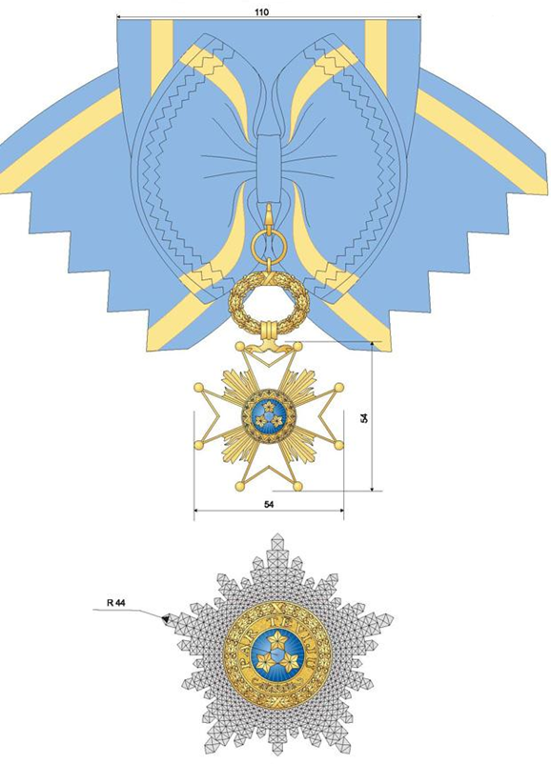

The Order of the Three Stars
the star of the Commander of the Great Cross of the Order and the cross with the ribbon of the Order for gentlemen

Annex 2

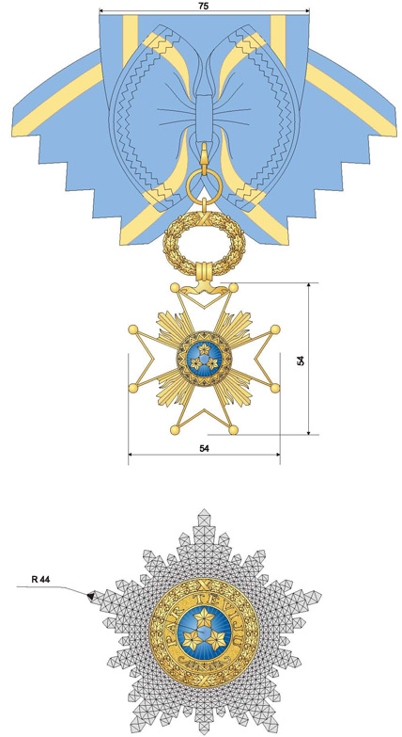

The Order of the Three Stars
the star of the Commander of the Great Cross of the Order and the cross with the ribbon of the Order for ladies

Annex 3
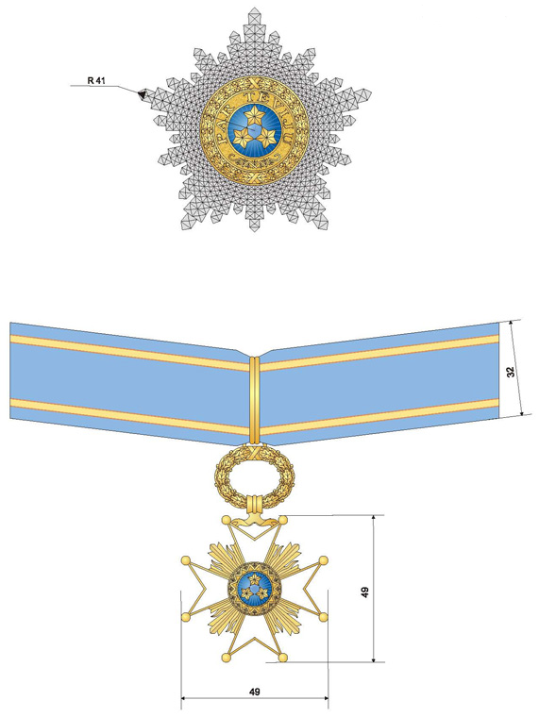

The Order of the Three Stars
the star of the Grand Officer of the Order and the cross with the ribbon of the Order for gentlemen

Annex 4
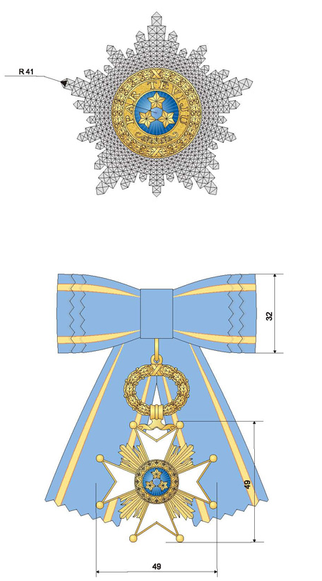

The Order of the Three Stars
the star of the Grand Officer of the Order and the cross with the ribbon of the Order for ladies

Annex 5
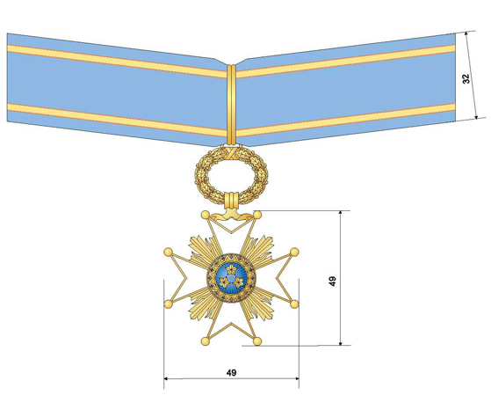

The Order of the Three Stars
the cross of the Commander of the Order with the ribbon of the Order for gentlemen

Annex 6
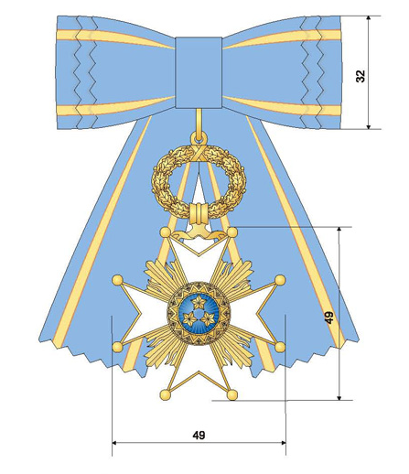

The Order of the Three Stars
the cross of the Commander of the Order with the ribbon of the Order for ladies

Annex 7
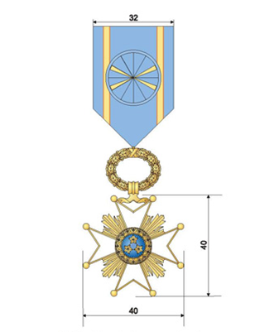

The Order of the Three Stars
the cross of the Officer of the Order with the ribbon of the Order for ladies and gentlemen

Annex 8
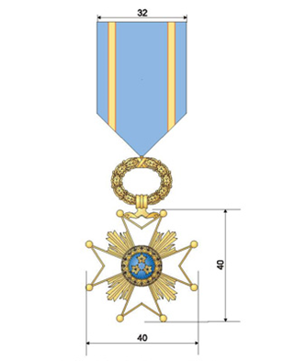
The Order of the Three Stars
the cross of the Bearer of the Order with the ribbon of the Order for ladies and gentlemen

Annex 9
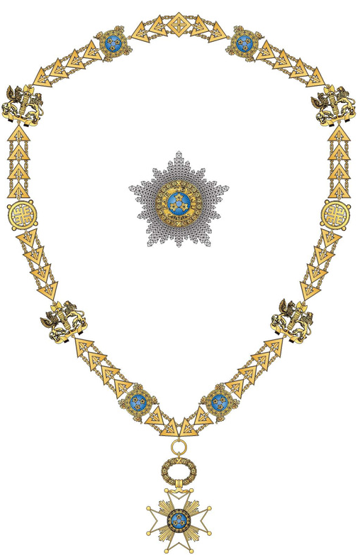

The Chain of the Order of the Three Stars with the Cross of the Order and the Star of the Order

Annex 10
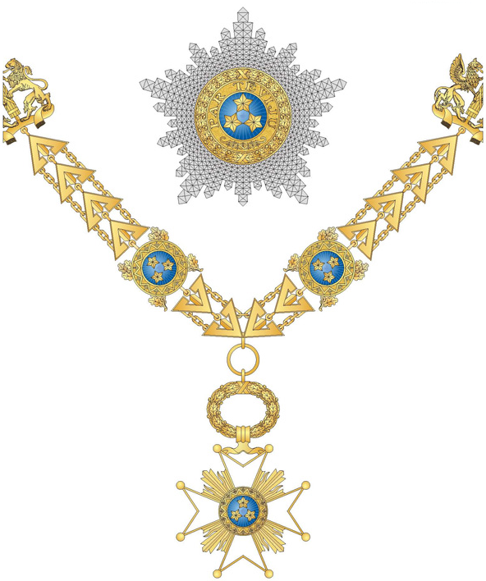

The Chain of the Order of the Three Stars with the Cross of the Order and the Star of the Order
Annex 11
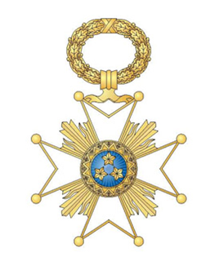

Mark of the Order of the Three Stars – Obverse of the Mark of the Order

Annex 12
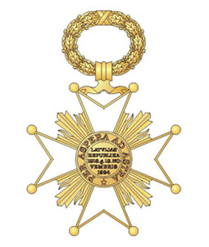

Mark of the Order of the Three Stars – Reverse of the Mark of the Order

Annex 13

First Level  (gilded) | Second Level  (silvered) | Third Level  (bronzed)

Obverse of Medals of Honour of the Order of the Three Stars

Annex 14

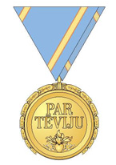

Reverse of Medals of Honour of the Order of the Three Stars

Annex 15

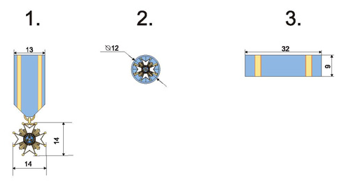

The Order of the Three Stars
Miniature versions:
1. – a miniature mark of the Order
2. – the rosette of the ribbon of the Order
3. – a piece of the ribbon of the Order

Annex 16

First Level  (gilded) | Second Level  (silvered) | Third Level  (bronzed)

Obverse of Miniature Medals of Honour of the Order of the Three Stars and Pieces of the Ribbon of the Order

Annex 17

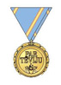

Reverse of Miniature Medals of Honour of the Order of the Three Stars

Annex 18
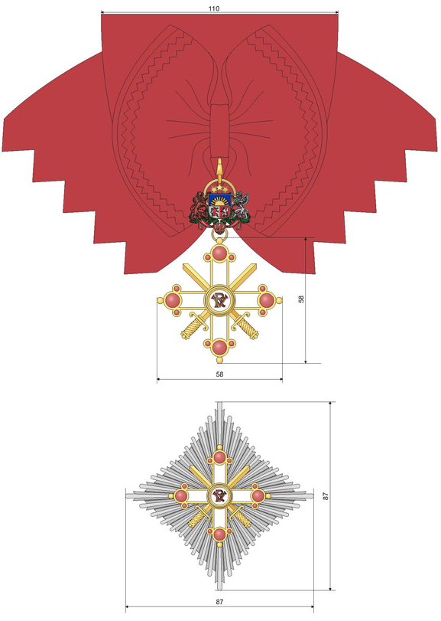

The Order of Viesturs (with Spears)
the star of the Commander of the Great Cross of the Order and the cross with the ribbon of the Order for gentlemen

Annex 19
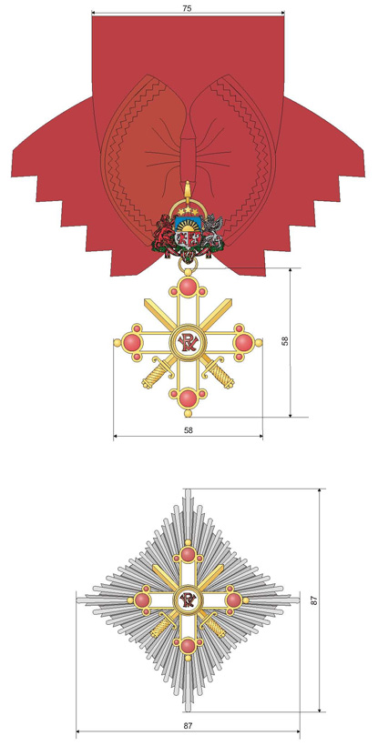

The Order of Viesturs (with Spears)
the star of the Commander of the Great Cross of the Order and the cross with the ribbon of the Order for ladies

Annex 20
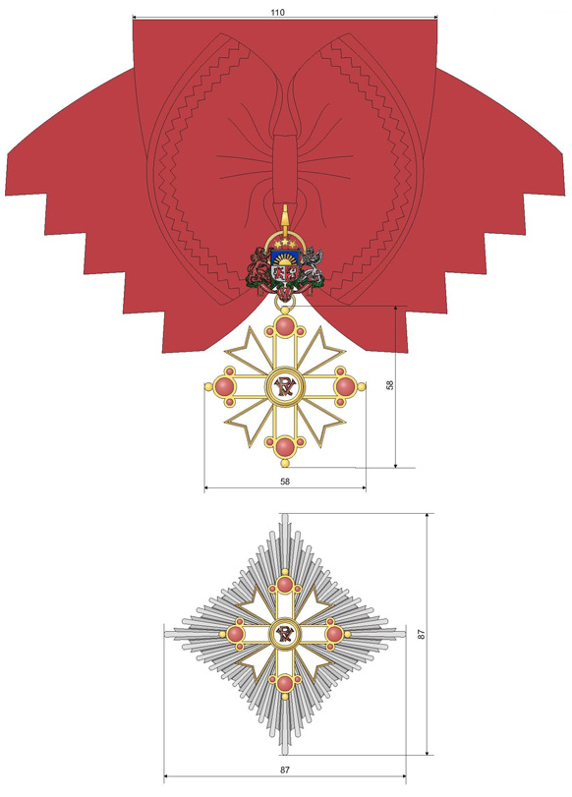

The Order of Viesturs
the star of the Commander of the Great Cross of the Order and the cross with the ribbon of the Order for gentlemen

Annex 21
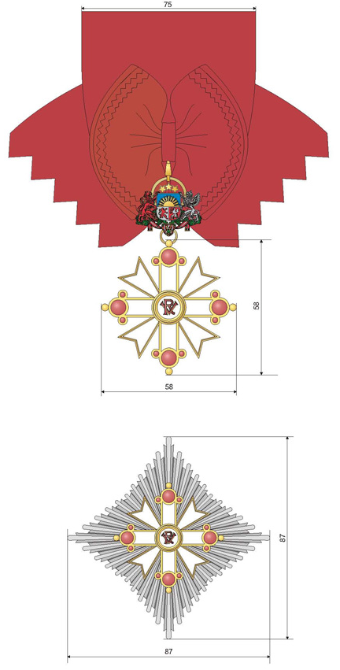

The Order of Viesturs
the star of the Commander of the Great Cross of the Order and the cross with the ribbon of the Order for ladies

Annex 22
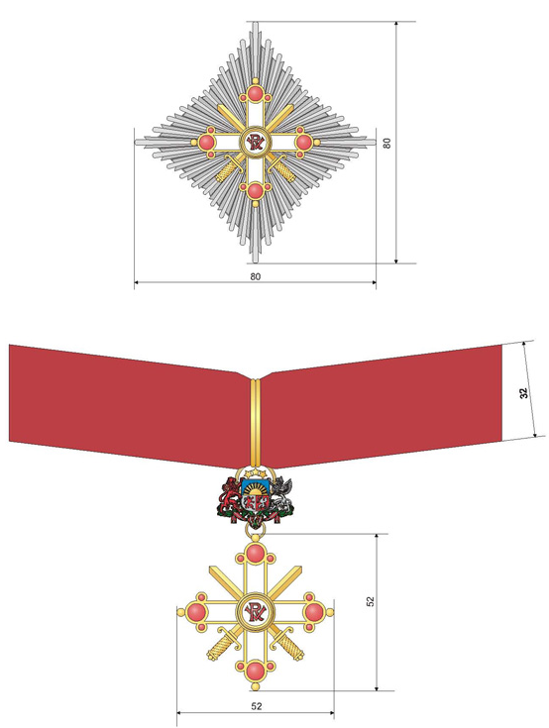

The Order of Viesturs (with Spears)
the star of the Grand Officer of the Order and the cross with the ribbon of the Order for gentlemen

Annex 23
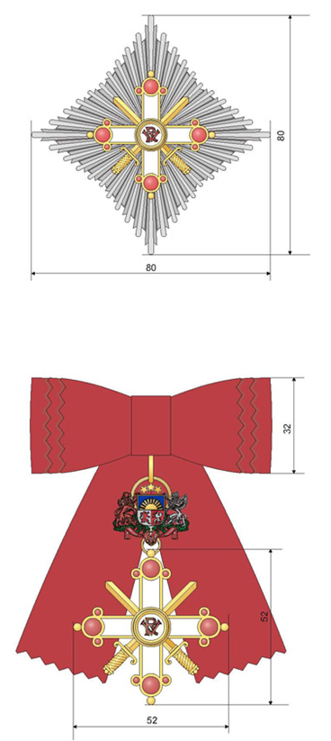

The Order of Viesturs (with Spears)
the star of the Grand Officer of the Order and the cross with the ribbon of the Order for ladies

Annex 24
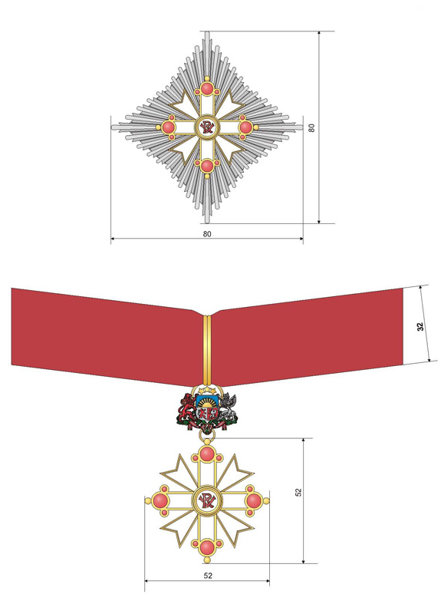

The Order of Viesturs
the star of the Grand Officer of the Order and the cross with the ribbon of the Order for gentlemen

Annex 25

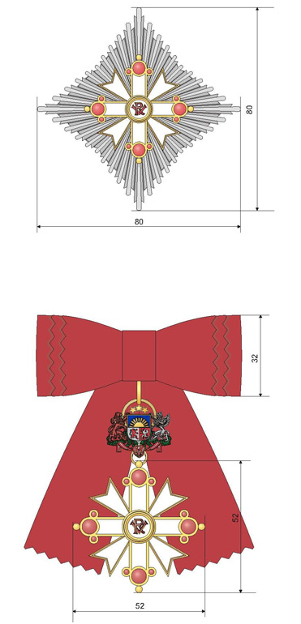

The Order of Viesturs
the star of the Grand Officer of the Order and the cross with the ribbon of the Order for ladies

Annex 26
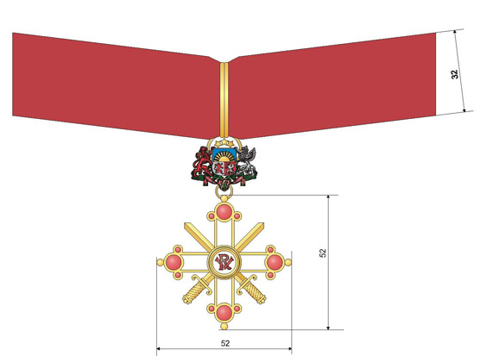

The Order of Viesturs (with Spears)
the cross of the Commander of the Order with the ribbon of the Order for gentlemen

Annex 27

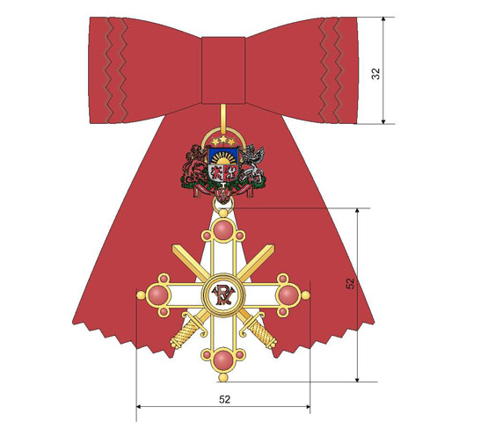

The Order of Viesturs (with Spears)
the cross of the Commander of the Order with the ribbon of the Order for ladies

Annex 28
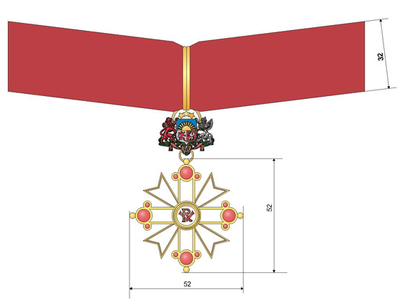

The Order of Viesturs
the cross of the Commander of the Order with the ribbon of the Order for gentlemen

Annex 29
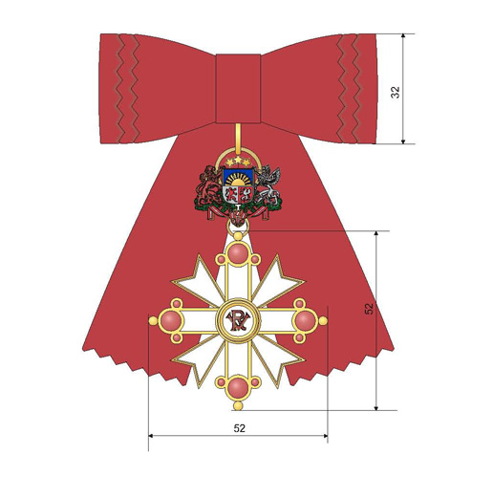

The Order of Viesturs
the cross of the Commander of the Order with the ribbon of the Order for ladies

Annex 30
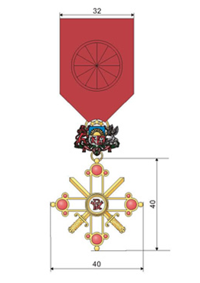

The Order of Viesturs (with Spears)
the cross of the Officer of the Order with the ribbon of the Order for ladies and gentlemen

Annex 31
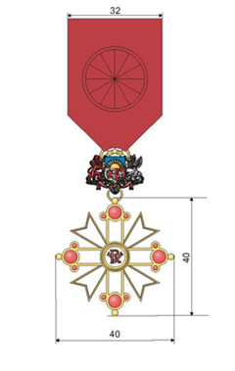

The Order of Viesturs
the cross of the Officer of the Order with the ribbon of the Order for ladies and gentlemen

Annex 32
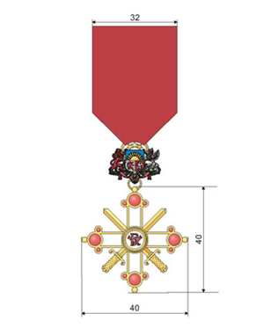

The Order of Viesturs (with Spears)
the cross of the Bearer of the Order with the ribbon of the Order for ladies and gentlemen

Annex 33
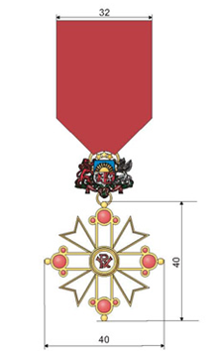

The Order of Viesturs
the cross of the Bearer of the Order with the ribbon of the Order for ladies and gentlemen

Annex 34
Mark of the Order of Viesturs (with Spears) – Obverse of the Mark of the Order |  | Mark of the Order of Viesturs – Obverse of the Mark of the Order

Annex 35
Mark of he Order of Viesturs (with Spears) – Reverse of the Mark of the Order |  | Mark of the Order of Viesturs – Reverse of the Mark of the Order

Annex 36

First Level  (gilded) | Second Level  (silvered) | Third Level  (bronzed)

Obverse of Medals of Honour of the Order of Viesturs (with Spears)

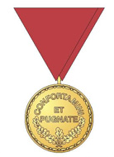

Reverse of All Medals of Honour of the Order of Viesturs

Annex 37

First Level  (gilded) | Second Level  (silvered) | Third Level  (bronzed)

Obverse of Medals of Honour of the Order of Viesturs

Annex 38
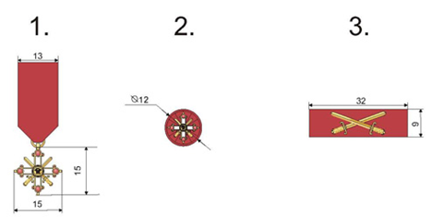

The Order of Viesturs (with Spears)
Miniature versions:
1. – a miniature mark of the Order
2. – the rosette of the ribbon of the Order
3. – a piece of the ribbon of the Order

Annex 39
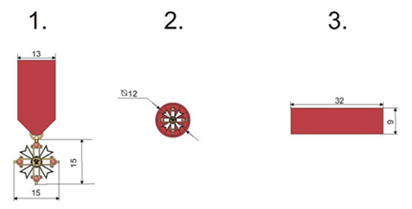

The Order of Viesturs
Miniature versions:
1. – a miniature mark of the Order
2. – the rosette of the ribbon of the Order
3. – a piece of the ribbon of the Order

Annex 40

First Level  (gilded) | Second Level  (silvered) | Third Level  (bronzed)

Obverse of Miniature Medals of Honour of the Order of Viesturs (with Spears) and Pieces of the Ribbon of the Order

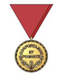

Reverse of All Miniature Medals of Honour of the Order of Viesturs

Annex 41

First Level  (gilded) | Second Level  (silvered) | Third Level  (bronzed)

Obverse of Miniature Medals of Honour of the Order of Viesturs and Pieces of the Ribbon of the Order

Annex 42
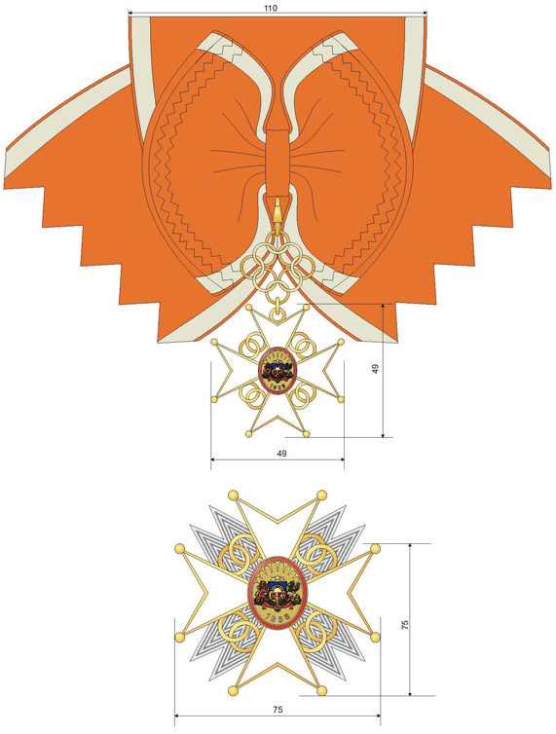

The Cross of Recognition
the star of the Commander of the Great Cross of the Order and the cross with the ribbon of the Order for gentlemen

Annex 43
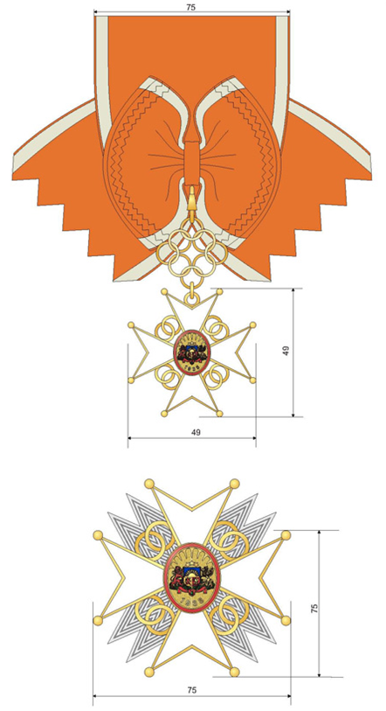

The Cross of Recognition
the star of the Commander of the Great Cross of the Order and the cross with the ribbon of the Order for ladies

Annex 44
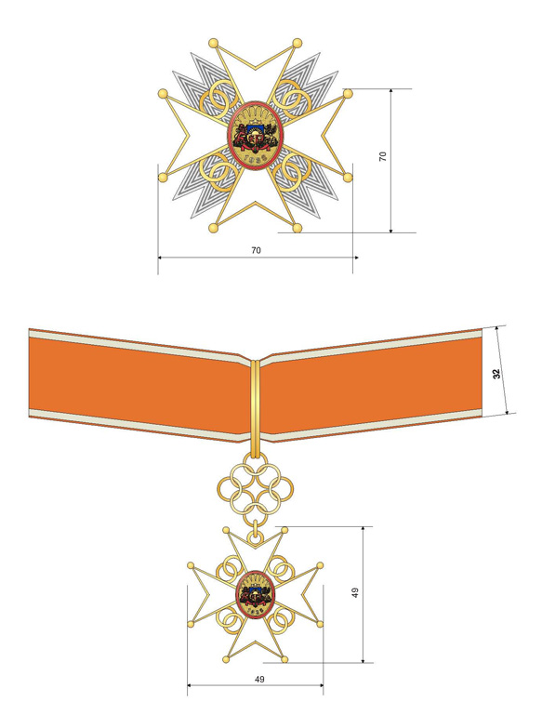

The Cross of Recognition
the star of the Grand Officer of the Order and the cross with the ribbon of the Order for gentlemen

Annex 45

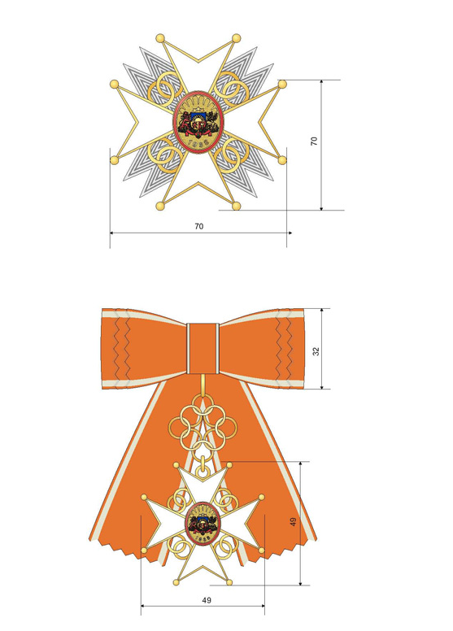

The Cross of Recognition
the star of the Grand Officer of the Order and the cross with the ribbon of the Order for ladies

Annex 46
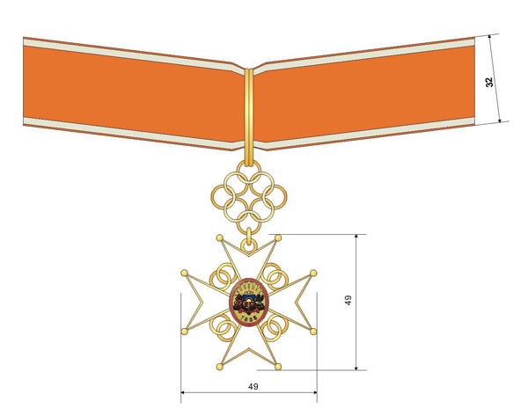
The Cross of Recognition
the cross of the Commander of the Order with the ribbon of the Order for gentlemen

Annex 47
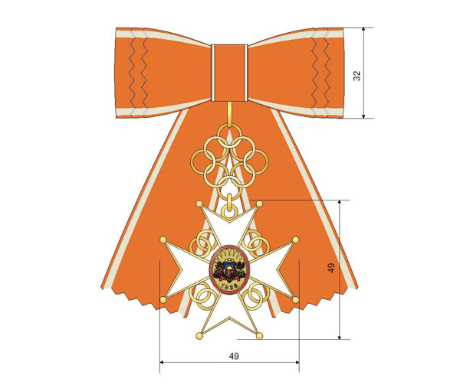

The Cross of Recognition
the cross of the Commander of the Order with the ribbon of the Order for ladies

Annex 48
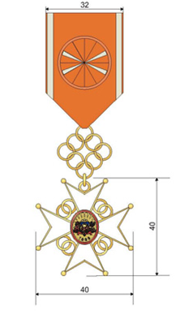

The Cross of Recognition
the cross of the Officer of the Order with the ribbon of the Order for ladies and gentlemen

Annex 49
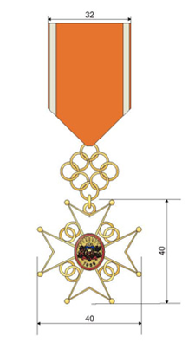

The Cross of Recognition
the cross of the Bearer of the Order with the ribbon of the Order for ladies and gentlemen
Annex 50
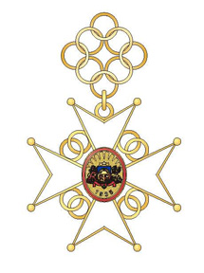

Mark of the Cross of Recognition – Obverse of the Mark of the Order

Annex 51
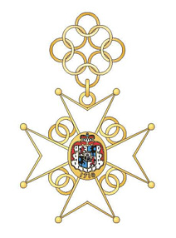

Mark of the Cross of Recognition – Reverse of the Mark of the Order

Annex 52

First Level  (gilded) | Second Level  (silvered) | Third Level  (bronzed)

Obverse of Medals of Honour of the Cross of Recognition

Annex 53
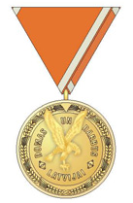

Reverse of Medals of Honour of the Cross of Recognition

Annex 54
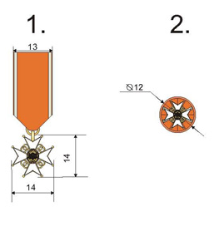
The Cross of Recognition
Miniature versions:
1. – a miniature mark of the Order
2. – the rosette of the ribbon of the Order

Annex 55

First Level  (gilded) | Second Level  (silvered) | Third Level  (bronzed)

Obverse of Miniature Medals of Honour of the Cross of Recognition

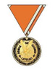

Reverse of Miniature Medals of Honour of the Cross of Recognition

