Text consolidated by Valsts valodas centrs (State Language Centre) with amending regulations of:
8 February 2022 [shall come into force on 12 February 2022].
If a whole or part of a paragraph has been amended, the date of the amending regulation appears in square brackets at the end of the paragraph. If a whole paragraph or sub-paragraph has been deleted, the date of the deletion appears in square brackets beside the deleted paragraph or sub-paragraph.

Republic of Latvia

Cabinet
Regulation No. 92
Adopted 9 February 2016

Regulations Regarding Vessel Traffic Within Internal Waters

Issued pursuant to
Section 48.¹, Paragraph one of the Maritime Administration and Marine Safety Law

1. General Provisions

1. The Regulation prescribes the procedures for the vessel traffic within the internal waters of Latvia, including the requirements for traffic participants and installed navigation signs and lights.

2. The Regulation shall apply to the internal waters of Latvia landwards from the sea coast line (e.g. rivers, lakes) and port areas (hereinafter – the internal waters).

3. Within the meaning of the Regulation:
3.1. vessel – an engineering technical device which is structurally designed for navigation, including:
3.1.1. a ship registered in the Latvian Ship Register of valsts sabiedrība ar ierobežotu atbildību “Latvijas Jūras administrācija” [State limited liability company Maritime Administration of Latvia] (hereinafter – the Maritime Administration) and in the register of valsts akciju sabiedrība “Ceļu satiksmes drošības direkcija” [State joint-stock company Road Traffic Safety Directorate] (hereinafter – the CSDD);
3.1.2. a vessel which, in accordance with the laws and regulations of the Republic of Latvia, need not be registered or the registration of which is voluntary;
3.1.3. a ship flying the flag of another state;
3.2. day – the time of the day from sunrise to sunset;
3.3. night – the time of the day from sunset to sunrise;
3.4. restricted visibility – weather conditions (for example, fog, rain, snow) due to which visibility in the navigation area is limited;
3.5. vessel in motion – a vessel which is not at anchor, or made fast to the shore, or aground;
3.6. minimum speed – the minimum speed at which the vessel retains control under the existing conditions;
3.7. all-round light – a light showing an unbroken light over an arc of the horizon of 360 degrees;
3.8. masthead light – a white light fixed on the diametral plane of the vessel (on the centreline) so as to show the light from right ahead to 22.5 degrees abaft the beam on either side of the vessel and to show an unbroken light over an arc of the horizon of 225 degrees;
3.9. sidelights – a green light on the starboard side and a red light on the port side each showing an unbroken light over an arc of the horizon of 112.5 degrees and so fixed as to show the light from right ahead to 22.5 degrees abaft the beam on its respective side. On a ship of less than 20 metres in length, the sidelights may be combined in one lantern placed on the diametral plane of the ship;
3.10. stern light – a white light placed as nearly as practicable at the stern showing an unbroken light over an arc of the horizon of 135 degrees and so fixed as to show the light 67.5 degrees from right aft on each side of the ship;
3.11. flashing light – a light flashing at regular intervals at a frequency of 120 flashes or more per minute;
3.12. border water area – the area of internal waters along which the state border of the Republic of Latvia has been determined in accordance with international agreements;
3.13. water traffic accident – an event on water in which a vessel has been damaged or lost, a person has died or sustained injuries, losses have been caused to a third person or damage to the environment has been caused;
3.14. the owner or possessor of internal waters – the State or local government, and also a legal person or natural person which has an internal water area in its ownership or possession or which leases it;
3.15. lifejacket – an industrially manufactured vest intended to keep a person afloat.
[8 February 2022]

4. The use of an unregistered vessel in water traffic, regardless of the state whose nationality markings it carries, shall be prohibited, except in the case where a vessel need not be registered or its registration is voluntary in accordance with the laws and regulations of the Republic of Latvia (hereinafter – the laws and regulations).

5. When operating a vessel which is used in the performance of the duties of State services, including control services, derogations from the requirements of the Regulation are permitted (except for the requirements referred to in Paragraph 9, Sub-paragraphs 21.12 and 21.13 of the Regulation and Chapters 6 and 7 of the Regulation) if it is necessary for the performance of service duties and the safety of other water traffic participants is being ensured. A vessel used in the performance of service duties shall be marked and, in so far as it does not interfere with the performance of service duties, equipped with stationary flashing lights and a raised flag of the State.

6. When navigating in a port area, regulations of the relevant ports shall be additionally complied with.

7. The traffic of vessels shall be supervised by the control services referred to in Paragraph 89 of the Regulation according to their competence.

8. Chapter 10 of the Regulation does apply to floating structures.

2. Operator of a Vessel

2.1. Qualification of the Operator of a Vessel

9. A person who has the following has the right to operate the respective vessel:
9.1. a certificate for an operator of small-size vessel, certificate for an operator of recreational craft or international certificate for an operator of recreational craft issued by the CSDD;
9.2. a qualification certificate issued by the Registry of Seamen of valsts sabiedrība ar ierobežotu atbildību “Jūras administrācija” [State limited liability company Maritime Administration] in accordance with the laws and regulations regarding the certification of seafarers;
9.3. an international certificate for an operator of recreational craft issued in accordance with the requirements of Resolution No 40 of the Working Party on Inland Water Transport of the Inland Transport Committee of the United Nations Economic Commission for Europe of 16 October 1998, International Certificate for Operators of Pleasure Craft;
9.4. for a foreigner – a document certifying the qualification of the operator of the vessel which has been issued in accordance with the laws and regulations of the relevant state.
[8 February 2022]

10. Paragraph 9 and Sub-paragraphs 21.4 and 21.5 of the Regulation shall not apply to operators of vessels for which the requirement for the certificate for an operator is not provided in the laws and regulations.

11. International certificates for operators of recreational craft issued by the competent authorities of other countries in accordance with the requirements of Resolution No 40 of the Working Party on Inland Water Transport of the Inland Transport Committee of the United Nations Economic Commission for Europe of 16 October 1998, International Certificate for Operators of Pleasure Craft, shall be recognised in Latvia.

12. A rowing boat may be operated by a person who has reached 14 years of age without the presence of an adult.

2.2. Rights and Duties of an Operator of a Vessel

13. The other rights and duties of an operator of a vessel which, depending on the type of vessel, arise from laws and regulations and international legal acts shall not be affected by the requirements specified in this Sub-chapter.

14. An operator of a vessel shall be obliged to take all measures to ensure safety of navigation, in particular by preventing:
14.1. risks to human life and health;
14.2. hazards to the safety of other vessels, including collisions and accidents of water traffic;
14.3. harm to the environment, coastal facilities or infrastructure.

15. When commencing navigation, the operator of the vessel shall check the technical condition and equipment of the vessel, including:
15.1. the condition of the engine;
15.2. the condition of the hull;
15.3. the life-saving appliances and equipment;
15.4. the navigation lights;
15.5. the steering equipment.

16. The operator of a vessel shall be responsible for the safety of all persons on board the vessel.

17. The operator of a vessel shall ensure that the number of lifejackets on the vessel corresponds to the number of persons on the vessel.

18. The operator of a vessel shall ensure that a person who is on the vessel and who is under 12 years of age is wearing a lifejacket of an appropriate size during transportation.

19. The operator of a vessel has a duty to provide assistance to people who are injured in accidents on water, including in compliance with the procedures specified in Chapter 7 of the Regulation.

20. The operator of a vessel shall be obliged to choose such navigation speed that is safe and does not endanger other water traffic participants.

21. The operator of a vessel shall be prohibited from:
21.1. using a vessel which is not in technical order or is not equipped with the equipment and life-saving appliances specified in the laws and regulations;
21.2. using an unregistered vessel (except when it does not need to be registered or its registration is voluntary in accordance with the laws and regulations);
21.3. using a registered vessel without carrying valid documents certifying the registration;
21.4. operating a vessel without a valid document certifying the qualifications of the operator;
21.5. operating a vessel if the qualification necessary for the operation of the vessel has not been acquired;
21.6. exceeding the load capacity of the vessel or the number of persons allowed to be transported;
21.7. exceeding the permitted navigation speed;
21.8. exceeding the minimum speed in the vicinity of public swimming areas and endangering swimmers;
21.9. operating a vessel in places where it is prohibited;
21.10. anchoring in the fairway, or mooring or standing by navigation signs and berths if they are not intended for the relevant type of vessel;
21.11. placing fishing gear in the fairway;
21.12. operating a vessel or teaching the operating of a vessel:
21.12.1. if the alcohol concentration in the blood exceeds 0.5 per mil;
21.12.2. while under the influence of narcotic, psychotropic, toxic, other substances of intoxication or medicinal products which reduce reaction time and attention;
21.12.3. while being ill or tired to the extent that it may influence the ability of the operator to work and the safety of water traffic;
21.13. using alcoholic beverages, narcotic, psychotropic or other intoxicating substances following a water traffic accident, and also after the vessel has been stopped at the request of the control services referred to in Paragraph 89 of the Regulation until the influence of alcoholic beverages or narcotic, psychotropic or other intoxicating substances is tested, or until the release from such a test. If the operator of a vessel refuses the inspection referred to in this Sub-paragraph, he or she shall be held liable in accordance with the procedures provided in the laws and regulations.

22. The operator of a vessel has a duty to stop the vessel at the request of the control services referred to in Paragraph 89 of the Regulation, and also to present the documents referred to in Sub-paragraphs 90.1, 90.2 and 90.3 of the Regulation.

23. Traffic of vessels in the border water area shall be permitted only during the day by informing the State Border Guard thereof in advance. When travelling through the border water area, the operator and persons on board the vessel must carry a personal identification document which shall be presented at the request of an official of the State Border Guard.

3. Training in Vessel Operations

24. The requirements referred to in this Chapter apply to persons who are undergoing certification in accordance with Sub-paragraph 9.1 of the Regulation.

25. An adult who has the certificate of the operator of the relevant vessel may provide instruction for the operation of a vessel.

26. A person who has attained 14 years of age may be instructed to operate a vessel.

27. A training in vessel operations shall be organised in places where it does not interfere with the common water traffic.

28. The person who is providing instruction on the operation of a vessel shall be in or on the vessel (e.g. on a personal watercraft). Only one person at a time may be instructed to operate a personal watercraft.

29. During the training in vessel operations, the operator of a vessel who provides the instructions shall be responsible for the safety on water.

4. Use of a Vessel

4.1. General Provisions

30. A vessel may participate in water traffic if it corresponds to the requirements specified in the binding laws and regulations, including the requirements for the registration, the technical condition, equipment and crew of a vessel.

31. Vessels registered with the CSDD and also rowing boats not registered with the CSDD shall be equipped in accordance with Annex 1 to the Regulation.

32. In a port, a vessel:
32.1. shall not impede traffic of such vessels which, due to draught, can only navigate in sections of the water area and canals marked by navigational signs and lights (for example, buoys, spar buoys, guidelines, leading lines). If a vessel needs to use such a fairway or canal, it shall remain as close as possible to the right (in the direction of movement) side in order to completely clear the way for a vessel which can only navigate the designated section of the water area. A vessel which, due to draught, can only navigate on designated sections of the water area and canals shall have priority over other vessels;
32.2. may cross a fairway or canal if the passing of vessels is not impeded at right angles to the axis line of the fairway or canal by staying astern of the passing vessel;
32.3. the length of which is less than 20 metres, or a sailing yacht may not impede the passage of a vessel which can only navigate safely within a narrow canal or fairway.

4.2. Safe Speed

33. The operator of a vessel shall choose such speed of the vessel (safe speed) to be able to take effective action in relation to safe navigation in a timely manner, including to be able to stop at a safe distance, avoiding a collision or not causing a threat to other water traffic participants.

34. In determining a safe speed for the vessel, the operator shall in addition take into account the following conditions:
34.1. visibility;
34.2. the traffic volume in the relevant part of the water area;
34.3. the manoeuvrability, especially the distance necessary to bring the vessel to a complete stop;
34.4. at night the presence of background light such as from shore lights or from back scatter of the lights of the vessel;
34.5. the state of wind, sea and current, and the proximity of navigational hazards;
34.6. the draught of the vessel in relation to the available depth of water;
34.7. the installed navigation signs and lights, as well as the requirements included in the relevant port regulations;
34.8. whether the speed of the vessel does not create an accompanying wave which facilitates the washing of the shores.

35. If a vessel uses a radar, the operator thereof shall, when determining a safe speed, additionally take into account the following conditions:
35.1. the parameters and efficiency of the radar equipment;
35.2. any constraints imposed by the range scale of the radar equipment to be used;
35.3. the effect on the operation of radar equipment of the water state, weather and other sources of interference;
35.4. the possibility that vessels, ice and other small-size vessels may not be detected by radar;
35.5. the number, location and movement of the vessels detected by radar.

36. The operating speed of vessels in the areas referred to in Annex 2 to the Regulation may not exceed:
36.1. 18 km/h (10 knots) – in the area of rivers Lielupe–Buļļupe;
36.2. 14 km/h (8 knots) –in the area of rivers Daugava–Buļļupe;
36.3. 18 km/h (10 knots) – in the canal Vecmīlgrāvis;
36.4. 14 km/h (8 knots) – in the area of lakes Ķīšezers-Jugla-Lielais Baltezers;
36.5. 9 km/h (5 knots) – in the area of lakes Lielais Baltezers-Mazais Baltezers;
36.6. 14 km/h (8 knots) – in the river Daugava from the Vanšu Bridge to the Railway Bridge.

4.3. Navigation Under and Near Bridges

37. A vessel shall use the spaces between the pillars of a bridge intended for such purpose to pass under a bridge. Rowing boats may use the space between the pillars of the bridge which is nearest to the bank for passing under bridges.

38. If only one space between the pillars of a bridge is intended for passage and two vessels which can cause interference for one another are approaching at the same time, they shall comply with the following provisions:
38.1. when travelling in opposite directions, the vessel travelling with the current shall be the first to pass under the bridge;
38.2. when travelling in one direction, the vessel on the right shall be the first to pass under the bridge.

39. A vessel shall be prohibited from stopping and standing under bridges or in canals if it interferes with the movement of other vessels.

40. The distance between the highest point of the vessel and the construction of the bridge shall be such that the passage is safe.

5. Navigation Lights, Signs and Sound Signals of a Vessel

5.1. Navigation Lights and Signs

41. A vessel:
41.1. the structure of which provides for the installation of navigational lights and signs shall be equipped in conformity with the Convention on the International Regulations for Preventing Collisions at Sea, 1972 (hereinafter – the COLREG);
41.2. which cannot fulfil a requirement of this Chapter due to its construction shall not apply it.

42. A vessel shall switch on the navigation lights at night and under conditions of restricted visibility.

43. The navigation signs of a vessel shall be exhibited during the day.

44. Power-driven vessels underway shall exhibit:
44.1. the masthead light forward;
44.2. a second masthead light abaft of the vessel and higher than the first masthead light (for a vessel of less than 50 metres in length, this requirement is not mandatory);
44.3. sidelights and stern lights.

45. A power-driven vessel of less than 12 meters in length:
45.1. may exhibit an all-round white light and sidelights instead of the lights referred to in Paragraph 44 of the Regulation;
45.2. may have the masthead light or all-round white light displaced in relation to the diametral plane of the vessel if its fitting on the diametral plane is not practicable. In this case, the sidelights must be combined in a one lantern installed in the diametral plane of the ship or as nearly as practicable to the diametral plane on which the masthead light or all-round white light is fitted.

46. Instead of the lights referred to in Paragraph 44 of the Regulation, a power-driven vessel of less than 7 meters in length whose maximum speed does not exceed 13 km/h (7 knots), may exhibit an all-round white light and, if practicable, also sidelights.

47. A vessel under oars may exhibit the lights referred to in Sub-chapter 5.3 of the Regulation, but if the vessel does not exhibit them, it shall have ready at hand an electric torch or lighted lantern showing a white light which shall be exhibited in sufficient time to prevent a collision.

48. A vessel (even if it is towed) shall exhibit all-round lights or have ready at hand an electric torch or lighted lantern showing a white light which shall be exhibited in sufficient time to prevent a collision when other vessels are approaching.

49. A vessel at anchor shall exhibit at the place where it can be best seen a ball or an object resembling a ball during the day, but at night – an all-round white light, and it shall ensure the maximum possible illumination of the deck.

50. A vessel engaged in underwater works shall exhibit the flag (sign) “A” (ALPHA) (Annex 3) at the place where it can be best seen and shall ensure all-round visibility.

5.2. Sound Signals

51. A vessel of 12 metres or more in length shall be provided with a sound signalling device, a whistle providing short (approximately one second) and prolonged (from four to six seconds) blasts that can be heard at a distance of not less than 900 metres, but a vessel of 20 metres or more in length shall be provided with a bell in addition to a whistle.

52. In conditions of restricted visibility, a power-driven vessel may signal as follows:
52.1. when making way through the water – one prolonged blast at regular intervals of not more than 2 minutes;
52.2. when making no way through the water – two prolonged blasts at regular intervals of not more than 2 minutes.

53. A power-driven vessel underway may, when the other vessel is in sight, confirm its manoeuvre by the following sound signals:
53.1. one short blast – “I am altering my course to starboard”;
53.2. two short blasts – “I am altering my course to port”;
53.3. three short blasts – “I am operating astern propulsion”;
53.4. at least five short and rapid blasts – the intentions or actions of the other vessel cannot be under or there are doubts whether the other vessel is taking sufficient action to avoid a collision.

54. Where vessels are in sight of one another in a narrow channel or fairway, the vessel intending to overtake the other vessel shall confirm this action by the following sound signals:
54.1. two prolonged blasts followed by one short blast which means “I intend to overtake you on your starboard side”;
54.2. two prolonged blasts followed by two short blasts which means “I intend to overtake you on your port side”.

55. The vessel which is about to be overtaken shall give the following signal:
55.1. one prolonged, one short, one prolonged and one short blast if it agrees with the manoeuvre;
55.2. the sound signal referred to in Sub-paragraph 53.4 of the Regulation, if the intentions or actions of the other vessel cannot be understood, or there are doubts whether the other vessel is taking sufficient action to avoid a collision.

5.3. Requirements for Sailing Yachts

56. Sidelights and a sternlight must be exhibited by a sailing yacht underway.

57. In a sailing yacht of less than 20 metres in length, the lights specified in Paragraph 56 of the Regulation may be combined in one lantern (a combined lantern) to be exhibited at or near the top of the mast where it can best be seen.

58. A sailing yacht underway may, in addition to the lights specified in Paragraph 56 of the Regulation, exhibit two all-round lights in a vertical line at or near the top of the mast, where they can best be seen, the upper being red and the lower green, but these lights shall not be exhibited in conjunction with the combined lantern permitted in accordance with Paragraph 57 of the Regulation.

59. A sailing yacht of less than 7 meters in length shall exhibit the lights referred to in Paragraphs 56 and 57 of the Regulation if it is practicable to do so. If a sailing yacht does not exhibit lights, an electric torch or lighted lantern showing a white light must be held ready at hand which shall be exhibited in sufficient time to prevent collision.

6. Prevention of Collisions Between Vessels

6.1. General Provisions

60. When a vessel is in motion, the operator thereof shall ensure a look-out appropriate in the prevailing circumstances (visual, audio, and all other available means) in order to continuously assess the surrounding situation and avoid a collision. If there are any doubts of the existence of a risk of collision, such risk shall be deemed to exist.

61. All available means appropriate to the prevailing circumstances and conditions must be used to determine whether a risk of collision exists for a vessel.

62. Any action to avoid a collision must be taken in a timely manner and must be positive.

63. Any alteration of the course and speed of a vessel which is made to avoid a collision must be large enough (if circumstances so permit) to be readily apparent to another vessel observing visually or by radar. A succession of small alteration of the course and (or) speed must be avoided.

64. In order to avoid collision with another vessel, actions shall be taken to ensure that the vessels can pass each other at a safe distance. The operator of the vessel shall control the action until the other vessel has completely passed by.

65. The most effective action to avoid a dangerous close-quarters situation is the alteration of course, provided that it is made in good time, is sufficient and does not lead to a close-quarters situation with other vessels.

66. If more time is needed to assess the situation in order to avoid a collision, the operator of the vessel shall reduce their speed or stop.

67. If a vessel is approaching a part of the water area with a limited navigation area, the canal limit, the coast, dredgers, stationary vessels, docks, ferries or operational diver vessels, it shall reduce the speed (if necessary, to the minimum speed) to avoid causing dangerous wash.

68. In narrow water areas (such as canals) where the passing of vessels is difficult, a vessel shall remain as close as possible to the right hand side. Overtaking in the areas referred to in Annex 2 to the Regulation shall be prohibited.

69. When two power-driven vessels in sight of one another are meeting on reciprocal or nearly reciprocal courses, both of the vessels shall alter their course to starboard so that each of them would pass at a safe distance on the port side of the other.

70. The situation referred to in Paragraph 69 of the Regulation shall be deemed to exist when a vessel sees the other vessel ahead or nearly ahead and by night it could see the masthead lights of the other vessel in a line or nearly in a line and (or) both sidelights, but by day it could see the corresponding aspect of the other vessel.

71. If two vessels (power-driven) in sight of one another are crossing so as to involve risk of collision, the vessel which has the other on its starboard side shall keep out of the way and shall avoid crossing ahead of the other vessel.

6.2. Conditions for Sailing Yachts

72. When two sailing yachts that see each other are approaching one another, so as to involve risk of collision, they shall comply with the following principles:
72.1. if sailing yachts have wind on different sides, the yacht which has the wind on the port side shall keep out of the way of the other;
72.2. if sailing yachts have wind on the same side, the sailing yacht which is to windward shall keep out of the way;
72.3. a sailing yacht with the wind on the port side which sees another sailing yacht to windward but cannot determine with certainty whether it has the wind on the port side or on the starboard side keep out of the way of the other sailing yacht.

73. The windward side shall be deemed to be the side opposite to that on which the mainsail is carried or, in the case of a square-rigged vessel, the side opposite to that on which the largest fore-and-aft sail is carried.

6.3. Overtaking

74. A vessel being overtaken shall maintain its course and speed during the overtaking manoeuvre. The overtaking vessel must keep at a safe distance from the other vessel.

75. An overtaking vessel is a vessel coming up to another vessel from a direction more than 22.5 degrees abaft her beam, that is, the overtaking vessel in such a position with reference to the vessel being overtaken that at night the overtaking vessel would be able to see only the sternlight of the vessel being overtaken but neither of its sidelights.

7. Actions in the Event of a Water Traffic Accident

76. In the event of a water traffic accident, the operator of the vessel or any other person who has information about the event shall call the single emergency call number 112 or 115.

77. If a person has been injured in a water traffic accident, the operator of the vessel or any other person who is at the scene of the accident shall, after the reporting referred to in Paragraph 76 of the Regulation, immediately:
77.1. provide first aid to the injured person;
77.2. take the injured person to the shore, where possible;
77.3. call for the emergency medical assistance or deliver the injured person to the nearest medical treatment institution.

78. Each person who is at the scene of the accident has the obligation to make every effort to provide first aid to the persons who have suffered in the accident.

8. Navigation Signs, Lights and the Installation Thereof

79. Navigation signs and lights must correspond to the requirements referred to in the Regulation (Annex 3, Chapter I). Other navigation signs and lights may also be installed if they conform with the European Code for Inland Waterways (CEVNI).

80. It is recommended to paint the boards of signs with fluorescent paint.

81. The dimensions of the sign shall be chosen such as to ensure the visibility of the sign within its whole the operational area.

82. The lights used in addition to the signs specified in the Regulation shall be placed on or directly above the board of the respective sign.

83. An owner or possessor of internal waters:
83.1. shall if necessary, fit the internal water area with the navigation signs and lights referred to in Annex 3 of the Regulation;
83.2. shall ensure the illumination of the pillars of the bridge at night if the traffic of vessels takes place in close proximity to the bridge;
83.3. shall ensure the placement of warning signs in the water area where the use of the relevant types of vessels is prohibited;
83.4. shall ensure that navigation signs and lights are continuously maintained in a suitable technical condition;
83.5. shall publish information on such water area where vessel traffic is prohibited and also on the establishment of swimming sites in the official gazette Latvijas Vēstnesis and in the largest periodical of the relevant administrative territory.

84. The fitting of civil engineering structures with navigation signs and lights shall be ensured by the owner or possessor of such structures.

85. The owner or possessor of navigation signs and lights shall agree upon a project for the placement of navigation signs and lights with the Maritime Administration (Annex 3, Chapter I) in the territory of the port and in the following water bodies:
85.1. the river Daugava from the Vanšu Bridge to Dole Island;
85.2. lake Ķīšezers;
85.3. river Buļļupe;
85.4. river Lielupe, from the sea coast line to the Sloka Bridge.
[8 February 2022]

86. In order to agree upon the project for the placement of navigation signs and lights (hereinafter – the project) in the territory of the port, the project developer shall submit the project approved by the harbour master of the relevant harbour to the Maritime Administration.

87. The following information shall be included in the project:
87.1. justification for the need of navigation signs or lights;
87.2. the analysis of existing navigation signs and lights, as well as the surrounding conditions;
87.3. the selection, location and results of the environmental assessment of the navigation signs and lights to be designed;
87.4. the planned operational parameters of the navigation signs and lights to be designed;
87.5. the selection and analysis of navigation signs and lighting equipment (for example, lights, power supplies).

88. The owner or possessor of the navigation signs and lights referred to in Chapter I of Annex 3 to the Regulation shall notify the Maritime Administration in writing about the installation of the navigation signs and lights in the water bodies referred to in Paragraph 85 of the Regulation.

9. Control Services

89. The State Police, the municipal police, the port police (in port areas), the State Environmental Service and the State Border Guard (in port areas and border areas) shall, according to the competence, control compliance with the Regulation. Officials monitoring the traffic of vessels must carry a service certificate which shall be presented upon a request of the operator of a vessel.

90. The control services have the right to stop a vessel and to carry out the inspections specified in the laws and regulations, including to check:
90.1. the vessel registration documents;
90.2. other documents attesting to the qualification of the operator of the vessel;
90.3. a trade certificate of the vessel (if such is issued to the vessel in accordance with the laws and regulations);
90.4. the conformity of the equipment of the vessel with Annex 1 to the Regulation (shall apply to vessels registered by the CSDD, and also to rowing boats not registered in the CSDD register).

91. When inspecting a vessel, the control services shall not pose a threat to the vessel and other water traffic participants.

10. Requirements for Floating Structures

92. Owners of floating structures shall ensure that floating structures are illuminated at night and also under conditions of restricted visibility.

93. The requirements referred to in Sub-chapter 5.1 of the Regulation shall apply to a moving floating structure underway.

94. The position of the floating structure may not interfere with the safety of other water traffic participants.

10.¹ Registration and Approval of Navigation Time and Journeys Carried Out in Service Record Book
[8 February 2022]

94.¹ This Chapter applies to crew members on the following craft:
94.¹ 1. vessels having a length of 20 metres or more;
94.¹ 2. vessels for which the product of length, breadth and draught is a volume of 1000 cubic meters or more;
94.¹ 3. tugs and pushers intended:
94.¹ 3.1. for towing or pushing the vessels referred to in Sub-paragraphs 94.¹ 1 and 94.¹ 2 of the Regulation;
94.¹ 3.2. for towing or pushing floating equipment;
94.¹ 3.3. for moving vessels or floating equipment moored alongside which are referred to in Sub-paragraphs 94.¹ 1 and 94.¹ 2 of the Regulation;
94.¹ 4. passenger vessels;
94.¹ 5. floating equipment.
[8 February 2022]

94.² This Chapter does not apply to persons who:
94.² 1. are navigating for sports or recreational purposes;
94.² 2. are engaged in the operation of such ferries which do not move independently;
94.² 3. are engaged in the operation of craft used by the armed forces, forces of public order, civil protection service, water transport administration, fire department and other emergency services.
[8 February 2022]

94.³ Within the meaning of this Chapter:
94.³ 1. inland waterway – a waterway in the internal waters referred to in Paragraph 2 of the Regulation which is open to navigation by craft referred to in Paragraph 94.¹ of the Regulation;
94.³ 2. service record book – a personal register that records details of a crew member’s work history – navigation time and carried out journeys in accordance with the legal provisions of another Member State of the European Union which take over the requirements of Directive (EU) 2017/2397 of the European Parliament and of the Council of 12 December 2017 on the recognition of professional qualifications in inland navigation and repealing Council Directives 91/672/EEC and 96/50/EC (hereinafter – Directive 2017/2397), issued in the Member State of the European Union or issued in another foreign state and recognised by the European Commission in accordance with the requirements of Directive 2017/2397;
94.³ 3. navigation time – the time, measured in days, that a deck crew member has spent aboard during a journey on a craft on inland waterways, including loading and unloading activities that require active navigational operations;
94.³ 4. deck crew member – a person who is engaged in the general operation of a craft navigating on inland waterways and who carries out various tasks (for example, tasks related to navigation, controlling the operation of the craft, cargo handling, stowage, passenger transport, marine engineering, maintenance and repair, communication, health and safety, and environmental protection), other than a person who is solely assigned to the operation of the engines, cranes, or electrical and electronic equipment;
94.³ 5. craft – a vessel or floating equipment;
94.³ 6. tug – a vessel specially built to perform towing operations;
94.³ 7. pusher –a vessel specially built to propel a pushed convoy;
94.³ 8. passenger vessel – a vessel constructed and equipped to carry more than 12 passengers;
94.³ 9. floating equipment – a floating installation carrying working gear such as cranes, dredging equipment, pile drivers or elevators;
94.³ 10. length – the maximum length of the hull in metres, excluding rudder and bowsprit;
94.³ 11. breadth – the maximum breadth of the hull in metres, measured to the outer edge of the shell plating (excluding paddle wheels, rub rails, and similar);
94.³ 12. draught – the vertical distance in metres between the lowest point of the hull, without taking into account the keel or other attached equipment, and the maximum draught line.
[8 February 2022]

94.⁴ Upon receipt of the relevant request from a deck crew member, the master of the craft shall register the navigation time and carried out journeys in the service record book of the respective deck crew member. The entries in the book shall be made in accordance with the requirements laid down in Annex II or Annex IV to Commission Implementing Regulation (EU) No 2020/182 of 14 January 2020 for samples in the field of professional qualifications for inland navigation.
[8 February 2022]

94.⁵ The Maritime Administration and the Ministry of Transport shall cooperate with other Member States of the European Union in order to ensure the validation of the navigation time and carried out journeys registered in the service record book of a deck crew member in accordance with the legal provisions of the relevant Member State of the European Union by which the requirements of Directive 2017/2397 have been taken over.
[8 February 2022]

94.⁶ The Maritime Administration shall identify and the Ministry of Transport shall notify to the European Commission of the inland waterways which have a maritime character. A justification based on the criteria referred to in Paragraph 94.⁷ of the Regulation shall be appended to the notice.
[8 February 2022]

94.⁷ The section of the inland waterway shall be classified as an inland waterway of a maritime character if it meets at least one of the following criteria:
94.⁷ 1. the Convention on the International Regulations for Preventing Collisions at Sea, 1972, is applied thereon;
94.⁷ 2. the buoys and signs therein conform with the system used at sea;
94.⁷ 3. terrestrial navigation is necessary therein;
94.⁷ 4. such marine navigation equipment needs to be used the operation of which requires special knowledge.
[8 February 2022]

11. Other Conditions

95. When riding a personal watercraft, sailing a sailboard, doing water skiing or similar water sports, a person must wear a lifejacket.

96. The organisation of sports competitions or other public events in water area, and also the procedures for the traffic of vessels during these events, shall be agreed upon with the owner or possessor of internal waters and, when it concerns border water areas, also with the State Border Guard.

97. Deviations from the requirements specified in the Regulation for safe speed, equipment, navigation under and in the vicinity of bridges and overtaking shall be allowed in events organised by the relevant water sports or non-governmental organisations (for example, in competitions, trainings, public events), if the organisers thereof ensure the safety of water traffic.

12. Closing Provisions

98. Cabinet Regulation No. 158 of 1 March 2005, Regulations Regarding the Traffic of Vessels in Internal Waters (Latvijas Vēstnesis, 2005, No. 46, 137; 2009, No. 33; 2010, No. 80; 2014, No. 47), is repealed.

99. The Regulation shall come into force on 1 May 2016.

Informative Reference to the European Union Directive
[8 February 2022]

The Regulation contains legal norms arising from Directive (EU) 2017/2397 of the European Parliament and of the Council of 12 December 2017 on the recognition of professional qualifications in inland navigation and repealing Council Directives 91/672/EEC and 96/50/EC.

Prime Minister Laimdota Straujuma

Acting for the Minister for Transport, Minister for the Interior Rihards Kozlovskis

Annex 1
Cabinet Regulation No. 92
9 February 2016

Equipment

This Annex (except for the requirement for a lifejacket referred to in Sub-paragraph 1.2) shall not apply to the following types of rowing boats: canoe, kayak, SUP board, academic (sports) rowing boat.

No. | Name of equipment | Vessel
 |  | unit of measurement | rowing boat¹ | motor boat and specialised craft | cruiser
1. | Life-Saving Appliances
1.1. | lifebuoy¹ (ring or horseshoe)
1.1.1. | if the length of the vessel² is less than 7 metres | units | 1  (except for the condition referred to in Note 2) | 1 | 1
1.1.2. | if the length of a vessel is 7 metres and more | units | 1 | 1 | 2
1.2. | lifejacket ^{3, 4} | units | ⁶ | ⁶ | ⁶
2. | Fire Extinguishing Equipment
2.1. | fire extinguisher
2.1.1. | if the length of a vessel is less than 7 metres | units | – | – | 1
2.1.2. | if the length of a vessel is 7 metres and more | units | – | 1 | 2
3. | Navigation Equipment
3.1. | compass | units | – | – | 1
4. | Bilge Pumping Equipment
4.1. | bilge water pump | units | – | – | 1
4.2. | bucket, shovel or hand water pump | units | 1 | 1 | 1
5. | Other Equipment
5.1. | anchor with chain or cable | units | – | – | 1
5.2. | first aid kit | units | 1 | 1 | 1
5.3. | waterproof electric torch | units | 1 | 1 | 1
5.4. | knife⁵ | units | 1 | 1 | 1
5.5. | oars | units | 1 (at least) | 1 (at least) | 1 (at least)

Notes.
¹ Lifebuoy is industrially manufactured and intended to hold a person afloat.
² Rowing boats of up to 4 metres in length are not subject to the requirement for a lifebuoy.
³ A certified flotation suit equivalent to the lifejacket (a suit that keeps a person afloat) which must be worn when on board the vessel may be used instead of a lifejacket.
⁴ Requirement for a lifejacket is not mandatory for an academic (sports) rowing boat if it is followed by an accompanying boat with a means of communication (telephone) and appropriate number of life-saving appliances.
⁵ A knife with which it is possible, for example, to untie knots, to cut the ropes.
⁶ The number of lifejackets must correspond to the number of people on board the respective vessel.

Acting for the Minister for Transport, Minister for the Interior Rihards Kozlovskis

Annex 2
Cabinet Regulation No. 92
9 February 2016

Areas with Speed Limits and Coordinates of Their Points

Point number | WGS 84 |  | LKS 92
 | latitude | longitude | X coordinate | Y coordinate
Lielupe-Buļļupe (Figure 1)
1. | 57° 00.077'N | 23° 55.764'E | 6317531.135 | 495711.591
2. | 57° 00.076'N | 23° 56.144'E | 6317529.259 | 496095.824
3. | 56° 59.902'N | 23° 56.956'E | 6317205.626 | 496918.387
4. | 56° 59.786'N | 23° 56.951'E | 6316989.376 | 496912.486
5. | 56° 59.431'N | 23° 56.372'E | 6316332.700 | 496325.612
6. | 56° 59.430'N | 23° 55.842'E | 6316330.812 | 495789.072
Daugava–Buļļupe (Figure 2)
1. | 57° 03.077'N | 24° 02.444'E | 6323095.109 | 502471.203
2. | 57° 03.072'N | 24° 02.594'E | 6323085.588 | 502622.408
3. | 57° 03.028'N | 24° 02.619'E | 6323003.771 | 502648.135
4. | 57° 02.379'N | 24° 03.681'E | 6321801.806 | 503722.849
5. | 57° 02.322'N | 24° 03.708' E | 6321695.067 | 503750.566
6. | 57° 01.685'N | 24° 01.706'E | 6320511.590 | 501725.972
7. | 57° 01.757'N | 24° 01.597'E | 6320645.355 | 501615.439
Vecmīlgrāvis (Figure 3)
1. | 57° 02.128'N | 24° 07.892'E | 6321341.251 | 507982.762
2. | 57° 02.150'N | 24° 07.939'E | 6321382.719 | 508030.304
3. | 57° 02.189'N | 24° 08.281'E | 6321456.152 | 508375.649
4. | 57° 02.050'N | 24° 08.387'E | 6321198.099 | 508483.887
5. | 57° 01.840'N | 24° 07.889'E | 6320807.293 | 507980.683
6. | 57° 01.908'N | 24° 07.790'E | 6320932.849 | 507880.086
Ķīšezers-Juglas Ezers-Lielais Baltezers (Figure 4)
1. | 57° 01.148'N | 24° 16.595'E | 6319550.661 | 516793.498
2. | 57° 01.086'N | 24° 16.694'E | 6319435.481 | 516893.377
3. | 57° 00.256'N | 24° 12.915'E | 6317881.342 | 513074.581
4. | 57° 00.157'N | 24° 13.018'E | 6317698.715 | 513179.032
5. | 57° 00.287'N | 24° 13.351'E | 6317940.232 | 513515.432
6. | 57° 00.281'N | 24° 13.372'E | 6317929.652 | 513537.405
7. | 57° 00.052'N | 24° 13.201'E | 6317503.019 | 513365.322
8. | 57° 00.044'N | 24° 13.214'E | 6317488.348 | 513378.934
9. | 56° 49.512'N | 24° 15.151'E | 6316508.353 | 515342.848
10. | 56° 59.539'N | 24° 15.265'E | 6316558.583 | 515458.324
Lielais Baltezers-Mazais Baltezers (Figure 5)
1. | 57° 02.500'N | 24° 18.698'E | 6322068.081 | 518909.945
2. | 57° 02.416'N | 24° 18.752'E | 6321911.365 | 518965.179
3. | 57° 02.462'N | 24° 19.203'E | 6321998.488 | 519421.120
4. | 57° 02.398'N | 24° 19.206'E | 6321881.038 | 519424.977
Daugava-Tilti (Figure 6)
1. | 56° 57.031'N | 24°05.488'E | 6311881.667 | 505563.926
2. | 56° 57.113'N | 24° 05.896'E | 6312033.398 | 505977.445
3. | 56° 56.606'N | 24° 06.579'E | 6311094.372 | 506670.778
4. | 56° 56.366'N | 24° 06.012'E | 6310647.985 | 506096.474
5. | 56° 56.913'N | 24° 05.576'E | 6311662.436 | 505652.811
6. | 56° 56.974'N | 24° 05.523'E | 6311774.822 | 505599.117

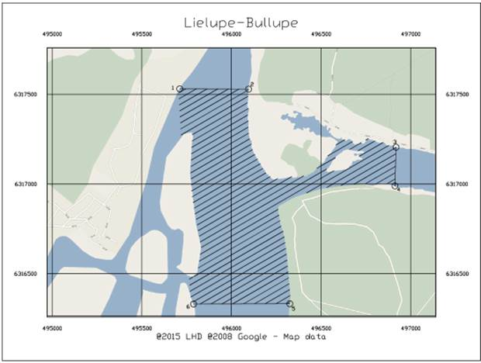

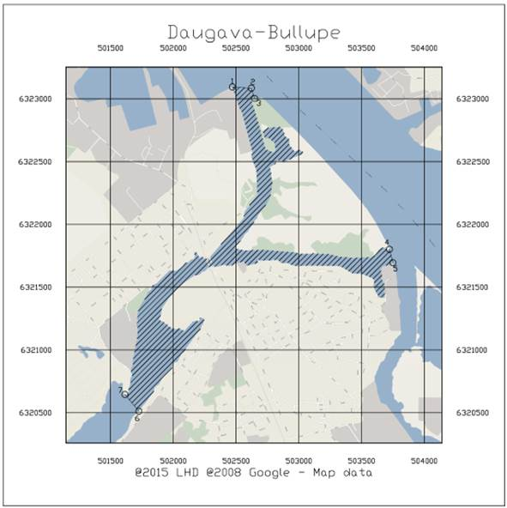

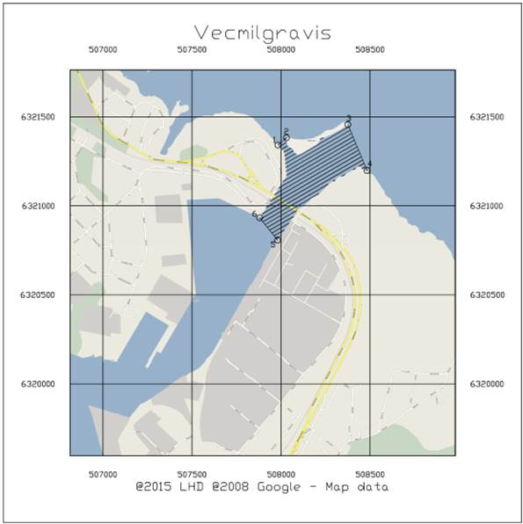

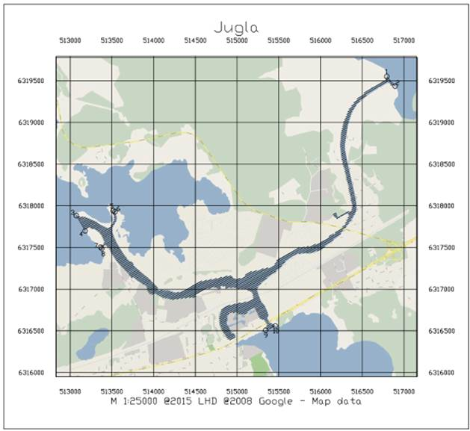

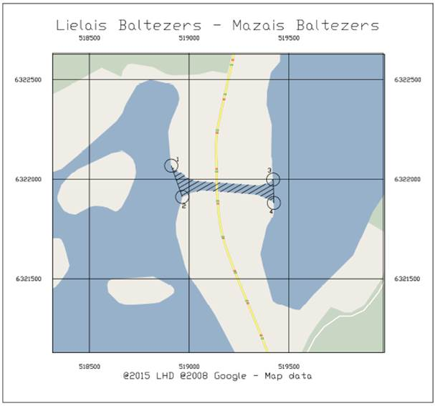

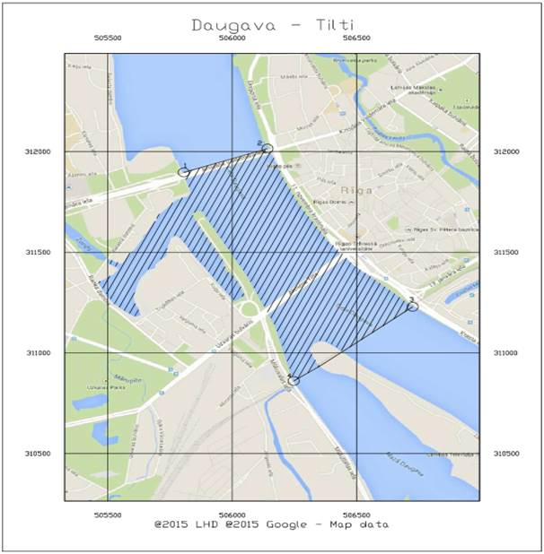

Acting for the Minister for Transport, Minister for the Interior Rihards Kozlovskis

Annex 3
Cabinet Regulation No. 92
9 February 2016

Navigation Signs and Lights

I. Navigation Signs and Lights for Internal Waters

1. Prohibitory signs determine certain water traffic limitations

No. | Name of sign | Description of sign | Marking by day | Marking by night
1.1. | No anchoring | For example, it is prohibited to drop anchor |  | Illuminated
1.2. | No entry for vessels | Navigation ahead is prohibited for vessels. At night this sign is marked by two fixed red lights mounted one above the other
1.3. | Do not create wash | Vessels must travel at such speeds that do not cause wash. At night this sign is marked by two lights mounted one above the other: top – red; bottom – white
1.4. | Motorised craft prohibited | Navigation ahead with motor driven vessels is prohibited |  | Illuminated
1.5. | All sports or recreational craft prohibited | Navigation with sports or recreational craft is prohibited |  | Illuminated
1.6. | Water skiing prohibited | All types of water skiing are prohibited |  | Illuminated
1.7. | Navigation for yachts and other vessels intended for sailing mainly by sails prohibited | Navigation for yachts and other vessels intended for sailing mainly by sails is prohibited |  | Illuminated
1.8. | All vessels other than motorized vessels or sailing craft prohibited | Use of all vessels, except for motorized vessels or sailing craft, are prohibited | 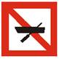 | Illuminated
1.9. | Use of sailboards prohibited | Use of sailboards prohibited |  | Illuminated
1.10. | No launching or beaching of vessels | No launching or beaching of vessels | 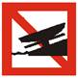 | Illuminated
1.11. | Personal watercrafts prohibited | Personal watercrafts prohibited |  | Illuminated
1.12. | Do not exceed the speed indicated (in km/h) | Do not exceed the speed indicated (in km/h) | 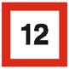 | Illuminated
1.13. | No anchoring or making fast to the bank | No anchoring or making fast to the bank |  | Illuminated
1.14. | No mooring | No mooring |  | Illuminated

2. Warning signs warn operators about the characteristics of water traffic and determine the water traffic regime

No. | Name of sign | Description of sign | Marking by day | Marking by night
2.1. | Keep a particularly sharp lookout | Indicate a section of a body of internal waters where particular caution is necessary |  | Illuminated
2.2. | Height of the bridge or overpass | Indicate a limited headroom to a bridge or overpass. Number indicates the distance in metres from the mean water level to the lower edge of the overpass |  | Illuminated
2.3. | Depth of water limited in meters | The number indicates the maximum permissible draught of a vessel at the specified section of the fairway in metres (reference from the mean water level) |  | Illuminated
2.4. | No passing outside the area marked | The sign is placed on the bridge supports or sections of the bridge overpass between which the fairway passes |  | The bridge supports are illuminated at night. The light source (spotlight) ray must be directed perpendicular to the surface of the water and must not interfere with the visibility of other navigation lights
2.5. | Proceed in the direction shown by the arrow | Indicates the direction of the movement of vessels | 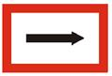 | Illuminated
2.6.a | Obligation to enter into a radiotelephone link | Obligation to enter into a radiotelephone link |  | Illuminated
2.6.b | Obligation to enter into a radiotelephone link on the channel indicated on the sign | Obligation to enter into a radiotelephone link on the channel indicated on the sign | 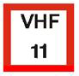 | Illuminated
2.7. | Width of fairway or channel limited | The width of the fairway or canal is indicated by a number at the centre of the sign | 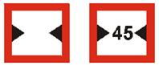 | Illuminated

3. Leading lines indicate the axis of the fairway. The leading line is formed by two cross-over markings placed one behind the other, and the first marking is positioned lower than the second one. The cross-over marks indicate at what point the fairway passes from one bank to another.

No. | Name of mark | Description of mark | Marking by day | Marking by night
3.1. | Leading line and cross-over mark | A yellow diamond mark with a central vertical black stripe shall be installed on the left bank of internal waters. Each mark shall be fitted with a yellow flashing or occulting light lit at night with an odd-number characteristic other than the rhythm of three flashes.
3.2. | Leading line and cross-over mark | A square yellow mark with a central vertical black stripe shall be installed on the right bank of internal waters. This mark shall be fitted with a yellow flashing or occulting light lit at night with an even-number characteristic other than the rhythm of two flashes. | 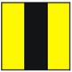

4. The bank marks on the bank indicate that the fairway may be positioned near the bank where the corresponding bank mark is placed.

No. | Name of mark | Description of mark | Marking by day | Marking by night
4.1. | Bank mark | A white square mark with a horizontal wide red stripe in the centre shall be installed on the right bank of the body of internal waters. This mark shall be fitted with a red light continuously lit at night.
4.2. | Bank mark | A two-colour combined diamond mark the upper triangle of which is green and the lower is white shall be installed on the left bank of the body of internal waters. This mark shall be fitted with a green light continuously lit at night.

5. Buoys indicate fairway limits

No. | Name of mark | Description of mark | Marking by day | Marking by night
5.1. | Buoys | Red cylindrical buoy with a flashing rhythmic red light which is lit at night indicates the right-hand side of the fairway | 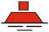
5.2. | Buoys | Green conical buoy with a flashing rhythmic green light which is lit at night indicates the left-hand side of the fairway

6. Fixed marks delineate dangerous areas and navigational obstacles

No. | Name of mark | Description of mark | Marking by day | Marking by night
6.1. | Fixed mark | Red fixed mark delineates dangerous areas and navigational obstacles to the right of the fairway |  | Unlit
6.2. | Fixed mark | Green fixed mark delineates dangerous areas and navigational obstacles to the left of the fairway |  | Unlit
6.3. | Fixed mark | The mark delineates dangerous areas and navigational obstacles that divide the fairway into two parts |  | Unlit

7. Informative signs

No. | Name of sign | Description of sign | Marking by day | Marking by night
7.1. | Launching or beaching of a vessel permitted | Launching or beaching of a vessel permitted |  | Unlit
7.2. | Personal watercrafts permitted | Personal watercrafts permitted |  | Unlit
7.3. | Making fast to the bank permitted | The sign shall be installed in places where the anchoring of a vessel or making fast of a vessel to the bank is permitted |  | Illuminated
7.4. | Use of motorboats permitted | Use of motorboats permitted |  | Unlit
7.5. | Use of sailboards permitted | Use of sailboards permitted |  | Unlit
7.6. | Navigation permitted for yachts and other vessels intended for sailing mainly by sails | Navigation permitted for yachts and other vessels intended for sailing mainly by sails |  | Unlit
7.7. | Water skiing permitted | All types of water skiing permitted |  | Unlit
7.8. | Sports or recreational craft permitted | Navigation with sports or recreational craft is permitted |  | Unlit
7.9. | Motorised vessels permitted | Navigation permitted for motor driven vessels |  | Unlit
7.10. | Drinking water supply point | Drinking water supply point |  | Unlit
7.11. | Telephone | Telephone |  | Unlit
7.12. | End of a prohibition or obligation applying to traffic in one direction only, or end of a restriction | End of a prohibition or obligation applying to traffic in one direction only, or end of a restriction |  | Unlit
7.13. | Possibility of obtaining nautical information by radio-telephone on the channel indicated | Possibility of obtaining nautical information by radio-telephone on the channel indicated |  | Unlit
7.14. | Berthing permitted on the stretch of water bounded by the two distances measured from, and shown on the board | Berthing permitted on the stretch of water bounded by the two distances measured from, and shown on the board |  | Unlit
7.15. | Berthing permitted on the stretch of water of the breadth measured from, and shown on the board | Berthing permitted on the stretch of water of the breadth measured from, and shown on the board |  | Unlit
7.16. | Maximum number of vessels permitted to berth abreast (side by side) | Maximum number of vessels permitted to berth abreast (side by side) |  | Unlit
7.17. | Vessels other than motorized vessels or sailing craft permitted | Vessels other than motorized vessels or sailing craft permitted |  | Unlit

8. Example of sign installation

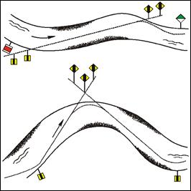

II. Ship Navigation Signs and Lights

The figures in this Chapter are illustrative in nature.

Figure 1.

A power-driven vessel of more than 50 metres in length underway in conformity with Paragraph 44 of the Regulation

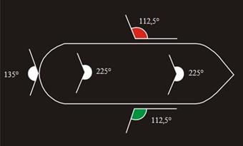

Figure 2.

A power-driven vessel of less than 12 metres in length underway in conformity with Paragraph 45 of the Regulation

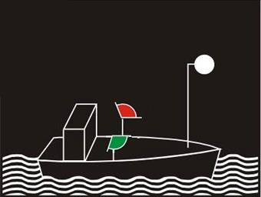

Figure 3.

A power-driven vessel of less than 7 metres in length underway and the maximum speed of which does not exceed 13 km/h in conformity with Paragraph 46 of the Regulation

Figure 4.

Vessel anchored in conformity with Paragraph 49 of the Regulation

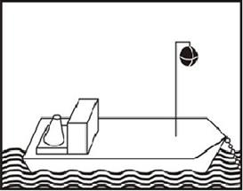 | 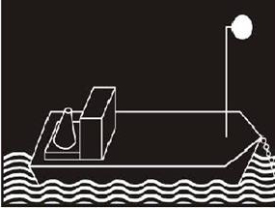
day | night

Figure 5.

Vessel engaged in underwater works in conformity with Paragraph 50 of the Regulation

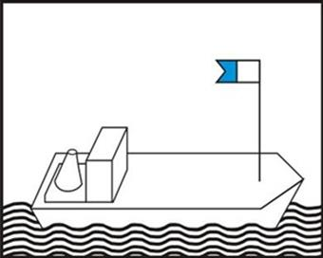

Figure 6.

Sailing yacht in conformity with Paragraph 56 of the Regulation

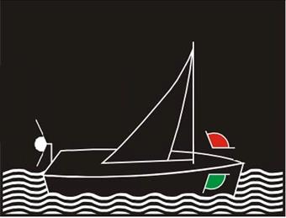

Figure 7.

Sailing yacht of less than 20 metres in length in conformity with Paragraph 57 of the Regulation

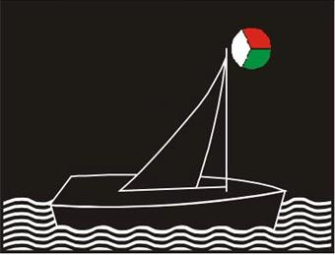

Acting for the Minister for Transport, Minister for the Interior Rihards Kozlovskis

