Republic of Latvia

Cabinet
Regulation No 1042
Adopted 27 December 2005

Regulations Regarding Specific Stability Requirements for Ro-Ro Passenger Ships

Issued pursuant to
Section 14, Paragraph one, Clause 3
of the Law on Structure of the Cabinet

I. General Provisions

1. These Regulations prescribe specific stability requirements (Annex 1) for ro-ro passenger ships (as specified in Regulation II-2/3 of the 1974 International Convention for the Safety of Life at Sea and Protocol of year 1988 thereof as amended (hereinafter – the SOLAS Convention) and which carry more than 12 passengers (every person, except the master, the members of the crew or other persons who are employed in any capacity or are hired on the ship for the needs of such ship, and children under one year of age)) regardless of the flag of such ships, which ensure regular service in international voyages from or to the ports of Latvia in order to improve the survivability of such type of ships following collision damage and ensure a high safety level of passengers and crew.

2. The Maritime Safety Inspectorate (hereinafter – Inspectorate) of the State stock company Latvijas Jūras administrācija [Maritime Administration of Latvia] (hereinafter – Maritime Administration of Latvia) or a recognised ship classification society, with which the Maritime Administration of Latvia has entered into an authorisation contract (hereinafter – classification society), shall inspect ro-ro passenger ships upon commencing voyages from or to the ports of Latvia so that they fully comply with the requirements of these Regulations.

II. Significant Wave Height

3. The significant wave height (hs) (the average height of the highest third of wave heights observed over a given period) shall be used for determining the height of water level on the car deck in applying the requirements specified in Annex 1 of these Regulations. The figures of significant wave height shall be determined as those, which are not exceeded by a probability of more than 10 % on a yearly basis.

III. Sea Areas

4. Sea areas crossed by ro-ro passenger ships that ensure regular service (series of voyages serving traffic between the same two or more ports, which are served either according to a published timetable or so regularly or frequently that they constitute a recognisable systematic series of voyages) to the ports of Latvia, and figures of significant wave height applicable thereto shall comply with the provisions specified in Annex 1 of an agreement (concluded at Stockholm on 28 February 1996 in accordance with the SOLAS Conference Resolution No. 14 Regional Arrangements On Specific Stability Requirements for Ro-ro Passenger Ships of 29 November 1995 (hereinafter – Stockholm Agreement).

5. If the target port State is not a member state of the Stockholm Agreement, international agreements that are in effect in the Republic of Latvia shall determine the sea areas and the figures of significant wave height applicable thereto. Where the route of a ship crosses more than one sea area, the ship shall satisfy the specific stability requirements for the highest value of significant wave height identified for these areas.

6. Information regarding the sea areas and the figures of significant wave height applicable thereto shall be published in the Internet home page of the Maritime Administration of Latvia.

IV. Specific Stability Requirements

7. In addition to the requirements of Regulation II-I/B/8 of the SOLAS Convention relating to watertight subdivision and stability in a damaged condition, all ro-ro passenger ships referred to in Paragraph one of these Regulations shall comply with the specific stability requirements specified in Annex 1 of these Regulations.

8. For ro-ro passenger ships operating exclusively in sea areas where the significant wave height is equal to or lower than 1,5 metres, compliance with the SOLAS Convention shall be considered equivalent to compliance with the requirements of Annex I of these Regulations.

9. The Inspectorate or classification society, in controlling the fulfilment of the requirements of Annex I of these Regulations, shall take into account the guidelines specified in Annex II, in so far that this is practicable and compatible with the design of the relevant ship.

V. Introduction of the Specific Stability Requirements

10. A new ro-ro passenger ship (a ship the keel of which is laid or which is at a similar stage of construction (stage at which construction works of the relevant ship begins or assembly of such ship has commenced comprising at least 50 tonnes or 1 % of the estimated mass of structural material, whichever is less) on or after 1 October 2004) shall comply with the specific stability requirements that are specified in Annex 1 of these Regulations.

11. Existing ro-ro passenger ships (ships, which are not new ships), except those ships to which Paragraph 8 of these Regulations applies, shall ensure the compliance with the requirements of Annex I of these Regulations not later than 1 October 2010. Existing ro-ro passenger ships, which comply with the requirements of Paragraph 8 of these Regulations on the day of coming into force of these Regulations, shall ensure the compliance with the requirements of Annex I not later than 1 October 2015.

VI. Certificates

12. All new and existing ro-ro passenger ships that fly the flag of Latvia shall carry a certificate issued by the Inspectorate or classification society, which confirms compliance of the ship with the specific stability requirements specified in Chapter IV and Annex I of these Regulations.

13. Compliance of a ship shall be evaluated and a certificate shall be issued in accordance with Part II of Annex I of these Regulations.

14. The certificate referred to in Paragraph 12 of these Regulations, which may be combined with other related certificates, shall indicate the significant wave height, up to which the ship can satisfy the specific stability requirements, and it shall remain valid as long as the ship operates in an area with the same or a lower value of significant wave height.

15. Latvia acting in its capacity as a port State shall accept certificates of other European Union Member States issued in accordance with Directive 2003/25/EC of the European Parliament and of the Council of 14 April 2003 on specific stability requirements for ro-ro passenger ships (hereinafter – Council Directive 2003/25), as well as certificates issued in accordance with the Stockholm Agreement by third countries.

VII. Seasonal and Short-term Period Operations

16. If a shipping company that ensures regular services on a year-round basis wishes to introduce additional ro-ro passenger ships to operate for a shorter period on that service, it shall notify the Maritime Administration of Latvia and the competent authorities of the port States not later than one month before the referred to ships start the operation of the relevant service.

17. If a shipping company wishes to operate a regular seasonal service for a time period that does not exceed six months a year, such company shall notify the Maritime Administration of Latvia and the competent authorities of the port States not later than three months before such operation takes place.

18. If operations referred to in Paragraph 17 of these Regulations take place under conditions of lower significant wave height than those established for the same sea area for all-year-round operation, the significant wave height value applicable for this shorter time period shall be used for determining the height of water level on the deck in accordance with international agreements that are in effect in the Republic of Latvia.

19. On a ro-ro passenger ship, which commences operation within the meaning of Paragraphs 17 and 18 of these Regulations, there shall be a certificate that confirms the compliance of the ship with the requirements of these Regulations, as is provided in Paragraphs 12 and 15 of these Regulations in accordance with international agreements that are in effect in the Republic of Latvia.

VIII. Closing Provision

20. These Regulations shall come into force on 1 January 2006.

Informative Reference to European Union Directives

These Regulations contain legal norms arising from:
1) Directive 2003/25/EC of the European Parliament and of the Council of 14 April 2003 on specific stability requirements for ro-ro passenger ships; and
2) Directive 2005/12/EC of the Commission of 18 February 2005 amending Annexes I and II of the Directive 2003/25/EC of the European Parliament and of the Council of 14 April 2003 on specific stability requirements for ro-ro passenger ships.

Prime Minister A. Kalvītis

Minister for Transport A. Šlesers

Annex 1
Cabinet Regulation No. 1042
27 December 2005

Specific Stability Requirements for Ro-ro Passenger Ships and Model Test Method

Part I.
Specific Stability Requirements for Ro-ro Passenger Ships

1. In addition to the requirements of Regulation II-1/B/8 of the SOLAS Convention relating to watertight subdivision and stability in damaged condition, all ro-ro passenger ships referred to in Paragraph 1 of these Regulations shall comply with the requirements of this Annex.
1.1. The provisions of Regulation II-1/B/8.2.3 of the SOLAS Convention shall be complied with when taking into account the effect of a hypothetical amount of sea water which is assumed to have accumulated on the first deck above the design waterline of the ro-ro cargo space or the special cargo space as defined in Regulation II-2/3 of the SOLAS Convention assumed to be damaged (hereinafter – the damaged ro-ro deck). The other requirements of Regulation II-1/B/8 of the SOLAS Convention need not be complied with in the application of the stability requirements referred to in this Annex. The assumed amount of seawater, which might accumulate, shall be calculated as follows:
1.1.1. level of water at a definite height above the lowest point of the deck edge of the damaged compartment of the ro-ro deck shall be taken into account; or
1.1.2. when the deck edge of the damaged compartment is submerged then the calculation is based on a fixed height above the still water surface at all heel and trim angles, i.e., 0,5 m if the residual freeboard (f_{r}) (the minimum distance between the damaged ro-ro deck and the final waterline at the location of the damage, without taking into account the additional effect of the sea water accumulated on the damaged ro-ro deck) is 0,3 m or less, 0,0 m if the residual freeboard (f_{r}) is 2,0 m or more, and intermediate values to be determined by linear interpolation, if the residual freeboard (f_{r}) is 0,3 m or more but less than 2,0 m, where the residual freeboard (f_{r}) is the minimum distance between the damaged ro-ro deck and the final waterline at the location of the damage in the damage case being considered without taking into account the effect of the volume of assumed accumulated water on the damaged ro-ro deck.
1.2. When a high-efficiency drainage system is installed, the administration of the flag State may allow a reduction in the height of the water surface.
1.3. For ships in geographically defined restricted areas of operation, the administration of the flag State may reduce the height of the water surface prescribed in accordance with Paragraph 1.1 of this Part by substituting such height of the water surface by the following:
1.3.1. 0,0 m if the significant wave height (h_{s}) in the area concerned is 1,5 m or less;
1.3.2. the value determined in accordance with Paragraph 1.1 if the significant wave height (h_{s}) in the area concerned is 4,0 m or above;
1.3.3. intermediate values to be determined by linear interpolation if the significant wave height (h_{s}) in the area concerned is 1,5 m or more but less than 4,0 m provided that the following conditions are fulfilled:
1.3.3.1. the Maritime Safety Inspectorate is satisfied that the defined area is represented by the significant wave height, which is not exceeded with a probability of more than 10 %; and
1.3.3.2. the area of operation and, if applicable, the part of the year for which a certain value of the significant wave height (h_{s}) has been established, are indicated on the certificates.
1.4. As an alternative to the requirements of Paragraphs 1.1 or 1.3 of this Part, the Maritime Safety Inspectorate may exempt application of the requirements of Paragraphs 1.1 or 1.3 and accept proof, established by model tests carried out for an individual ship in accordance with the model test method specified in Part II of this Annex and that justify that the ship will not capsize with the assumed extent of damage as provided in Regulation II-1/B/8.4 of the SOLAS Convention in the worst location, which is referred to in Paragraph 1.1, in an irregular seaway, and
1.5. reference to acceptance of the results of the model test, which are accepted as an equivalence to compliance with the requirements of Paragraphs 1.1 or 1.3, and the value of the significant wave height used in the model tests shall be entered on the ship's certificates.
1.6. The information, which is supplied to the master in accordance with Regulations II-1/B/8.7.1 and II-1/B/8.7.2 of the SOLAS Convention, as developed for the compliance with Regulations II-1/B/8.2.3 to II-1/B/8.2.3.4, shall be applied unchanged for such ro-ro passenger ships that are approved according to these requirements.

2. For assessing the effect of the volume of the assumed accumulated sea water on the damaged ro-ro deck in referred to in Paragraph 1 of this Part, the following provisions shall be taken into account:
2.1. a transverse or longitudinal bulkhead shall be considered intact if all parts thereof lie inboard of vertical surfaces on both sides of the ship, which are situated at a distance from the shell plating that is equal to one-fifth of the breadth of the ship (B/5), as defined in Regulation II-1/2 of the SOLAS Convention, and measured at right angles to the centreline at the level of the deepest subdivision load line;
2.2. in the cases where the ship's hull is structurally partly widened for the compliance with the provisions of this Annex, the resulting increase of the value of one fifth of the breadth thereof is to be used in all calculations, but shall not govern the location of existing bulkhead penetrations, piping systems, etc., which were acceptable prior to the widening;
2.3. the tightness of transverse or longitudinal bulkheads, which are taken into account as effective to confine the assumed accumulated sea water in the compartment concerned in the damaged ro-ro deck, shall be commensurate with the drainage system, and shall withstand hydrostatic pressure in accordance with the results of the damage calculation. Such bulkheads shall be at least 4 m in height, if the height of water is less than 0,5 m. In such cases the height of the bulkhead may be calculated as follows:

Bh = 8hw,

where:
Bh is the height of the bulkhead,
and hw is the height of water.

In any case height of bulkhead shall be at least 2,2 m. However, as regards ships with hanging car decks, the minimum height of the bulkhead shall be not less than the height to the underside of the hanging deck when in its lowered position;
2.4. for special arrangements such as, for example, full-width hanging decks and wide side casings, other bulkhead heights may be accepted on the basis of detailed model tests;
2.5. the effect of the volume of the assumed accumulated sea water shall not be taken into account for any compartment of the damaged ro-ro deck, provided that such a compartment has on each side of the deck freeing ports that are evenly distributed along the sides of the compartment and comply with the following parameters:
2.5.1. A >=0,31,
where A is the total area of freeing ports on each side of the deck in m²; and l is the length of the compartment in metres;
2.5.2. the ship shall maintain a residual freeboard of at least 1,0 m in the worst damage condition without taking into account the effect of the assumed volume of water on the damaged ro-ro deck; and
2.5.3. such freeing ports shall be located within the height of 0,6 m above the damaged ro-ro deck, and the lower edge of the ports shall be within 2 cm above the damaged ro-ro deck; and
2.5.4. such freeing ports shall be fitted with closing devices or flaps in order to prevent water entering the ro-ro deck whilst allowing water, which may accumulate on the ro-ro deck, to drain.
2.6. when a bulkhead above the ro-ro deck is assumed damaged, both compartments bordering the bulkhead shall be assumed flooded to the same height of water surface as calculated in Paragraphs 1.1 or 1.3 of this Part.

3. In determining significant wave height, the wave heights that are specified in accordance with Annex 1 of the Stockholm Agreement according to Chapter III of these Regulations shall be used.
3.1. for ships, which are to be operated only for a shorter season, the Maritime Administration of Latvia shall determine in agreement with the other country whose port is included in the ships route, the significant wave height to be used.

4. Model tests shall be conducted in accordance with Part II of this Annex.

Part II.
Model Test Method

1. Objectives

In the tests of the stability requirements referred to in Part I, Paragraph 1.4 of this Annex, the ship shall be capable of withstanding a seaway referred to in Paragraph 3 of Part I hereunder in the worst-damage-case scenario.

2. Ship Model

2.1. The model shall comply with the actual ship for both outer configuration and internal arrangement, in particular all damaged spaces, which may have an effect on the process of flooding and shipping of water. The damage shall represent the worst damage case, which is specified in accordance with Regulation II-1/B/8.2.3.2 of the SOLAS Convention. An additional test is required at a level keel midship damage, if the worst damage location according to the standard of the SOLAS Convention is outside the range ± 10 % L_{pp} from the midship. This additional test is only required when the ro-ro spaces are assumed to be damaged.
2.2. The model shall comply with the following parameters:
2.2.1. length between perpendiculars (L_{pp}) shall be at least 3 m;
2.2.2. the hull shall be thin enough in areas where thickness thereof may have an influence on the results;
2.2.3. the characteristics of motion shall be modelled properly to the motion of the actual ship, paying particular attention to scaling of radii of mass inertia in roll and pitch motions. Draught, trim, heel and centre of gravity shall represent the worst damage case;
2.2.4. main design features such as watertight bulkheads, air escapes, etc., above and below the bulkhead deck that can result in asymmetric flooding shall be modelled properly as far as practicable to represent the real situation; and
2.2.5. the shape of the damage opening shall be as follows:
2.2.5.1. rectangular side profile with a width specified in Regulation II-1/B/8.4.1 of the SOLAS Convention and unlimited vertical extent; and
2.2.5.2. isosceles triangular profile in the horizontal plane with a height equal to B/5 according to Regulation II-1/B/8.4.2 of the SOLAS Convention.

3. Procedure for Experiments

3.1. The model shall be subjected to a long-crested irregular seaway, which is specified by the Jonswap spectrum, with a significant wave height (h_{s}) defined in Annex 1, Part I, Paragraph 1.3 of these Regulations of the stability requirements and having peak enhancement factor γ and peak period T_{p} as follows:
3.1.1. T_{p} = 4√h_{s} with γ = 3,3; and
3.1.2. T_{p} equal to the roll resonant period for the damaged ship without water on deck at the specified loading condition but not higher than 6√h_{s} and with γ = 1.
3.2. The model shall be free to drift and placed in beam seas (90° heading) with the damage hole facing the oncoming waves. The model shall not be restrained in a manner to resist capsize. If the ship is upright in flooded condition, 1° of heel towards the damage shall be given.
3.3. At least five experiments for each peak period shall be carried out. The test period for each run shall be of such duration that a stationary state has been reached, but shall be run for not less than 30 minutes in full-scale time. A different wave realisation train shall be used for each test.
3.4. If none of the experiments result in final inclination towards the damage, the experiments shall be repeated with five runs at each of the two specified wave conditions or, alternatively, the model shall be given an additional one angle of heel towards the damage and the experiment shall be repeated with two runs at each of the two specified wave conditions. The purpose of these additional experiments is to demonstrate, in the best possible way, survival capability against capsize in both directions.
3.5. The tests shall be carried out for the following damage cases:
3.5.1. the worst damage case with regard to the area under the curve of righting level (GZ) according to the SOLAS Convention; and
3.5.2. the worst midship damage case with regard to the residual freeboard in the midship area if Paragraph 2.1 of Part I requires it.

4. Survival Criteria

The ship shall be considered as surviving if a stationary state is reached for the successive test runs as required in Paragraph 3.3 of this Part, provided that angles of roll of more than 30 ° against the vertical axis, if they occur more frequently than in 20 % of the rolling cycles, or steady heel greater than 20 ° shall be taken as capsizing events even if a stationary state is reached.

5. Test Approval

5.1. Proposals for model test programmes shall be submitted to the Maritime Administration of Latvia to be approved in advance. It shall also be borne in mind that lesser cases of damage may create a worst-case scenario.
5.2. The test shall be documented by means of a report and a video or other visual record containing all relevant information on the ship and test results.

Minister for Transport A. Šlesers

Annex 2
Cabinet Regulation No. 1042
27 December 2005

Guidelines for Application of Specific Stability Requirements

Part I. Applicability

In applying the specific stability requirements specified in Annex 1 of these Regulations, administration of the flag State or classification society shall use the guidelines specified in this Annex, in so far as this is practicable and compatible with the design of the relevant ship. The paragraph numbers used hereinafter in this Annex correspond to those in Annex I.

Paragraph 1

All ro-ro passenger ships referred to in Paragraph 1 of these Regulations shall comply with the requirements of the SOLAS Convention of residual stability as it applies to all passenger ships constructed on or after 29 April 1990. It is the application of this requirement that defines the residual freeboard (f_{r}), necessary for the calculations required in Paragraph 1.1 of these Regulations.

Paragraph 1.1

1. This paragraph shall apply to a hypothetical amount of water accumulated on the bulkhead (ro-ro) deck. It shall be assumed that the water has entered the deck via a damage opening. This paragraph requires that the ship in addition to complying with all requirements of the SOLAS Convention shall further comply with that part of the criteria of the SOLAS Convention, which is contained in Points 2.3 to 2.3.4 of Regulation II-1/B/8, taking into account a defined amount of water on deck in calculations. For this calculation no other requirements of Regulation II-1/B/8 shall be taken into account. For example, the ship shall not, for this calculation, comply with the requirements for the angles of equilibrium or non-submergence of the margin line.

2. The accumulated water shall be added as a liquid load with one common surface inside all compartments, which are assumed flooded on the car deck. The height (h_{w}) of water on deck shall depend on the residual freeboard (f_{r}) after damage, and shall be measured in way of the damage (see figure 1). The residual freeboard is the minimum distance between the damaged ro-ro deck and the final waterline (after equalisation measures if any have been taken) in way of the assumed damage after examining all possible damage scenarios in determining the compliance with the requirements of the SOLAS Convention as required in Paragraph 1 of Part I of Annex I. No account shall be taken of the effect of the hypothetical volume of water assumed to have accumulated on the damaged ro-ro deck when calculating (f_{r}).

3. If (f_{r}) is 2,0 m or more, it shall be assumed that no water has accumulated on the ro-ro deck. If (f_{r}) is 0,3 m or less, then height of water level shall be assumed to be 0,5 m. Intermediate heights of water are obtained by linear interpolation (see figure 2).

Paragraph 1.2

The means for drainage of water shall be considered as effective only if such means are of a capacity to prevent large amounts of water from accumulating on the deck i.e. many thousands of tonnes per hour, which is far beyond the capacities fitted at the time of the adoption of these Regulations. Such high efficiency drainage systems may be developed and approved in the future (based on guidelines to be developed by the International Maritime Organisation (hereinafter – IMO)).

Paragraph 1.3

1. The amount of assumed accumulated water on deck may, in addition to any reduction in accordance with Paragraph 1.1, be reduced for operations in geographically defined restricted areas. Such areas shall be determined in accordance with the significant wave height defining the area in accordance with the provisions of Chapter III of these Regulations.

2. If the significant wave height (h_{s}), in the area concerned, is 1,5 m or less, then it shall be assumed that no additional water has accumulated on the damaged ro-ro deck. If the significant wave height in the relevant area is 4,0 m or more, then the height of the assumed accumulated water shall be the value, which is calculated in accordance with Paragraph 1.1. Intermediate values shall be determined by linear interpolation (see figure 3).

3. The height of water (h_{w}) shall be kept constant; therefore, the amount of added water shall be variable as it is dependent upon the heeling angle and whether at any particular heeling angle the deck edge is immersed or not (see figure 4). It shall be taken into account that the assumed permeability of the car deck spaces is to be taken as 90 % (Circular No. 649 of the Maritime Safety Committee (hereinafter – MSC) of the IMO (MSC/Circ.649)), whereas other assumed flooded spaces permeabilities shall be those specified in the SOLAS Convention.

4. If the calculations, which are performed in order to demonstrate the compliance with these Regulations, relate to a significant wave height less than 4,0 m, such restricting significant wave height shall be recorded on the vessel's passenger ship safety certificate.

Paragraphs 1.4 and 1.5

As an alternative to complying with the new stability requirements, which are specified in Paragraph 1.1 or 1.3, an administration of the flag State or classification society may accept proof of compliance that are obtained via model tests. The model test requirements are detailed in Part II of Annex 1. Guidance notes on the model tests are contained in Part II of this Annex.

Paragraph 1.6

Requirements of the SOLAS Convention, which derive limiting operational curve(s) (KG or GM), may not remain applicable in cases where, in accordance with these Regulations, it is assumed that water has accumulated on deck and it may be necessary to specify revised limiting curve(s), which take into account the effects of such added water. To this effect sufficient calculations corresponding to an adequate number of operational draughts and trims shall be carried out.

Note: Revised limiting operational KG/GM curves may be derived by iteration, whereby the minimum excess GM resulting from damage stability calculations with water on deck is added to the input KG (or deducted from the GM), which is used to determine the damaged freeboards (f_{r}), according to which the quantities of water on deck are determined, this process being repeated until the excess GM becomes negligible.

It is anticipated that operators would begin such an iteration with the maximum KG and minimum GM, which complies with reasonable indicators of operation, and would seek to manipulate the resulting deck bulkhead arrangement in order to minimise the excess GM that is derived from damage stability calculations with water on deck.

Paragraph 2.1

As for damage cases specified in the requirements of the SOLAS Convention, bulkheads inboard of the B/5 line shall be considered intact in the event of side collision damage.

Paragraph 2.2

If side structural sponsons are fitted in order to enable compliance with the requirements of Regulation II-1/B/8, and as a consequence there is an increase in the breadth (B) of the ship and hence the vessel's B/5 distance from the ship's side, such modification shall not cause the relocation of any existing structural parts or any existing penetrations of the main transverse watertight bulkheads below the bulkhead deck (see figure 5).

Paragraph 2.3

1. Existing transverse or longitudinal bulkheads/barriers, which are taken into account to confine the movement of assumed accumulated water on the damaged ro-ro deck, shall not be strictly watertight. Small amounts of leakage may be permitted if the water drainage provisions allow to prevent an accumulation of water on the other side of the bulkhead or barrier. In such cases where scuppers become inoperative as a result of a loss of positive difference of water levels, other means of passive drainage of water shall be provided.

2. The height (B_{h}) of transverse and longitudinal bulkheads/barriers shall be not less than (8 × h_{w}) metres, where h_{w} is the height of the accumulated water, which is calculated, taking into account the residual freeboard and significant wave height (as referred to in Paragraphs 1.1 and 1.3). However in no case is the height of the bulkhead/barrier to be less than the greater of these values:
(a) 2,2 metres; or
(b) the height between the bulkhead deck and the lower point of the underside structure of the intermediate or hanging car decks, when these are in their lowered position. It shall be taken into account that any gaps between the top edge of the bulkhead and the underside of the plating must be plated-in in the transverse or longitudinal direction as appropriate (see figure 6).

Bulkheads/barriers with a height less than that specified above, may be accepted if model tests are carried out in accordance with Part II of this Annex in order to confirm that the alternative design ensures appropriate requirements of survivability in accordance with the SOLAS Convention. Care shall be taken when fixing the height of the bulkhead/barrier such that the height shall also be sufficient to prevent progressive flooding within the required stability range. Such stability range shall not be prejudiced by model tests.

Note: The referred to range may be reduced to 10 degrees provided the corresponding area under the curve is increased (as referred to in IMO MSC 64/22).

Paragraph 2.5.1

The area "A" shall apply to permanent openings. It shall be taken into account that the freeing ports option is not suitable for ships, which require the buoyancy of the whole or part of the superstructure in order to meet the relevant criteria. The freeing ports shall be fitted with closing flaps to prevent water entering, but allowing water to drain.
Such flaps shall not be operated by active means. They shall be self-operating and it shall be shown that they do not restrict outflow to a significant degree. The fitting of additional openings shall compensate any significant efficiency reduction so that the required area is maintained.

Paragraph 2.5.2

For the freeing ports to be considered effective the minimum distance from the lower edge of the freeing port to the damaged waterline shall be at least 1,0 m. The calculation of the minimum distance shall not take into account the effect of any additional water on deck (see figure 7).

Paragraph 2.5.3

Freeing ports shall be sited as low as possible in the side bulwark or shell plating. The lower edge of the freeing port opening shall be no higher than 2 cm above the bulkhead deck and the upper edge of the opening no higher than 0,6 m (see figure 8).

Note: Spaces, to which Paragraph 2.5 applies, i.e. such spaces that are fitted with freeing ports or similar openings, shall not be included as intact spaces in the determination of the intact and damage stability curves.

Paragraph 2.6

1. The specified extent of damage shall be applied along the length of the ship. Depending on the requirements of the SOLAS Convention as regards the subdivision, the damage may not affect any bulkhead or may only affect a bulkhead below the bulkhead deck or only bulkhead above the bulkhead deck or various combinations.

2. All transverse and longitudinal bulkheads/barriers, which constrain the assumed accumulated amount of water, shall be in place and secured at all times when the ship is at sea.

3. In such cases where the transverse bulkhead/barrier is damaged, the accumulated water on deck shall have a common surface level on both sides of the damaged bulkhead/barrier at the height h_{w} (see figure 9).

Figure 1

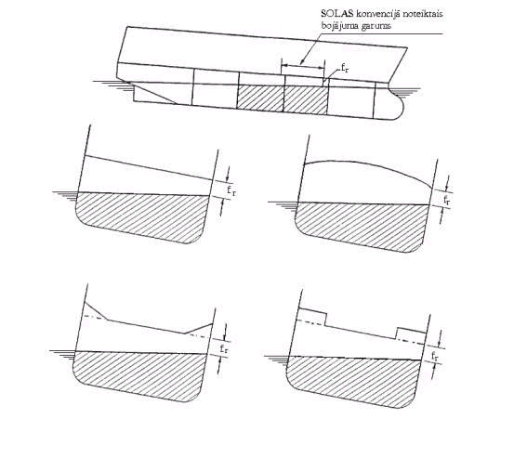
SOLAS Damage length

Figure 2

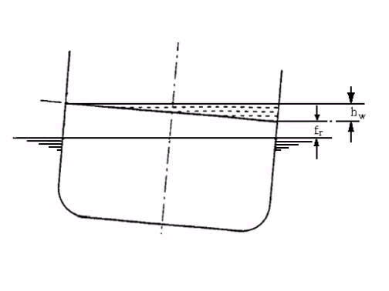

1. If residual freeboard (f_{r}) = 2,0 m, height of water on deck (h_{w}) = 0,0m.

2. If residual freeboard (f_{r}) < 0.3 m, height of water on deck (h_{w}) = 0.5 m.

Figure 3

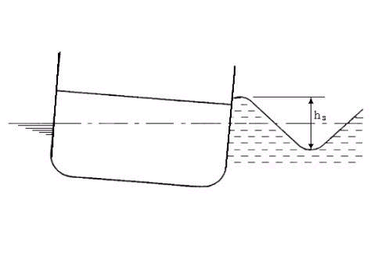

1. if the significant wave height (h_{s}) = 4,0 m, height of water on deck shall be calculated as indicated in Figure 3.

2. If the significant wave height (h_{s}) < 1.5 m, height of water on deck (h_{w}) = 0,0m.

Example.
If residual freeboard (f_{r}) = 1,15 m and the significant wave height (h_{s}) = 2,75 m, height of water (h_{w}) = 0,125 m.

Figure 4

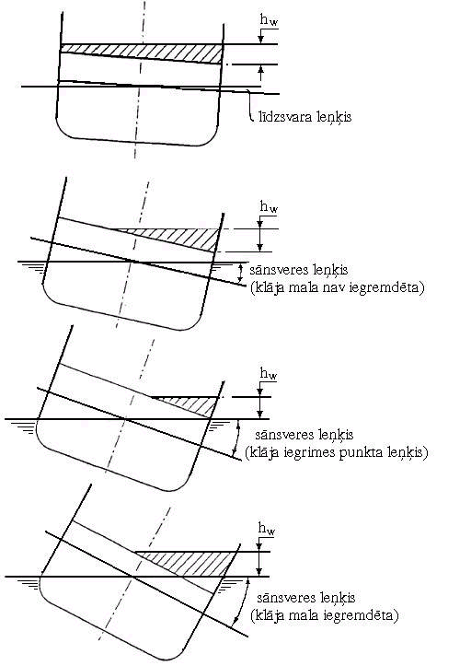

angle of equilibrium
heel angle (deck edge is not immersed)
heel angle (deck angle point of immersion)
heel angle (deck edge immersed)

Figure 5

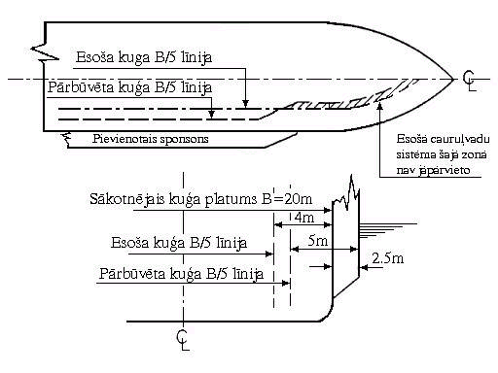

Existing ship B/5 line | Existing piping in this area need not to be re-sited
Modified ship B/5 line | Existing piping in this area need not to be re-sited
Added sponsons | Existing piping in this area need not to be re-sited
Original breadth of the ship B=20 m | Existing piping in this area need not to be re-sited
Existing ship B/5 line | Existing piping in this area need not to be re-sited
Modified ship B/5 line | Existing piping in this area need not to be re-sited

Figure 6

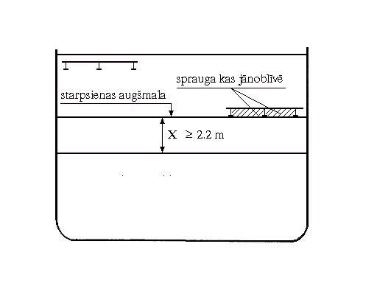

top of bulkhead | gap to be plated-in

Ship without hanging car decks

1. Example 1.

Height of water on deck = 0,25 m
Minimum required height of barrier = 2,2 m

Ship with hanging deck (in the way of the barrier)

2. Example 2.

Height of water on deck = 0,25 m
Minimum required height of barrier = x

Figure 7

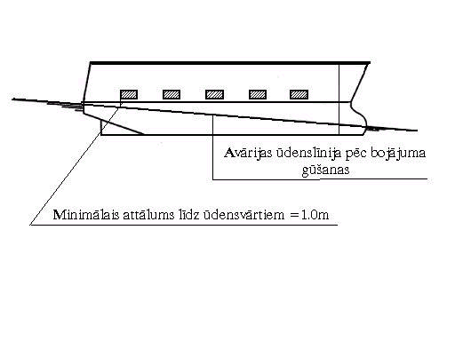

Minimum distance to freeing port = 1.0m | Final stage damage waterline

Minimum required freeboard to freeing port = 1.0 m

Figure 8

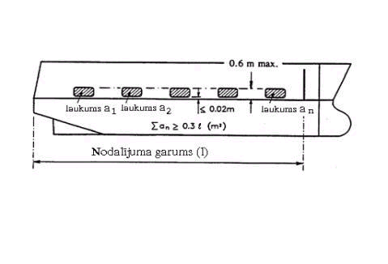

area a₁ | area a₂ | area a_{n}
Length of compartment (l)

Figure 9

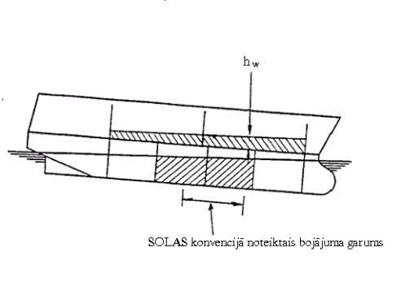
SOLAS Damage length

Deck edge not immersed

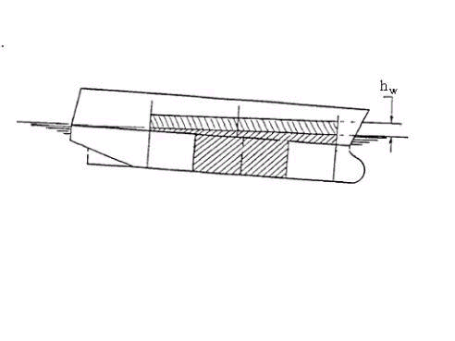

Deck edge immersed

Part II. Model Testing

1. Purpose

The purpose of these guidelines is to ensure uniformity in the methods, which are used in the construction and verification of the model, as well as in the performance of the model tests and analyses of the results.

The content of Paragraph 1 of Part II of Annex I is self-explanatory.

2. Ship Model

2.1. The material, of which the model is made, shall not important, provided that the model both in the intact and damaged condition is sufficiently rigid to ensure that hydrostatic properties thereof are the same as those of the actual ship and also that the flexural response of the hull in waves is negligible.
It shall also be important to ensure that the damaged compartments are modelled as accurately as practicably possible in order to ensure that the correct volume of floodwater is represented.
Since ingress of water (even small amounts) into the intact parts of the model will affect its behaviour, measures shall be taken in order to ensure that this ingress does not occur.
In model tests, which involve worst damages intended in the SOLAS Convention near the ship ends, it has been observed that progressive flooding was not possible because of the tendency of the water on deck to accumulate near the damage opening and hence flow out. As such models were able to survive very high sea states, while they capsized in lesser sea states with less onerous damages intended in the SOLAS Convention, away from the bow and stern ends. In order to prevent it, limit ± 35 % was introduced.
The extensive research carried out for the purpose of developing appropriate criteria for new vessels has clearly shown that in addition to the metacentric height (hereinafter – GM) and freeboard, which are important parameters in the survivability of passenger ships, the area under the residual stability curve is also another major factor. Consequently in choosing the worst damage intended in the SOLAS Convention for compliance with the requirements of this Paragraph, the worst damage shall be taken as that, which gives the least area under the residual stability curve.

2.2. Model Particulars
2.2.1. In recognising that scale effects play an important role in the behaviour of the model during tests, it shall be important to ensure that these effects are minimised as much as practically possible. The model shall be as large as possible since details of damaged compartments are easier constructed in larger models and the scale effects are reduced. It is therefore recommended that the model length is not less than that corresponding to 1:40 scale or 3 metres, choosing the largest value.
2.2.2. (a) The model in way of the assumed damages shall be as thin as practically possible in order to ensure that the amount of floodwater and its centre of gravity is adequately represented. The thickness of the hull shall not exceed 4 mm. It is recognised that it may not be possible for the model hull and the elements of primary and secondary subdivision in way of the damage to be constructed with sufficient detail and due to these constructional limitations it may not be possible to calculate accurately the assumed permeability of the space.
2.2.2 (b) It has been found during tests that the vertical extent of the model can affect the results when tested dynamically. It is therefore required that the ship is modelled to at least three super structure standard heights above the bulkhead (freeboard) deck so that the large waves of the wave train do not break over the model.
2.2.2 (c) It is important that not only the draughts in the intact condition are verified, but also that the draughts of the damaged model are accurately measured for correlation with those that are derived from the damaged stability calculation. For practical purposes tolerance shall be + 2 mm for each approved draught. After measuring the damaged draughts it may be found necessary to make adjustments to the permeability of the damaged compartment by either introducing intact volumes or by adding weights. However it is also important to ensure that the centre of gravity of the floodwater is accurately represented. In this case, any adjustments made shall be performed complying with the adequate safety requirements in accordance with the SOLAS Convention;
2.2.2 (d) If the model is required to be fitted with barriers on deck and the barriers are less than the height indicated below, the model is to be fitted with closed circuit television (CCTV) so that any splashing over and any accumulation of water on the undamaged area of the deck can be monitored. In such case a video recording of the event shall form part of the test records.
The height of transverse or longitudinal bulkheads, which are taken into account as effective in order to confine the assumed accumulated sea water in the compartment concerned in the damaged ro-ro deck, shall be at least 4 m in height, unless the height of water is less than 0,5 m. In such cases the height of the bulkhead may be calculated as follows:

Bh = 8hw,

where Bh is the bulkhead height; and hw is the height of water.

In any event, the minimum height of the bulkhead shall not be less than 2,2 m. However, as regards ships with hanging car decks, the minimum height of the bulkhead shall be not less than the height to the underside of the hanging deck when in its lowered position.
2.2.3. In order to ensure that the model motion characteristics represent those of the actual ship, it is important that the model is both inclined and rolled in the intact condition so that the intact GM and the mass distribution of the ship are verified.
The transverse radius of gyration of the actual ship shall be in range 0,35B to 0,4 B and the longitudinal radius of gyration shall be in range 0,2L to 0,25L.

Note: While inclining and rolling the model in the damaged condition may be accepted as a check for the purpose of verifying the residual stability curve, such tests shall not be accepted in lieu of the intact tests.

2.2.4. It shall be assumed that the ventilators of the damage compartment of the actual ship are adequate for unhindered flooding and movement of the floodwater. However in trying to scale down the ventilating arrangements of the actual ship, undesirable scale effects may be introduced in the model. In order to ensure that no such effects occur, it is recommended to construct the ventilating arrangements to a larger scale than that of the model, ensuring that this does not affect the flow of water on the car deck.
2.2.5. It is deemed appropriate to consider a damage shape representative of a cross section of the striking ship in the bow region. The 15° angle is based in a study of the cross section at a distance of B/5 from the bow for a representative selection of vessels of different types and sizes.
The isosceles triangular profile of the prismatic damage shape is that corresponding to the load waterline. Additionally in cases where side casings of width less than B/5 are fitted and in order to avoid any possible scale effects, the damage length in way of the side casings shall not be less than 25 mm.
In the original model test method of Resolution 14 of the 1995 Conference of the SOLAS Convention the effect of heeling induced by the maximum moment deriving from any of passenger crowding, launching a survival craft, wind and turning of the ship was not considered even though this effect was part of the SOLAS Convention. Results from an investigation have shown, however, that it would be prudent to take these effects into account and to retain the minimum of 1° heel towards the damage for practical purposes. It is to be noted that heeling due to turning was considered not to be relevant.
In cases where there is a margin in the GM in the actual loading conditions compared to the GM limiting curve specified in the SOLAS Convention, the Maritime Administration of Latvia may accept that such a margin is taken advantage of in the model test. In such cases the GM limiting curve shall be adjusted. Such adjustment may be done as follows:

d = dS-0,6 (dS-dLS)

where: dS is the subdivision draught; and dLS is the ship’s draught without flooding.

The adjusted curve is a straight line between the GM used in the model test at the subdivision draught and the intersection of the original curve specified in the SOLAS Convention and draught d.

3. Procedure for Experiments

3.1. Wave Spectra

3.1.1. The JONSWAP spectrum shall be used as this describes fetch and duration limited seas, which correspond to the majority of the conditions worldwide. In this respect it shall be important that not only the peak period of the wave train is verified but also that the zero crossing period is correct.
3.1.2. It is required that for every test run the wave spectrum is recorded and documented. Measurements for this recording shall be taken at the probe closest to the wave-making machine.
3.2. It is also required that the model is instrumented so that its motions (roll, heave and pitch) as well as its attitude (heel, sinkage and trim) are monitored and recorded throughout the test.
It has been found that it is not practical to set absolute limits for significant wave heights, peak periods and zero crossing periods of the model wave spectra. An acceptable margin has therefore been introduced.
3.3. To avoid interference of the mooring system with the ship dynamics, the towing carriage, to which the mooring system is attached, shall follow the model at its actual drifting speed. In a sea state with irregular waves the drift speed will not be constant. A constant carriage speed would result in low frequency and large amplitude drift oscillations, which may affect the behaviour of the model.
3.4. A sufficient number of tests in different wave trains shall be necessary in order to ensure statistical reliability, the objective of which is to determine with a high degree of certainty that an unsafe ship will capsize in the selected conditions. A minimum number of ten runs shall be considered to provide a reasonable level of reliability.

4. Survival Criteria

The content of this Paragraph are considered self-explanatory.

5. Test Approval

The following document shall be part of the report to be submitted to the Maritime Administration of Latvia:
a) damage stability calculations for worst damage specified in the SOLAS Convention and mid-ship damage (if they differ );
b) general arrangement drawing of the model together with details of the construction and instrumentation;
c) inclining experiment and measurements of radii of gyration;
d) nominal and measured wave spectra (at the three different locations for a representative realisation and for the tests with the model from the probe closest to the wave maker);
f) representative record of model motions, attitude and drift; and
g) relevant video recordings.

Note. The Maritime Administration of Latvia shall witness all tests.

Minister for Transport A. Šlesers

