Republic of Latvia

Cabinet
Regulation No. 209
Adopted 28 May 2002

Regulations Regarding Labelling of Household Washing Machines, Tumble Dryers and Combined Washer-Dryers and Information to be Included in Distance Contracts

Issued pursuant to Section 10, Paragraph four and Section 21, Paragraph one of the Consumer Rights Protection Law

1. These Regulations determine household washing machines, tumble dryers and combined washer-dryers placed on the Latvian market (hereinafter – appliances), which require special labelling, procedures for labelling of appliances and information to be included in distance contracts.

2. These Regulations apply to the following appliances, which operate utilising electricity (except for appliances, which may operate utilising batteries, accumulators or other similar energy sources):
2.1. household washing machines, except for those with no spin drying capability, and machines with separate washing and spin drying vessels;
2.2. household tumble dryers; and
2.3. household combined washer-dryers.

3. These Regulations are also applicable to appliances used in other areas of activity other than household use.

4. It is prohibited to distribute appliances, which do not meet the requirements of these Regulations.

5. In order to inform consumers of the consumption by appliances of electricity, other types of energy and essential resources, and to provide other information necessary to evaluate the consumption by appliances of energy or other essential resources, the manufacturer, its authorised representative or importer shall label the appliances intended for sale, hire, sale on credit or demonstration with a label and provide with a fiche.

6. Labelling of used appliances or appliances the manufacturing of which has suspended before the coming into force of these Regulations, shall not be necessary.

7. The Ministry of Economics shall co-operate with the relevant technical committee for standardisation and shall recommend a list of adaptable standards to the non-profit-making organisation State limited liability company Latvijas standarts [Latvian Standard]. The non-profit-making State limited liability company Latvijas standarts shall submit a list of those harmonised European standards which may be applied to the performance of these Regulations for publication in the newspaper Latvijas Vēstnesis [the official Gazette of the Government of Latvia].

8. In order to determine the veracity of the information provided in the labelling, the manufacturer, its authorised representative or importer shall ensure technical documentation for appliances. The documentation shall include the following information:
8.1. the name and address of the manufacturer, its authorised representative or importer;
8.2. a general description of the model, in order for it to be precisely identified;
8.3. drawings with the main features of the model and technical drawings of those parts, which affect energy consumption;
8.4. tests performed in accordance with the standards referred to in Paragraph 7 of these Regulations; and
8.5. instructions for use (if any).

9. It is permitted to substitute the documentation referred to in Paragraph 8 of these Regulations with technical documentation, which has been developed regarding the appliance on the basis of other regulatory enactments if all the information specified in Paragraph 8 of these Regulations has been included in such documentation.

10. The manufacturer, its authorised representative or importer shall ensure that the technical documentation is available to a market supervision institution for inspection for five years after the manufacture of the last appliance.

11. The label referred to in Paragraph 5 of these Regulations shall be made in conformity with Sample 1 set out in Annex 1 of these Regulations, by including the information prescribed in the explanatory notes. The label shall be attached on the outside of the front or upper part of the appliance in a clearly visible place. The label shall consist of an explanatory part, which shall be the same for all appliances of a specific type and a product information sticker, which shall be prepared for each appliance.

12. The fiche referred to in Paragraph 5 of these Regulations shall be indicated in all brochures and information sheets on the appliance. If no brochure or information sheet on the appliance is provided for, the manufacturer, its authorised representative or importer shall indicate the fiche in any other document on the appliance . The fiche shall be freely accessible.

13. The fiche for household washing machines shall contain the following information in a specified form:
13.1. the name or trade mark of the manufacturer, its authorised representative or importer;
13.2. the identifier of the specific model;
13.3. the energy efficiency class of the model in accordance with Annex 2 of these Regulations. It shall be indicated as follows: “Energoefektivitātes klase ... uz skalas no A (efektīvāk) līdz G (mazāk efektīvi)” [Energy efficiency class … on a scale of A (more efficient) to G (less efficient)]. If this information is provided in a table it may be expressed differently but it shall be clearly indicated that the measurement scale is from A (more efficient) to G (less efficient).
13.4. if the Eco-Label may be utilised for the labelling of the relevant appliance , the information shall be provided in a table and the column heading shall be [European Community Eco-label], the entry shall contain the Eco-label mark (flower);
13.5. energy consumption (kWh) per cycle if the standard 60 °C cotton cycle is used. It shall be indicated as follows: “Enerģijas patēriņš XYZ kWh ciklā, pamatojoties uz standarta cikla “kokvilnas mazgāšana 60 °C temperatūrā” testu rezultātiem.” [Energy consumption XYZ kWh per cycle, based on standard test results for 60 °C cotton cycle.] Faktiskais enerģijas patēriņš atkarīgs no iekārtas lietošanas veida.” [Actual energy consumption will depend on how the appliance is used.];
13.6. washing performance class in accordance with Annex 2 of these Regulations. It shall be indicated as follows: “Mazgāšanas izpildes klase ... uz skalas no A (labāka) līdz G (sliktāka)” [Washing performance class … on a scale of A (higher) to G (lower)]. It may be expressed differently but it shall be clearly indicated that the measurement scale is from A (higher) to G (lower). This information may also be provided in respect of other washing cycles;
13.7. spin drying performance class in accordance with Annex 2 of these Regulations. It shall be indicated as follows: “Centrifugēšanas izpilde ... uz skalas no A (labāka) līdz G (sliktāka)” [Spin drying performance … on a scale of A (higher) to G (lower)]. Followed by the statement: “Atcerieties! [Remember!] Izvēloties veļas mazgāšanas mašīnu ar A centrifūgu G centrifūgas vietā, Jūs samazināsiet žāvēšanas izmaksas uz pusi.[In choosing a washing machine with A-rated spin, instead of one with a G-rated spin will halve your tumble drying costs.] Drēbju centrifugēšana parasti patērē vairāk enerģijas nekā to mazgāšana” [Spin drying clothes usually uses more energy than washing them]. This statement may also be included in a note. If the information regarding spin drying performance class is provided in a table, it may be expressed differently but it shall be clearly indicated that the measurement scale is from A (higher) to G (lower) and the data regarding running costs shall be included in the table or in a footnote. This information may also be provided in respect of other washing cycles;
13.8. water extraction efficiency for a standard 60 °C cotton cycle. It shall be indicated as follows: “Ūdens, kas paliek pēc centrifugēšanas, ... [Water remaining after spin …] ” (as a proportion of dry weight of wash)]. This information may also be provided in respect of other washing cycles;
13.9. maximum spin speed for a standard 60 °C cotton cycle. This information may also be provided in respect of other washing cycles;
13.10. capacity of appliance (kg), utilising standard 60 °C cotton cycle. This information may also be provided in respect of other washing cycles;
13.11. water consumption (in litres) for a standard 60 °C cotton cycle. This information may also be provided in respect of other washing cycles;
13.12. programme time for a standard 60 °C cotton cycle. This information may also be provided in respect of other washing cycles;
13.13. the average annual consumption of energy and water, which has been calculated on the basis of 200 standard 60 °C cotton cycles. It shall be indicated as follows: “Paredzamais enerģijas un ūdens gada patēriņš četru personu saimniecībai (ja izmantoti 200 standarta cikli “kokvilnas mazgāšana 60 °C temperatūrā”) [The estimated annual consumption of energy and water for a four-person household (if 200 standard 60 °C cotton cycles have been used)]; and
13.14. the level of noise during washing and spinning per standard cycle (if the manufacturer or importer wishes to indicate such).

14. The fiche for household tumble dryers shall contain the following information:
14.1. name or trade mark of the manufacturer, its authorised representative or importer;
14.2. identifier of the specific model;
14.3. energy efficiency class of the model in accordance with Annex 2 of these Regulations. It shall be indicated as follows: “Energoefektivitātes klase ... uz skalas no A (efektīvāk) līdz G (mazāk efektīvi)” [Energy efficiency class … on a scale of A (more efficient) to G (less efficient)]. If this information is provided in a table it may be expressed differently but it shall be clearly indicated that the measurement scale is from A (more efficient) to G (less efficient).
14.4. if the Eco-label may be utilised for the labelling of the relevant appliance , the information shall be provided in a table and the column heading shall be [European Community Eco-label], the entry shall contain the Eco-label mark (flower);
14.5. energy consumption (kWh) for "sausa kokvilna” [dry cotton] cycle. This information may also be provided in respect of other drying cycles;
14.6. rated capacity of cotton (kg). This information may also be provided in respect of other drying cycles;
14.7. water consumption (in litres) for "sausa kokvilna” [dry cotton] cycle (if water is consumed). This information may also be provided in respect of other drying cycles;
14.8. drying time for a "sausa kokvilna” [dry cotton] cycle. This information may also be provided in respect of other drying cycles;
14.9. the information referred to in Sub-paragraphs 14.5, 14.6, 14.7 and 14.8 of these Regulations regarding the cycles “sausa kokvilna gludināšanai” [iron dry cotton] and “saudzīgi kopjami audumi” [easy care textiles]. This information shall not be indicated if the relevant appliances do not have the cycles referred to;
14.10. the average annual consumption of energy (if necessary, also water consumption) for "sausa kokvilna” [dry cotton] cycle when drying 150 kg, for “sausa kokvilna gludināšanai” [iron dry cotton] cycle when drying 280 kg and for “saudzīgi kopjami audumi” [easy care textiles] cycle when drying 150 kg. It shall be indicated as follows: “Paredzamais enerģijas gada patēriņš četru personu saimniecībai, kas parasti izmanto žāvētāju.” [The estimated annual energy consumption for a four-person household normally using a drier];
14.11. the type of appliance (air vented or condensing); and
14.12. the level of noise (if the manufacturer or importer wishes to indicate such).

15. The fiche for household combined washer-dryers shall contain the following information:
15.1. name or trade mark of the manufacturer, its authorised representative or importer;
15.2. identifier of the specific model;
15.3. energy efficiency class of the model in accordance with Annex 2 of these Regulations. It shall be indicated as follows: “Energoefektivitātes klase ... uz skalas no A (efektīvāk) līdz G (mazāk efektīvi)” [Energy efficiency class … on a scale of A (more efficient) to G (less efficient)]. If this information is provided in a table it may be expressed differently but it shall be clearly indicated that the measurement scale is from A (more efficient) to G (less efficient);
15.4. if the Eco-label may be utilised for the labelling of the relevant appliance , the information shall be provided in a table and the column heading shall be “ [European Community Eco-label], the entry shall contain the Eco-label mark (flower);
15.5. energy consumption (kWh) for washing, spinning and drying per complete operating cycle. This information may also be provided in respect of other washing and drying cycles;
15.6. energy consumption (kWh) for washing and spinning only per washing cycle. This information may also be provided in respect of other washing and drying cycles;
15.7. washing performance class in accordance with Annex 2 of these Regulations. It shall be indicated as follows: “ Mazgāšanas izpildes klase ... uz skalas no A (labāka) līdz G (sliktāka)” [Washing performance class … on a scale of A (higher) to G (lower)]. It may be expressed differently but it shall be clearly indicated that the measurement scale is from A (higher) to G (lower). This information may also be provided in respect of other washing and drying cycles;
15.8. water extraction efficiency for a standard 60 °C cotton washing cycle. It shall be indicated as follows: “Ūdens, kas paliek pēc žāvēšanas, ... [Water remaining after drying …] ”(as a proportion of dry weight of wash)] This information may also be provided in respect of other washing and drying cycles;
15.9. the maximum spin speed for a standard 60 °C cotton washing cycle. This information may also be provided in respect of other washing and drying cycles;
15.10. capacity of the appliance (kg) for a standard 60 °C cotton washing cycle. This information may also be provided in respect of other washing and drying cycles;
15.11. capacity of the appliance (kg) for a standard "sausa kokvilna” [dry cotton] drying cycle. This information may also be provided in respect of other washing and drying cycles;
15.12. water consumption (in litres) for washing, spinning and drying per complete operating cycle. This information may also be provided in respect of other washing and drying cycles;
15.13. water consumption (in litres) for washing and spinning only per standard 60 °C cotton washing (and spinning) cycle. This information may also be provided in respect of other washing and drying cycles;
15.14. washing and drying time — programme time for a complete operating cycle (60 °C cotton washing cycle and "sausa kokvilna” [dry cotton] drying cycle) for the calculated washing capacity. This information may also be provided in respect of other washing and drying cycles;
15.15. energy and water consumption for 200 cycles referred to in Sub-paragraphs 15.5 and 15.12 of these Regulations. It shall be indicated as follows: “ Paredzamais enerģijas un ūdens gada patēriņš četru personu saimniecībai, kas parasti izmanto žāvētāju (200 cikli)” [Estimated annual energy and water consumption for a four-person household that normally uses a drier (200 cycles)];
15.16. energy and water consumption for 200 cycles referred to in Sub-paragraphs 15.6 and 15.15 of these Regulations. It shall be indicated as follows: “Aprēķinātais enerģijas un ūdens gada patēriņš četru personu saimniecībai, kas nekad neizmanto žāvētāju (200 cikli)” [Estimated annual energy and water consumption for a four-person household that never uses the drier (200 cycles)]; and
15.17. the level of noise during washing, spinning and drying using a standard 60 °C cotton washing cycle and "sausa kokvilna” [dry cotton] drying cycle (if the manufacturer or importer wishes to indicate such).

16. The fiche may contain a copy of the label in colour or in black and white. In such case the information, which in accordance with these Regulations is necessary to be specified in the fiche shall be provided in addition.

17. The information specified in the fiche may be provided as a description of the appliance or in a table, in which the information with respect to several appliances of one manufacturer shall be provided. In such case the information shall be specified in the sequence prescribed in Paragraphs 13, 14 and 15 of these Regulations.

18. The manufacturer, its authorised representative and importer shall be liable for the accuracy of the data provided.

19. The manufacturer, its authorised representative or importer shall supply labels and fiches free of charge to retail traders and other persons who sell, hire, sell on credit or demonstrate appliances to users. If labels have not been supplied the persons referred to shall send a relevant request to the manufacturer, its authorised person or importer.

20. If appliances are offered for sale, hire or sale on credit by using means of distance communication, the distance contract shall include and the offer expressed to the consumer, in addition to the information determined by Cabinet regulations regarding distance contracts, shall provide the following information:

20.1. energy efficiency class;
20.2. energy consumption (for household combined washer-dryers the energy consumption for washing, spinning and drying and energy consumption for washing and spinning only shall be indicated separately);
20.3. washing performance class (if possible);
20.4. spinning performance class (if possible);
20.5. maximum spin speed (if possible);
20.6. capacity (for household combined washer-dryers the capacity per washing cycle and drying cycle shall be indicated separately);
20.7. water consumption per cycle (for household combined washer-dryers the water consumption for washing, spinning and drying and water consumption for washing and spinning only shall be indicated separately);
20.8. annual energy and water consumption estimate for a four-person household (for household combined washer-dryers the annual energy and water consumption estimate for a four-person household always using the drier (200 cycles) and the annual energy and water consumption estimate for a four-person household never using the drier (200 cycles) shall be indicated separately);
20.9. for household combined washer-dryers — water extraction efficiency; and
20.10. the level of noise (if the manufacturer or importer wishes to indicate such).

21. The information referred to in Paragraph 20 of these Regulations shall be provided in a form that is appropriate to the relevant distance communication means . The information shall be indicated in a clearly visible place and be clearly legible in accordance with the procedures set out in Cabinet regulations regarding distance contracts .

22. If in addition to the information referred to in Paragraph 20 of these Regulations also other information indicated in the fiche is provided, it shall be indicated in conformity with the requirements and sequence prescribed in Paragraphs 13, 14 and 15 of these Regulations.

23. If the labelling does not conform with these Regulations the manufacturer, its authorised representative or importer shall rectify the non-conformity and distribute the corrected label.

24. The manufacturer, its authorised representative or importer, shall cover if the information provided in the labelling does not conform with the information obtained in a test, the expenses related to the performance of the test.

25. Cabinet Regulation No. 29 of 23 January 2001, Regulations Regarding Labelling of Household Washing Machines, Tumble Dryers and Combined Washer-Dryers (Latvijas Vēstnesis, 2001, No. 15) is repealed.

Prime Minister A. Bērziņš

Minister for Economics A. Kalvītis

Annex 1
Cabinet Regulation No. 209
28 May 2002

Sample Label

1. For household washing machines:
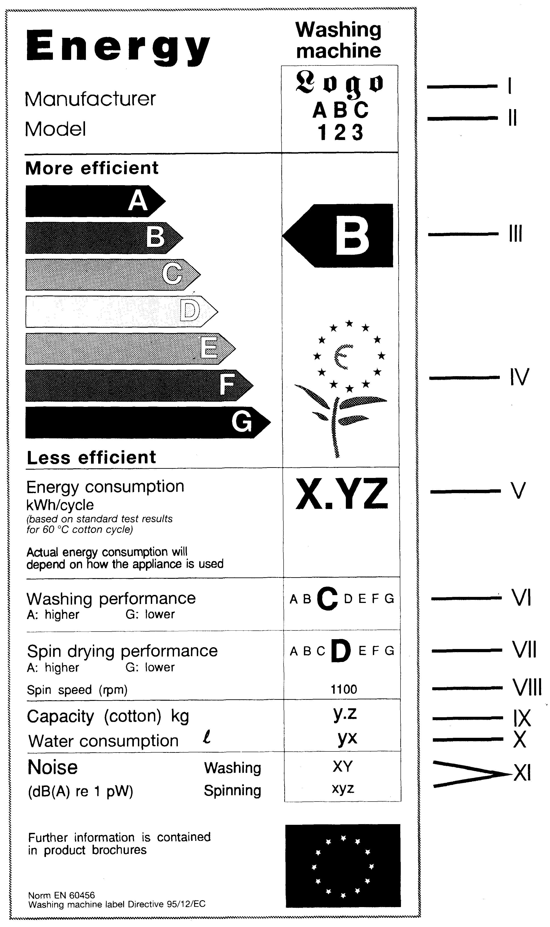
Explanatory notes

I — the name or trade mark of the manufacturer, its authorised representative or importer;

II — the identifier of the specific model;

III — the energy efficiency class in accordance with Annex 2 of these Regulations. The arrow shall be placed at the same level as the relevant letter;

IV — the European Commission Eco-label (flower) if the Eco-label may be utilised for labelling the relevant appliance;

V — energy consumption (kWh) per standard 60 °C cotton cycle;

VI — washing performance class in accordance with Annex 2 of these Regulations;

VI — spin drying performance class in accordance with Annex 2 of these Regulations;

VIII — maximum spin speed attained for standard 60 °C cotton cycle;

IX — capacity of appliance (kg) for standard 60 °C cotton cycle;

X — water consumption (in litres) for standard 60 °C cotton cycle;

XI — level of noise for 60 °C cotton washing and drying standard cycle (if the manufacturer or importer wishes to indicate such).
2. For tumble dryers:
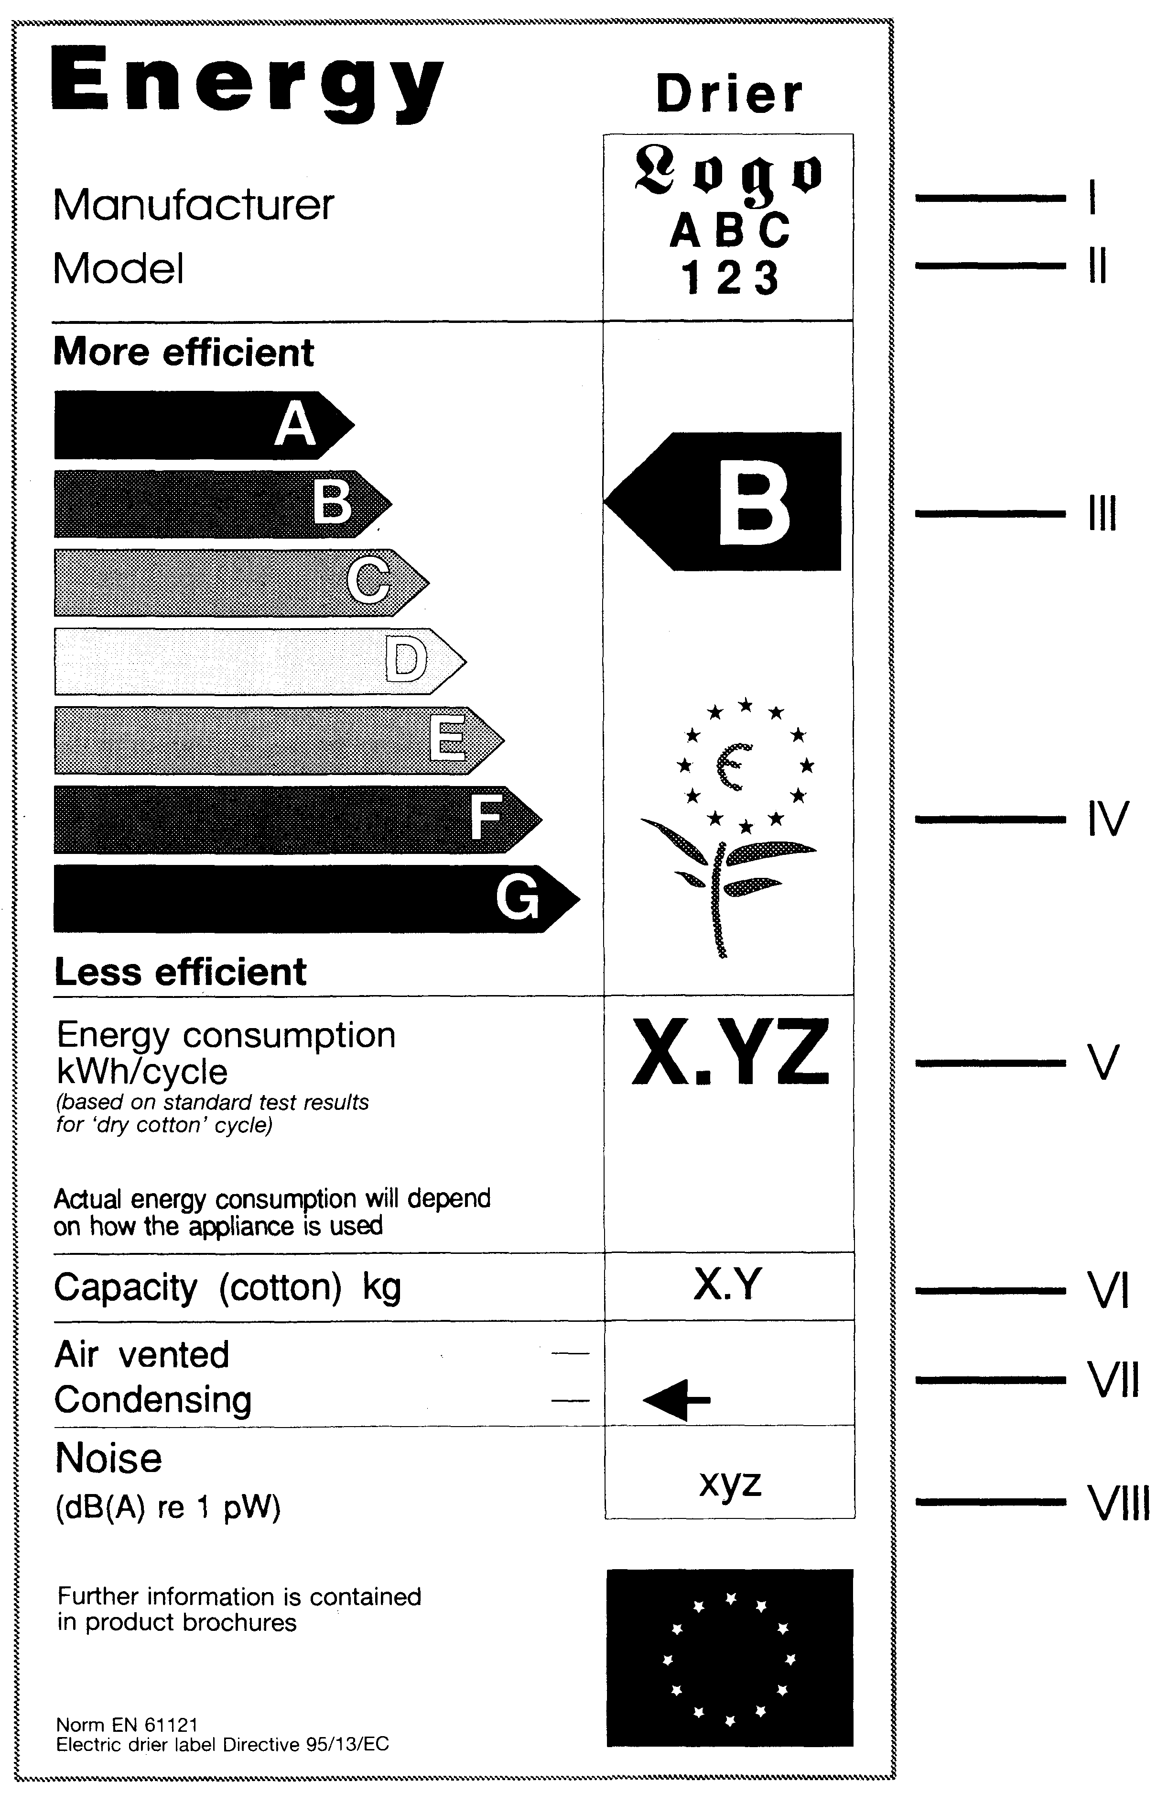

Explanatory notes

I — the name or trade mark of the manufacturer, its authorised representative or importer;

II — the identifier of the specific model;

III — energy efficiency class in accordance with Annex 2 of these Regulations. The arrow shall be placed at the same level as the relevant letter;

IV — the European Commission Eco-label (flower) if the Eco-label may be utilised for labelling of the relevant appliance;

V — energy consumption (kWh) for "sausa kokvilna” [dry cotton] cycle;

VI — rated capacity of cotton (kg);

VII — type of appliance (air vented or condensing). The arrow shall be placed at the same level as the relevant type;

VIII — level of noise (if the manufacturer or importer wishes to indicate such).

3. For household combined washer-dryers:
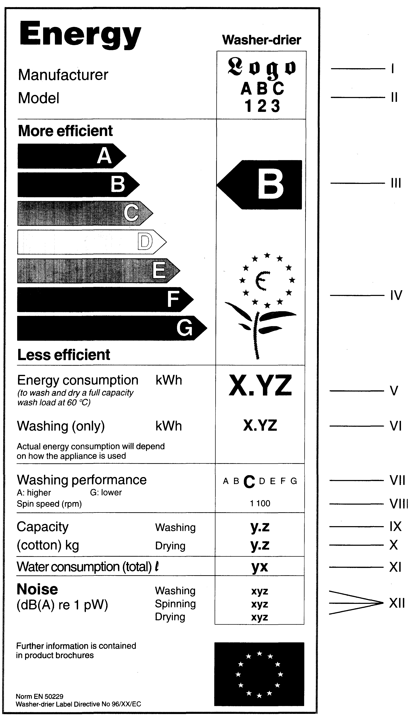

Explanatory notes

I — the name or trade mark of the manufacturer, its authorised representative or importer;

II — the identifier of the specific model;

III — the energy efficiency class in accordance with Annex 2 of these Regulations. The arrow shall be placed at the same level as the relevant letter;

IV — the European Commission Eco-label (flower) if the Eco-label may be utilised for labelling of the relevant appliance;

V — the energy consumption (kWh) per complete operating (washing, spinning and drying) standard 60 °C cotton cycle and "sausa kokvilna” [dry cotton] drying cycle;

VI — energy consumption (kWh) for washing (washing and spinning only) using a standard 60 °C cotton cycle;

VII — washing performance class in accordance with Annex 2 of these Regulations;

VIII — maximum spin speed for standard 60 °C cotton cycle;

IX — capacity of appliance (kg) for standard 60 °C cotton cycle without drying;

X — capacity of appliance (kg) for "sausa kokvilna” [dry cotton] drying cycle;

XI — water consumption (in litres) per complete operating (washing, spinning, drying) cycle using standard 60 °C cotton cycle and "sausa kokvilna” [dry cotton] drying cycle;

XII — level of noise during washing, spinning and drying using standard 60 °C cotton cycle and "sausa kokvilna” [dry cotton] drying cycle (if the manufacturer or importer wishes to indicate such).
4. Label dimensions:
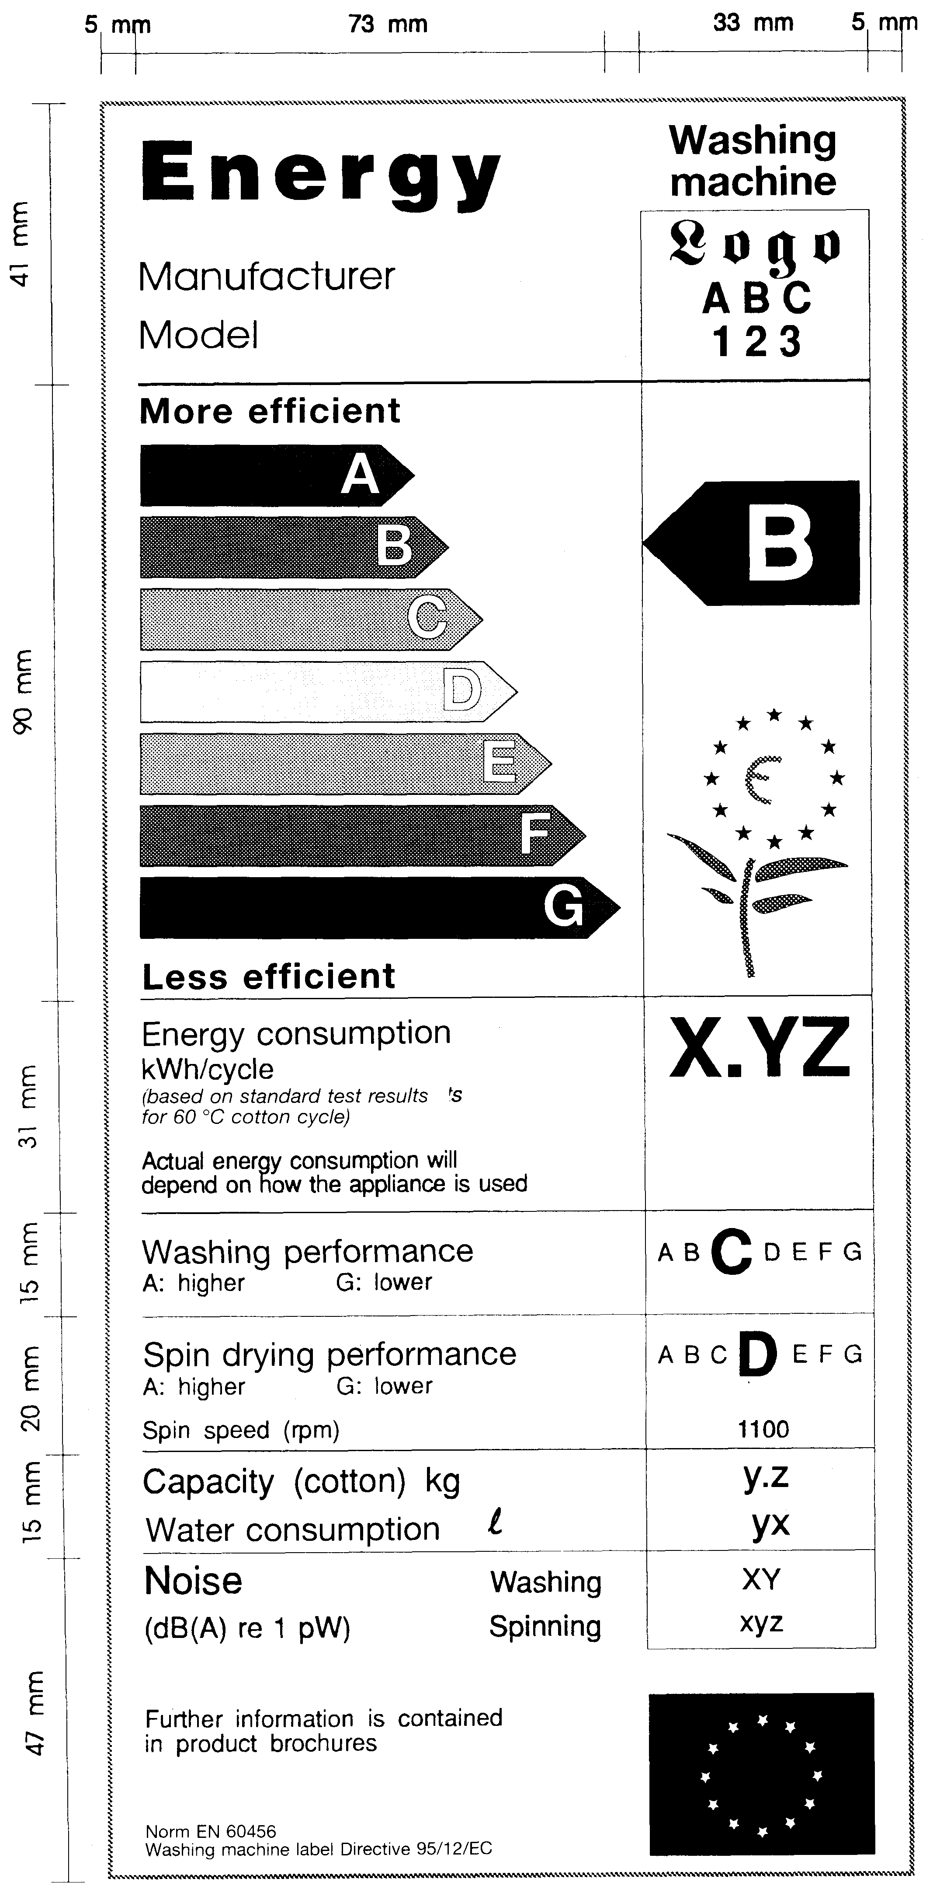
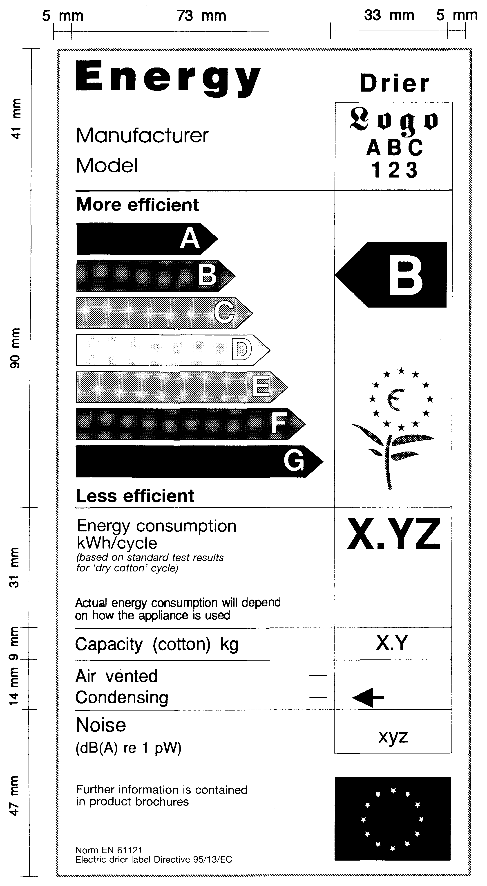

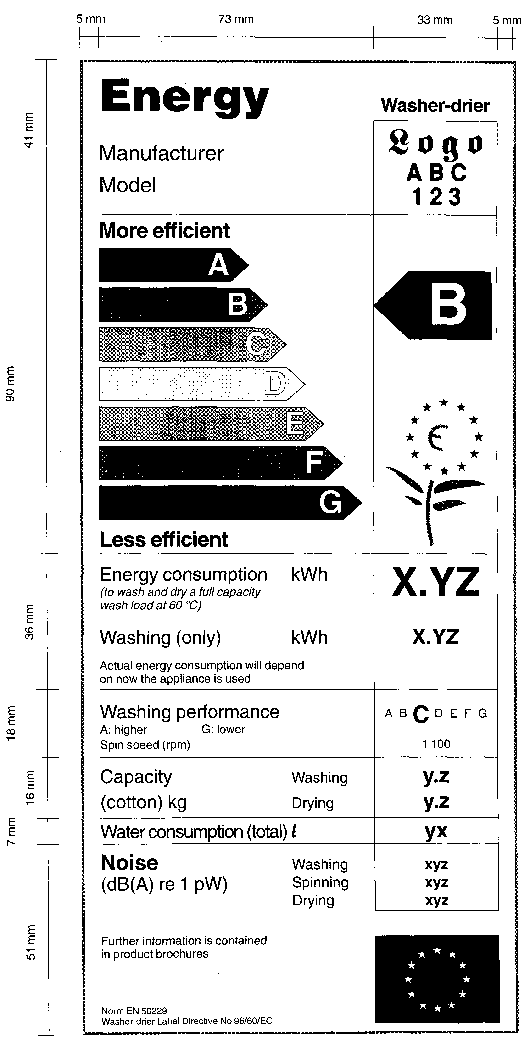

5. Colours:

5.1. arrow A: 100 % cyan, 0 % magenta, 100 % yellow, 0 % black;

5.2. arrow B: 70 % cyan, 0 % magenta, 100 % yellow, 0 % black;

53. arrow C: 30 % cyan, 0 % magenta, 100 % yellow, 0 % black;

5.4. arrow D: 0 % cyan, 0 % magenta, 100 % yellow, 0 % black;

5.5. arrow E: 0 % cyan, 30 % magenta, 100 % yellow, 0 % black;

5.6. arrow F: 0 % cyan, 70 % magenta, 100 % yellow, 0 % black;

5.7. arrow G: 0 % cyan, 100 % magenta, 100 % yellow, 0 % black;

5.8. outlines: 100 % cyan, 0 % magenta, 70 % yellow, 0 % black;

5.9. the text shall be in black, the background of the label shall be white.

Minister for Economics A. Kalvītis

Annex 2
Cabinet Regulation No. 209
8 May 2002

Efficiency Class

1. Energy efficiency class of household washing machines:

No. | Energy efficiency class | Energy consumption C (kWh/kg) for standard 60 °C cotton cycle;
1.1. | A | C ² 0.19
1.2. | B | 0.19 < C ² 0.23
1.3. | C | 0.23 < C ² 0.27
1.4. | D | 0.27 < C ² 0.31
1.5. | E | 0.31 < C ² 0.35
1.6. | F | 0.35 < C ² 0.39
1.7. | G | 0.39 < C

2. Energy efficiency class of household tumble dryers with air ventilation dryers:

No. | Energy efficiency class | Energy consumption C (kWh/kg) for the "sausa kokvilna” [dry cotton] cycle
2.1. | A | C ² 0.51
2.2. | B | 0.51 < C ² 0.59
2.3. | C | 0.59 < C ² 0.67
2.4. | D | 0.67 < C ² 0.75
2.5. | E | 0.75 < C ² 0.83
2.6. | F | 0.83 < C ² 0.91
2.7. | G | C > 0.91

3. Energy efficiency class of household tumble dryers with condensation dryers:

No. | Energy efficiency class | Energy consumption C (kWh/kg) for the "sausa kokvilna” [dry cotton] cycle
3.1. | A | C ² 0.55
3.2. | B | 0.55 < C ² 0.64
3.3. | C | 0.64 < C ² 0.73
3.4. | D | 0.73 < C ² 0.82
3.5. | E | 0.82 < C ² 0.91
3.6. | F | 0.91 < C ² 1.00
3.7. | G | C > 1.00

4. Energy efficiency class of household combined washer-dryers:

No. | Energy efficiency class | Energy consumption C (kWh/kg) for complete operating (washing, spinning, drying) 60 °C cotton cycle and the "sausa kokvilna” [dry cotton] drying cycle
4.1. | A | C ² 0.68
4.2. | B | 0.68 < C ² 0.81
4.3. | C | 0.81 < C ² 0.93
4.4. | D | 0.93 < C ² 1.05
4.5. | E | 1.05 < C ² 1.17
4.6. | F | 1.17 < C ² 1.29
4.7. | G | 1.29 < C

5. Washing performance class of household washing machines and household combined washer-dryers:

No. | Washing performance class | Washing performance index P which has been determined in accordance with standard tests referred to in Paragraph 6 of these Regulations for a standard cycle (60 °C)
5.1. | A | P > 1.03
5.2. | B | 1.03 ³ P > 1.00
5.3. | C | 1.00 ³ P > 0.97
5.4. | D | 0.97 ³ P > 0.94
5.5. | E | 0.94 ³ P > 0.91
5.6. | F | 0.91 ³ P > 0.88
5.7. | G | 0.88 ³ P

6. Spin drying performance class of household washing machines:

No. | Spin drying performance class | Water extraction efficiency D which has been determined in accordance with standard tests referred to in Paragraph 6 of these Regulations for a standard cycle (60 °C)
6.1. | A | D < 45 %
6.2. | B | 45 % ² D < 54 %
6.3. | C | 54 % ² D < 63 %
6.4. | D | 63 % ² D < 72 %
6.5. | E | 72 % ² D < 81 %
6.6. | F | 81 % ² D < 90 %
6.7. | G | 90 % ² D

Minister for Economics A. Kalvītis

