Text consolidated by Tulkošanas un terminoloģijas centrs (Translation and Terminology Centre) with amending regulations of:
Clarification 1 June 2006 (No. 85).
If a whole or part of a paragraph has been amended, the date of the amending regulation appears in square brackets at the end of the paragraph. If a whole paragraph or sub-paragraph has been deleted, the date of the deletion appears in square brackets beside the deleted paragraph or sub-paragraph.

Republic of Latvia

Cabinet
Regulation No 316
Adopted 25 April 2006

Procedures for the Completion and Submission of the Declaration Form for Declaration of Cash at the State Border and Verification of the Information Provided therein

Issued pursuant to
Section 7, Paragraph three
of the Law On Declaration of Cash at the State Border

1. These Regulations approve the standard declaration form for the declaration of cash at the State Border (hereinafter – declaration) and prescribe the procedures for the filling in of the declaration and submission thereof and procedures for the verification of the information provided therein.

2. A natural person, who in accordance with the Law On Declaration of Cash at the State Border has a duty to declare the cash, shall fill in a declaration (Annex) (in two copies on self-copying paper) and submit such declaration to an authorised person of the competent authority at the place of the border crossing.

3. Declaration forms (on the self-copying paper) in Latvian, English and Russian shall be available free of charge at the competent authority at the place of the border crossing.

4. An officer of the competent authority shall register the declaration, assign the identification number thereto, indicate his or her name, surname, and the registration date therein, sign and approve such declaration with a seal or stamp attesting the acceptance of the declaration. The competent authority shall keep the copy of the declaration on which is the original of the declarant’s signature.

5. An officer of the competent authority shall ascertain in accordance with the principle of sampling or in accordance with the information at its disposal regarding the compliance of the declared cash amount with the actual amount and regarding the veracity of other information provided in the declaration.

6. The State Revenue Service shall order declaration forms at the typography and cover the expenditures for the manufacture thereof.

7. These Regulations shall come into force on 1 July 2006.

Prime Minister A. Kalvītis

Minister for Finance O. Spurdziņš
Annex
Cabinet Regulation No. 316
25 April 2006

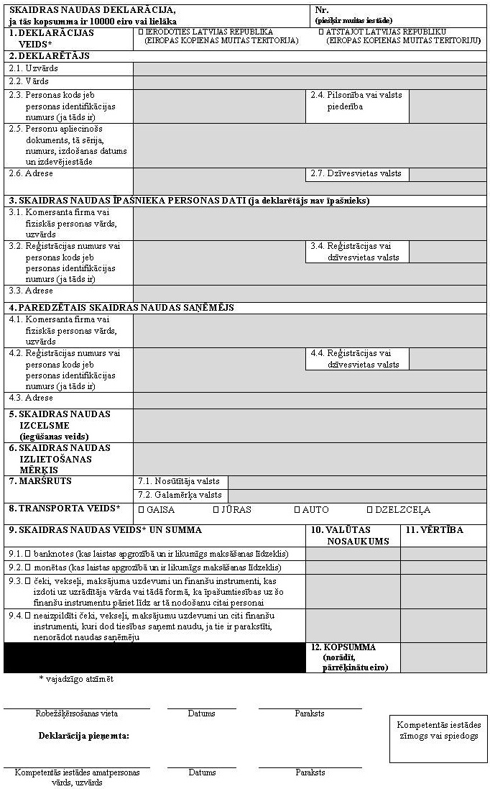
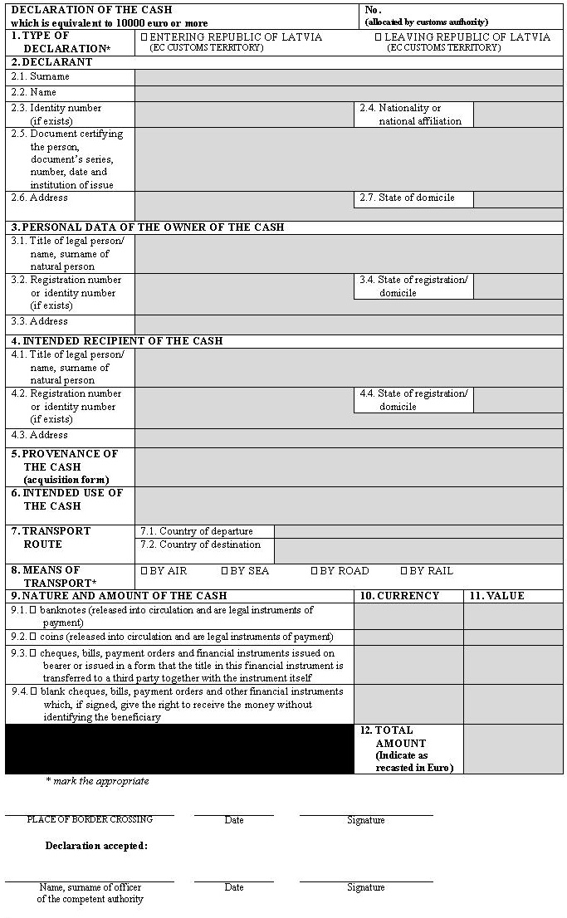
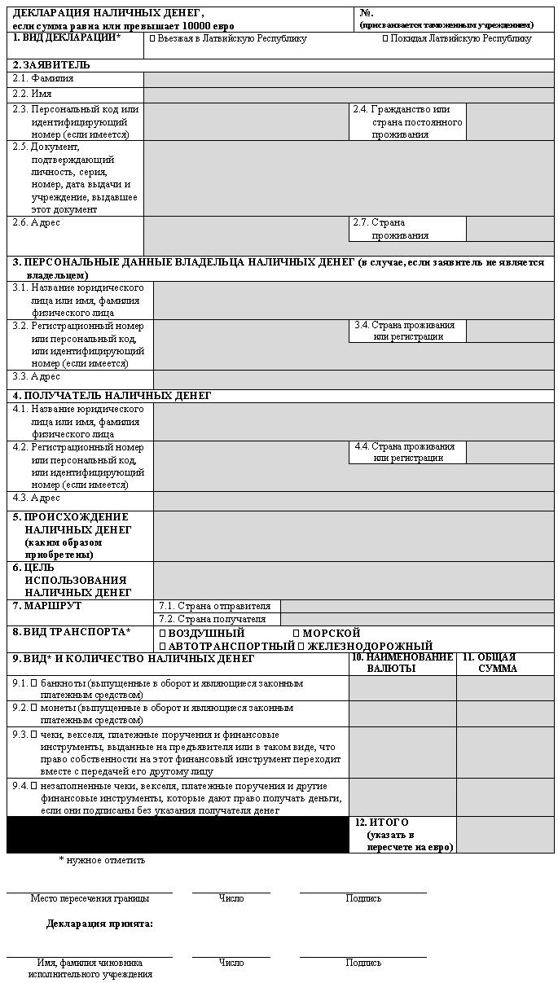

Minister for Finance O. Spurdziņš

