Text consolidated by Valsts valodas centrs (State Language Centre) with amending regulations of:
16 July 2013 [shall come into force from 1 January 2014];
10 December 2013 [shall come into force from 14 December 2013];
16 May 2017 [shall come into force from 20 May 2017].
If a whole or part of a paragraph has been amended, the date of the amending regulation appears in square brackets at the end of the paragraph. If a whole paragraph or sub-paragraph has been deleted, the date of the deletion appears in square brackets beside the deleted paragraph or sub-paragraph.

Republic of Latvia

Cabinet
Regulation No. 454
Adopted 21 June 2011

Regulations Regarding Forced Return of Foreigners, Standard Travel Document and the Issue Thereof

Issued pursuant to
Section 50.³, Paragraph two and Section 50.⁵, Paragraph two of the Immigration Law

I. General Provisions

1. This Regulation prescribes the procedures for forced return of a foreigner, as well as the procedures for the issue of the standard travel document.
[16 May 2017]

2. Within the meaning of this Regulation, vulnerable persons are minor foreigners, disabled people, foreigners who have reached the age when old-age pension is granted in the Republic of Latvia, pregnant women, single-parent families (father or mother only) with minor children and persons who have been subjected to serious psychological, physical or sexual violence.

II. Procedures for Forced Return of a Foreigner

3. If the head of the Office of Citizenship and Migration Affairs (hereinafter – the Office) or his authorised official takes a decision on forced return of a foreigner (hereinafter – the decision), the Office shall, within one working day, send it to the State Border Guard for execution. If the decision has been taken in respect of the foreigner referred to in Paragraph 25 of this Regulation, the Office shall also inform the relevant place of imprisonment in writing.
[16 May 2017]

4. If the head of the State Border Guard or his authorised official takes the decision, the State Border Guard shall, within three working days, inform the Office thereof.

5. A foreigner shall confirm his or her becoming acquainted with the decision with his or her signature and receive one copy of the decision. If the foreigner refuses to certify with his or her signature the fact of becoming acquainted with the decision, the official of the State Border Guard shall make a note in respect of this in the decision and issue a copy of the decision to the foreigner. The foreigner is entitled to explain in writing the reason for refusal.

6. [16 May 2017]

7. When implementing forced return, a foreigner shall be removed to his or her country of citizenship. If this is not possible, the foreigner shall be removed to the third country from which he or she has entered, or to another third country which he or she has the right to enter (hereinafter – the country of destination).

8. The condition referred to in Paragraph 7 of this Regulation shall not restrict the forced return of the foreigner on the basis of the international agreements binding to the Republic of Latvia regarding the return of persons who are staying in the State territory illegally (hereinafter – the readmission agreement).

9. After performance of all the preparatory activities provided for in this Regulation, the forced return of the foreigner shall be implemented as soon as possible.

10. For the implementation of the forced return of the foreigner the State Border Guard shall obtain all the documents necessary (for example, travel (return) documents, visa, insurance document), as well as organise the transportation and accompanying of the foreigner under the supervision of guards (hereinafter – escorting).

11. Forced return of the foreigner may be implemented by escorting the foreigner to:
11.1. the border crossing point of the Republic of Latvia;
11.2. the border crossing point of the transit country on the removal route;
11.3. the border crossing point of the country of destination;
11.4. the place of residence of the foreigner or a specialised institution in the country of destination. The condition referred to in this Sub-paragraph may only be applied to vulnerable persons.

12. When taking a decision on escorting the foreigner to the place referred to in Paragraph 11 of this Regulation, the following conditions shall be evaluated:
12.1. the state of health of the foreigner;
12.2. the psychological traits and risk of absconding of the foreigner;
12.3. the availability of direct flights;
12.4. the consent of the transit country on the removal route to implement the forced return through the territory of the country in question;
12.5. the conditions for participation in the joint return operation to be organised by a European Union Member State;
12.6. the need to hand over the vulnerable person to a family member, legal representative or the representative of a specialised institution.

13. The State Border Guard, when carrying out forced return of the foreigner, shall comply with the requirements of the laws and regulations governing the field of the relevant transport operation. If forced return is carried out, by using air space, the laws and regulations of the European Union laying down the criteria on safety rules in respect of a joint return, by using air space, shall be complied with.
[10 December 2013]

14. When implementing forced return in the cases referred to in Paragraph 11 of this Regulation, the State Border Guard shall pay the foreigner money in the amount of 30 EUR provided for covering food and transport costs, to be reimbursed from the European Union policy instrument programmes or the funds of other foreign financial assistance. The amount of money shall be issued in cash confirming it with a signature. The amount of money provided for a minor foreigner shall be issued to his or her legal representative.
[16 July 2013; 16 May 2017]

15. If the foreigner does not have a valid travel document (except for the case when the readmission procedure has been initiated), the State Border Guard shall send a request to the diplomatic or consular representation of the country of citizenship of the foreigner to issue a travel document to the foreigner or a request to the Consular Department of the Ministry of Foreign Affairs (hereinafter – the Consular Department) to address the diplomatic or consular representation of the relevant country for the receipt of travel (return) document and attach the following documents:
15.1. a filled-in questionnaire of the foreigner (Annex 2);
15.2. the dactyloscopic card of the foreigner;
15.3. four matt photographs (35 x 45 mm) in colour, made of one photo-negative and in one block;
15.4. a filled-in standard form specified by the relevant country for the receipt of a travel (return) document (if there is such in the diplomatic or consular representation of the relevant country);
15.5. an application of the foreigner for the receipt of a travel document in the diplomatic or consular representation of the relevant country. In the application the person shall justify the need for the receipt of the travel (return) document;
15.6. other documents or evidence, which justify addressing the diplomatic or consular representation of the relevant country (if any).
[16 May 2017]

16. A foreigner who refuses to sign the application referred to in Sub-paragraph 15.5 of this Regulation may provide an explanation regarding the reasons for refusal. The explanation of the foreigner shall be attached to the documents referred to in Paragraph 15 of this Regulation, or it shall be indicated in the accompanying letter, by which the documents referred to in Paragraph 15 of this Regulation are submitted for the receipt of travel (return) documents, that the foreigner has refused to write an application and provide explanations regarding reasons for refusal.

17. After receipt of the travel (return) document for a foreigner issued by the diplomatic or consular representation of the relevant country the Consular Department shall, within one working day, hand it over to the State Border Guard.

18. If the diplomatic or consular representation of the relevant country refuses to issue a travel (return) document to the foreigner, the Consular Department shall, within one working day, inform the State Border Guard thereof in writing.

19. The State Border Guard has the right to invite the officials from the country of citizenship of the foreigner to identify the foreigner and issue a travel document to him or her.

20. The State Border Guard shall suspend the implementation of the forced return of the foreigner for a specific period of time if:
20.1. the state of health of the foreigner prevents the implementation of forced return;
20.2. the implementation of forced return is not possible due to technical reasons, or the issue of the travel (return) document of the foreigner is delayed;
20.3. the circumstances referred to in Section 47 of the Immigration Law are determined.

21. The State Border Guard official shall, not later than 12 hours prior to the commencement of return, inform the foreigner being returned regarding the planned return date, and also regarding changes in the implementation of forced return in a language, which the foreigner understands or which he or she should justifiably be able to understand. The foreigner shall certify with a signature that he or she has become acquainted with the abovementioned information and obtains one copy of the certification. If the foreigner refuses to sign the certification regarding becoming acquainted with the provided information, the State Border Guard official shall make a note thereon.
[10 December 2013]

21.¹ The time period referred to in Paragraph 21 of this Regulation may be shortened for the time period, which is not less than one hour before commencement of the return, if:
21.¹1. the foreigner poses a threat to national security or public order and safety;
21.¹ 2. return of the foreigner is possible to be organised within less than 12 hours.
[10 December 2013]

22. Prior to the implementation of removal the medical examination (checkup) of the foreigner shall be performed in order to determine whether his or her state of health permits travelling.

23. If it is not possible to obtain a travel (return) document for the foreigner, the State Border Guard shall return the foreigner with a standard travel document issued in accordance with the procedures provided for in Chapter IV of this Regulation, if the relevant country agrees to accept the foreigner with the relevant document.

24. The State Border Guard, when implementing forced return, shall make a note about departure of the foreigner on the decision.

III. Organisation of Forced Return in Case if the Foreigner has no Right to Reside in the Republic of Latvia after Release from a Place of Imprisonment
[16 May 2017]

25. The place of imprisonment shall, within 30 days after the foreigner has been placed in a place of imprisonment, inform the following in writing:
25.1. the State Border Guard regarding the foreigner upon whom an additional punishment has been imposed in accordance with the Criminal Law – removal from the Republic of Latvia;
25.2. the State Border Guard and the Office regarding the foreigner who is not the citizen of a European Union Member State, a European Economic Area State or the Swiss Confederation.
[16 May 2017]

26. When providing information regarding the foreigner referred to in Paragraph 25 of this Regulation, the place of imprisonment shall draw up a notification (Annex 3) and attach thereto:
26.1. a copy of the court judgment or an extract from the judgment (with an indication of the coming into legal effect of the court judgment);
26.2. a copy of the curriculum vitae of the foreigner (the original shall be sent to the State Border Guard);
26.3. a copy of the personal identification document of the foreigner (if any);
26.4. a copy of the travel document of the foreigner (if any);
26.5. the explanation form of the foreigner (Annex 4) (the original shall be sent to the State Border Guard).
[16 May 2017]

27. In addition to the documents referred to in Sub-paragraphs 26.1, 26.2, 26.3, and 26.5 of this Regulation, the place of imprisonment, upon notifying regarding the foreigner referred to in Paragraph 25 of this Regulation, who does not have a travel document, shall send the documents referred to in Paragraph 15 of this Regulation to the State Border Guard.
[16 May 2017]

28. The place of imprisonment shall submit information to the State Border Guard by electronic mail regarding the activities performed in connection with the foreigners referred to in Paragraph 25 of this Regulation if:
28.1. an appeal for clemency has been submitted;
28.2. the administrative committee of the institution has taken a decision to propose to the court that the convicted person be conditionally released from serving of the sentence before to the end of the term;
28.3. the foreigner has been handed over to another country for further serving of the sentence.
[16 May 2017]

29. After receipt of an act of clemency or a court decision regarding conditional release from serving of the sentence before to the end of the term, prior to the release of the foreigner the place of imprisonment shall, without delay, inform the relevant territorial board of the State Border Guard by telephone of the date and time of release of the foreigner.
[16 May 2017]

30. When organising forced return, the State Border Guard shall co-ordinate the procedures for taking over of the foreigner referred to in Paragraph 25 of this Regulation with the place of imprisonment if:
30.1. a decision has been taken in respect of the foreigner;
30.2. an additional punishment has been imposed on the foreigner – removal from the Republic of Latvia.
[16 May 2017]

31. After serving of the sentence in the place of imprisonment, the forced return of the foreigner shall be implemented in accordance with Chapter II of this Regulation.
[16 May 2017]

IV. Sample Form of Standard Travel Document and the Procedures for the Issue Thereof

32. A standard travel document shall be issued by the head of the Office or the State Border Guard or his authorised official.

33. The standard travel document shall be drawn up in accordance with Regulation (EU) 2016/1953 of the European Parliament and of the Council of 26 October 2016 on the establishment of a European travel document for the return of illegally staying third-country nationals, and repealing the Council Recommendation of 30 November 1994.
[16 May 2017]

34. The standard travel document shall be filled-in in Latvian, English and French and an official of the Office or the State Border Guard shall approve it with a seal and signature.
[16 May 2017]

V. Closing Provision

35. Paragraph 14 of this Regulation shall come into force on 1 July 2011.

Informative Reference to European Union Directive

This Regulation contains legal norms arising from Directive 2008/115/EC of the European Parliament and of the Council of 16 December 2008 on common standards and procedures in Member States for returning illegally staying third-country nationals.

Prime Minister V. Dombrovskis

Minister for Justice, Acting for the Minister for the Interior A. Štokenbergs

Annex 1
Cabinet Regulation No. 454
21 June 2011

Standard Travel Document
[16 May 2017]

Annex 2
Cabinet Regulation No. 454
21 June 2011

Questionnaire of Foreigner

1. General information

1.1. | Given name (names), surname  (for women – maiden name)
1.2. | Ethnic nationality
1.3. | Nationality
1.4. | Year of birth, date of birth
1.5. | Place of birth
1.6. | Place of residence (permanent and last residential address prior to arrival in the Republic of Latvia), telephone
1.7. | Marital status (surname, given name, address, telephone of the wife, husband)
1.8. | Dependent family members (surname, given name, year, date of birth, nationality)
1.9. | Education (which educational institution has been finished)
1.10. | Place of employment, position, speciality, telephone
1.11. | Documents certifying identity
1.12. | Departed from the country of residence (date, reason, means of entering in the Republic of Latvia)
1.13. | Country of residence for the last three years
1.14. | Closest relatives (given name, surname, year of birth, place of residence, telephone of parents, brothers, sisters)
1.15. | Property (immovable, movable registered with State authorities)

2. Description of the Person

2.1. | Height (cm)
2.2. | Face
2.3. | Eyes
2.4. | Teeth
2.5. | Chin
2.6. | Nose
2.7. | Distinguishing marks, tattoos
2.8. | Gestures and mimicry
2.9. | Pace
2.10. | Speech
2.11. | Notes

Data was provided by | _______________________________________________________  (given name, surname, signature of the foreigner)
Data was interpreted from | the _______________________language
Interpreted by | _______________________________________________________  (signature and full name of the interpreter)
Questionnaire was filled-in by | _______________________________________________________  (given name, surname, signature of official)

Date: ___ ___________ 20___

Minister for Justice, Acting for the Minister for the Interior A. Štokenbergs

Annex 3
Cabinet Regulation No. 454
21 June 2011
[16 May 2017]

Notification

In accordance with Paragraph 26 of Cabinet Regulation No. 454 of 21 June 2011, Regulations Regarding Forced Return of Foreigners, Standard Travel Document and the Issue Thereof, I inform that:

Name of the place of imprisonment
The following person is serving a sentence
Given name (names), surname of the person
Date of birth
Place of birth
Ethnic nationality
Nationality and type thereof
Place of residence prior to convicting

The person has been convicted on ___ _____________ 20__ in accordance with

(indicate Section, Paragraph and Clause) of the Criminal Law
Term of deprivation of liberty
Additional punishment – removal from the country | has been applied |  | has not been applied
Other punishments

The period of serving the sentence ends on ___ ____________20____

Family members
specify the degree of kinship,
surname (surnames), given name (names), data of birth
staying at

The file contains

indicate personal identification documents (series, number, date of issue, period of validity)
(name of the institution) |  | (given name, surname, signature of official)

Date: ___ ___________ 20___

Minister for Justice, Acting for the Minister for the Interior A. Štokenbergs

Annex 4
Cabinet Regulation No. 454
21 June 2011

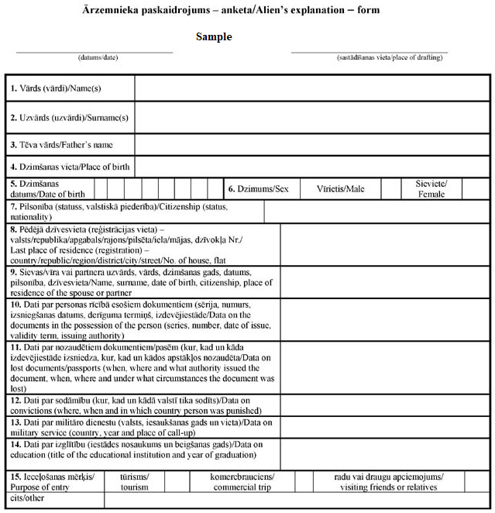

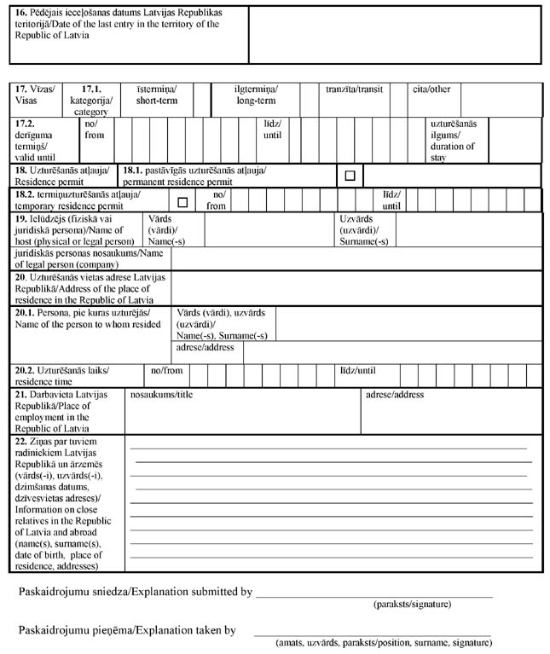
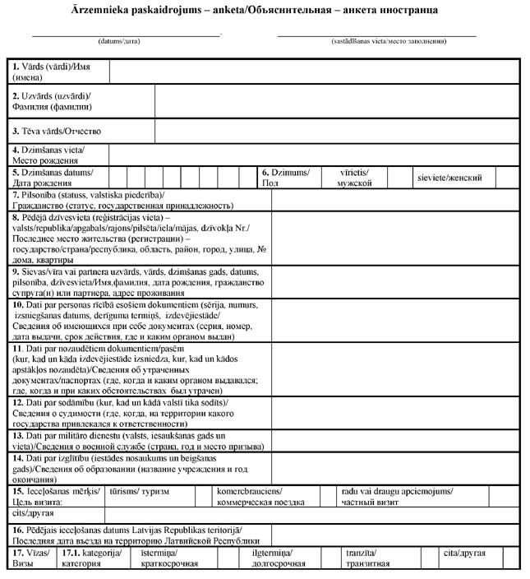
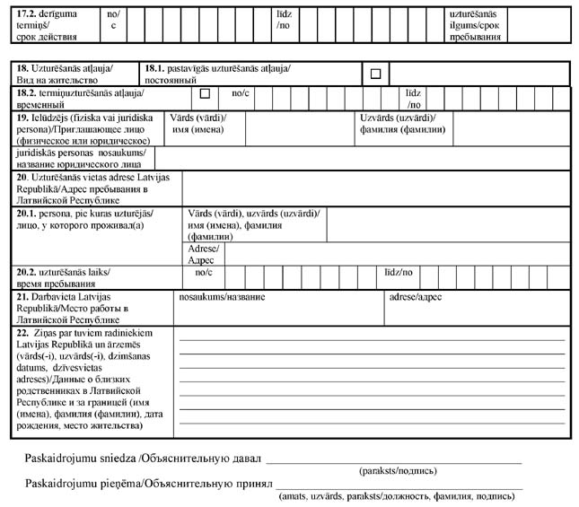

Minister for Justice, Acting for the Minister for the Interior A. Štokenbergs

