Republic of Latvia

Cabinet
Regulation No. 524
Adopted 7 July 2008

Regulations for Use of the Section of Subsoil of
National Significance the “Dobele Structure”

Issued pursuant to Section 10,
Paragraph eight of the
Law On Subsoil

1. These Regulations prescribe the section of subsoil of national significance the “Dobele structure” (hereinafter – section).

2. The area of the section shall be 99.2 square kilometres. The scheme of boundaries of the section and the co-ordinates of boundary points have been determined in the Annex to these Regulations.

3. These Regulations shall not apply to the extraction of mineral resources, recreation and tourism activities, extraction of materials for the creation of mineralogical, palaeontological and other geological collections.

4. It is allowed to carry out the research of the useful properties of the subsoil of the section (hereinafter – research) after a licence for the research of the section (hereinafter – research licence) has been received in the Latvian Environmental, Geological and Meteorological Agency.

5. In order to determine the research licence recipient, the Agency shall organise a competition and shall work out a by-law of the competition. The following criteria shall be included in the by-law of the competition:
5.1. experience of the applicant in the performance of geological research work;
5.2. personal qualification in the field of geological research;
5.3. technical support for the performance of geological research work;
5.4. programme of research work that includes the amounts and terms of research work; and
5.5. contract regarding civil liability insurance of the performance of the work (the existence thereof).

6. Information, characterising the geological construction of the section and information necessary to the participant in the competition for the compilation of a research work programme shall be prepared and issued by the Agency.

7. The Agency shall issue one research licence for research of the entire section.

8. Upon receiving the research licence, a representative of the licence recipient shall present the following:
8.1. a document that certifies the authorisation of the licence recipient to receive the research licence on behalf of the licence recipient; and
8.2. a document that certifies the payment of the State fee regarding the research licence.

9. The research licence shall have the following annexes:
9.1. conditions for the research of subsoil;
9.2. conditions regarding the procedures for and term within which the licence recipient shall submit to the Agency data, samples and information obtained in the geological research of the section; and
9.3. a map or plan of the territory where geological research is intended to be carried out and co-ordinates of the boundary points in the LKS92TM geodesic co-ordinate system of Latvia.

10. When carrying out research of the section, it is prohibited for the licence recipient to drain the withdrawn groundwater on the surface and groundwater horizons.

11. It is prohibited to make boreholes that are deeper than 500 metres without a written co-ordination with the Agency.

12. An owner or lawful possessor of land, with whom the contract regarding the research has been concluded (hereinafter – land owner), may not restrict or hinder the research. The licence recipient shall inform the relevant land owner in writing regarding the place and time of performance of research work at least two weeks prior to the commencement of work.

13. Research work that is planned on agricultural land shall be carried out within the time period when these areas are not taken up by agricultural crops or when the preservation of agricultural crops is possible, as well as observing the territory of Natura 2000, and the general and individual provisions for protection and use of other specially protected nature territories.

14. After the performance of research work, the licence recipient shall restore the areas in such a state that they are useful for utilisation in conformity with the type of use of land.

15. The licence for the utilisation of the useful properties of the subsoil shall be issued when the section is geologically researched sufficiently enough so that it is possible to commence the referred to utilisation, and the research data are evaluated and accepted in the Agency.

16. Territorial local governments, in the territories of which the section is located, within a time period of 18 months after the coming into force of these Regulations shall carry out the necessary amendments in the spatial plan.

17. Until the date of coming into force of these Regulations, the issued licences for geological research of subsoil and utilisation of the useful properties of the subsoil, the licence area of which is located within the boundaries of the section, shall be in force until the end of the term thereof or annulment according to the procedures specified by the Law On Subsoil.

18. The licence area of the research shall be determined in the entire territory of the section, except for the licence areas referred to in Paragraph 17 of these Regulations, until the end of the term thereof or annulment according to the procedures specified by the Law On Subsoil.

Prime Minister I. Godmanis

Minister for the Environment R.Vējonis

Annex
Cabinet
Regulation No. 524
7 July 2008

Scheme of Boundaries of the Section of Subsoil of National Significance the “Dobele Structure” and the Co-ordinates of Boundary Points

I. Scheme of Boundaries

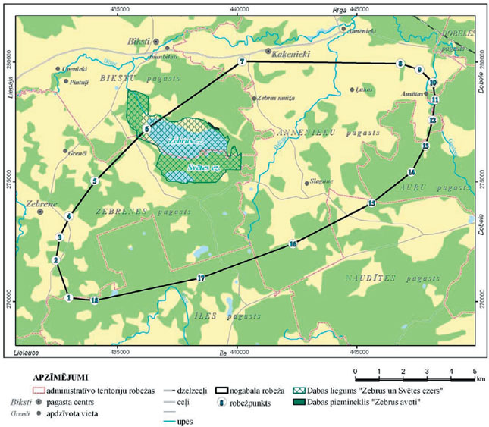

II. Co-ordinates of Boundary Points

No. | Boundary point | Co-ordinate X | Co-ordinate Y
1. | 1 | 270143.6 | 432974.2
2. | 2 | 271721.6 | 432430.2
3. | 3 | 272688.0 | 432592.4
4. | 4 | 273555.9 | 433001.5
5. | 5 | 275022.7 | 434074.6
6. | 6 | 277173.7 | 436168.2
7. | 7 | 280030.4 | 440203.8
8. | 8 | 279934.6 | 446808.5
9. | 9 | 279678.6 | 447609.7
10. | 10 | 279149.4 | 448168.0
11. | 11 | 278439.6 | 448263.1
12. | 12 | 277581.1 | 448154.4
13. | 13 | 276508.9 | 447855.5
14. | 14 | 275407.8 | 447273.1
15. | 15 | 274106.0 | 445622.0
16. | 16 | 272409.2 | 442328.9
17. | 17 | 270984.1 | 438492.0
18. | 18 | 270034.0 | 434052.2

Co-ordinates of the boundary points have been indicated in the LKS92TM co-ordinate system of Latvia.

Minister for the Environment R. Vējonis

