Republic of Latvia

Cabinet
Regulation No. 55
Adopted 28 January 2003

Procedures by which Value Added Tax is to be Refunded to Non-residents for Goods Purchased and Services Received in the Republic of Latvia

Issued pursuant to Section 12.2 of the Law on Value Added Tax

1. These Regulations prescribe:
1.1. procedures by which the value added tax (hereinafter – tax) that has been paid for goods purchased and services received in the Republic of Latvia for engaging in business activities outside the territory of the Republic of Latvia shall be refunded to non-residents not registered in the Enterprise Register of the Republic of Latvia, who are not registered in the Register of persons subject to value added tax in the State Revenue Service of the Republic of Latvia, and who do not perform registrable business activities in accordance with regulatory enactments in the Republic of Latvia (hereinafter – non-resident);
1.2. time periods for the refunding of tax and the minimum amount of tax to be reimbursed;
1.3. the documents to be submitted to the State Revenue Service and the time periods for their submission; and
1.4. a sample form (Annex) for the application for refund of value added tax to non-residents (hereinafter – application).

2. A non-resident shall pay a tax for goods purchased and services received in the Republic of Latvia in accordance with tax invoices (including bills of lading invoices, sales invoices, electronic cash register receipts).

3. The Large Taxpayers Department of the State Revenue Service (hereinafter – State Revenue Service) shall refund the tax on the basis of an application from a non-resident or – on behalf of a non-resident – an authorised person thereof. The application shall be completed in Latvian or in English. A person who has the right to sign an application on behalf of an applicant shall confirm with their signature that the information specified in the application is true, the goods purchased and services received have been utilised for the performance of business activity outside the territory of the Republic of Latvia and the business activity has not been performed in the Republic of Latvia in the relevant taxation year.

4. An authorised person of the non-resident referred to in Paragraph 3 of these Regulations may be:
4.1. a natural or a legal person registered in the Republic of Latvia who acts in accordance with a notarially certified power of attorney issued in the Republic of Latvia; or
4.2. a natural or a legal person registered in the Republic of Latvia or another country who acts:
4.2.1. in accordance with a power of attorney issued in another country and approved by the competent authority of such country in conformity with the 5 October 1961 Hague Convention Abolishing the Requirements of Legalisation for Foreign Public Documents if the relevant country has joined this Convention.
4.2.2. in accordance with a power of attorney issued in another country and validated in the Diplomatic or Consular Representation of the Republic of Latvia in the relevant country if the relevant country has not joined the 5 October 1961 Hague Convention Abolishing the Requirements of Legalisation for Foreign Public Documents; or
4.2.3. in accordance with a power of attorney issued in another country if the Republic of Latvia has concluded a bilateral or multilateral agreement with such country on legal assistance and legal relationships and the power of attorney conforms to the form specified in the agreement.

5. Tax shall be refunded for the taxation year. An application shall be submitted within a time period of six months after the end of the taxation year. The last date for submission of an application shall be 30 June of the post-taxation year. If the application is sent by post, the date of submission shall be deemed to be the date on which the application has been handed over to the post office (postmark). If the time period specified has been exceeded, the application shall not be accepted for examination and tax shall not be refunded.

6. The application shall have appended:
6.1. tax invoices paid (originals) on goods purchased and services received in the Republic of Latvia where the following information shall be indicated:
6.1.1. name, legal address (given name, surname, and permanent place of residence of a natural person) and registration number of the seller of goods or service provider in the Register of persons subject to value added tax in the State Revenue Service;
6.1.2. name, country of residence of the non-resident and registration number of a taxable person;
6.1.3. name and quantity of goods or type and amount of services;
6.1.4. price of the goods or services;
6.1.5. total value of goods and services;
6.1.6. the tax rate and the calculated tax;
6.1.7. the date of making out the invoice;
6.2. a statement (original) issued by the tax authority of the relevant country which certifies that the non-resident at the moment of purchase of goods or receipt of services has been registered in his or her country of residence as a taxable person (the statement shall be valid for a time period of 12 months from the date of issuance thereof); and
6.3. a power of attorney prepared in conformity with the requirements referred to in Paragraph 4 of these Regulations (original), if an authorised person submits the application.

7. If the refund of tax has been requested for fuel purchased in the Republic of Latvia, in addition to the documents referred to in Paragraph 6 of these Regulations the application shall have appended:
7.1. permits for international carriage of freight by road provided for in the agreement between the Republic of Latvia and the relevant country (or copies of the technical documentation of the vehicle in which laden weight or lifting capacity of the vehicle has been specified if in accordance with intergovernmental agreements of the Republic of Latvia international carriage by road permits shall not be obtained), the permit from the European Conference of Ministers of Transport (ECMT), or the international consignment note (CMR) with entries regarding crossings of the State border of the Republic of Latvia;
7.2. a copy of the special permit (licence) for the performance of international motor carriage of passengers as provided for in the agreement between the Republic of Latvia and the relevant country (related to non-scheduled international motor carriages of passengers and regular transit motor carriages of passengers which are performed in the territory of the Republic of Latvia without stopping for embarkation and disembarkation of passengers).

8. The State Revenue Service shall:
8.1. examine the conformity of the application and documents attached thereto to the conditions referred to in Paragraphs 3, 4, 5, 6 and 7 of these Regulations;
8.2. verify whether the transaction specified in the application for which the refund of tax is requested has taken place;
8.3. verify whether the non-resident has registered in his or her country of residence as a taxable person (if necessary, by contacting the tax authority of the relevant country); and
8.4. within a time period of three months from the day of receipt of the application take a decision on the tax refund.

9. If the information indicated in the application and documents attached thereto is not sufficient for taking a decision, the State Revenue Service has the right to request additional information from the applicant. The Ministry of Foreign Affairs shall provide information on procedures for tax refunds in the relevant country upon a request of the State Revenue Service.

10. If the State Revenue Service has taken a decision to refund the tax (fully or partly), not later than within a time period of a month after the date of taking the decision it shall complete Part VI of the application, send a copy of the application to the applicant and the originals of tax invoices with a notation that the tax has been refunded, and transfer the tax amount to be refunded and specified in Part VI of the application to the bank account of the non-resident or authorised person thereof indicated in the application. The costs of the bank transfer shall be deducted from the tax amount to be refunded. Tax invoices for which the value added tax is not refunded shall be sent to the applicant without making a notation on them.

11. If the State Revenue Service has taken a decision not to refund the tax, it shall notify the non-resident or the authorised person in writing, not later than within a time period of 15 days of the date of taking the decision, regarding the reasons for the refusal, attaching a copy of the application and the originals of the tax invoices.

12. Tax shall not be refunded:
12.1. if the conditions referred to in Paragraphs 3, 4, 5, 6 and 7 of these Regulations have not been complied with or the documents (including tax invoices) have not been prepared correctly;
12.2. if during the verification referred to in Sub-paragraph 8.2 it is not confirmed that the transaction has been performed;
12.3. if the total value (without the tax) of goods purchased and services received specified in the application is less than 100 lati;
12.4. for such goods and services specified in one tax invoice the total value of which (without the tax) is less than 20 lati;
12.5. for acquisition of unused immovable property and services received in relation to construction, reconstruction, renovation, restoration or repair of immovable property; and
12.6. for goods purchased and services received for personal use (for example, rental, maintenance, repair of an automobile, purchase of fuel, lubricants and spare parts intended for an automobile, costs for recreation activities, food serving (including restaurant), health improvement activities and entertainment).

13. If the utilisation of an automobile referred to in Sub-paragraph 12.6 of these Regulations in the territory of the Republic of Latvia is fully or partly connected with the business activities of a non-resident in his or her country of residence, the tax for purchase of goods and receipt of services for operation of the automobile (rental, maintenance, repair, as well as purchase of fuel, lubricants and spare parts) shall be refunded fully or partly in conformity with the utilisation of the automobile in relation to the business activity if the application has appended the documents that justify the utilisation of the automobile (for example, a waybill, route description).

14. If other tax refund restrictions have been specified for legal persons registered in the Enterprise Register of the Republic of Latvia in another country, the tax for goods purchased and services received in the Republic of Latvia shall be refunded to the legal persons of the relevant country in compliance with the principle of parity.

15. If a non-resident who has received a notification of the State Revenue Service regarding a decision not to refund the tax, on the basis of the fact that the conditions referred to in Paragraphs 3, 4, 5 and 7 of these Regulations have not been complied with or documents (including tax invoices) have not been prepared correctly, submits correctly prepared documents within a time period of a month after the receipt of the notification, the State Revenue Service shall take a decision on a tax refund within a time period of a month after the receipt of the relevant documents.

16. If documents are submitted repeatedly in accordance with Paragraph 15 of these Regulations, a non-resident or an authorised person thereof shall forward to the State Revenue Service the corrected, updated documents or documents to be submitted in addition together with originals of the value added tax invoices and an accompanying letter in which the date of receipt of the notification of the State Revenue Service is indicated and the documents repeatedly sent are enumerated. If the documents are submitted repeatedly, the time period referred to in Paragraph 5 of these Regulations shall not be binding.

17. The procedures specified in these Regulations shall be applied to tax that has been paid for:
17.1. fuel (including petrol, diesel fuel, petroleum gas) purchased in the Republic of Latvia in 2002; and
17.2. goods purchased and services received in the Republic of Latvia beginning with 1 January 2003;

18. These Regulations shall apply as of 1 January 2003.

Prime Minister E. Repše

Minister for Finance V. Dombrovskis
Annex
Cabinet Regulation No. 55
2003. 28 January 2003

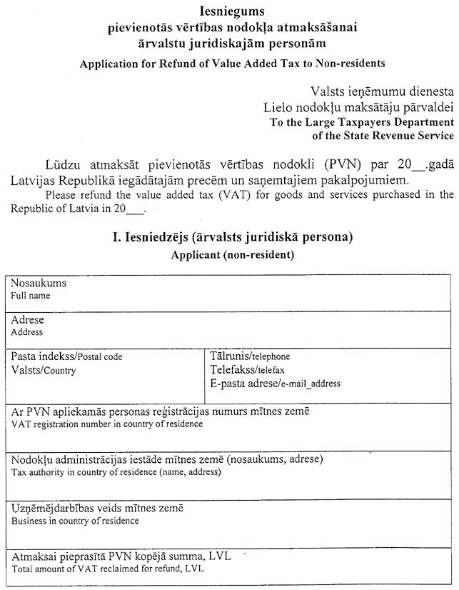

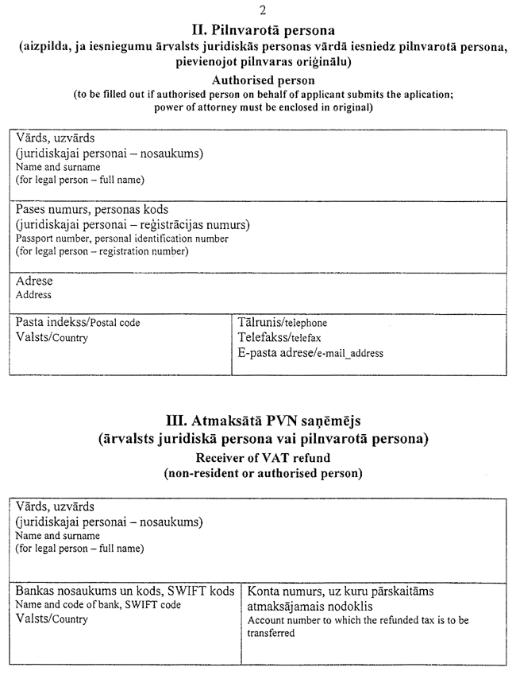

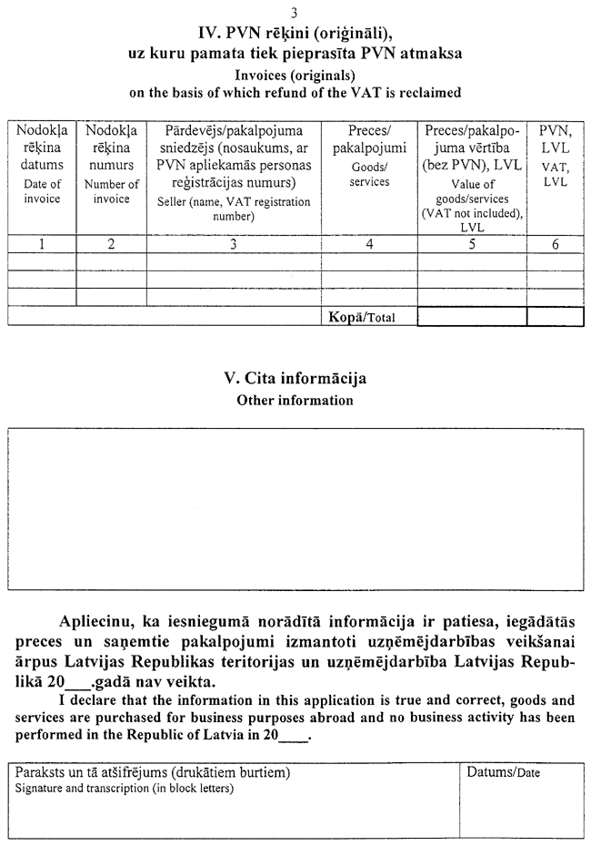

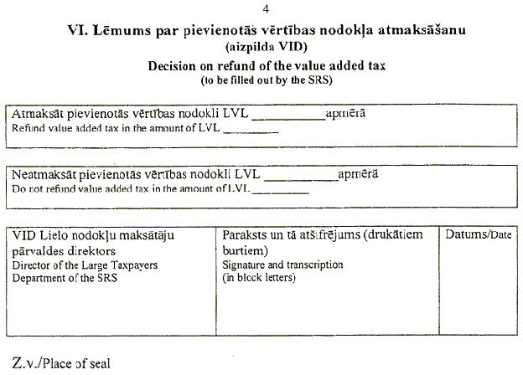

Minister for Finance V. Dombrovskis

