Republic of Latvia

Cabinet
Regulation No. 856
Adopted 14 October 2008

Pre-flight (Post Flight) Inspection Procedures for Foreign Aircraft

Issued pursuant to
Section 30, Paragraph two;
Section 31, Paragraph three and Section 50
of the Law On Aviation

I. General Provisions

1. These Regulations prescribe:
1.1. the procedures by which pre-flight (post flight) inspections shall be performed (hereinafter – inspection) on third-country (states which are not European Union Member States or European Economic Area Member States) aircraft utilising an aerodrome of the Republic of Latvia, in order to ascertain that they conform with the Convention on International Civil Aviation of 7 December 1944 and the safety requirements included in the Annexes thereof, as well as with the safety assessment of foreign aircraft programme (hereinafter – SAFA programme) requirements in conformity with the rights of the European Union;
1.2. the procedures by which the inspection of the aircraft of the European Union or European Economic Area Member State shall be performed;
1.3. the procedures by which the operation of any foreign aircraft shall be suspended or prohibited or restrictions are specified on the operation of an aircraft;
1.4. the manner by which information, that has been obtained by the procedures prescribed by these Regulations, shall be available to the European Commission, the European Aviation Safety Agency (EASA), as well as the competent authorities of the European Union and European Economic Area Member States and the public thereof;
1.5. the requirements for the civil aviation personnel inspecting foreign aircraft (hereinafter – SAFA inspector) and the training organisations which prepare SAFA inspectors.

2. These Regulations shall not apply to the state aircraft and aircraft, the maximum certified take-off mass of which is less than 5700 kilograms, referred to in Article 3 of the Convention on International Civil Aviation of 7 December 1944, if the aircraft operator utilises them for non-commercial purposes.

3. The inspection of foreign aircraft shall be performed by the State agency “Civil Aviation Agency” (hereinafter – Civil Aviation Agency), assigning one or more SAFA inspectors. If several SAFA inspectors have been assigned to the safety inspection, they shall divide the duties between them.

II. Performance of an Inspection and Follow-up Actions Associated Thereto

4. The Civil Aviation Agency shall perform an inspection of a third-country aircraft, as well as a European Union or European Economic Area Member State aircraft if information has been received that it may endanger public order and safety. Special attention shall be paid, if:
4.1. information has been received that proper maintenance has not been performed on the aircraft or the aircraft has visual defects;
4.2. a report has been received that the foreign aircraft, upon entering the airspace of the Republic of Latvia, undertook manoeuvres raising reasonable suspicion regarding the flight safety of the aircraft;
4.3. deficiencies have been detected for the relevant foreign aircraft at the previous inspection raising reasonable suspicion regarding the non-compliance of the aircraft to the requirements of the SAFA programme, and the Civil Aviation Agency is not convinced that the defects have been corrected;
4.4. there is evidence that the competent aviation authority of the foreign aircraft’s registration state has not performed the appropriate flight safety supervision;
4.5. the information referred to in Paragraph 5 of these Regulations indicates that non-compliance of the aircraft operator or the aircraft being operated with the requirements of the SAFA safety programme was detected during the previous inspection.

5. The Civil Aviation Agency shall utilise the sample of the standard SAFA Report Form prescribed in Annex 1 to these Regulations in order to compile information regarding:
5.1. the flight safety of the foreign aircraft;
5.2. The decisions taken by the European Union and European Economic Area Member States as regard foreign aircraft or their operators in accordance with the non-compliance to the requirements of the SAFA safety programme detected during a foreign aircraft inspection;
5.3. the operators of foreign aircraft utilising or planning to utilise aerodromes of the Republic of Latvia.

6. The Civil Aviation Agency shall obtain the information referred to in Paragraphs 4 and 5 of these Regulations from:
6.1. the data base which has been established in accordance with the regulatory enactments of the Republic of Latvia prescribing the notification procedures regarding occurrences in civil aviation. Information shall be compiled and stored in the data base regarding occurrences which threaten or, if not prevented, may threaten the aircraft, persons on the aircraft, or any other person;
6.2. the centralised foreign aircraft safety inspections data base maintained by the European Aviation Safety Agency;
6.3. notifications by aircraft operators;
6.4. reports from the competent aviation authorities of the European Union or European Economic Area Member States;
6.5. complaints from private persons.

7. The Civil Aviation Agency, taking into account the requirements of the European Aviation Safety Agency and the activities to be performed during the inspection process referred to in Annex 2 to these Regulations, as well as the time and resources allocated, shall prescribe the following for the aircraft:
7.1. a full inspection – all the items referred to in the sample of the SAFA Ramp Inspection Report Form (Annex 3) shall be inspected;
7.2. a partial inspection – separate items referred to in the sample of the SAFA Ramp Inspection Report Form (Annex 3) shall be inspected.

8. The Civil Aviation Agency regardless of the inspections referred to in Paragraph 4 of these Regulations, in compliance with the non-discrimination principle and in accordance with international and European Union rights may perform random inspection of aircraft, the compliance of which to the requirements of the SAFA programme are not brought into question.

9. After the inspection of a foreign aircraft the Civil Aviation Agency shall, within 15 working days, prepare a report utilising the sample SAFA Standard Report Form specified in Annex 1 to these Regulations. The information included in the report shall be entered in the SAFA data base.

10. The SAFA inspector assigned by the Civil Aviation Agency prior to commencing the inspection shall inform the relevant aircraft pilot in command, other member of the flight crew or a representative of the aircraft operator regarding thereof. If the persons referred to in this Paragraph have not been informed about the planned inspection, the SAFA inspector shall only be permitted to carry out a visual inspection of the aircraft’s exterior during the inspection.

11. After the inspection the SAFA inspector shall fill out the sample Proof of Inspection (Annex 4), which shall be signed by one of the persons referred to in Paragraph 10 of these Regulations. If the persons referred to in Paragraph 10 of these Regulations refuse to sign the Proof of Inspection, the SAFA inspector shall make a note of that in the Inspection Certificate.

12. The information referred to in Paragraph 5 of these Regulations regarding the non-compliance of the foreign aircraft to the requirements of international air safety shall be included in the report in such a way that it shall not be possible to identify the reporter.

13. The Civil Aviation Agency, when performing an aircraft inspection, shall ensure that the departure of the foreign aircraft from an aerodrome of the Republic of Latvia shall not be delayed, except in the case if the Civil Aviation Agency has assigned the non-compliance category referred to in Sub-paragraph 14.3 of these Regulations to the foreign aircraft.

14. The Civil Aviation Agency shall write in the report referred to in Paragraph 9 of these Regulations the non-compliance category of the foreign aircraft detected during the inspection process of the foreign aircraft. In accordance with the requirements of the SAFA programme the non-compliance of aircraft shall be classified as follows:
14.1. non-compliance Category 1 – the non-compliance of the aircraft is minor and does not have a significant effect on the flight safety of the aircraft;
14.2. non-compliance Category 2 – the non-compliance of the aircraft may have a significant influence on the safety of the aircraft;
14.3. non-compliance Category 3 – the non-compliance of the aircraft creates a direct threat to the safety of the aircraft.

15. In accordance with the prescribed requirements of the European Aviation Safety Agency, taking into account the non-compliance category assigned to the foreign aircraft, the Civil Aviation Agency shall carry out the following measures:
15.1. verbally inform the persons referred to in Paragraph 10 of these Regulations regarding the results of the aircraft inspection, as well as issue a copy of the Proof of Inspection referred to in Paragraph 11 of these Regulations. These actions shall be performed irrespective of the inspection results;
15.2. if during an inspection non-compliance of a Category 2 or Category 3 has been detected, the Civil Aviation Agency shall:
15.2.1. inform in writing the aircraft pilot in command, as well as the aircraft operator and the competent authorities of the state of registry and the state of the aircraft operator regarding the actual deficiencies detected during the inspection of the aircraft;
15.2.2. harmonise measures with the aircraft operator and, if necessary, with the other authorities referred to in Sub-paragraph 15.2.1, which must be performed to correct the detected deficiencies;
15.3. if during an inspection non-compliance of a Category 3 has been detected, the Civil Aviation Agency shall inform the persons and authorities referred to in Sub-paragraph 15.2.1 of these Regulations, by sending the aircraft inspection report without delay, as well as:
15.3.1. prescribe operation restrictions (permit the aircraft to fly in certain weather conditions or on a specific route), the observance of which shall permit the aircraft to depart from an aerodrome of the Republic of Latvia. If the non-compliance effects the validity of airworthiness certificate, the aircraft operator prior to departure shall receive a written permit from the competent state authorities, above whose territories the flight shall be performed;
15.3.2. request that the non-compliances be corrected prior to departure of the aircraft, except in the case where it is necessary for the aircraft to perform the flight to the maintenance base.

16. If the Civil Aviation Agency determines that the aircraft operator cannot correct the non-compliances to the requirements of the SAFA programme detected during the aircraft inspection according to the procedures referred to in Sub-paragraph 15.3 of these Regulations, it shall take a decision to prohibit the foreign aircraft from departing from an aerodrome of the Republic of Latvia until the non-compliance is corrected, except in the case where it is necessary for the aircraft to perform the flight to the maintenance base.

17. The exception referred to in Paragraph 16 of these Regulations shall not be applied if the Civil Aviation Agency determines that it is a hazard to the flight safety of the aircraft in accordance with the requirements of the SAFA programme.

18. The Civil Aviation Agency shall immediately inform the competent authorities of the state of registry and the state of the aircraft operator and the Ministry of Transport regarding the taking of the decision referred to in Paragraph 16 of these Regulations. The decision regarding lifting the prohibition shall be taken when the deficiencies have been corrected and permission has been received from the aircraft’s state of registration.

19. If the decision referred to in Paragraph 16 of these Regulations is taken in relation to a third country aircraft, the Ministry of Transport shall immediately inform the European Commission thereof.

20. The Civil Aviation Agency upon a request by another European Union or European Economic Area Member State shall issue to them, as well as request from them, information regarding:
20.1. aerodromes in the territory of the State that are open to international air traffic;
20.2. the number of aircraft inspections performed at the respective aerodrome during each calendar year and the non-compliances detected therein (having a separate section for third-country aircraft);
20.3. the number of third-country aircraft flights performed at the respective aerodrome during each calendar year.

21. The Civil Aviation Agency shall once a month inform the European Aviation Safety Agency regarding the measures performed in the Republic of Latvia regarding correction of the non-compliances detected during inspections.

22. Upon a request by the European Commission, competent authorities of other European Union and European Economic Area Member States or the European Aviation Safety Agency, the Civil Aviation Agency shall provide the information included in the report and aircraft inspection report referred to in Paragraphs 5 and 9 of these Regulations.

23. If the reports certify that a potential threat exists to flight safety, or it has been indicated in the aircraft inspection report that the aircraft does not comply to the requirements of the SAFA programme or may create a threat to flight safety, the Civil Aviation Agency shall immediately dispatch the relevant reports to all the European Union and European Economic Area Member States and the European Commission.

24. Information which has been obtained according to the procedures prescribed in Paragraphs 5, 9 and 20 of these Regulations in accordance with the Freedom of Information Law has a restricted access status.

25. The Civil Aviation Agency shall issue a public review of the number of aircraft inspections performed at aerodromes in the territory of the Republic of Latvia during each calendar year.

III. Requirements for SAFA Inspectors and the Training Organisations Preparing SAFA Inspectors

26. A SAFA inspector may be a person:
26.1. who works in the field of civil aviation;
26.2. whose education or practical work experience is associated with air navigation or the field of aeronautical maintenance;
26.3. who is qualified in aircraft operations, airworthiness, personnel licensing or performing inspections on transport of dangerous goods.

27. A SAFA inspector shall gain the qualification referred to in Sub-paragraph 26.3 of these Regulations if, in accordance with the requirements set out by the European Aviation Safety Agency:
27.1. he or she has successfully passed the theoretical training course at any European Union or European Economic Area Member State’s competent aviation authority or a training organisation accredited by it;
27.2. he or she has successfully passed the practical training at the institutions or organisations referred to in Sub-paragraph 27.1 of these Regulations. A candidate for SAFA inspector may obtain a training course delivered by a senior SAFA inspector nominated by any European Union or European Economic Area Member State’s competent aviation authority;
27.3. under the direction of a senior inspector nominated by any European Union or Economic Area Member State’s competent authority has performed at least three inspections.

28. In order to maintain the validity of the obtained qualification, a SAFA inspector:
28.1. shall participate in the training course referred to in Sub-paragraph 27.1 of these Regulations at least once every three years;
28.2. shall perform not less than three inspections every year.

29. The requirements referred to in Sub-paragraph 28.2 of these Regulations shall not be applied to a SAFA inspector if the SAFA inspector has gained qualification in aircraft operations or performance of flight inspections at the Civil Aviation Agency and regularly participates in the aircraft inspections of the aircraft operators of the Republic of Latvia.

30. In order for the inspections to be performed in accordance with the prescribed requirements of the EASA and these Regulations, the Civil Aviation Agency may appoint a senior SAFA inspector.

31. A person may be appointed as a senior SAFA inspector, who:
31.1. has performed the functions of a SAFA inspector for at least three years;
31.2. during the last three years has performed at least 36 SAFA inspections;
31.3. is accredited for ensuring aircraft operations or supervising aircraft airworthiness;
31.4. has a good command of at least two foreign languages, including fluent command of English.

32. The SAFA inspector training organisation in the Republic of Latvia my be a natural or legal person, or institution which has received a certificate from the Civil Aviation Agency regarding the right to deliver SAFA inspector training.

33. In order to receive the certificate referred to in Paragraph 32 of these Regulations, the training organisation shall submit the following documents to the Civil Aviation Agency:
33.1. application, in which the type of intended training, name (given name, surname) and legal (declared) address are indicated;
33.2. a document regarding the management structure and planned internal control of the quality of training;
33.3. a personnel list and documents certifying to the qualifications and work experience of the personnel;
33.4. a document certifying ownership rights or user rights to the teaching premises;
33.5. a list of the equipment and facilities that shall be utilised during the training process;
33.6. a detailed plan of the SAFA inspector training course.

34. The Civil Aviation Agency shall, within 30 days after receipt of the documents referred to in Paragraph 33 of these Regulations, examine them and verify the capability of the training organisation to provide SAFA inspector training in accordance with the requirements prescribed by the European Aviation Safety Agency.

35. If there is insufficient information in the submitted documents to objectively take a decision on the issue, the Civil Aviation Agency shall postpone reviewing the matter and shall inform the training organisation in writing thereof. The issue shall be reviewed subsequent to receiving the necessary information and documents.

36. If upon evaluating the plan of the SAFA inspector training course developed by the training organisation, the Civil Aviation Agency has doubts about its compliance with the requirements prescribed by the European Aviation Safety Agency, the Civil Aviation Agency shall dispatch the SAFA inspector training course plan to the European Aviation Safety Agency for evaluation and provision of an opinion, as well as inform in writing the training organisation thereof. The issue regarding the issuance of a certificate shall be reviewed by the Civil Aviation Agency subsequent to the receipt of the opinion from the European Aviation Safety Agency.

37. After examining the document referred to in Paragraph 33 and, if necessary, after receipt of an opinion from the European Aviation Safety Agency the Civil Aviation Agency shall take a decision to issue a certificate to the training organisation regarding the right to deliver SAFA inspector training or refuse to issue a certificate.

38. The issuance of certificate regarding the right to perform SAFA inspector training shall be refused if:
38.1. any of the documents referred to in Paragraph 33 of these Regulations has not been submitted;
38.2. the SAFA inspector training course programme does not comply with the prescribed requirements of the European Aviation Safety Agency.

39. A certificate regarding the right to perform SAFA inspector training shall be issued for an indefinite period.

40. After the issuance of a certificate from the training organisation, the Civil Aviation Agency:
40.1. regularly, but not less than once a year shall audit the teaching organisation;
40.2. in accordance with Commission Regulation (EC) No. 736/2006 of 16 May 2006 on the standardisation inspection working methods of the European Aviation Safety Agency may invite the European Aviation Safety Agency to perform the audit at its certified training organisation.

IV. Closing Provisions

41. Cabinet Regulation No. 449 of 30 May 2006 Procedures by which Pre-Flight (Post Flight) Inspections Shall be Performed, a Restriction or Prohibition to Fly From an Aerodrome of the Republic of Latvia shall be Determined (Latvijas Vēstnesis, 2006, No. 96) is repealed.

42. Chapter III of these Regulations shall come into effect on 1 January 2009.

43. A SAFA inspector shall repeatedly acquire the training course referred to in Sub-paragraph 27.1 of these Regulations by 1 July 2010.

Informative Reference to European Union Directives

These Regulations contain legal norms arising from:
1) Directive 2004/36/EC of the European Parliament and of the Council of 21 April 2004 on the safety of third-country aircraft using Community airports.
2) Commission Directive 2008/49/EC of 16 April 2008 amending Annex II to Directive 2004/36/EC of the European Parliament and of the Council regarding the criteria for the conduct of ramp inspections, which are performed on aircraft using Community airports.

Prime Minister I. Godmanis

Acting for the Minister for Transport –
Minister for Special Assignments for Children and Family Affairs A. Baštiks

Annex 1
Cabinet Regulation
No. 856
14 October 2008

Sample of the SAFA Standard Report Form

Republic of Latvia
State agency CIVIL AVIATION AGENCY
SAFA
Standard Report
No._._._._-_._._._-_._._.

Location of the Source________________
Date __.__.____
Local time ____.____
Operator _____________________
Operator’s Certificate Number ____________
State ________________________________

Flight from |  |  |  | Flight number
Flight to |  |  |  | Flight number
Charterer (if applicable) |  |  |  | Charterer’s state

Type of aircraft _________________________
Registration mark ________________

Manufacturer’s Series number _____________

Flight crew
State of Licensing ______________________________

Notes:
_________________________________________________________________________
_________________________________________________________________________
_________________________________________________________________________
_________________________________________________________________________

Action taken:
_________________________________________________________________________
_________________________________________________________________________
_________________________________________________________________________
_________________________________________________________________________

Given name, surname of the National Co-ordinator
Signature ____________________________

Acting for the Minister for Transport –
Minister for Special Assignments for Children and Family Affairs A. Baštiks

Annex 2
Cabinet Regulation
No. 856
14 October 2008

The Process for Pre-flight and Post Flight Inspection

1. During the process of a pre-flight or post flight inspection the Civil Aviation Agency shall perform the following activities:
1.1. check the documentation necessary in performing international air traffic with an aircraft (aircraft registration certificate, journey log book, airworthiness certificate for the aircraft, the aircraft crew members’ licences, radio licence, passenger list and cargo documents) and its term of validity;
1.2. check the compliance of the flight crew and of the qualifications of the flight crew personnel with the requirements of Annexes 1 and 6 to the Convention on International Civil Aviation (hereinafter – Convention);
1.3. check the operations documentation of the aircraft (flight data, flight plan, technical log book) and the compliance of the aircraft’s readiness for flight with the requirements of Annex 6 to the Convention;
1.4. check if the aircraft has the following in accordance with the requirements of Annex 6 to the Convention:
1.4.1. Air operator certificate;
1.4.2. Noise and Emission Certificate;
1.4.3. Operations manual (including Minimum Equipment List) and flight manual;
1.4.4. safety equipment;
1.4.5. equipment necessary for the specific flight, including radio communication and radio navigation equipment;
1.4.6. flight data recorders;
1.5. check that the condition of the aircraft and its equipment (including aircraft damage repairs performed) ensures compliance with the standards of Annex 8 to the Convention.

2. An inspection report shall be drawn up after the ramp inspection which includes the information referred to in Paragraph 1 of this Annex and a list of items checked, together with an indication of any deficiencies found for each of the items separately. The SAFA inspector of the Civil Aviation Agency may include in the inspection report other information which the referred to inspector considers to be relevant.

Acting for the Minister for Transport –
Minister for Special Assignments for Children and Family Affairs A. Baštiks

Annex 3
Cabinet Regulation
No. 856
14 October 2008

Sample of the SAFA Ramp Inspection Report Form

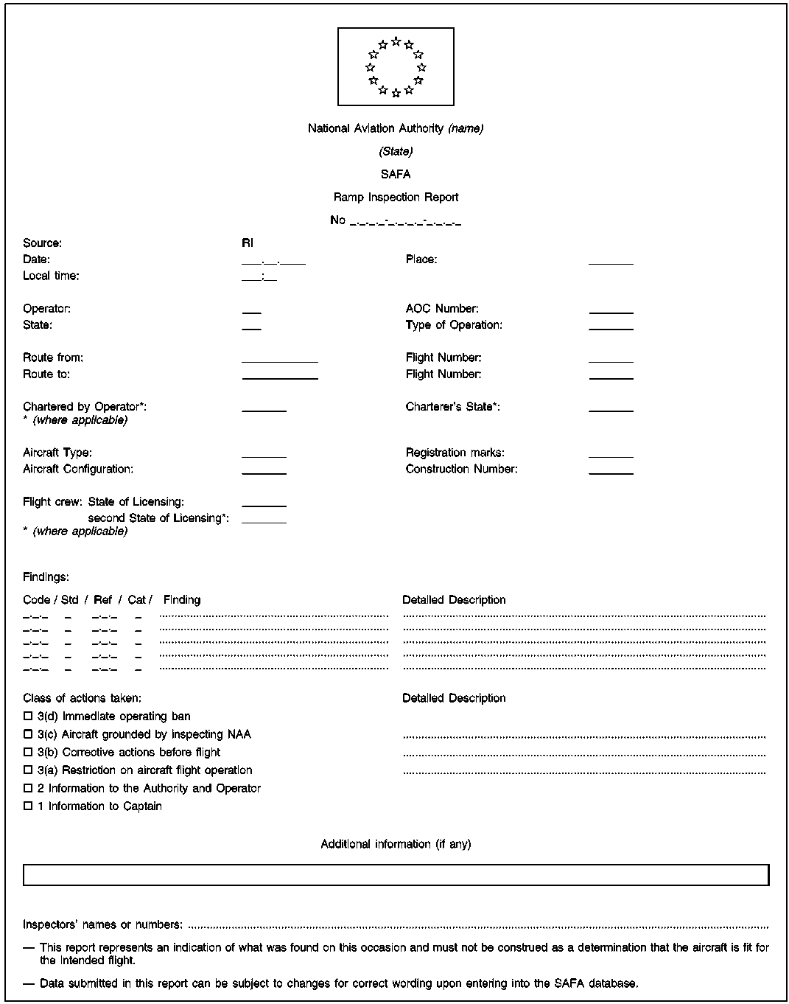
Republic of Latvia
State agency CIVIL AVIATION AGENCY

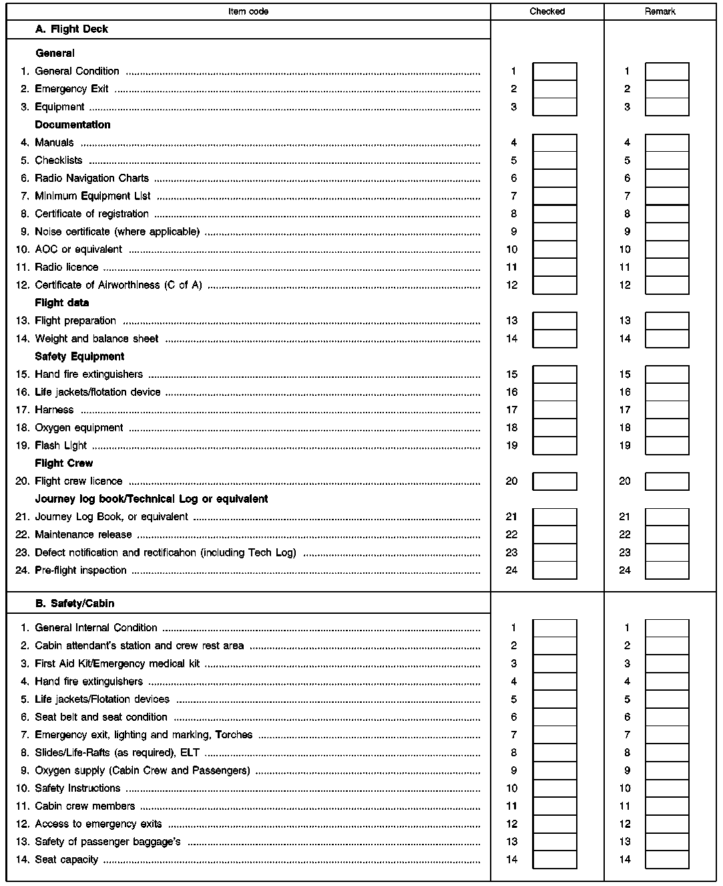

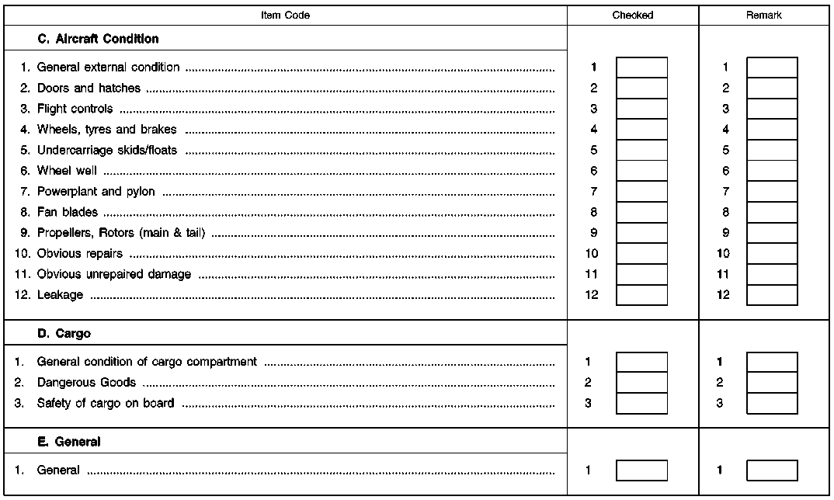

Acting for the Minister for Transport –
Minister for Special Assignments for Children and Family Affairs A. Baštiks

Annex 4
Cabinet Regulation
No. 856
14 October 2008

Sample of the Proof of Inspection

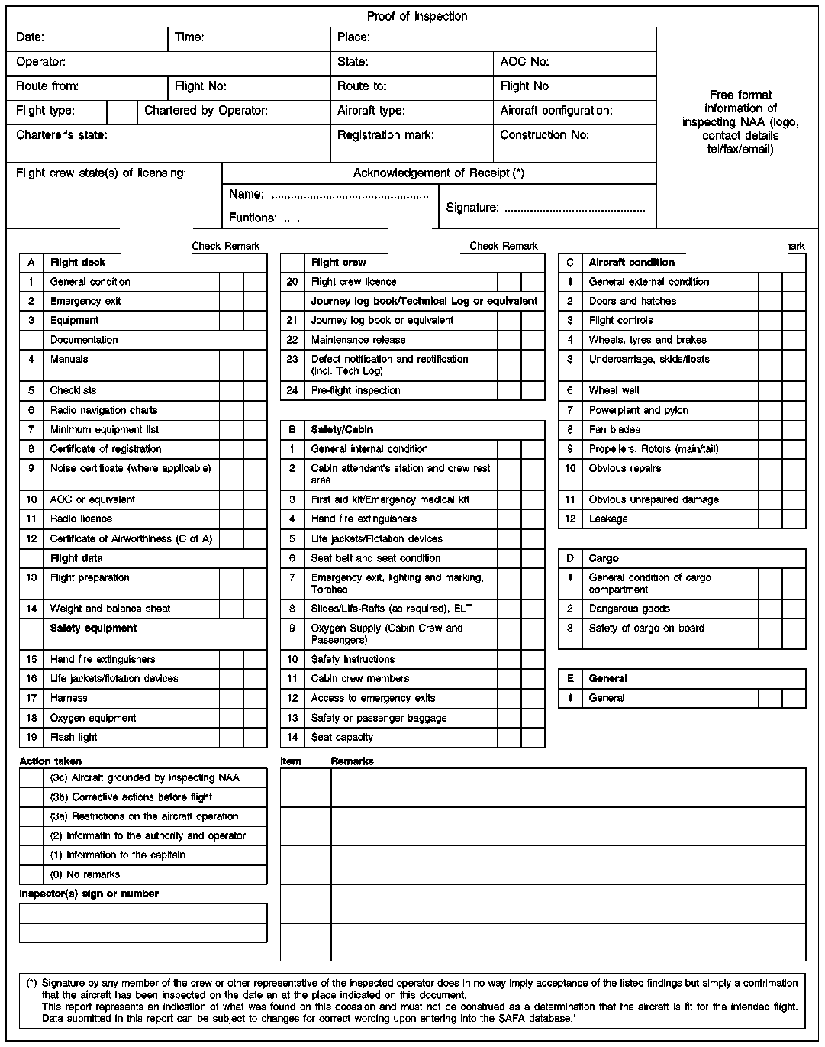

Acting for the Minister for Transport –
Minister for Special Assignments for Children and Family Affairs A. Baštiks

