Republic of Latvia

Cabinet
Regulation No. 1422
Adopted 15 December 2009

Regulations Regarding Return Certificates

Issued pursuant to
Section 6.¹, Paragraph one of the
Personal Identification Documents Law

1. These Regulations prescribe the procedures for the issuance, transfer and cancellation of a return certificate, the term of validity thereof, as well as the information to be included in the return certificate and the sample return certificate.

2. A return certificate (Annex 1) shall be issued to the person referred to in Section 4.¹, Paragraph two of the Personal Identification Documents Law (hereinafter – person) by a diplomatic or consular representation of the Republic of Latvia (hereinafter – representation) or by an honorary consul of the Republic of Latvia who in accordance with the procedures specified in regulatory enactments has been authorised to issue return certificates (hereinafter – honorary consul). If there is neither a representation, nor an honorary consul, in the foreign country, the return certificate shall be issued by the Consular Department of the Ministry of Foreign Affairs (hereinafter – Department).

3. In order to apply for a return certificate, a person shall submit the following in person, by mail or electronically to a representation, honorary consul or the Department:
3.1. a completed and signed application for the issuance of a return certificate (Annex 2) (hereinafter – application). For a minor, if he or she is not travelling independently, the application shall be completed and signed by one of his or her parents, guardian or authorised accompanying person according to the procedures specified in the regulatory enactments regarding crossing of the State border of the Republic of Latvia;
3.2. two photographs (35 x 45 mm);
3.3. the response of a police institution to the application submitted by the person (or a copy thereof), if the passport has been stolen or robbed; and
3.4. the invalid travel document or other documents, which attest to the identity of the person, or copies thereof.

4. A representation or the Department may take a decision to issue a return certificate even if any of the requirements referred to in Sub-paragraphs 3.3 and 3.4 of these Regulations has not been fulfilled.

5. A representation or the Department shall, within one working day, send the copies of the documents referred to in Paragraph 3 of these Regulations to the Office of Citizenship and Migration Affairs (hereinafter – Office), if it is impossible to verify the authenticity of the information indicated in an application of a person.

6. If the legal status of a person in the Republic of Latvia has been determined and if an additional examination or information is not necessary in order to provide an opinion, the Office shall provide the referred to opinion within two working days after receipt of the application by the Office.

7. If an additional examination or information is necessary from other State or local government institutions in order to take a decision regarding the legal status of a person in the Republic of Latvia, the Office shall provide an opinion regarding an application within two working days after determination of the legal status of the person in the Republic of Latvia. The Office has the right to apply the procedures for submitting the opinion referred to in Paragraph 6 of these Regulations to a minor, the legal status of which in the Republic of Latvia has not been determined, but one of the parents of which is the person referred to in Paragraph 2 of these Regulations, and all the documents necessary for determining legal status in the Republic of Latvia personally have been presented or sent electronically or by mail to the institution referred to in Paragraph 2 of these Regulations.

8. The Office shall, within the deadlines referred to in Paragraphs 6 and 7 of these Regulations, inform the representation or the Department regarding the legal status of a person in the Republic of Latvia and send an opinion regarding the application.

9. If a representation or the Department can verify the veracity of the information indicated in a person’s application in the Population Register and the conformity of personal data – the given name, surname, photograph and personal identification number – in the Passport Information System, a return certificate shall be issued within one working day without co-ordination with the Office.

10. The documents which have been submitted for receipt of a return certificate, which are necessary in order that the Office may prepare an opinion regarding the application, and the opinion provided by the Office shall be sent by the relevant honorary consul and Office accordingly with the intermediation of the Department.

11. A return certificate shall be completed in Latvian and English, French, Russian or German.

12. The following information shall be included in a return certificate:
12.1. eye colour;
12.2. height;
12.3. signature of the bearer of the certificate (if the person is not able to sign due to physical deficiencies, medical reasons or inability to write, the person shall not sign and the field for the signature shall not be completed);
12.4. surname;
12.5. the given name (names);
12.6. personal identity number;
12.7. legal status;
12.8. place of birth;
12.9. date of birth;
12.10. place of residence;
12.11. place of issue;
12.12. date of issue;
12.13. term of validity;
12.14. signature of the official and stamp of the issuer; and
12.15. remarks (if necessary, mention the states, which the bearer of the certificate will cross when returning, the given name and surname of the minors who are travelling with the bearer of the return certificate, the number of the travel document, information regarding payment of the State fee). The competent authorities of foreign countries shall glue visas in the “Remarks” section, if such are necessary.

13. A photograph of the person shall be affixed to the return certificate in the placed indicated. The photograph shall be certified by the stamp of the issuer of the return certificate issuer.

14. A return certificate shall be approved by an official of a representation, honorary consul, the director of the Department or his or her authorised official.

15. The validity term of a return certificate shall not exceed 30 days.

16. The invalid return certificates in the possession of a representation shall be cancelled, by marking them with a note “Cancelled”. The representation shall destroy the cancelled and damaged return certificates and return certificate application forms, preparing a deed regarding thereof (Annex 3).

Return certificates issued up to the day of coming into force of these Regulations shall be valid up to the end of the term of validity thereof.

Prime Minister V. Dombrovskis

Minister for Foreign Affairs M. Riekstiņš

Annex 1
Cabinet Regulation No. 1422
15 December 2009

Sample Return Certificate

1. Page 1 of the document - cover (Picture 1c)
1.1. LATVIJAS REPUBLIKA
REPUBLIC OF LATVIA
REPUBLIQUE DE LETTONIE
1.2. Greater State Coat of Arms in brown colour
1.3. Atgriešanās apliecība
Return certificate
Certificat du retour

2. Page 2 of the document (Picture 2a)
2.1. Acis/Eyes/Yeux
2.2. Augums/Height/Taille
2.3. Turētāja paraksts/Signature of bearer/Signature du titulaire
2.4. Uzvārds/Surname/Nom
2.5. Vārds/Name/Prénom
2.6. Personas kods/Code of identity/Code d’identité
2.7. Tiesiskais statuss/Legal status/État de droit
2.8. Photograph of the person
2.9. Hologram picture of the Greater State of Arms of Latvia with the inscription LATVIJAS REPUBLIKAS ATGRIEŠANAS APLIECĪBA (Return Certificate of the Republic of Latvia)
2.10. Certificate number

3. Page 3 of the document (Picture 2b)
3.1. Dzimšanas vieta/Place of birth/Lieu de naissance
3.2. Dzimšanas datums/Date of birth/Date de naissance
3.3. Apliecība izsniegta/Issued by/Delivré par
3.4. Certificate number

4. Page 4 of the document (Picture 2c)
4.1. Izsniegšanas datums/Date of issue/Date de délivrance
4.2. Derīga līdz/Date of expiry/Valable jusqu’au
4.3. Amatpersonas paraksts un zīmogs/Signature and stamp of authority/Signature et cachet de l’autorité
4.4. Certificate number

5. Page 5 of the document (Picture 1a)
5.1. Īpašas atzīmes/Remarks/Remarques

6. Page 6 of the document (Picture 1b)

Specimen form

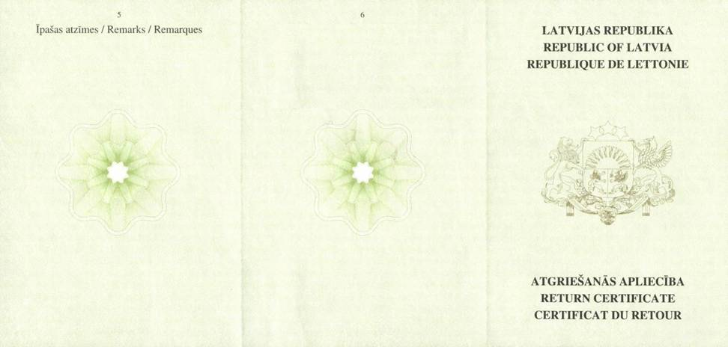
Picture 1a | Picture 1b | Picture 1c

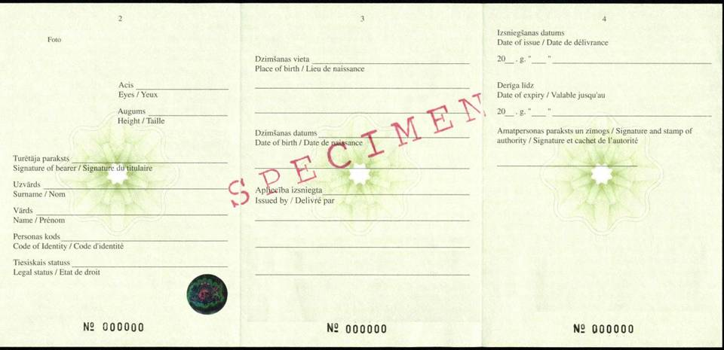
Picture 2a | Picture 2b | Picture 2c

Minister for Foreign Affairs M. Riekstiņš

Annex 2
Cabinet Regulation No. 1422
15 December 2009

Application for Receipt of a Return Certificate

1. | Given name, surname
 |  |  |  |  |  |  |  |  |  |  |  |  |  |  |  |  |  |  |  |  |  |  |  |  |  |  |  |  |  |  |  |  |  |  |  |  |  | Photograph
2. | Date and place of birth
3. | Height |  |  |  |  |  |  |  | cm |  |  |  |  |  |  |  |  | eye colour
4. | Address of the permanent place of residence
5. | Personal identity number |  |  |  |  |  |  |  |  |  |  |  | - |  |  |  |  |  |  |  |  |  |  | 6. Legal status in Latvia
7. | Document, which was used to depart from Latvia
8. | * Number of the referred to document |  |  |  |  |  |  |  |  |  |  |  |  |  |  |  |  |  |  |  |  |  |  |  | Date of issue
 | and place of issue
9. | When and under what conditions the document became invalid
10. | *Place of residence in the foreign country
11. | Information regarding persons under the age of 18 years, who are being accompanied (surname, given name, date of birth)
12. | Date, when it is planned to return to Latvia
13. |  | States, which it is intended to cross, returning to Latvia
Signature of the submitter; |  |  |  |  |  |  |  |  |  |  |  |  |  |  |  |  |  |  |  |  |  |  |  |  |  |  | Date

Notes.
1. * To be filled in, if the required information is at the disposal of the person
2. The details of the document “signature” and “date” shall not be completed if the electronic document has been drawn up in conformity with the regulatory enactments regarding drawing up of electronic documents.

Minister for Foreign Affairs M. Riekstiņš

Annex 3
Cabinet Regulation No. 1422
15 December 2009

Sample Deed Regarding Destruction of a Return Certificate

APPROVED

___________________________
(position)
_________________________ ______________
(given name, surname) (signature)*
__________________________
(date)* Place for a seal*

DEED No. _______
regarding destruction of a return certificate

prepared regarding the fact that
(name of the institution)

on ____ ______________ 20__ destroyed
(total number in numbers and words)

return certificates with these consecutive numbers:

Reason for the destruction

Destroyed by:
 | (position) |  | (given name, surname) |  | (signature)*

Notes.
1. The deed shall be prepared in two copies, one of which shall be kept by the record-keeping of the representation, but the other – shall be sent to the Consular Department of the Ministry of Foreign Affairs. If the deed is prepared at the Consular Department of the Ministry of Foreign Affairs, it shall be prepared in one copy.

Minister for Foreign Affairs M. Riekstiņš

* Details of the document “signature”, “date” and “Place for a seal” shall not be completed if the electronic document has been drawn up in conformity with the regulatory enactments regarding the drawing up of electronic documents.

