Republic of Latvia

Cabinet
Regulation No. 358
Adopted 2 May 2006

By-law of the Crisis Management Council

Issued pursuant to Section 13 of the
the State Administration Structure Law

I. General Provision

1. The Crisis Management Council (hereinafter – Council) is a co-ordinating institution, the objective of operation of which is to promote co-ordinated actions of State administrative institutions for overcoming of danger to the State.

II. Functions, Tasks and Rights of the Council

2. The Council shall have the following functions:
2.1. to co-ordinate the activities of State administrative institutions in cases of danger to the State; and
2.2. to co-ordinate the civil-military co-operation and the operational measures of State administrative institutions for overcoming of danger to the State.

3. The Council shall have the following tasks:
3.1. to examine the information prepared by State and local government institutions regarding danger to the State and to submit proposals to the Cabinet regarding actions for overcoming of danger to the State;
3.2. to examine the forecast of danger to the sectors within the competence of ministries;
3.3. to prepare proposals for announcement of extraordinary situation, state of emergency and mobilisation;
3.4. to evaluate proposals regarding the development of draft regulatory enactments and policy planning documents for prevention and overcoming of danger to the State;
3.5. to inform the Cabinet regarding the decisions taken by the Council;
3.6. to provide the Cabinet with proposals regarding the opportunities to provide humanitarian aid to a foreign state in a crisis situation, as well as regarding ensuring of aid to Latvian citizens and residents in crisis situations in foreign states;
3.7. if necessary, to provide the Cabinet with proposals regarding foreign aid necessary to Latvia in a crisis situation;
3.8. to co-ordinate the integration of the crisis response system of the North Atlantic Treaty Organization in the crisis management system of Latvia and the introduction thereof in State administrative institutions and security institutions;
3.9. to prepare and submit to the Cabinet proposals regarding the aggregate of the national objects vital for the national safety and the security measures to be taken; and
3.10. to perform other tasks specified for the Council in regulatory enactments.

4. The Council has the following rights:
4.1. to invite officials and specialists of the State, local governments and other institutions to the meetings of the Council; and
4.2. to request and receive information necessary for the fulfilment of the tasks of the Council from State and local government institutions, as well as from natural persons and legal persons governed by private law in accordance with the procedures specified in regulatory enactments.

III. Structure of the Council

5. The Chairperson of the Council shall:
5.1. convene and chair meetings of the Council;
5.2. approve the agenda of the Council meetings;
5.3. sign the decisions and minutes of the meetings of the Council;
5.4. represent the Council without special authorisation; and
5.5. upon proposals of Vice-chairpersons of the Council, approve the personnel and tasks of expert groups.

6. The Minister for Defence, the Minister for Foreign Affairs and the Minister for the Interior shall be the Vice-chairpersons of the Council.

7. Vice-chairpersons of the Council or authorised persons thereof shall manage and organise the work of expert groups. The structure of the Council is indicated in the Annex.

IV. Work of the Council

8. The Chairperson of the Council shall convene meetings of the Council not less than once every six months. A meeting of the Council shall also be convened if it is proposed by any of the Council members or by the head of the Council secretariat.

9. The Council shall have a quorum if not less than half of the members of the Council participate in a meeting thereof. Decisions of the Council shall be taken by open ballot with a simple majority. In the event of a tied vote, the vote of the Chairperson of the Council shall be the decisive vote.

10. Minutes shall be taken at Council meetings. The agenda and the decisions taken, as well as the persons who participated in the meeting and their opinion on the relevant matters shall be recorded in the minutes of the meeting of the Council.

11. The Chairperson of the Council and the head of the Council secretariat shall sign the minutes of the meetings and the decisions of the Council.

12. The meetings of the Council shall be open to the public. Upon the proposal of a member of the Council, the Council shall take a decision regarding examination of matters in a closed meeting by a simple majority of the members of the Council in attendance. Participants of a closed meeting have a duty not to disclose the information regarding the decisions taken in the meeting.

13. The work of the Council secretariat shall be provided by the Ministry of the Interior.

14. The Crisis Management Council shall approve the Council secretariat upon recommendation of the Ministry of the Interior. The head of the Council secretariat shall participate in meetings of the Council, as well as in meetings of expert groups in advisory capacity.

15. The Council secretariat shall have the following tasks:
15.1. to perform the tasks specified in the National Security Law;
15.2. to notify the members of the Council and the persons invited to a meeting of the Council regarding the planned meeting of the Council;
15.3. to prepare draft documents for examination in meetings of the Council;
15.4. to provide the members of the Council with materials for the subsequent meeting;
15.5. to record meetings of the Council in minutes and to draw up decisions;
15.6. to send a copy of the minutes of the Council meeting to all members of the Council, as well as to send the decisions of the Council to all interested institutions and officials; and
15.7. to provide the Council with operational information regarding overcoming of a situation of danger to the State.

16. The Council secretariat has the following rights:
16.1. to submit proposals to the Chairperson of the Council regarding agenda of a meeting of the Council;
16.2. if necessary, to request additional materials from the submitters of draft documents;
16.3. to involve officials of other institutions in the preparation of materials for the meetings;
16.4. to provide the Chairperson of the Council with proposals regarding creation of additional expert groups, taking into account the type or scale of danger to the State;
16.5. to control the tasks specified for State administrative institutions in decisions of the Council and to report to the Council regarding the fulfilment thereof; and
16.6. to provide the mass media with information regarding the activities of the Council and the decisions taken by the Council.

Prime Minister A. Kalvītis

Minister for the Interior Dz. Jaundžeikars

Annex
Cabinet Regulation
No. 358
2 May 2006

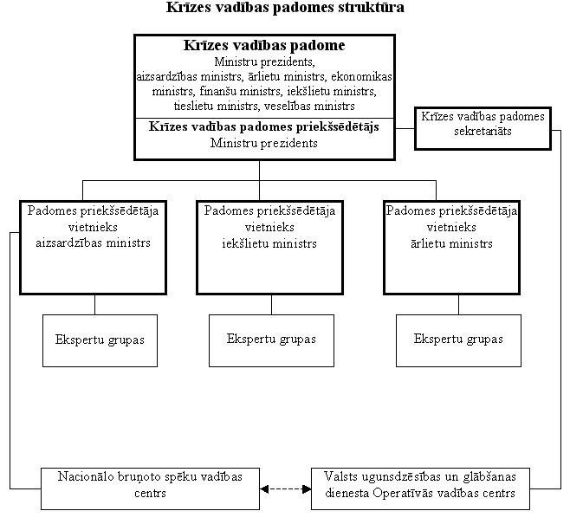
Structure of the Crisis Council
Crisis Management Council
Prime Minister, Minister for Defence, Minister for Foreign Affairs, Minister for Economics, Minister for Finance, Minister for the Interior, Minister for Justice, Minister for Health
Chairperson of the Crisis Management Council
Prime Minister
Secretariat of the Crisis Management Council
Vice-chairperson of the Council
Minister for Defence
Vice-chairperson of the Council
Minister for the Interior
Vice-chairperson of the Council
Minister for Foreign Affairs
Expert groups
Control Centre of the National Armed Forces
Operational Control Centre of the State Fire-fighting and Rescue Service

Minister for the Interior Dz. Jaundžeikars

