Text consolidated by Valsts valodas centrs (State Language Centre) with amending regulations of:
7 June 2005 (No. 396);
10 June 2008 (No. 413).
If a whole or part of a paragraph has been amended, the date of the amending regulation appears in square brackets at the end of the paragraph. If a whole paragraph or sub-paragraph has been deleted, the date of the deletion appears in square brackets beside the deleted paragraph or sub-paragraph.

Republic of Latvia

Cabinet
Regulation No. 374
Adopted 8 July 2003

Procedures for Determination of Medical Fitness of Seafarers for Work on a Ship and Criteria for Conformity Determination

Issued pursuant to
Section 29, Paragraphs two and three of
the Maritime Administration and
Marine Safety Law

I. General Provisions

1. These Regulations prescribe the procedures for the performance of medical examination of seafarers and issuance of a physician’s opinion regarding the conformity of health condition of seafarers with the specified criteria, as well as determine the criteria by which conformity of seafarers for work on a ship shall be determined during medical examination in accordance with the International Convention on Standards of Training, Certification and Watchkeeping for Seafarers of 7 July 1978, as amended (hereinafter – the STCW Convention) and the requirements of the International Labour Organisation.

2. Any person intending to receive a seafarer’s qualification document or to start service on a ship, as well as any person already employed on a ship (hereinafter – seafarer) shall undergo medical examination. If the seafarer’s health condition conforms with the examination criteria set out in these Regulations and the seafarer has, in a physician’s opinion, been attested fit for work on a ship, the seafarer shall be issued a medical examination report/certificate (hereinafter – certificate) (Annex 1).

3. The opinion on a seafarer’s health condition and conformity thereof for work on a ship, as well as the certificate shall be issued by an internist who, according to the Latvian Registry of Seamen and Section 5, Clause 12 of the Maritime Administration and Maritime Safety Law, complies with the requirements of the STCW Convention (hereinafter – physician of seafarers).

4. The physician of seafarers who issues an opinion on the seafarer’s health condition and conformity thereof for work on a ship shall be independent, in professional and financial terms, from the seafarer’s employers, their representatives, employees working in institutions of the seafarer’s employers, shipowners and maritime organisations.

5. The owner and the master of a ship has a duty to control that a seafarer is transferred to and employed on board the ship only after receipt of the relevant certificate.

II. Medical Examination Report/Certificate of a Seafarer

6. The certificate shall be valid for a period of 24 months, except for the following cases:
6.1. if a person under 18 years or above 50 years of age, the certificate shall be valid for a period of 12 months;
6.2. if a person commences work on a ship after reaching 18 years of age or where more than five years have passed since the last medical examination of the person, the certificate shall be valid for a period of 12 months; or
6.3. the validity period of the certificate issued to a ship’s cook, steward or to a member of the service staff of a passenger ship shall be 12 months.

7. Where the validity of a certificate expires during the course of a voyage, the certificate shall be deemed valid until the first port of call at which it is possible undergo medical examination by a physician of seafarers approved by the respective port State. The validity of the certificate may be extended until the expiry of the employment contract, but not more than for two months.

8. A seafarer shall undergo an extraordinary medical examination in the following cases:
8.1. if the seafarer has during the voyage sustained a disease or injury and because of that reason has been repatriated; or
8.2. upon a substantiated request by the owner or master of the ship.

III. Criteria for Medical Examination

9. The following procedures and criteria shall apply to the examination of a seafarer’s eyesight and the ability to distinguish colours:
9.1. visual acuity shall be tested at a distance of 5–6 metres. The ship masters and members of the deck department shall additionally be examined for visual acuity using the reading test (nearpoint acuity);
9.2. the eyesight conforms with the standards set out in Annex 2 to these Regulations;
9.3. if the ability to distinguish colours is in doubt or impaired, colour vision shall be examined by using the Ishihara colour plates or Lantern test; and
9.4. if the required level of visual acuity can only be reached with the help of glasses or contact lenses, the seafarer shall be obliged to wear those aids while at work, as well as it shall be determined that a reserve set of the respective visual aids shall be kept on board the ship.

10. The following procedures and criteria shall apply to the examination of a seafarer’s hearing ability:
10.1. hearing shall be examined with the pure tone audiometer, calibrated at least once in three years. It is prohibited to use any hearing aids during such test;
10.2.any seafarer engaged in navigational watch must have a hearing ability of no less than 30 dB (without hearing aids) in one (the more capable) ear and 40 dB (without hearing aids) for the other ear, if the frequencies are 250, 500, 1000, 2000, 3000, 4000 and 6000 Hz (with the ability to hear a whispering speech from a distance of three and two metres, respectively);
10.3. any seafarer performing functions related to the vessel’s safety must have a hearing ability of at least 40 dB (without hearing aids) in one (the more capable) ear, if the frequencies are 250, 500, 1000, 2000, 3000, 4000 and 6000 Hz (with the ability to hear a whispering speech from a distance of two metres); and
10.4. any seafarer not engaged in navigational watch or functions related to the vessel’s safety must have satisfactory hearing ability, which is sufficient for oral communication.
[10 June 2008]

11. Where a seafarer has been, or is, sustaining a disease referred to in Annex 3 to these Regulations, the physician of seafarers shall assess the conformity of the seafarer for work on a ship and determine whether the seafarer should or should not be recognised fit for such work.

IV. Medical Examination and Issuance of the Certificate

12. Prior to the medical examination, the physician of seafarers shall verify the identity of a seafarer according to the seafarer’s passport or another personal identification document.

13. A seafarer has a duty to provide the physician of seafarers with true and comprehensive information about his health condition, by filling in the personal declaration of seafarer’s medical examination form (Annex 4, Section A). The seafarer shall sign the declaration in the presence of the physician and it shall remain with the doctor.

14. The initial and any regular medical examination of a seafarer shall be carried out with the criteria set out in Chapter III of these Regulations, as well as in addition the following tests and analyses shall be carried out: physical examination, electrocardiography, full blood count, urine test, serological test for syphilis, serological tests for hepatitis B and HIV, large-format fluorogram or roentgenogram of lungs and blood glucose level measurements. The seafarer has a duty to undergo vaccination, taking into account the potential sailing area and the validity term of his employment contract. Seafarers employed on tanker vessels carrying hazardous chemical substances shall, in addition, take tests for measuring the level of ALT (alanine aminotransferase) and AST (aspartate aminotransferase) in blood. Cooks, stewards and service staff shall, in addition, take tests for detection of salmonellosis.

15. Upon taking the initial medical examination, the seafarer shall submit:
15.1. an extract from the personal outpatient card on any sustained diseases and injuries or a statement from his health record;
15.2. a psychiatrist’s opinion on the person’s health condition;
15.3. a narcologist’s opinion on the person’s health condition; and
15.4. vaccination certificate.
[7 June 2005]

16. The medical practitioner shall record the results of the medical examination into the seafarer’s medical examination form (Annex 4, Section B) and into the outpatient medical card (medical form No. 025/u).

17. A seafarer may be issued a certificate indicating job-specific, function-specific and route-specific restrictions or other limitations, taking into account the following conditions:
17.1. whether there is a medical practitioner on board the ship or whether medical assistance is available in the sailing area;
17.2. whether the seafarer’s health condition may affect health of other seafarers; and
17.3. whether the seafarer is able to act effectively in emergency situations.

18. Upon issuing an opinion on the conformity of a seafarer for work on a ship (Annex 4, Section C), the medical practitioner shall review the seafarer’s medical file, take into account the conformity of the seafarer’s health condition with the examination criteria specified in Chapter III of these Regulations, the seafarer’s length of service onboard vessel ship and shall indicate very precisely the applicable restrictions in the seafarer’s medical examination form and in the certificate.

19. If a seafarer’s health condition does not meet the examination criteria set out in Chapter III of these Regulations, the physician of seafarers shall issue to the seafarer a declaration regarding the non-conformity of the seafarer for work on a ship due to health reasons (Annex 5). One copy of the declaration shall be sent to the Latvian Registry of Seamen, while the other copy shall remain with the physician of seafarers.

20. A medical practitioner shall, in accordance with the requirements specified in regulatory enactments, ensure storage and record-keeping of the medical documentation related to seafarers’ medical examinations, also of copies of the issued certificates.

21. Any seafarer shall be provided access to the documents of his medical file. The medical practitioner has a duty to inform the seafarer regarding such right of access.

22. Within the framework of the flag State supervision, the medical practitioner shall ensure the availability of the following information to the inspectors of the Latvian Registry of Seamen:
22.1. the given name, surname and position of the recipient of the certificate;
22.2. the number of the certificate; and
22.3. the date of issuance and validity term of the certificate.

V. Review of the Medical Practitioner’s Decision

23. A seafarer may, within one month after receipt of the opinion of the physician of seafarers regarding medical examination, contest the opinion by submitting a submission to the Health Inspectorate.
[10 June 2008]

24. The seafarer shall, in his submission, indicate that he consents to the relevant medical information being available to the involved parties.

25. Upon reviewing the seafarer’s submission, the Health Inspectorate shall take into consideration the conditions referred to in Paragraph 17 of these Regulations.
[10 June 2008]

VI. Closing Provisions

26. Certificates issued prior to the coming into force of these Regulations shall be valid until the end of their validity term.

27. Seafarers and fishermen not engaged in international navigation and not subject to the requirements of the STCW Convention may undergo the initial and any regular medical examination at any certified doctor of occupational diseases or family doctor. In such case, the seafarer shall be issued a medical statement certifying the conformity of health condition with the specified criteria.

28. These Regulations shall fully apply to the fishermen engaged in international navigation outside the waters of the Republic of Latvia.

29. These Regulations shall not apply to border guards performing their duties on board a ship.

Prime Minister E. Repše

Acting for the Minister for Transport –
Minister for Environment R. Vējonis

Annex 1
Cabinet Regulations No. 374
8 July 2003

LATVIJAS REPUBLIKA  SATIKSMES MINISTRIJA  JŪRNIECĪBAS DEPARTAMENTS | Supplemented lesser State coat of arms | MINISTRY OF TRANSPORT  OF THE REPUBLIC OF LATVIA  MARITIME DEPARTAMENT

JŪRNIEKA VESELĪBAS PĀRBAUDES PROTOKOLS/SERTIFIKĀTS
SEAMAN’S MEDICAL EXAMINATION REPORT/CERTIFICATE
Nr./No. ________________
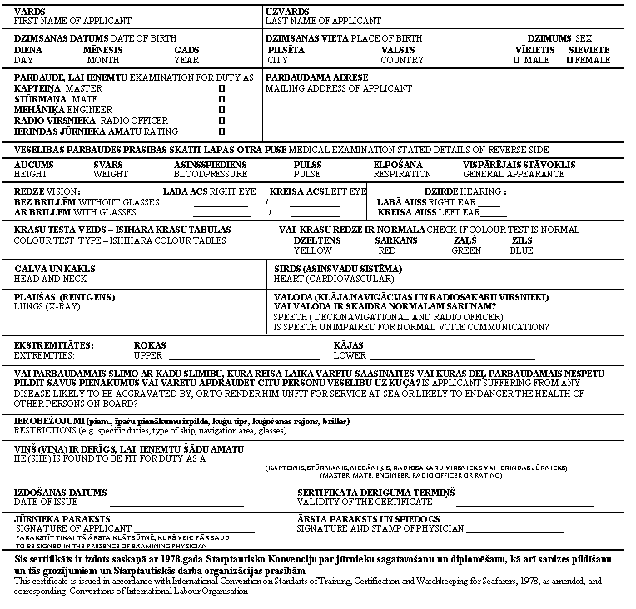

(reverse side of the page)
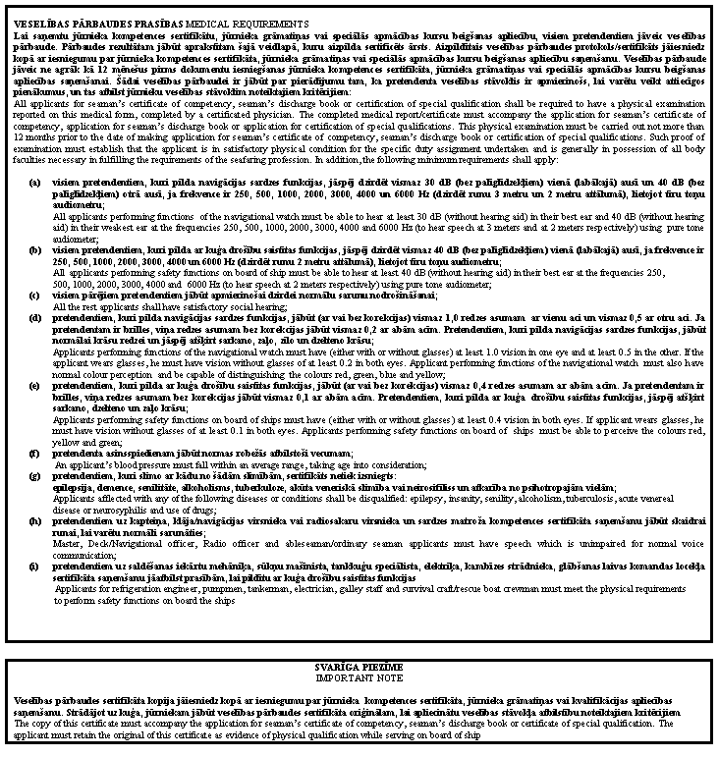

Acting for the Minister for Transport –
Minister for Environment R. Vējonis

Annex 2
Cabinet Regulations No. 374
8 July 2003

Minimum Eyesight Standards for Seafarers

No. | Provisions of the STCW Convention | Seafarer category | Distant vision |  | Vision, near/ intermediate distances | Colour vision | Visual fields | Night blindness | Diplopia  (double vision)
No. | Provisions of the STCW Convention | Seafarer category | One eye | Other eye | both eyes simultane-ously  (with or without correction)
1. | I/11  II/1  II/2  II/3  II/4 | Masters, navigation officers, watchkeeping seamen  With correction  Without correction | 0,8  0,2 | 0,5  0,2 | Vision adequate for steering a vessel (for reading maps and navigational publications, using navigational aids and identifying the means to be used in navigation) |  | Normal visual fields | Vision sufficient to fulfil all duties in darkness | No indications
2. | I/11  III/1  III/2  III/3  III/4 | All watchkeeping engineer officers, watchkeeping motormen  With correction  Without correction | 0,4  0,1 | 0,4  0,1 | Vision adequate for reading the measuring equipment from a short distance, dealing with mechanisms, as well as identifying systems and their components |  | Adequate visual fields | Vision sufficient to fulfil all duties in darkness | No indications
3. | I/11  IV/2 | Radio officers, electrical engineer officers  With correction  Without correction | 0,4  0,1 | 0,4  0,1 | Vision adequate for reading the measuring equipment from a short distance, dealing with mechanisms, as well as identifying systems and their components |  | Adequate visual fields | Vision sufficient to fulfil all duties in darkness | No indications

Acting for the Minister for Transport –
Minister for Environment R. Vējonis

Annex 3
Cabinet Regulations No. 374
8 July 2003

Diseases and Other Reasons due to which a Seafarer may not be Qualified as Fit for Work on a Ship or may be Qualified with Restrictions

Diseases and their criteria | Persons under 18 years of age or persons engaged in work on a ship for the first time or resuming work on a ship after a period of more than five years | Professional seafarers and seafarers resuming work on a ship after a period of less than five years
1 | 2 | 3
I. Infectious and parasitary diseases in infectious stage
1. Tuberculosis in active form | Does not qualify | Does not qualify
2. Tuberculosis, completely cured or in inactive form | May qualify | May qualify
3. Any other infection or parasitary disease in an acute or exacerbation stage | Does not qualify | May qualify with restrictions, taking into account the eventual risk of infection
4. Asymptomatic HIV infection | May qualify with restrictions, taking into account the sailing area | May qualify with restrictions, taking into account the sailing area
II. Tumours
Tumours, benign and malignant | Does not qualify in case of direct danger to the health or if the ability to perform work is endangered. May qualify after a surgery (in case of satisfactory results) or may qualify with restrictions throughout the validity of the certificate, as well as taking into account the sailing area, if there is no direct danger to the health or if the ability to perform work is endangered | Does not qualify in case of direct danger to the health or if the ability to perform work is endangered. May qualify after a surgery (in case of satisfactory results) or may qualify with restrictions throughout the validity of the certificate, as well as taking into account the sailing area, if there is no direct danger to the health or if the ability to perform work is endangered
III. Endocrine, metabolic and immune disorders
1. Uncontrolled adrenal insufficiency | Does not qualify | Does not qualify
2. Insulin-dependent diabetes mellitus – to be treated with insulin | Does not qualify | Does not qualify
3. Insulin-independent diabetes mellitus – to be treated with oral hypoglycemic drugs | May qualify with restrictions throughout the validity of the certificate (specifying that the validity period thereof is up to one year), as well as taking into account the functions to be fulfilled, except for functions of navigational watch, watchkeeping machinery and ship safety functions, if during the last two years there have been no hypoglycemic episodes of the disease, as well as if the disease can be controlled and there is a medical practitioner on board the ship or the seafarer is able to control the situation himself | May qualify with restrictions throughout the validity of the certificate (specifying that the validity period thereof is up to one year), if during the last two years there have been no hypoglycemic episodes of the disease, as well as the disease can be controlled by the seafarer and there is a medical practitioner on board the ship or the seafarer is able to control the situation himself
4. Insulin-independent diabetes mellitus – to be treated with a diet | May qualify with restrictions throughout the validity of the certificate, if the disease has no material symptoms, can be controlled and there is a medical practitioner on board the ship or the seafarer is able to control the situation himself | May qualify with restrictions throughout the validity of the certificate, if the disease has no material symptoms and can be controlled and there is a medical practitioner on board the ship or the seafarer is able to control the situation himself
5. Obesity, with the body mass index (BMI) of > 40 kg/m² | Does not qualify | Qualifies with restrictions throughout the validity of the certificate, taking into account the functions to be fulfilled and the sailing area
6. Thyroid diseases | Does not qualify | Does not qualify
IV. Disorders or anomalies of the hematopoietic and circulatory systems
Disorders or anomalies of the hematopoietic and circulatory systems | Does not qualify | Does not qualify
V. Mental disorders
1. Alcoholism, dating back at least two years as attested by a medical practitioner | Qualifies with restrictions throughout the validity of the certificate, taking into account the functions to be fulfilled and the sailing area | Qualifies with restrictions throughout the validity of the certificate, taking into account the functions to be fulfilled and the sailing area
2. Psychosis – current or with an episode within the last four years | Does not qualify | Does not qualify
3. Psychosis – with an episode dating back more than four years | Qualifies with restrictions throughout the validity of the certificate, taking into account the functions to be fulfilled | Qualifies with restrictions throughout the validity of the certificate, taking into account the functions to be fulfilled
4. Neurotic condition | Does not qualify | Does not qualify
5. Neurotic condition without symptoms for at least the last four years | Qualifies with restrictions throughout the validity of the certificate, taking into account the functions to be fulfilled | Qualifies with restrictions throughout the validity of the certificate, taking into account the functions to be fulfilled
6. Other mental disorders | Does not qualify | Does not qualify
7. Addiction to narcotic and psychotropic substances | Does not qualify | Does not qualify
8. Past addiction to narcotic and psychotropic substances, dating back at least two years as attested by a medical practitioner | Qualifies with restrictions throughout the validity of the certificate, taking into account the functions to be fulfilled and the sailing area | Qualifies with restrictions throughout the validity of the certificate, taking into account the functions to be fulfilled and the sailing area
9. Past addiction to the smoking of marijuana and hashish, dating back at least one year as attested by a medical practitioner | Qualifies with restrictions throughout the validity of the certificate, taking into account the functions to be fulfilled and the sailing area | Qualifies with restrictions throughout the validity of the certificate, taking into account the functions to be fulfilled and the sailing area
VI. Nervous system diseases
1. Epilepsy | Does not qualify | Does not qualify
2. Epilepsy without seizures for at least the last ten years, of which at the last five years without the need for medical treatment | Subject to a neurologist’s assessment, qualifies with restrictions applicable to watchkeeping and safety-related functions | Subject to a neurologist’s assessment, qualifies with restrictions applicable to watchkeeping and safety-related functions
3. Meniere’s disease | Does not qualify | Does not qualify
4. Cognitive disorders | Does not qualify | Does not qualify
5. Organic neurological diseases or disorders caused by a nutritional disease resulting in muscular dysfunction or balance, coordination or concentration disorders | Does not qualify | Does not qualify
VII. Disorders of the cardiovascular system causing inability to work
1. Ischemic heart disease, congenital and acquired heart disorders | Does not qualify, where the treatment cannot normalise the situation. If the treatment leads to normalisation, may qualify with restrictions throughout the validity of the certificate, taking into account the sailing area | Does not qualify, where the treatment cannot normalise the situation. If the treatment leads to normalisation, may qualify with restrictions throughout the validity of the certificate, taking into account the sailing area
2. Heart surgery | Does not qualify during the first two months. If the treatment leads to normalisation, may qualify with restrictions throughout the validity of the certificate, taking into account the sailing area | Does not qualify during the first two months. If the treatment leads to normalisation, may qualify with restrictions throughout the validity of the certificate, taking into account the sailing area
3. Rhythm disorders (symptomatic velocity anomaly) | Does not qualify, where the treatment cannot normalise the situation. If the treatment leads to normalisation, may qualify with restrictions throughout the validity of the certificate, taking into account the sailing area | Does not qualify, where the treatment cannot normalise the situation. If the treatment leads to normalisation, may qualify with restrictions throughout the validity of the certificate, taking into account the sailing area
4. Hypertonia (blood pressure above 180/100 mm/Hg) | Does not qualify, where it is not possible to control and stabilise the situation. If it is possible, may qualify with restrictions throughout the validity of the certificate | Does not qualify, where it is not possible to control and stabilise the situation. If it is possible, may qualify with restrictions throughout the validity of the certificate
5. Aortic aneurysm | Does not qualify | May qualify with restrictions throughout the validity of the certificate, taking into account the sailing area
6. Diseases of brain blood vessels | Does not qualify, where the treatment cannot normalise the situation. If the treatment leads to normalisation, may qualify with restrictions throughout the validity of the certificate, taking into account the sailing area | Does not qualify, where the treatment cannot normalise the situation. If the treatment leads to normalisation, may qualify with restrictions throughout the validity of the certificate, taking into account the sailing area
7. Vein diseases | May qualify with restrictions throughout the validity of the certificate, taking into account the sailing area | May qualify with restrictions throughout the validity of the certificate, taking into account the sailing area
VIII. Respiratory diseases causing inability to work)
Bronchial asthma | Does not qualify | Does not qualify
IX. Disorders of the digestive system
1. Peptic ulcer | Does not qualify | May qualify with restrictions throughout the validity of the certificate, taking into account the sailing area
2. Bleeding from stomach/gut | Does not qualify | Does not qualify
3. Liver cirrhosis | Does not qualify | Does not qualify
4. Pancreatitis, repeated | Does not qualify | Does not qualify
5. Intestinal stoma | Does not qualify | Does not qualify
6. Hepatitis A | Does not qualify | May qualify with restrictions throughout the validity of the certificate, taking into account the sailing area
X. Pregnancy
Pregnancy | Does not qualify | Up to the sixth month of pregnancy, may qualify with restrictions, taking into account the sailing area and functions to be fulfilled. After the sixth month of pregnancy, does not qualify
XI. Skin diseases
Skin infections, dermatosis | May qualify with restrictions, taking into account the sailing area and functions to be fulfilled | May qualify with restrictions, taking into account the sailing area and functions to be fulfilled
XII. Connective tissue diseases
Lupus erythematosus, scleroderma | Upon assessment of the physician of seafarers, may qualify with restrictions, taking into account the sailing area and functions to be fulfilled | Upon assessment of the physician of seafarers, may qualify with restrictions, taking into account the sailing area and functions to be fulfilled
XIII. Defects of the musculoskeletal system
1. Polyarthritis | Does not qualify | May qualify with restrictions, taking into account the sailing area and functions to be fulfilled
2. Arthrosis | Does not qualify | May qualify with restrictions, taking into account the sailing area and functions to be fulfilled
3. Amputations, which may prevent the performance of the seafarer’s duties | Does not qualify | Does not qualify
4. Repeated dislocation of an important joint, which may prevent the performance of the seafarer’s duties | Does not qualify | Does not qualify
XIV. Genital, urinary and gallbladder diseases
1. Gallbladder diseases with acute symptoms | Does not qualify | Does not qualify
2. Gallbladder diseases without acute symptoms during the last two years | May qualify with restrictions, taking into account the sailing area and functions to be fulfilled | May qualify with restrictions, taking into account the sailing area and functions to be fulfilled
3. Kidney transplantation, single-kidney extraction, large symptomatic hydrocele | Does not qualify | Does not qualify
4. Gynaecological diseases | May qualify with restrictions throughout the validity of the certificate, taking into account the sailing area and functions to be fulfilled | May qualify with restrictions throughout the validity of the certificate, taking into account the sailing area and functions to be fulfilled
XV. Diseases of the hearing organs
Infectious ear inflammations | May qualify with restrictions throughout the validity of the certificate, taking into account the sailing area and functions to be fulfilled | May qualify with restrictions throughout the validity of the certificate, taking into account the sailing area and functions to be fulfilled
XVI. Diseases of the organs of sight
Obviously progressing pathological conditions in both eyes | Does not qualify | Does not qualify
XVII. Hernia
Hernia | May qualify after surgery and cure | May qualify after surgery and cure
XVIII. Speech disorders
1. Severe speech disorders | Does not qualify | Does not qualify
2. Speech disorders | May qualify with restrictions applicable to the functions to be fulfilled | May qualify with restrictions applicable to the functions to be fulfilled
XIX. Other diseases
Other diseases, which may endanger the seafarer’s health or the safety of the ship | Upon assessment of the physician of seafarers, does not qualify or may qualify with restrictions throughout the validity of the certificate, taking into account the functions to be fulfilled and the sailing area | Upon assessment of the physician of seafarers, does not qualify or may qualify with restrictions throughout the validity of the certificate, taking into account the functions to be fulfilled and the sailing area

Acting for the Minister for Transport –
Minister for Environment R. Vējonis

Annex 4
Cabinet Regulation No. 374
8 July 2003

Sample Form of Seafarers Medical Examination

KONFIDENCIĀLI/CONFIDENTIAL

Tikai ārsta lietošanai / For doctor’s use only
Vārds __________________ |  | Uzvārds_____________________
Name |  | Surname
Dzimšanas datums ________ |  | Personas kods ________________ | Dzimums _________
Date of birth |  | Identity code | Sex
Amats __________________ |  | Adrese
Position | Domicile

A. Personiskā deklarācija
A. Personal declaration
 | Jā  Yes | Nē  No | Kad  (gads)  When  (year)
1. Vai Jums iepriekš ir veikta jūrnieka veselības pārbaude?
Have you previously undergone a medical examination for seafarers?
2. Vai Jūs esat iepriekš atzīts par nederīgu darbam uz kuģa vai atzīts par derīgu ar ierobežojumiem?
Have you been declared unfit for sea service or fit subject to limitations at any previous medical examination?
3. Vai Jūs kādreiz esat bijis ievietots slimnīcā?
Have you ever been hospitalized?
4. Vai Jums pēdējo divu gadu laikā ir bijis darbnespējas periods, ilgāks par 30 dienām?
Have you within last two years had unbroken period of sickness leave of more than 30 days?
5. Vai Jūs esat iepriekš slimojis ar plaušu slimībām (arī tuberkulozi un astmu)?
Have you been sick with lung diseases including tuberculosis and asthma?
6. Vai Jūs esat iepriekš slimojis ar sirds un asinsvadu slimībām?
Have you ever been sick with any heart and circulatory diseases?
7. Vai Jūs esat iepriekš slimojis ar dzirdes orgānu slimībām?
Have you ever been sick with any ear diseases?
8. Vai Jūs esat iepriekš slimojis ar redzes orgānu slimībām?
Have you ever been sick with any eye diseases?
9. Vai Jūs esat slimojis ar epilepsiju?
Have you been sick with epilepsy?
10. Vai Jūs esat slimojis ar diabētu?
Have you been sick with diabetes?
11. Vai Jums ir kādreiz bijusi nopietna alerģiska reakcija/ekzēma/ādas slimība?
Have you had any serious allergic reaction/eczema/skin disease?
12. Vai Jums ir bijuši psihiski traucējumi?
Have you had any mental disturbances?
13. Vai Jums ir bijušas problēmas ar alkohola vai narkotiku lietošanu?
Have you had trouble with drug or alcohol abuse?
14. Vai Jums ir bijušas mugurkaula traumas vai slimības, ieskaitot lumbago un išiasu?
Have you had any back trouble, including lumbago and sciatica?
15. Vai Jūs esat pārcietis smagu traumu ar pastāvīgi jūtamām sekām?
Have you been suffered serious injury leaving permanent effects?
16. Vai Jums ir bijušas gremošanas trakta slimības, ieskaitot gastrītu?
Have you had any digestion disorders, including gastric disorders?
17. Vai Jūs regulāri lietojat medikamentus?
Do you use medical drugs or other medicines regularly?
18. Vai Jūs lietojat kontaktlēcas vai brilles, lai uzlabotu redzi?
Are you using contact lenses or glasses to improve your eyesight?
19. Vai Jums ir grūtības orientēties sliktā apgaismojumā?
Do you have difficulties in orientatig yourself under reduced lighting?

Apliecinu, ka informācija norādīta saskaņā ar ārstu, slimnīcu vai citu veselības aprūpes iestāžu sniegtajiem atzinumiem un ir patiesa.
Confirm that information concerning previous sickness being obtained from doctors, hospitals and other health institution and is true.

Jūrnieka paraksts __________________
Seaman’s signature

Datums _______________
Date

B. Veselības pārbaude
B. Health examination

Augums ________ cm  Medical | Svars _______ kg  Weight | Asinsspiediens _________  Blood pressure

Dzirdes pārbaude/Examination of hearing
Tīru toņu audiometrijas pārbaude/Audiometry using pure tone audiometer

Hz | 250 | 500 | 1000 | 2000 | 3000 | 4000 | 6000
Labā auss/Right ear
Kreisā auss/Left ear

Redzes pārbaude/Sight examination
Redzes asums (5–6 m attālumā )/ Power of sight (distance – 5–6 m)

 | Labā acs  Right eye | Kreisā acs  Left eye | Abas acis  Both eyes | Atbilst kritērijiem/Confirming to requirements
 |  |  |  | Jā/Yes | Nē/No
Bez korekcijas/Uncorrected
Ar korekciju/Corrected

Redzes lauki/Field of vision

 | Labā acs/  Right eye | Kreisā acs/  Left eye | Piezīmes, ja redzes lauki traucēti/  Remarks if not normal
Normāli/Normal
Traucēti/Not normal

Krāsu redze/Colour vision

Normāla ___  Normal | Apšaubāma ___  Doubtfull | Traucēta ___  Not normal | Nav pārbaudīta ___  Not examined

Lietot palīglīdzekļus, lai uzlabotu krāsu redzi, ir aizliegts.
The use of contact lenses or glasses to improve colour vision is not permitted.

C. Atzinums
C. Decision

Jūrnieks ir derīgs darbam uz kuģa Jā ___ Nē ___
The seafarer is medicaly fit for intended service Yes No

Jūrnieka veselības pārbaudes sertifikāts ir izsniegts bez ierobežojumiem Jā ___ Nē ___
There are no limitations relating to seamen’s health certificate: Yes No

Saskaņā ar jūrnieku ārsta atzinumu veselības pārbaudes sertifikāts izsniedzams ar šādiem ierobežojumiem:
The seamen’s doctor has decided to issue Health certificate with following limitation:

___ attiecībā uz derīguma termiņu _____________________________________________
regarding to time

___ attiecībā uz izpildāmajām funkcijām
(navigācijas sardze, sardze mašīntelpā, citas funkcijas) __________________
regarding to function (look-out duty, engine-room duty, another functions)

___ attiecībā uz kuģošanas rajonu
(Eiropas ūdeņi līdz 100 jūdzēm no krasta, Latvijas piekrastes ūdeņi, ostu akvatorijas)__
regarding to trade area (European waters up to 100 miles from coasts, Latvian coastal waters, port areas)

Ja jūrnieka veselības stāvoklis neatbilst noteiktajiem kritērijiem un jūrnieks nav derīgs darbam uz kuģa, norādīt iemeslus
In case if seafarer is medically unfit for intended service, reasons for decision should be given below:
____________________________________________________________________________

Datums ________________ Jūrnieku ārsta paraksts _________________________
Date Signature of the seamens doctor

Acting for the Minister for Transport –
Minister for Environment R. Vējonis

Annex 5
Cabinet Regulation No. 374
8 July 2003

Declaration on Insufficient Medical Fitness for Work on a Ship

Given name | Surname ________________________

Date of birth ___________ | Personal identity number[ ] [ ] [ ] [ ] [ ] [ ] - [ ] [ ] [ ] [ ] [ ] [ ]

Address ________________________________________________________________

Position________________________________________________________________

_______________________________________________________________________

On the basis of results of the medical examination, the seafarer has been found not medically fit for work on a ship:

completely | ____________
for an unlimited period of time | ____________
for a limited period of time* | ____________
_____________________
(please indicate the date)

___________________________________________________________________________

Place and date of issuance of the declaration

Name and surname of the physician of seafarers

Address of the physician of seafarers _____________________________________________

Signature of the physician of seafarers _____________________ | Place for a seal

Note:
The declaration shall be issued to the seafarer. The first copy of the declaration shall be sent to the Latvian Registry of Seamen. The second copy of the declaration shall be kept with the physician of seafarers.

Acting for the Minister for Transport –
Minister for Environment R. Vējonis

* Up to a time, when certain medical indicators will be ascertained, or the minimum time required to completely cure the respective symptoms

