Republic of Latvia

Cabinet
Regulation No. 868
Adopted 21 October 2008

Regulations Regarding Addition of Colour Photographs or
Illustrations to Tobacco Packaging Units

Issued pursuant to
Section 6, Paragraph four of
the Law On Restrictions regarding Sale,
Advertising and Use of Tobacco Products”
.

I. General Provision

1. These Regulations prescribe the procedures, by which concurrently with the special warnings included in Section 6, Paragraph three of the Law On Restrictions regarding Sale, Advertising and Use of Tobacco Products tobacco packaging units shall be supplemented with colour photographs or other illustrations (the combined warning) in accordance with Annex to these Regulations.

II. Placing of Combined Warnings

2. The combined warning shall be printed on the second most visible (largest) surface of the tobacco packaging unit, as well as on any outside packaging, except for additional transparent wrappers, which are used in the retail trade of tobacco products, observing the format and proportions of the photograph or other illustration, as well as the graphic integrity of the image and text.

3. Each tobacco packaging unit to be marketed in Latvia shall have an indication “The Ministry of Health warns” before the combined warning.

4. The combined warning (except the indication “Ministry of Health warns”) shall cover not less than 40% of the outside surface of the tobacco packaging unit on the second most visible surface and shall be located in parallel to the upper edge in the same direction as the other information on the packaging. In relation to tobacco products, which are not cigarettes and the most visible surface of the packaging unit of which is larger than 75 cm², the combined warning shall be placed on the second most visible surface, and it shall cover an area in the size of at least 22.5 cm².

5. Combined warnings shall be changed in order to guarantee regular use of all combined warnings. The amount of the different combined warnings used shall not exceed five percent within one year.

6. The combined warning shall be surrounded by a black border, which is not less than three millimetres and not more than four millimetres wide and which does not cover any textual or visual element of the combined warning. The border shall not be considered as part of the area provided for the warning.

7. The combined warning shall be printed so that it would not be possible to remove and erase it, as well as it shall not in any way be hidden and interrupted by other written or illustrative material or opening of the packaging. It is prohibited to completely or partially cover the combined warning or any element thereof with any type of wrappers or covers or other means. It is prohibited to print the combined warning or any element thereof with tax stamps or price labels.

8. The combined warning on the tobacco packaging shall in no way be commented, paraphrased and shall not be made reference to, except the indication “Ministry of Health is warning”.

9. It is allowed to attach the combined warnings to tobacco products other than cigarettes in the form of stickers, observing the condition that such stickers are irremovable.

III. Technical Specification of Combined Warnings

10. The combined warning shall be printed in four-colour print (CMYK) 133 lines per inch.

11. The combined warning shall be regarded as a whole unchangeable image. The combined warning shall be reproduced without changing the proportions or colours.

12. It is allowed to alter the combined warning by changing the size of letters and the make-up of lines if it is related to the size of the tobacco packaging:
12.1. in the combined warning where the illustration is a text, the graphic imaging shall be performed by changing the size of letters and the make-up of lines, preserving the ratio of sizes of areas, which are covered by the text illustration and the corresponding text of the special warning;
12.2. in the combined warning, which includes a photograph or other image, the graphic imaging shall be performed by proportionally changing the size of the photograph or other image and changing the ratio of sizes of the areas, which are covered by the photograph or other image and the corresponding text of the special warning:
12.2.1. if the height and width ratio of the combined warning is less than 0.8, the corresponding text of the special warning may be moved to the right of the photograph or other illustration if it is placed beneath the photograph or other illustration; or
12.2.2. if the height and width ratio of the combined warning is more than 1.2, the corresponding text of the special warning may be moved beneath the photograph or other illustration if it is placed to the right or to the left of the photograph image or other illustration.

IV. Closing Provision

13. Colour photographs and illustrations to be used in combined warnings may be received in electronic form at the Ministry of Health upon submission of a justified request.

Prime Minister I. Godmanis

Minister for Health I. Eglītis
Annex
Cabinet Regulation
No. 856
21 October 2008

Combined Warnings

1. Smokers die younger

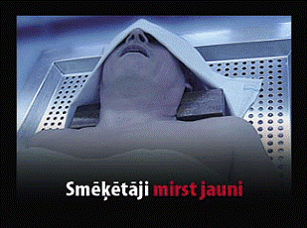

2. Smoking clogs the arteries and causes heart attacks and strokes

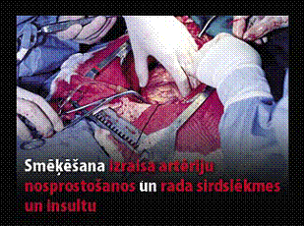

3. Smoking causes incurable lung cancer

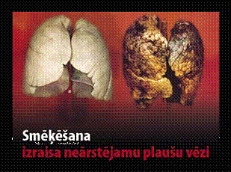

4. Smoking when pregnant harms your baby

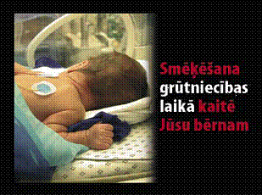

5. Protect children: don’t make them breathe tobacco smoke!

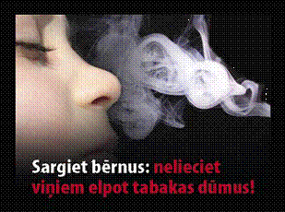

6. Your family doctor and pharmacist can help you stop smoking

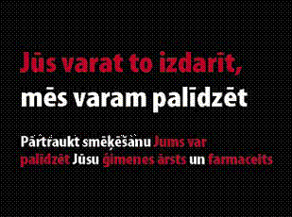
You can do it, we can help

7. Smoking is highly addictive, don’t start!

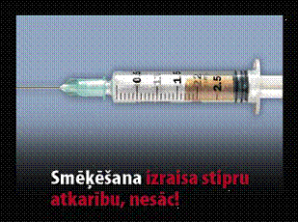

8. Stopping smoking reduces the risk of becoming ill with incurable heart and lung diseases

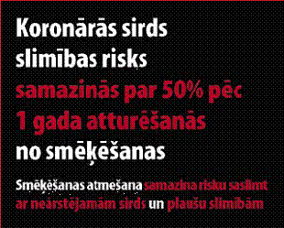
The risk of coronary heart disease is reduced by 50% after 1 year of refraining from smoking

9. Smoking may cause a slow and painful death

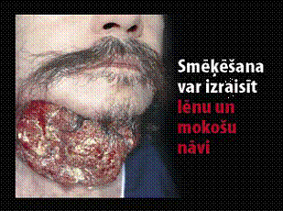

10. Ask for help to stop smoking!

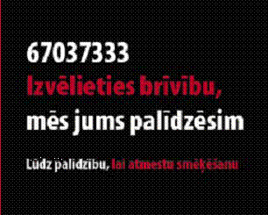
Choose freedom, we will help you

11. Smoking may reduce the blood flow and cause impotence

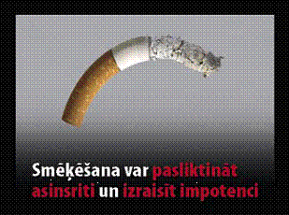

12. Smoking accelerates ageing of the skin

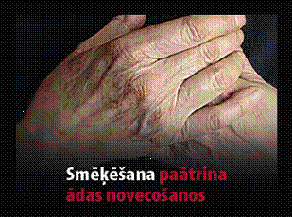

13. Smoking may damage the sperm and decrease fertility

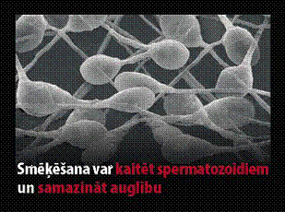

14. Tobacco smoke contains benzene, nitrosamines, formaldehyde and hydrogen cyanide

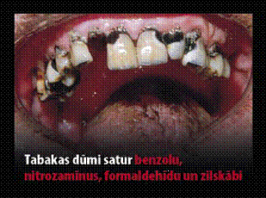

Minister for Health I. Eglītis

