Republic of Latvia

Cabinet

Regulation No. 306

Adopted 17 May 2016

**Regulations Regarding the Requirements for Health Warnings to be Placed on Packaging**

*Issued pursuant to*

*Section 7, Paragraph six of the Law on Circulation of Tobacco Products, Herbal Products for Smoking, Electronic Smoking Devices and Liquids Thereof*

**I. General Provisions**

1. This Regulation prescribes:

1.1. the procedures by which health warnings shall be presented and placed on the packaging of tobacco products, herbal products for smoking, electronic cigarettes and refill containers;

1.2. the combined health warnings (hereinafter – the combined warning) to be placed on a unit packet and outside packaging of a tobacco product for smoking, and the text warnings to be included therein;

1.3. the procedures by which a manufacturer or an importer shall report on placing of the combined warning.

**II. General Requirements**

2. The health warnings placed on a unit packet or any outside packaging of tobacco products shall cover the entire surface reserved for them, and they shall not be commented on, paraphrased or referred to in any form.

3. The health warnings placed on a unit packet or any outside packaging shall:

3.1. be irremovably printed, indelible and fully visible, including not being partially or totally hidden or interrupted by tax stamps, price marks, security features, wrappers, jackets, boxes, or other items;

3.2. remain intact when opening the unit packet. In the event of a unit packet with a flip-top lid, the health warnings may be split when opening the unit packet, but only in a manner that ensures the graphical integrity and visibility of the text, photographs and smoking cessation information.

4. The health warnings placed on a unit packet shall in no way hide or interrupt the tax stamps, price marks, tracking and tracing marks, or security features.

5. The dimensions of the general warnings, information messages, combined warnings to be placed on a unit packet or any outside packaging of tobacco products for smoking, as well as of the health warnings to be placed on a unit packet or any outside packaging of smokeless tobacco products shall be calculated in relation to the surface concerned when the unit packet or outside packaging is closed.

6. The health warnings placed on a unit packet or any outside packaging of the tobacco product shall be surrounded by a black border of a width of one millimetre inside the surface area reserved for the health warnings.

7. Images intended for consumers which reproduce a unit packet or any outside packaging shall comply with the requirements of the laws and regulations regarding circulation of tobacco products, herbal products for smoking, electronic cigarettes and refill containers thereof.

8. On unit packets of tobacco products other than cigarettes and roll-your-own tobacco in pouches, the health warnings may be affixed by means of stickers, provided that such stickers are irremovable.

**III. Requirements for Placing of the General Warning and the Information Message on a Unit Packet or any Outside Packaging of the Tobacco Product for Smoking**

9. Both the general warning and the information message placed on a unit packet or any outside packaging of the tobacco product for smoking shall cover 50 % of the surfaces on which they are printed.

10. For cigarette packets and roll-your-own tobacco in cuboid packets the general warning shall appear on the bottom part of one of the lateral surfaces of the unit packets, and the information message shall appear on the bottom part of the other lateral surface. These health warnings shall have a width of not less than 20 millimetres.

11. For a unit packet of the tobacco product for smoking in the form of a shoulder box with a hinged lid that results in the lateral surface being split into two when the packet is open, the lateral surface shall have a height of not less than 16 millimetres. For such unit packet the general warning shall be printed in its entirety on the larger part of the split surface and on the inside of the top surface that is visible when the packet is open, but the the information message shall appear in its entirety on the larger part of the split surface.

12. For a unit packet of roll-your-own tobacco, either in the form of a rectangular pocket with a flap that covers the opening (a foldable pouch or a flat pouch) or in the form of a standing pouch the general warning and the information message shall appear on the surfaces that ensure the full visibility thereof.

13. For a flat or a foldable pouch the general warning and the information message shall be placed and presented in accordance with Paragraphs 1 and 2 of Annex 1 to this Regulation under the following conditions:

13.1. the general warning and the information message shall be printed on two surfaces that are visible when the packet is fully open;

13.2. the general warning and the information message shall be placed at the top edge of the surfaces concerned;

13.3. the general warning shall be printed on the top surface.

14. For a foldable pouch made of polyethylene, polypropylene or laminated material the general warning and the information message shall be placed and presented in accordance with Paragraph 3 of Annex 1 to this Regulation under the following conditions:

14.1. the information message shall be placed on the surface that is visible when the packet is partly open;

14.2. the general warning shall be placed on the bottom surface that is visible when the packet is fully open;

14.3. the inside of the flap that is visible when the packet is fully open shall not be printed or used in any other way;

14.4. the general warning and the information message shall be placed at the top edge of the surfaces on which they are printed.

15. For a standing pouch the general warning and the information message shall be placed and presented in accordance with Paragraph 4 of Annex 1 to this Regulation under the following conditions:

15.1. the general warning and the information message shall be placed on the base surfaces that are visible when the standing pouch of roll-your-own tobacco is laid flat with the back downward.

15.2. the general warning shall be printed on the surface above the base fold line of the standing pouch of roll-your-own tobacco;

15.3. the information message shall be printed on the surface below the base fold line of the standing pouch of roll-your-own tobacco;

15.4. the surface area shall be calculated using dimensions when edges are closed.

16. For a unit packet of roll-your-own tobacco in the form of a cylindrical packet the general warning shall appear on the outside surface of the lid and the information message on the inside surface of the lid.

17. For a unit packet and any outside packaging of the tobacco product for smoking the general warning and the information message shall be printed in black *Helvetica* bold type on a white background at the centre of the surface reserved for them. On a cuboid packet and any outside packaging the general warning and the information message shall be parallel to the lateral edge of the unit packet or of the outside packaging.

**IV. Requirements for Placing of the Combined Warning**

18. The combined warning placed on each unit packet and any outside packaging of the tobacco product for smoking shall:

18.1. contain one of the images included in Annex 2 to this Regulation which consists of a corresponding colour photograph and one of the text warnings referred to in Annex 3 to this Regulation;

18.2. contain the smoking cessation information referred to in Section 7, Paragraph two, Clause 3 of the Law on Circulation of Tobacco Products, Herbal Products for Smoking, Electronic Smoking Devices and Liquids Thereof;

18.3. be placed on both the external front and back surface of the unit packet and any outside packaging, and cover 65 % of each surface. Each unit packet and any outside packaging shall show the same text warning and corresponding colour photograph on both sides of the unit packet and any outside packaging. Cylindrical packets shall display two combined health warnings, equidistant from each other, each covering 65 % of their respective half of the curved surface;

18.4. appear at the top edge of a unit packet and any outside packaging, and be positioned in the same direction as any other information appearing on the same surface of the packaging;

18.5. comply with the following requirements in the case of unit packets of cigarettes:

18.5.1. height: not less than 44 millimetres;

18.5.2. width: not less than 52 millimetres.

19. In accordance with Annex 2 to this Regulation, there are three sets of combined warnings. Each set shall be used in a given year and rotated on an annual basis and replaced by another set of combined warnings. Each set of combined warnings available for use in a given year shall be displayed to the extent possible in equal numbers on each packet of tobacco products for smoking.

20. A manufacturer or an importer shall, within one month after the tobacco product for smoking is placed on the market, notify the Health Inspectorate of the set of combined warnings used in the given year.

21. Depending on the height and width of the combined warning, the manufacturer shall place the combined warning as follows:

21.1. if the height of the combined warning exceeds 70 % of its width, the combined warning shall appear in a column in accordance with Paragraph 1 of Annex 4 to this Regulation;

21.2. if the height of the combined warning exceeds 20 % but is less than 65 % of its width, the combined warning shall appear in adjacent layout in accordance with Paragraph 2 of Annex 4 to this Regulation;

21.3. if the height of the combined warning is 65 % of its width or more but does not exceed 70 %, the combined warning may appear in a column or adjacent layout, on the condition that all elements of the combined warning remain fully visible and are not deformed.

22. When placing the combined warning in accordance with Paragraph 1 of Annex 4 to this Regulation in a column, a photograph shall be placed on the top side of the combined warning, but the text warning and the smoking cessation information shall appear below the photograph. The photograph shall cover 50 %, the text warning – 38 % and the smoking cessation information – 12 % of the surface area of the combined warning which is inside the outside black edge.

23. When placing the combined warning in accordance with Paragraph 2 of Annex 4 to this Regulation in adjacent layout, a photograph shall be placed on the left side of the combined warning, the text warning – on the top right side, and the smoking cessation information shall appear on the bottom right side. The photograph shall cover 50 %, the text warning – 40 % and the smoking cessation information – 10 % of the surface area of the combined warning which is inside the outside black edge.

24. If due to the form of a unit packet or outside packaging the height of the combined warning is 20 % of its width or less, the combined warning shall be placed in special adjacent layout in accordance with Paragraph 3 of Annex 4 to this Regulation. In this case the photograph shall cover 35 %, the text warning – 50 % and the smoking cessation information –15 % of the surface area of the combined warning which is inside the outside black edge.

25. The combined warning shall be printed using the CMYK four-colour model (colour model of cyan, magenta, yellow and black). All elements in black shall correspond to C0, M0, Y0 and K100, and elements in warm yellow – to C0, M10, Y100 and K0. The combined warning shall be reproduced with a minimum resolution of 300 dpi, if it is printed at its actual size.

26. The text warnings shall be printed in white on a black background, and the smoking cessation information – in black on a warm yellow background in accordance with Annex 4 to this Regulation.

27. If the combined warning is placed in adjacent layout, reversed column or especially wide adjacent layout, a black border of a width of one millimetre shall appear in the surface area reserved for the smoking cessation information between the said information and a photograph.

28. A manufacturer or an importer shall ensure that a photograph contained in the combined warning:

28.1. is reproduced without using effects, adjusting colours, retouching or expanding background;

28.2. is not cut too close to the focal point of the image or too far from it;

28.3. is scaled proportionally without expanding or condensing.

29. A manufacturer shall ensure that:

29.1. the text warning and the smoking cessation information are aligned to the left and centred vertically;

29.2. the text warning and the smoking cessation information are printed in *Neue Frutiger Condensed Bold* font;

29.3. the text warning is printed in letters of the same size;

29.4. the size of the letters of the text warning and the smoking cessation information is as large as possible in order to ensure the maximum visibility of the text;

29.5. the minimum size of the letters of the text warning is 6 points, and the minimum size of the letters of the smoking cessation information is 5 points;

29.6. he line spacing is by 2 points larger than the size of the letters of the text warning and by 1–2 points larger than the size of the letters of the smoking cessation information;

29.7. the text warning is reproduced, as referred to in Annex 3 to this Regulation, including the use of capital letters, but except for numbering.

30. When presenting the combined warning on a unit packet or any outside packaging of the tobacco product for smoking other than cigarettes, roll-your-own tobacco or waterpipe tobacco, if it is impossible to apply Sub-paragraphs 29.5 and 29.6 of this Regulation, manufacturers or importers may reduce the size of the letters of the text warning and the smoking cessation information or the line spacing, on the condition that all elements of the combined warning are preserved and remain fully visible.

31. Paragraph 22 of this Regulation shall not apply to the combined warning to be placed in front of a unit packet with a flip-top lid. The following conditions shall apply to such combined warning:

31.1. if the lid is smaller than the surface area reserved for the photograph and referred to in Paragraphs 22 and 23 of this Regulation and compliance with the requirements contained in Paragraph 22 resulted in splitting of the photograph at the moment of opening of the packet:

31.1.1. the text warning shall be placed on the top side of the combined warning, and the smoking cessation information and the photograph shall appear below the text warning in accordance with Paragraph 4 of Annex 4 to this Regulation (in reversed column);

31.1.2. the photograph shall cover at least 50 %, the text warning – at least 30 % and the smoking cessation information – at least 10 % but not more than 12 % of the surface area of the combined warning which is inside the outside black edge;

31.2. if the lid is larger than the surface area reserved for the photograph and referred to in Paragraphs 22 and 23 of this Regulation and compliance with the requirements contained in Paragraph 22 resulted in splitting of the text warning or the smoking cessation information at the moment of opening of the packet:

31.2.1. the photograph shall be placed on the top side of the combined warning, and the text warning and the smoking cessation information shall appear below the photograph in accordance with Paragraph 1 of Annex 4 to this Regulation;

31.2.2. the photograph shall cover at least 50 %, the text warning – at least 30 % and the smoking cessation information – at least 10 % but not more than 12 % of the surface area of the combined warning which is inside the outside black edge;

31.3. the manufacturer shall ensure that none of the elements of the combined warning referred to in Sub-paragraphs 18.1 and 18.2 is split at the moment of opening of the unit packet.

**V. Presentation of Health Warnings to be Placed on the Packaging of Smokeless Tobacco Products, Herbal Products for Smoking, Electronic Cigarettes and Refill Containers**

32. The health warning shall be placed on a unit packet or any outside packing of a smokeless tobacco product, electronic cigarette and refill container:

32.1. on two largest surfaces;

32.2. parallel to the main text on the surface reserved for this warning;

32.3. in compliance with Paragraph 17 of this Regulation.

33. The health warning on a unit packet of the herbal product for smoking shall be printed on front and back surfaces of the unit packet, as well as on any outside packaging and comply with Paragraph 17 of this Regulation.

34. The health warnings to be placed on a unit packet or any outside packaging of the smokeless tobacco product, herbal product for smoking, electronic cigarette and refill container shall cover 30 % of the surface on which they are printed.

**VI. Closing Provisions**

35. The tobacco products manufactured or placed on the market and labelled until 19 May 2016 in accordance with Cabinet Regulation No. 868 of 21 October 2008 “Regulations Regarding Addition of Colour Photographs or Illustrations to Tobacco Packaging Units” are allowed to be placed on the market until 20 May 2017.

36. Paragraph 14 of this Regulation and Paragraph 3 of Annex 1 to this Regulation shall be in force until 20 May 2018.

37. The roll-your-own tobacco in pouches manufactured or released for free circulation until 20 May 2018 and labelled with the general warning and the information message in accordance with Paragraph 14 of this Regulation and Paragraph 3 of Annex 1 to this Regulation is allowed to be placed on the market until 20 May 2019.

38. Until 19 May 2019, the combined warnings printed on back surface of a cardboard unit packet shall be placed directly below the excise tax stamp. If a unit packet is made of a soft material, the excise tax stamp may be placed in a rectangular area, so that the height of the tax stamp does not exceed 13 millimetres between the top edge of the packet and the top end of the combined warning. Brand names or logos shall not be placed above the health warnings.

39. This Regulation shall come into force on 20 May 2016.

**Informative Reference to the European Union Directives**

This draft Regulation contains legal norms arising from:

1) Commission Directive 2012/9/EU of 7 March 2012 amending Annex I to Directive 2001/37/EC of the European Parliament and of the Council on the approximation of the laws, regulations and administrative provisions of the Member States concerning the manufacture, presentation and sale of tobacco products;

2) Commission Directive 2014/39/EU of 12 March 2014 amending Directive 2012/9/EU as regards the date for its transposition and the deadline for the end of the transitional period;

3) Directive 2014/40/EU of the European Parliament and of the Council of 3 April 2014 on the approximation of the laws, regulations and administrative provisions of the Member States concerning the manufacture, presentation and sale of tobacco and related products and repealing Directive 2001/37/EC;

4) Commission Directive 2015/1139/EU of 13 July 2015 amending Directive 2012/9/EU as regards the date for its transposition and the deadline for the end of the transitional period;

5) Commission Delegated Directive 2014/109/EU of 10 October 2014 amending Annex II to Directive 2014/40/EU of the European Parliament and of the Council by establishing the library of picture warnings to be used on tobacco products.

Prime Minister Māris Kučinskis

Minister for Health Guntis Belēvičs

**Annex 1**

to Cabinet Regulation

No. 306

of 17 May 2016

**Precise Position of the General Warning and of the Information Message on Roll-Your-Own Tobacco Sold in Pouches**

1. Flat pouch

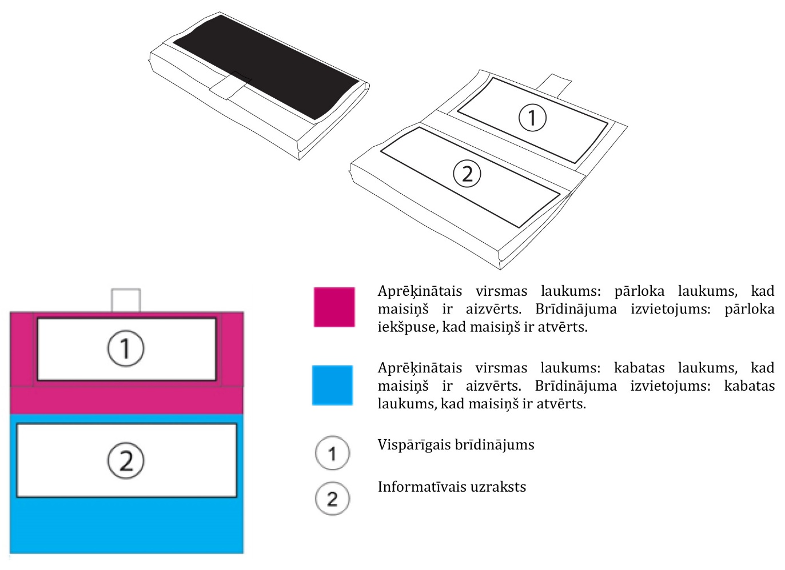

Calculated surface area: flap area when the pouch is closed Position of the warning: inside of the flap when the pouch is open

Calculated surface area: pocket area when the pouch is closed Position of the warning: pocket area when the pouch is open

General warning

Information message

2. Foldable pouch

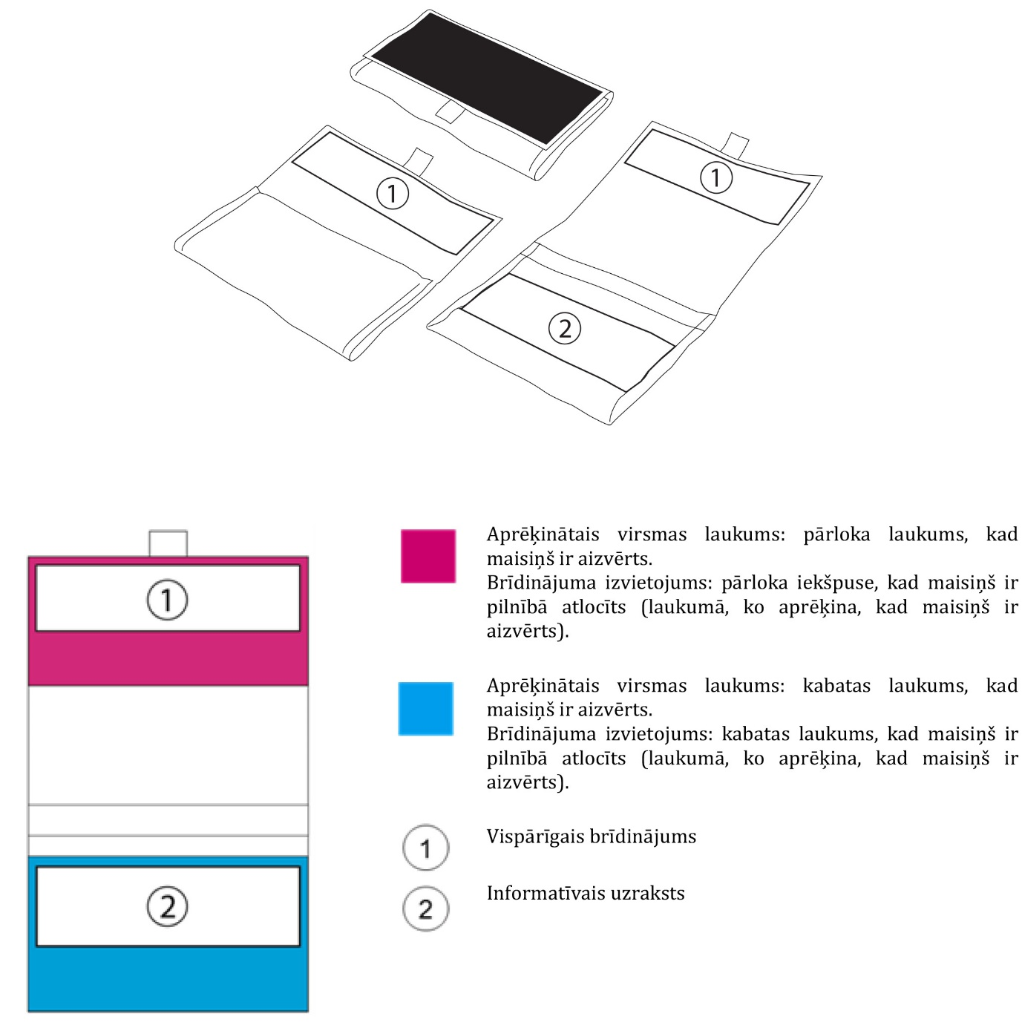

Calculated surface area: flap area when the pouch is closed

Position of the warning: inside of the flap when the pouch is fully unfolded (in the area calculated when the pouch is closed)

Calculated surface area: pocket area when the pouch is closed

Position of the warning: pocket area when the pouch is fully unfolded (in the area calculated when the pouch is closed)

General warning

Information message

3. Foldable pouch (different position)

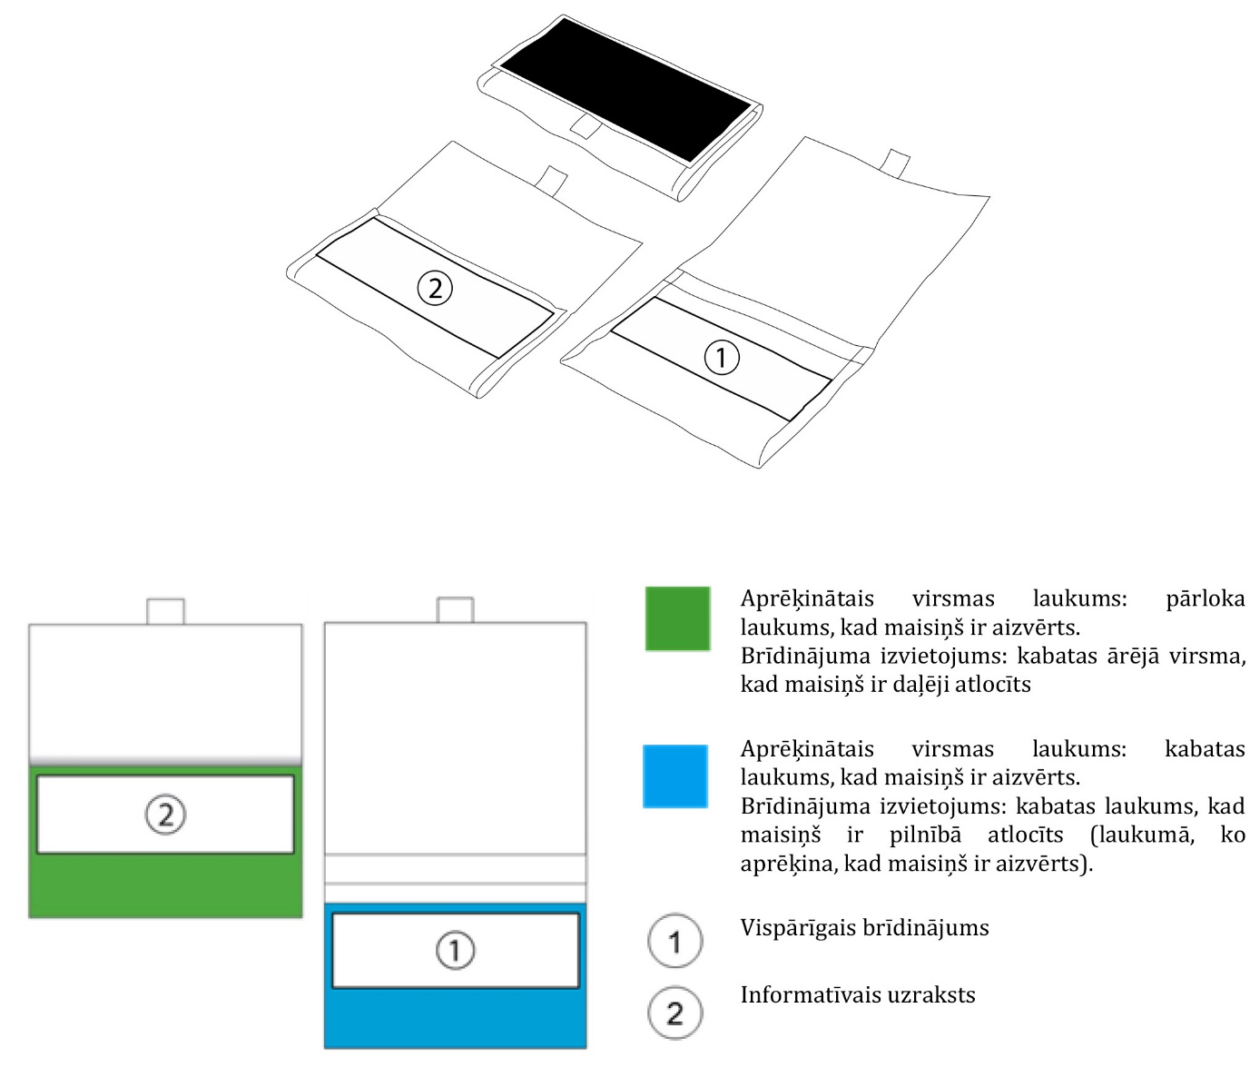

Calculated surface area: flap area when the pouch is closed

Position of the warning: external surface of pocket when the pouch is partly unfolded

Calculated surface area: pocket area when the pouch is closed

Position of the warning: pocket area when the pouch is fully unfolded (in the area calculated when the pouch is closed)

General warning

Information message

4. Standing pouch

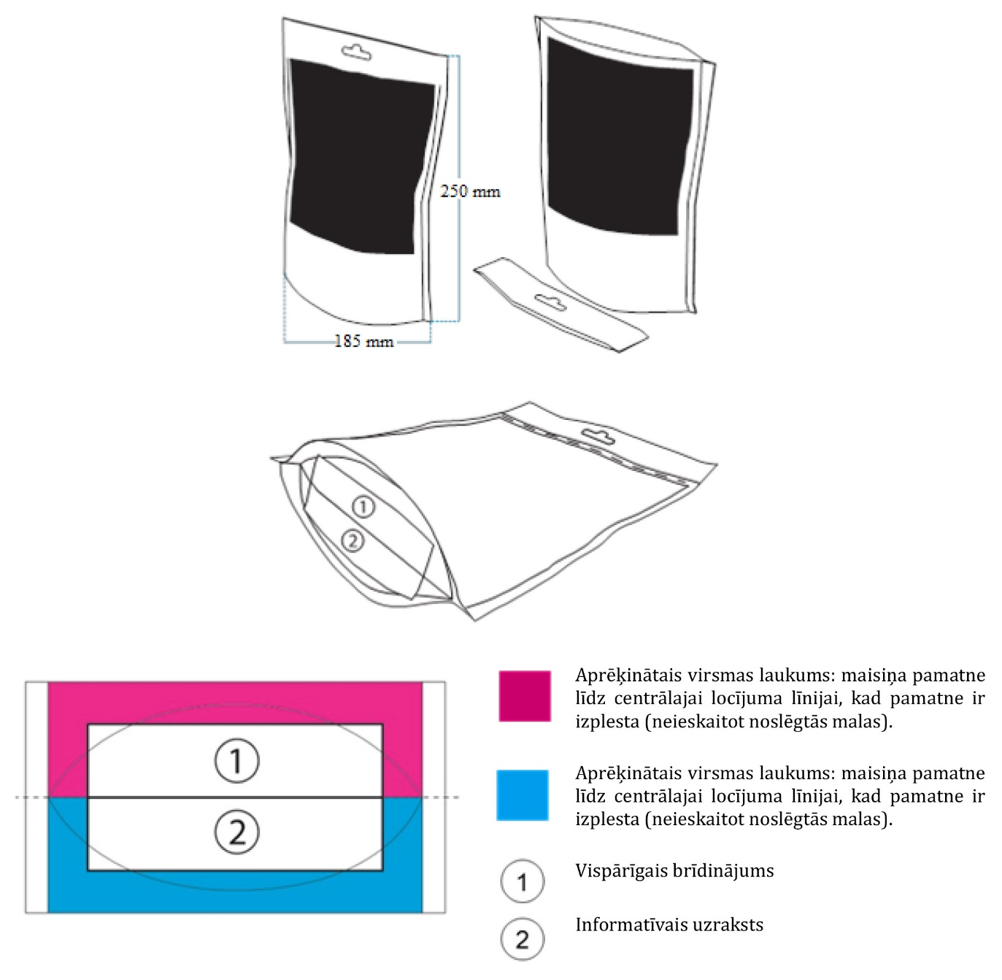

Calculated surface area: base of the pouch up to the central fold line when the base is spread (excluding the closed edges)

Calculated surface area: base of the pouch up to the central fold line when the base is spread (excluding the closed edges)

General warning

Information message

Minister for Health Guntis Belēvičs

**Annex 2**

to Cabinet Regulation

No. 306

of 17 May 2016

**Images of the Combined Health Warnings**

**Set 1**

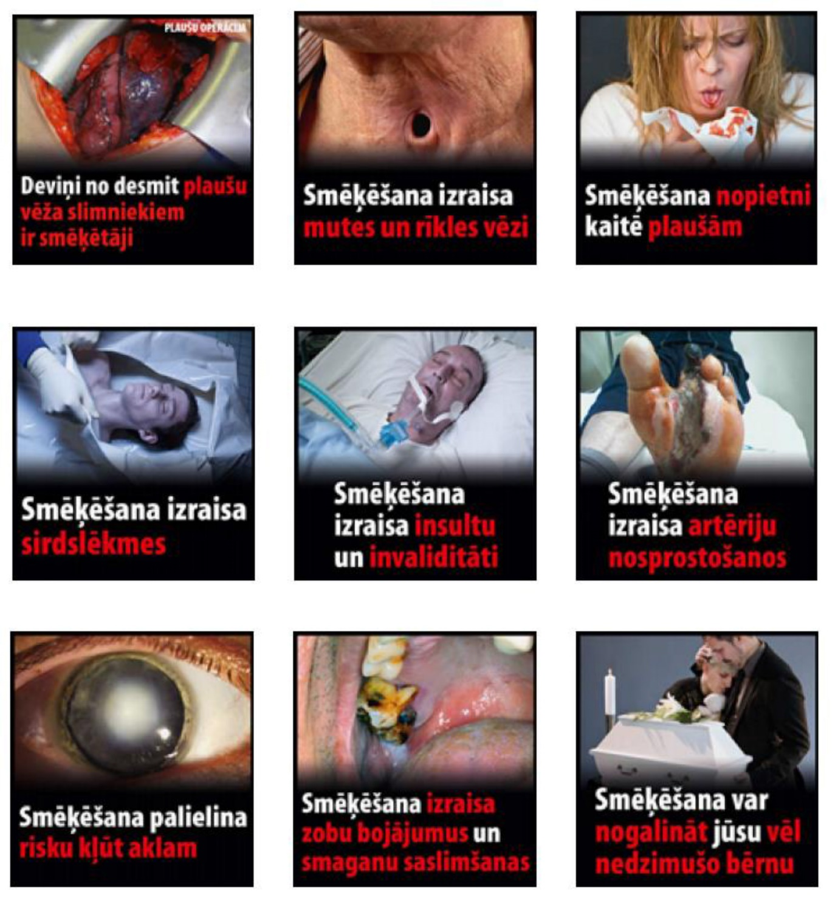

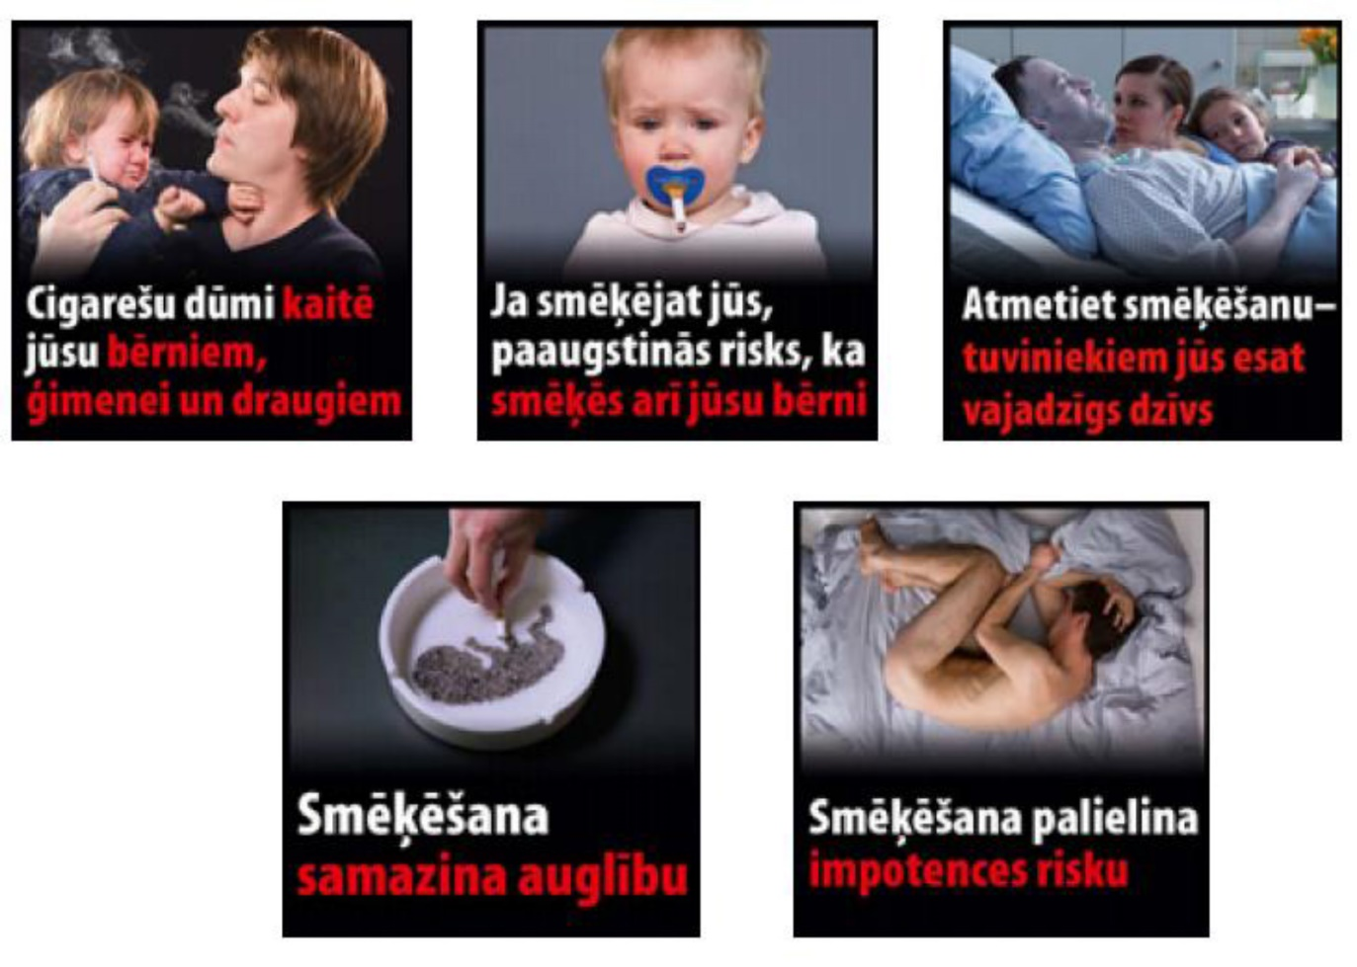

**Set 2**

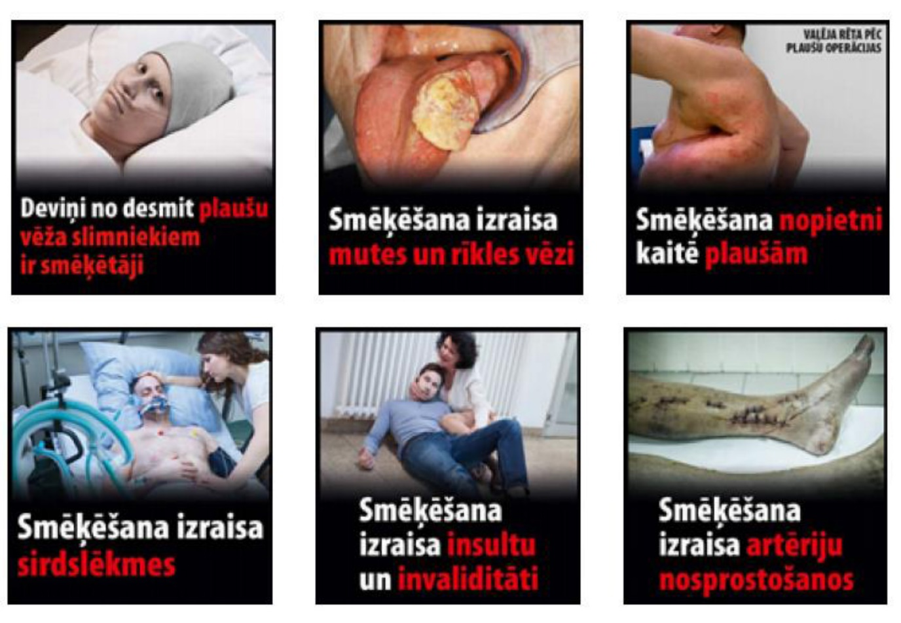

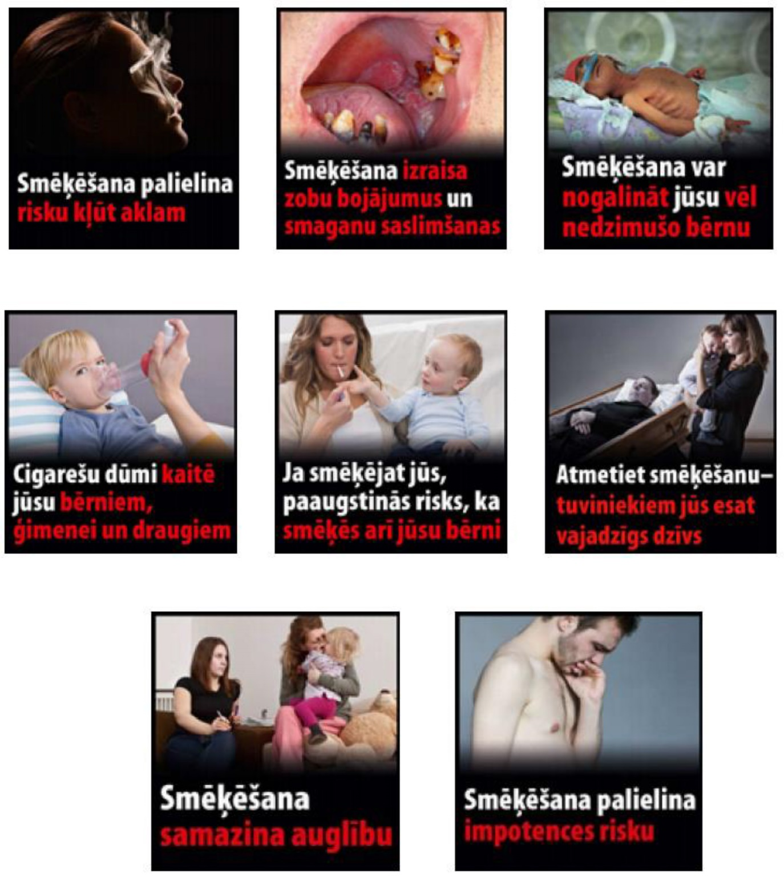

**Set 3**

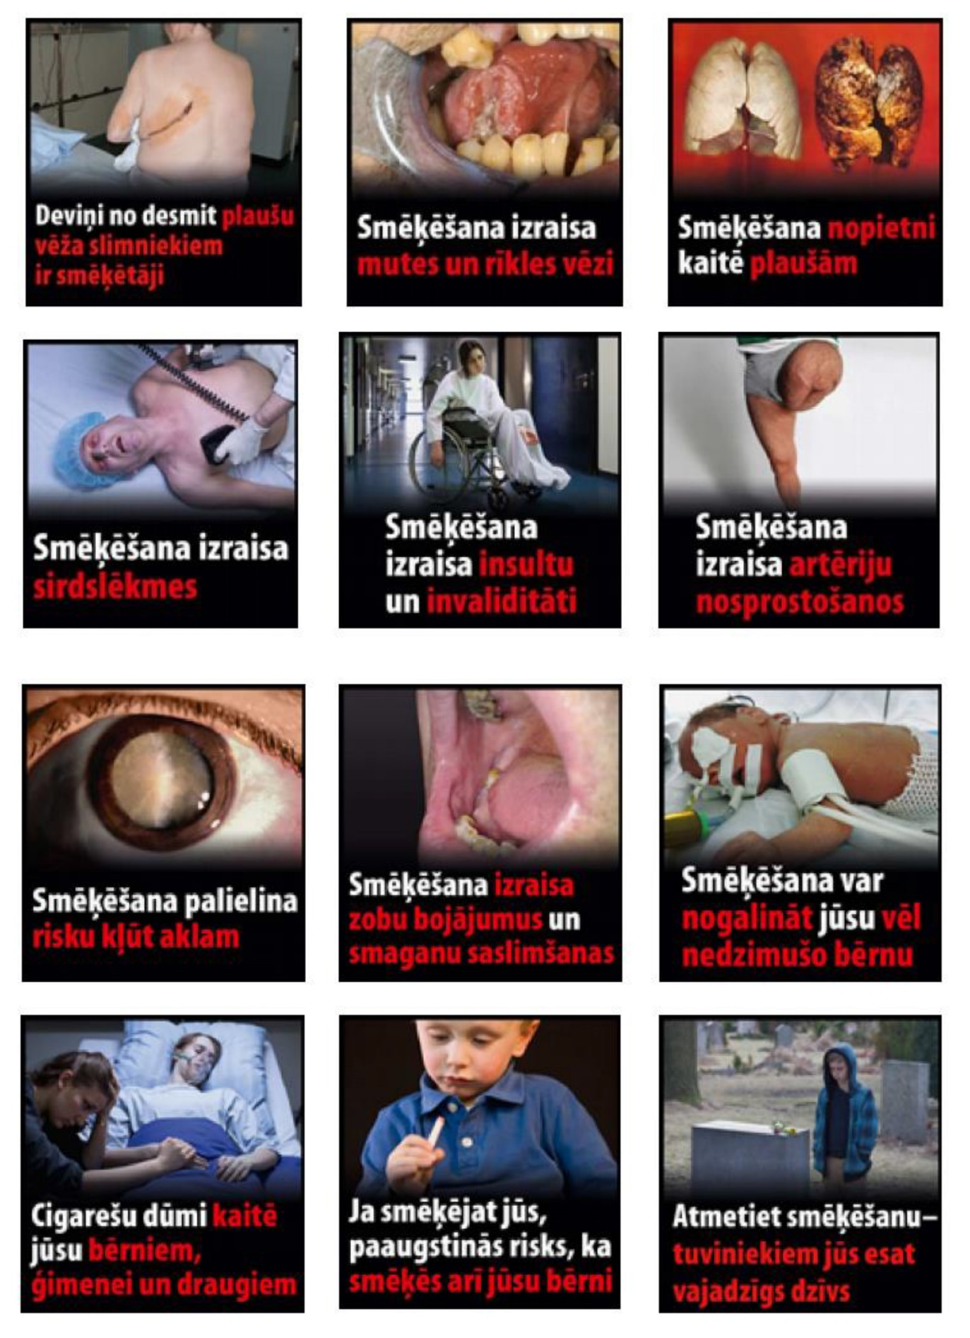



Minister for Health Guntis Belēvičs

**Annex 3**

to Cabinet Regulation

No. 306

of 17 May 2016

**Text Health Warnings**

1. Smoking causes 9 out of 10 lung cancers

2. Smoking causes mouth and throat cancer

3. Smoking damages your lungs

4. Smoking causes heart attacks

5. Smoking causes strokes and disability

6. Smoking clogs your arteries

7. Smoking increases the risk of blindness

8. Smoking damages your teeth and gums

9. Smoking can kill your unborn child

10. Your smoke harms your children, family and friends

11. Smokers' children are more likely to start smoking

12. Quit smoking – stay alive for those close to you

13. Smoking reduces fertility

14. Smoking increases the risk of impotence

Minister for Health Guntis Belēvičs

**Annex 4**

to Cabinet Regulation

No. 306

of 17 May 2016

**Position of the Combined Health Warnings**

**1. Column format**

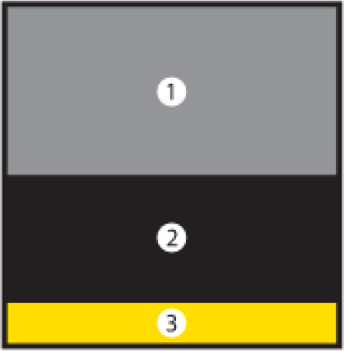

1. Photograph 2. Text warning 3. Smoking cessation information

**2. Adjacent layout format**

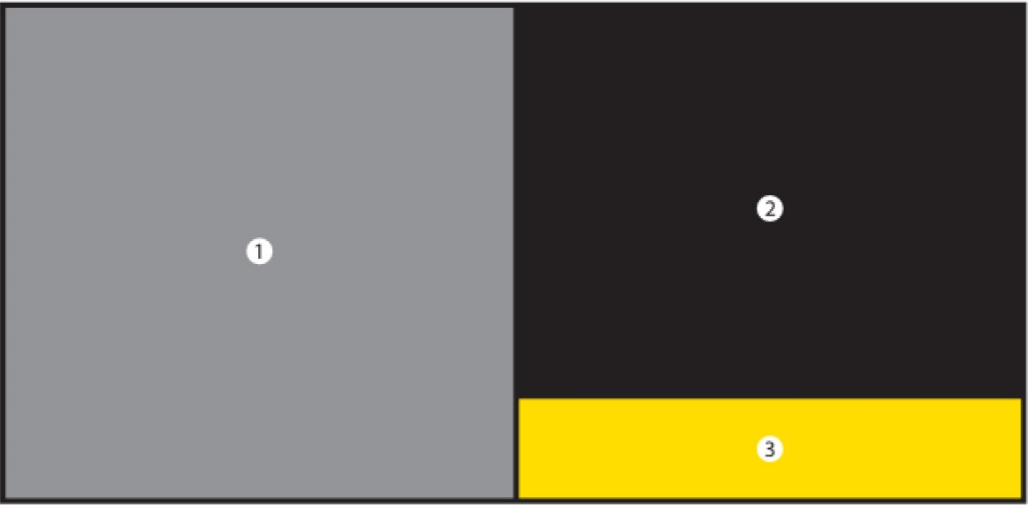

1. Photograph 2. Text warning 3. Smoking cessation information

**3. Especially wide adjacent layout format**

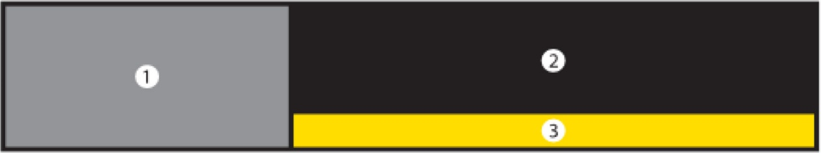

1. Photograph 2. Text warning 3. Smoking cessation information

**4. Reversed column format**

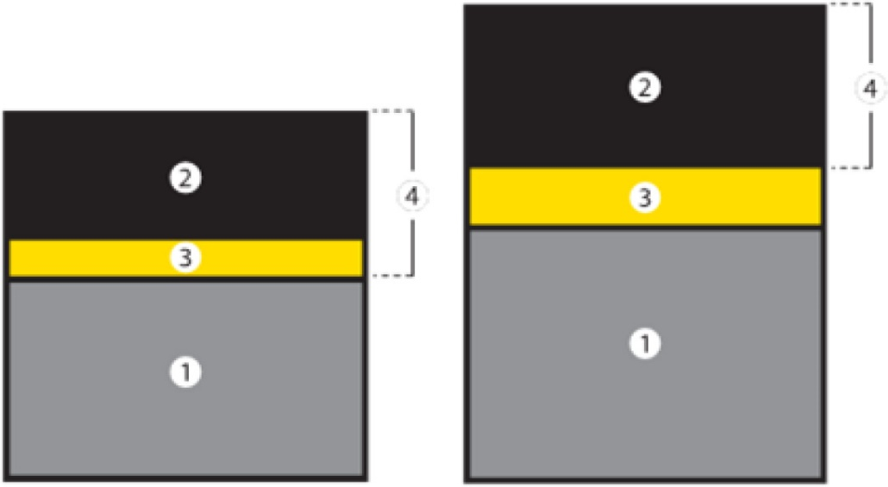

1. Photograph 2. Text warning 3. Smoking cessation information 4. Flip-top lid

Minister for Health Guntis Belēvičs