Republic of Latvia

Cabinet
Regulation No. 976
Adopted 20 December 2005

Regulations Regarding the Procedures for Placement of Informative Notices or Symbols Regarding Prohibition to Smoke and Permission to Smoke, as well as Regarding the Samples of Notices and Symbols

Issued pursuant to
Section 11, Paragraph six of the
the Law On Restrictions regarding Sale, Advertising and
Use of Tobacco Products

I. General Provision

1. These Regulations prescribe the procedures, by which informative notices or symbols regarding prohibition to smoke or permission to smoke (hereinafter – notices or symbols) shall be placed, as well as samples of the notices and symbols.

II. Description of Notices and Symbols

2. Prohibition to smoke shall be indicated by the sign “Smēķēt aizliegts” [Smoking prohibited] (Annex 1) or by the symbol regarding the prohibition to smoke (Annex 2).

3. Permission to smoke shall be indicated by the sign “Atļauts smēķēt” [Smoking permitted] (Annex 3) or by the symbol regarding permission to smoke (Annex 4).

4. Indications near the entrances to buildings or structures where State or local government institutions and capital companies, in which more than 50 per cent of capital shares (stocks) belong to the State or local government, are located shall bear a notice “Nesmēķēt 10 metrus no ieejas” [Do not smoke within 10 metres of the entrance] (Annex 5) or the symbol regarding the prohibition to smoke. In places provided for smoking near buildings and structures where State or local government institutions and capital companies, in which more than 50 per cent of capital shares (stocks) belong to the State or local government, are located a notice or symbol regarding permission to smoke shall be placed.

III. Requirements for the Placement of Notices and Symbols

5. Notices or symbols shall be placed in such areas (buildings, structures, premises and territories) where smoking restrictions have been specified in accordance with Section 11, Paragraphs one, two and four of the Law On Restrictions regarding Sale, Advertising and Use of Tobacco Products:
5.1. the notices or symbols “Atļauts smēķēt” [Smoking permitted] shall be placed only in specially designated smoking areas in the places, buildings and structures referred to in Section 11, Paragraph one, Clauses 1, 2, 6 and 7 of the Law. The notices or symbols “Atļauts smēķēt” [Smoking permitted] shall not be placed in other premises; or
5.2. if there are no specially designated smoking areas in the places, buildings and structures referred to in Section 11, Paragraph one, Clauses 1, 2, 6 and 7 of the Law, the notices or symbols “Smēķēt aizliegts” [Smoking prohibited] shall be placed by the entrance to buildings or structures.

6. Notices or symbols shall be placed in clearly visible places. Notices and signs in public territories shall be placed not less than 1.8 metres above the ground.

7. The possessors or holders of the respective buildings, structures and premises shall be responsible for the making, placement and keeping of notices or symbols.

8. The possessors or holders of the respective buildings, structures and premises shall cover the expenditures related to the making and placement of notices or symbols.

IV. Closing Provisions

9. Paragraph 4 of these Regulations comes into force on 1 January 2006.

10. The notices or symbols, which have been placed until the date of coming into force of these Regulations and do not conform to the requirements of these Regulations or the requirements specified in regulations regarding labour protection as regards the use of safety signs, shall be changed by 1 July 2006.

Prime Minister A. Kalvītis

Minister for Health G. Bērziņš

Annex 1
Cabinet Regulation
No. 976
20 December 2005

Informative Notice Regarding Prohibition to Smoke

1. The informative notice regarding prohibition to smoke (white letters on a red background):


Smoking prohibited

2. The size of the informative notice may be proportionately enlarged or reduced, but the height of the letters on the informative notice shall be not less than 25 mm.

Minister for Health G. Bērziņš

Annex 2
Cabinet Regulation
No. 976
20 December 2005

Informative Symbol Regarding Prohibition to Smoke

1. The informative symbol regarding prohibition to smoke shall consist of a picture of a black lighted cigarette on a white background, which is encircled by a red borderline in the shape of circle, the width of which is one-tenth of the diameter of the symbol. The cigarette shall be intersected by a red diagonal line, which begins at the upper left part of the borderline at an angle of 135 degrees and ends at the lower right part of the borderline and the width of which is one-tenth of the diameter of the symbol, dividing the circle into two parts.

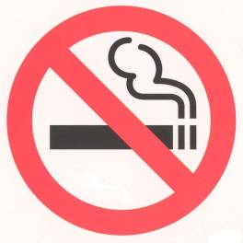

2. The size of the informative symbol may be proportionately enlarged or reduced, however, the external diameter of the symbol shall be not less than 60 mm.

Minister for Health G. Bērziņš

Annex 3
Cabinet Regulation
No. 976
20 December 2005

Informative Notice Regarding Permission to Smoke

1. The informative notice regarding permission to smoke (white letters on a green background):

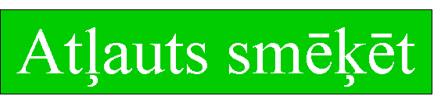
Smoking permitted

2. The size of the informative notice may be proportionately enlarged or reduced, but the height of the letters on the informative notice shall be not less than 25 mm.

Minister for Health G. Bērziņš

Annex 4
Cabinet Regulation
No. 976
20 December 2005

Informative Symbol Regarding Permission to Smoke

1. The informative symbol regarding permission to smoke shall consist of a picture of a black lighted cigarette on a white background, which is encircled by a green borderline in the shape of circle, the width of which is one-tenth of the diameter of the symbol.

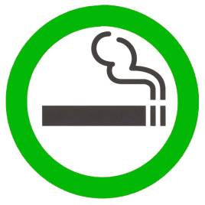
2. The size of the informative symbol may be proportionately enlarged or reduced, however, the external diameter of the symbol shall be not less than 60 mm.

Minister for Health G. Bērziņš

Annex 5
Cabinet Regulation
No. 976
20 December 2005

Informative Notice Regarding Prohibition to Smoke near State and Local Government Institutions and Capital Companies

1. Informative notice regarding prohibition to smoke near State and local government institutions and capital companies (white letters on a red background):

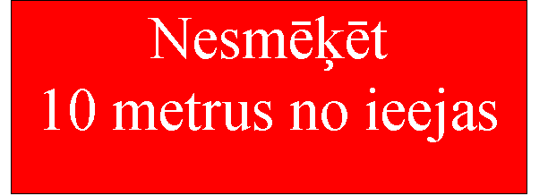
Do not smoke within 10 metres of the entrance

2. The size of the informative notice may be proportionately enlarged or reduced, but the height of the letters on the informative notice shall be not less than 25 mm.

Minister for Health G. Bērziņš

