Cabinet Order No. 5
6 January 2010

Guidelines for the Optimisation of the Network of Vocational Education Institutions
2010-2015
(Informative Part)

Content

Abbreviations Used in the Text p. 3
Explanation of the Terms Used in the Guidelines p. 4
1. Link of the Guidelines with the Priorities and Approved Planning
Documents of the Government and the Ministry and the Basic Principles of the
Policy for the Optimisation of the VEI Network p. 5
2. Problems Related to the Formation of the Network of
Vocational Education Institutions p. 7
3. Objective and Sub-objectives of the Guidelines p. 7
4. Planned Outcomes of the Guideline Policy and Outcomes of the Activity p. 8
5. Main Tasks for Achievement of the Guideline Outcomes p. 8
5.1. Vocational Education Institutions and Education Programmes
Implemented Thereby from the Point of View of Sectors and Regions p. 10
5.1.1. Mechanical Engineering and Metal Working p. 11
5.1.2. Construction and Civil Construction p. 12
5.1.3. Power Industry, Electronics and Automatics p. 14
5.1.4. Mechanical Sciences (Road and Rail Transport) p. 15
5.1.5. Production of Food Products p. 17
5.1.6. Textile Production Technologies p. 18
5.1.7. Organisation of Tourism and Recreation, Hotel and Restaurant Services p. 19
5.1.8. Woodworking Technologies p. 20
5.1.9. Agriculture p. 21
5.2. Demographic Situation in Latvia and the Plan for Optimisation of
Vocational Education Institutions Related Thereto p. 22
5.2.1. Optimisation Plan in Kurzeme Region p. 25
5.2.2. Optimisation Plan in Latgale Region p. 27
5.2.3. Optimisation Plan in Riga Region p. 29
5.2.4. Optimisation Plan in the City of Riga p. 30
5.2.5. Optimisation Plan in Vidzeme Region p. 32
5.2.6. Optimisation Plan in Zemgale Region p. 33
6. Schedule for Execution of Tasks p. 35
7. Planning of the Allocated and Additionally Necessary
Financing Corresponding to the Tasks p. 38
8. Institutions Responsible for Execution of the Tasks p. 39
9. Procedures for the Submission and Evaluation of Reports p. 39
Annex 1
Annex 2
Annex 3
Annex 4

Abbreviations Used in the Text

TS | Trade school
TSS | Secondary school of trades
ERDF | European Regional Development Fund
EU | European Union
ESF | European Social Fund
MoC | Ministry of Culture
FTUCL | Free Trade Union Confederation of Latvia
ECL | Employers’ Confederation of Latvia
MoW | Ministry of Welfare
MoI | Ministry of the Interior
MoES | Ministry of Education and Science
Cabinet | Cabinet
VEI | Vocational education institution
WB | World Bank
VSS | Vocational secondary school
RTC | Riga Technical College
RTU | Riga Technical University
RSTC | Riga State Technical College
IMF | International Monetary Fund

Explanation of the Terms used in the Guidelines

Terms are used in the Guidelines in accordance with the terms used in the Education Law, the Vocational Education Law, Cabinet Regulation No. 990 of 2 December 2008, Regulations Regarding the Classification of Education in Latvia, and the Concept “Promotion of Interest in Vocational Education and Participation of Social Partners in Assuring the Quality of Vocational Education” (hereinafter – Concept) (approved by Cabinet Order No. 629 of 16 September 2009).

In addition such terms are used in the Guidelines which will be incorporated in the new Vocational Education Law, which should be developed in accordance with Paragraph 3 of Cabinet Order No. 629 of 16 September 2009, On the Concept “Promotion of Interest in Vocational Education and Participation of Social Partners in Assuring the Quality of Vocational Education” by 31 December 2010.

Vocational education competence centre | – | a vocational education institution, which contains the necessary material basis for the acquisition of vocational education in all relevant primary professions in a sector and the task of which is to provide the necessary methodical support to other vocational education institutions for the acquisition of professions of the relevant sector and to serve as the place for the acquisition of new technologies for young persons and adults, as well as is intended for fulfilling the functions of examination centres in the future, including for recognition of informal education.
Vocational education institution with a specialisation | – | a vocational education institution, which contains the necessary material basis for the acquisition of vocational qualification skills in primary professions and for the acquisition of qualification in the specialisation of primary professions in a specific education programme (for example, apiarist, pisciculturist, road construction machinery mechanic, etc).
Vocational education institution for the acquisition of basic skills | – | a vocational education institution where such education programmes are implemented, which give the basic skills in one or several professions and which contain all the necessary material basis for the acquisition of basic skills.
Integrated education institution | – | an education institution in which different programmes of general education and vocational education, as well as the training and further education of adults are implemented.
Branch of vocational education institution | – | a structural unit of a vocational education institution, which is territorially separated from a VEI, education programmes are implemented which give the basic skills in one or several professions.

1. Link of the Guidelines with the Priorities and Approved Planning Documents of the Government and the Ministry and the Basic Principles of the Policy for the Optimisation of the VEI Network

The Ministry of Education and Science (hereinafter – MoES) has developed the Guidelines for the Optimisation of the Network of Vocational Education Institutions (hereinafter – Guidelines) in accordance with the task given in Paragraph 5 of Cabinet Protocol No. 58 of 15 September 2009 “Report on the Progress of the Structural Reform of the Education System and the Planned Measures for Further Implementation Thereof”.

The priority tasks for optimisation of vocational education institutions were prepared in accordance with Paragraph 29 of the Action Plan for Introduction of the Programme for Stabilisation and Restoration of Growth of the Economy of Latvia (approved by Cabinet Order No. 123 of 19 February 2009) – to implement comprehensive reforms in the field of education in 2009, as well as in accordance with the recommendations of the WB and the IMF on the necessary changes in the sector of education. The priority tasks were prepared in accordance with the tasks specified by the MoES in the Declaration on the Implementation of Activities Intended by the Cabinet Managed by Valdis Dombrovskis (hereinafter – Declaration) for the development of vocational education and future strategic vision of vocational education and training presented in other planning documents, which contain clearly defined objectives and tasks, measures and indicators.

The priority tasks for the optimisation of vocational education institutions have been prepared in accordance with the strategic aim of the EU Lisbon Strategy – to make the EU the most competitive and dynamic knowledge-based economy in the world. Optimisation of vocational education institutions will promote the provision of the labour market with the necessary number of specialists according to the employment structure.

A strategic aim is set out in the “Latvian National Development Plan 2007-2013” – education and knowledge for the economic growth and technological excellence.

In accordance with the aforementioned strategic aim, a primary objective for the development of education – to provide each inhabitant with an opportunity to acquire qualitative education throughout his or her life according to individual interests, abilities and the economic development needs of the State – is set out in the “Guidelines for the Development of Education 2007-2013” (approved by Cabinet Order No. 742 of 27 September 2006). Specific objectives have been set out for achievement of the primary objective, including to ensure an offer of education corresponding to the needs of economic development; to broaden education opportunities for different groups of inhabitants in all regions; to strengthen the capacity for ensuring and managing the quality of education.

In Sub-paragraph 10.1 of the Declaration, the MoES has been assigned, to promote the development of qualitative, accessible and resource-efficient education and knowledge at all levels for the sustainability and competitiveness of the State, ensuring the maintenance of intellectual and material resources in the conditions of a crisis; in Sub-paragraph 10.2 of the Declaration it is prescribed to arrange the network of education institutions in co-operation with self-governments, varying the offer of education programmes and ensuring rational use of school premises for both general and vocational education purposes; in Sub-paragraph 10.5 of the Declaration, the modernisation and adaptation of the content of education at all levels of education according to the abilities, needs and interests of pupils has been prescribed; in Sub-paragraph 10.6 of the Declaration, the review of the content of the initial vocational education and conformity thereof with market requirements in co-operation with representatives delegated by sectors has been prescribed; and, in Sub-paragraph 10.7 of the Declaration, the introduction of the recognition of informal vocational knowledge, skills and competence means has been prescribed.

The Guidelines have been developed, taking into account the solution specified in the Concept for the differentiation of VEI, as well as the activities of the Ministry included in the informative report developed by the MoES “On the Planned Structural Changes in the Sector of Education, the Course of Implementation Thereof and the Anticipated Benefits” (hereinafter – Informative Report) (reviewed at the Cabinet Meeting of 24 April 2009) in the conditions of financial cutbacks specified for education by the government for the time period from 2009-2011 in order to achieve the overarching objective of the management of education processes for this and the next 3 years – to ensure more efficient use of the public funds, promoting access to qualitative and resource-efficient education at all levels and the development of science for the sustainability and competitiveness of the State, as well as planned activities for achievement of the overarching objective.

The basic principles of the policy for optimisation of the VEI network are as follows:

Accessibility – when planning the VEI network, all members of the society have equal opportunities for acquisition of vocational education, observing the demographic situation of the State.

Co-operation – when planning the VEI network, all interested parties are be involved: State, self-government and planning region institutions and sectoral associations.

Resource efficiency – rational and purposeful use of the available funds.

In order to ensure achievement of the overarching objective, the main tasks in the field of vocational education have been specified in the Informative Report: optimisation of the VEI network; transfer of VEI to self-governments; review of the content of vocational education; promotion of participation and responsibility of State, self-governments and employers in ensuring the accessibility and quality of vocational education.

The tasks set out in the planning documents for the development of vocational education also conform with the tasks of Activity 3.1.1.1 “Modernisation of Equipment and Improvement of Infrastructure for Implementation of Vocational Education Programmes” (hereinafter – Activity 3.1.1.1) and Activity 3.1.3.2 “Support for Optimisation of the Network of General Education Institutions” (hereinafter – Activity 3.1.3.2) of the supplement to the activity programme “Infrastructure and Services”.

The review of the content of vocational education and the promotion of participation and responsibility of the State, self-governments and employers in ensuring the accessibility and quality of vocational education will be promoted by implementing Priority 1.2 “Education and Skills” of the supplement to the activity programme “Human Resources and Employment”, Measure 1.2.1 “Development of Vocational Education and General Skills”, Activity 1.2.1.1“Development of the Vocational Education System and Improvement of the Quality, Conformity and Attraction Thereof”, Sub-activities: 1.2.1.1.2 “Improvement of the Competence of Teachers Involved in Vocational Education”, 1.2.1.1.3 “Support to Improvement and Implementation of the Quality of Implementation of Initial Vocational Education Programmes”, 1.2.1.1.4 “Promotion of Attraction of Initial Vocational Education”.

It is anticipated to implement the Guidelines within 6 years. It is intended that VEI will be transferred to self-governments gradually, but not later than after 6 years, on voluntary basis and in accordance with the procedures for financing approved by the Cabinet.

2. Problems Related to the Formation of the
Network of Vocational Education Institutions

The following problems were identified as a result of the analysis of the planning documents:

1. The number of places in VEIs exceeds the number of pupils.

2. The same education programmes are being implemented in adjacent or nearby VEIs. Consolidation of education programmes is necessary.

3. There is an imbalanced arrangement of vocational education programmes. For example, in Kurzeme and Zemgale where food undertakings are located, appropriate education programmes are not being implemented.

4. The VEI infrastructure and material basis have aged, majority of the buildings were built in the 1960s-70s, have not been renovated and do not comply with contemporary requirements.

5. There is insufficient participation and responsibility of self-governments, planning regions and employers in ensuring the accessibility of vocational education.

6. The use of financial resources for the creation of material and technical basis of VEIs is not rational enough.

7. A financing system which would ensure a unified financing principle “money follows the pupil” has not been developed for all education institutions.

3. Objective and Sub-Objectives of the Guidelines

The objective of the Guidelines is to ensure further implementation of the structural reforms of the vocational education system, optimising the number and layout of VEIs in regions and performing the differentiation of VEIs, to establish a modern and logistical support of vocational education corresponding to contemporary requirements, to promote more efficient use of all types of resources, improving the quality and accessibility of vocational education.

Sub-objectives:

1. to improve co-operation with self-governments and sectoral associations, as well as to involve planning regions in the development of a balanced network of schools in the relevant region, in order for State administrative institutions, self-governments and planning regions and sectoral associations to mutually co-ordinate their activities, optimising the VEI network and planning the network of education institutions of all types, using complex approach;

2. to establish a cost-efficient and energy efficient network of VEIs, which is accessible to inhabitants, in order to rationally use the State and foreign financial instruments and properties of vocational education institutions, to establish a modern and contemporary material and technical basis adequate for the acquisition of vocational education programmes resulting in promotion of the quality and conformity of vocational education with the requirements of the labour market; and

3. to develop a financing system which would ensure a unified financing principle “money follows the pupil” for all education institutions with the aim of encouraging self-governments to perform complex planning of the operation of education institutions of all types and optimisation of the school network, as well as to promote co-operation with sectoral undertakings which are interested in supporting vocational education and participating in the optimisation of the network of vocational education institutions with their co-financing.

4. Planned Outcomes of the Guideline Policy and Outcomes of the Activity

The quality of vocational education, accessibility to inhabitants and cost-effectiveness thereof are the main planned outcomes of the Guideline policy, which are characterised by the following indicators:

1. a differentiated, resource-efficient and energy efficient network of vocational education institutions which is commensurate with the demographic trends will be developed in the State;

2. a balanced offer of opportunities for the acquisition of vocational education programmes will be ensured (at regional and national level) with the aim of preparing the number of specialists required for the labour market and ensuring that the offer of education complies with the employment structure; and

3. the principle of co-operation between State institutions, self-governments and sectoral associations will be observed during the process of VEI optimisation with the aim of ensuring flexible and efficient use of all types of resources and an opportunity of reacting quickly to changes in the demand of the labour market.

5. Main Tasks for Achievement of the Guideline Outcomes

1. Preparation of draft legal acts ensuring optimisation of VEIs.

2. Drawing up of VEI development and investment strategies:

2.1. co-operation with self-governments and sectoral associations in matters of optimisation of the VEI network, using complex approach to planning of the network of education institutions of all types in accordance with the foreseeable demographic situation and promoting the initiative and participation of co-operation partners in taking of decisions; and

2.2. evaluation of the existing network of vocational education institutions in accordance with the demographic forecast for the next 5-10 years and planning of optimisation, taking into account the total foreseeable number of pupils at the level of secondary education; planning and formation of the layout of vocational education competence centres.

3. Evaluation and co-ordination of the development and investment strategies developed for VEIs.

4. Preparation of draft legal acts regarding the financing procedures of VEIs.

5. Optimisation of the VEI network, ensuring optimal filling of existing buildings, cessation of the use of buildings unnecessary for the operation of education institutions:

5.1. merging of education institutions if it is possible to ensure more optimal operation with a unified administration and unified infrastructure (sports complex, library, catering and service hotel);

5.2. consolidation of the offer of programmes with the aim of using all types of resources rationally, including planned investments for improvement of equipment;

5.3. implementation of the approved investment projects, optimisation and differentiation of the network of vocational education institutions included in the VEI optimisation plan, complex renovation of buildings, ensuring resource efficiency and energy efficiency which will ensure the reimbursement of investments in long-term; and

5.4. attraction of other financial resources, for example, funding of the Financial Instrument for Climate Changes.

VEIs are differentiated as follows:
1) vocational education competence centre;
2) VEI with a specialisation;
3) VEI for the acquisition of basic skills;
4) a branch of a vocational education institution; and
5) an integrated education institution.

Regardless of the founder and differentiation, applications for VEI projects for attracting investments for the development of VEIs are developed in co-operation with self-governments and submitted on the basis of the development and investment strategy.

The development and investment strategy will provide a view on the regional development trends from the point of view of economic development, the planned status of VEIs, the nature of material and technical facilities, the performance of investments made in previous years, the planned measures for ensuring the acquisition of the new status of VEIs and the financing necessary for implementation of the planned measures.

The VEI development and investment strategy co-ordinated with the MoES will be appended to the relevant project submission (Activity 3.1.1.1, Activity 3.1.3.2, etc) in order for VEI to qualify for the relevant foreign financial assistance.

Figure 1. Vocational Education Institutions in Latvia, on 1 September of School Year 2009/2010

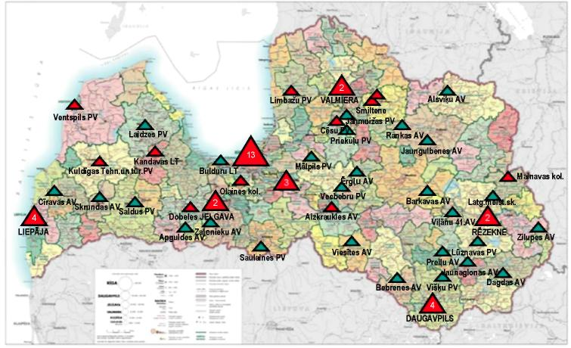

5.1. Vocational Education Institutions and the ducation Programmes Implemented Thereby in School Year 2009/2010 from the Point of View of Sectors and Regions
(In Annex No. 2 the proposals provided by sectoral associations are presented)

In order to ensure balanced arrangement of the VEI network in the territory of Latvia, when planning the VEI network, the following is taken into account:

1) the existing VEI network and access to the acquisition of the relevant profession in all planning regions;

2) support of the relevant sector to a VEI with a specialisation and a vocational education competence centre, which is based on the demand for a vocational education programme in the relevant territory.

When planning reforms of the vocational education system, the existing VEI network was evaluated on the basis of the following VEI evaluation criteria:

1) VEIs which are important in the planning region or at national level;

2) VEIs in which resources from the ERDF were invested in 2004-2006 and which have received the support of the relevant regional in order to invest the resources from the ERDF therein in the time period from 2007-2013;

3) the actual number of pupils at a VEI and the capacity of the education institution, as well as existence of a service hotel;

4) types of education programmes, the conformity thereof with the requirements of the labour market, also observing the costs of the programme per educatee; and

5) special directions of operation of a VEI– teaching of pupils with special needs.

5.1.1. Mechanical Engineering and Metal Working

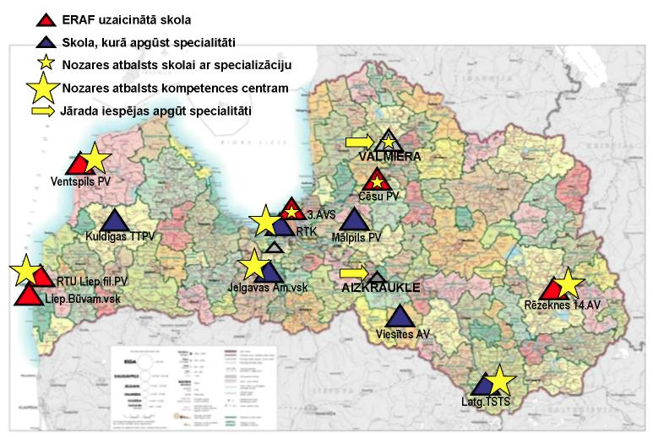

Figure 2. Vocational Education Institutions Implementing Education Programmes in the Thematic Area Mechanical Engineering and Metal Working

At large, in Latvia vocational education programmes in the thematic area of education “Mechanical Engineering and Metal Working” may be acquired in all regions and access to the acquisition of professions is ensured in sufficiently balanced form, except North Vidzeme and East Zemgale where the opportunity for the acquisition of an initial vocational education programme is not ensured.

Vocational education programmes in the field of mechanical engineering and metal working are implemented:

In the city and region of Riga – Mechanics and Technology College of Olaine (Technician of chemical and biochemical industrial equipment), Riga Technical College (Numerical programme control machine operator), Riga State Technical College (Mechanical engineering technician), Riga Trade School No. 3 (Locksmith, Turner, Welder Manual metal arc welder, Operator of technological installations for metalworking), Riga Business College (Mechanic of refrigerating plants).

In Kurzeme region – Liepāja Secondary School of Building Trade Activities (Locksmith), Vocational Secondary School of RTU Liepāja branch (Mechatronic system technician), Ventspils Vocational Secondary School (Locksmith, Turner), Kuldīga Vocational Secondary School of Technology and Tourism (Locksmith).

In Latgale region – Latgale Technical School of Transport and Communications (Metal processing labourer, Turner, Locksmith, Locomotive mechanical engineering technician, Transport wagon technician, Railway mechanical engineering technician, Rolling stock locksmith).

In Vidzeme region – education programmes in the thematic area of education “Mechanical Engineering and Metal Working” are only implemented at Cēsis Vocational Secondary School (Locksmith, Mechanic of metalworking installations).

In Zemgale region – education programmes in the thematic area of education “Mechanical Engineering and Metal Working” are only implemented in Jelgava Secondary School of Crafts

5.1.2. Construction and Civil Construction

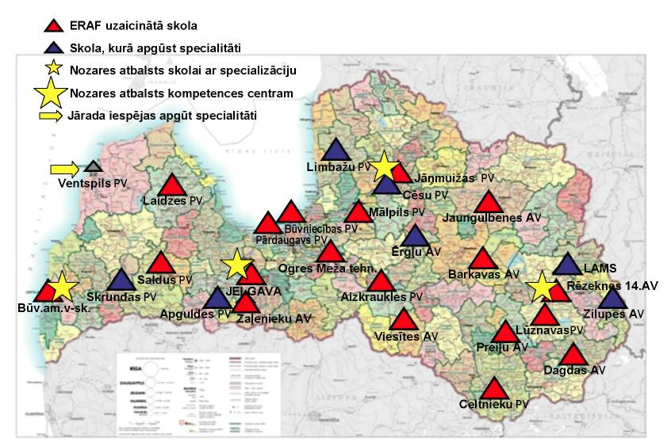

Figure 3. Vocational Education Institutions Implementing Education Programmes in the Thematic Area “Construction and Civil Construction”

Vocational education programmes in the thematic area of education “Construction and Civil Construction” are implemented in Riga and all municipalities of Latvia. Notwithstanding the large number of schools in which individual finishing works specialities may be acquired, there is not one modern education institution in Latvia conforming to contemporary requirements. Vocational education institutions in this area are located relatively close to each other and implement the same or similar vocational education programmes. It hinders the enrolling of pupils in education institutions and rational use of financial resources, as well as prevents the opportunity of purposeful planning the resources for improvement of education programmes in construction.

On the basis of the opinion of the Latvian Builders Association, the implementation of education programmes in construction should be preserved in Riga and all regions of Latvia, ensuring balanced acquisition of primary profession education programmes in construction throughout Latvia. Consolidation of the implementation of education programmes in construction is necessary, concentrating the acquisition of primary profession education programmes, thus promoting qualitative provision of vocational education, as well as at least one modern vocational education competence centre in the field of construction should be created.

Vocational education programmes in the field of construction are implemented: In the city of Riga – Riga Secondary School of Construction (Technician of finishing works, Finishing work labourer, Carpenter, Plumbing equipment assembler, Masonry stove builder and Building structure assembler, Civil engineering technician), Riga Pārdaugava Vocational Secondary School (Technician of finishing works, Dry construction builder), Riga Building College (Architectural technician, Civil engineering technician, Civil engineering network technician, Road construction technician).

In Riga region – Ogre Forestry Technical College (Carpenter), Mālpils Vocational Secondary School (Civil engineering network technician), Limbaži Vocational Secondary School (Technician of finishing works, Finishing work labourer, Tilesetter).

In Kurzeme Region – Liepāja Secondary School of Building Trade Activities (Technician of finishing works, Plumbing equipment assembler, Bricklayer), Saldus Vocational Secondary School (Building technician, Road construction technician), Laidze Vocational Secondary School (Technician of finishing works), Skrunda Secondary School of Trades (Building construction labourer).

In Latgale region – Dagda Secondary School of Trades (Finishing work labourer), Daugavpils Construction Vocational Secondary School (Technician of finishing works, Finishing work labourer, Bricklayer, Masonry stove builder Plumbing equipment assembler, Road construction technician), Rēzekne Secondary School of Trades No. 14 (Finishing work labourer, House builder), Lūznava Vocational Secondary School (Technician of finishing works), Jaunaglona Secondary School of Trades (Log cabin builder, Carpenter, Repair worker), Latgale School of Craftsmanship (Carpenter), Zilupe Secondary School of Trades (Building construction labourer).

In Vidzeme region – Jāņmuiža Vocational Secondary School (House builder), Ērgļi Secondary School of Trades (Log cabin builder, Carpenter), Cēsis Vocational Secondary School (Carpenter), Barkava Secondary School of Trades (Technician of finishing works, Finishing work labourer, House builder, Building construction labourer).

In Zemgale Region – Jelgava Secondary School of Craftsmanship (Technician of finishing works, Finishing work labourer), Viesīte Secondary School of Trades (Finishing work labourer, Building construction labourer, Industrial boiler operator), Apgulde Secondary School of Trades (Technician of finishing works, House builder, Bricklayer), Zaļenieki Secondary School of Trades (Bricklayer).

5.1.3. Power Industry, Electronics and Automatics

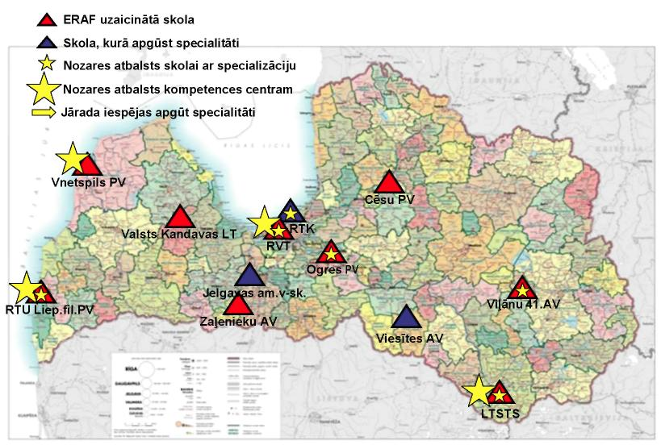

Figure 4. Vocational Education Institutions Implementing Education Programmes in the Thematic Area “Power Industry, Electronics and Automatics”

Vocational education programmes in the field of power industry are being implemented in Riga and all regions of Latvia. Vocational education programmes in the field of electronics and automatics are being implemented in Riga and in Riga region, in turn, vocational education programmes in the field of mechatronics are being implemented in Riga and Liepāja.

Vocational education programmes in the field of power industry, electronics and automatics are implemented:

In the city and region of Riga – Riga Technical College (Electrician, Electrical engineering technician, Telecommunications technician), Riga State Technical College (Electrician), Riga Secondary School of Construction (Electrical assembler), Kandava State Agricultural Technical College (Electrician).

In Kurzeme region – Vocational Secondary School of RTU Liepāja branch (Electrician, Mechatronic systems technician), Ventspils Vocational Secondary School (Electrician).

In Latgale region – Latgale Technical School of Transport and Communications (Electrician), Viļāni Secondary School of Trades No. 41 (Electrician), Daugavpils Secondary School of Trades No. 1 (Electrical assembler).

In Vidzeme region – Cēsis Vocational Secondary School (Electrician).

In Zemgale region – Zaļenieki Secondary School of Trades (Electrician), Jelgava Secondary School of Craftsmanship (Electrician, Electrical assembler), Viesīte Secondary School of Trades (Electrical assembler).

Education programmes for electrical engineering technician are being implemented at Riga Technical College and Ogre Vocational Secondary School.

Education programmes for mechatronic systems technician are being implemented in Riga Technical College and Vocational Secondary School of RTU Liepāja branch.

5.1.4. Mechanical Sciences (Road and Rail Transport)

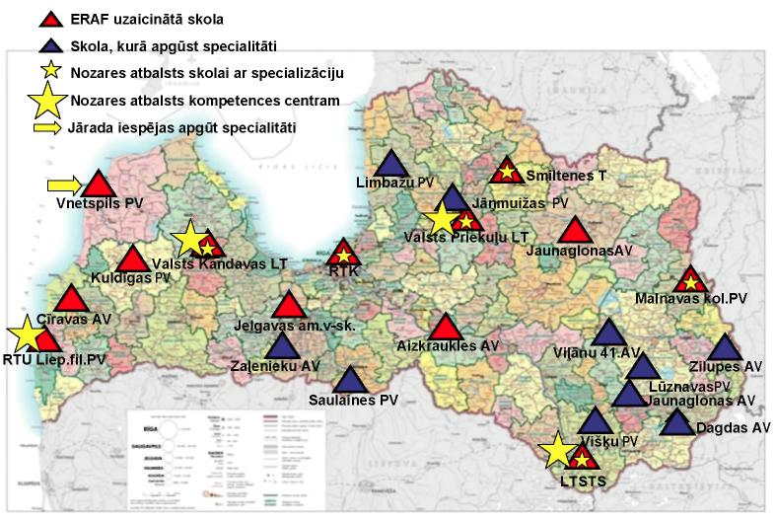

Figure 5. Vocational Education Institutions Implementing Education Programmes in the Thematic Area “Mechanical Sciences (Road and Rail Transport)”

Vocational education programmes in the field “Mechanical Sciences (Road Transport)” are being implemented throughout the territory of Latvia. Road transport is the most popular profession in vocational education institutions of Latvia. There is a particularly extensive coverage of road transport programmes in Latgale region. Consolidation of the implementation and specialisation of vocational education programmes in the field of road transport is necessary.

Vocational education programmes in the field “Mechanical Sciences (Rail Transport)” are being implemented in Riga and Daugavpils.

Vocational education programmes in the field of mechanical sciences are implemented:

In the city and region of Riga – Riga State Technical College (Motor vehicle mechanic, Rail transport automatics, telemechanics and communications technician, Railway track technician, Locomotive mechanical engineering technician, Rail transport carriage organisation and traffic safety technician, Transport car technician), Riga Technical College (Motor vehicle mechanic), Riga Secondary School of Construction (Motor vehicle mechanic, Motor vehicle mechanics assistant), Kandava State Agricultural Technical College (Motor vehicle mechanic, Agricultural machinery).

In Kurzeme region – Cīrava Secondary School of Trades (Motor vehicle technician), Kuldīga Secondary School of Technology and Tourism (Motor vehicle technician), Vocational Secondary School of RTU Liepāja branch (Motor vehicle mechanic), Ventspils Vocational Secondary School (Motor vehicle mechanic).

In Latgale region – Dagda Secondary School of Trades (Motor vehicle mechanic), Daugavpils Vocational Secondary School of Construction (Motor vehicle electrician), Jaunaglona Secondary School of Trades (Motor vehicle mechanic), Latgale Technical School of Transport and Communications (Motor vehicle mechanic, Railway track technician, Locomotive mechanical engineering technician, Rail transport carriage safety technician, Rail transport automatics, telemechanics and communications technician), Lūznava Vocational Secondary School (Motor vehicle mechanic), Malnava College (Motor vehicle mechanic), Viļāni Secondary School of Trades No. 41 (Motor Vehicle Mechanic), Višķi Vocational Secondary School (Agricultural machinery mechanic), Zilupe Secondary School of Trades (Motor vehicle mechanic’s assistant).

In Vidzeme region – Jāņmuiža Vocational Secondary School (Motor vehicle mechanic), Priekuļi State Agricultural Technical College (Motor vehicle mechanic), Smiltene Vocational Secondary School (Motor vehicle mechanic, Construction and road building machinery mechanic).

In Zemgale region – Aizkraukle Secondary School of Trades (Motor vehicle mechanic), Jelgava Secondary School of Craftsmanship (Motor vehicle mechanic), Saulaine Vocational Secondary School (Motor vehicle mechanic), Zaļenieki Secondary School of Trades (Motor vehicle mechanic).

Education programmes in the field of rail transport and services are being implemented at Riga State Technical College and in Latgale Technical School of Transport.

An education programme for construction and road building machinery mechanic is being implemented at Smiltene Vocational Secondary School.

Vocational education programmes in the field of agricultural machinery are being implemented at Kandava State Agricultural Technical College, Višķi Vocational Secondary School, Priekuļi State Agricultural Technical College.

5.1.5. Production of Food Products

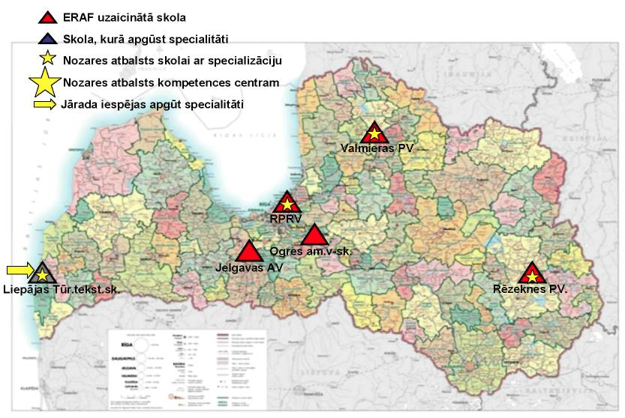

Figure 6. Vocational Education Institutions Implementing Education Programmes in the Thematic Area “Production of Food Products”

Vocational education programmes in the educational area of production of food products are implemented in Riga and in Riga region, Latgale and Vidzeme, however, they are not implemented in Kurzeme and Zemgale. As food production undertakings are present in all the regions of Latvia, it is necessary to commence the implementation thereof also in Kurzeme and Zemgale.

Vocational education programmes in the area of production of food products are implemented:

In the city of Riga – State limited liability company “Riga Secondary School of Food Producers” (Food product production technician, Bread and pastry confectionery product specialist), Riga Business College (Food product production technician).

In Riga region – Ogre Secondary School of Craftsmanship (Bread and pastry confectionery product specialist).

In Latgale region – Rēzekne Vocational Secondary School (Food product production technician).

In Vidzeme region – Valmiera Secondary School of Food Producers (Food product production technician) and Barkava Secondary School of Trades (Baker).

5.1.6. Textile Production Technologies

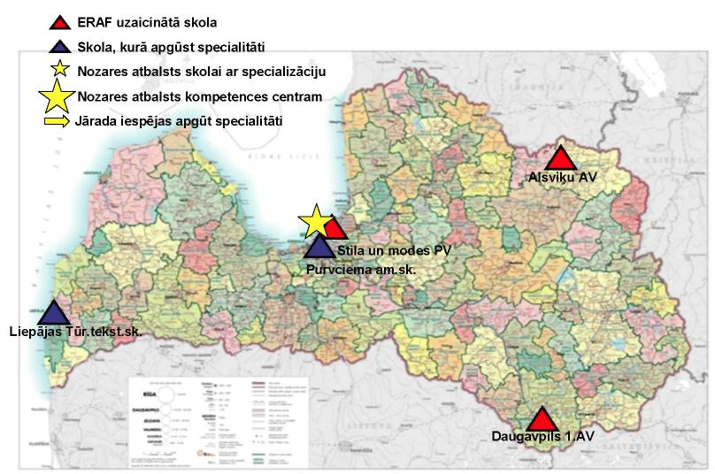

Figure 7. Vocational Education Institutions Implementing Education Programmes in the Thematic Area “Textile Production Technologies”

Vocational education programmes in the educational area of textile production technologies are implemented in all regions of Latvia, except Zemgale region, however, the number of pupils acquiring professions in this particular area of education is small.

Vocational education programmes in the field of textile production are implemented:

In the city of Riga – Riga Purvciems Crafts School (Sewing worker, Sewing production technician, Knitted production technician. Modiste, Clothes modelling and design specialist, Clothes designer), Riga School of Style and Fashion (Sewing worker, Tailor, Modiste).

In Kurzeme region – Liepāja School of Tourism and Textiles (Sewing worker, Dressmaker, Assistant Dressmaker, Tailor), Kuldīga School of Technology and Tourism (Tailor).

In Latgale region – Viļāni Secondary School of Trades No. 41 (Sewing worker, Dressmaker), Daugavpils Secondary School of Trades No. 1 (Assistant dressmaker, Dressmaker, Tailor), Dagda Secondary School of Trades (Tailor).

In Vidzeme region – Alsviķi Vocational Secondary School (Dressmaker).

In Zemgale region – Jelgava Secondary School of Craftsmanship (Tailor).

5.1.7. Organisation of Tourism and Recreation, Hotel and Restaurant Services

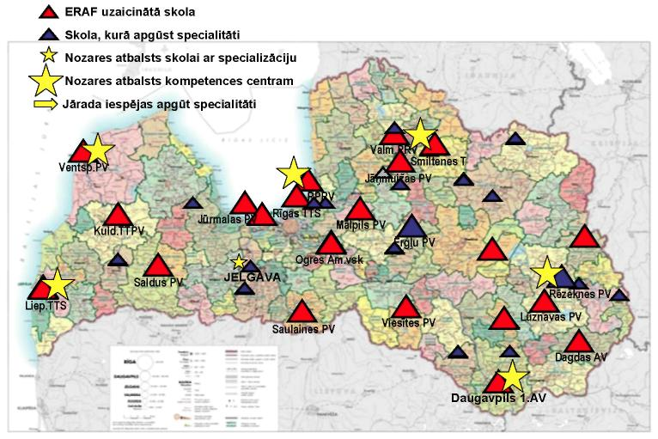

Figure 8. Vocational Education Institutions Implementing Education Programmes in the Thematic Area “Organisation of Tourism and Recreation, Hotel and Restaurant Services”

Vocational education programmes in the field of organisation of tourism and recreation, hotel and restaurant services are implemented in the city of Riga and all regions of Latvia.

Vocational education programmes in the field of organisation of tourism and recreation and hotel and restaurant services are implemented:

In the city of Riga – Riga Secondary School of Food Producers (Catering service specialist, Cook, Hospitality services specialist), Riga School of Tourism and Trade (Cook, Catering service specialist, Hotel services specialist), Riga Secondary School of Construction (Cook), Riga Purvciems Crafts School (Hospitality services specialist).

In Riga region – State limited liability company “Bulduri Secondary School of Horticulture” (Catering service specialist), Kandava State Agricultural Technical College (Catering service specialist, Hotel service specialist), Mālpils Vocational Secondary School (Catering service specialist).

In Kurzeme region – Liepāja School of Tourism and Textiles (Catering services specialist, Hospitality services specialist, Assistant cook), Ventspils Vocational Secondary School (Catering services specialist, Hotel services specialist), Cīrava Secondary School of Trades (Cook), Kuldīga Secondary School of Technologies and Tourism (Catering services specialist), Skrunda Secondary School of Trades (Assistant cook), Saldus Vocational Secondary School (Hospitality services specialist).

In Latgale region – Bebrene Vocational Secondary School (Hotel services specialist), Dagda Secondary School of Trades (Catering services specialist, Assistant cook), Rēzekne Vocational Secondary School (Catering services specialist, Hospitality services specialist), Višķi Vocational Secondary School (Catering services specialist), Daugavpils School of Trades (Cook, Pastry cook, Restaurant services specialist), Preiļi Secondary School of Trades (Cook), Zilupe Secondary School of Trades (Cook).

In Vidzeme region – Jāņmuiža Vocational Secondary School (Catering services specialist), Smiltene Technical College (Catering services specialist, Hospitality services specialist, Rural tourism services), Valmiera Secondary School of Food Producers (Catering services specialist), Alsviķi Vocational Secondary School (Cook, Assistant cook), Ranka Secondary School of Trades (Cook, Assistant cook), Jaungulbene Secondary School of Trades (Assistant cook), Ērgļi Secondary School of Trades (Hospitality services specialist), Valmiera Secondary School of Trades No. 36 (Hospitality services specialist), Barkava Secondary School of Trades (Hospitality services specialist).

In Zemgale region – Jelgava Secondary School of Craftsmanship (Catering services specialist), Saulaine Vocational Secondary School (Catering services specialist, Hospitality services specialist), Vecbebri Vocational Secondary School (Catering services specialist), Viesīte Secondary School of Trades (Cook), Zaļenieki Secondary School of Trades (Cook, Assistant cook).

5.1.8. Woodworking Technologies

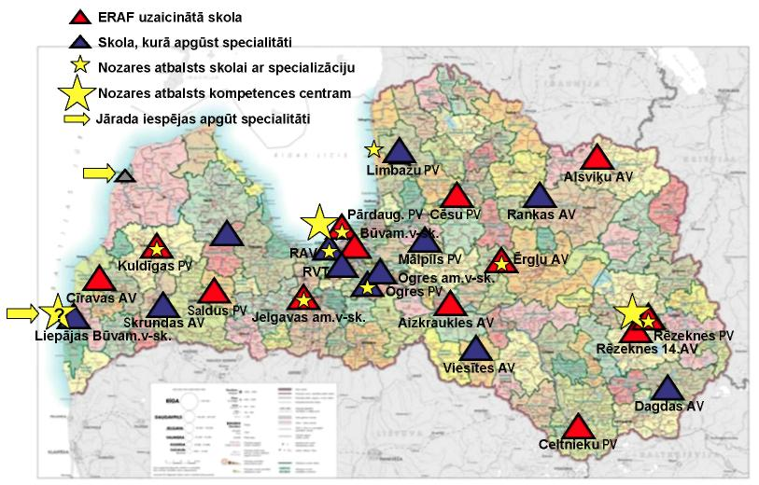

Figure 9. Vocational Education Institutions Implementing Education Programmes in the Thematic Area “Woodworking Technology”

Vocational education programmes in the field of woodworking are implemented in Riga and all regions of Latvia. Woodworking is one of the primary professions of Latvia and access to the acquisition thereof should be ensured throughout the territory of Latvia.

Vocational education programmes in the field of woodworking are implemented: In the city of Riga – Riga Pārdaugava Vocational Secondary School (Cabinet-maker), Riga Secondary School of Construction (Joiner), Riga Technical College (Cabinet-maker), Riga State Technical College (Wood treater).

In Riga region – Limbaži Vocational Secondary School (Joiner, Assistant joiner), Ogre Vocational Secondary School (Building ware joiner), Ogre Secondary School of Craftsmanship (Cabinet-maker).

In Kurzeme region – Cīrava Secondary School of Trades (Joiner, Assistant joiner), Kuldīga Secondary School of Technologies and Tourism (Cabinet-maker), Liepāja Secondary School of Building Trade Activities (Joiner), Saldus Vocational Secondary School (Building ware joiner).

In Latgale region – Daugavpils Secondary School of Trades No. 1 (Assistant joiner), Daugavpils Vocational Secondary School of Builders (Cabinet-maker, Joiner), Rēzekne Secondary School of Trades No. 14 (Cabinet-maker).

In Vidzeme region – Cēsis Vocational Secondary School (Cabinet-maker), Ranka Secondary School of Trades (Building ware joiner).

In Zemgale region – Aizkraukle Secondary School of Trades (Building ware joiner), Jelgava Secondary School of Craftsmanship (Cabinet-maker, Joiner), Viesīte Secondary School of Trades (Joiner).

5.1.9. Agriculture

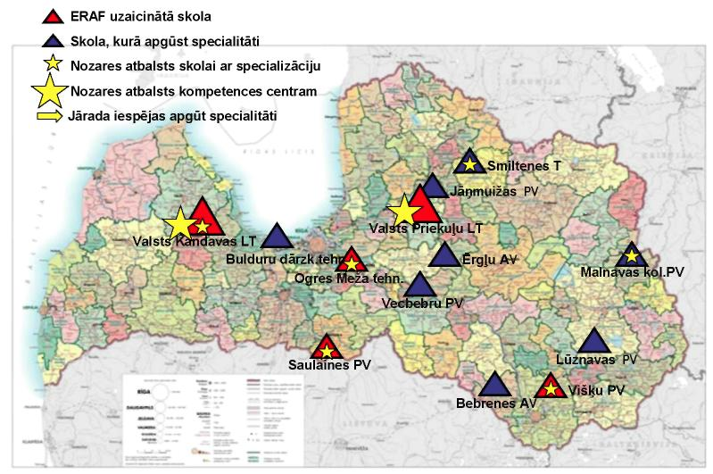

Figure 10. Vocational Education Institutions Implementing Education Programmes in the Thematic Area “Agriculture”

Vocational education programmes in the field of agriculture are not implemented in the city of Riga and Kurzeme region, however, taking into account the low interest of young persons in agricultural programmes, introduction of programmes in this field in Kurzeme should be evaluated thoroughly. In the next 5 years the existing programmes will need to be consolidated in Vidzeme and Latgale. Experience attests that agricultural programmes should be implemented together with mechanical sciences (agricultural technology) programmes.

Vocational education programmes in the field of agricultural specialities are implemented:

In Riga region – Kandava State Agricultural Technical College (Agricultural machinery mechanic), Bulduri Secondary School of Horticulture (Gardener, Horticulturist, Nursery grower, Park keeper), Ogre Forestry Technical College (Forestry technician, Forestry machinery mechanic).

In Latgale region – Malnava College (Manager of rural properties), Višķi Vocational Secondary School (Manager of rural properties, Agricultural machinery mechanic), Lūznava Vocational Secondary School (Pisciculturist), Bebrene Vocational Secondary School (Veterinarian’s assistant).

In Vidzeme region – Jāņmuiža Vocational Secondary School (Manager of rural properties), Priekuļi State Agricultural Technical College (Agricultural machinery mechanic), Ērgļi Secondary School of Trades (Tree tender (Arborist)), Smiltene Technical College (Veterinarian’s assistant).

In Zemgale region – Saulaine Vocational Secondary School (Manager of rural properties, Crop production worker), Vecbebri Vocational Secondary School (Apiarist).

5.2. Demographic Situation in Latvia and the Plan for Optimisation of Vocational Education Institutions Related Thereto

The VEI network will be optimised according to the foreseeable demographic situation and the development trends in economic sectors in order to ensure the preparation of the specialists necessary for the needs of regions and sectors.

The Guidelines have been developed, taking into account:

1) the demographic situation in a region, municipality or town and the impact of the demographic situation on the network of education institutions;

2) the proportion of the number of pupils at secondary level and the capacity of education institutions;

3) the results of negotiations with sectoral associations and professional organisations (the Association of Hotels and Restaurants of Latvia, the Authorised Motor Vehicle Traders Association of Latvia, the Food Industry Federation of Latvia, the Co-operation Council of Agricultural Organisations, the Electricity and Energy Builders Association of Latvia, the Electrical Engineering and Electronics Industry Association of Latvia, the Association of Woodworking Industries and Exporters of Latvia, the Associations “Latvijas mēbeles” and “Latvijas koks”, the Latvian Printers’ Association, the Association of Mechanical Engineering and Metalworking, the Builders’ Association of Latvia, the Latvian Information and Communications Technology Association, the Association of Light Industries, the Association of Latvian Chemical and Pharmaceutical Industry) on the network of education institutions in order to ensure balanced offer of opportunities for the acquisition of professions at regional and national level, as well as the opinion of sectors on the number of vocational education competence centres necessary for the sector;

4) results of negotiations with self-governments on complex development of the network of education institutions of all types, as well as information regarding the readiness to take over vocational education institutions (see Annex 1);

5) the existing material and technical basis and development opportunities of education institutions, as well as the operational results of the previous years, including admission indicators and opportunities for consolidation of programmes;

6) link of the programmes with regional college and higher education programmes; and

7) the necessity to ensure the number of specialists required for the labour market, as well as to ensure the conformity of the offer of education with the employment structure, which conforms to the strategic objective of the EU Lisbon Strategy – to make the EU the most competitive and dynamic knowledge-based economy in the world.

In co-operation with sectoral associations and self-governments, the existing VEI network has been evaluated in the plan, including from the point of view of access to programmes. The Guidelines anticipate to ensure opportunities for the acquisition of primary professions in all regions, as well as opportunities for specialisation according to the number of specialists necessary in the relevant sector.

Table 1
Number of Vocational Education Institutions in the School Year 2009-2010
(Source: data of the MoES)

Indicators | Number of VEIs (number of pupils) subordinate to the MoES | Number of self-government VEIs | Number of VEIs subordinate to the MoC | Number of VEIs subordinate to the MoW | Number of VEIs subordinate to the MoI | Number of private VEIs
Colleges* | 6  (3115)
VEI** | 59  (27674)
In total | 65  (30789) | 5  (1120) | 14  (1827) | 1  (286) | 1  (138) | 4  (1023)
In total*** | 90  (35183)

The capacity of vocational education institutions according to the demographic forecast and programmes offered has been evaluated and development opportunities are being planned in the Guidelines, taking into account the number of pupils not only in the education institutions subordinate to the MoES, but also in self-government education institutions and colleges which implement initial vocational education programmes.

Table 2
Planned Number of Vocational Education Institutions in 2015
(Except private VEIs and VEIs subordinate to other ministries)

Indicators | Total number of VEIs  subordinate to the MoES | including the number of vocational education competence centres
 | 2015 | 2015
In total | 30* | 14*

In accordance with data of the Central Statistics Bureau (source: CSB Yearbook: Demographic Forecasts) in 2015 there will be 93 788 inhabitants in Latvia in the age group between 15 to 19 years (156 053 inhabitants in 2009). Observing this fact, reduction of the age group from 15-19 years is 40%. Notwithstanding the negative demographic trend, a steady addition of specialists to the national economy should be ensured. As a result of optimisation of VEIs, the number of VEIs will be reduced, concurrently modernising education institutions. In order to provide specialists for the national economy, the proportion between the pupils of general education schools and the pupils of VEIs will be increased to 50:50.

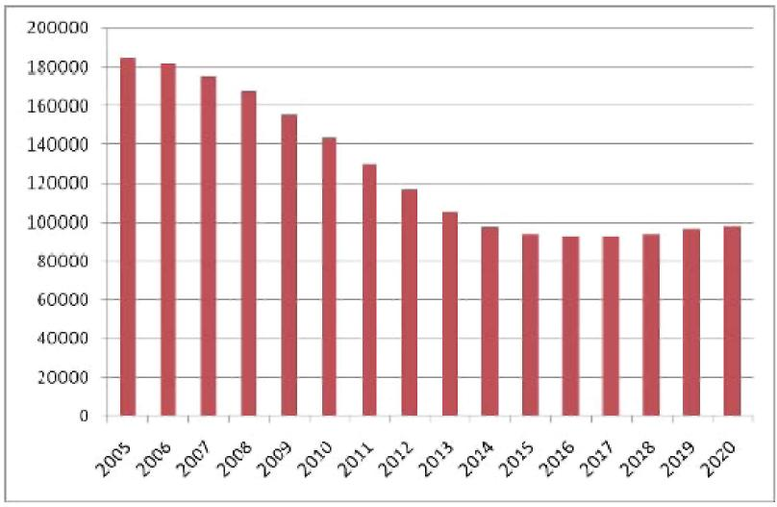

Figure 11. Expected Number of Inhabitants in the Age Groups Between 15-19 Years

5.2.1. Optimisation Plan in Kurzeme Region

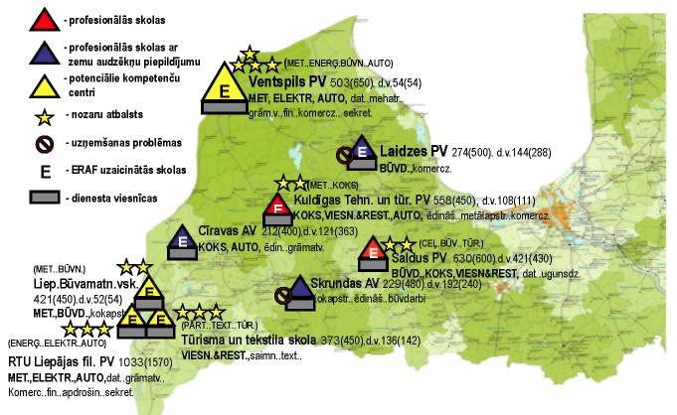

Figure 12. Vocational Education Institutions in Kurzeme

In Kurzeme region in total there are 9 vocational education institutions subordinate to the Ministry of Education and Science (one of which is the Vocational Secondary School of RTU Liepāja branch), which implement initial vocational education programmes. The total number of pupils in vocational education institutions in the region is 4247 and the total number of places (capacity) in all vocational education institutions is 5300, the average degree of filling 80%. 6719 pupils are studying in Grades 10-12 at secondary schools, which is 61% of the total number of pupils at the secondary level of education. Accordingly the proportion of pupils of vocational education institutions is 39%, which is lower than in Latvia at large.

There are three vocational education institutions and nine secondary schools (including one gymnasium) in the city of Liepāja. The total number of educatees at secondary level on 1 October 2009 was 3729, of which 1827 (49%) pupils were studying at vocational education institutions and 1902 pupils (51%) were studying in Grades 10-12 of secondary schools. The total number of places in Liepāja vocational education institution is 2220. The degree of filling of the vocational education institution is 82%.

There is one vocational education institution and six secondary schools (including one gymnasium) in the city of Ventspils. The total number of pupils at secondary level on 1 October 2009 was 1424, of which 503 (35%) pupils were studying at vocational education institutions and 921 pupils (65%) were studying in Grades 10-12 of secondary schools. The total number of places in Ventspils vocational education institution is 650. The degree of filling of the vocational education institution is 77%.

In municipalities of Kurzeme region the total number of educatees are 5813, of which 1917 pupils (33%) are studying in vocational education institutions. The number of places in vocational education institutions in Kurzeme region is 2430. The degree of filling of vocational education institutions on 1 October 2009 in municipalities of Kurzeme region was 79%.

Table 3
Optimisation Plan for Vocational Education Institutions of Kurzeme Region
(Thematic areas of education to be implemented in VEIs and the appropriate education programmes will be determined in the VEI development and investment strategy)

Vocational education institution | Anticipated status of the vocational education institution
Liepāja Secondary School of Building Trade Activities merged with Liepāja School of Tourism and Textiles and Vocational Secondary School of RTU Liepāja branch | Vocational education competence centre
Ventspils Vocational Secondary School | Vocational education competence centre
Laidze Vocational Secondary School | 1. To become a branch of Ventspils VSS  2. Self-government of Talsi municipality has expressed a wish to take over (see Annex 1)
Cīrava Secondary School of Trades | 1. To become a branch of Kuldīga VSS
Kuldīga Vocational Secondary School of Technologies and Tourism | VEI with specialisation
Saldus Vocational Secondary School | VEI with specialisation
Skrunda Secondary School of Trades | 1. To become a branch of Kuldīga VSS  2. Self-government of Skrunda municipality has expressed a wish to take over (see Annex 1)

After optimisation of vocational education institutions of Kurzeme region, 2 vocational education competence centres will be created in Kurzeme region, including the formation of Liepāja vocational education competence centre on the basis of all three vocational education institutions in the city, 2 vocational education institutions with a specialisation, 3 vocational education institutions will be established as branches of other vocational education institutions, self-government of Talsi municipality and self-government of Skrunda municipality have expressed a wish to gradually take over Laidze Vocational Secondary School and Skrunda Secondary School of Trades.

5.2.2. Optimisation Plan in Latgale Region

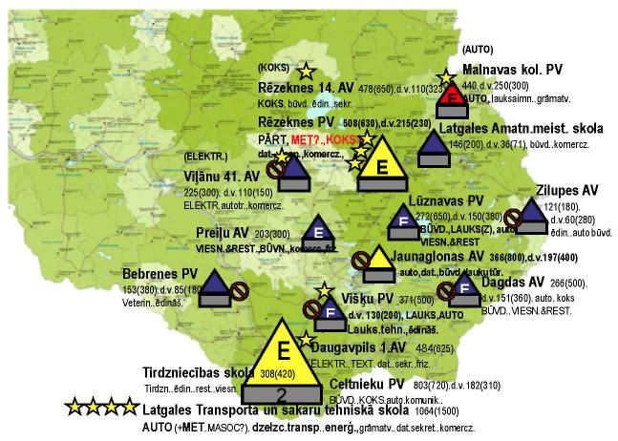

Figure 13. Vocational Education Institutions in Latgale

In total in Latgale region there are 15 vocational education institutions and one college subordinate to the Ministry of Education and Science, which implement initial vocational education programmes. The total number of pupils in vocational education institutions in the region is 5768 and the total number of places (capacity) in all vocational education institutions is 7855, the average degree of filling 73%. 7010 pupils are studying in Grades 10-12 at secondary schools, which is 55% of the total number of educatees at the secondary level of education. Accordingly the proportion of pupils of vocational education institutions is 45%, which is higher than in Latvia at large.

There are four vocational education institutions and thirteen secondary schools (including three gymnasiums) in the city of Daugavpils. The total number of places in Daugavpils vocational education institution is 3265. The degree of filling of vocational education institutions is 81%.

The total number of educatees at secondary level on 1 October 2009 was 4859, of which 2659 (55%) pupils were studying at vocational education institutions and 2200 pupils (45%) were studying in Grades 10-12 of secondary schools.

There are two vocational education institutions and eight secondary schools (including one gymnasium) in the city of Rēzekne. The total number of places in Daugavpils vocational education institution is 1280. The degree of filling of vocational education institutions is 77%.

The total number of pupils at secondary level on 1 October 2009 was 2130, of which 986 (46%) of pupils were studying at vocational education institutions and 1144 pupils (54%) were studying in Grades 10-12 of secondary schools.

In municipalities of Latgale region the total number of educatees is 5791, of which 2123 pupils (37%) are studying at vocational education institutions. The number of places in vocational education institutions in Kurzeme region is 3310. The degree of filling of vocational education institutions on 1 October 2009 in municipalities of Kurzeme region was 64%.

Table 4
Optimisation Plan for Vocational Education Institutions of Latgale Region
(Thematic areas of education to be implemented in VEIs and the appropriate education programmes will be determined in the VEI development and investment strategy)

Vocational education institution | Anticipated status of the vocational education institution
Latgale Technical School of Transport and Communications merged with Daugavpils Secondary School of Trades No. 1 | Vocational education competence centre
Daugavpils Trade School | VEI with specialisation
Daugavpils Vocational Secondary School of Builders | VEI with specialisation
Rēzekne Secondary School of Trades No. 14 merged with Rēzekne Vocational Secondary School with the following branches: Viļāni Secondary School of Trades No. 41, Latgale School of Craftsmanship, Zilupe Secondary School of Trades, Lūznava Vocational Secondary School (the option of choosing whether to stay with the vocational education competence centre of East Latgale or join the vocational education competence centre Central Latgale will be given) | Vocational education competence centre of East Latgale
Bebrene Vocational Secondary School | Self-government has expressed a wish to take over  (See Annex 1)
Jaunaglona Secondary School of Trades, Preiļi Secondary School of Trades, Višķi Vocational Secondary School, Dagda Secondary School of Trades merged into one VEI | Vocational education competence centre of Central Latgale
Malnava College | VEI with specialisation

After implementation of the optimisation guidelines, it is anticipated to create 3 vocational education competence centres in Latgale region, 3 vocational education institutions with specialisation (including Malnava College), self-government of Ilūkste municipality has expressed a wish to take over Bebrene Vocational Secondary School.

5.2.3. Optimisation Plan in Riga Region

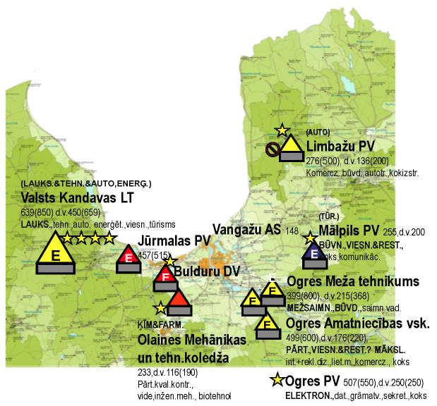

Figure 14. Vocational Education Institutions in Riga Region

In Riga region, including Riga, in total there are 16 vocational education institutions subordinate to the Ministry of Education and Science, four colleges, as well as one self-government vocational education institution which implements initial vocational education programmes. The total number of pupils in vocational education institutions in the region is 11 338 and the total number of places (capacity) in all vocational education institutions is 13 325, average degree of filling 85%. There are 27 539 pupils in secondary schools which is 71% of the total number of pupils at secondary education level. Accordingly the proportion of pupils of vocational education institutions is 29%, which is lower than in Latvia at large.

There is one vocational education institution and seven secondary schools (including one gymnasium) in Jūrmala. The total number of pupils at secondary level on 1 October 2009 was 1805, of which 457 (25%) pupils were studying at vocational education institutions and 1348 pupils (75%) were studying in Grades 10-12 of secondary schools. The total number of places in Jūrmala vocational education institution is 515. The degree of filling of the vocational education institution is 89%.

In the municipalities of Riga region the total number of educatees is 8147, of which 2637 pupils (32%) are studying at vocational education institutions. The number of places in vocational education institutions in municipalities of Riga region is 3650. The degree of filling of vocational education institutions on 1 October 2009 in the municipalities of Riga region was 72%.

Table 5
Optimisation Plan for Vocational Education Institutions of Riga Region
(Thematic areas of education to be implemented in VEIs and the appropriate education programmes will be determined in the VEI development and investment strategy)

Vocational education institution | Anticipated status of the vocational education institution
Bulduri Secondary School of Horticulture | VEI with specialisation
Kandava State Agricultural Technical College | Vocational education competence centre
Limbaži Vocational Secondary School | VEI for the acquisition of primary skills
Ogre Secondary School of Craftsmanship  Ogre Forestry Technical College  Ogre Vocational Secondary School | Vocational education competence centre
Olaine College of Mechanics and Technology | VEI with specialisation
Mālpils Vocational Secondary School | VEI for the acquisition of primary skills

After implementation of the optimisation guidelines, 2 vocational education competence centres, 2 vocational education institutions with a specialisation (including Olaine College of Mechanics and Technology) and 2 vocational education institutions for the acquisition of basic skills (including Mālpils Vocational Secondary School which is a self-government education institution) will be created in Riga region.

5.2.4. Optimisation Plan in the City of Riga

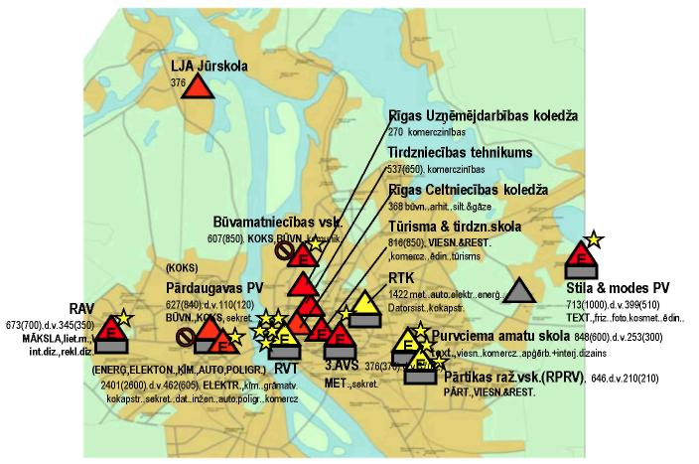

Figure 15. Vocational Education Institutions in the City of Riga

There are 10 vocational education institutions and 94 secondary schools (including twelve gymnasiums), and three colleges in the city of Riga. The total number of pupils at secondary level on 1 October 2009 was 28 925, of which 8244 (28%) pupils were studying at vocational education institutions and 20 681 pupils (72%) were studying in Grades 10-12 of secondary schools. The total number of places in vocational education institutions of the city of Riga is 9160. The degree of filling of vocational education institutions is 90%.

Table 6
Optimisation Plan for Vocational Education Institutions of the City of Riga
(Thematic areas of education to be implemented in VEIs and the appropriate education programmes will be determined in the VEI development and investment strategy)

Vocational education institution | Anticipated status of the vocational education institution
Riga Secondary School of Food Producers merged with  Riga Purvciems School of Crafts and Riga School of Tourism and Trade | Vocational education competence centre
Riga State Technical College | Vocational education competence centre
Rīga School of Trades No. 3 | VEI with specialisation
Riga Secondary School of Craftsmanship | VEI with specialisation
Riga Secondary School of Construction | VEI with specialisation
Riga Pārdaugava Vocational Secondary School | VEI with specialisation
Riga School of Style and Fashion | VEI with specialisation
Riga Technical College of Trade | VEI with specialisation
Riga Technical College | Vocational education competence centre
Riga College of Construction | VEI with specialisation
Riga Business College | VEI with specialisation

After implementation of the optimisation guidelines there will be 3 vocational education competence centres (including RTC) and 8 vocational education institutions with specialisation (including Riga College of Construction and Riga Business College) in the city of Riga.

5.2.5. Optimisation Plan in Vidzeme Region

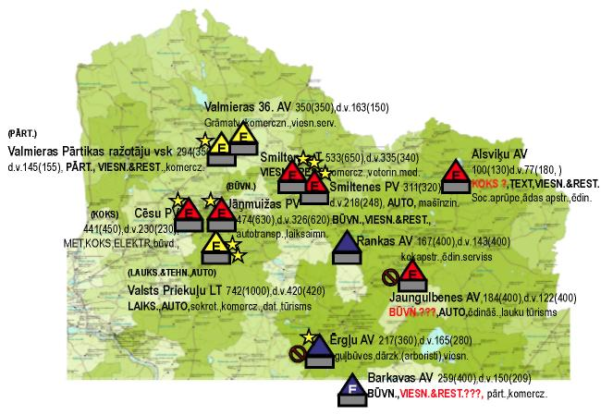

Figure 16. Vocational Education Institutions in Vidzeme Region

In total in the Vidzeme region there are 12 vocational education institutions subordinate to the Ministry of Education and Science, which implement initial vocational education programmes. The total number of pupils in vocational education institutions in the region is 4078 and the total number of places (capacity) in all vocational education institutions is 5440, the average degree of filling 75%. 6643 pupils are studying in Grades 10-12 at secondary schools, which is 62% of the total number of educatees at the secondary level of education. Accordingly the proportion of pupils of vocational education institutions is 38%, which is lower than in Latvia at large.

Table 7
Optimisation Plan for Vocational Education Institutions of Vidzeme Region
(Thematic areas of education to be implemented in VEIs and the appropriate education programmes will be determined in the VEI development and investment strategy)

Vocational education institution | Anticipated status of the vocational education institution
Jāņmuiža Vocational Secondary School merged with  Cēsis Vocational Secondary School | VEI with specialisation
Priekuļi State Agricultural Technical College | Vocational education competence centre
Valmiera Secondary School of Trades No. 36 and Valmiera Secondary School of Food Producers (Vidzeme vocational education centre) | Vocational education competence centre
Alsviķi Vocational Secondary School | Vocational education institution for educatees with special needs for the acquisition of basic skills
Barkava Secondary School of Trades | 1. VEI for the acquisition of primary skills  2. The council of Madona municipality has expressed a wish to take over (see Annex 1)
Ērgļi Secondary School of Trades | 1. VEI with specialisation  2. Self-government of Ērgļi municipality has expressed a wish to take over (see Annex 1)
Jaungulbene Secondary School of Trades | 1. VEI with specialisation
Ranka Secondary School of Trades | 1. VEI for the acquisition of basic skills  2. The council of Gulbene municipality has expressed a wish to take over (see Annex 1)  3. Add as a branch to Jaungulbene Secondary School of Trades
Smiltene Technical College | VEI with specialisation
Smiltene Vocational Secondary School

After implementation of the optimisation guidelines 2 vocational education competence centres and 4 vocational education institutions with specialisation, 3 vocational education institutions for the acquisition of basic skills are anticipated for Vidzeme region.

The council of Madona municipality, the self-government of Ērgļi municipality and the council of Gulbene municipality have expressed a wish to take over Barkava Secondary School of Trades, Ērgļi Secondary School of Trades and Ranka Secondary School of Trades.

5.2.6. Optimisation Plan in Zemgale Region

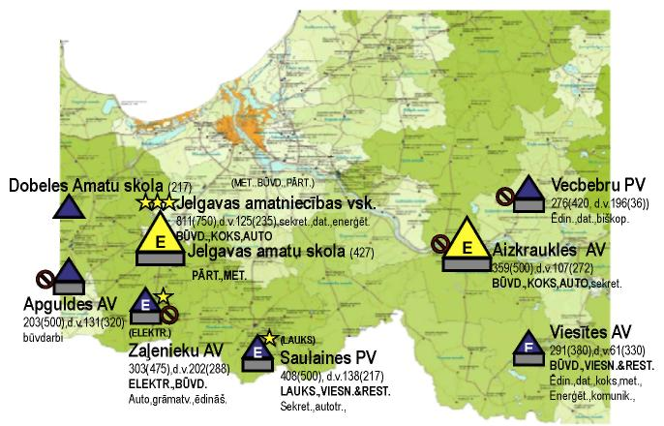

17. Figure 9. Vocational Education Institutions in Zemgale Region

In total in the Zemgale region there are 7 vocational education institutions subordinate to the Ministry of Education and Science, one college and 2 self-government education institutions – in Dobele and Jelgava – which implement initial vocational education programmes. The total number of pupils in vocational education institutions in the region is 3027 and the total number of places (capacity) in all vocational education institutions is 4342, the average degree of filling 70%. 6128 pupils are studying in Grades 10-12 at secondary schools, which is 67% of the total number of educatees at the secondary level of education. Accordingly the proportion of pupils vocational education institutions is 33%, which is lower than in Latvia at large.

There are two vocational education institutions and six secondary schools (including three gymnasiums) in the city of Jelgava. The total number of places in Jelgava vocational education institutions is 1327. The degree of filling of vocational education institutions is 93%.

The total number of educatees at secondary level on 1 October 2009 was 2745, of which 1239 (45%) pupils were studying at vocational education institutions and 1506 pupils (55%) were studying in Grades 10-12 of secondary schools.

In municipalities of Zemgale region the total number of educatees is 6422 pupils, of which 1800 pupils (30%) are studying at vocational education institutions. The number of places in vocational education institutions in municipalities of Zemgale region is 3015. The degree of filling of vocational education institutions on 1 October 2009 in municipalities of Kurzeme region was 60%.

Table 8
Optimisation Plan for Vocational Education Institutions of Zemgale Region
(Thematic areas of education to be implemented in VEIs and the appropriate education programmes will be determined in the VEI development and investment strategy)

Vocational education institution | Anticipated status of the vocational education institution
Jelgava Secondary School of Craftsmanship merged with  Jelgava Secondary School of Crafts | Vocational education competence centre of West Zemgale
Aizkraukle Secondary School of Trades | Vocational education competence centre of East Zemgale
Apgulde Secondary School of Trades | The council of Dobele municipality has expressed a wish to take over (see Annex 1)
Saulaine Vocational Secondary School | 1. VEI with specialisation  2. The council of Rundāle municipality has expressed a wish to take over Saulaine Vocational Secondary School (see Annex 1)
Vecbebri Vocational Secondary School | 1. To be established as a branch of the Vocational education competence centre of East Zemgale  2. The council of the Koknese municipality has expressed a wish to take over Vecbebri Vocational Secondary School (see Annex 1) 1)
Viesīte Secondary School of Trades | 1. To be established as a branch of the Vocational education competence centre of East Zemgale  2. The self-government of Viesīte municipality has expressed a wish to take over Viesīte Secondary School of Trades (see Annex 1)
Zaļenieki Secondary School of Trades | 1. To be established as a branch of Saulaine Vocational Secondary School. 2. The self-government of Jelgava municipality has expressed a wish to take over Viesīte Secondary School of Trades (see Annex 1).
Jēkabpils Agrobusiness College | VEI with specialisation

After implementation of the optimisation guidelines 2 vocational education competence centres and 2 vocational education institutions with specialisation, including Jēkabpils Agrobusiness College, will be created in Zemgale region. The council of Dobele municipality, the council of Rundāle municipality, the council of Koknese municipality and the self-government of Viesīte municipality have expressed a wish to take over Apgulde Secondary School of Trades, Saulaine Vocational Secondary School, Vecbebri Vocational Secondary School and Viesīte Secondary School of Trades.

6. Schedule for Execution of Tasks

In planning the schedule for execution of the main tasks for achieving the results of the Guidelines, the maximum deadline set for the execution of tasks is year 2015, however, the execution of tasks may also take place sooner.

Table 9
Schedule for Execution of Tasks

No. | Planned task | Time for execution of the task (date/month/year)
1. | Preparation of Cabinet orders regarding the reorganisation of VEIs ensuring the optimisation of the VEI network | 01/07/2015
2. | Submission of the development and investment strategy developed by VEIs in co-operation with self-governments (which have been invited to submit project submissions in Activity 3.1.1.1) in order for VEIs to qualify for support within the scope of Activity 3.1.1.1 | 01/02/2010
3. | Evaluation, co-ordination or conditional co-ordination of the development and investment strategy developed by VEIs (in accordance with Task 2) | 01/03/2010
4. | Preparation of the draft legal acts for the financing procedures of VEIs. | 01/05/2010
5. | Optimisation of the VEI network, ensuring optimal filling of existing buildings, cessation of the use of buildings unnecessary for the operation of institutions | 01/07/2015
5.1. | merging of education institutions if it is possible to ensure more optimal operation thereof with a unified administration and unified infrastructure (sports complex, library, catering and service hotel) | 01/07/2015
5.2. | consolidation of the offer of programmes with the purpose of using all types of resources rationally, including planned investments for improvement of equipment | 01/07/2015
5.3. | implementation of the approved investment projects, optimisation and differentiation of vocational education institutions included in the VEI optimisation plan, complex renovation of buildings, ensuring resource efficiency and energy efficiency which will ensure the return of investments | 01/07/2015
5.4. | Attraction of other financial resources, for example, funding of the Financial Instrument for Climate Changes (FICC) | 01/07/2015

Table 10
Planning of Execution of the Guidelines for Optimisation of the Network of Vocational Education Institutions Subordinate to the MoES

Indicators | Total number of VEIs subordinate to the MoES | Total number of VEIs subordinate to the MoES | including the number of competence centres | Education institutions integrated by self-governments
 | 2009 | 2015 | 2015
Riga region  including Bulduri Secondary School of Horticulture | 6 | 4 | 2 | -
City of Riga  including Riga Secondary School of Food Producers | 10 | 9* | 3* | -
Kurzeme | 9 | 4 | 2 | 2
Latgale | 15 | 5 | 3 | 1
Vidzeme | 12 | 6 | 2 | 3
Zemgale  excluding Jelgava and Dobele Secondary Schools of Crafts | 7 | 2 | 2 | 4
In total | 59 | 30* | 14* | 10

Upon optimising the VEI network by creating vocational education competence centres and vocational education centres with a specialisation and for the acquisition of basic skills, the number of VEIs will reduce by 20.

Competence Centres and Vocational Education Centres

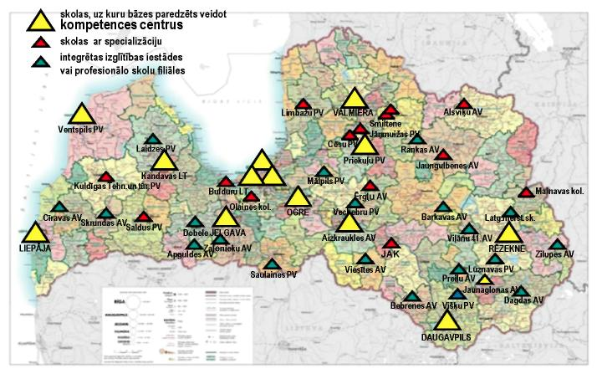

Figure 18. Optimisation of the Network of Vocational Education Institutions

In order to promote the prestige of vocational education and to improve the quality of vocational education, it is necessary to transform the vocational education system, making it modern, contemporary and corresponding to the rapidly changing needs of the labour market.

Re-structuring and modernisation of the vocational education system is performed within the conditions of reduced funds from the State budget, therefore, foreign financial instruments must be attracted as much as possible (Activity 3.1.1.1, Activity 3.1.3.2, Financial Instrument for Climate Changes, etc).

The national economy of Latvia is also interested in the development of vocational education, therefore, several undertakings of Latvia are prepared to support the optimisation of VEIs with their co-financing, for example, stock company “Grindeks”.

Harmonised and unified actions of partners (self-governments of cities and municipalities, planning regions, social partners, sectoral associations and undertakings) are of great significance to the development of vocational education, it must be created as a unified mechanism for the development of vocational education.

In order to strengthen the co-operation mechanism and to determine the co-responsibility of each party involved in the process, amendments to the Education Law and Vocational Education Law, as well as appropriate Cabinet Regulations will be prepared. Upon preparing the aforementioned amendments, the same basic principles for ERDF financing will be ensured for State and self-government vocational education institutions, equal conditions for pupils to receive grants both in State and self-government vocational education institutions, as well as financing for maintenance costs should also be ensured for vocational education institutions which are being taken over by self-governments, in accordance with the norm for each pupil to the same extent as in State vocational education institutions.

7. Planning of the Allocated and
Additionally Necessary Financing Corresponding to the Tasks

Taking into account the limited State budget funds, foreign financial instrument assistance, including the resources of the European Union funds and the Financial Instruments for Climate Changes, is actually the only resource for the renovation of vocational education institution buildings, energy efficiency measures and for the purchase and modernisation of equipment and teaching aids.

The total financing currently available for the VEI infrastructure and equipment in ERDF Activity 3.1.1.1 in the amount of LVL 58 911 511 and in ERDF Activity 3.1.3.2 in the amount of LVL 9 681 449 is not sufficient in order to perform complex renovation and equipping of all vocational education institutions according to the requirements of employers, which will operate after implementation of the optimisation guidelines. Estimates attest that in order to completely ensure all requirements related to the development of the infrastructure of vocational education institutions, additional 200 million lats would be necessary.

The aforementioned estimates have been performed, taking into account the foreseeable number of pupils, the necessary area according to the anticipated number of pupils and the average costs of renovation:

1) according to the analytical catalogue of construction costs (2009) developed by the Ministry of Economics, the costs of renovation per m² are LVL 500;

2) according to the requirements of regulatory enactments, 1 pupil requires 10 m² (premises for training, workshop courses, common use and other premises), as a result of which the costs of renovation per pupil is 500 x 10 = LVL 5000, also taking into account the poor condition of vocational education institution buildings;

3) accordingly 5000 x 14 000 = 70 million lats are necessary for the renovation of vocational education competence centres; and

4) investments in the amount of at least 25% of the total financing are necessary for the purchase of equipment for vocational education competence centres.

It is anticipated to use also other sources of financing for heat insulation of buildings and other energy efficiency measures, for example, financing of the Financial Instrument for Climate Changes. Therefore, VEIs will have to update the development and investment strategies of the education institutions thereof, anticipating all positions of complex renovation, energy efficiency measures and equipment modernisation, presenting costs of individual positions and total costs, as well as indicating the priority tasks.

The matter of renovation of official accommodation facilities must be resolved separately, which is currently not anticipated from ERDF funds, however, is vitally important for the provision of optimum operation of vocational education competence centres.

The main benefit of the Guidelines will be a modern, attractive and prestigious vocational education system which will ensure high quality of vocational education in accordance with the requirements of the labour market.

The saving of financial resources can be anticipated in relation to optimisation of the maintenance costs of the VEIs to be reorganised, including long-term return of energy efficiency measures, efficient use of teaching equipment, as well as consolidation of programmes.

8. Institutions Responsible for Execution of the Tasks

The institution responsible for the implementation of the Guidelines is the MoES. Co-operation partners will be involved in the implementation of the Guidelines – sectoral associations and self-governments, and planning regions will also be involved. The MoES will create working groups for the implementation of the Guidelines, in the composition of which representatives of sectoral associations, planning regions, self-governments and VEIs will be included.

9. Procedures for the Submission and Evaluation of Reports

The MoES shall evaluate the implementation of the Guidelines with the participation of representatives of self-governments and sectoral associations and social partners – the Employers’ Confederation of Latvia and the Free Trade Union Confederation of Latvia. The MoES shall provide the following in accordance with the procedures specified by the Cabinet:

1. by 1 March 2013 — an informative report on the progress of implementation of the Guidelines for the time period from 1 January 2010 until 31 December 2012; and

2. by 1 March 2016 — an informative report on the progress of implementation of the Guidelines for the time period from 1 January 2010 until 31 December 2015.

Minister for Education and Science T. Koķe

(Cabinet Order No. 5
6 January 2010

Summary of the Guidelines for the Optimisation of the Network of Vocational Education Institutions 2010-2015

1. Objective and Sub-Objectives of the Guidelines

The Ministry of Education and Science (hereinafter – MoES) has developed the Guidelines for the Optimisation of the Network of Vocational Education Institutions (hereinafter – Guidelines) in accordance with the task given in Paragraph 5 of Cabinet Protocol No. 58 of 15 September 2009 “Report on the Progress of the Structural Reform of the Education System and the Planned Measures for Further Implementation Thereof”.

The objective of the Guidelines is to ensure continuous implementation of the structural reforms of the vocational education system, optimising the number and arrangement of vocational education institutions in regions, as well as promoting the differentiation thereof, to establish a modern and logistical support of vocational education meeting the contemporary requirements, to promote more efficient use of all types of resources, improving the quality and accessibility of vocational education.

Sub-objectives

1. To improve co-operation with self-governments and sectoral associations, as well as to involve the planning regions in the development of a balanced network of schools in the relevant region in order for State administrative institutions, self-governments and planning regions, as well as sectoral associations to mutually co-ordinate their activities, optimising the network of vocational education institutions and performing complex planning of the network of education institutions of all types, as well as to offer solutions for transferring vocational education institutions to self-governments.

2. To establish a cost-efficient and energy efficient network of VEIs, which is accessible to inhabitants, in order to use State and foreign financial instruments and properties of vocational education institutions rationally , to establish a modern and contemporary material and technical basis appropriate for the acquisition of vocational education programmes and promoting the quality and compliance of vocational education with the requirements of the labour market.

3. To develop a financing system which would ensure a unified financing principle “money follows the pupil” for all education institutions in order to encourage self-governments to perform complex planning of activities of all types of education institutions and optimisation of the school network, as well as to promote co-operation with such sectoral undertakings which are interested in supporting vocational education and participating in optimisation of the network of vocational education institutions with their co-financing.

2. Planned Outcomes of the Guideline Policy and Outcomes of the Activity

The quality of vocational education, accessibility thereof to inhabitants and cost-effectiveness are the main planned outcomes of the Guideline policy, which are characterised by the following indicators:

1. A differentiated network of vocational education institutions commensurate with demographic trends will be developed in the State.

2. A balanced offer of opportunities for the acquisition of vocational education programmes will be ensured (at regional and national level) in order to prepare the number of specialists neccesary for the labour market and to ensure the conformity of the offer of education with the employment structure.

3. The principle of co-operation between State institutions, self-governments and sectoral associations will be observed during the optimisation process of VEIs in order to ensure flexible and efficient use of all types of resources, as well as the opportunity of reacting quickly to changes in the demand of the labour market.

Table 1
Number of Vocational Education Institutions Implementing Initial Vocational Education Programmes
(Source: data of the MoES)

Indicators | Number of vocational education institutions subordinate to the MoES (number of pupils) | Number of vocational education institutions subordinate to self-governments | Number of vocational education institutions subordinate to the Ministry of Culture | Number of vocational education institutions subordinate to the Ministry of Welfare | Number of vocational education institutions subordinate to the Ministry of the Interior | Number of private vocational education institutions
Colleges* | 6  (3115)
Vocational education institutions** | 59  (27674)
In total | 65  (30789) | 5  (1120) | 14  (1827) | 1  (286) | 1  (138) | 4  (1023)
In total*** | 90  (35183)

In accordance with the data of the Central Statistics Bureau (source: CSB Yearbook: Demographic Forecasts) in 2015 there will be 93 788 inhabitants in Latvia in the age group between 15 to 19 years (in 2009 there were 156 053). Observing the referred to fact, reduction in the age group from 15 to 19 years in 2015 will be 40%. Although the demographic trend is negative, a steady addition of specialists to the national economy should be ensured. Upon optimising vocational education institutions, the number of vocational education institutions will be reduced, concurrently modernising education institutions. In order to provide specialists for the national economy, the proportion between the pupils of general education schools and VEI pupils will be increased to 50:50.

The Guidelines provide for the creation of 14 vocational education competence centres (including Riga Technical College), which are expected to ensure a complex material and technical basis, in order to provide pupils with opportunities to acquire a vocational qualification in all primary professions of the relevant sector. Vocational education competence centres will also perform the functions of methodical supreme command and examination centres in the relevant region. It is anticipated to use the material and technical basis of vocational education competence centres for training of pupils of other vocational education institutions for work with the latest technologies, using appropriate workstations and equipment which is not possible to be ensured for each education institution, as well as for improving the qualification of employees and retraining of unemployed persons.

The necessary material basis for the acquisition of vocational qualification skills in primary professions and for the acquisition of vocational qualification in specialisations of primary professions in specific education programmes will be ensured in vocational education institutions with a specialisation.

The necessary material basis for the acquisition of basic skills in one or several professions will be ensured in vocational education institutions.

3. Results-based Indicators for Achievement of the
Outcomes of the Guideline Policy

Introduction of the Guidelines will improve the co-operation and co-ordinated actions of the partners involved in the optimisation process of the network of vocational education institutions and improve the quality and accessibility of vocational education at the time of insufficiency of financial resources for education.

The network of vocational education institutions will be optimised according to the development trends of sectors of the national economy and the foreseeable demographic situation and will ensure the preparation of the specialists necessary for the needs of the regions and sectors.

Due to negative demographic trends, which will affect regional municipalities to a greater extent than towns, the number of pupils at vocational education institutions will reduce to 25-40%. Therefore, subsequent operation of these vocational education institutions will only be possible if self-governments create integrated education institutions on the basis of these education institutions, in which different general education and vocational education programmes, as well as training and further education of adults will be implemented. It is anticipated to increase the role of planning regions, determining co-liability for planning of a balanced school network in the relevant region.

Upon optimising the network of vocational education institutions, creating vocational education competence centres, vocational education institutions with a specialisation and vocational education institutions for the acquisition of basic skills, the number of vocational education institutions will reduce by 20.

Table 2
Schedule for Execution of the Guidelines for the Optimisation of the Network of Vocational Education Institutions Subordinate to the MoES

Indicators | Total number of vocational education institutions subordinate to the MoES | Total number of vocational education institutions subordinate to the MoES | Including number of vocational education competence centres | Education institutions integrated by self-governments
 | 2009 | 2015 | 2015
Riga region  Including Bulduri Secondary School of Horticulture | 6 | 4 | 2 | -
City of Riga  Including Riga Secondary School of Food Producers | 10 | 9* | 3* | -
Kurzeme | 9 | 4 | 2 | 2
Latgale | 15 | 5 | 3 | 1
Vidzeme | 12 | 6 | 2 | 3
Zemgale  excluding Jelgava and Dobele Secondary Schools of Crafts | 7 | 2 | 2 | 4
In total | 59 | 30* | 14* | 10

Note. It is planned that Riga Technical College will be the vocational education competence centre in Riga.

Competence Centres and Vocational Education Centres

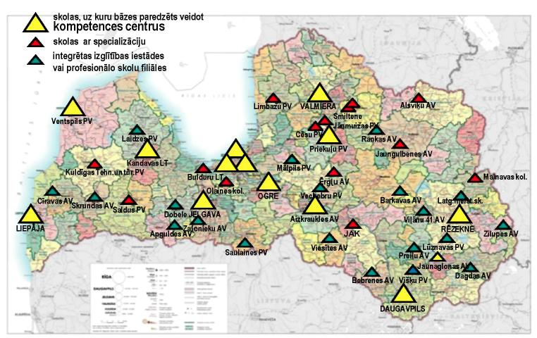

4. Main Tasks for Achievement of the Guideline Outcomes

1. Preparation of draft legal acts relating to optimisation of vocational education institutions.

2. Drawing up of development and investment strategies for vocational education institutions:
2.1. co-operation with self-governments and sectoral associations in matters of optimisation of the network of vocational education institutions, with complex planning of the network of education institutions of all types in accordance with the foreseeable demographic situation and promoting the initiative and participation of co-operation partners in taking of decisions; and
2.2. evaluation of the existing network of vocational education institutions in accordance with the demographic forecast for the next 5-10 years and planning of optimisation, taking into account the foreseeable number of pupils at the level of secondary education; planning and creation of the arrangement of vocational education competence centres.

3. Evaluation and co-ordination of the drawn up development and investment strategies of vocational education institutions.

4. Preparation of draft legal acts regarding the procedures for financing vocational education institutions.

5. Optimisation of the network of vocational education institutions, ensuring optimal filling of existing buildings, cessation of the use of buildings unnecessary for the operation of institutions:
5.1. merging of education institutions if it is possible to ensure more optimal operation with a unified administration and unified infrastructure (sports complex, library, catering and official accommodation facilities);
5.2. consolidation of the offer of programmes in order to use all types of resources rationally, including the planned investments for improvement of equipment;
5.3. implementation of the approved investment projects, optimisation and differentiation of the network of vocational education institutions included in the plan for optimisation of vocational education institutions, thorough renovation of buildings, ensuring resource efficiency and energy efficiency which will ensure long-term reimbursement of investments; and
5.4. attraction of other financial resources, for example, funding of the Financial Instrument for Climate Changes.

Differentiation of vocational education institutions:
1. vocational education competence centre;
2. vocational education institution with a specialisation;
3. vocational education institution for the acquisition of basic skills;
4. branch of a vocational education institution; and
5. integrated education institution

Notwithstanding the founder and differentiation, project applications for attracting investments for the development of vocational education institutions will be drawn up and submitted on the basis of the development and investment strategy.
The development and investment strategy shall include description of the regional development trends, taking into account the development of the national economy, the planned status of the vocational education institution shall be referred to, the material and technical facilities existing in a vocational education institution, the performance of investments made in previous years, the planned measures for ensuring the acquisition of the new status of the vocational education institution and the financing necessary for the implementation of the planned measures will be described.
The development and investment strategy of a vocational education institution co-ordinated with the Ministry of Education and Science will be appended to the relevant project application (for example, Activity 3.1.1.1, Activity 3.1.3.2) in order for the vocational education institution to qualify for the relevant foreign financial assistance.

5. Planning of the Allocated and
Additionally Necessary Financing Corresponding to the Tasks

Taking into account the limited funds from the State budget, foreign financial instrument assistance, including the European Union funds and the Financial Instrument for Climate Changes, is actually the only resource for the renovation and energy efficiency measures of vocational education institution buildings and for the purchase and modernisation of equipment and teaching aids.
The total financing currently available for the VEI infrastructure and equipment in the ERDF Activity 3.1.1.1 in the amount of LVL 58 911 511 and in the ERDF Activity 3.1.3.2 in the amount of LVL 9 681 449 is not sufficient for complex renovation and equipping of all vocational education institutions according to the requirements of employer, which will operate after implementation of the optimisation guidelines. Estimates attest that in order to completely ensure all requirements related to the development of the infrastructure of vocational education institutions, additional 200 million lats would be required.
Taking into account the anticipated number of pupils, the necessary area and the average renovation costs, calculations have been performed. They anticipate:
5) according to the analytical catalogue of construction costs (2009) developed by the Ministry of Economics, the costs of renovation per m² are LVL 500;
6) according to the requirements specified in regulatory enactments, 1 pupil requires 10 m² (premises for training, workshop courses, commune use, also taking into account the poor condition of the vocational education institution buildings), the costs of renovation per pupil are 500 x 10 = LVL 5000;
7) accordingly 5000 x 14000 = 70 million lats are necessary for the renovation of vocational education competence centres; and
8) investments in the amount of at least 25 % of the total financing are necessary for the purchase of equipment for vocational education competence centres.

It is anticipated to use also other sources of financing, for example, financing of the Financial Instrument for Climate Changes, for heat insulation of buildings and other measures of energy efficiency. Therefore, vocational education institutions will have to update the development and investment strategies of education institutions, anticipating all complex renovations, energy efficiency measures and the positions of equipment modernisation, presenting costs of individual items and total costs, as well as indicating the priority tasks.
The matter of renovation of official accommodation facilities must be resolved separately, which is currently not anticipated from the ERDF funds, however, is vitally important for ensuring optimum activity of vocational education competence centres.
The main benefit of the Guidelines will be a modern, attractive and prestigious vocational education system which will ensure high quality of vocational education in accordance with the requirements of the labour market.
Saving of financial resources can be foressen in relation to the optimisation of the maintenance costs of the vocational education institutions to be reorganised, including long-term return of energy efficiency measures, efficient use of teaching equipment, as well as consolidation of programmes.

Minister for Education and Science T. Koķe

* Except medical colleges and the College of Seafaring and Maritime School of the Latvian Maritime Academy because the specialities which may be acquired at these education institutions are reviewed in separate programmes.
** Including the Vocational Secondary School of Riga Technical University Liepāja branch, Riga Secondary School of Food Producers and Bulduri Secondary School of Horticulture.
*** Including private VEIs and VEIs subordinate to other ministries.
* Note. It is planned that Riga Technical College will be the vocational education competence centre in Riga.
* Note. It is planned that Riga Technical College will be the vocational education competence centre in Riga.
* Except medical colleges, as well as the Maritime School of the Latvian Maritime Academy and Liepāja College of Seafaring because the specialities which may be acquired at these education institutions are reviewed in individual programmes.
** Including the Vocational Secondary School of Riga Technical University Liepāja branch and the State limited liability company “Riga Secondary School of Food Producers” and “Bulduri Secondary School of Horticulture”.
*** Including vocational education institutions subordinate to other ministries and private vocational education institutions.

